

**“Oracle Forms & Reports”**

**I**

**N**

**T**

**E**

**R**

**N**

**S**

**H**

**I**

**P**

**R**

**E**

**P**

**O**

**R**

**T**



**I**

**N**

**T**

**E**

**R**

**N**

**S**

**H**

**I**

**P**

**R**

**E**

**P**

**O**

**R**

**T**

ON

**“Oracle Forms & Reports”**

**At**

**S**

**U**

**B**

**M**

**I**

**T**

**T**

**E**

**D**

**T**

**O**

**:**

Senior Lecturer



**S**

**U**

**B**

**M**

**I**

**T**

**T**

**E**

**D**

**B**

**Y**

**:**

Anika Hossain

United International University

ID: 011 151 122

D

ate of

S

ubmission: January 03, 2020

# *ACKNOWLEDGEMENT*



First of all, I wish to express my gratitude to the almighty ALLAH for giving me the strength

to perform my responsibilities as an intern and complete the report within the stipulated time.

I am deeply indebted to my Faculty Advisor Dr. Prof. Md. Nurul Huda, Professor, United International University for his whole-hearted supervision during my organizational attachment period. I am also grateful to **Suraya Akhtar**, as my organizational and technical supervisor. It would have been very difficult to prepare this report up to this mark without their guidance.

My gratitude goes to entire CSE Department, of United International University for arranging Internship Program that facilitates integration of theoretical knowledge with real life situation.

Last but not the least, I would like to convey my gratitude to Mr. **Syed Nazmul Huda,** AGM, IT for helping me in furnishing the report. Moreover, I would also like to express my gratitude to my Acme Laboratories Ltd. fellows, seniors and colleagues who gave me good advice, suggestions, inspiration and support. I must mention the wonderful working environment and group commitment of this organization that has enabled me to deal with a lot of things.

# *SUMMARY*



This report is prepared on the basis of my three-month practical experience at ACME

Laboratories LTD. This internship program helped me to learn about the practical scenario of a Corporate Company. The ACME Laboratories Ltd. is a leading company for manufacturing world-class and top-quality pharmaceutical products in Bangladesh. They are currently producing more than 700 products in different dosage forms covering broader therapeutic categories which include anti-infective, cardiovascular, antidiabetics, gastrointestinal, CNS, respiratory disease etc. among many others. The success in local market prompted us to explore the international market and over the years they gained a firm presence in South East Asia, Africa and Central America and continuously discovering new horizons to improve the quality of life for patients, to further the success of their customers and to help meet global challenges. Through the outstanding knowledge, professionalism and commitment of more than 7500 employees, they are consistently building upon their facilities, capabilities and also portfolio to meet the growing health care needs.

The report mentions about the Oracle Forms and Reports that I have learnt at ACME Laboratories LTD and build a small project based on their product.

# *Table of Content*



Acknowledgement …………………………………………………………… I

Summary……………………………………………………………………….II

1. Introduction………………………………………………………………….1

2. Features……………………………………………………………………......1

3. Description…………………………………………………………………….2

3.1 Admin Panel………………………………………………………......3

3.1.1. Product……………………………………………………....4

3.1.2. Order………………………………………………………

3.1.3. Shipment……………………………………………………

3.1.4. Supply………………………………………………………

3.1.5. Store………………………………………………………

3.1.6. Employees and Departments……………………………….

3.2. Customer Panel………………………………………………………

3.2.1. Order Product………………………………………………

3.2.2. Status………………………………………………………

4. Conclusion…………………………………………………………………..

# *Introduction*



This report is a short description of my four-month internship carried out as compulsory component of the small project that I did during internship which is based on inventory management system. As Acme laboratories LTD. Is a corporate office and they are producing different type of products so I choose medicine among them to build this small project. In this project a customer can order their medicines and an admin can see and manage those orders as well as they can add supplies, stores, whole employees and department’s information.

This internship report contains my activities that have contributed to achieve a number of my stated goals. In the following chapter a feature contains the features that I have implemented in my project. In the description part I have described those features with the project images. Finally, I give a conclusion on the internship experience according to my learning goals.

# *2. Features*



1. Add/Update /Delete /Search / Data History Product, Order, Order details , Supply, Store, Employees, Departments information ------Admin Panel
2. Search , order product and see order status -----------Customer Panel

# *Description*



Mainly I have built a small project where customer can order medicines and see their order status. An admin can see the orders as well as they can add products, can handle which supply will deliver which product and also they can handle medicine store information. For the customer and admin panel both have a different home page where they have to sign in first to see the home page. But the customer can only see product without log in. The features description is given below with project images.

###### 3.1. Admin Panel

As I have built two panel one is for the customer and another is for admin. Customer and Admin both have to log in first to enter the home page. If they are new then, they have to sign up first. For customer sign in they have to answer a secret question, this secret question has been given if they forgot their password they can easily get another password by answering that question. Both of the customer and admin can change their password in future. If admin face any software related problem they can easily comment it out.

***3.1.1. Product***

Admin panel can add a product with its corresponding image, as I have worked on medicine so admin can add medicine and its detail information. If customer order any product admin can see it in status bar.

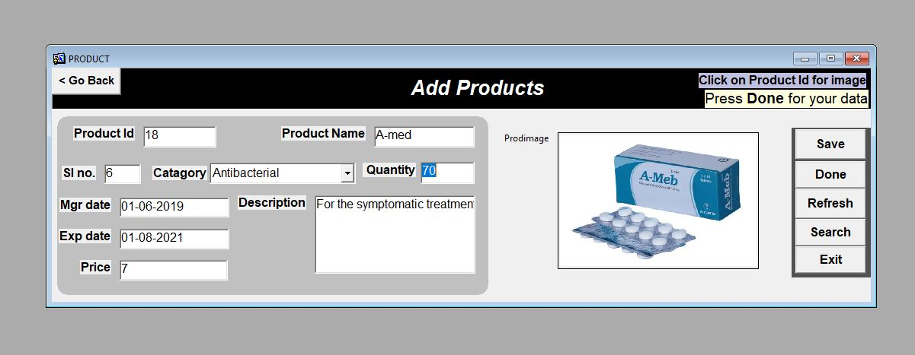

**Image: Add product**

**Report**

### There is a report based on product details. By selecting specific product category, it will show all the products that are present in that category.

Image: Report based on product details

### *Supply*

Admin can also handle supplier information like which supply will deliver which product for a specific address and also admin can change the status bar. If product has been delivered in time then admin can change the status from No to Yes. This status will be also visible for customer status section.

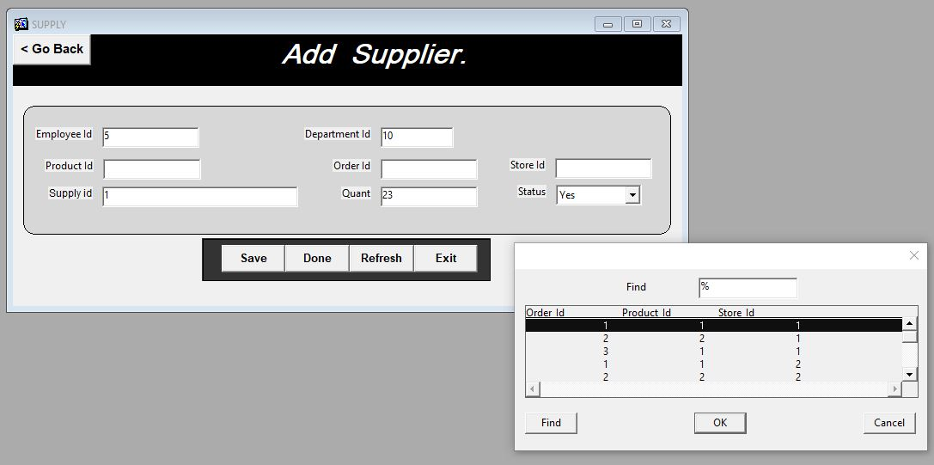 . Image: Supplier Information

### *3.1.3. Order*

There is a section named order panel. In this part admin can add ordered product and also the quality along with the price.

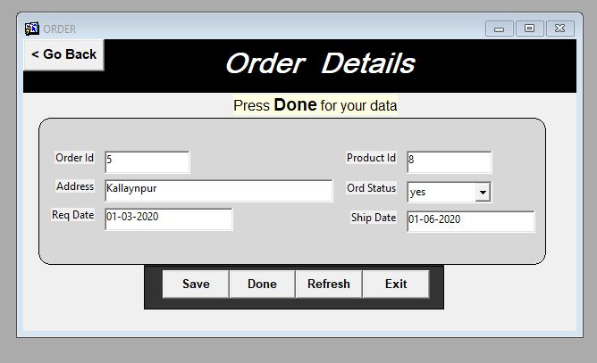

Image: Order details

**Report**

For different orders I have prepared a report. By choosing order id admin can see a report based on order details.

### *3.1.4. Shipment*

By giving order id for different customer order admin can choose supplier for shipment.

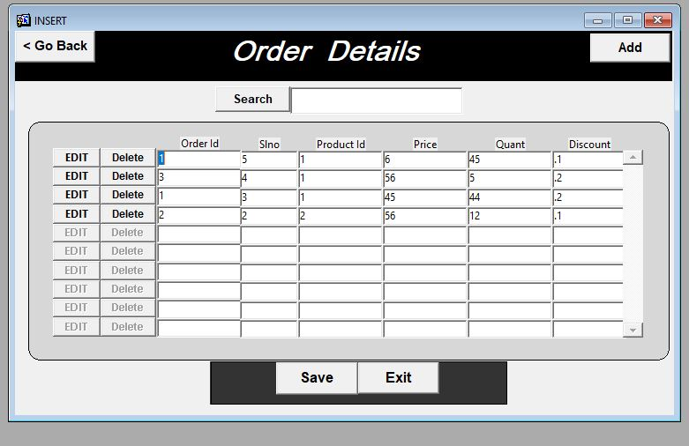

Image: Shipment Details

### *3.1.5. Store*

Another section named store house. Admin can add and see store house details. Mainly store house contain with products. The supplier can pick those product from the store and deliver it to the customer.

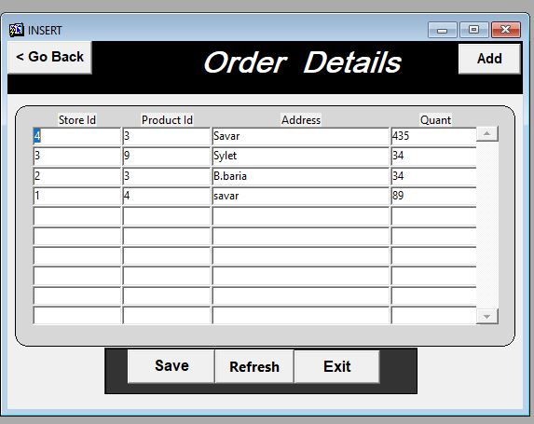

### *3.1.6. Employees and Departments*

Employees section mainly consist with employee’s history. Also there admin can see and add employees, managers details. In department section admin can add departments and also employee’s information. For employees section there are some conditions for the salary for different post salary and commission will be different. Like if someone chooses ‘ST_CLERK’ as job id then his salary and commission must be in a given range, so they cannot insert more than that amount for the specific job id.

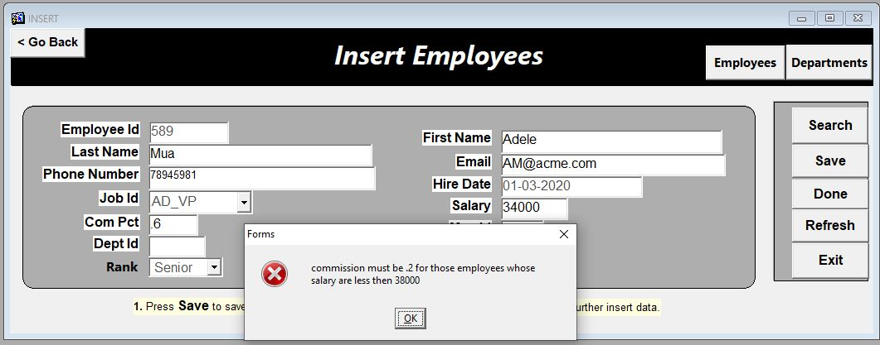

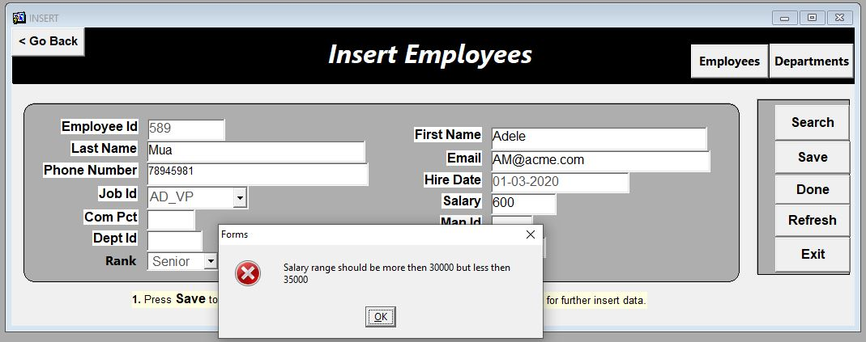

**Report**

Admin can see three types of employee and department report. By giving employee id range they can see employee history. Selecting specific department id admin can see how many employees are working in that department and also the average salary for that department. By giving manager id and date range admin can also see for those selecting data.

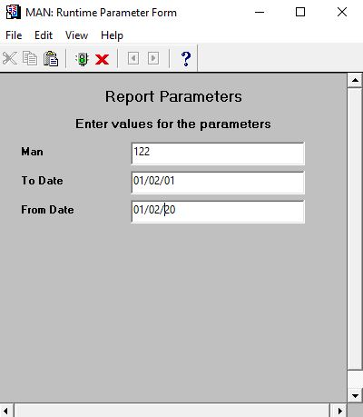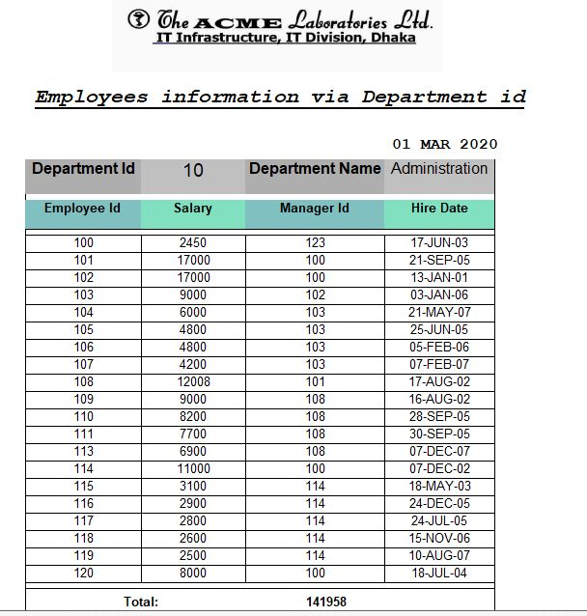

# **3.2. Customer Panel**

If Customer face any problem while ordering product or software related any issues occurs than they can easily give their feedback by commenting in comment box. If someone forgot the log in the password, they can easily log in the home page by answering the secret question and after logged in they can easily change their password.

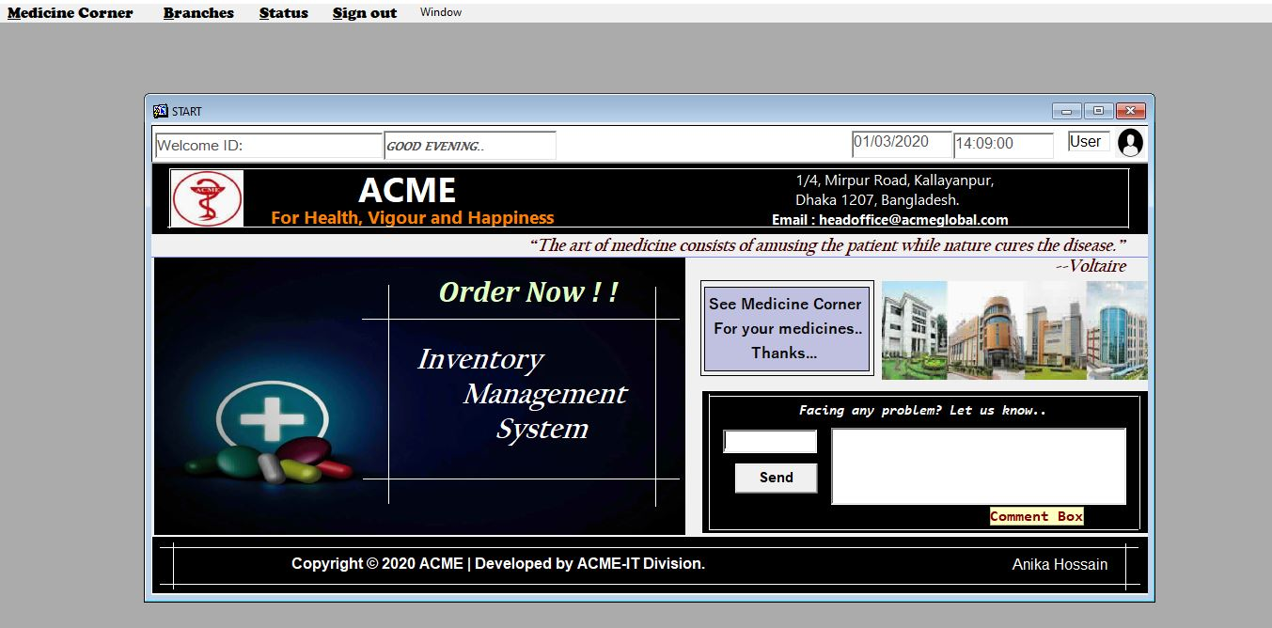

***3.2.1. Medicine Corner***

* Search product
* Order Product
* Remove Product from ordered product before confirming order.
* Show notices.
* Show Grand total before and after discount.

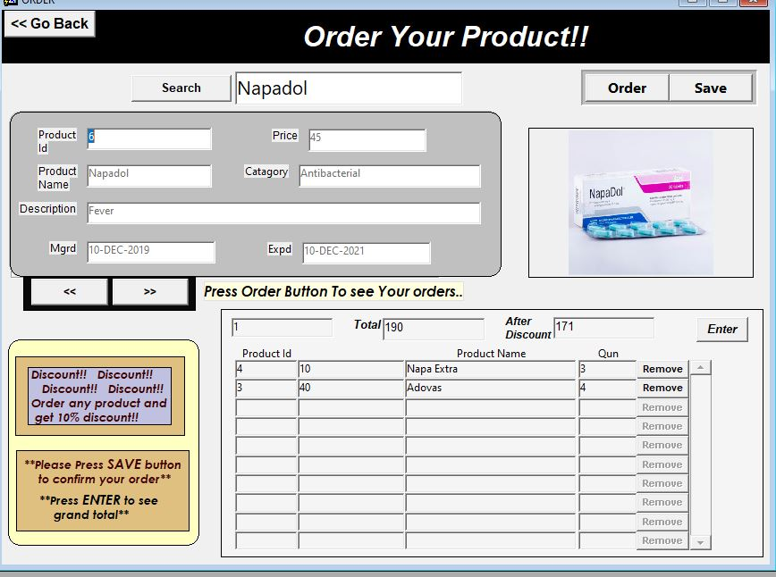

***3.2.2. Status***

* Can see status of customer’s product.
* Can search products in status section.

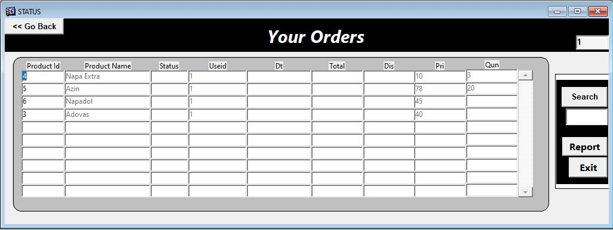

# *Conclusion*



In a nutshell, this internship has been an excellent and rewarding experience. I can conclude that there have been a lot I’ve learnt from my work at ACME Laboratories LTD. Needless to say, the technical aspects of the work I’ve done are not flawless and could be improved provided enough time. Not only did I gain practical skills, but I also had the opportunity to meet many fantastic people. The atmosphere at the ACME office was always welcoming which made me feel right at home. Additionally, I felt like I was able to contribute to the company by assisting and working on projects throughout the summer. For example, I made some forms in Oracle for their project. Mainly two main things that I’ve learned the importance of are time-management skills and self-motivation.

Overall, my internship at ACME has been a success. I was able to gain practical skills, work in a fantastic environment, and make connections that will last a lifetime. I could not be more thankful.