**Assignment # 3 : Fitting Observed data to a Distribution**

**For Odd Student Id**

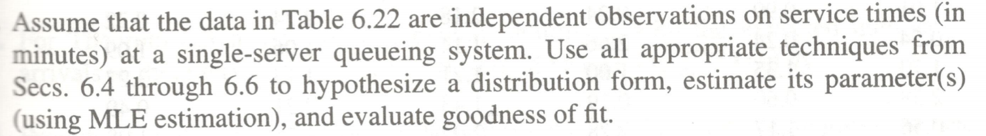

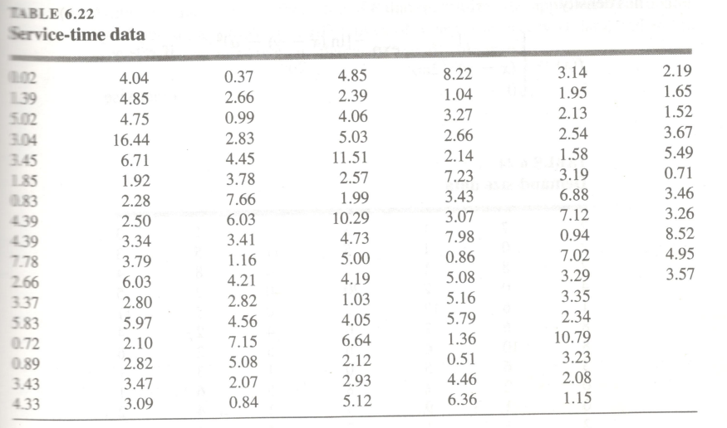

**For Even Student Id**

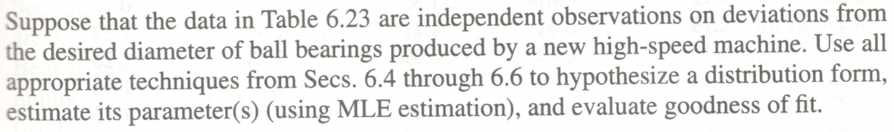

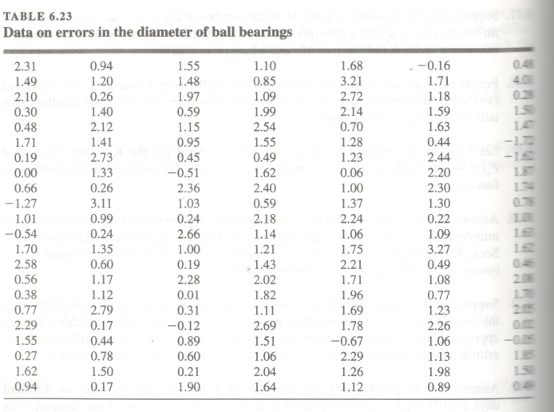

Note: Section 6.4 to Section 6.6 is covered by Slides Chapter 6.5, Chapter 6.6, Chapter 6.7 and Chapter 6.8.