Name : Bari Aniket Prabhakar
Seat No: 704153

Create database using following schema. Apply given Integrity Constraints and answer the following queries Using SQL

Create database Hospital;
create table Doctor
(
Did int not null,
Dname varchar(20) not null,
Daddress varchar(20) not null,
qualification varchar (20) not null,
primary key(Did)
);

insert into Doctor values(101,'Rahul Patil','Jalgaon','MBBS');
insert into Doctor values(102,'Nilesh Chaudhari','Bhusawal','BDS');
insert into Doctor values(103,'Atul Mahajan','Surat','BHMS');
insert into Doctor values(104,'Paresh Shinde','Pune','DHMS');
insert into Doctor values(105,'Darshan Wani','Mumbai','BPT');

select *from Doctor

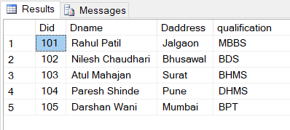

create table Patientmaster
(
Pcode int primary key,
Pname varchar(20) not null,
Padd varchar(20) not null,
Age int not null,
Gender char(1) Check (Gender in ('M','F')),
bloodgroup varchar(5) not null,
Did int ,
foreign key (Did) references Doctor(Did),
);

insert into Patientmaster values(1,'Ninad','Faizpur',21,'M','A+',101);
insert into Patientmaster values(2,'Puja','Jalgaon',19,'F','O-',102);
insert into Patientmaster values(3,'Darshan','Pune',44,'M','AB+',105);
insert into Patientmaster values(4,'Sumit','Chopda',34,'M','B+',104);
insert into Patientmaster values(5,'Komal','Ujjain',60,'F','B-',103);

select *from Patientmaster

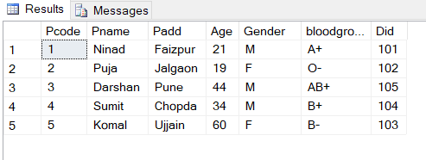

create table Admitpatient
(
Pcode int not null,
Entry_date date not null,
Discharge_date date not null,
Wardno int not null,
Disease varchar(30) not null,
foreign key (Pcode) references Patientmaster(Pcode)
);
insert into Admitpatient values(1,'2021-05-21','2021-06-10',5,'Diabetes');
insert into Admitpatient values(2,'2020-7-21','2021-06-10',4,'Liver Diseas');
insert into Admitpatient values(4,'2019-05-21','2021-06-10',3,'Heart Diseas');
insert into Admitpatient values(3,'2020-05-21','2021-06-10',2,'Cancer');
insert into Admitpatient values(5,'2020-01-21','2021-02-05',1,'Corona');

select * from Admitpatient

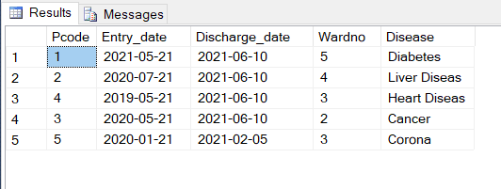

Querie : Find the details of doctor who are treating the patient of ward no 3 ?
select * from Doctor
join Patientmaster
on Doctor.Did = Patientmaster.Did
join Admitpatient
on Patientmaster.Pcode = Admitpatient.Pcode
where Wardno = 3;

