Name : Patel Shoeab Sharif
Seat No: 704188

create table Match
(
MatchId int,
Date_Played Date not null,
location varchar(20) not null,
primary key(MatchId)
);
insert into Match values (101,'2021-05-21','Mumabi');
insert into Match values (102,'2021-05-22','Pune');
insert into Match values (103,'2021-05-23','Delhi');
insert into Match values (104,'2021-05-24','Hyderabad');
insert into Match values (105,'2021-05-25','Pune');
insert into Match values (106,'2021-05-26','Bengaluru');
insert into Match values (107,'2021-05-27','Mumabi');
insert into Match values (108,'2021-05-28','Hyderabad');
insert into Match values (109,'2021-05-29','Bengaluru');
insert into Match values (110,'2021-05-30','Delhi');

select *from Match

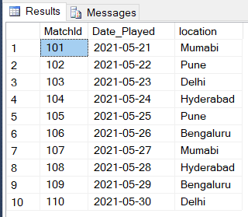

create table Team
(
TeamId int,
Name varchar(20) not null,
Sponsor varchar(20) not null
primary key(TeamId)
);
insert into Team values (1,'India','Byjus');
insert into Team values (2,'Australia','Adidas');
insert into Team values (3,'South Africa','Bata');
insert into Team values (4,'Afghanistan','Amul');
insert into Team values (5,'Pakistan','Pepsi');
insert into Team values (6,'WestIndies','Standard Bank');
insert into Team values (7,'Bangladesh','Lifeboy');
insert into Team values (8,'New zealand','Oopo');
insert into Team values (9,'Zimbabwe','Natwest');
insert into Team values (10,'England','Nike');

select *from Team

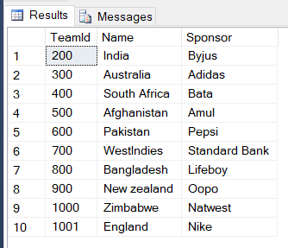

create table Score
(
MatchId int not null,
TeamId int not null,
Score int not null,
foreign key (MatchId) references Match(MatchId),
foreign key (TeamId) references Team(TeamId),
);
insert into Score values (101,200,100);
insert into Score values (102,300,100);
insert into Score values (103,400,100);
insert into Score values (104,500,100);
insert into Score values (105,600,100);
insert into Score values (106,700,100);
insert into Score values (107,800,100);
insert into Score values (108,900,100);
insert into Score values (109,1000,100);
insert into Score values (110,1001,100);

select *from Score

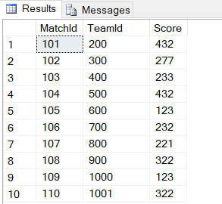

create table Referee
(
RefId int not null,
Phone numeric not null,
Addres varchar(20) not null,
primary key (RefId)
);
insert into Referee values (201,1234567890,'Jalgaon');
insert into Referee values (202,1123453212,'Mumabi');
insert into Referee values (203,6677338822,'Bhusawal');
insert into Referee values (204,1100992233,'Pune');
insert into Referee values (205,0099887766,'Nashik');
insert into Referee values (206,1122334455,'Bengluru');
insert into Referee values (207,1092837643,'Pune');
insert into Referee values (208,6789054321,'Hyderabad');
insert into Referee values (209,6543217890,'Delhi');
insert into Referee values (210,0987654321,'Mumbai');

select *from Referee

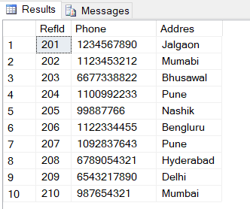

create table Match_Ref
(
MatchId int not null,
RefId int not null,
foreign key (MatchId) references Match(MatchId),
foreign key (RefId) references Referee(RefId),
);

insert into Match_Ref values(101,201);
insert into Match_Ref values(102,202);
insert into Match_Ref values(103,203);
insert into Match_Ref values(104,204);
insert into Match_Ref values(105,205);
insert into Match_Ref values(106,206);
insert into Match_Ref values(107,207);
insert into Match_Ref values(108,208);
insert into Match_Ref values(109,209);
insert into Match_Ref values(110,210);

select * from Match_Ref;

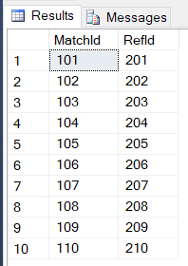

create table Player
(
Player_id int not null,
TeamId int not null,
Name varchar(20) not null,
Phone numeric not null ,
DoB date not null
primary key (Player_id),
foreign key (TeamId) references Team(TeamId),
);
insert into Player values (501,200,'Sachin Tendulakar',1234567890,'1986-05-12');
insert into Player values (502,300,'Greg Chappell',0987654321,'1971-01-08');
insert into Player values (503,400,'Jack Kalis',5511223344,'1970-05-12');
insert into Player values (504,500,'Mohammad Nabi',0099887766,'1987-06-30');
insert into Player values (505,600,'Shoeab Akhtar',1122334455,'1985-07-26');
insert into Player values (506,700,'Kieron Pollard',6677889900,'1978-10-27');
insert into Player values (507,800,'Shakib-al-hsan',1029384756,'1998-12-09');
insert into Player values (508,900,'Kane Williamson',0192837465,'1956-11-15');
insert into Player values (509,1000,'Bredon Telar',1092837465,'1996-07-06');
insert into Player values (510,1001,'Jos Buttler',1233212121,'1990-04-01');

select *from Player

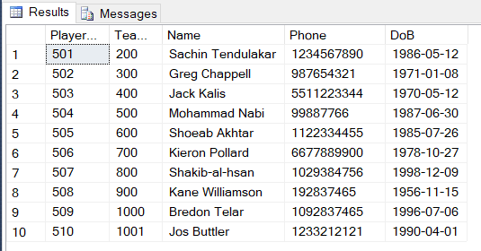

create table PlayerStatus
(
MatchId int not null,
TeamId int not null,
Player_id int not null,
foreign key (MatchId) references MatchId(MatchId),
foreign key (TeamId) references Team(TeamId),
foreign key (Player_id) references Player(Player_id)
);

insert into PlayerStatus values (101,200,501);
insert into PlayerStatus values (102,300,502);
insert into PlayerStatus values (103,400,503);
insert into PlayerStatus values (104,500,504);
insert into PlayerStatus values (105,600,505);
insert into PlayerStatus values (106,700,506);
insert into PlayerStatus values (107,800,507);
insert into PlayerStatus values (108,900,508);
insert into PlayerStatus values (109,1000,509);
insert into PlayerStatus values (110,1001,510);

select *from PlayerStatus

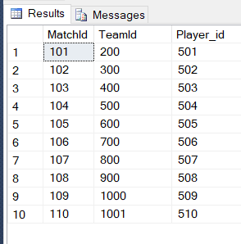

A)Find the TeamId with matchId who scored maximum score at location Bangalore
select * from Match
Join Score
on Score.MatchId = Match.MatchId
where Location = 'Bengaluru'

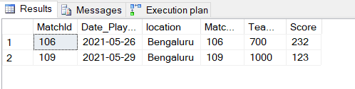

B) Find the names of players who are playing for Team whose TeamId is ‘200’
select * from Player
where TeamId=200

