Image-Based Kinematic Analysis of Droplet Impact and Bounce Dynamics on a Solid Substrate
Project Report
Image-based measurement of droplet deformation, motion and rebound behaviour

Name: Aniket kumar
Roll Number: 2401ME12
Date: 01-09-2026

1. Methodology

1.1 Overview of the Processing Workflow
The analysis was performed in MATLAB on a high-speed video (sample.mp4) of a liquid droplet impacting and bouncing on a solid substrate, recorded at an actual frame rate of 3000 fps. The workflow proceeds in four stages: (i) frame acquisition and grayscale conversion, (ii) spatial calibration using a reference image containing a known 2 mm scale bar, (iii) single-frame droplet segmentation and geometric measurement, and (iv) frame-by-frame processing of the entire video to extract droplet diameters, volume, centroid trajectory, and top/bottom boundary heights, followed by automated bounce detection.
The first video frame was read using VideoReader/readFrame and converted to grayscale with rgb2gray. The frame dimensions were obtained directly from the grayscale matrix using size(), giving the image height and width in pixels that anchor all subsequent pixel-to-millimetre conversions.

1.2 Spatial Calibration
Because pixel coordinates alone carry no physical meaning, a dedicated calibration image (calibration_img.png) was used to convert pixel measurements into millimetres. Two colour-based masks were built from the RGB channels of the calibration image:
- A blue mask (B > 80, B > 1.2R, B > 0.9G) was used to isolate a blue reference marking whose vertical extent corresponds to a known physical height on the calibration rig; morphological area-opening (bwareaopen) removed spurious small regions.
- A red mask (R > 150, R > 1.5G, R > 1.5B) was used to isolate the 2 mm red scale bar, and its horizontal pixel length was measured directly from the bounding pixel coordinates.
The pixel-to-millimetre scale for the calibration image was computed as calibration_example = (2 mm) / (red bar length in pixels). Because the calibration image and the experiment video were not necessarily captured at the same optical zoom/resolution, this scale was rescaled by the ratio of the blue-marked reference height to the full video frame height (vidObj.Height), giving a single conversion factor mmPerPixel that was applied uniformly to every subsequent measurement in the video.

1.3 Droplet Segmentation
For each analysed frame, the grayscale image was binarised with imbinarize and inverted (~) so that the dark droplet became the foreground. Two fixed regions were masked out: the top rows above the needle/support region (rows 1–262) and a strip at the bottom of the frame corresponding to the substrate, so that only the droplet itself would be picked up by the largest-object filter. Any internal holes created by specular reflection on the droplet surface (visible as the bright patch on the droplet in Figure 1) were closed with imfill(...,'holes'), and the single largest connected foreground region was retained using bwareafilt(mask,1), which is a reasonable assumption here because the droplet is by far the largest dark blob once the needle and substrate rows are excluded.
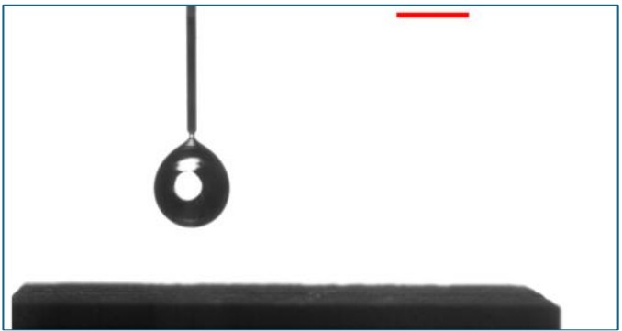
Figure 1. Representative raw grayscale video frame: pendant droplet prior to release, with the substrate below and the 2 mm red calibration bar visible top-right.
The droplet outline was then extracted with bwboundaries (Task 4, Figure 2), and its bounding rectangle with regionprops(...,'BoundingBox') (Task 6, Figure 3). The droplet area (Task 5) was obtained simply as the pixel count of the mask (nnz) multiplied by mmPerPixel².

1.4 Full-Video Kinematics Extraction
The same segmentation logic was then applied to every frame of the video inside a single hasFrame loop. For each frame k, the following quantities were computed and stored:
- Horizontal and vertical diameters (xDiam, yDiam): width and height of the bounding box, converted to mm.
- Volume (volumeArr): the droplet was approximated as a stack of thin circular "disks", one per pixel row between the top and bottom of the mask. For each row, the horizontal pixel width was converted to a local radius, and the volume of that row's disk (πr²·dz) was summed over all rows — i.e. a solid-of-revolution (Abel-type) approximation about the vertical centreline.
- Centroid height (cenY): the vertical centroid from regionprops, expressed as a height above the substrate line by subtracting it from a fixed substrateRow reference (established during calibration) and converting to mm.
- Top/bottom boundary heights (topHeight, botHeight): the top and bottom edges of the bounding box, expressed relative to the same substrate reference.
- Time vector: t(k) = (k−1)/3000 s, using the known acquisition frame rate rather than an assumed playback rate.
Frames in which no droplet mask was found (e.g. before/after the droplet is in view) were discarded using a validity mask on t.

1.5 Bounce Detection
The centroid trajectory was smoothed with a Savitzky–Golay filter (smoothdata(...,'sgolay',11)) to suppress pixel-level segmentation noise while preserving the shape of the bounce cycles. Local minima of the smoothed trajectory (i.e. points where the droplet is closest to the substrate) were located with findpeaks on the negated signal, using a minimum peak separation and prominence to avoid spurious detections. Candidate contact events were then filtered against an expected resting centroid height (derived from the mean droplet radius over the first 10 frames) so that only minima consistent with the droplet actually touching down were retained. This gave a total bounce count and the corresponding contact frame indices, annotated directly on the centroid-height plot.

1.6 Assumptions and Key Choices
- The droplet is assumed to be axisymmetric about the vertical axis for the volume calculation; this is a reasonable approximation for a droplet observed from the side during free fall and low-speed impact, but breaks down during the flattest/most-deformed part of an impact.
- A single largest-object rule (bwareafilt(...,1)) is used to isolate the droplet; this assumes the droplet remains the dominant dark blob in the cropped region, which fails at the exact instants the droplet visually merges with the substrate (discussed in Section 4).
- The substrate row and frame-cropping limits were fixed constants tuned to this particular camera framing rather than detected adaptively.

2. Results

2.1 Droplet Detection and Geometric Measurement (Single Frame)
Applying the segmentation pipeline of Section 1.3 to Frame 1 correctly isolates the pendant droplet from the needle and background, as shown by the closed red contour in Figure 2. The corresponding bounding rectangle (Figure 3) tightly encloses the droplet body without including the needle stem, confirming that the row-masking and largest-object selection were effective for this frame.
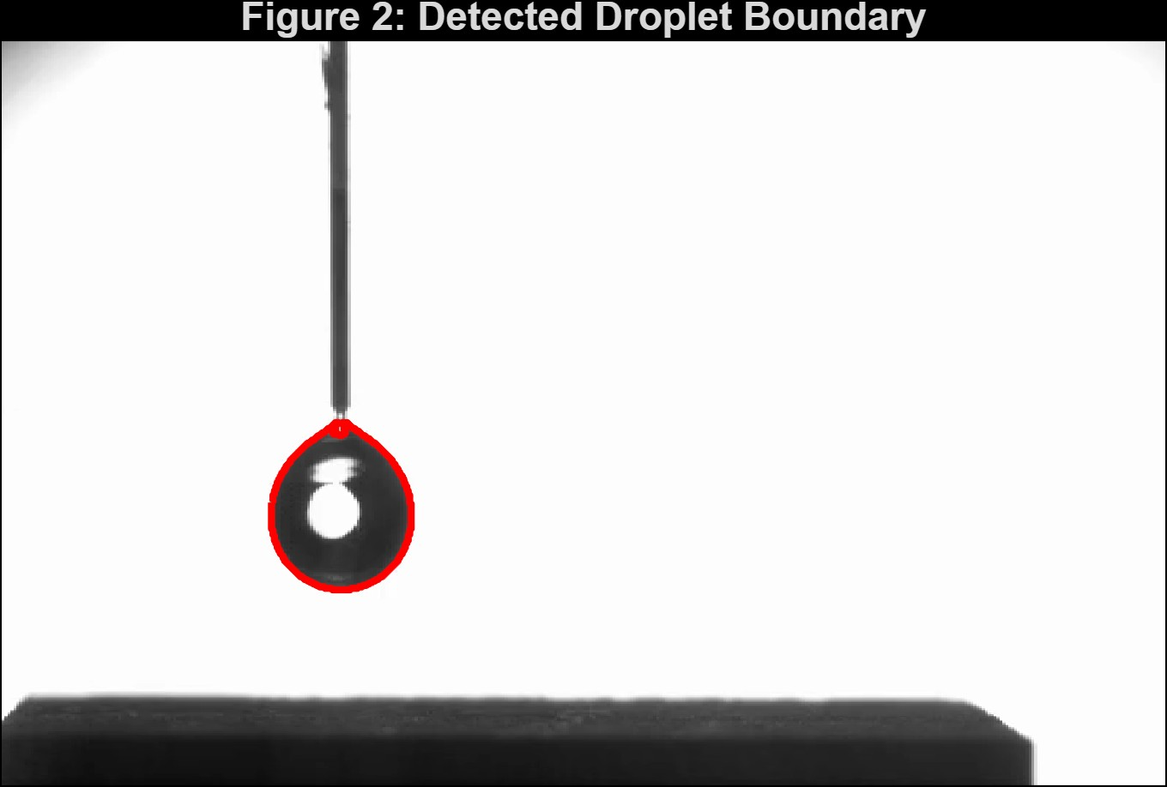
Figure 2. Detected droplet boundary (Task 4) overlaid on Frame 1.
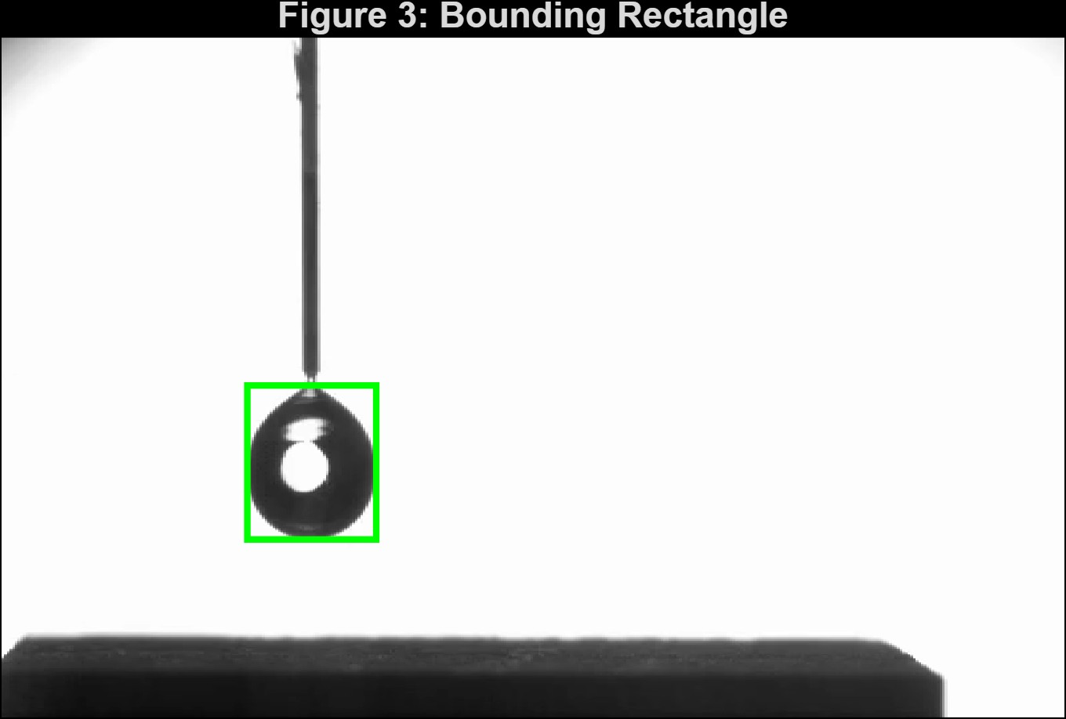
Figure 3. Bounding rectangle (Task 6) fitted to the segmented droplet in Frame 1.
The droplet area and geometric extent of this frame were computed directly from the segmented mask (areaPx, areaMM2) and are reported alongside the console-derived calibration factor (mmPerPixel) in the student's run output.

2.2 Diameter Evolution Over the Full Impact/Bounce Sequence
Figure 4 shows the horizontal (x) and vertical (y) droplet diameters over the ~0.34 s duration of the tracked sequence. The vertical diameter oscillates in a clearly periodic, decaying pattern: it starts near 1.8 mm, dips to roughly 1.0–1.2 mm at each substrate contact (the droplet flattening on impact), rebounds to a local maximum of about 2.0–2.1 mm just after each bounce, and the oscillation amplitude visibly decays from bounce to bounce, settling to a narrow band around 1.5–1.9 mm by the end of the record. The horizontal diameter trace shows the same underlying baseline (~1.7–1.9 mm) but is punctuated by short, very large excursions to about 11.8 mm — close to the full analysed frame width — that occur once per bounce cycle. These excursions are a segmentation artefact rather than real droplet behaviour (see Section 4.1).
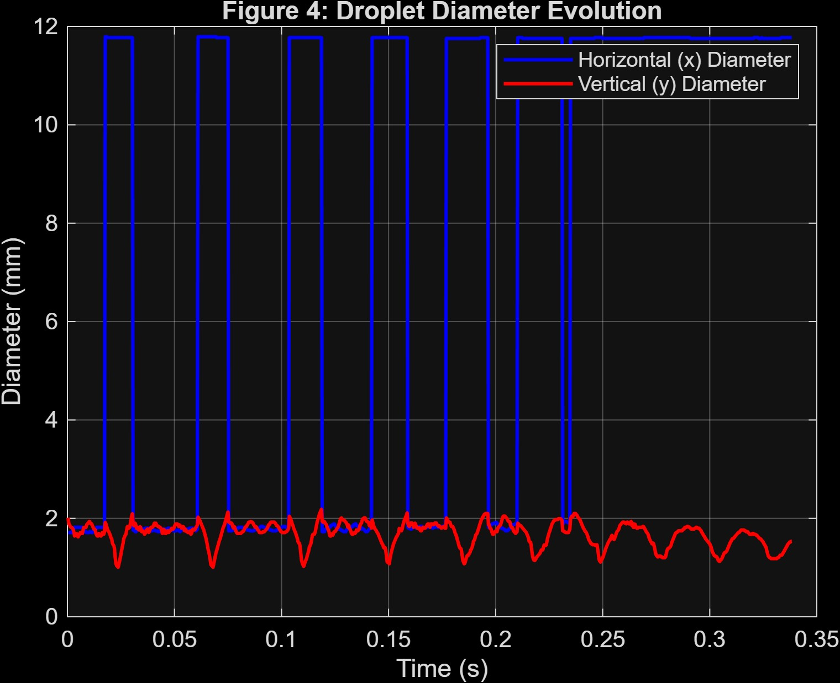
Figure 4. Horizontal and vertical droplet diameter versus time (Task 7).

2.3 Droplet Volume
Figure 5 shows the estimated droplet volume from the disk-summation model. During the airborne portion of each cycle the estimated volume is stable at approximately 17.0–17.5 mm³, consistent with volume conservation of a free, non-evaporating droplet in flight. During each substrate-contact interval, however, the computed volume drops sharply to about 3 mm³ — coinciding exactly with the same intervals in which the horizontal diameter spikes in Figure 4. Later in the sequence (from roughly t = 0.24 s onward) the plateau value shows more fluctuation, including two brief dips to about 15–16.5 mm³ around t ≈ 0.31 s and t ≈ 0.33 s, corresponding to smaller, closer-spaced bounces where the droplet spends less time fully airborne between contacts.
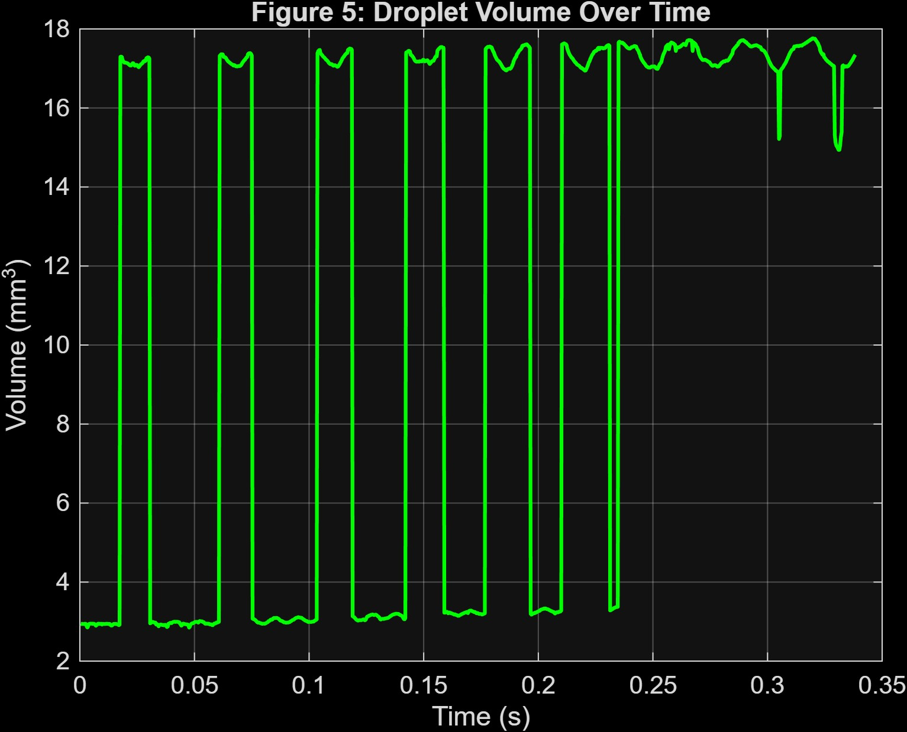
Figure 5. Estimated droplet volume versus time (Task 8).

2.4 Centroid Trajectory and Bounce Detection
Figure 6 shows the droplet centroid height above the substrate together with the automatically detected bounce events. The trajectory is a classic damped bouncing pattern: an initial fall from about +0.6 mm to a first contact near −1.4 mm, followed by nine further bounces (B1–B10 marked) with progressively smaller peak heights (from about +0.3 mm after the first bounce down to under +0.05 mm by the later bounces) and progressively shorter periods between contacts. A total of 10 bounces were detected over the tracked window, consistent with a rapidly-damping impact rather than a single elastic rebound.
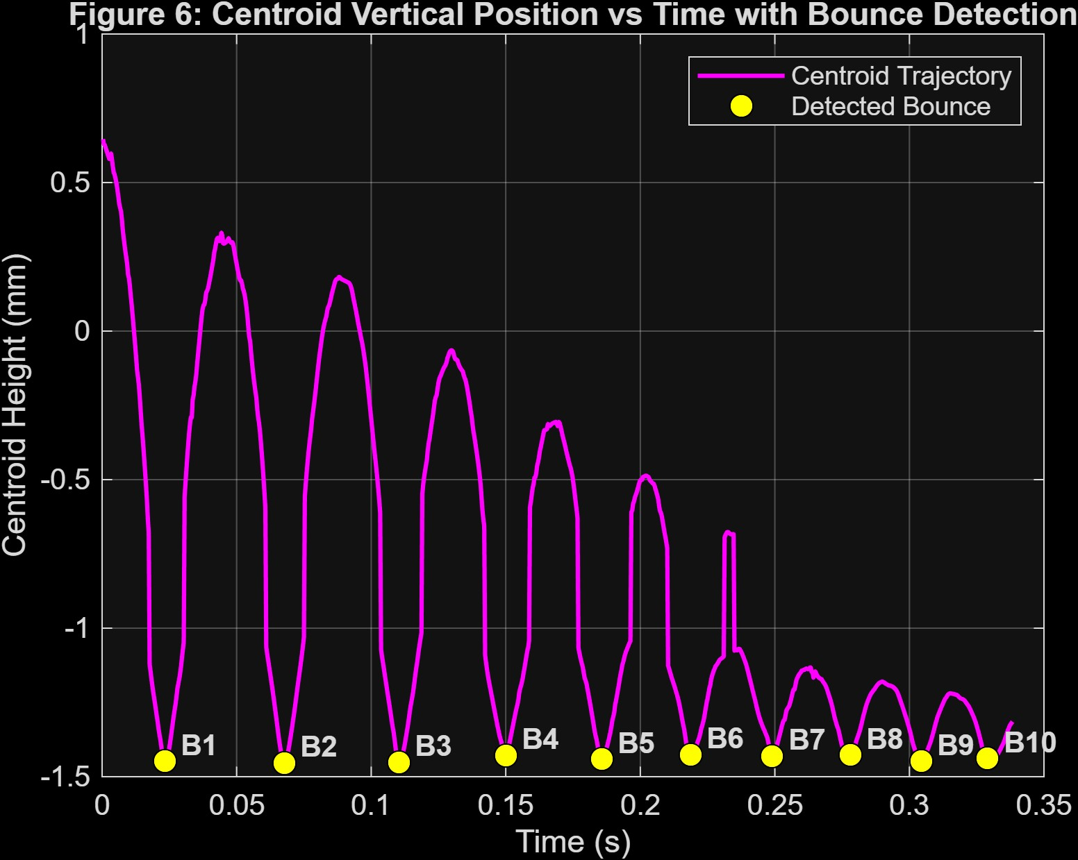
Figure 6. Centroid vertical position versus time with detected bounce events B1–B10 (Tasks 9 and 11).

2.5 Top/Bottom Boundary Tracking
Figure 7 tracks the top and bottom edges of the droplet's bounding box relative to the substrate. Both traces follow the same damped, decaying oscillation seen in the centroid data, with the top boundary falling from an initial height of about 1.7 mm to under 0.1 mm by the final bounces, mirroring the loss of rebound height. The bottom-boundary trace repeatedly clips at a fixed floor value (about −1.78 mm) during each contact interval; this coincides with the same frames affected by the segmentation artefact discussed above, where the bounding box extends to the edge of the cropped analysis region rather than to the true droplet base.
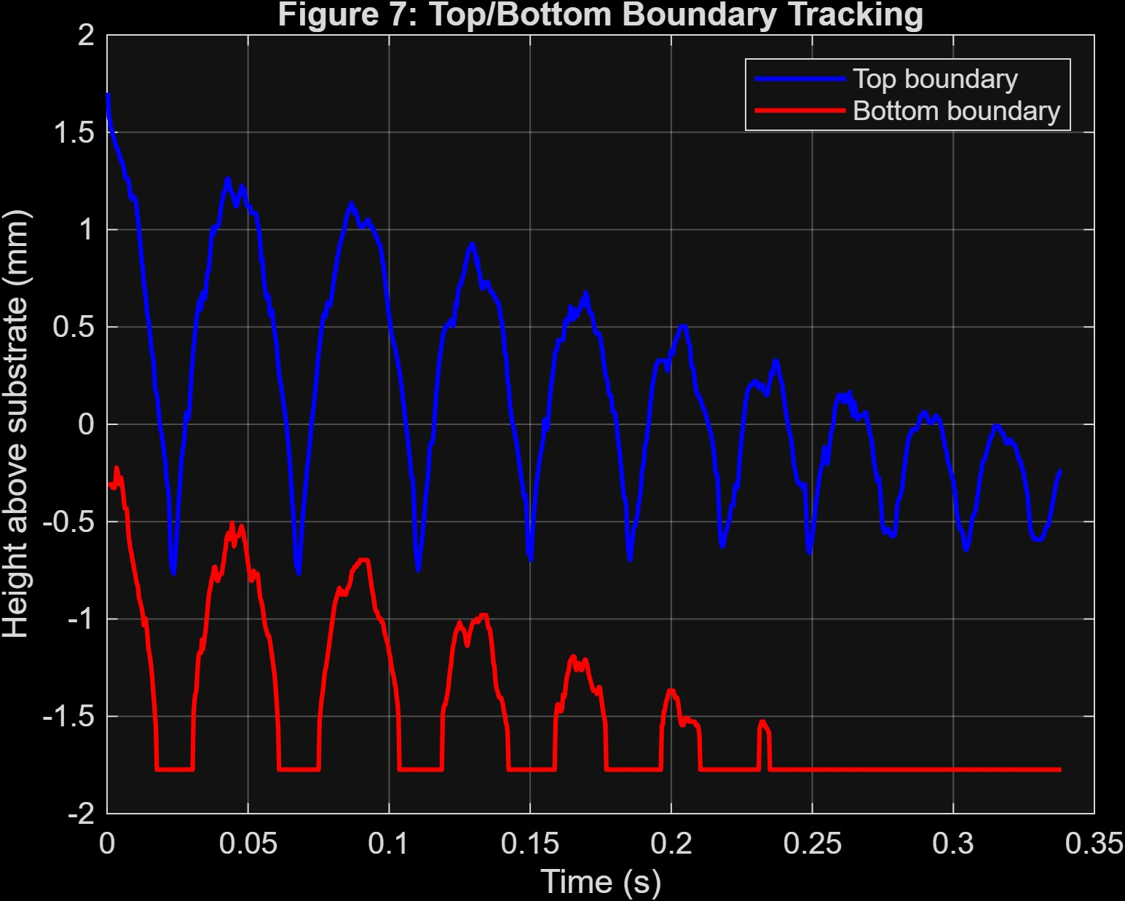
Figure 7. Top and bottom boundary height above the substrate versus time (Task 10).

3. Analysis and Interpretation

3.1 Deformation and Impact/Rebound Behaviour
The vertical diameter minima in Figure 4 and the centroid minima in Figure 6 occur at the same instants, confirming that each contact event is accompanied by visible flattening of the droplet (vertical diameter compressed to ~1.0–1.2 mm from a resting value nearer 1.8 mm) as kinetic energy is converted into surface deformation on impact. The subsequent rapid recovery of the vertical diameter after each bounce, together with the rebound in centroid height, shows the droplet is behaving elastically enough to store and partially release this deformation energy as it leaves the surface again, rather than simply spreading and sticking.

3.2 Energy Loss and Damping
The steadily decreasing peak centroid height from bounce to bounce (Figure 6) is direct evidence of energy dissipation on each impact — most plausibly through viscous dissipation within the droplet, contact-line friction at the substrate, and residual internal oscillation (shape ringing) of the droplet that is not recovered as translational kinetic energy. The bounce period also shortens noticeably as the sequence progresses (bounces become more closely spaced after about B5), which is consistent with a damped-oscillator picture in which both the rebound velocity and the associated "flight time" shrink together as energy is lost.

3.3 Volume Conservation and Its Limits
The volume estimate in Figure 5 is essentially constant during flight (~17 mm³), which is the expected physical result for a non-evaporating droplet — no material is being added or removed, so any true volume change over the whole record should be negligible. The large apparent drops to ~3 mm³ during ground contact are not physically meaningful; they occur because the axisymmetric disk model breaks down once the droplet's mask merges with the substrate mask in the same frames responsible for the diameter and boundary artefacts (Sections 2.2, 2.5, 4.1), and should be excluded from any quantitative volume-conservation argument.

3.4 Overall Physical Picture
Taken together, Figures 4–7 describe a droplet released above a substrate that falls, deforms substantially on first contact, and then undergoes a sequence of progressively smaller, faster bounces before settling toward rest — a signature of moderately elastic, energy-dissipating impact typical of droplets on a non-wetting or textured substrate rather than a fully wetting one, where the droplet would spread and arrest on the first contact instead of rebounding ten times.

4. Method Evaluation

4.1 Accuracy and Known Errors
The single-largest-object segmentation rule (bwareafilt(mask,1)) is accurate for airborne frames, where the droplet is clearly the largest and only dark region within the cropped analysis window. However, at the instant of substrate contact the droplet mask touches (and in some frames merges with) the dark substrate region left inside the crop, so the "largest object" briefly becomes the droplet-plus-substrate blob rather than the droplet alone. This is the direct cause of: (i) the ~11.8 mm horizontal-diameter spikes in Figure 4, which are close to the full crop width rather than a real droplet dimension; (ii) the corresponding erroneous volume drops to ~3 mm³ in Figure 5, since the disk-summation model is being fed a badly-shaped merged mask; and (iii) the bottom-boundary clipping at a fixed floor value in Figure 7.

4.2 Limitations
- Fixed row-cropping limits (rows 1–262 at the top, last 50 rows at the bottom) and a fixed substrate reference row were tuned by inspection for this specific camera framing and would need re-tuning for a different camera position or zoom.
- The volume model assumes axisymmetry, which is only approximate once the droplet deforms substantially on impact (it is not perfectly circular in cross-section during flattening).
- The bounce-detection thresholds (MinPeakDistance, MinPeakProminence, and the 1.5× resting-centroid cut-off) were chosen empirically and could merge or split closely-spaced late-time bounces differently under a different choice.
- Calibration relies on colour-threshold detection of a blue reference marking and a red scale bar in a single calibration image; lighting changes between the calibration and experiment recordings could introduce a systematic error in mmPerPixel.

4.3 Possible Improvements
- Exclude the substrate row band more tightly during contact frames (e.g. re-detect the substrate edge per frame) or use a connected-component filter that rejects blobs touching the image's cropped bottom edge, to remove the merged-blob artefact at its source rather than after the fact.
- Fit an ellipse (regionprops 'Eccentricity'/'Orientation') to the droplet mask instead of using only an axis-aligned bounding box, to better capture non-axisymmetric deformation during the flattest part of impact.
- Cross-check the frame-rate-based time vector and the mmPerPixel calibration against a second independent reference (e.g. a dot pattern of known spacing) to bound the calibration uncertainty quantitatively.

5. Conclusions
- An automated MATLAB image-processing pipeline was developed that calibrates pixel measurements to millimetres using a colour-thresholded reference image, and reliably segments the droplet in the great majority of frames using inverse binarisation, region-of-interest cropping, and largest-connected-component selection.
- The droplet undergoes 10 detected bounces over the ~0.34 s analysis window, with steadily decreasing peak centroid height (from ~0.6 mm to under 0.05 mm) and progressively shorter bounce periods, indicating rapid damping of the impact energy.
- The vertical diameter compresses from a resting ~1.8 mm to ~1.0–1.2 mm at each contact and recovers within a fraction of the bounce period, showing clear elastic deformation and recovery rather than simple spreading/sticking.
- Airborne droplet volume is stable at approximately 17.0–17.5 mm³ throughout the sequence, consistent with expected volume conservation for a non-evaporating droplet in free flight.
- A repeatable segmentation artefact occurs at every substrate-contact frame, where the droplet mask merges with the substrate; this is clearly identifiable in the diameter, volume, and boundary-tracking plots and should be masked out (or the segmentation refined) before those contact-frame values are used quantitatively.

6. Declaration
I declare that I take full responsibility for the analysis, results, MATLAB code, interpretations, and conclusions presented in this report and the accompanying presentation. I may have consulted various resources during the development of this project. However, I have reviewed and understood the material used in my work, adapted it to my requirements, and confirm that I am able to explain and defend the methodology, code, results, and conclusions presented by me. I further confirm that the submitted work represents my own independent analysis and has not been copied from the work, code, or results of another student.
Name: Aniket kumar
Roll Number: 2401ME12
Signature: 
Date: 01-09-2026

References
[1] MathWorks, "Image Processing Toolbox Documentation" — functions rgb2gray, imbinarize, bwareaopen, bwareafilt, imfill, bwboundaries, regionprops. Available: https://www.mathworks.com/help/images/
[2] MathWorks, "VideoReader" and "smoothdata", "findpeaks" function documentation. Available: https://www.mathworks.com/help/matlab/
[3] Generative AI Tool, used for optimizing MATLAB code syntax, debugging image processing loops, and refining document structure. Available: Assistance utilized during project development [Online].

