🌸 FERNS & PETALS
Sales Analysis Report
Revenue, Delivery Performance & Customer Insights across 1,000 Orders

Prepared by
Aniket Kalushe
Tools & Technologies
Python (Pandas) • Power BI • DAX • Data Visualization

Contents
1. Executive Summary
2. Key Performance Indicators
3. Total Revenue
4. Average Order & Delivery Time
5. Monthly Sales Performance (2023)
6. Top Products by Revenue
7. Customer Spending Analysis
8. Top 10 Cities by Number of Orders
9. Order Quantity vs. Delivery Time
10. Revenue Comparison Between Occasions
11. Product Popularity by Occasion
12. Category-Level View
13. Recommendations
14. Tools & Methodology

1 Executive Summary
Ferns & Petals (FNP) is a gifting company delivering products across Indian cities for occasions such as Diwali, Raksha Bandhan, Holi, Valentine's Day, Birthdays, and Anniversaries. This analysis covers 1,000 orders placed by 100 customers across 71 products, with the goal of identifying revenue drivers, delivery performance, and customer spending patterns to support data-driven sales strategy.
The dataset was cleaned and joined using Python (Pandas), and the findings were rebuilt as an interactive Power BI dashboard with DAX measures, giving both a static report view and a self-serve exploration tool.

2 Key Performance Indicators
1,000  TOTAL ORDERS | ₹35.2L  TOTAL REVENUE | 5.53 days  AVG. DELIVERY TIME | ₹35,210  AVG. CUSTOMER SPEND

100  UNIQUE CUSTOMERS | 71  UNIQUE PRODUCTS | 7  OCCASIONS COVERED | 7  PRODUCT CATEGORIES

3 Total Revenue
The total revenue generated across all 1,000 orders is:
₹ 35,20,984.00
This figure is calculated as the sum of (Quantity × Product Price) across every order — a single top-line number for overall business performance.

4 Average Order & Delivery Time
The average time between order placement and delivery is 5.53 days, derived by calculating the difference between Delivery_Date and Order_Date for every order and averaging across all 1,000 records.
💡 Insight: This is a key operational KPI — it reflects fulfilment efficiency and directly impacts customer satisfaction.

5 Monthly Sales Performance (2023)
Revenue shows sharp seasonal spikes rather than steady growth. February (₹7,04,509) and August (₹7,37,389) are the strongest months, with a smaller peak in November (₹4,49,169). The remaining months sit in a much lower ₹95K–₹1.6L band.
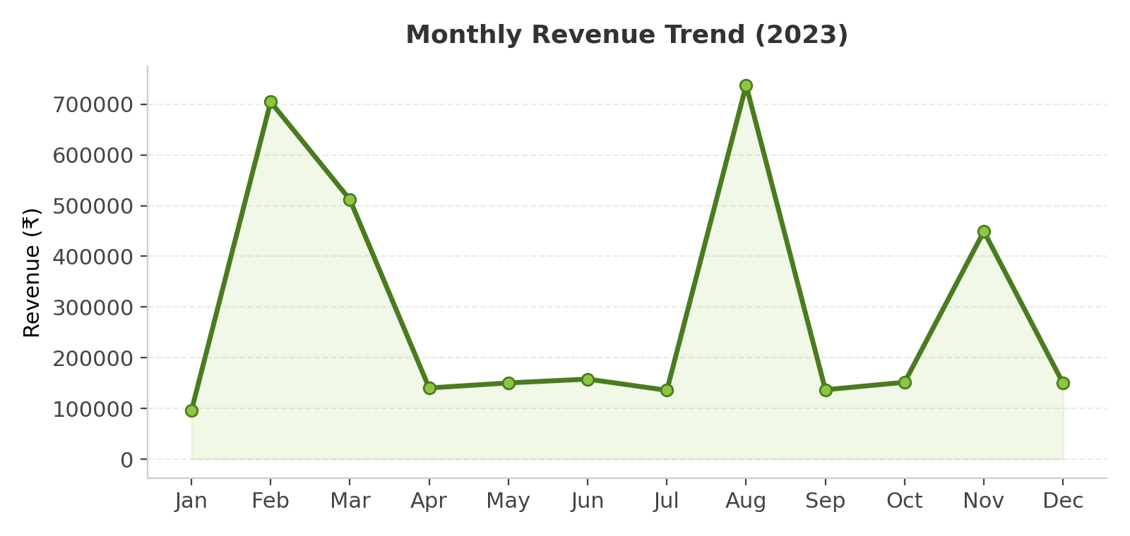
💡 Insight: February aligns with Valentine's Day season, and August/November likely align with festive and Raksha Bandhan / pre-Diwali buying. Revenue is occasion-driven, not uniformly distributed — marketing and inventory should be front-loaded ahead of these peak months.

6 Top Products by Revenue
Rank | Product | Revenue (₹)
1 | Magnam Set | 1,21,905
2 | Quia Gift | 1,14,476
3 | Dolores Gift | 1,06,624
4 | Harum Pack | 1,01,556
5 | Deserunt Box | 97,665

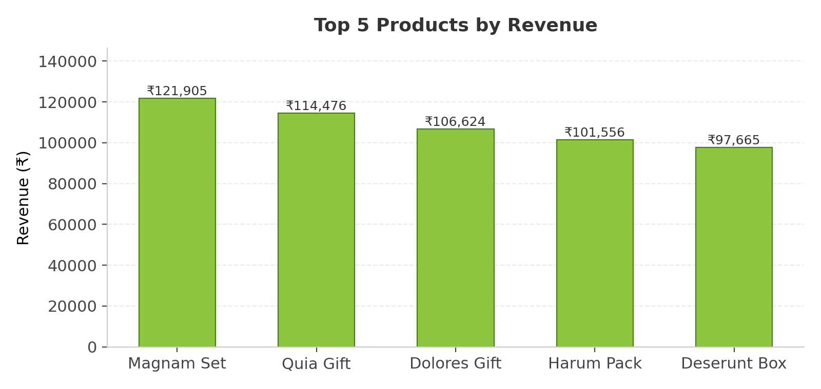

7 Customer Spending Analysis
Across 100 unique customers, the average customer spend is ₹35,209.84, calculated by grouping total revenue by Customer_ID and averaging. This gives a baseline for customer lifetime value and can be used to identify high-value customers for loyalty or retention campaigns.

8 Top 10 Cities by Number of Orders
Order volume is spread fairly evenly across cities rather than concentrated in metros — Bareilly and Ghaziabad lead with 9 orders each, followed by Bhilai (8), and several cities tied at 7.
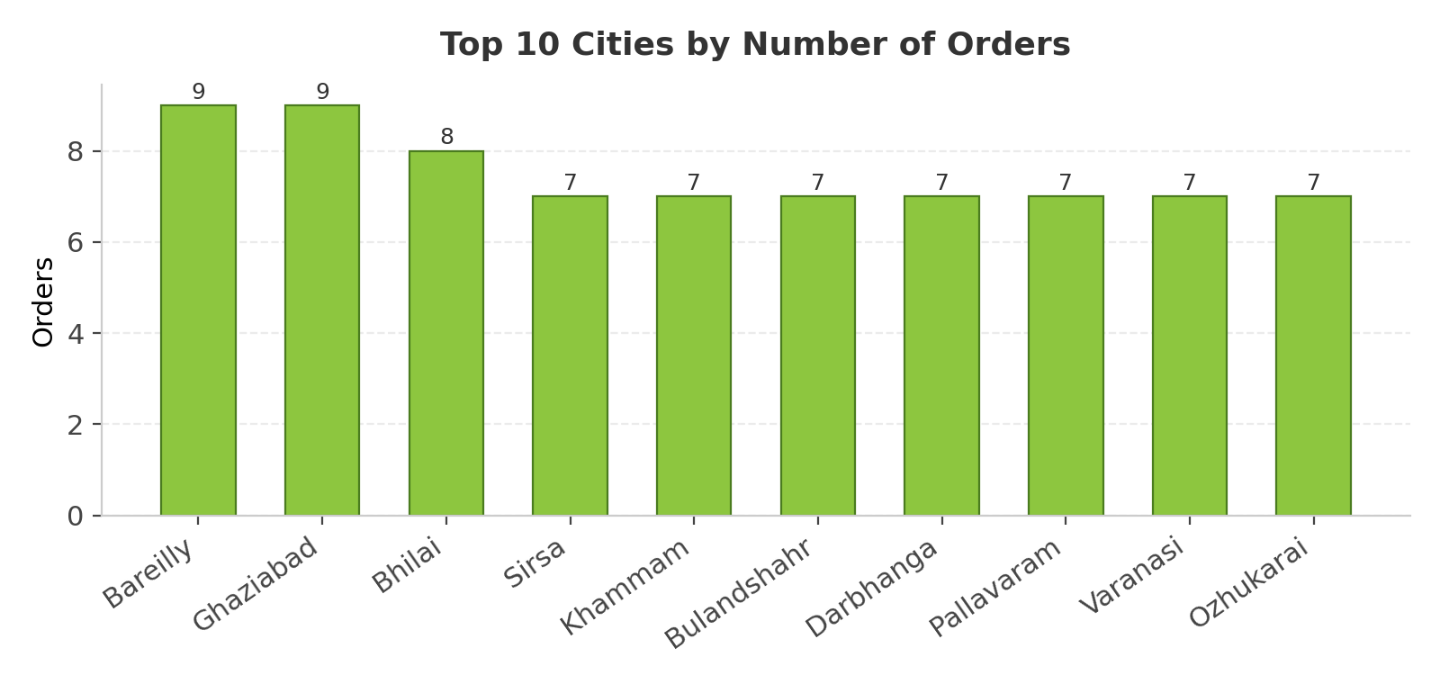
💡 Insight: Unlike typical e-commerce patterns dominated by Tier-1 metros, FNP's order base spans Tier-2/3 cities — logistics and delivery-partner planning should account for this wider geographic footprint.

9 Order Quantity vs. Delivery Time
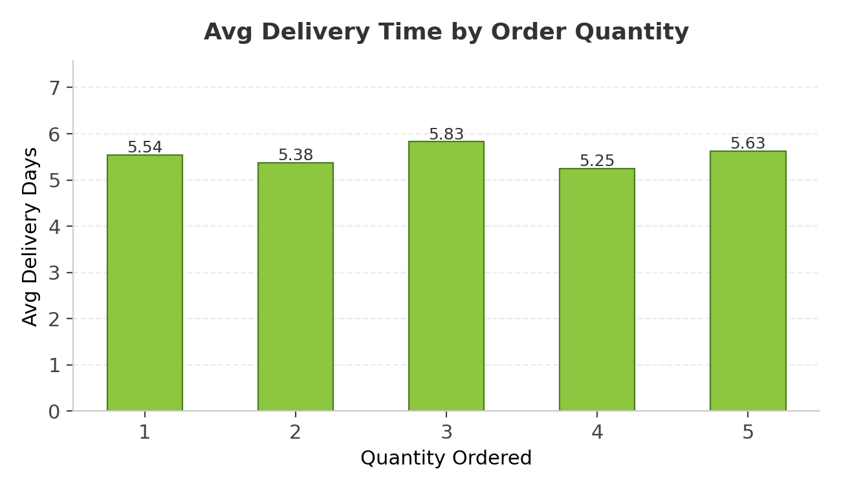
A correlation analysis between Quantity and Delivery_Days returns a coefficient of approximately 0.003 — effectively zero. Average delivery time stays within a tight 5.25–5.83 day band regardless of order size (1 to 5 units).
💡 Insight: Order quantity does NOT meaningfully impact delivery time. Delivery duration is more likely driven by destination city, courier partner, or order timing than by order size.

10 Revenue Comparison Between Occasions
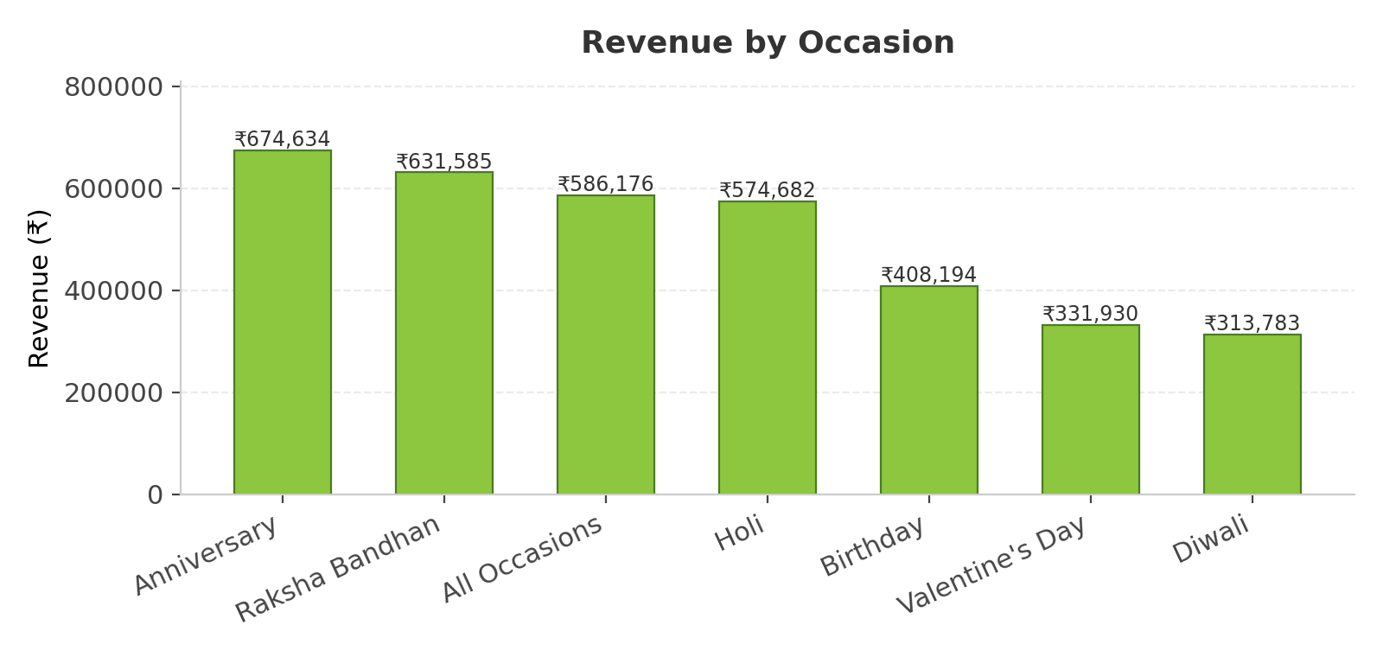
Anniversary (₹6,74,634) and Raksha Bandhan (₹6,31,585) are the highest-revenue occasions, followed by Holi (₹5,74,682). Diwali (₹3,13,783) and Valentine's Day (₹3,31,930) generate comparatively lower revenue despite being high-profile gifting occasions.

11 Product Popularity by Occasion
The best-selling product differs by occasion, showing that customer preferences are occasion-specific rather than uniform:
Occasion | Top Product | Revenue (₹)
Raksha Bandhan | Dolores Gift | 1,06,624
Holi | Harum Pack | 1,01,556
Birthday | Deserunt Box | 97,665
Anniversary | Dignissimos Pack | 90,036
Valentine's Day | Eius Gift | 85,904
Diwali | Aut Box | 81,057

💡 Insight: Curating occasion-specific product bundles around these top performers could lift conversion for each seasonal campaign.

12 Category-Level View
Colors (₹10,05,645), Soft Toys (₹7,40,831), and Sweets (₹7,33,842) are the top three revenue-generating categories, together contributing over 70% of total revenue.
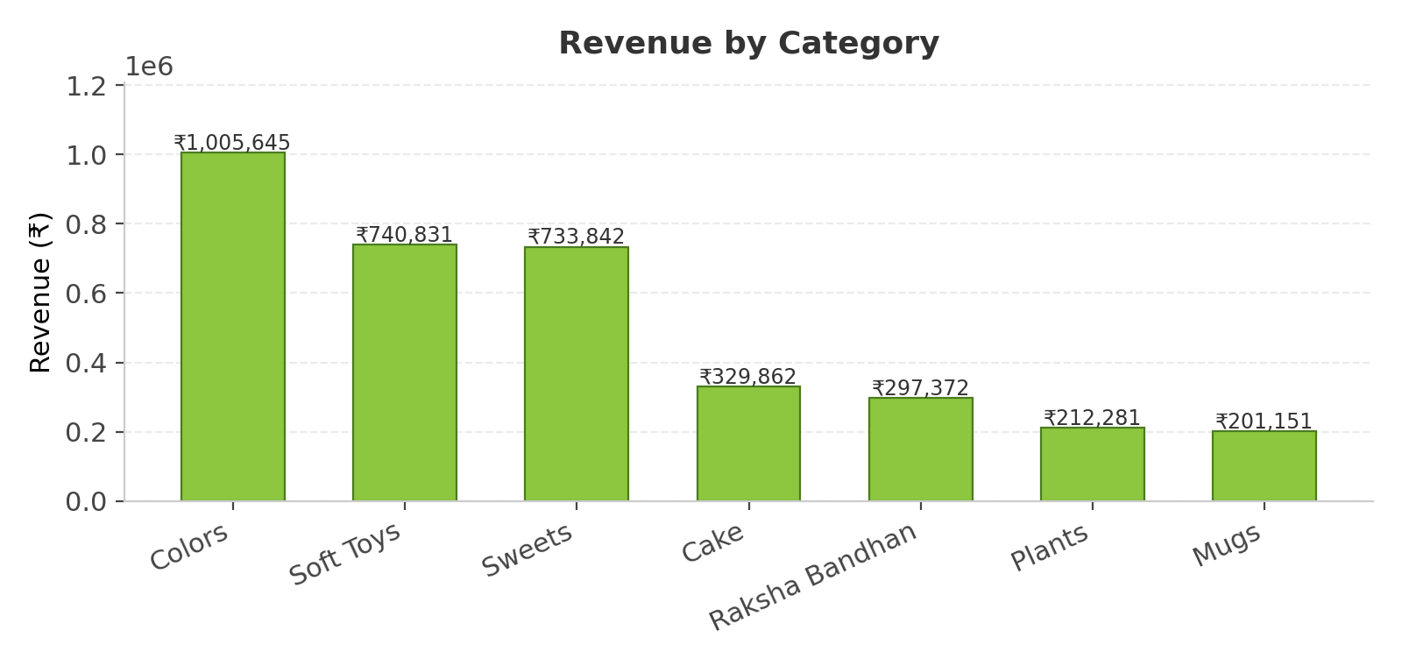

13 Recommendations
- Ramp up inventory and marketing spend ahead of February and August, the clear seasonal revenue peaks.
- Protect stock availability for the top 5 hero products (Magnam Set, Quia Gift, Dolores Gift, Harum Pack, Deserunt Box).
- Since delivery time doesn't vary with order quantity, investigate city/courier-level delivery data to reduce the 5.53-day average.
- Design occasion-specific bundles using the top product per occasion to increase campaign relevance.
- Investigate why Diwali and Valentine's Day underperform relative to Anniversary/Raksha Bandhan despite being major gifting occasions.

14 Tools & Methodology
Data was cleaned and joined (Orders ⋈ Products ⋈ Customers) using Python (Pandas). Delivery time was derived as Delivery_Date − Order_Date, and Revenue as Quantity × Price. The interactive dashboard — KPIs, trend lines, top-N breakdowns, and slicers for Occasion, Order_Date, and Delivery_Date — was built in Power BI using DAX measures for Total Revenue, Avg Order-Delivery Time, and Avg Customer Spend.

