Smart Crop Protection System



“Smart Crop Protection System”

Submitted to the

## Savitribai Phule Pune University

In partial fulfillment for the award of the Degree of

## Bachelor of Engineering

**in**

## Electronics & Telecommunication

**By**

**Team No.: 30**

|  |  |  |
| --- | --- | --- |
| **Sr No** | **Names** | **Seat No** |
| **1.** | Aniket Gund | T190073043 |
| **2.** | Prajwal Shahane | T190073154 |
| **3.** | Urvi Patil | T190073129 |

(TE E&TC)

Department of (Electronics & Telecommunication) PVGCOET&GKPIOM(W), Pune

Pune, Maharashtra 411009

CERTIFICATE

This is to certify that the project-based learning report entitled **“Smart Crop Protection System”** is being submitted by **Aniket Gund, Prajwal Shahane, Urvi Patil Roll No: T190073043, T190073154, T190073129** is a record of Bonafide work carried out by us under the supervision and guidance of **Mr. R. K. Patil** in partial fulfillment of the requirement for T**E(E&TC) 2019 course** of Savitribai Phule Pune University, Pune in the academic year2023-24.

Date:

Place: Pune

Mr. R. K. Patil Dr. K.J. Kulkarni

(Guide) (Head of the Department)

**ACKNOWLEDGEMENT**

I would like to express my deepest gratitude to all those who have contributed to the successful completion of the Smart Crop Protection System project for Farmers. First and foremost, I would like to thank my supervisor, [**Prof. R. K. Patil**], for their guidance, support, and in valuable insights throughout the entire duration of this project. Their expertise and encouragement have been instrumental in shaping the project and pushing it towards its completion.

I would also like to extend my appreciation to the faculty members of [**PVGCOET Pune**], whose knowledge and teachings have provided a strong foundation for this endeavor. Their dedication to education and commitment to fostering innovation have been inspiring. Furthermore, I would like to express my gratitude to the participants who volunteered their time and provided feedback during the development and testing stages of the Smart crop protection system. Their input has been in valuable in refining the functionality and usability of the device, ensuring its effectiveness.

We are deeply grateful to all individuals and entities who have supported us along this journey. Their encouragement, guidance, and resources have been indispensable in overcoming challenges and realizing our vision for a more effective and efficient crop protection system.

Thank you.

|  |  |  |  |
| --- | --- | --- | --- |
| **CONTENTS** | | | |
| **Sr. No** |  | **TITLE** | **PageNo.** |
|  |  | ABSTRACT | 5 |
| **1** |  | INTRODUCTION | 6 |
|  | 1.1 | Aim | 7 |
|  | 1.2 | Objective | 8 |
|  |  |  |  |
| **2** |  | LITERATURE SURVEY | 9 |
|  |  |  |  |
| **3** |  | SYSTEM REQUIREMENTS SPECIFICATIONS | 10 |
|  | 3.1 | Hardware Requirement | 11 |
|  | 3.2 | Software Requirement | 12 |
|  |  |  |  |
| **4** |  | DESIGN AND SIMULATION | 13 |
|  | 4.1 | System Block Diagram/Architecture Diagram | 14 |
|  | 4.2 | Simulation & Schematic Photographs | 15 |
|  | 4.3 | Flow chart of Software program | 16 |
|  |  |  |  |
| **5** |  | Graphical user Interface |  |
|  | 5.1 | Bread Board prototype Photographs while Mounting components | 17 |
| **6** |  | FUTURE SCOPE | 18 |
|  |  |  |  |
| **7** |  | CONCLUSION | 19 |
|  |  |  |  |
| **8** |  | Reference | 21 |
|  |  |  |  |
| **9** |  | Data Sheets | 25 |

|  |  |  |
| --- | --- | --- |
| **fig. No.** | **TITLE of Figure** | **Page No.** |
| **1** | Micro-controller ESP32 | 8 |
| **2** | PIR Sensor | 9 |
| **3** | Buzzer | 10 |
| **4** | GSM Sim800L Module | 10 |
| **5** | LCD I2C Module | 11 |
| **6** | Block diagram of Smart Crop Protection System | 17 |
| **7** | Simulation on Proteus 8 | 18 |
| **8** | Flow chart of the program | 20 |
| **9** | Testing | 21 |
| **10** | Data Sheets | 25 |

# ABSTRACT

In recent years, the agricultural sector has faced significant challenges due to crop damage caused by wildlife intrusion and other threats. To address this issue, an innovative Smart Crop Protection System (SCPS) has been developed, leveraging modern technologies to safeguard farmlands effectively. The SCPS integrates various sensors, including PIR (Passive Infrared), smoke, and soil moisture sensors, along with ESP32 Microcontroller and GSM module for real-time monitoring and alerting. The system operates by detecting intruders or potential threats such as animals and fire outbreaks. Upon detection, it triggers alarms, sends SMS alerts to farmers, and provides vital information about soil moisture levels, crucial for crop health. Additionally, the use of renewable energy sources like solar power enhances the system's sustainability and makes it suitable for remote or off-grid agricultural locations. Through its adaptive and proactive approach, the SCPS offers farmers a reliable solution to mitigate crop losses, ensure farm security, and improve overall productivity in the agricultural sector.

**Chapter-01**

# INTRODUCTION

## Introduction to project:

India is an agricultural land. Farming has unendingly been India's most critical economical sector. While the greater part of India's population is indulged into farming, the farmers still experience numerous issues. Accordingly, interruption of creatures in local locations is being raised step by step which is influencing the human existence, property that makes struggle among human and creatures. Agriculture is the foundation of the economy, nevertheless, would bring about gigantic harvest misfortune due to creature interruption in agricultural land. Elephants and other creatures entering into people’s place of residence has bought adverse consequence in different ways, for example, crop annihilation, harm to food stores, water supply, homes and other properties, injury and human demise. Struggle between human creatures may likewise be a difficult issue where huge amounts of cash are squandered and life is in danger. Farmers in India have been confronting genuine dangers from natural calamity, bugs and harm by creatures prompting lower yields. Conventional techniques trailed by farmers aren't much viable and it's not achievable to recruit monitors to focus an eye on the yields and prevent nature creatures. Consequently, this zone is to be checked consistently to forestall section of this sort of creatures or the other undesirable.

**SUPPORT SYSTEM**

The support system helps with the effective and proper obstacle detection around gadget which covert the large area of detection.

There are various components which helps to make it complete.

1. Micro-controller ESP32
2. PIR Sensor
3. Buzzer
4. GSM module
5. LCD I2C Panel
6. Power Supply
7. **Micro-controller ESP32**

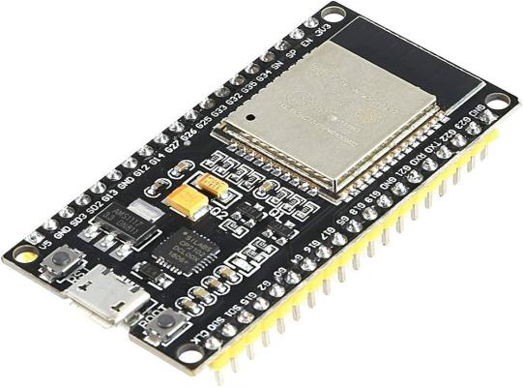

**Figure1: Micro-controller ESP32**

* The ESP32 is a powerful microcontroller module developed by Espressif Systems.
* Microcontroller: Dual-core Xtensa LX6 microprocessor, running at up to 240 MHz
* Wireless Connectivity:

Wi-Fi: 802.11 b/g/n (2.4 GHz) and 802.11 n/ac/ax (5 GHz)

Bluetooth: Bluetooth v4.2 BR/EDR and BLE (Bluetooth Low Energy)

* Memory:

RAM: Up to 520 KB SRAM

Flash Memory: Up to 16 MB

* GPIO (General Purpose Input/Output): Multiple GPIO pins for interfacing with sensors, actuators, and peripherals
* Analog-to-Digital Converter (ADC): 12-bit SAR ADCs with up to 18 channels
* Peripheral Interfaces:

SPI, I2C, I2S, UART, PWM: SD/MMC card interface

* Security Features:

Hardware-accelerated AES encryption/decryption

Secure boot and flash encryption

* Operating Voltage: 2.2V to 3.6V
* Operating Temperature: -40°C to +125°C
* Power Consumption:

Low-power modes for battery-operated applications

* Form Factor: Various development boards and modules are available, with different form factors and pin configurations.
* Development Environment: Support for multiple development frameworks and programming languages, including Arduino IDE, MicroPython, ESP-IDF (Espressif IoT Development Framework), and others.
* Cost-Effective: The ESP32 modules are cost-effective, making them suitable for a wide range of applications, including IoT, home automation, industrial automation, and more.

**2.PIR Sensor:**

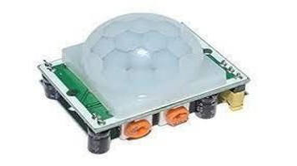

**Figure2: PIR Sensor**

A PIR sensor allows us to sense movement. It accustomed detect whether a warm body has moved in or out of the sensor’s range. They’re small, inexpensive, low-power, easy to use and do not wear out. For this reason, they’re usually found in home appliances and gadgets utilized in business. PIRs are basically manufactured from pyroelectric material (which we can see above as the round-shaped plastic material with a rectangular crystal in the center), which detects the degree of infrared radiation. The sensor is actually split in two halves. The explanation for that is, that we are looking to detect motion (change) not average IR levels. The two halves are wired up so that they cancel one another out. If one half sees more or less IR radiation than the other, the output will swing high or low.

**3. Buzzer:**

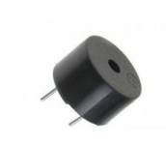

**Figure3: Buzzer**

A buzzer is an electronic device that emits loud noise. Most current ones are affable safeguard or air-attack alarms, cyclone alarms, or the alarms on crisis administration vehicles like ambulances, squad cars and fire engines. There are two general types, pneumatic and electronic.

Specifications:

• Rated Voltage: 6V DC

• Operating Voltage: 4 to 8V DC

• Rated Current: ≤30mA

• Sound Output at 10cm: ≥85dB

• Resonant Frequency: 2300 ±300Hz

• Tone: Continuous

1. **GSM Sim800L Module:**

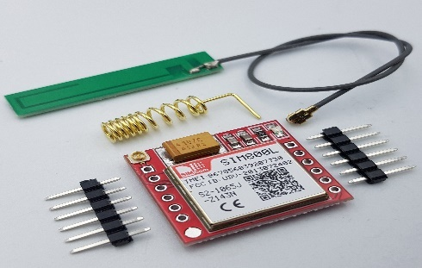

**Figure 4: GSM Sim800L Module**

A GSM/GPRS modem is a class of remote modem, intended for correspondence over the GSM and GPRS organization. It requires a SIM (Subscriber Identity Module) card actually like cell phones to initiate correspondence with the organization. Additionally, they have IMEI (International Mobile Equipment Identity) number like cell phones for their distinguishing proof. It was made to depict the conventions for second-age (2G) advanced cell networks utilized by cell phones and is presently the default worldwide standard for mobile correspondences.

**5. LCD I2C Module:**

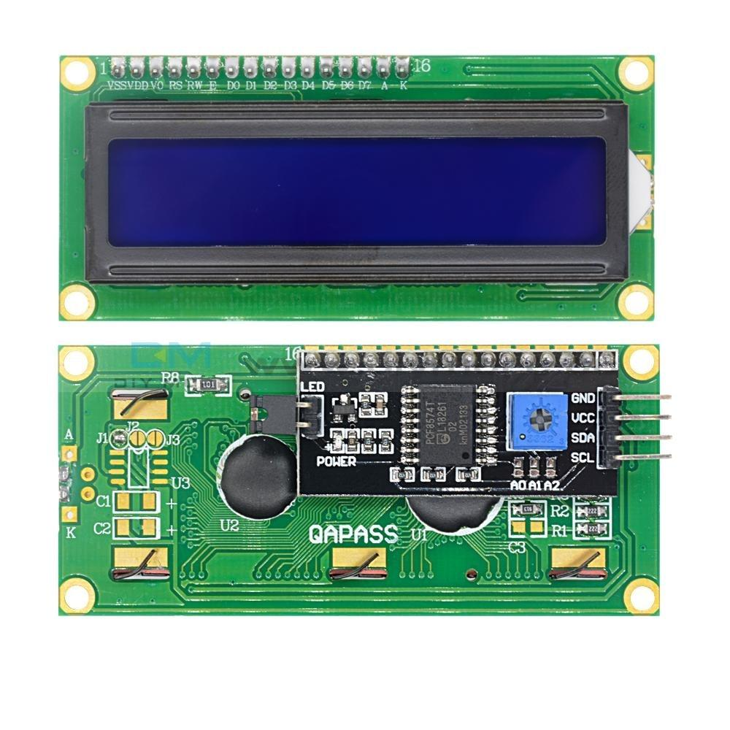

**Figure 5: LCD I2C Module**

* Compatible with Arduino Board or other controller board with I2C bus.
* Display Type: Negative white on Blue backlight.
* I2C Address:0x38-0x3F (0x3F default)
* Supply voltage: 5V
* Interface: I2C to 4bits LCD data and control lines.
* Contrast Adjustment: built-in Potentiometer.
* Backlight Control: Firmware or jumper wire.
* Board Size: 80x36 mm.

## Motivation behind project topic:

* + - 1. The motivation behind the Smart Crop Protection System project stems from the pressing need to address the significant losses incurred by farmers due to animal intrusion in agricultural fields. With a large portion of India's population reliant on agriculture for livelihood, safeguarding crops against animals such as wild boars, buffaloes, and birds is crucial for ensuring food security and economic stability. By developing an innovative system that combines advanced technologies like ESP32, PIR sensors, and GSM modules, we aim to empower farmers with an efficient and cost-effective solution to protect their crops round the clock, thereby enhancing agricultural productivity and livelihood sustainability.

## Aim:

* + - 1. The aim of Smart Crop Protection System is to provide a low-cost, portable, and reliable device that can help farmers to protect their farms from wild animals.

## Objective of the work:

1. Develop and deploy a comprehensive crop protection system to detect and deter wild animal messing with agricultural fields.
2. Establish a real-time alert mechanism to instantly notify farmers of any animal activity, allowing them to take immediate preventive measures.

## Purpose of the project:

The Smart Crop Protection System integrates ESP32, PIR sensor, buzzer, LCD panel, and GSM module to offer comprehensive crop surveillance and protection. Leveraging these components, the system detects animal intrusion, triggers alerts via GSM messaging, and provides real-time feedback on crop security status through the LCD panel, ensuring efficient crop management and minimizing losses.

## Existing System and Disadvantages:

## 

In early days method by erecting human puppets and effigies in their farms, which is ineffective in warding off the wild animals and, though is useful to some extent to ward off birds. The other commonly used methods by the farmers in order to prevent the crop vandalization by animals include building physical barriers, use of electric fences, fire crackles, and manual surveillance various such exhaustive and dangerous methods.

## Proposed System with Features:

In this propose system, crop monitoring is done by placing sensors in the agricultural field.

In our proposed work ultrasonic sensors is uses sonar to determine distance and movement to

any object and send this data to the ESP32 microcontroller which react as brain of project

and send acting reaction to the IoT (Internets of things) Wi-Fi module which result as loud

Noise from Bhonga speaker for irritating animal and woo away from farmland at same time it

will send SMS to the farm owner. This all systems name as farm watchman machine with

ESP32 microcontroller. The GSM module is used for sending SMS to farmer when

movement is detected.

**Chapter – 02**

# LITERATURE SURVEY

|  |  |  |  |
| --- | --- | --- | --- |
| **Sr no** | **Title of the paper** | **Description** | **Author** |
| 1. | “SMART CROP PROTECTION SYSTEM FROM ANIMALS” | His research paper Proposes a system for continuous crop monitoring, addressing challenges faced by farmers. Raspberry Pi as the core, this project offers an efficient solution for farmers. | By Jayesh Redij. |
| 2 | “SMART CROP PROTECTION USING ARDUINO" | Proposes an Arduino Uno based framework utilizes a PIR sensor to identify intruders close to the field and additional to it a smoke sensor. | By Varshini B.M. |
| 3 | "SMART PROTECTION SYSTEM TO MANAGE CROP VANDALIZATION USING RENEWABLE ENERGY” | Presents a system driven by the NODE MCU32S microcontroller, employs IoT technology to detect and deter animals in agricultural fields. | By MohiniS.Lohakare. |

**Chapter - 03**

# SYSTEM REQUIREMENTS SPECIFICATIONS

The Smart crop protection system project system requirements specification outlines the functional and non-functional requirements for the proposed system. The following is a list of some of the key requirements that should be included in the specification:

## 

## 3.1 Hardware Requirements:

* + - Micro-controller ESP32
    - GSM Module
    - PIR Sensor
    - I2C Module
    - LCD Panel
    - Buzzer
    - Power Supply
    - Buck Converter

## Software Requirements:

Arduino IDE (Integrated Development Environment)

Proteus 8 for designing and simulating the hardware layout and components

The software is responsible for controlling the PIR sensors and the GSM Module. It uses the PIR sensors to detect Animals in the farm and then sends feedback to the user via the GSM Module. The ESP32 board acts as the central processing unit and is responsible for executing the software.

To get started with this project, you can use the Proteus 8 software to design and simulate the hardware layout and components. This will help you to visualize the final product and make necessary changes before you begin prototyping. Once you have the design ready, you can begin assembling the hardware by connecting the PIR sensor, LCD I2C Module and the GSM Module to the ESP32 board.

Finally, you can use the Arduino IDE to upload the software code to the board and test the system. With the completed hardware and software, the device can be used by a visually impaired individual to detect objects in their environment and receive feedback via vibrations to navigate safely.

**Chapter – 04**

# SYSTEM DESIGN

**4.1System Block Diagram:**

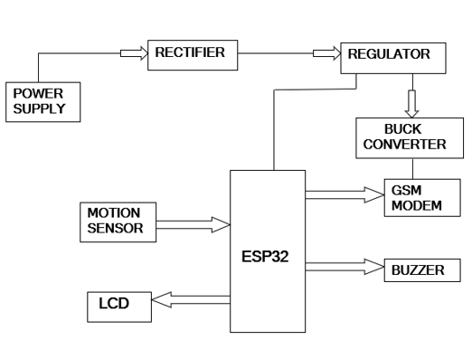

**Figure 6: Block diagram of Smart Crop Protection system**

## 4.2Simulation & Schematic Photographs:

## 

**Figure 7: Power Supply Off**

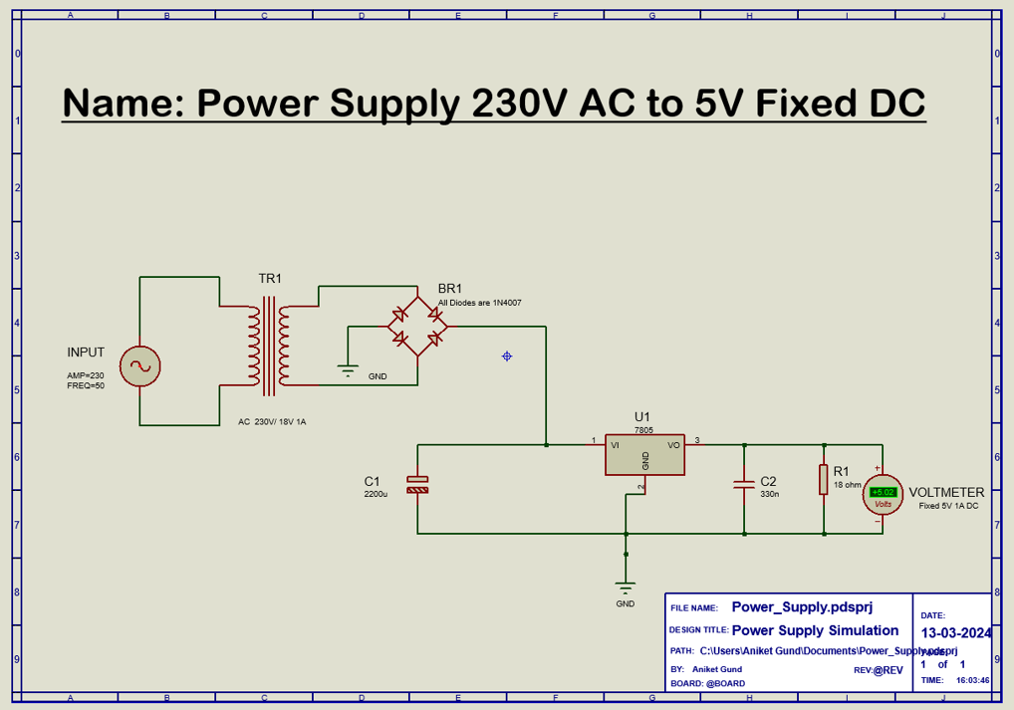

**Figure 8: Power Supply ON**

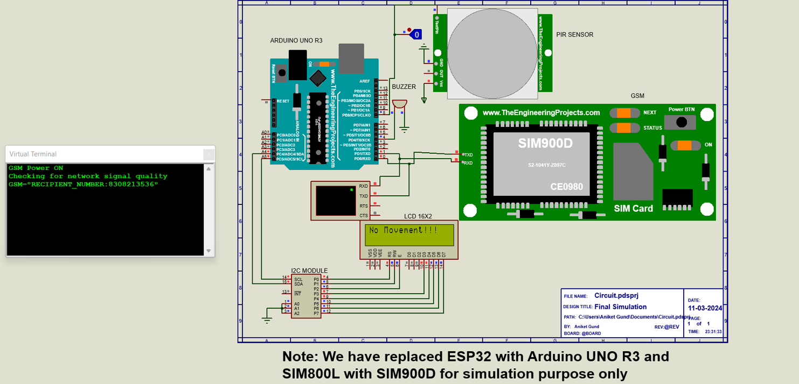

**Figure 9: Final Without Detection**

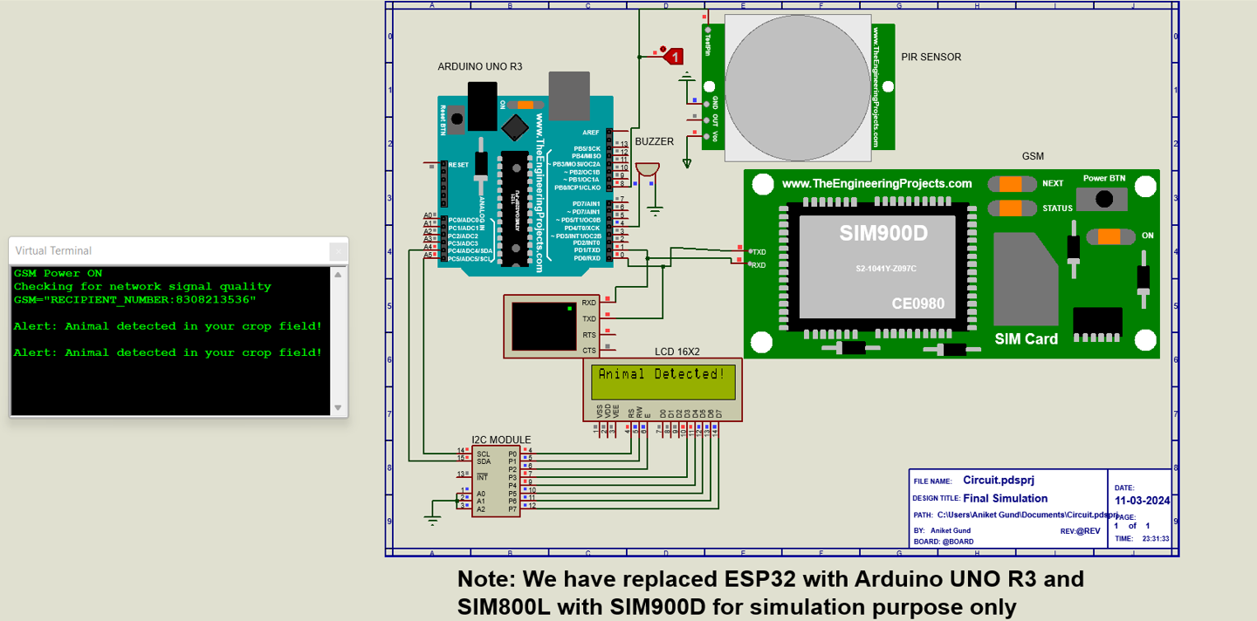

**Figure 10: Final With Detection**

**4.3 Flow Chart:**

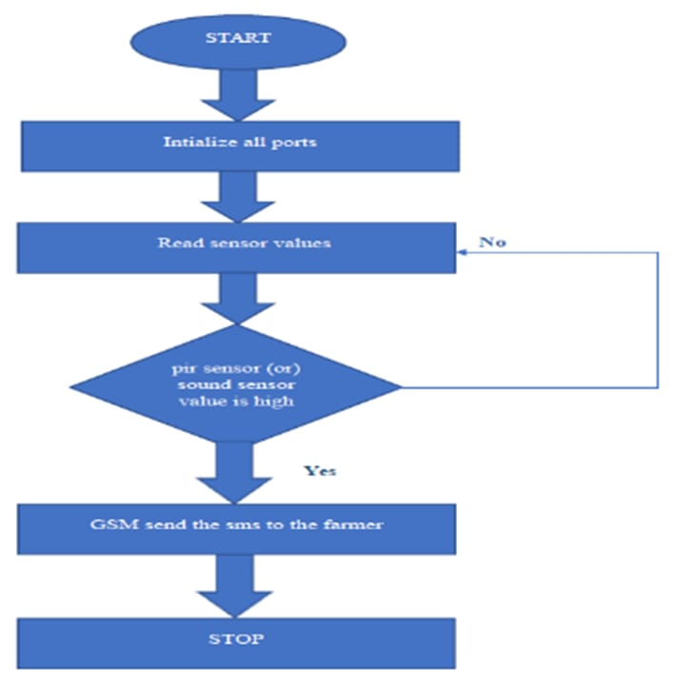

**Figure 11: Flow of the program use for the project**

**Chapter – 05**

# GRAPHICAL USER INTERFACE

## Photographs while Mounting components:

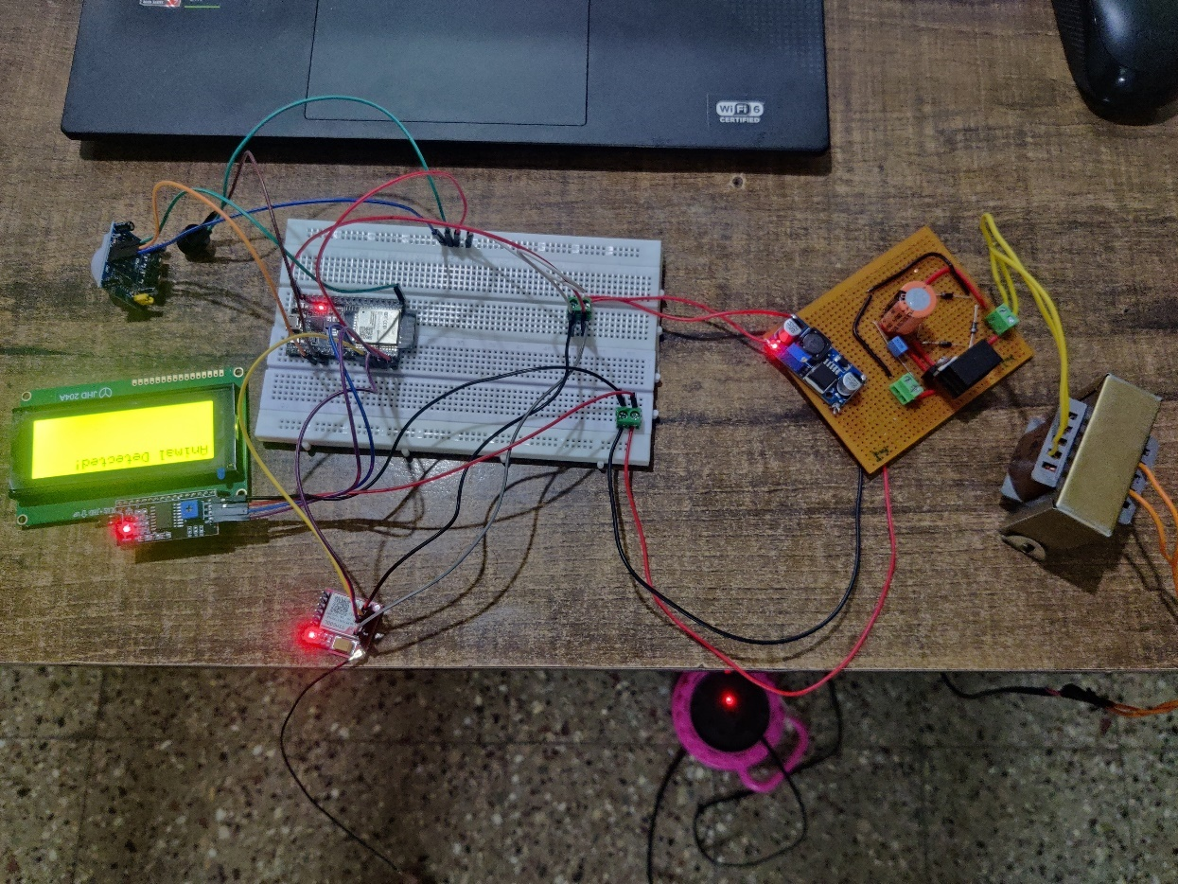

**Fig.12 Bread Board Implementation**

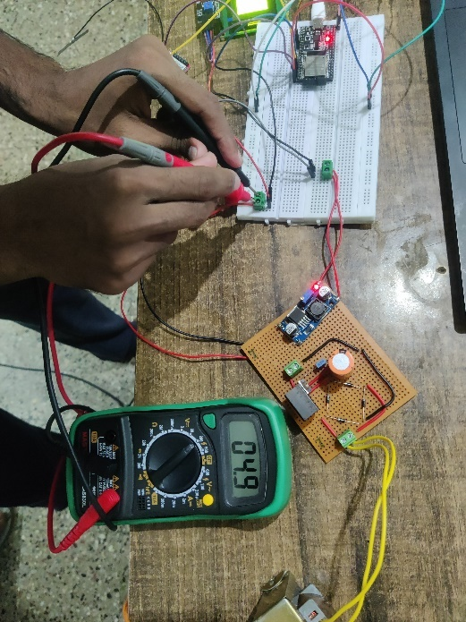

**Fig.13 Power Supply Testing**

**Testing Report:**

|  |  |  |  |
| --- | --- | --- | --- |
| **Sr. No** | **Component Name** | **Component Testing Parameters (Digital Multimeter and DSO/CRO)** | **Testing Photographs** |
| **1.** | **Power Supply** | **Voltage: 4.9 V (Fixed DC)** |  |
| **2.** | **Power Supply** | **Current: 1.14 A** |  |
| **3.** | **Power Supply for GSM Module** | **Voltage: 3.7 V** |  |
| **4.** | **Power Supply for GSM Module** | **Current: 2.94 A** |  |
| **5.** | **PIR Sensor** | **Voltage (without Detection): 0.015 V** |  |
| **6.** | **PIR Sensor** | **Voltage (with Detection):0.020V** |  |

**Chapter -06**

# FUTURE ENHANCEMENTS

The Smart Crop Protection System has the potential for many future enhancements. Some possible improvements include:

1. Implement machine learning algorithms to enhance the system's ability to differentiate between different types of animals and human intruders.
2. Integrate weather forecasting capabilities to provide real-time alerts to farmers about impending weather conditions that could impact crop protection.
3. Explore image processing for precise wild animal detection.
4. Develop a mobile application interface for farmers to remotely monitor their fields, receive alerts, and control the system.
5. Enhance the communication capabilities by incorporating LoRa or NB-IoT for long-range connectivity in remote agricultural areas.
6. Integrate data analytics tools to analyze historical data and provide insights for optimizing crop protection strategies and resource allocation.

**Chapter – 07**

# CONCLUSION

In India many times farmers face huge loss just because of animals. Hence, to overcome this issue, the designed system produces the sound to scare the animals, so that animals will automatically ran away. The main aim is to prevent the loss of crops and to protect the area from intruders and wild animals which poses a major threat to the agriculture areas. The GSM module is used to make a call to the farmer to alert him. Therefore, the designed system is affordable and useful to the farmers. The designed system won’t be harmful to animals and persons and it protects the farm areas. The system is capable to protect the farm in day and night with IOT monitoring.

**7. REFERENCES**

* 1. [https://iarjset.com/papers/smart-crop-protection-using-arduino/](https://iarjset.com/papers/smart-crop-protection-using-arduino/ )
  2. [https://www.jetir.org/view?paper=JETIR2203572](https://www.jetir.org/view?paper=JETIR2203572 )
  3. [https://ijcrt.org/papers/IJCRTO020033.pdf](https://ijcrt.org/papers/IJCRTO020033.pdf )
  4. https://github.com/Aniket-Gund/Smart-Crop-Protection-System

**For Reference for all stuff like program, PPT, Datasheet, Research Papers:**



**8. Datasheets:**

1. **ESP32 Microcontroller:**

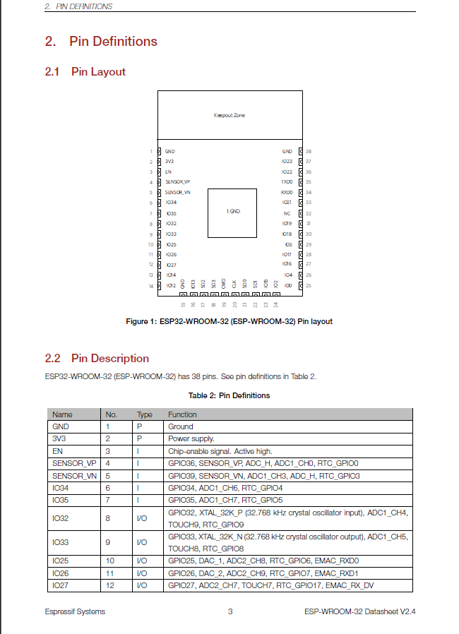

1. **PIR sensor:**

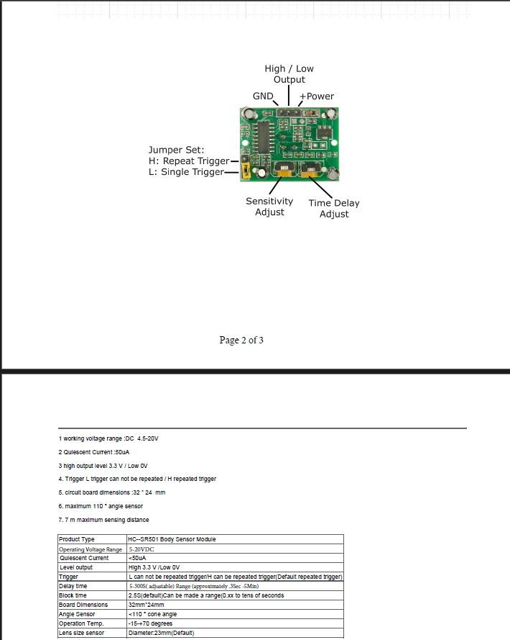

1. Buzzer

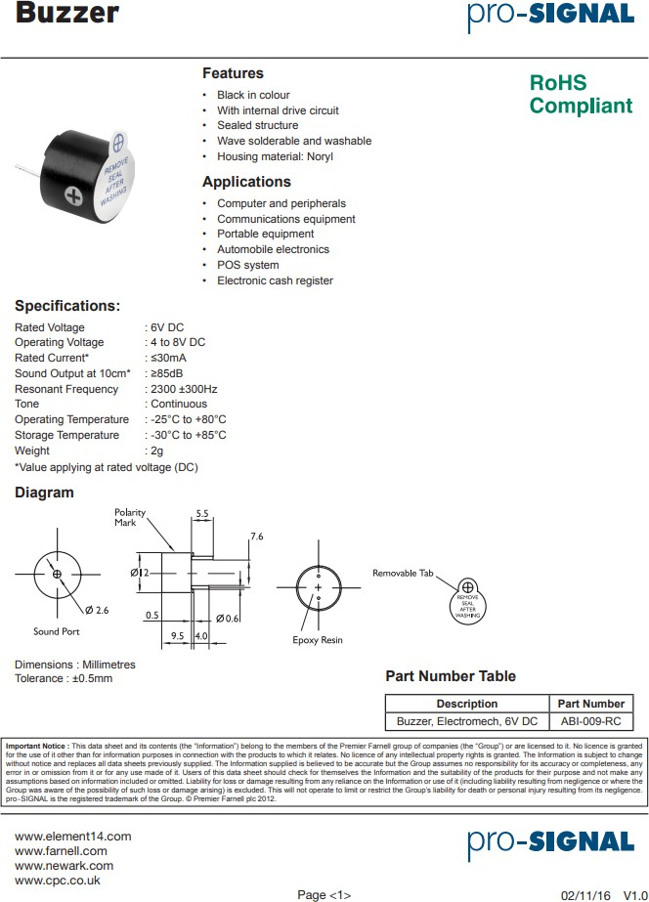

1. LCD I2C Module:

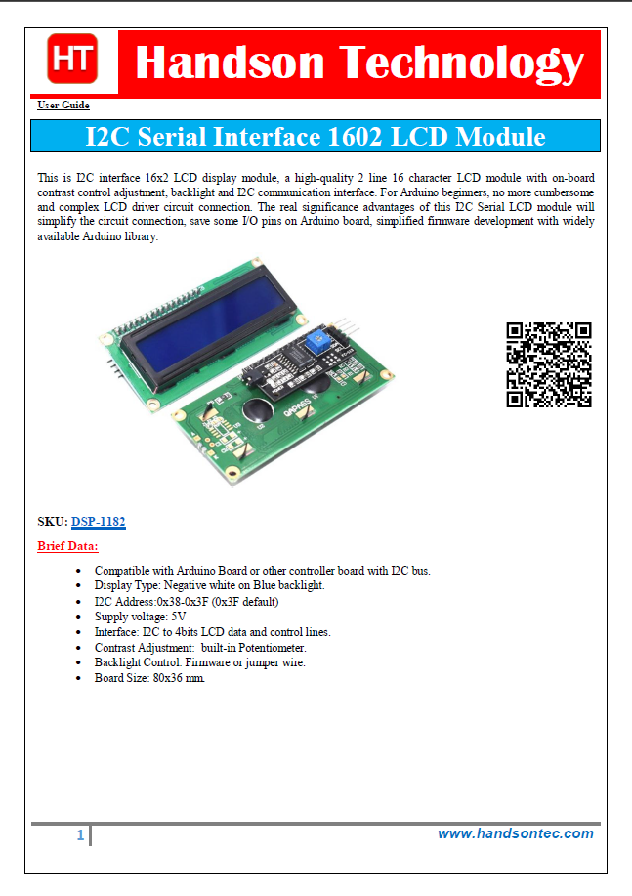

**5.GSM Sim800L Module:**

