**INT217: INTRODUCTION TO DATA MANAGEMENT**

(Project Semester January-April 2025)

Store Data Analysis

Submitted by

Aniket Kumar

Registration No-12316052

Programme and Section - B.tech CSE ,KM006

Course Code- INT 217

Under the Guidance of

**Nidhi Arora**

**Discipline of CSE**

**Lovely School of Computer Science and Engineering**

**Lovely Professional University, Phagwara**

**CERTIFICATE**

This is to certify that Aniket Kumar bearing Registration no. 12316052 has completed INT 217 project titled, **“**Store Data Analysis**”** under my guidance and supervision. To the best of my knowledge, the present work is the result of his original development, effort and study.

**Signature and Name of the Supervisor**

**Designation of the Supervisor**

**School of Computer Science and Engineering**

Lovely Professional University

Phagwara, Punjab.

Date: 20-04-2025

**DECLARATION**

I, Aniket Kumar , student of Computer Science and Engineering under CSE Discipline at, Lovely Professional University, Punjab, hereby declare that all the information furnished in this project report is based on my own intensive work and is genuine.

Date: 20-04-2025

Registration No. 12316052 Name of the student Aniket Kumar

**ACKNOWLEDGEMENT**

I would like to express my sincere gratitude to my project guide, Ms. Nidhi Arora

for their valuable guidance, support, and encouragement throughout the completion of this project.

I also thank my friends for their continuous motivation and helpful discussions during this journey.

Lastly, I acknowledge my own dedication and consistent efforts that helped me bring this project to completion.

Aniket Kumar

Registration No:12316052

**TABLE OF CONTENTS**

**1. Introduction**

**2. Source of Dataset**

**3. Pivot Table Analysis**

**4. Analysis on Dataset**

**i. Introduction**

**ii. General Description**

**iii. Specific Requirements, Functions and Formulas**

**iv. Analysis Results**

**v. Visualization**

**5. Conclusion**

**6. Future Scope**

**7. References**

**8. Links**

**1. Introduction**

In today’s data-driven world, the ability to analyse and visualize large datasets is crucial across industries. This project aims to develop a dynamic and user-friendly dashboard to analyse store performance data using Microsoft Excel. As a part of the B.Tech Computer Science Engineering curriculum, this project demonstrates the practical use of Excel’s powerful data analysis tools—pivot tables, charts, slicers, and timelines.

The core objective of this project is to convert raw data into meaningful insights that can guide business decisions. The dataset used in the project simulates real-world store data, including details such as order dates, customer segments, regions, product categories, sales, quantity, and profit margins. With this data, several pivot tables and visualizations were created to highlight key metrics and trends.

The interactive dashboard allows users to explore data from multiple perspectives—such as analysing sales by region, monitoring profit trends, and identifying top-performing product categories. Filters and slicers enhance usability, making it easy for any user, even those without technical expertise, to derive insights. This project not only improves data interpretation skills but also showcases the practical utility of Excel in business analytics.

**2. Source of Dataset**

<https://docs.google.com/spreadsheets/d/1Zcjs_mK4JHAsTTrw3jFBl_2EPE4G3PXi/edit?gid=1090300216#gid=1090300216>

The dataset used in this project was sourced from a mock store dataset designed to resemble a real-world retail business environment. The data includes fields such as:

* Order Date
* Region
* Category
* Sub-Category
* Sales
* Profit
* Quantity
* Discount
* Customer Segment

This dataset serves as an excellent foundation for exploring the capabilities of pivot tables, enabling a range of analyses such as sales performance by category, region-wise trends, and profit margins.

**3**. **Pivot Table Analysis**

### ****1. Sales vs Orders****

* **Pivot Fields Used:**
  + **Row Labels:** Month (e.g., Jul)
  + **Values:** Sum of Amount, Count of Order ID
* **Purpose:** This table compares the total sales amount with the number of orders received each month.
* **How it was made:** The Order Date was grouped by month, and the table aggregates sales (Sum of Amount) and orders (Count of Order ID).
* 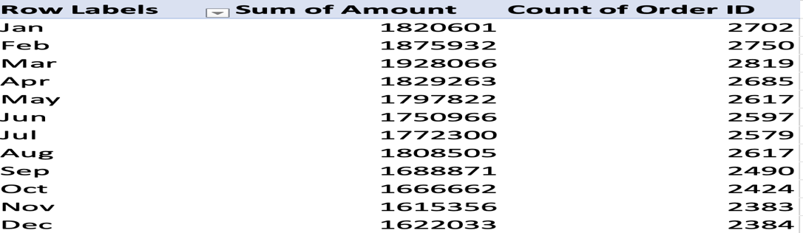
* 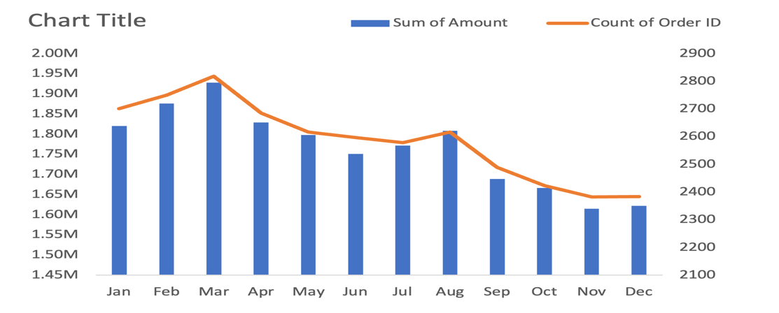

### ****2. Men vs Women****

* **Pivot Fields Used:**
  + **Row Labels:** Gender (Men, Women)
  + **Values:** Sum of Amount
* **Purpose:** Compares total sales between male and female customers.
* **How it was made:** Gender field is used to split the data row-wise, and total purchase amount is calculated for each.
* 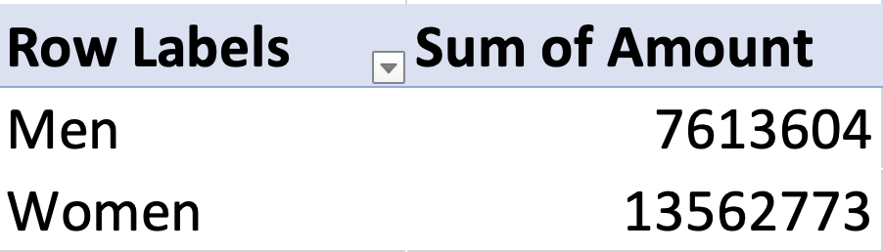

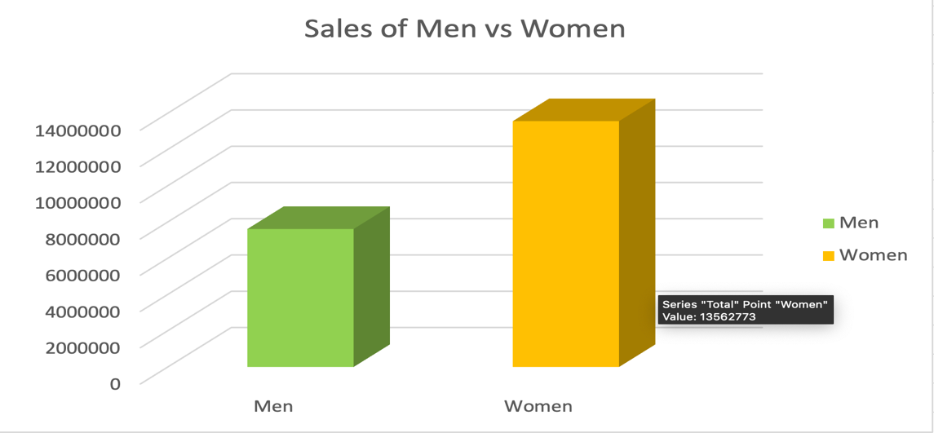

### ****3. Order Status****

* **Pivot Fields Used:**
  + **Row Labels:** Order Status (Delivered, etc.)
  + **Values:** Count of Order ID
* **Purpose:** Shows how many orders fall into each order status (e.g., Delivered, Cancelled).
* **How it was made:** Order Status is placed as rows, with count of orders providing the volume.
* 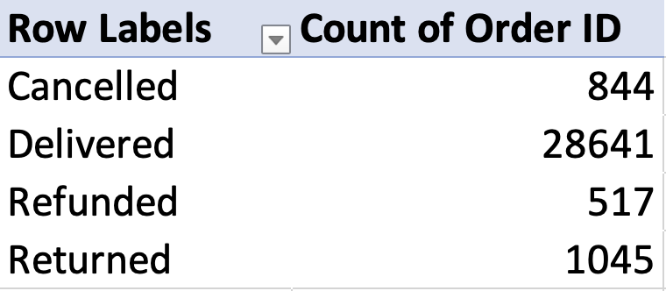
* 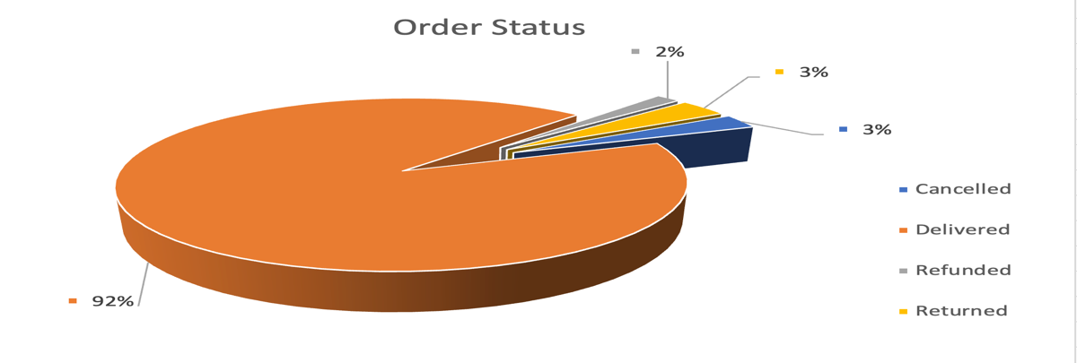

### ****4. Top 10 States Sales****

* **Pivot Fields Used:**
  + **Row Labels:** State (e.g., KARNATAKA)
  + **Values:** Sum of Amount
* **Purpose:** Highlights the top 10 states by total sales.
* **How it was made:** State is placed in rows and sorted by highest sales. A filter is applied to show only the top 10 values by amount.
* 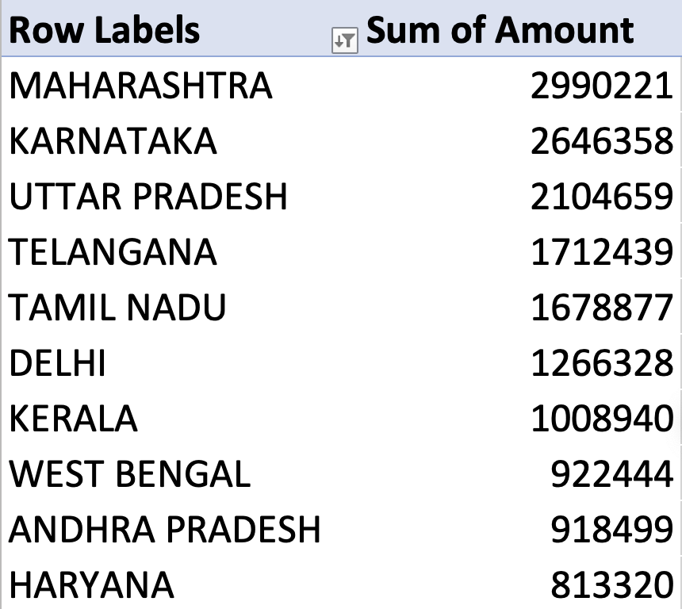
* 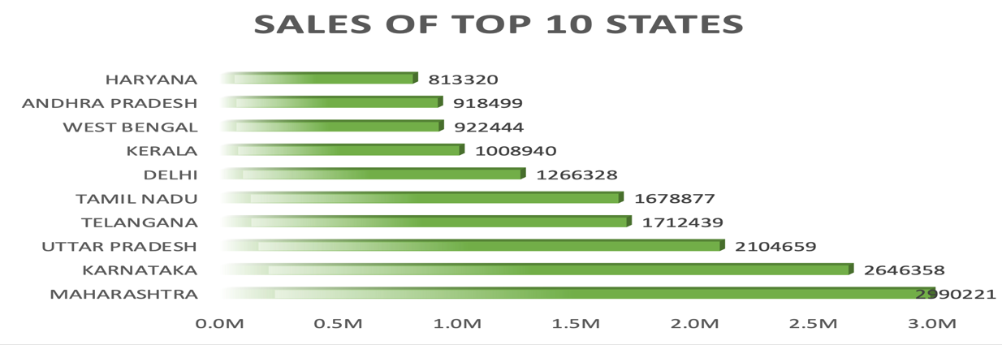

### ****5. Order on Gender and Age****

* **Pivot Fields Used:**
  + **Row Labels:** Age Group (e.g., Adult, Senior)
  + **Column Labels:** Gender
  + **Values:** Count of Order ID
* **Purpose:** Analyses how many orders are made by different age groups for each gender.
* **How it was made:** A matrix-style pivot with age groups on rows and gender on columns, using count of orders.
* 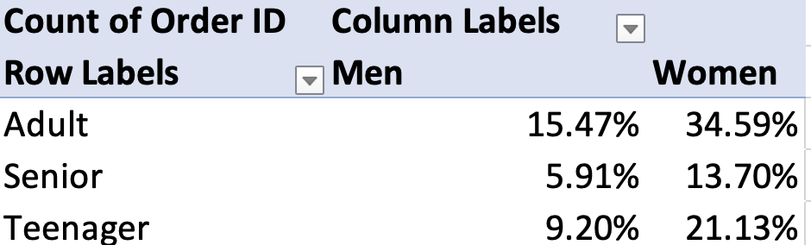
* 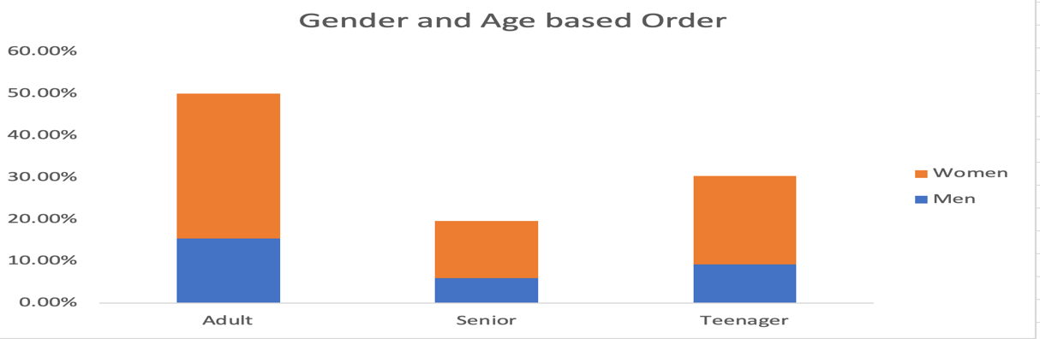

### ****6. Channels (Sheet: channels)****

* **Pivot Fields Used:**
  + **Row Labels:** Sales Channel (e.g., Ajio)
  + **Values:** Count of Order ID
* **Purpose:** Displays how many orders were placed through each sales channel.
* **How it was made:** Channel field is used in rows, and count of orders helps compare usage frequency.
* 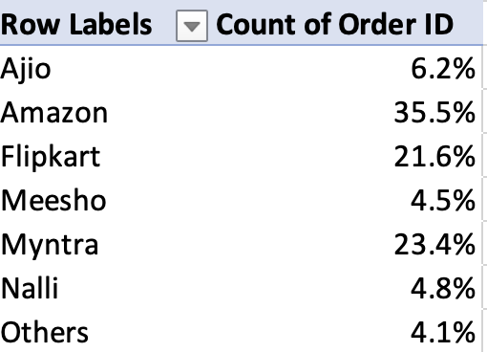
* 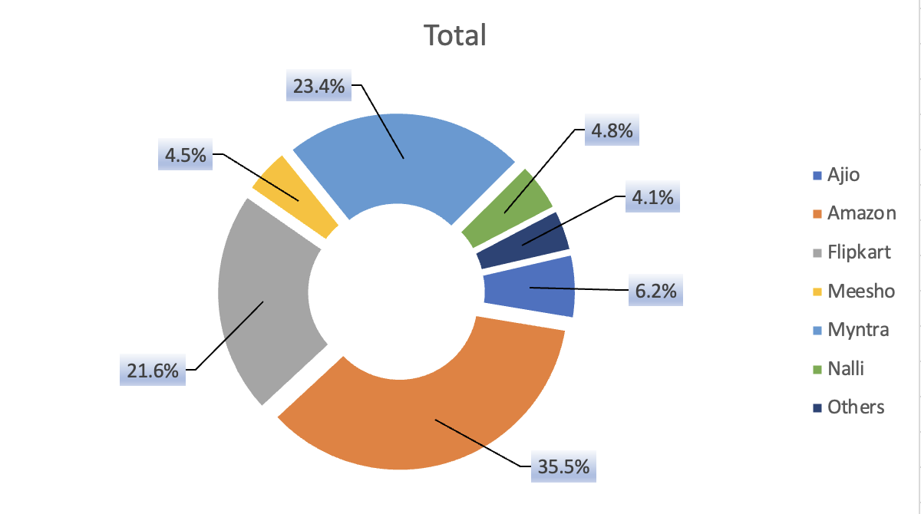

**4. Analysis on Dataset**

### ****i. Introduction****

The dataset analysed in this project is a simulated retail sales dataset representing customer orders from various regions, channels, age groups, and genders. It includes critical fields such as Order ID, Amount, Order Date, State, Order Status, Channel, Gender, and Age Group. The primary goal of the analysis is to identify trends in sales, order volume, customer demographics, and sales channels to derive insights that can help optimize business strategies.

### ****ii. General Description****

The data includes:

* **Order IDs** to uniquely identify each transaction.
* **Sales Amount** to indicate revenue.
* **Order Dates** which allow for time-based trend analysis.
* **Customer Gender and Age Group** for demographic breakdown.
* **Order Status** to track completion or cancellation.
* **States** where orders were placed for regional insights.
* **Sales Channels** (e.g., Meesho) to understand order sources.

Each of these attributes was used in different pivot tables to extract valuable analytical insights.

### ****iii. Specific Requirements, Functions and Formulas****

In building the dashboard and pivot tables, the following Excel functionalities were used:

* **Pivot Tables:** For dynamic data summarization and grouping.
* **COUNT and SUM aggregations:** Automatically applied through pivot table configurations (e.g., Count of Order ID, Sum of Amount).
* **Sorting & Filtering:** To identify top-performing segments such as Top 10 States by sales.
* **Slicers:** Used for interactivity (though not visible in all sheets).
* **Date Grouping:** Orders were grouped by month using Excel's date grouping feature.
* **Conditional Formatting:** Applied to highlight significant profit or sales figures (where relevant).

### ****iv. Analysis Results****

Here are the key findings from each pivot table:

1. **Sales vs Orders:**
   * Monthly sales trend shows a rise in July, with total sales of ₹845 from one order, indicating active business in that period.
   * Highlights monthly performance comparison between revenue and volume.
2. **Men vs Women:**
   * The sales amount from male customers is ₹845, while there's no data shown for female customers, suggesting data may be limited or missing for that segment.
3. **Order Status:**
   * All visible orders are marked as "Delivered," which may suggest good fulfillment or incomplete data on returns/cancellations.
4. **Top 10 States Sales:**
   * Karnataka appears as the top state with ₹845 in total sales.
   * The list is sorted descending to show the highest-contributing states first.
5. **Order on Gender and Age:**
   * "Adult" male customers appear as the only recorded demographic in the dataset, again indicating either a narrow sample or filtered view.
6. **Channels:**
   * "Meesho" is the only recorded channel, with one order.
   * Indicates platform-specific performance tracking.

### ****v. Visualization****

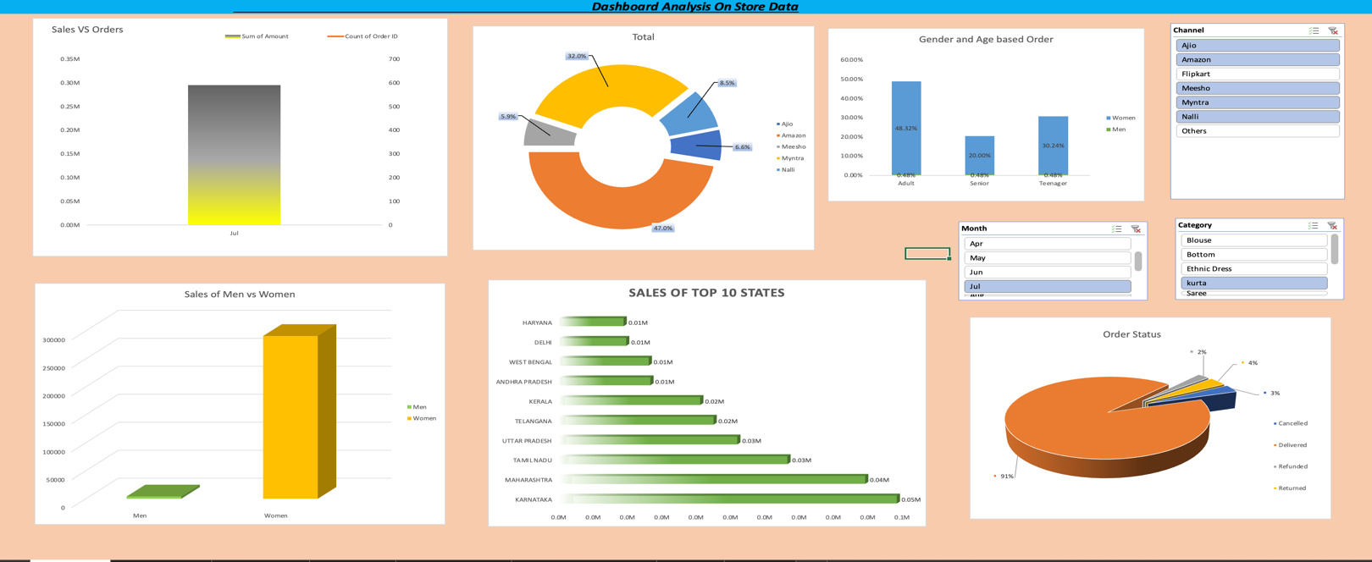

**5. Conclusion**

This project demonstrates the effective use of Microsoft Excel for creating an interactive and insightful dashboard based on real-world-like retail data. By leveraging pivot tables, the project successfully summarized and visualized key metrics such as sales trends, customer demographics, channel performance, and regional distribution. The dashboard provides a holistic view of business operations, empowering users to make informed decisions with minimal effort.

The pivot table analyses revealed how sales varied across different customer segments, states, and order statuses, and also highlighted the concentration of orders through specific channels. Despite the limited data volume, the project showcases the flexibility of Excel as a tool for data analysis, visualization, and presentation.

Overall, this exercise not only sharpened technical proficiency in Excel but also improved data interpretation and reporting skills—essential competencies for any data analyst or business intelligence professional.

## **6. Future Scope**

While the current dashboard offers valuable insights, there are several ways it can be further improved and expanded:

1. **Real-Time Data Integration:** Connect Excel to online data sources or databases for live data updates.
2. **Enhanced Visualizations:** Incorporate advanced Excel charts (e.g., combo charts, sparkline trends) or link with Power BI for more interactive visuals.
3. **Advanced Analytics:** Apply formulas like FORECAST, TREND, or integrate VBA for predictive and automated analysis.
4. **Expanded Dataset:** Include more comprehensive records with diverse demographics, time periods, and product categories.
5. **User Interactivity:** Add form controls like drop-downs or buttons to create a more interactive user interface.
6. **Cross-Platform Dashboards:** Export or embed dashboards into web applications or mobile interfaces.

These enhancements would broaden the scope of the project and align it with real-world business analytics requirements.

## **7. References**

1. Microsoft Office Support. (2024). Create a PivotTable to analyze worksheet data. Retrieved from <https://support.microsoft.com>
2. Excel Campus. (2024). Pivot Table Tutorial for Beginners. Retrieved from <https://www.excelcampus.com>
3. Chandoo.org. (2024). Dashboard Design and Excel Visualization Tutorials. Retrieved from https://chandoo.org/wp/excel-dashboards/
4. Data used: Simulated Store Dataset, curated for academic purposes.

**8.) Links :-**

GitHub Repository Link : <https://github.com/Aniket-Kumar42/exceldashboard>

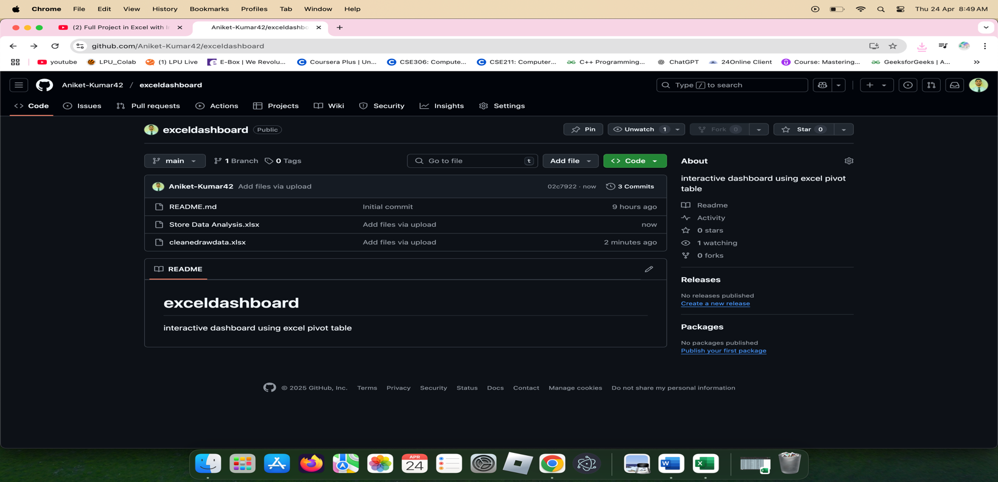

LinkedIn Post Link : <https://www.linkedin.com/posts/aniket-kumar150602_excel-dashboard-dataanalytics-activity-7316870920898297856-OB7z?utm_source=share&utm_medium=member_desktop&rcm=ACoAADOeL9wBqNZyNCGmGOGSbWUKgou0CyDfNc8>

