Wind Flow Direction using
NOAA Data and python

Aniket Maity
Department of Applied Electronics and Instrumentation Engineering
Techno International New Town
Koltaka, India
Email: aniket.maity@outlook.com

ABSTRSCTS: Now days for weather forecasting companies uses trends of data for several times to predict the forecast for next 10 days by different mathematical models. Sometimes for understand the data structure we have to read and write data for every imagery data from NOAA images, but using python PILLOWS and NumPy module we can trend millions of images for forecasting weather and wind flow.

Keywords: NOAA (National Oceanic and Atmospheric Administration)

Introduction (Heading 1)

National Oceanic and Atmospheric Administration (NOAA) is an organization where they grab the images of earth from space since 1974 daily and 6 times a day. We can imagine the vastness of data for analysis. Sometimes for analyzing these types of huge data sets can be a painful work for man using mathematical models, but using python for this kind of data set can help us to solve more algorithms rather than computing the whole data set using mathematical model. Python’s NumPy module helps us to load the image’s bit wise RGB values because when we use image as a data set we have to consider all pixels in that image. By analyzing the bit map data for corresponding two images we can analyze the path of wind.

III. Ease of Use
USABILITY OF PYTHON: Python is a high-level language. Using python language one can easily generate the database for a dataset. Using Python’s “imread” module we can easily fetch the image data from the websites.

E.G:
img=imread(“https://www.ncdc.noaa.gov/gibbs/image/GRD-1/IR/2017-01-01-06”)

NUMPY AND PILLOWS LIBRARY: For datasets like 10,000 images normal python code may run slow but using the NumPy library we can load “N” number of data (N-Dimension) easily. The NumPy library uses low the memory while loading data because it only loads “chunk” of data at a time. So that the code will be slows down.

After loading the images, we have to deconstruct the images in pixel form as (R, G, B) data. If the image is of size (300 x 400) sqPix then the size of the NumPy array of (R, G, B) values will be of size (300 x 400 x 3). The Pillows library helps us to deconstruct the image into its pix array data of (R, G, B) values.

For analyzing the NOAA data imagery first, we have to construct a database.

- Fetching NOAA data from web: Using Python’s “imread” library we have to fetch the data for construct database. For a database of more than 10,000 image if we download image by ourselves it will take a life-time to just fetching the data from the web. So, we use the python program for constantly construction of dataset.
For this type of data fetching first we have to analyze the pattern of the imagery links on NOAA data. E.G: https://www.ncdc.noaa.gov/gibbs/image/GRD-1/IR/2017-01-01-06
If we travers the links we can find the pattern of links. Then of we found the pattern of links then we can code the pattern for 10,000 times and the computer python code will do the rest for data fetching.
As an example, if we look at the example links, we can find that:
“2017-01-01” is a date and if we traverse the links for some time, we can find that:
“-06” is the particular time of that date.
Then we have to store the images in a folder which will be the database of the project.

(SOURCE CODE: https://github.com/Aniket-Maity/WIND-FLOW-with-NOAA )

Image analysis and cloud mapping: When we load an image, we can find that the image is too big for analysis. Then we have to consider a part of image (In this project we consider the INDIAN OCIAN part of the image). If we consider a part of the image then we have to cut short the image portion. When we finished this operation then we can see an image like fig1. 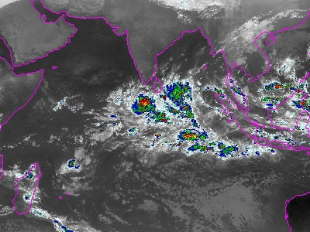

As we can see that the image contains land, Water and cloud but for our analysis we only need the cloud formation. For that we have to use the “CV2” library in python. Using the CV2 library when we open an image it shows the pixel values of (0 to 1) in float data instead of (R, G, B).
For analyzing the cloud first, we have to know the CV2 values of clouds (for our case the cloud CV2 value is more than 0.45).

Now for separating the cloud from the rest of the image we have to assign CV2 values of less than 0.45 to be ZERO (“0”) and rest (cloud) will be one.
After doing that operation we can see an image like fig2.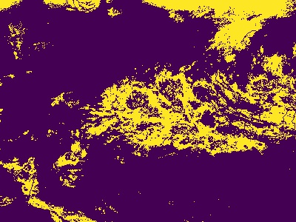

WIND FLOW ANALYSIS:
Now for analysing the wind flow direction first we have to select the area on which we want to analyse the wind. The analysis part has two segment:
1. Area Selection:
2. Contours count:

For area selection we have to give the co-ordinates on which we start the analysis. We have to give the co-ordinats like: e.g-(x1,y1) , (x2,y2)
When we are finished in inputs the map starts analysing in the given area.

For contours count the map countours(1’s pixel points: yellow spots) has to be count in the given co-ordinates.

WIND DIRECTION COUNT:
The given co-ordinates now create a rectangle on which the flow
directions are counted. For the counting process first we have to
divide the location into 4 equal parts. Then for analyzing:
- Present state:
In present image the contours are counted then in the four equal areas. The data should be counted on a floating
format. Then for next analysis:
- Future state:
Future state or the conjugate next image is the future of the present state image. For analyzing we again have to count for the contours in the future state. Then we can relate the data of 1st segment of present with the 2nd segment of future state image. And if the contours count of future segment w.r.t the contours count of first segment is positive then the wind is flowing from left to right.

e.g.
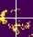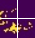
Present state Future state

Conclusion

On the analysis of Wind Count we can present the flow nature
of the wind in different regions. By python-based NOAA image
analysis we can further expand into this analysis. We can have
more knowledge on the wind flow, direction, nature by using
more data in analysis using Machine Learning algorithms. This
project represents only the flow direction for a certain region for
a certain amount times. By using this data, we can further expand
into AI and ML for predicting weather in a region. And by using
extrapolation in those data we can predict the next day wind
directions. We can conclude that this project has its objective
cleared and has more potential to grow in further fields.

