1. Create custom docker nginx image

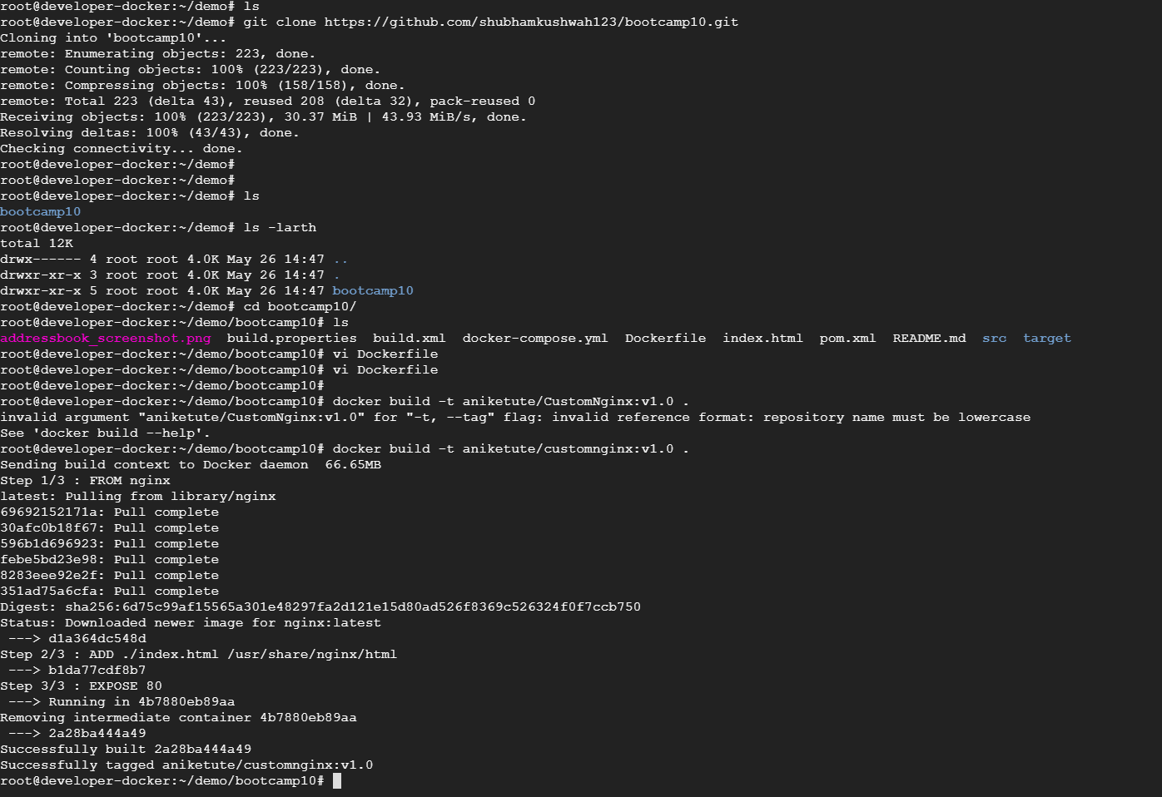

2. Docker run

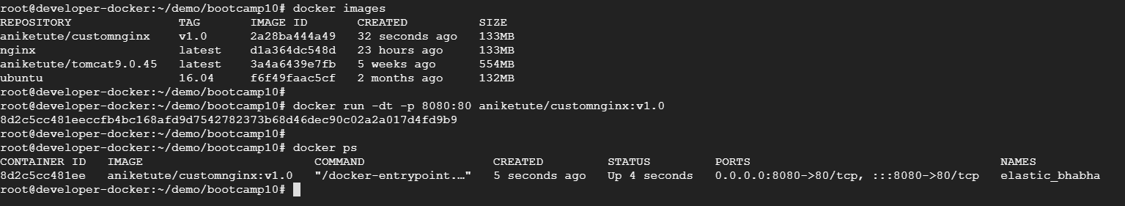



1. Push image in docker hub

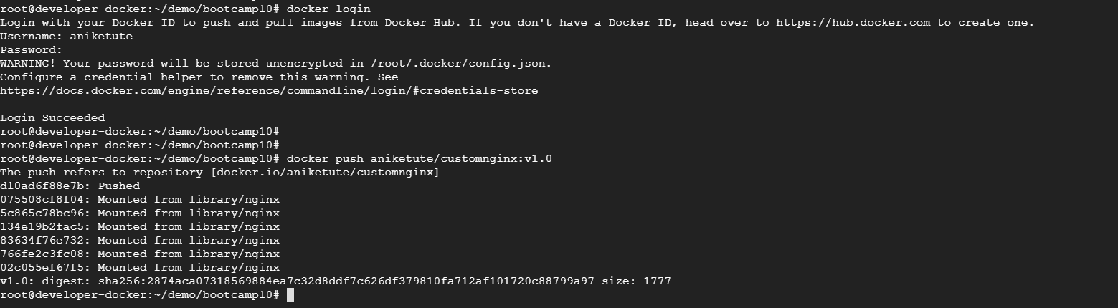

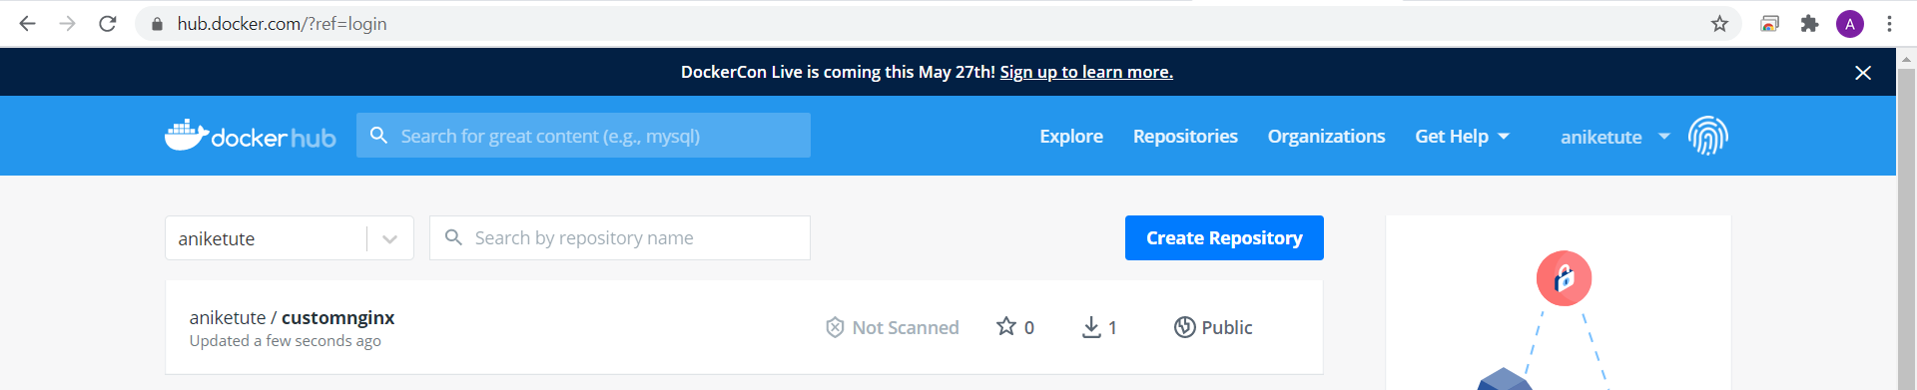

1. Pull image in another server and run it.

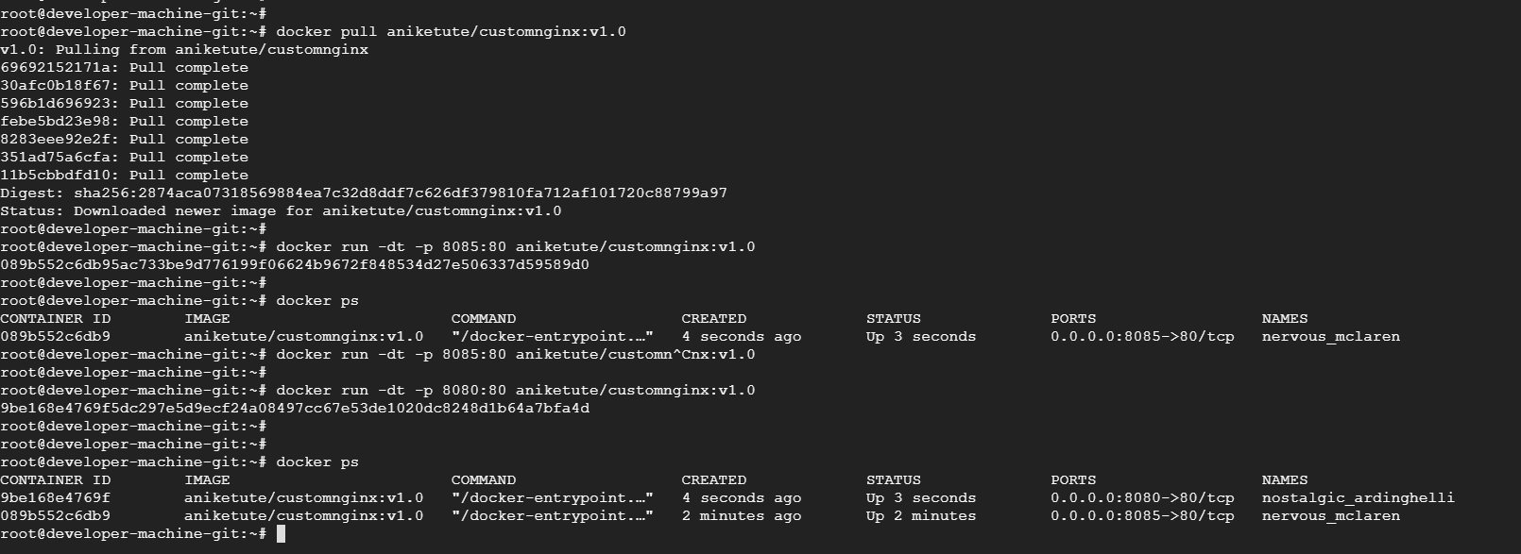



1. Docker-compose to run new custom ngnix image and run it.

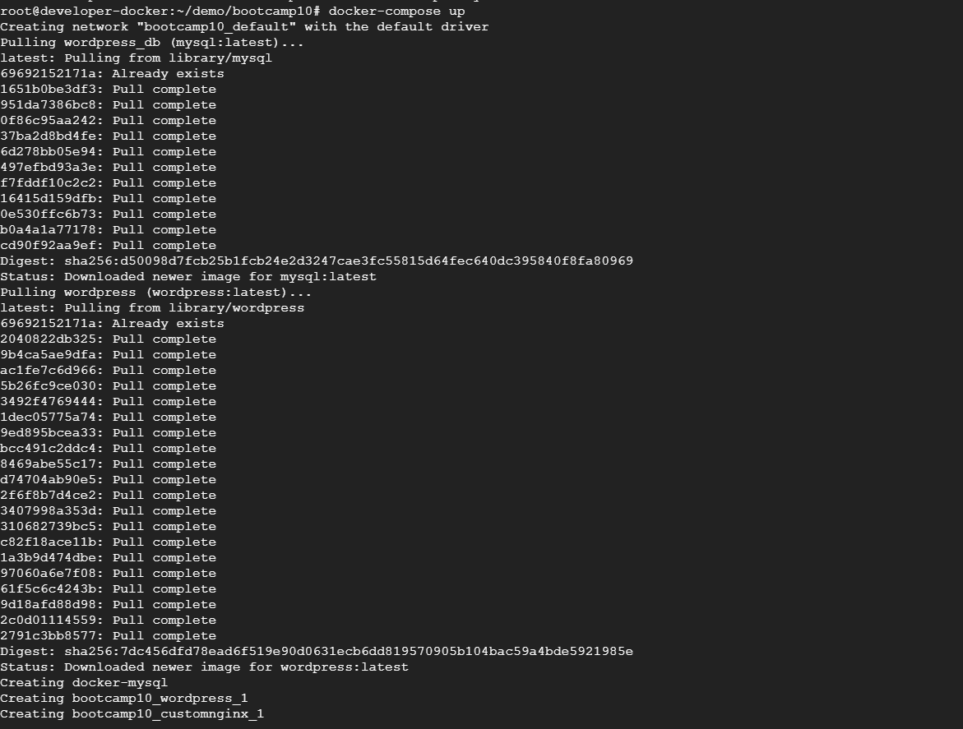

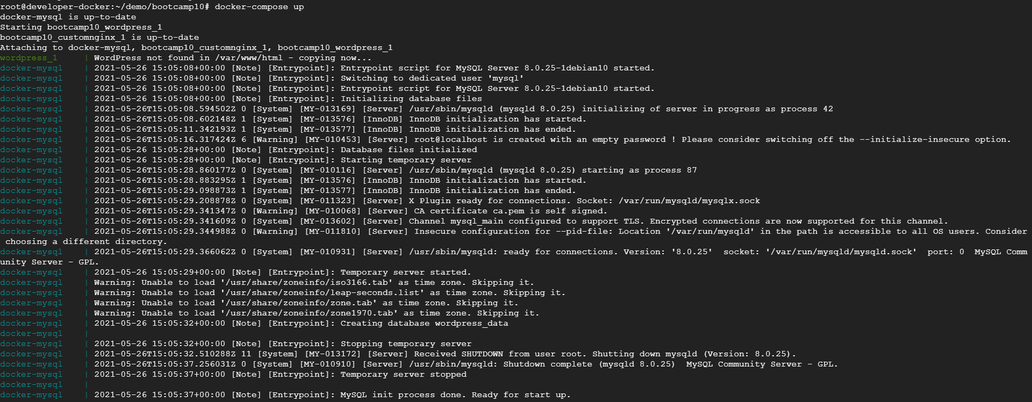



1. Login mysql db instance and create table.

