1. Ansible master node

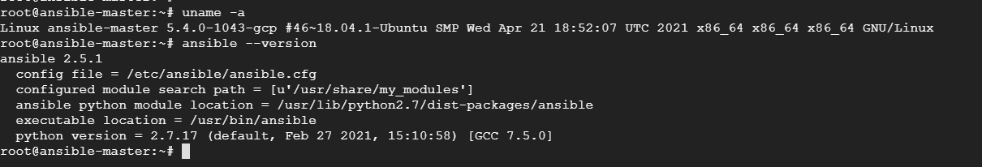

1. Ansible master to node password less login.

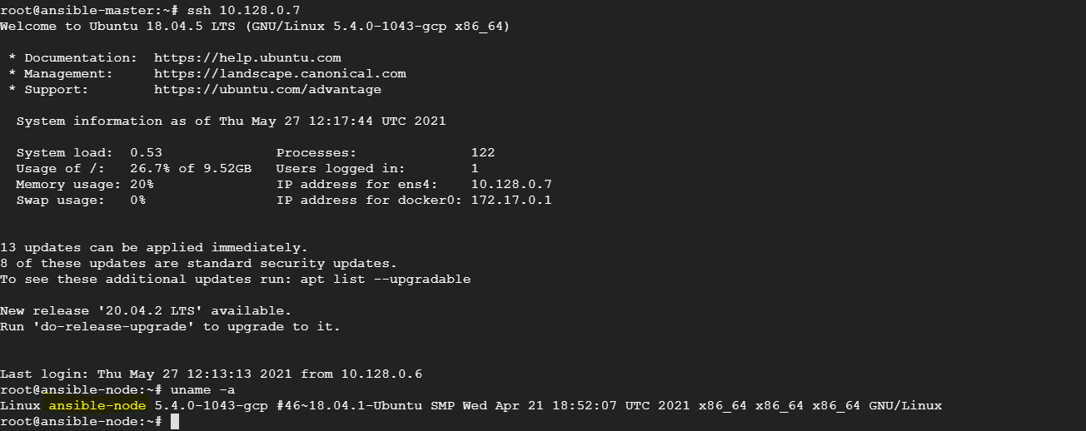

1. Ansible command test on node.

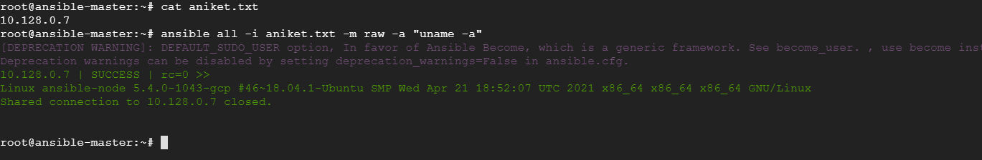

1. Playbook to install all files.

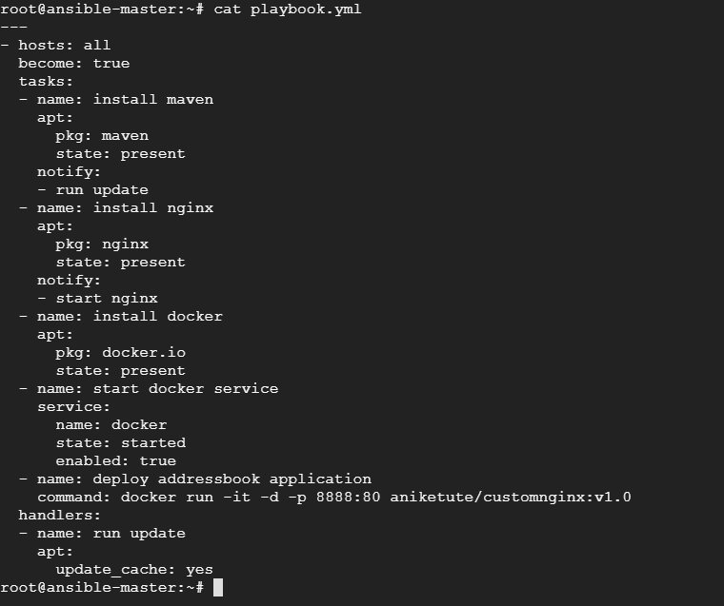

1. Execution of playbook

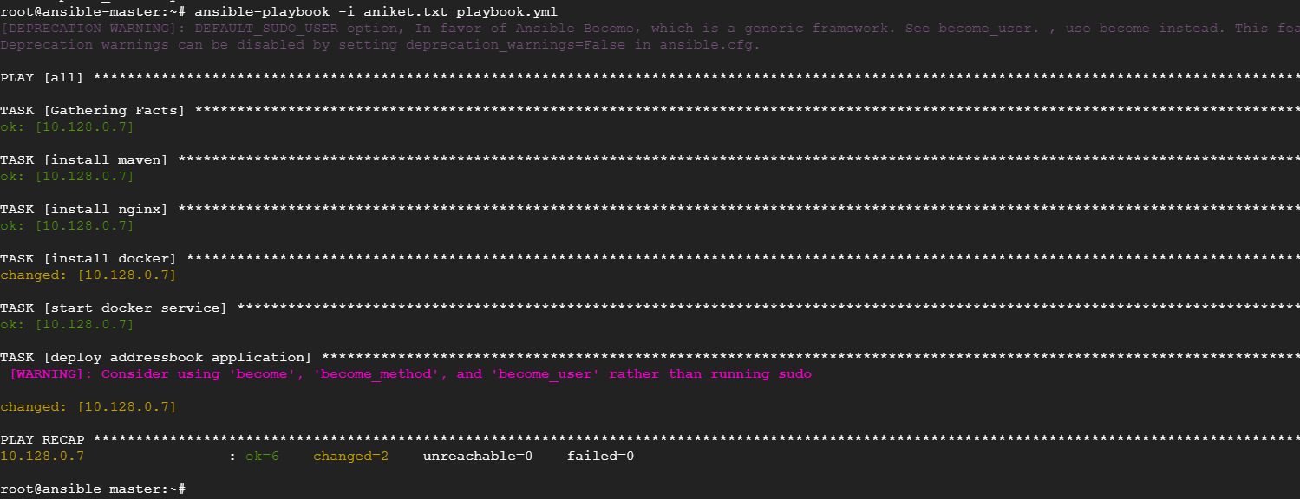

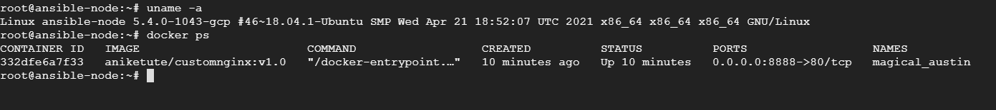

1. Output

