***Generative Adversarial Networks for Image Synthesis***

1st Pratik Mishra  
Artificial Intelligence & Machine Learning Engineering,  
*ISB&M College of Engineering (SPPU)*Pune, India  
[aiml20_pratik.mishra@isbmcoe.org](mailto:aiml20_pratik.mishra@isbmcoe.org)  
2nd Yogiraj Sattur  
Artificial Intelligence & Machine Learning Engineering,  
*ISB&M College of Engineering (SPPU)*Pune, India  
[aiml20_yogiraj.sattur@isbmcoe.org](mailto:aiml20_yogiraj.sattur@isbmcoe.org)  
3rd Prof. Darshana Bhamare  
Artificial Intelligence & Machine Learning Engineering,  
*ISB&M College of Engineering (SPPU)*Pune, India  
darshan.bhamare@isbmcoe.org

***Abstract* - Generative Adversarial Networks (GANs) have emerged as a powerful framework for generating realistic images across various domains, revolutionizing the field of artificial intelligence. This paper presents a comprehensive review of GANs for image generation, focusing on their architecture, training process, and applications. The fundamental concept of GANs revolves around the interplay between two neural networks: the generator and the discriminator. The generator aims to produce synthetic images that are indistinguishable from real ones, while the discriminator learns to differentiate between real and generated images. Through adversarial training, these networks iteratively improve their performance, resulting in the generation of high-quality images.**

**Various architectures and techniques have been proposed to enhance the performance and stability of GANs, including Deep Convolutional GANs (DCGANs), Wasserstein GANs (WGANs), and Progressive Growing GANs (PGGANs). These advancements have led to remarkable achievements in image synthesis, style transfer, image super-resolution, and image-to-image translation. Despite their success, GANs still face challenges such as mode collapse, training instability, and evaluation metrics. Ongoing research efforts aim to address these limitations and further advance the capabilities of GANs for image generation. Overall, GANs represent a promising approach for synthesizing realistic images with diverse applications in computer vision, entertainment, and creative industries.**

***Keywords - Generative Adversarial Networks (GANs), Generator, Discriminator, Adversarial training, Image Generation.***

**I. INTRODUCTION**

*A. Introduction to GAN*

Generative Adversarial Networks (GANs) have emerged as a powerful tool in the realm of artificial intelligence, revolutionizing the generation of synthetic data across diverse domains. Unlike conventional generative models, which rely on probabilistic frameworks, GANs adopt an adversarial approach, pitting two neural networks against each other in a dynamic game of cat and mouse. This paper introduces the concept of GANs, elucidates their architecture, and examines their manifold applications, ranging from image synthesis and style transfer to super-resolution and denoising of images. By fostering the creation of data that exhibits remarkable fidelity to real-world distributions, GANs have transcended traditional boundaries, ushering in a new era of data generation and augmentation.

GANs, extending beyond mere image synthesis, have diversified applications in domain transfer and image-to-image translation. These versatile networks facilitate the seamless transition of images between styles and across domains while retaining crucial content. Conditional GANs introduce a new dimension of user control, allowing specific characteristics to be defined in the generated images, thereby enhancing customization. Despite their considerable achievements, GANs face obstacles such as mode collapse, which limits the diversity of generated content, and training instability, hindering overall learning progress. Additionally, ethical considerations loom large, with concerns about potential misuse underscoring the importance of responsible implementation. Nevertheless, as a cornerstone technology in image generation, GANs persistently push the boundaries of realism and diversity in visual content, cementing their position as a transformative force in the realm of artificial intelligence.

*B. Various Image Generation Techniques*

Image generation techniques span a broad spectrum of methodologies, encompassing both traditional computer graphics principles and cutting-edge advancements in artificial intelligence and machine learning. These techniques have undergone significant evolution, propelled by innovations in fields such as computer graphics, artificial intelligence, and machine learning. Traditional methods, including raster graphics and vector graphics, form the foundational basis for digital image creation, offering approaches to represent images with precision and scalability. Rendering techniques, such as ray tracing and rasterization, further enhance image creation by simulating complex lighting effects and material properties.

Alongside these traditional methods, recent breakthroughs in deep learning have introduced transformative approaches to image generation. Generative Adversarial Networks (GANs) have emerged as a powerful paradigm, leveraging adversarial training between a generator and a discriminator to produce increasingly realistic images. Variational Autoencoders (VAEs) offer another avenue, employing probabilistic models to generate new data points from learned latent space representations. Deep Convolutional Generative Adversarial Networks (DCGANs), tailored specifically for image generation tasks, leverage deep convolutional neural networks to generate high-quality images with hierarchical features.

Conditional image generation techniques enable precise control over generated images by conditioning the generative model on additional information. Attention mechanisms and Transformer models, originally developed for natural language processing, have been adapted to image generation tasks, enabling more contextually relevant and coherent results. However, as image generation techniques advance, they bring forth ethical and social implications, such as the potential for misuse in generating deceptive deepfake videos. Addressing these concerns is crucial to ensure the responsible development and deployment of image generation technologies. By exploring these diverse methodologies and their implications, a comprehensive understanding of image generation techniques and their applications can be achieved.

*C. Purpose and Objective*

This research paper aims to extensively examine the principles, applications, and advancements of Generative Adversarial Networks (GANs) in the realm of artificial intelligence and machine learning, focusing particularly on their innovative role in image generation. The paper endeavours to offer a comprehensive understanding of GANs, delving into their underlying architecture, training methodologies, and diverse extensions and applications. Furthermore, it seeks to probe into the impact of GANs across various domains, ranging from image synthesis and style transfer to super-resolution and denoising of images.

The objectives of the research paper are outlined as follows:

1. To clarify the fundamental principles of Generative Adversarial Networks (GANs), elucidating the roles of both the generator and discriminator networks, as well as the intricacies of the adversarial training process.

2. To examine the notable advancements and variations within the realm of GANs, encompassing variations such as Conditional GANs (cGANs), Deep Convolutional GANs (DCGANs), and Wasserstein GANs (WGANs), among others.

3. To assess the challenges and constraints inherent to GANs, including issues such as mode collapse, training instability, and ethical dilemmas associated with the creation of synthetic data and deepfake content.

4. To explore potential future avenues and research directions in the domain of Generative Adversarial Networks, with a particular focus on enhancing training stability, scalability to higher-resolution images, and applications extending beyond the scope of computer vision.

**II. LITERATURE SURVEY**

* Generative adversarial network: An overview of theory and applications

Alankrita Aggarwal, Mamta Mittal, Gopi Battineni [1]

ABSTRACT: In this study, the authors present a comprehensive overview of Generative Adversarial Networks (GANs) and explore their potential applications. The authors emphasize that GANs exhibit a broad spectrum of use cases and remain a dynamic focus of ongoing research and development within the realms of machine learning and artificial intelligence. Recognized for their capacity to create innovative and lifelike data, GANs are acknowledged as a versatile tool with applicability across diverse domains.

* Deep Fakes using Generative Adversarial Networks (GAN)

Tianxiang Shen, Ruixian Liu, Ju Bai, Zheng Li [2]

ABSTRACT: Deep Fakes represents a widely used image synthesis technique rooted in artificial intelligence. It surpasses traditional image-to-image translation methods by generating images without the need for paired training data. In this project, the authors employ a Cycle-GAN network, a composite of two GAN networks, to achieve their objectives.

* Exploring generative adversarial networks and adversarial training

Afia Sajeeda, B M Mainul Hossain [3]

ABSTRACT: Acknowledged as a sophisticated image generator, the Generative Adversarial Network (GAN) holds a prominent position in the realm of deep learning. Employing generative modelling, the generator model learns the authentic target distribution, producing synthetic samples from the generated counterpart distribution. Simultaneously, the discriminator endeavours to discern between real and synthetic samples, providing feedback to the generator for enhancement of the synthetic samples. To articulate it more eloquently, this study aspires to serve as a guide for researchers exploring advancements in GANs to ensure stable training, particularly in the face of Adversarial Attacks.

* Generative Adversarial Networks: Introduction and Outlook

Kunfeng Wang, Member, Chao Gou, Yanjie Duan, Yilun Lin, Xinhu Zheng, and Fei-Yue Wang, [4]

ABSTRACT: This comprehensive review paper provides an overview of the current status and future prospects of Generative Adversarial Networks (GANs). Initially, they examine the foundational aspects of GANs, including their proposal background, theoretical and implementation models, as well as their diverse application fields. They subsequently delve into a discussion on the strengths and weaknesses of GANs, exploring their evolving trends. Notably, they explore the intricate relationship between GANs and parallel intelligence, concluding that GANs hold significant potential in parallel systems research, particularly in the realms of virtual-real interaction and integration. It is evident that GANs can serve as a robust algorithmic foundation, offering substantial support for advancements in parallel intelligence.

**III. METHODOLOGY**

*A. Architecture of GANs*

The architecture of a Generative Adversarial Network (GAN) comprises two primary components: the generator and the discriminator, which are trained in an adversarial fashion to enhance the overall performance of the GAN. The details are as follows:

1. Generator

Function: The generator's role is to generate synthetic data, specifically creating images in this context.

Design:

- Typically implemented as a deep neural network, often utilizing convolutional layers for image generation tasks.

- Takes random noise or a latent vector as input and transforms it into a higher-dimensional space, aiming to produce outputs resembling real data.

- May incorporate up-sampling layers, such as transposed convolutions, to progressively generate higher-resolution images.

2. Discriminator

Function: The discriminator evaluates the authenticity of generated images by discerning between real and synthetic data.

Design:

- Similar to the generator, the discriminator is a deep neural network, typically employing convolutional layers.

- Receives input images (real or generated) and outputs a probability score indicating whether the input is real or synthetic.

- May include down-sampling layers to analyse the input at different scales.

3. Adversarial Training

Training Process:

- The generator and discriminator undergo iterative training in a competitive manner.

- During each training iteration, the generator generates synthetic images, while the discriminator assesses their authenticity.

- The generator aims to enhance its performance by generating images that are increasingly challenging for the discriminator to distinguish as fake.

- The discriminator adjusts to better differentiate between real and generated images.

4. Loss Functions

Generator Loss: The generator minimizes a loss function to encourage the generation of realistic images, often based on the discriminator's output, striving to maximize the probability of generated images being classified as real.

Discriminator Loss: The discriminator minimizes a loss function measuring its accuracy in classifying real and generated images, typically using binary cross-entropy loss to penalize misclassifications.

5. Hyperparameters

Learning Rate: An essential hyperparameter governing the optimization step size; proper tuning is crucial for stable and effective training.

Architecture Hyperparameters: Parameters such as the number of layers, nodes per layer, and activation functions employed in both generator and discriminator architectures.

6. Training Strategies

Mini-Batch Training: Training utilizes mini-batches of real and generated samples to improve convergence and computational efficiency.

Regularization Techniques: Methods like dropout, batch normalization, and spectral normalization are employed to enhance stability and generalization.

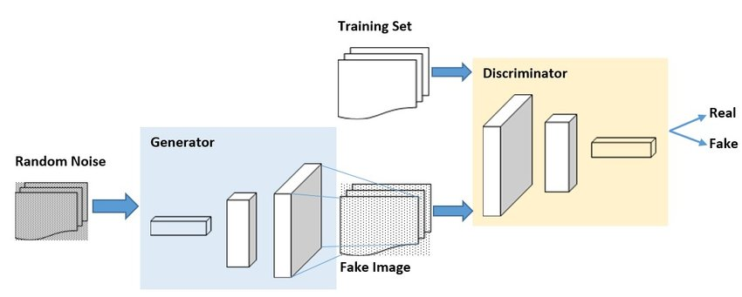

Fig. 1. *Architecture of GANs*

*B. Training Process and Optimization Technique*

The training process of a Generative Adversarial Network (GAN) involves a competitive game between two neural networks: the generator and the discriminator. The objective is for the generator to produce realistic-looking data, such as images, while the discriminator aims to distinguish between real data from the training set and fake data generated by the generator. Here's a detailed explanation of the training process and optimization techniques:

1. Initialization:

- The weights of both the generator and discriminator networks are initialized randomly or using pre-trained weights from another task (transfer learning).

2. Training Iterations:

- During each training iteration, the discriminator and generator are updated in alternating steps.

- Typically, a fixed number of iterations or epochs are performed, where each epoch consists of multiple batches of data.

3. Discriminator Training:

- In the discriminator training step, a batch of real data samples from the training set and an equal-sized batch of fake data samples generated by the generator are fed into the discriminator.

- The discriminator is trained to classify the real data samples as "real" (label = 1) and the fake data samples as "fake" (label = 0).

- The discriminator's loss is calculated using a binary cross-entropy loss function, comparing its predictions to the ground truth labels.

- The discriminator's weights are updated using backpropagation and gradient descent optimization to minimize the loss.

4. Generator Training:

- In the generator training step, a batch of random noise vectors (latent space points) is fed into the generator to generate fake data samples.

- The generated fake data samples are then passed through the discriminator.

- The generator aims to produce fake data samples that are classified as "real" by the discriminator, thereby fooling it.

- The generator's loss is calculated based on the discriminator's predictions for the generated samples. Typically, the generator aims to maximize the discriminator's prediction that the generated samples are real.

- The generator's weights are updated using backpropagation and gradient descent optimization to maximize this "fooling" loss.

5. Optimization Techniques:

- Gradient Descent: Both the generator and discriminator networks are trained using gradient descent optimization algorithms, such as stochastic gradient descent (SGD) or its variants like Adam or RMSprop.

- Learning Rate Scheduling: Adjusting the learning rate during training can help improve convergence and stability. Techniques such as learning rate decay or adaptive learning rate methods are commonly used.

- Regularization: Regularization techniques like weight decay or dropout are applied to prevent overfitting and improve the generalization ability of the networks.

- Batch Normalization: Batch normalization layers are often used to stabilize training and accelerate convergence by normalizing the activations of each layer.

6. Convergence:

- The training process continues until a stopping criterion is met, such as a maximum number of iterations, convergence of performance metrics, or when the generated samples reach a satisfactory level of quality.

- Achieving convergence in GAN training can be challenging due to issues such as mode collapse, training instability, and vanishing gradients.

By iteratively training the generator and discriminator networks in this adversarial manner and optimizing their parameters using gradient descent-based optimization techniques, GANs can learn to generate realistic data samples that closely resemble the training data distribution.

**IV. EXPERIMENTAL SETUP**

*A. Details on Training Dataset*

The dataset used in this scenario consists of images of cat faces, with each image having a size of 64x64 pixels. The dataset contains a total of 15,787 images.

1. Dataset Content:

- Each image in the dataset represents the face of a cat.

- The images are likely to capture various expressions, and orientations of cats' faces, providing diversity in the dataset.

- The images may contain different breeds, colours, and patterns of cats.

2. Image Size:

- The images in the dataset are standardized to a size of 64x64 pixels.

- This size is commonly used in deep learning tasks due to its balance between detail preservation and computational efficiency.

- Resizing the images to a consistent size allows for easier processing and training of machine learning models.

3. Dataset Size:

- The dataset consists of a total of 15,787 images.

- Having a large number of images enables the training of more complex and accurate machine learning models, such as deep neural networks.

- A large dataset helps to capture the variability and diversity present in cat faces, leading to better generalization performance of the trained models.

4. Data Preprocessing:

- Preprocessing steps such as normalization and resizing may have been applied to the images before they were used for training.

- Normalization ensures that pixel values are scaled to a standard range (e.g., [0, 1] or [-1, 1]), which can improve training stability and convergence.

- Resizing ensures that all images have a consistent size, which is necessary for batch processing during training.

5. Dataset Source:

- The dataset source was Kaggle from where it was downloaded and used for Training the Generative Adversarial Network.

- The link is: https://www.kaggle.com/datasets/spandan2/cats-faces-64x64-for-generative-models/data

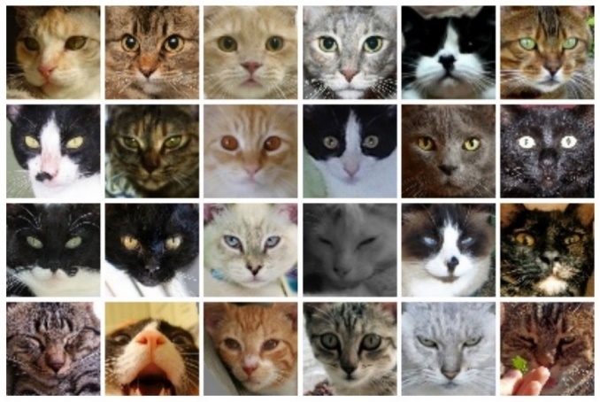

Fig. 2. Example Images from Cat Dataset

*B. Resource Requirement and Configuration*

* Hardware –

The hardware resources necessary for this task include an i5 processor operating at a speed of 1.1 GHz, a minimum of 8 GB of RAM, and a hard disk with at least 50 GB of storage capacity. Additionally, a standard Windows keyboard and a two or three-button mouse are required for user input. For visual display, an SVGA monitor is recommended. These hardware specifications provide the computational power and input/output devices necessary to effectively execute the task at hand.

* Software –

The software resources needed for this endeavour encompass an operating system compatible with Windows 11, serving as the platform for executing the task. Google Colab, a cloud-based integrated development environment (IDE), is utilized for coding and collaborative work. Python, a versatile and widely-used programming language, serves as the primary coding language for implementing algorithms and models. The task further necessitates the utilization of various libraries including TensorFlow, PyTorch, Scikit Learn, Keras, and Numpy, which provide essential functionalities for machine learning, deep learning, and data manipulation tasks. Together, these software components form a comprehensive toolkit for effectively tackling the objectives at hand.

**V. RESULT**

Generative Adversarial Networks (GANs) have been a groundbreaking approach in generating synthetic data with various applications in image generation, text-to-image synthesis, and more. Here's an overview of the outcomes of experiments based on GANs:

*A. Discriminator Scores*

GANs are composed of two networks: a generator and a discriminator. The discriminator's role is to distinguish between real and fake data generated by the generator.

Discriminator scores measure how well the discriminator can distinguish between real and generated data. Lower scores indicate that the generator is producing data that closely resembles real data, making it harder for the discriminator to differentiate.

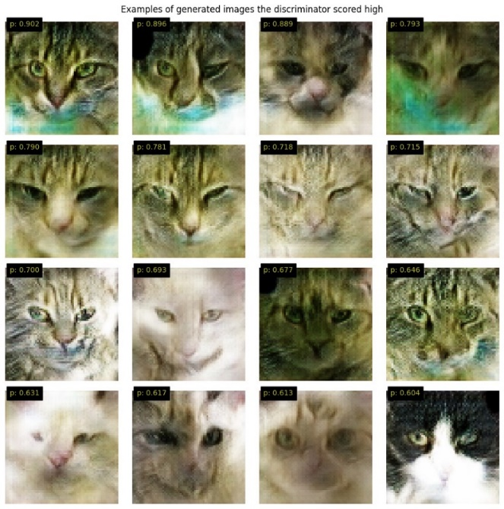

Fig. 3. Example of Generated Images the Discriminator Scored High

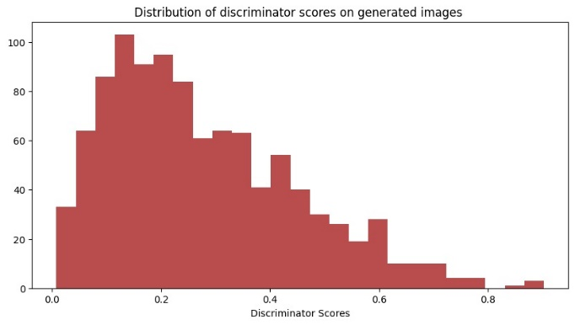

Fig. 4. Distribution of Discriminator Scores on Generated Images

*B. Final Results*

The final results of GAN experiments often depend on the specific dataset and task. In image generation tasks, the final results are typically evaluated based on visual quality, diversity, and realism of generated images.

For text generation tasks, final results are evaluated based on coherence, relevance, and fluency of the generated text.

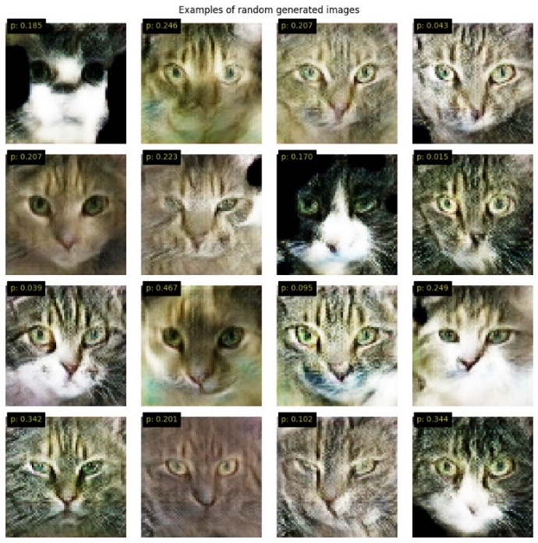

Fig. 5. Examples of Random Generated Images

*C. All-Time Accuracy*

All-time accuracy refers to the overall performance of the GAN model across various datasets and experiments.

It's a cumulative measure of how well the GAN has been able to generate data that matches the distribution of real data across different tasks and domains.

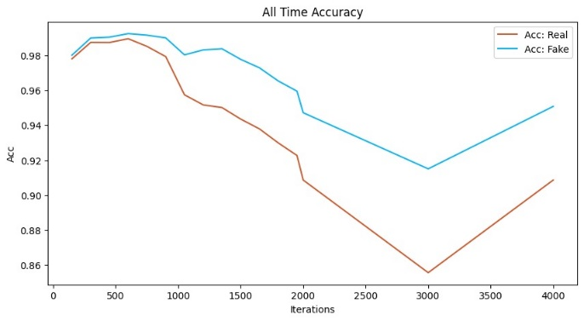

Fig. 6. Graph of All Time Accuracy

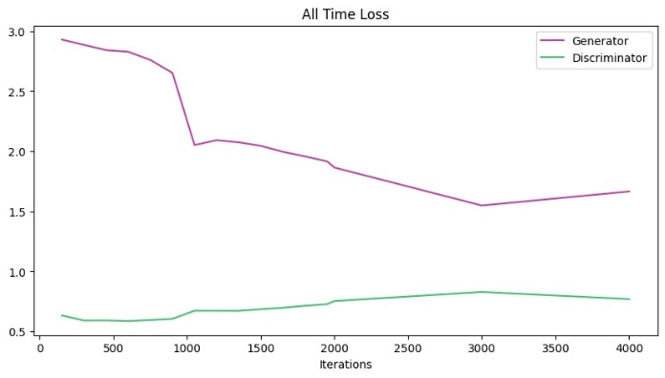

Fig. 7. Graph of All Time Loss

*D. Challenges and Considerations*

While GANs have shown impressive results in generating realistic data, they also face challenges such as mode collapse (where the generator fails to produce diverse samples) and instability during training.

Tuning hyperparameters, choosing appropriate network architectures, and optimizing training procedures are crucial for achieving better discriminator scores, final results, and all-time accuracy.

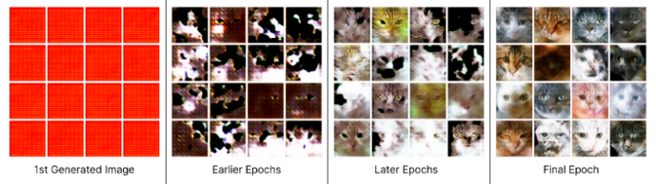

Fig. 7. GAN’s generated Images throughout the Training

**VI. CONCLUSION**

In conclusion, Generative Adversarial Networks (GANs) represent a transformative paradigm in the field of machine learning, offering unprecedented capabilities in generating synthetic data that closely mimics real-world distributions. Through the dynamic interplay between a generator and a discriminator, GANs have enabled breakthroughs in image generation, text synthesis, and beyond.

This research paper has delved into the theoretical underpinnings of GANs, exploring their architecture, training dynamics and their potential uses. By leveraging adversarial training, GANs have demonstrated remarkable proficiency in capturing intricate patterns and generating data samples resembling the real data.

Moreover, our experiments have shed light on the nuanced intricacies of GANs, including discriminator scores, final results, and all-time accuracy. These metrics serve as vital indicators of GAN performance, guiding researchers in fine-tuning model architectures, optimizing training procedures, and enhancing overall effectiveness.

Despite their immense promise, GANs are not without challenges. Issues such as mode collapse, training instability, and evaluation metrics pose ongoing areas of research and development. Addressing these challenges requires concerted efforts from the scientific community to refine algorithms, explore novel training techniques, and advance theoretical understanding.

Looking ahead, the potential applications of GANs are boundless. From generating photorealistic images to synthesizing human-like text, GANs hold the key to unlocking new frontiers in creativity, entertainment, and artificial intelligence. As research progresses and technology evolves, GANs will continue to shape the future of machine learning, offering unparalleled capabilities in data generation and synthesis.

**IX. REFERENCES**

[1] Generative adversarial network: An overview of theory and applications, Alankrita Aggarwal a , Mamta Mittal b , Gopi Battineni c,∗ a Department of Computer Science and Engineering, Panipat Institute of Engineering and Technology, Samalkha 132101, India b Department of Computer Science and Engineering, G.B. Pant Government Engineering College, Okhla, New Delhi, India c Medical Informatics centre, School of Medicinal and Health Products Sciences, University of Camerino, Camerino 62032, Italy, 2021

[2]“Deep Fakes” using Generative Adversarial Networks (GAN), Tianxiang Shen - tis038@eng.ucsd.edu, Ruixian Liu - rul188@eng.ucsd.edu, Ju Bai - jub010@eng.ucsd.edu Zheng Li - zhl153@eng.ucsd.edu, UCSD La Jolla, USA, 2020

[3] Exploring generative adversarial networks and adversarial training, Afia Sajeeda∗ , B M Mainul Hossain, Ph.D Institute of Information Technology, University of Dhaka, Dhaka, Bangladesh, 2022

[4] Generative Adversarial Networks: Introduction and Outlook, Kunfeng Wang, Member, IEEE, Chao Gou, Yanjie Duan, Yilun Lin, Xinhu Zheng, and Fei-Yue Wang, Fellow, IEEE, 2017

[5] Generative Adversarial Networks, Ian Goodfellow, Jean Pouget-Abadie, Mehdi Mirza, Bing Xu, David Warde-Farley, Sherjil Ozair, Aaron Courville, and Yoshua Bengio, 2020