**FIFA Player Position Prediction**

**Aim :-**

Predicting the position of a player based on given data is the goal here. The FIFA franchise by EA Sports has become a sort of gaming bible for football fans around the world. The game’s popularity can be understood from the fact that last year EA and FIFA announced that more than 20 M players participated in FIFA 18’s gaming competition. Despite competition from Konami’s PES, FIFA dominates the market. Its latest installment, FIFA 19, sold over 4.3 M units worldwide within its first week. Due to this demand for the FIFA, there is huge scope for the analysis of the FIFA data.

**Data set :-**

Complete Data set includes :

Player personal attributes (Nationality, Club, Photo, Age, Value etc.)

Player performance attributes (Overall, Potential, Aggression, Agility etc.)

Player preferred position and ratings at all positions.

**Link :-** [**https://www.kaggle.com/thec03u5/fifa-18-demo-player-dataset**](https://www.kaggle.com/thec03u5/fifa-18-demo-player-dataset)

**Algorithm :-**

Models Tested –

1. Random Forest – 78% accuracy

2. Decision Tree – 69% accuracy

3. Logistic Regression – 85% accuracy

4. Neural Network – 80% accuracy

Steps -

Data manipulation

Data normalization

Predict binary targets (attack vs defend positions) with logistic regression

Feature selections

Predict all positions (14 targets) with logistic regression

Libraries Used -

pandas, numpy, matplotlib, seaborn, sklearn

**Result :-**

Logistic Regression gave the highest accuracy of 85% which is good enough to have.

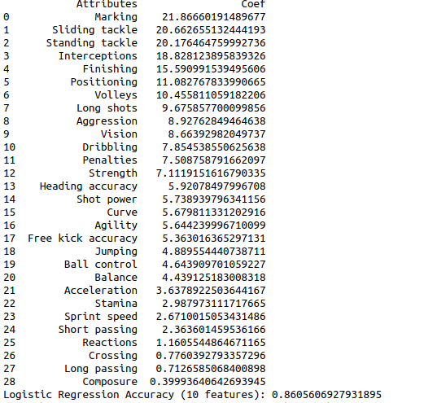

**Conclusion :-**

We can achieve good accuracy because we have pre processed data such that we have binary model to predict and it becomes easy with logistic regression.  
With **Random Forest and Decision Tree** (clustering algorithm) accuracy decreases. **Neural network** gives good prediction of 80% but this can be increased with feedback loops and large data set.

Therefore, **Logistic regression** is giving accuracy of around **85%** which is very good to have. So, we can conclude that this model fits the data set.