🎓 CampusBarter — Complete Development Roadmap
Student Marketplace App · SAIT ITS Project · Generated March 02, 2026

This document lists every task required to complete the CampusBarter marketplace app — from backend API completion to UI polish — in the recommended order. Work through each phase top-to-bottom. Each task builds on the previous one.

────────────────────────────────────────────────────────────────────────────────
✅ Phase 1 — Foundation (COMPLETE)
Everything in this phase is already built and deployed.
Infrastructure & DevOps
✅ Task 1: Azure SQL Database
8 tables: Users, Listings, Chats, Messages, Notifications, Reviews, AuditLog, TimeCredits
✅ Task 2: Azure App Service
Node 22 LTS, Canada Central, Linux, running campusbarter-api
✅ Task 3: Azure Key Vault
All secrets stored securely — no hardcoded credentials
✅ Task 4: Azure Blob Storage
Container created for listing images and profile photos
✅ Task 5: Azure Application Insights
Request tracking, error logging, security event monitoring
✅ Task 6: CI/CD Pipeline
GitHub Actions: Security Scan → Lint → TypeScript Build → Deploy to Azure on push to main
✅ Task 7: Kanban Automation
GitHub Projects board auto-updates on issue/PR events
✅ Task 8: Dependabot
Weekly vulnerability scanning on all npm packages
Security & Compliance
✅ Task 9: Azure AD Authentication
JWT verification middleware, SAIT email enforcement (@sait.ca / @edu.sait.ca)
✅ Task 10: RBAC System
Three roles: Student, Moderator, Admin — enforced on every route
✅ Task 11: Security Headers
Helmet.js (11 headers), CORS whitelist, rate limiting (100 req/15 min)
✅ Task 12: SQL Injection Prevention
100% parameterized queries throughout db.ts
✅ Task 13: Audit Logging
Every API mutation logged to AuditLog table with user, IP, action
✅ Task 14: OWASP Top 10 Coverage
Documented in infrastructure/security.md
✅ Task 15: Compliance Documents
PIPEDA Data Retention, AUP, Incident Response Plan (NIST SP 800-61)
✅ Task 16: Azure Monitor Alerts
High error rate, CPU spike, service down — email notifications

🔧 Phase 2 — Complete the Backend API
The API routes exist as skeletons. This phase wires them to real database logic and adds missing features.
2A — Complete API Route Business Logic
✅ Task 1: Listings API — Full CRUD
GET /api/listings (paginated), POST (create with image), PUT (update own), DELETE (own or mod/admin). Wire all calls to db.ts functions.
✅ Task 2: Users API — Profile Management
GET /api/users/:id (public profile), PUT /api/users/me (update name, bio, avatar), GET /api/users/me/credits (Time Credits balance).
✅ Task 3: Chats API — Messaging
POST /api/chats (start conversation on a listing), GET /api/chats (list my chats), GET /api/chats/:id/messages (get messages), POST /api/chats/:id/messages (send message).
✅ Task 4: Reviews API — Ratings
POST /api/reviews (submit after exchange), GET /api/users/:id/reviews (list reviews for a user). Prevent reviewing yourself. One review per exchange.
✅ Task 5: Notifications API
GET /api/notifications (list unread), PUT /api/notifications/:id/read (mark read). Triggered by system events.
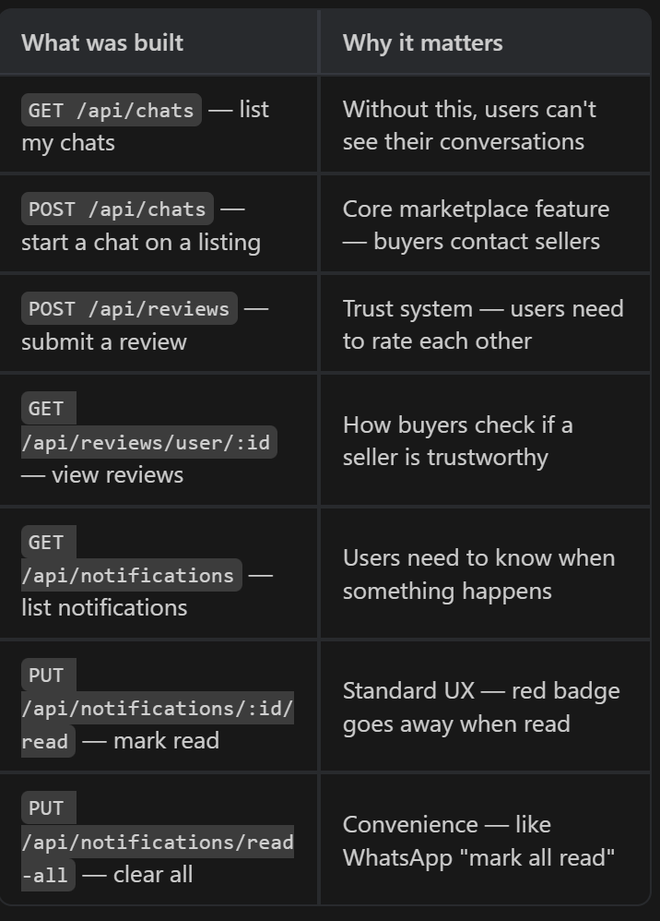

2B — Time Credits System (Core Feature)
✅ Task 6: Time Credits Business Logic
Award credits when a service is completed. Deduct credits when requesting a service. Prevent negative balances. Log all transactions in TimeCredits table.
✅ Task 7: Credits Transfer API
POST /api/credits/transfer — transfer credits between two users when exchange is confirmed. Both users must agree.
✅ Task 8: Credits Balance & History
GET /api/credits/balance (current balance), GET /api/credits/history (transaction log with pagination).
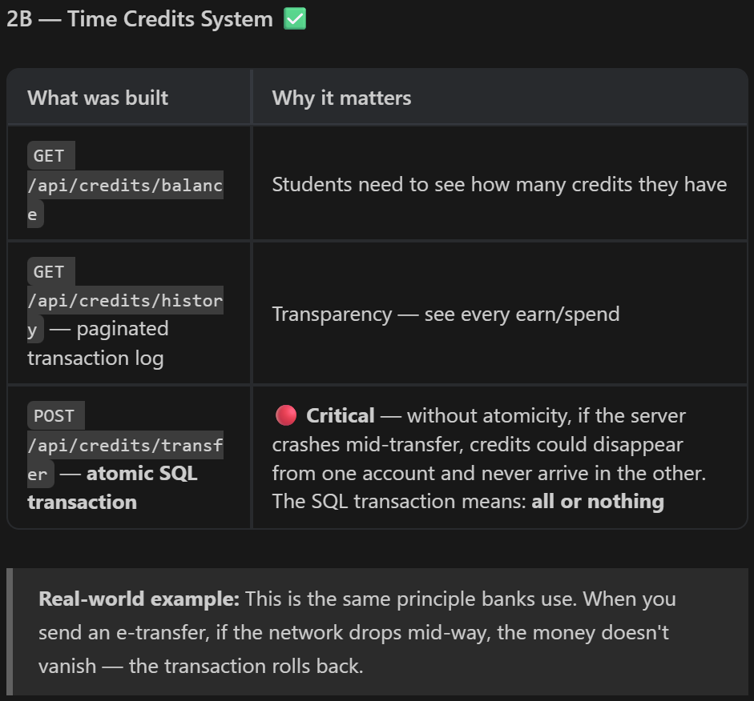

2C — Image Upload
✅ Task 9: Azure Blob Storage Integration
POST /api/upload — accept multipart image upload. Validate file type (jpg/png only) and size (<5MB). Store in Blob Storage. Return public URL.
✅ Task 10: Image Moderation
Integrate Azure Content Moderator to auto-reject inappropriate images before storing them. Flag for admin review.
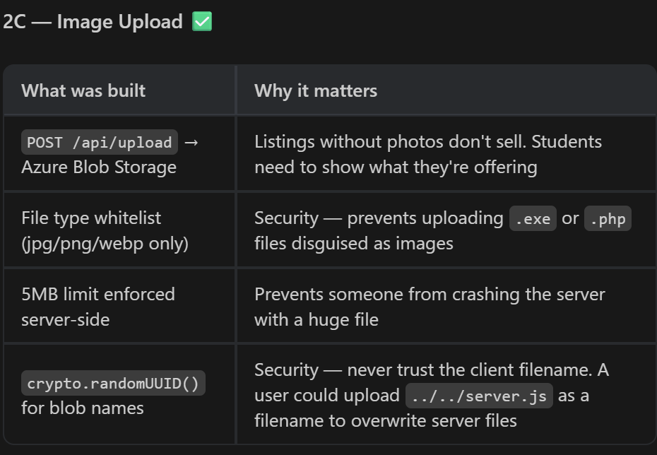
2D — Input Validation & Testing
✅ Task 11: Add express-validator
Install express-validator. Add validation middleware to every POST/PUT route. Sanitize all string inputs. Return structured error messages.
✅ Task 12: Write Unit Tests
Install Jest + supertest. Write tests for: auth middleware, listings CRUD, credits transfer, input validation. Target 80%+ coverage.
✅ Task 13: Write Integration Tests
Test full request flow: auth → route → DB → response. Use a test Azure SQL database (separate from production).
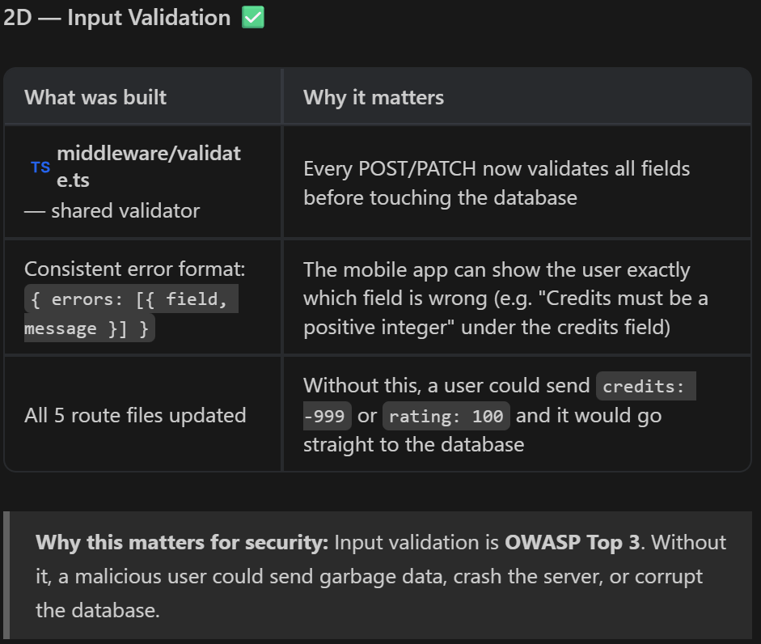
⚡ Phase 3 — Real-Time Features
Upgrades chat and notifications from REST (request/response) to real-time (push updates).
✅ Task 1: WebSocket Server
Add socket.io or ws to the Express server. Handle connect/disconnect/auth. Route chat messages through WebSocket instead of polling.
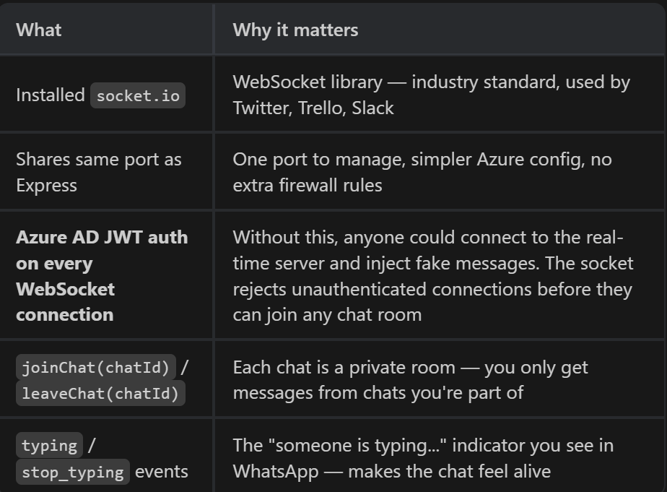

✅ Task 2: Real-Time Chat
When a message is sent, push it instantly to all participants in the chat room. Show typing indicators.
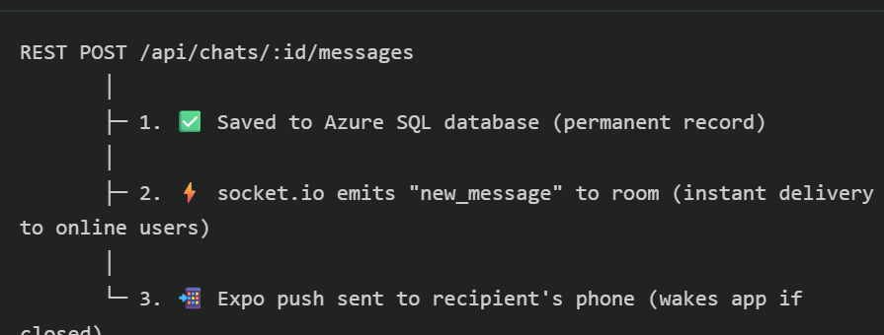
✅ Task 3: Push Notifications — Expo
Integrate expo-notifications. Store device push tokens in the Users table. Send push when: new message, listing matched, exchange request received.
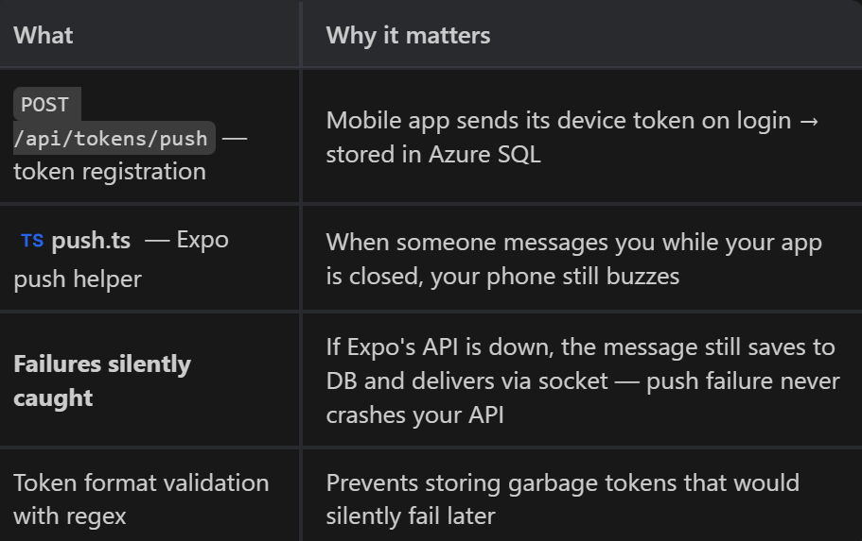
⬜ Task 4: Email Notifications
Set up Azure Communication Services. Send email on: account creation, exchange confirmed, security alert (e.g. login from new device).

✅ Task 5: Smart Matching Engine
When a new listing is posted, query existing listings/requests and send notifications to users who might be interested. Basic keyword matching.
📱 Phase 4 — Complete the Mobile App Frontend
Replace Firebase calls with your new Azure API. Complete all screens.
4A — Replace Firebase with Azure API
✅ Task 1: Create API Service Layer
Create lib/api.ts — a central file with helper functions for all API calls. Include auth token injection (get token from MSAL/Azure AD). Replace all firestore.ts calls.
✅ Task 2: Update Listings Screen
Call GET /api/listings instead of Firestore. Show loading spinner, handle empty state, handle errors. Show listing photos from Blob Storage.
✅ Task 3: Update Chat Screen
Connect to WebSocket for real-time messages. Show sent/received message bubbles. Show online/typing indicators.
✅ Task 4: Update Profile Screen
Show Time Credits balance. Show user's active listings. Show reviews/rating. Allow editing name and bio.
✅ Task 5: Update Create Listing Screen
Add image picker (expo-image-picker). Upload to POST /api/upload. Submit listing with image URL. Show validation errors inline.
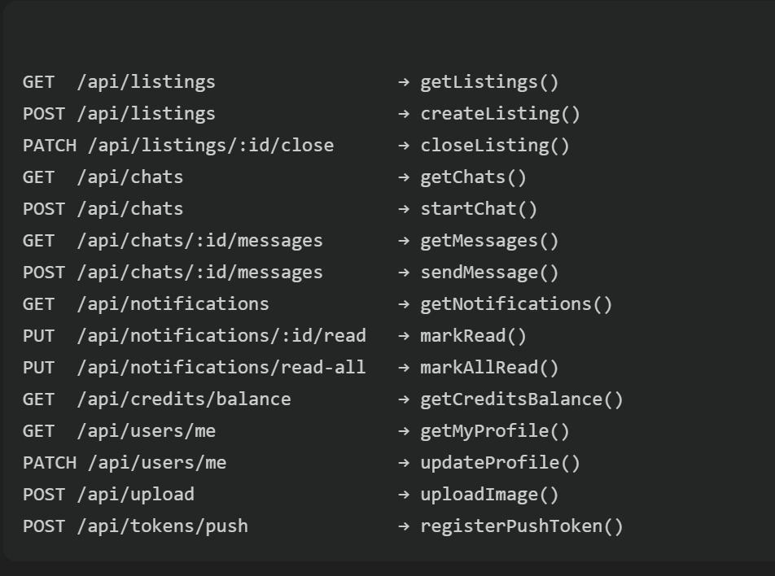
4B — New Screens
⬜ Task 6: Notifications Screen
List all unread notifications with type icon (message, match, review). Tap to navigate to relevant screen. Mark read on view.
⬜ Task 7: Time Credits Screen
Show current balance. Show full transaction history (earned, spent). Show leaderboard of top helpers.
⬜ Task 8: Reviews Screen
After an exchange is confirmed, prompt both users to leave a review. Show star rating + written review. Display on user profile.
⬜ Task 9: Admin Dashboard Screen
Only visible to Admin role. List reported listings. Ability to delete any listing. View audit log. View user list with roles.
4C — UI Polish
⬜ Task 10: Design System
Define consistent colors, fonts, spacing, shadows. Apply across all screens. Use SAIT brand colors where appropriate.
⬜ Task 11: Dark Mode
Implement system-aware dark/light mode switching using React Native's useColorScheme.
⬜ Task 12: Animations & Micro-interactions
Add skeleton loaders while fetching. Animate list items on scroll. Add haptic feedback on key actions (send message, confirm exchange).
⬜ Task 13: Accessibility
Add accessibilityLabel to all interactive elements. Ensure contrast ratios meet WCAG AA. Support screen readers.
⬜ Task 14: Error Handling & Offline State
Show friendly error messages instead of crashes. Detect no internet connection and show offline banner.

🛡️ Phase 5 — Advanced Security (Production-Level)
These steps bring the app to the security level of real production apps.
⬜ Task 1: API Versioning
Prefix all routes with /api/v1/. Add deprecation headers for old routes. Document versioning policy.
⬜ Task 2: Content Security Policy
Add strict CSP headers via Helmet to prevent XSS. Set frame-ancestors: none to prevent clickjacking.
⬜ Task 3: Key Vault Auto-Rotation
Configure 90-day automatic secret rotation in Azure Key Vault. Set up rotation alerts.
⬜ Task 4: Certificate Pinning
Pin the Azure AD public certificate in the app to prevent MITM attacks.
⬜ Task 5: Penetration Testing
Run OWASP ZAP against the live API. Fix all High and Critical findings before submission.
⬜ Task 6: Security Headers Audit
Use securityheaders.com to audit the API response headers. Achieve A+ rating.
⬜ Task 7: Secrets Rotation Policy Doc
Document how and when each secret is rotated. Add to infrastructure/ folder.

💡 Phase 6 — Creative Features (Stand Out)
These features will make CampusBarter unique and impressive for your instructor and future portfolio.
⬜ Task 1: Campus Map View
Show listings pinned to SAIT campus buildings on an interactive map. Use expo-leaflet or react-native-maps. Filter by building.
⬜ Task 2: AI Listing Suggestions
Connect Azure OpenAI. When a student registers their courses, suggest listings they might need (e.g. enrolled in MATH → suggest calculator listings).
⬜ Task 3: QR Code Exchange Verification
When both parties agree to an exchange, generate a unique QR code. Both must scan to confirm in-person pickup. Triggers credit transfer.
⬜ Task 4: Time Credits Leaderboard
Weekly leaderboard of top helpers (most credits earned). Reset every Monday. Display on home screen. Encourages engagement.
⬜ Task 5: AI Image Moderation
Use Azure Content Moderator API to automatically scan listing images for inappropriate content before they go live.
⬜ Task 6: Schedule Exchange
After a chat agreement, offer a built-in calendar to book a meeting time. Integrated with Azure Communication Services.
⬜ Task 7: Market Insights
Show trending listings this week on campus. Most wanted categories. Average credit value by category. Visual charts.

🎓 Phase 7 — Testing, Documentation & Submission
⬜ Task 1: End-to-End Testing
Test every user flow manually: register → browse → create listing → chat → exchange → review.
⬜ Task 2: Performance Testing
Load test the API with k6 or Artillery. Ensure <200ms response under 100 concurrent users.
⬜ Task 3: Final Security Scan
Run npm audit, OWASP ZAP, and check Azure Security Center recommendations.
⬜ Task 4: API Documentation
Write full API docs using Swagger/OpenAPI. Document every endpoint, request body, response, and error code.
⬜ Task 5: README Update
Update repo README with: architecture diagram, setup instructions, environment variables, API URL.
⬜ Task 6: Video Demo
Record a 3-5 minute app demo showing all features working end-to-end.
⬜ Task 7: Final Submission
Submit GitHub repo link, live API URL, and all documentation to your instructor.

────────────────────────────────────────────────────────────────────────────────
📌 Tip: Work through phases in order. Don't skip to UI polish before the backend is complete — the frontend needs working API endpoints.
📌 Tip: After every task, run 'git add . && git commit -m "task: description" && git push origin main' to keep your CI/CD pipeline green.
📌 Generated by Antigravity AI · 2026-03-02 03:37

