**Smart India Hackathon 2025: Project Report**

**Project Title:** PRAHARI (Protective Robotic Aerial High-Altitude Response Initiative)  
**Team Name:** Technovators  
**Problem Statement:** SIH25256 - Counter-Drone Solution for High-Altitude Operations (Indo-Tibetan Border Police)

**Executive Summary**

Project PRAHARI is a comprehensive, modular counter-drone solution designed to meet the specific and challenging operational requirements of the Indo-Tibetan Border Police (ITBP). Deployed in remote, high-altitude, and sub-zero environments, the ITBP faces a growing threat from enemy drones, including coordinated swarm attacks. Our solution provides a multi-layered defense umbrella through robust detection, precise tracking, and effective soft-kill (jamming and spoofing) capabilities.

Drawing inspiration from our initial robotic tracking prototype, PRAHARI evolves this concept into a rugged, field-deployable system. It comprises three core modules: the **Rakshak Base Station** with a robotic multi-sensor tracking turret, the **Drishti Portable Detector** for patrols, and the **Vajra Counter-Drone** for extended mobile response. By integrating commercial off-the-shelf (COTS) components with advanced AI/ML algorithms, PRAHARI offers a cost-effective, scalable, and highly effective solution to safeguard India's borders.

**1. Introduction & Problem Statement Analysis**

The Indo-Tibetan Border Police operate under some of the most extreme conditions on earth. The combination of high-altitude terrain, sub-zero temperatures, and high-speed winds severely degrades the performance of both personnel and standard electronic equipment. This environment is increasingly vulnerable to intrusion by enemy Unmanned Aerial Vehicles (UAVs) for surveillance or hostile action.

**Client Requirements Analysis:**

* **Multi-Layered Defense:** A complete "detect, track, and neutralize" chain is required.
* **Harsh Environment Operation:** All components must be ruggedized to withstand temperatures down to -30°C or lower and other environmental stressors.
* **Long-Range Detection & Neutralization:**
  + **Detection:** 5 km for small drones, 10 km for medium drones.
  + **Jamming:** 3 km (omni-directional), 4 km (directional).
  + **GNSS Spoofing:** 20 km (omni-directional), 40 km (directional).
* **Swarm Defense:** The system must be capable of tracking and neutralizing multiple drones approaching from different directions.
* **Portability & Modularity:** The need for portable modules for patrols and flexible deployment.
* **Offensive Countermeasure:** Capability to deploy a friendly drone to execute soft-kill measures.

**2. Proposed Solution: Project PRAHARI**

PRAHARI is an integrated system of systems, designed for modularity and resilience.

**System Architecture:**

The system consists of three interconnected modules communicating over a secure LoRaWAN (Long Range Wide Area Network) mesh, suitable for mountainous terrain where line-of-sight can be a challenge.

1. **Rakshak Base Station:** The central command and control hub. It features a 6-DOF robotic turret for automated tracking and houses the primary processing units and long-range directional effectors.
2. **Drishti Portable Detector:** A handheld, battery-operated RF scanner for personnel on patrol. It provides early warnings and location data of potential threats, relaying this information back to the Rakshak station.
3. **Vajra Counter-Drone:** A friendly UAV equipped with a lightweight jammer/spoofer. It can be launched from the base station to engage threats beyond the station's effective range, provide an alternate angle of attack, or pursue fleeing targets.

**3. Technical Approach & Implementation Details**

Our approach is centered on using adaptable, cost-effective COTS components, mirroring the successful rapid prototyping seen in modern defense solutions.

**Module 1: Rakshak Base Station**

* **Mechanical Structure:**
  + We will adapt the 6-DOF robotic arm concept, upgrading from the Niryo One frame to a more robust design using powerful **NEMA-17 stepper motors** rated for low temperatures.
  + All custom parts (mounts, enclosures) will be 3D printed using **ASA (Acrylonitrile Styrene Acrylate)** or **PETG**, which offer superior UV resistance and durability in freezing conditions compared to standard PLA.
* **Multi-Sensor Turret Payload:** The robotic arm will be equipped with:
  + **Wide-Band RF Detector:** For initial 360° detection of drone communication links.
  + **High-Gain Directional Antenna (Yagi):** For precise tracking of the RF source and targeted jamming/spoofing.
  + **EO/IR Camera System:** A Raspberry Pi High-Quality Camera with a telephoto lens and an infrared module for visual tracking and identification, day or night.
* **Processing & Control:**
  + **Primary Controller:** An **NVIDIA Jetson Nano** or a ruggedized Single Board Computer (SBC) designed for extreme temperatures (-40°C to +85°C). This provides the necessary GPU power for running AI models.
  + **Detection & Tracking Workflow:**
    1. The omni-directional RF detector identifies a potential threat signal.
    2. The system determines the signal's bearing and slews the robotic turret to face the target.
    3. The EO/IR camera engages, and a **YOLOv8 model** visually acquires and locks onto the drone.
    4. A **Reinforcement Learning (RL) policy** provides smooth, predictive tracking by controlling the arm's joints to keep the drone centered, even during evasive maneuvers.
* **Neutralization (Soft Kill):**
  + A **Software-Defined Radio (SDR) like the HackRF One or BladeRF** will be used to generate jamming and spoofing signals.
  + **Jamming:** The SDR will broadcast noise on common drone control frequencies (2.4 GHz, 5.8 GHz) and GNSS frequencies (L1, L2).
  + **Spoofing:** The SDR will transmit false GNSS signals, using tools like gps-sdr-sim, to deceive the drone about its location, allowing ITBP to redirect it to a safe landing zone.

**Module 2: Drishti Portable Detector**

* **Components:** A handheld unit built with a **Raspberry Pi Zero 2 W**, a small LCD display, a rechargeable LiPo battery pack, and a portable SDR.
* **Functionality:** It will run a lightweight RF scanning software (e.g., GQRX) to detect drone signals. Upon detection, it alerts the operator and transmits the signal data and bearing to the Rakshak station via a **LoRaWAN module**, extending the defensive perimeter.

**Module 3: Vajra Counter-Drone**

* **Airframe:** A medium-sized quadcopter frame capable of carrying a 1-1.5 kg payload in high-altitude, thin-air conditions.
* **Payload:** A lightweight SDR, a compact battery, and a LoRaWAN module for command and control.
* **Operation:** Commanded from the Rakshak station, it flies towards a designated target to perform localized, high-power jamming or spoofing, acting as a force multiplier.

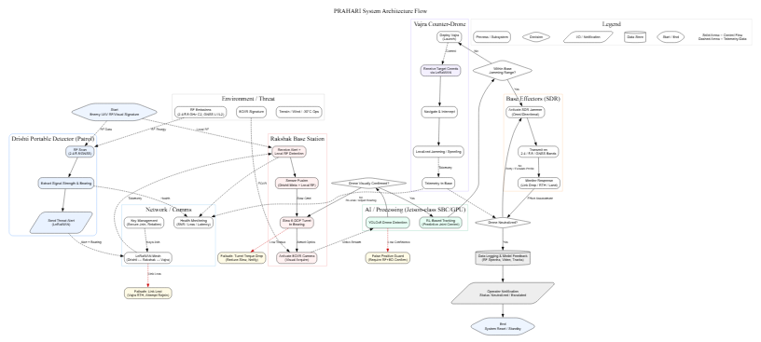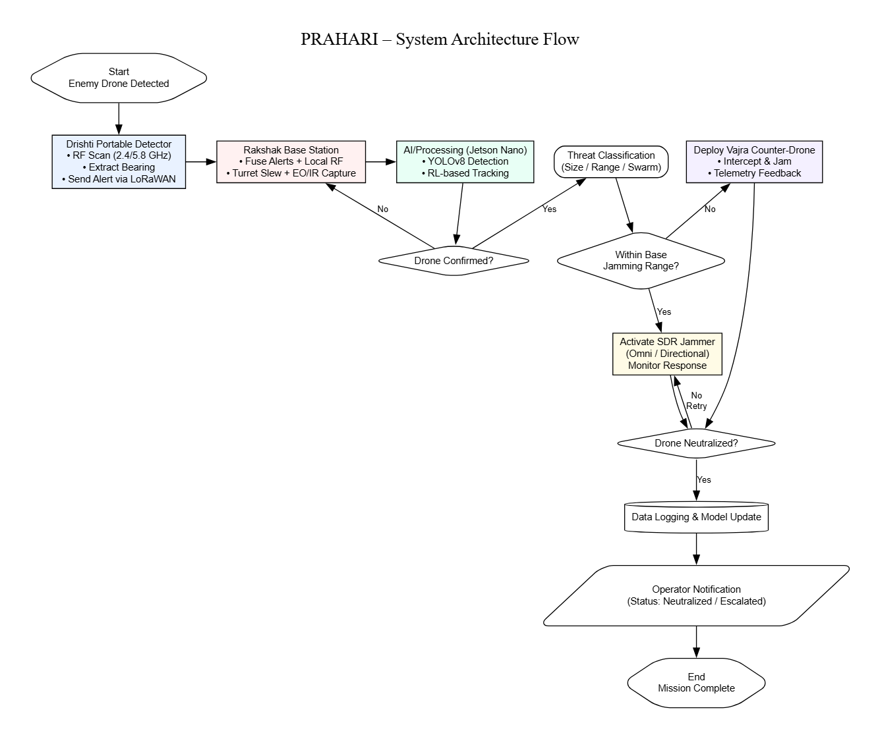

**4. Bill of Materials (BoM) - Hackathon Prototype**

This list focuses on accessible, off-the-shelf components to build a proof-of-concept.

|  |  |  |  |  |
| --- | --- | --- | --- | --- |
| Component | Module | Est. Quantity | Est. Cost (INR) | Purpose |
| NVIDIA Jetson Nano Dev Kit | Rakshak Station | 1 | ₹12,000 | Main AI/ML Processor |
| NEMA 17 Stepper Motors (High Torque) | Rakshak Station | 6 | ₹6,000 | Robotic Arm Joints |
| Stepper Motor Drivers (A4988/DRV8825) | Rakshak Station | 6 | ₹1,200 | Motor Control |
| HackRF One (SDR) | Rakshak Station | 1 | ₹25,000 | Primary Jamming & Spoofing |
| Raspberry Pi HQ Camera + Lens | Rakshak Station | 1 | ₹7,000 | Visual Tracking (EO) |
| IR Camera Module | Rakshak Station | 1 | ₹1,500 | Night Vision (IR) |
| Raspberry Pi Zero 2 W | Drishti Detector | 1 | ₹2,500 | Portable Detector CPU |
| Portable SDR (e.g., RTL-SDR) | Drishti Detector | 1 | ₹3,000 | Portable RF Scanning |
| LoRaWAN Transceiver Modules | All | 3 | ₹3,000 | Inter-module Communication |
| 3D Printer Filament (ASA/PETG) | Rakshak Station | 2 kg | ₹3,000 | Custom Housings & Mounts |
| Ruggedized Tablet/Laptop | Command & Control | 1 | (Existing) | User Interface |
| Total Estimated Cost |  |  | **~₹64,200** | *Excludes drone airframe & power supplies* |

**5. Feasibility, Viability & Scalability**

* **Technical Feasibility:** The use of COTS hardware and open-source software (Python, GNU Radio, TensorFlow) makes this project highly achievable for a skilled student team. The core challenge lies in the system integration and optimizing the AI models.
* **Operational Viability:** The modular design directly addresses ITBP's requirements. The system's effectiveness is enhanced by its ruggedization features—weatherproof enclosures (3D printed with gaskets) and components selected for wide operating temperature ranges.
* **Scalability:** The architecture is inherently scalable. A wider border area can be secured by deploying multiple Drishti detectors and Rakshak stations, all networked together to provide a common operational picture.

**6. Innovation & Comparison with Existing Indian Solutions**

Several Indian entities, including DRDO with its **D4 System**, and companies like Zen Technologies, Adani Defence, and Paras Aerospace, are developing sophisticated counter-drone solutions. These systems are often comprehensive but can be expensive and monolithic.

**Project PRAHARI's Innovation:**

* **Cost-Effective AI Tracking:** Our novel use of a 6-DOF robotic arm combined with a Reinforcement Learning policy for smooth visual tracking is a significant innovation at the student level, offering precise targeting for directional jamming without needing expensive radar-guided systems.
* **Extreme Modularity:** The three-part system (Station, Portable Detector, Counter-Drone) provides unprecedented operational flexibility compared to a single, vehicle-mounted solution.
* **Rapid Prototyping and Field Repair:** By using 3D-printed parts and COTS components, the system can be rapidly iterated upon and repaired in the field with minimal specialized equipment.
* **Accessible Technology:** We leverage the power of the open-source community, particularly in the realm of Software-Defined Radio, to implement advanced jamming and spoofing capabilities at a fraction of the cost of proprietary systems.

**7. Conclusion**

Project PRAHARI is a robust, intelligent, and adaptable counter-drone system engineered to protect the ITBP in the world's most challenging terrain. By fusing advanced AI-driven robotics with the flexibility of Software-Defined Radio and a rugged, modular design, our solution provides a much-needed, cost-effective force multiplier. We are confident that this system will significantly enhance the safety and operational effectiveness of our forces guarding the high-altitude frontiers.