Outputs:

1. create table Employee(emp_id number, emp_name varchar(20), emp_address varchar(50), emp_phone_no number, dept_id number, dept_name varchar(20), job_id number, salary number);

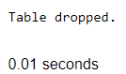

1. describe Employee;

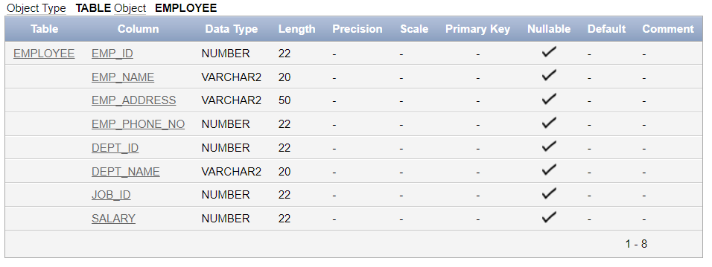

1. alter table Employee add(hire_date varchar(10));

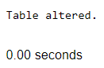

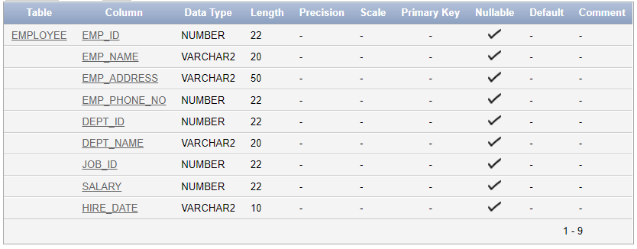

1. alter table Employee modify(job_id varchar(20));

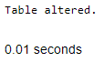

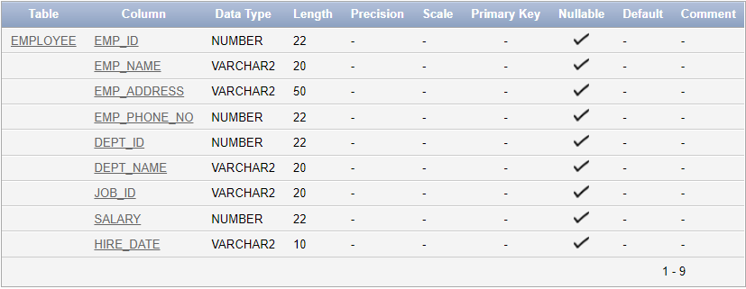

1. alter table Employee rename column emp_id to e_id;



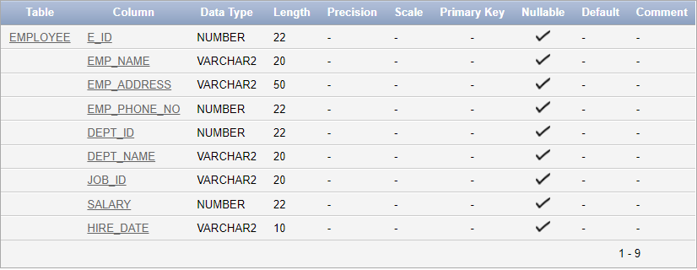

1. alter table Employee add(job_field varchar(30));



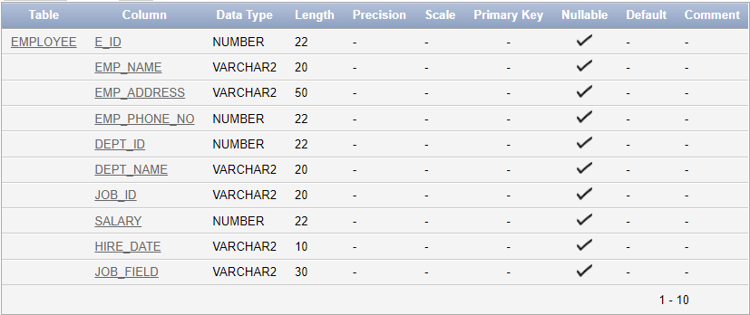

alter table Employee modify(job_field varchar(20));



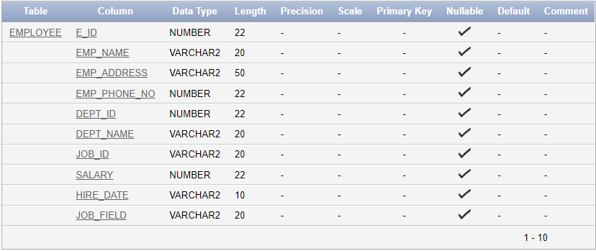

1. alter table Employee drop column job_field;



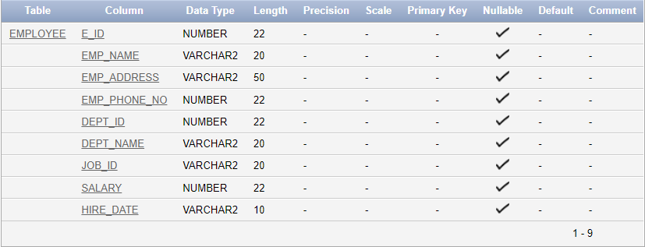

1. rename Employee to Emp_Dept;

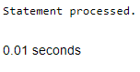

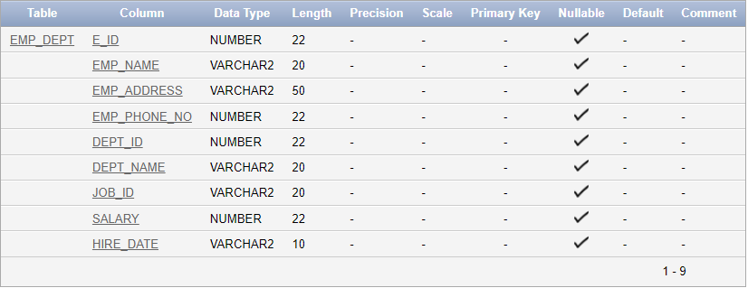

1. drop table Emp_Dept;

