1. Cloned Kubernetes manifests that you'll use to deploy Jenkins.

git clone https://github.com/GoogleCloudPlatform/continuous-deployment-on-kubernetes.git

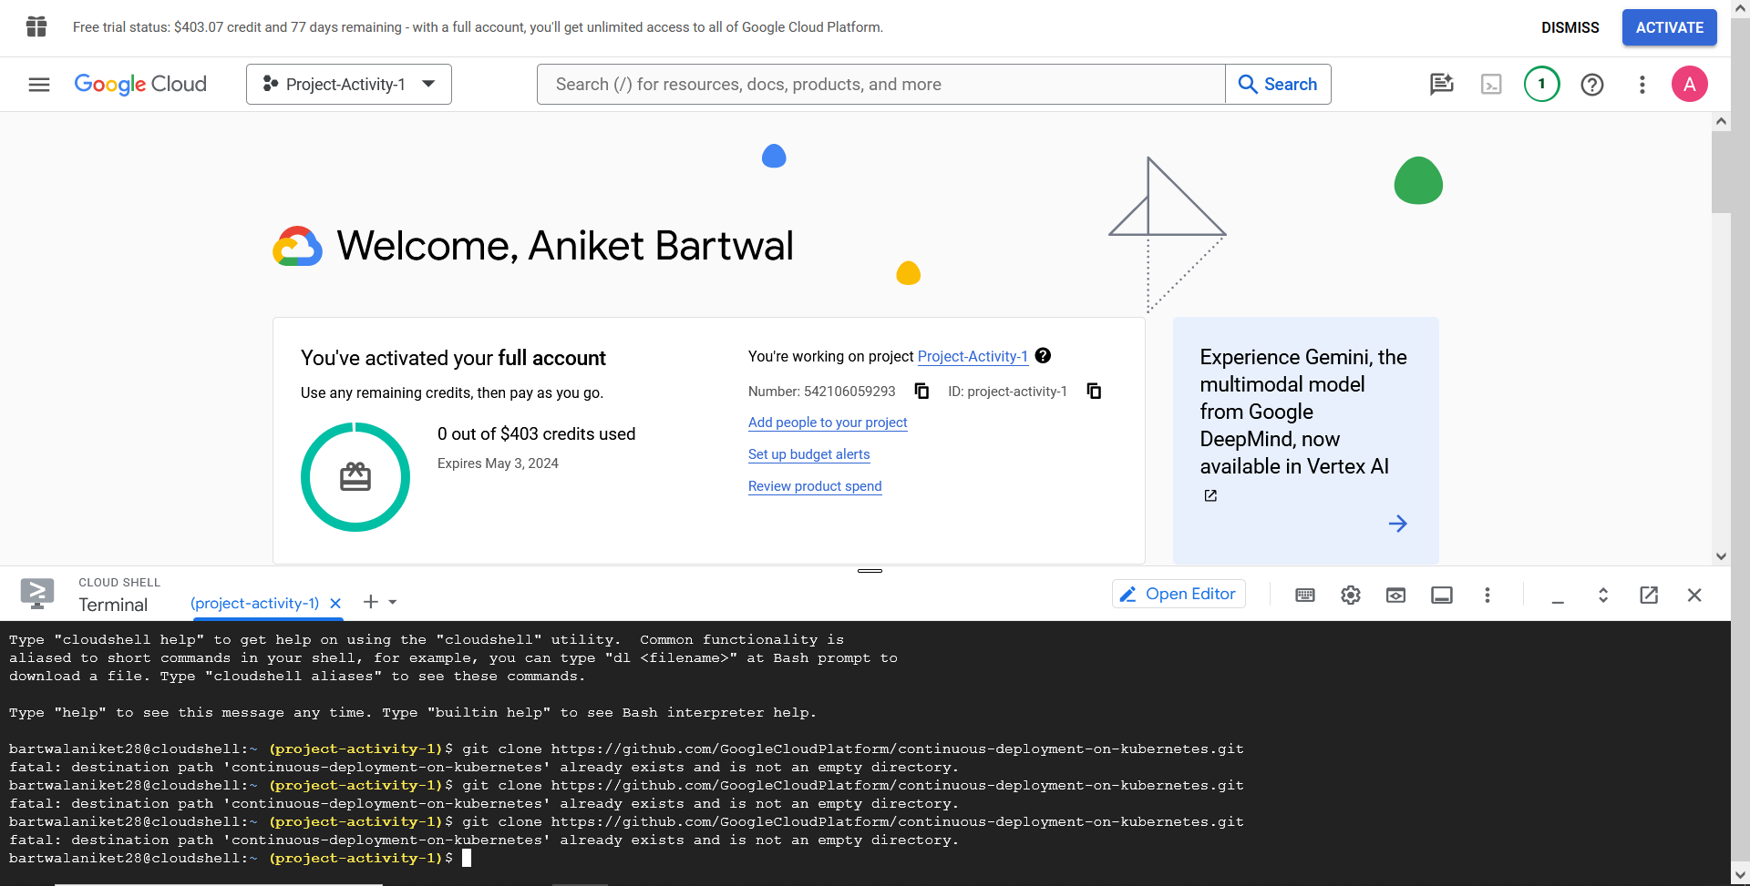

1. Navigated to the sample code directory

cd continuous-deployment-on-kubernetes

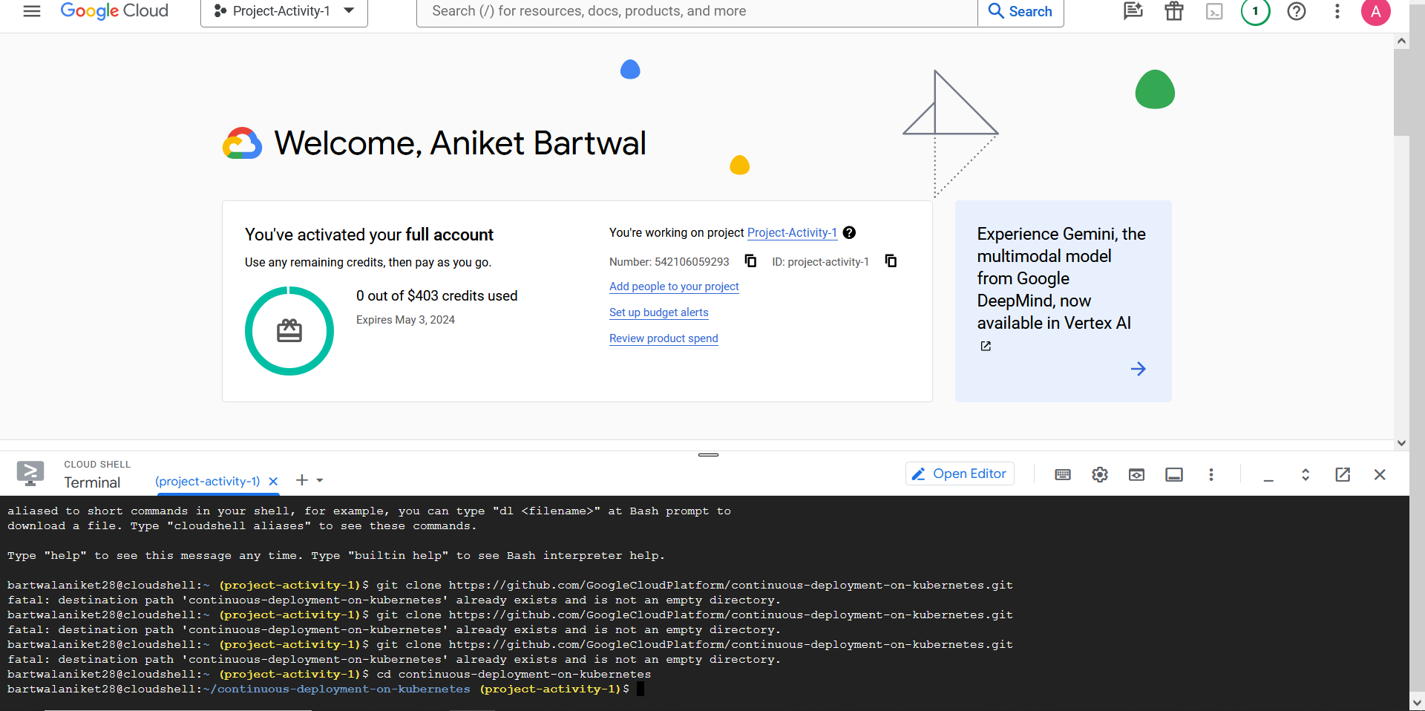

1. Enables Jenkins to access Cloud Source Repositories and Container Registry.

gcloud container clusters create jenkins-cd \

--zone us-east1-d --scopes cloud-platform

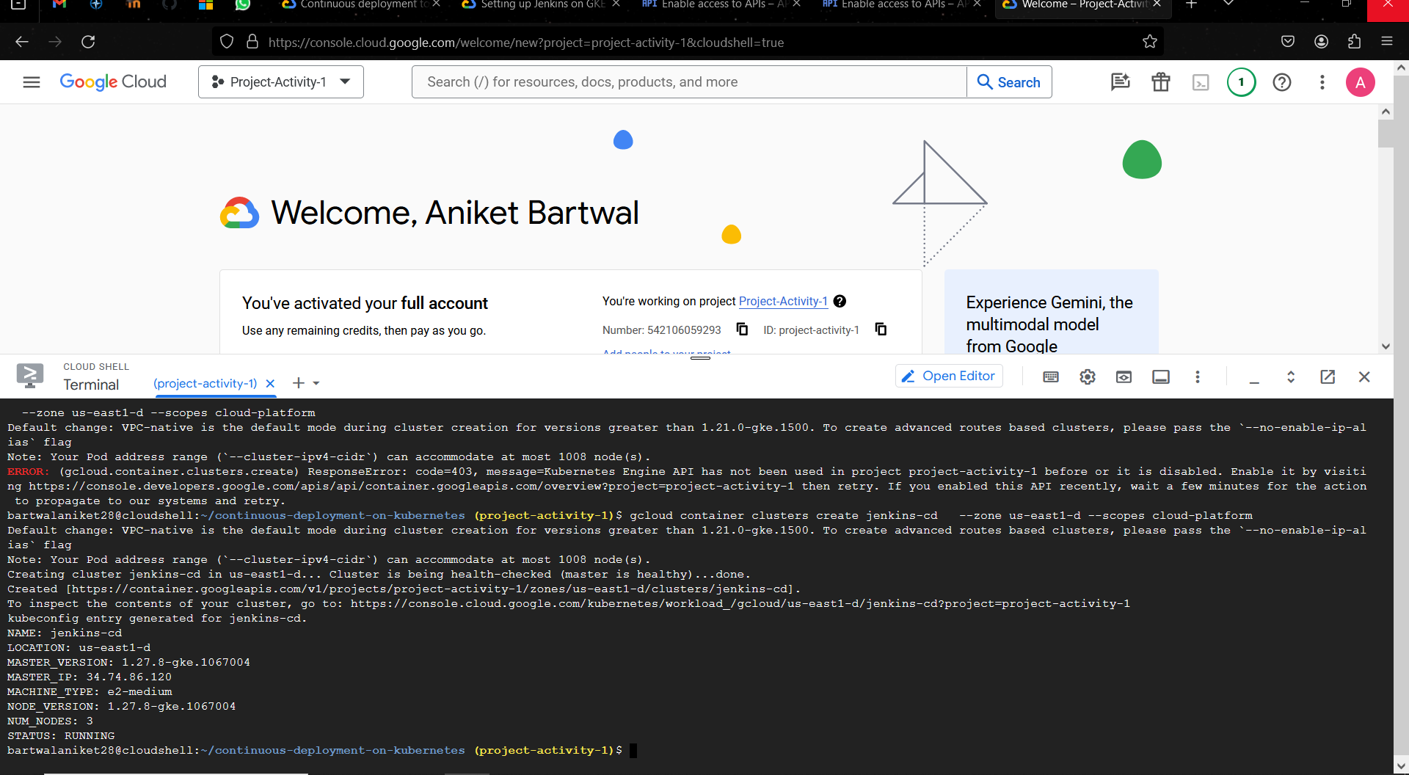

1. Cluster info

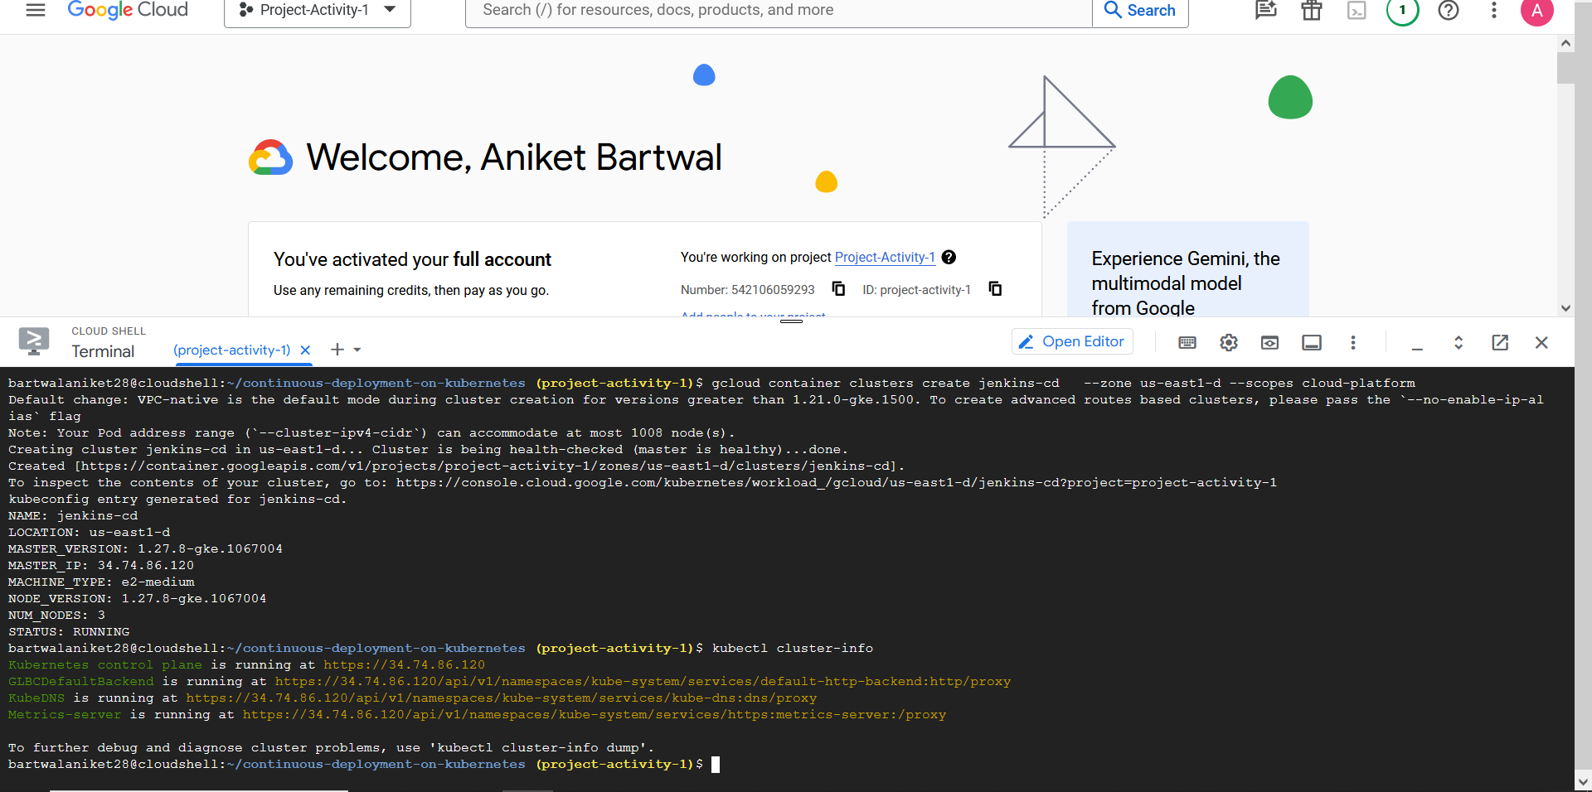

1. 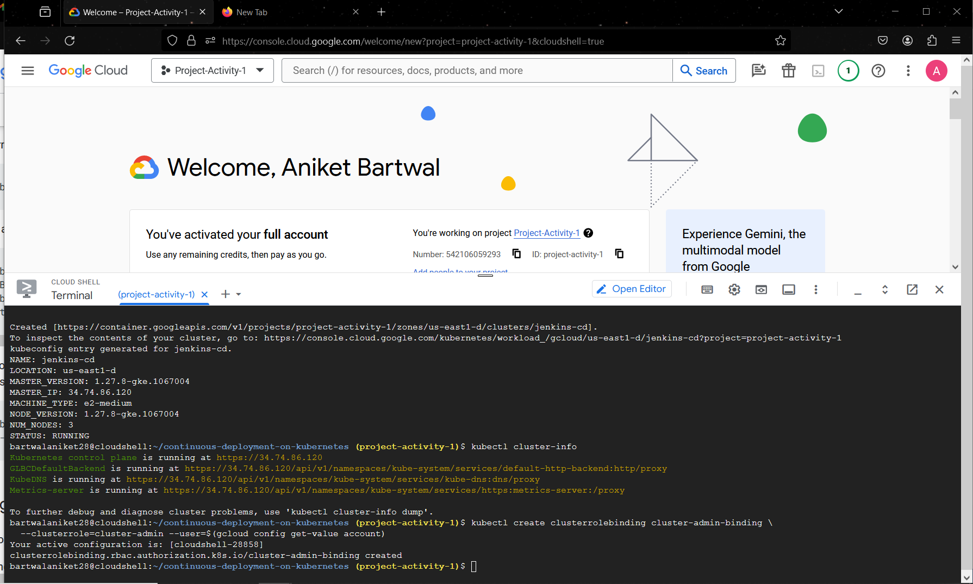
2. kubectl get pods

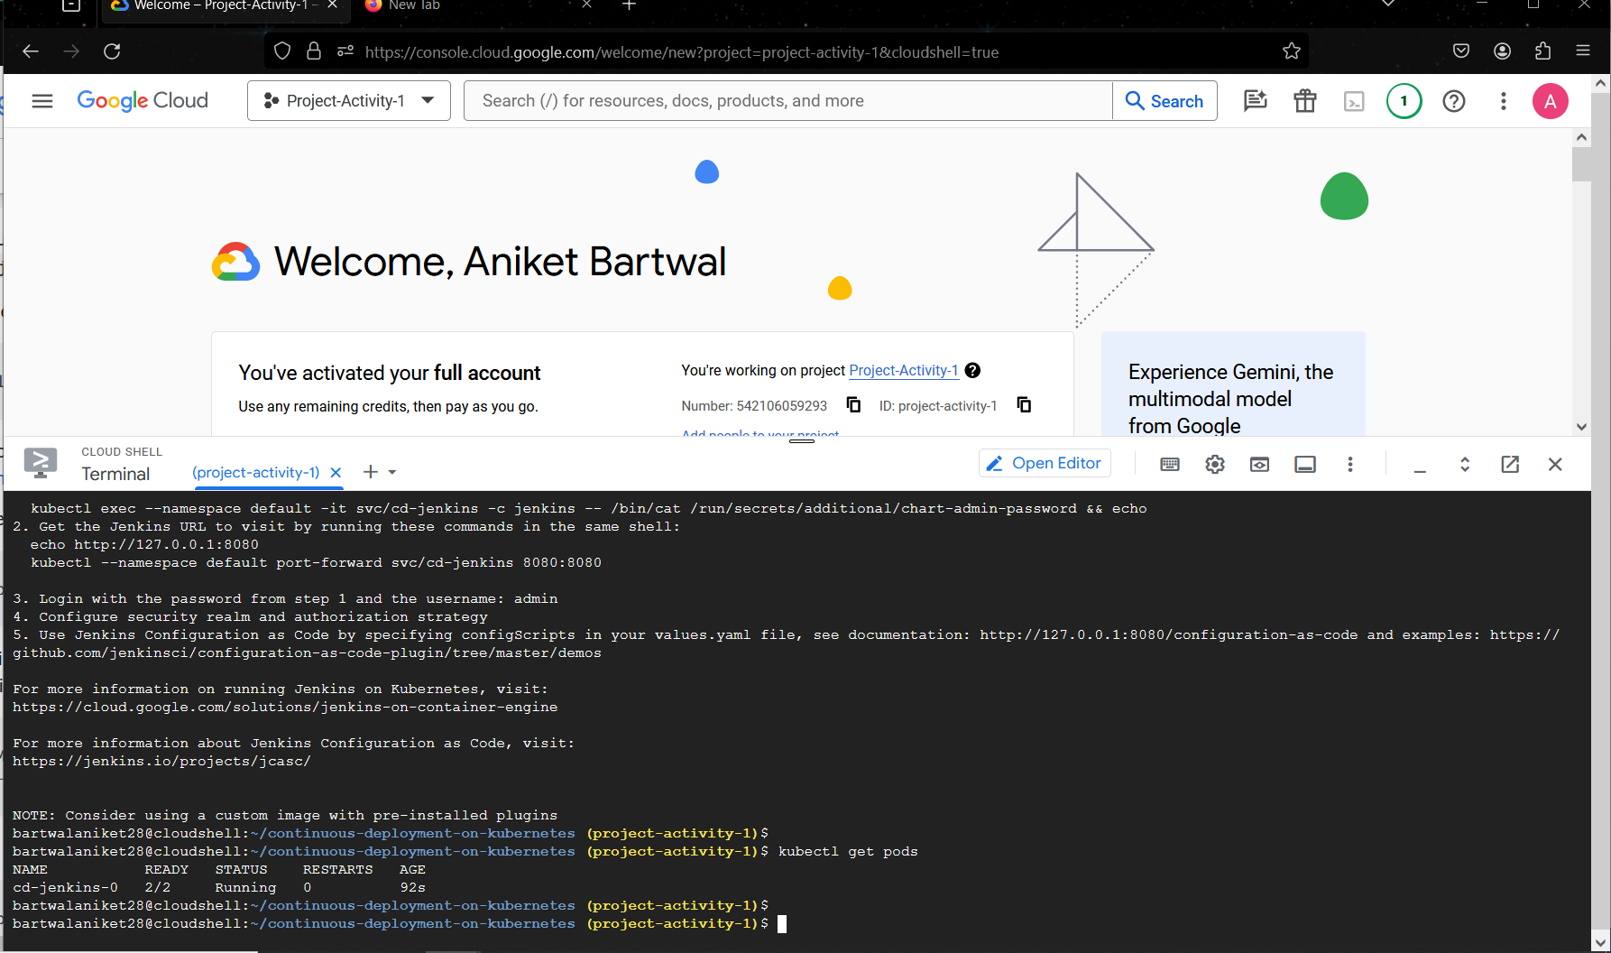

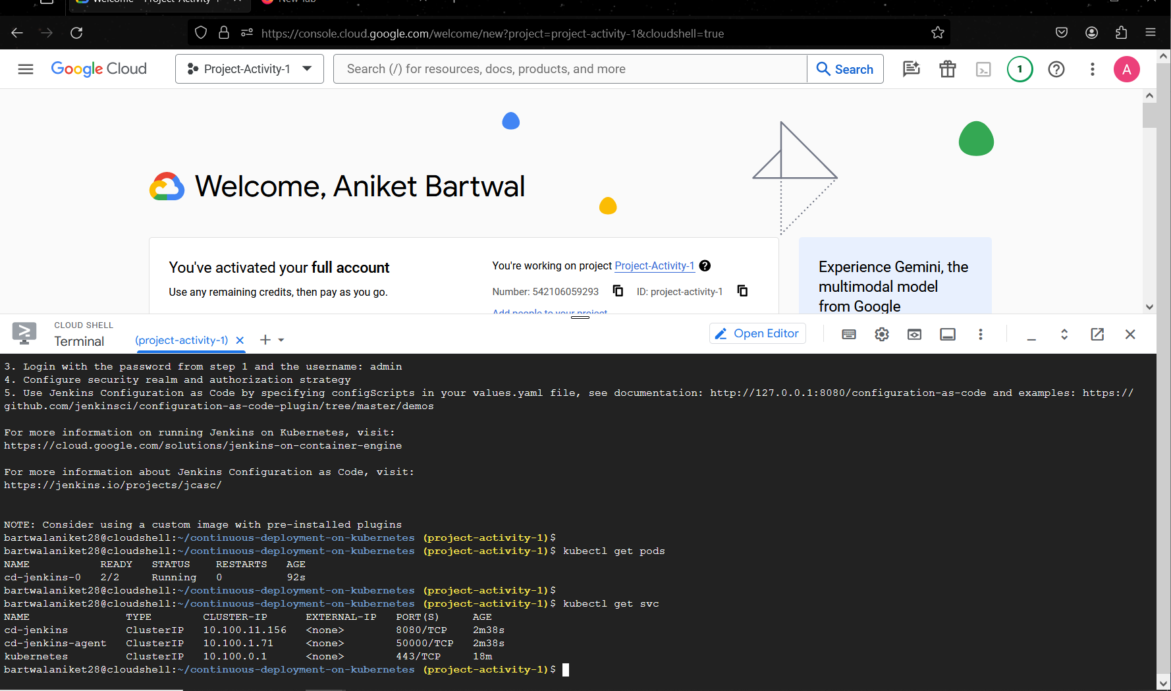

**Connecting to Jenkins**

**Jenkins successfully deployed.**

1. 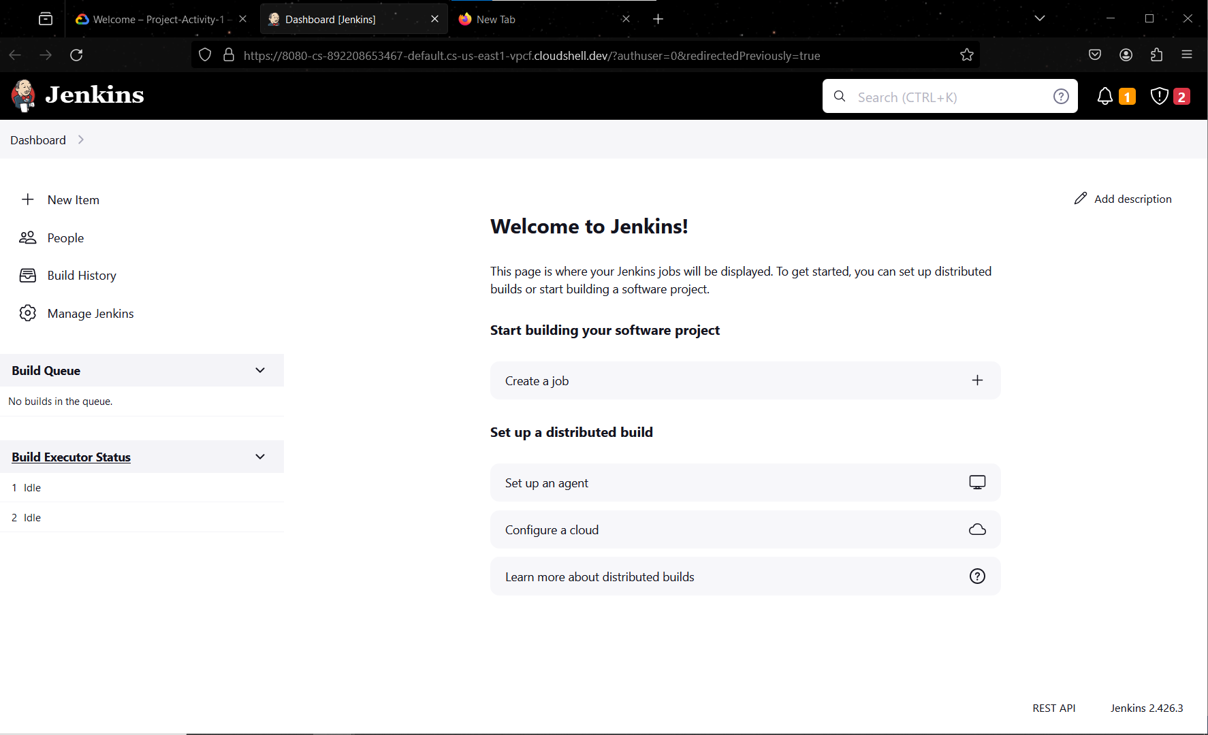
2. Apply the cluster-admin role to the Jenkins service account

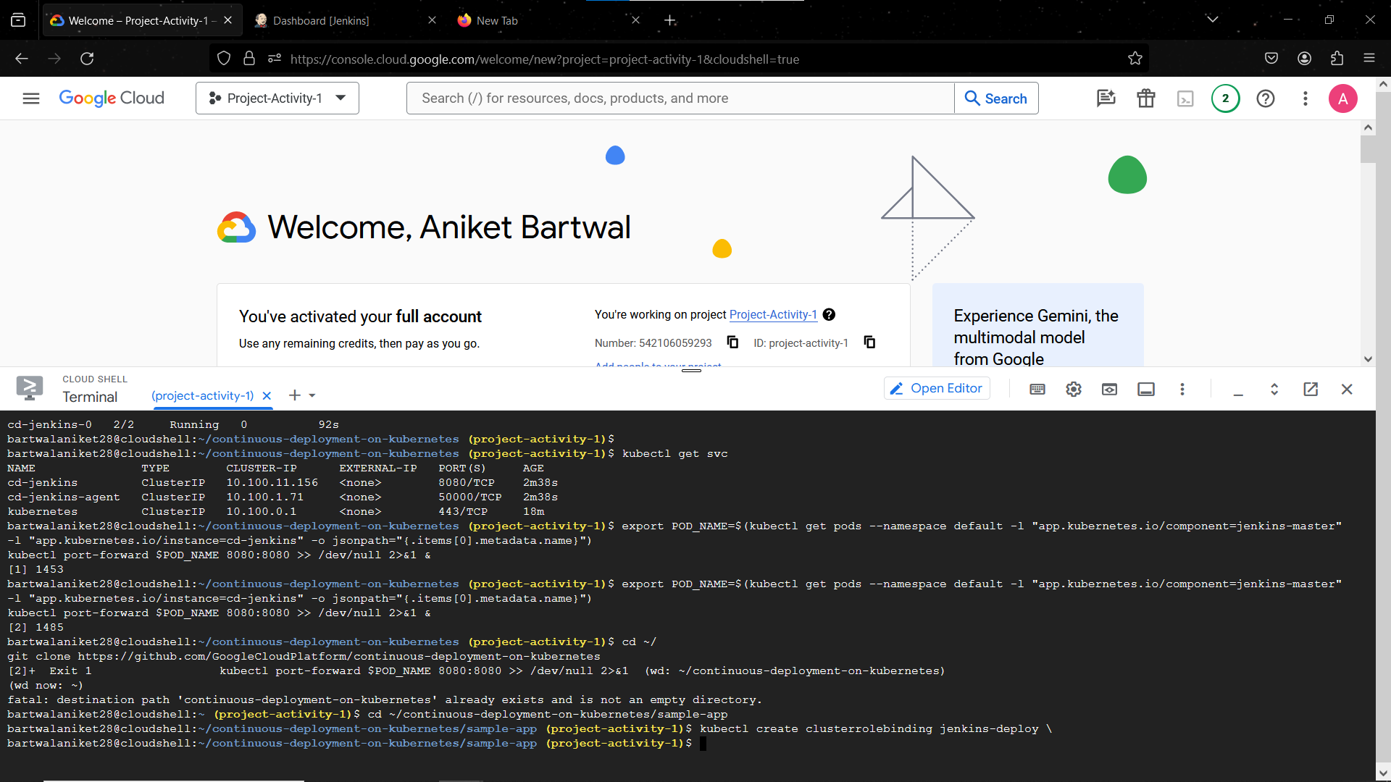

## Building the sample app

export PROJECT_ID=$(gcloud info --format='value(config.project)')  
  
find . -type f -name "*" -exec sed -i 's|gcr.io/cloud-solutions-images/gceme:1.0.0|gcr.io/'"${PROJECT_ID}"'/gceme:1.0.0|g' {} +  
  
gcloud builds submit --tag gcr.io/${PROJECT_ID}/gceme:1.0.0

1. 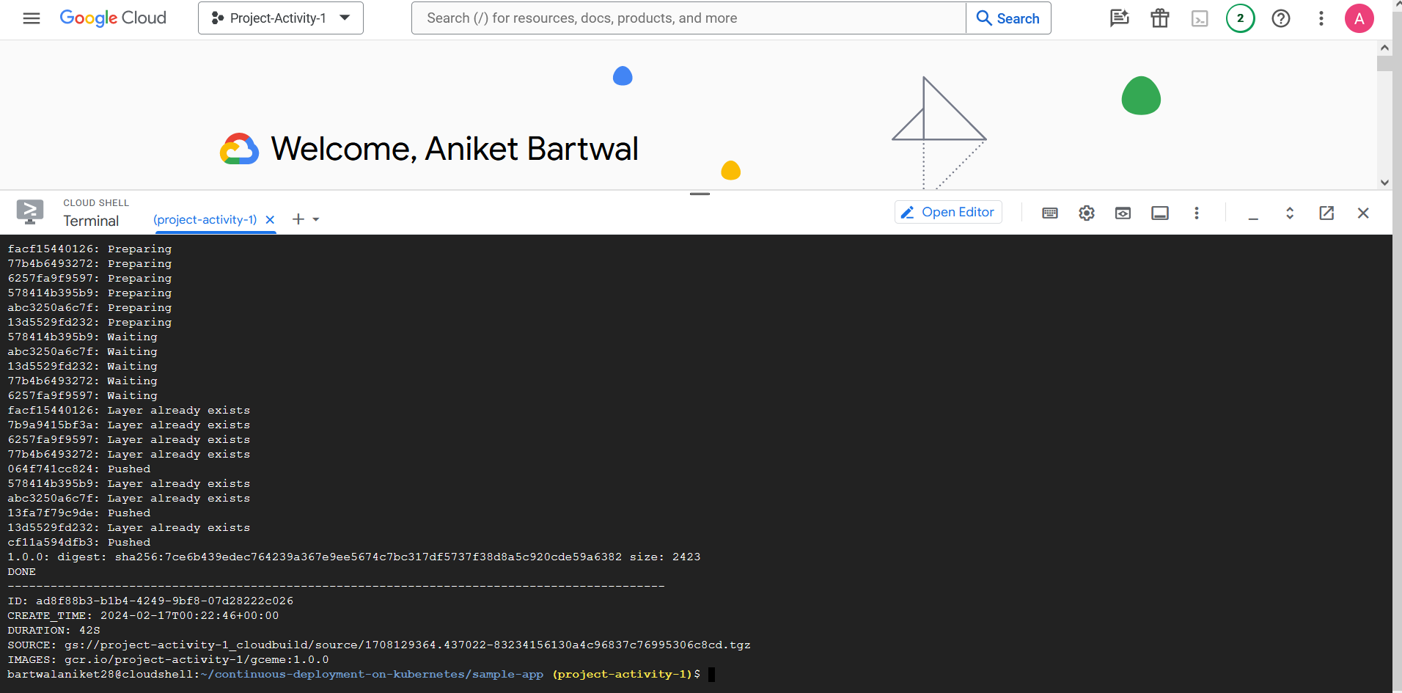

**Deploying the gceme frontend and backend to Kubernetes using manifest files**

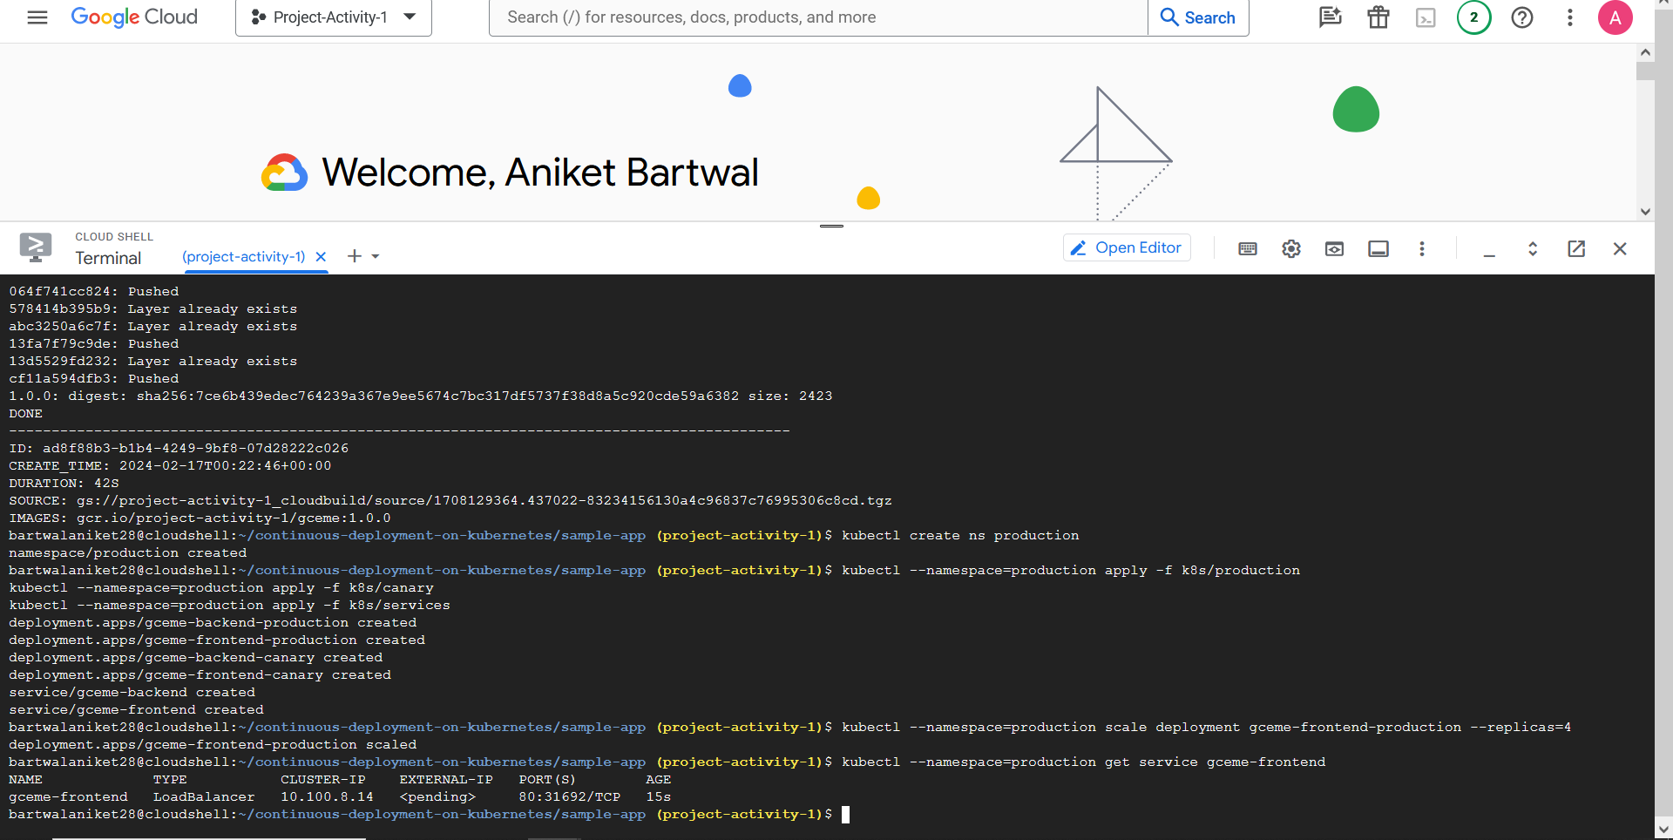

**External IP**

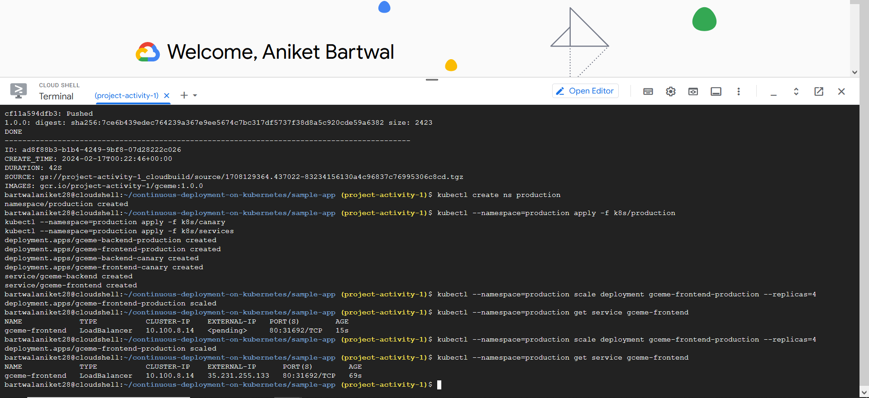

## Creating a repository to host the sample app source code

gcloud services enable sourcerepo.googleapis.com  
gcloud source repos create gceme

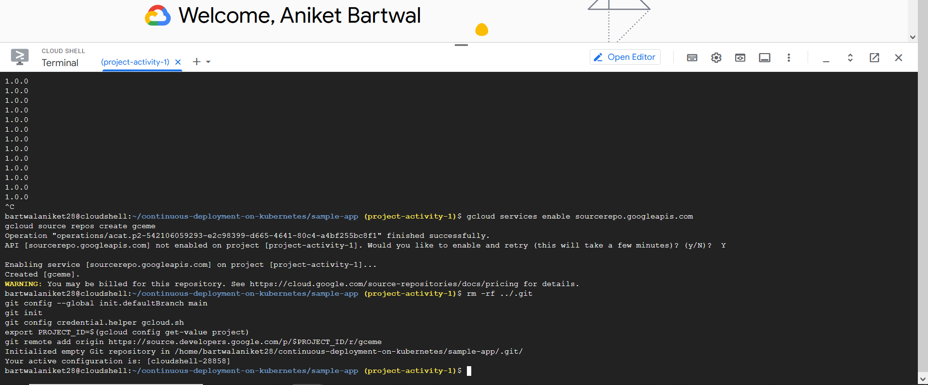

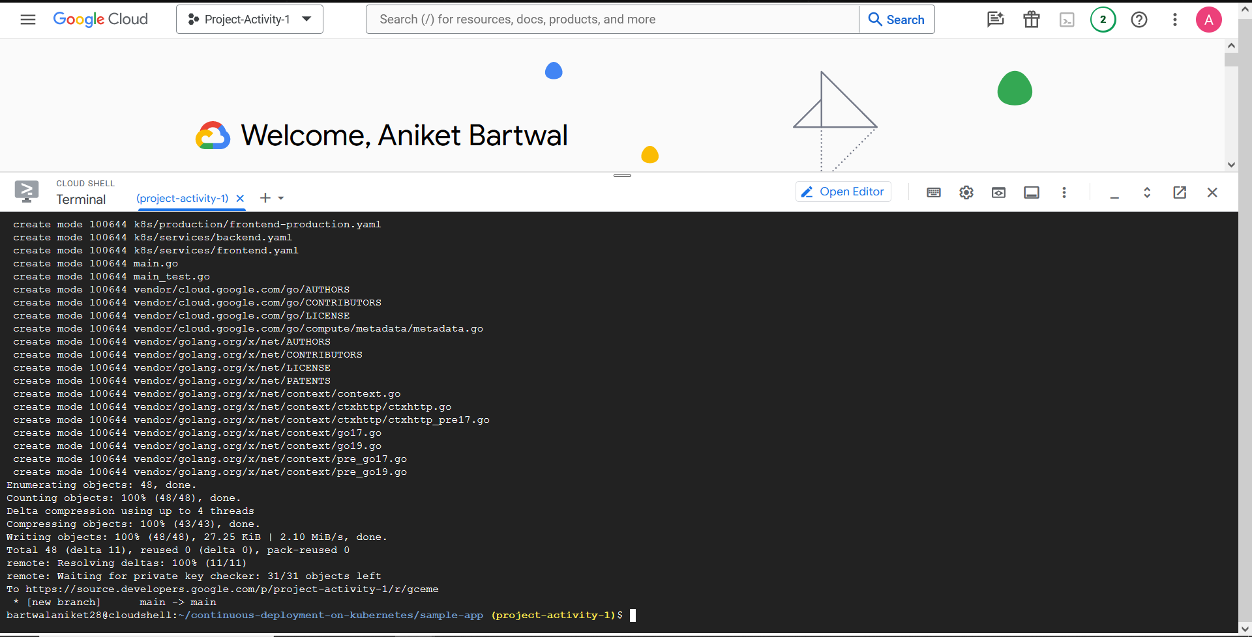

## Create a service account

export SA=jenkins-sa  
export SA_EMAIL=${SA}@${PROJECT_ID}.iam.gserviceaccount.com  
  
gcloud iam service-accounts create $SA  
  
gcloud projects add-iam-policy-binding $PROJECT_ID \  
  --member serviceAccount:$SA_EMAIL \  
  --role roles/source.writer  
  
gcloud projects add-iam-policy-binding $PROJECT_ID \  
  --member serviceAccount:$SA_EMAIL \  
  --role roles/container.developer

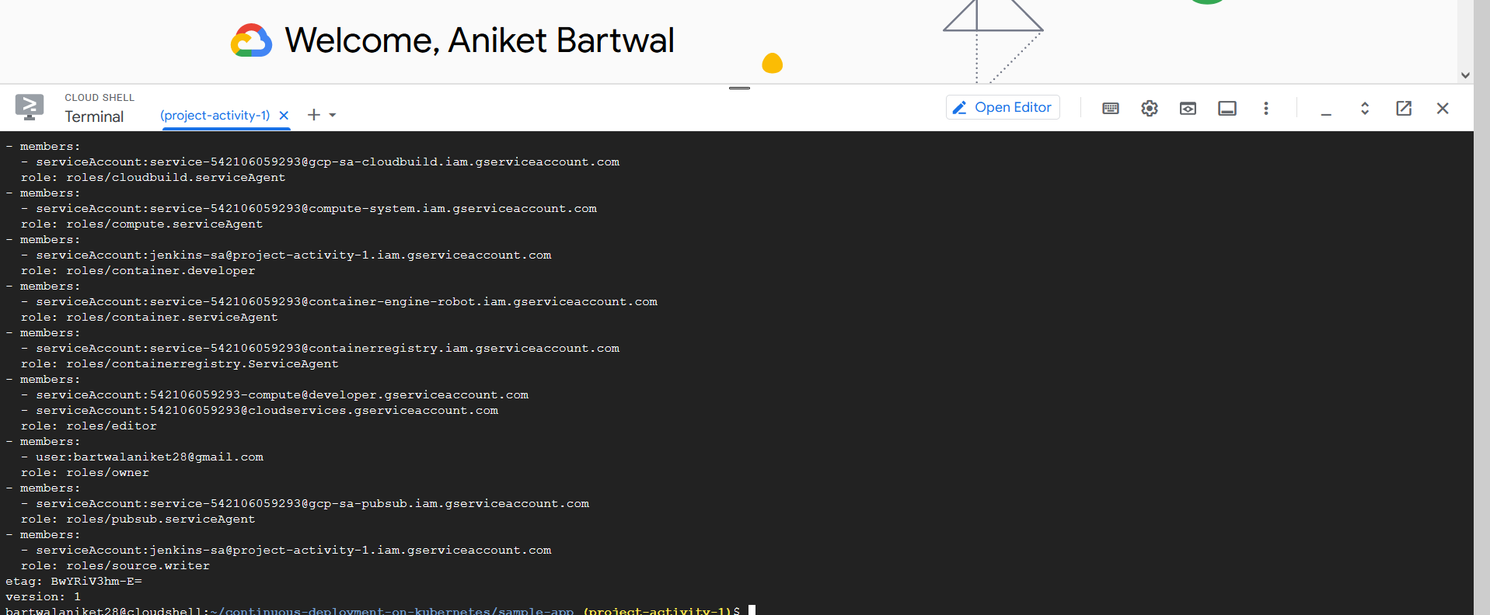

## Configure Jenkins Cloud for Kubernetes

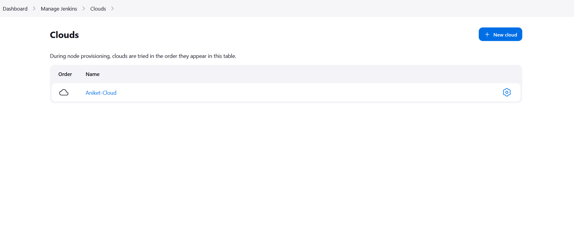

# **Created** Global credential

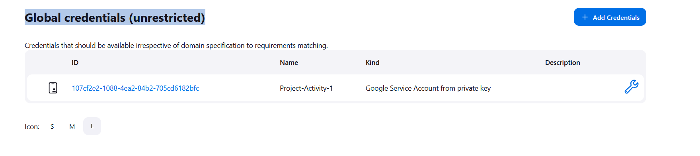

### Creating a Jenkins job

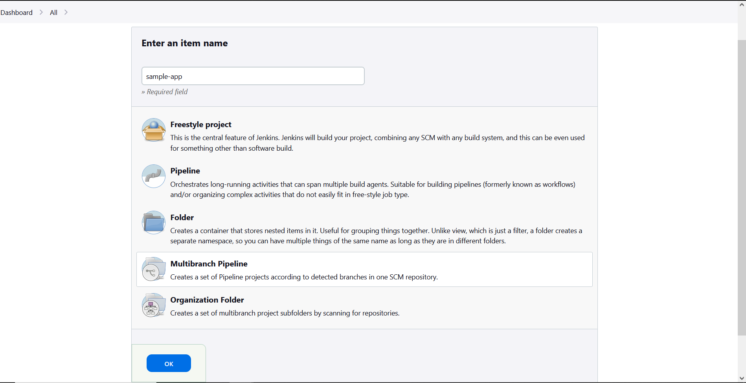

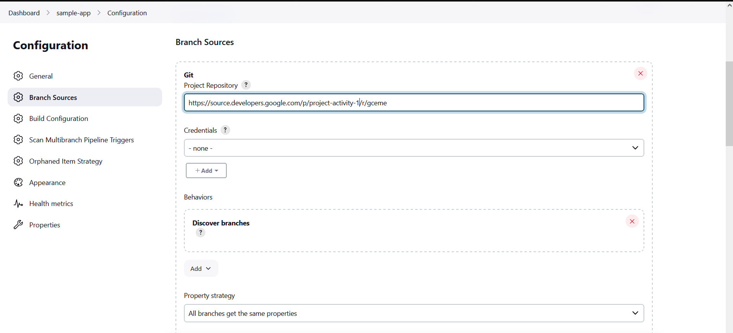

**Log:**

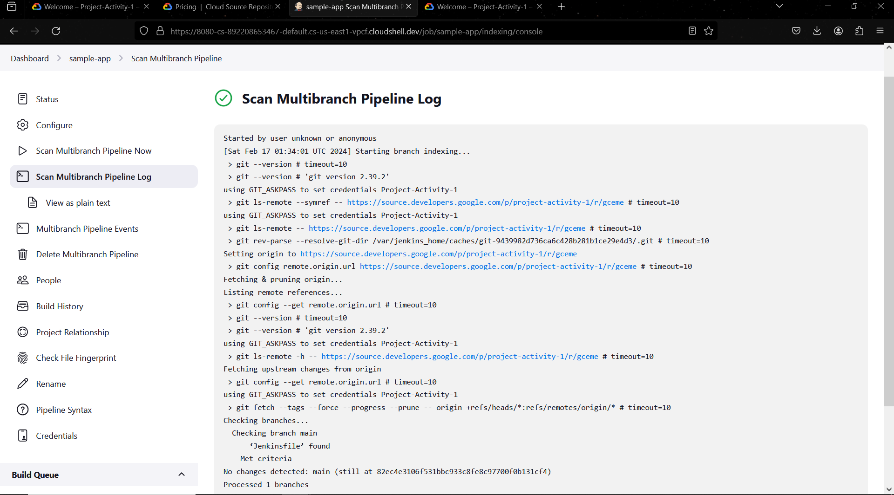

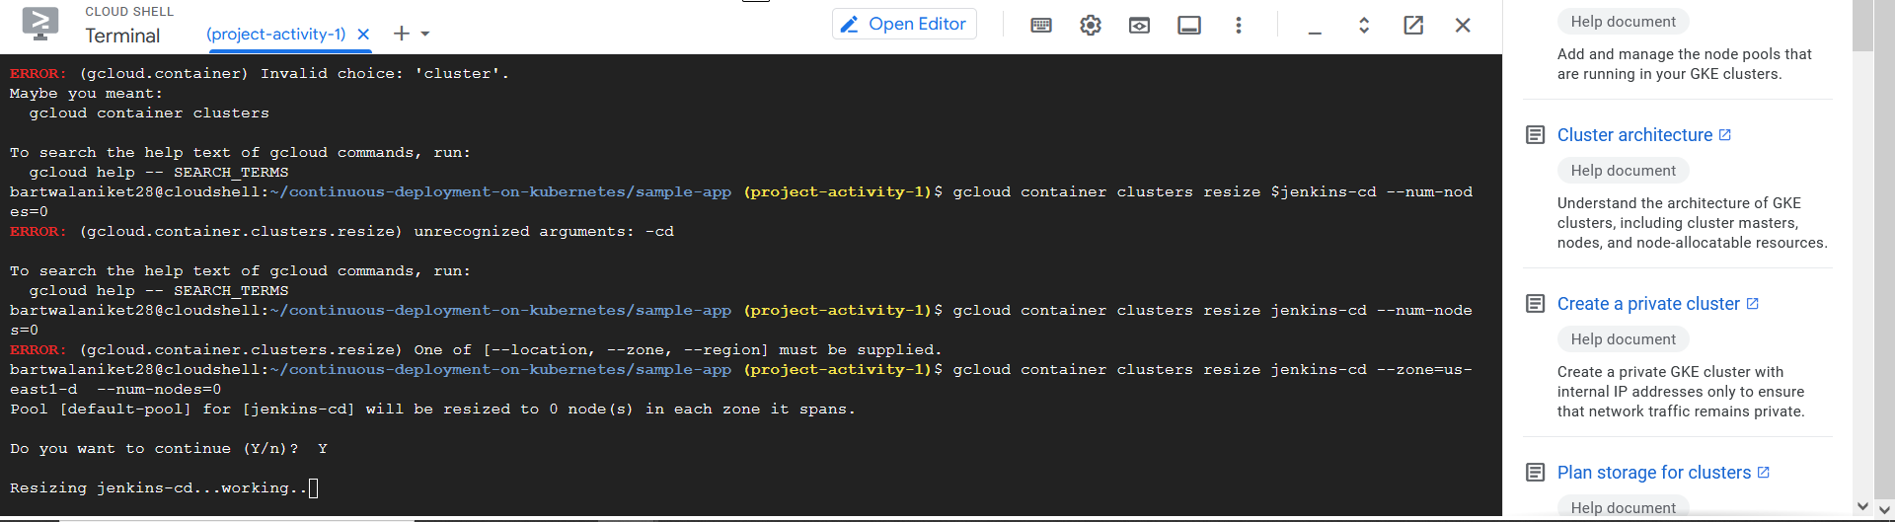

## Deployed a canary release

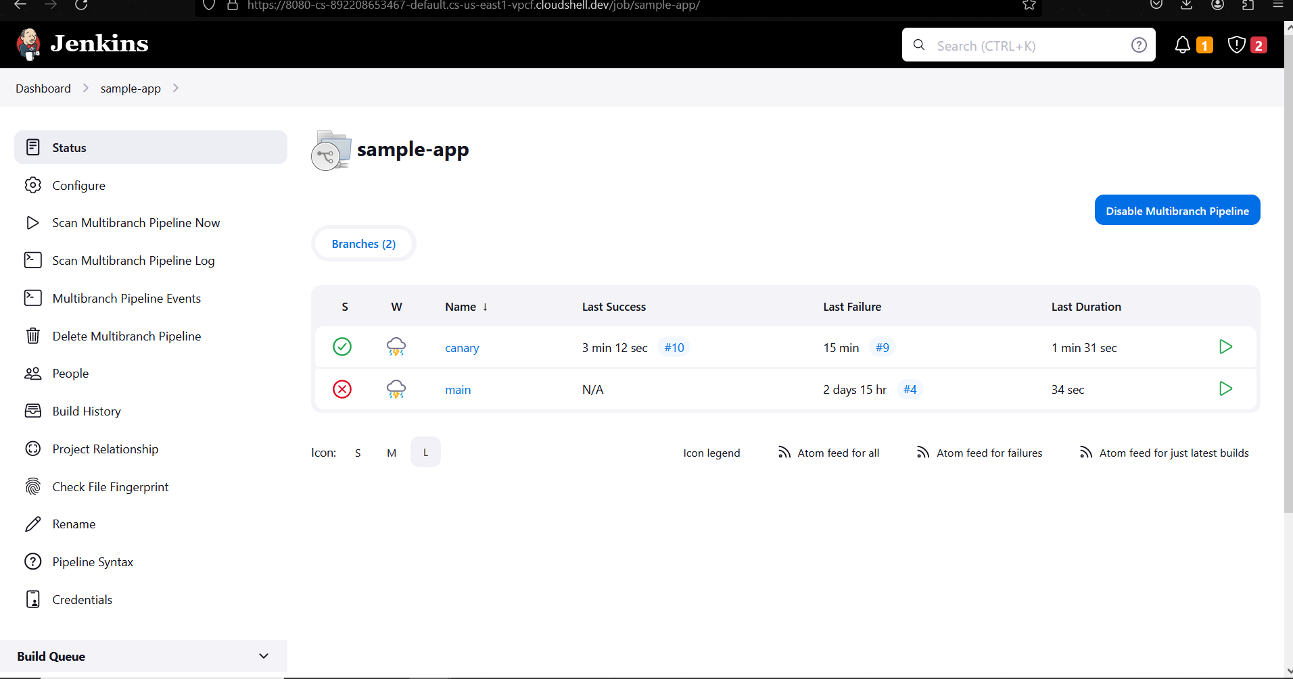

Merged with the main branch

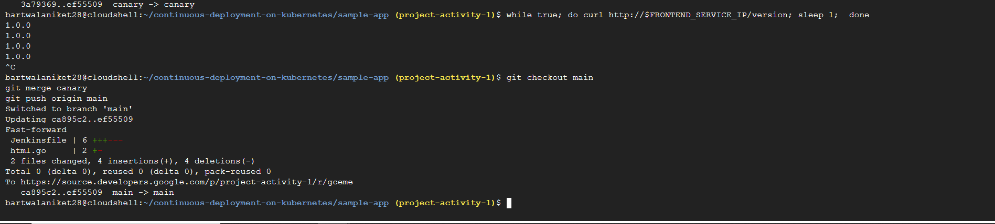

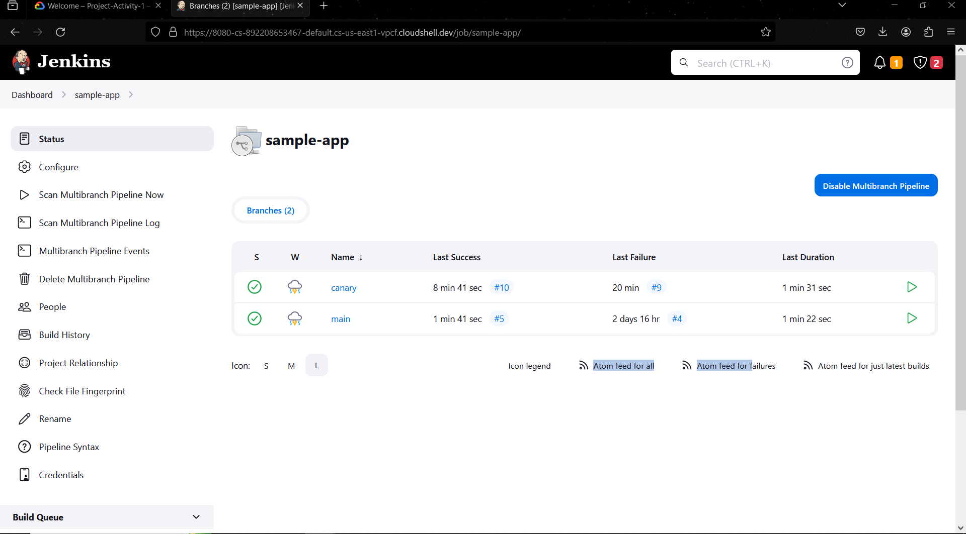

Successfully merged the branch and the pipeline is working fine.

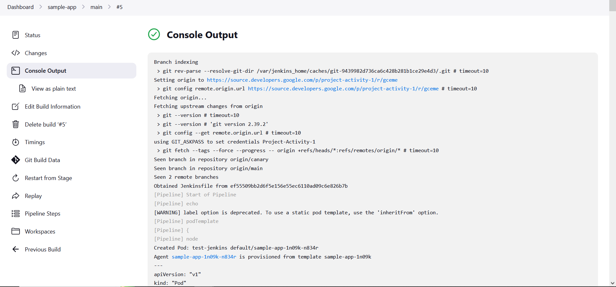

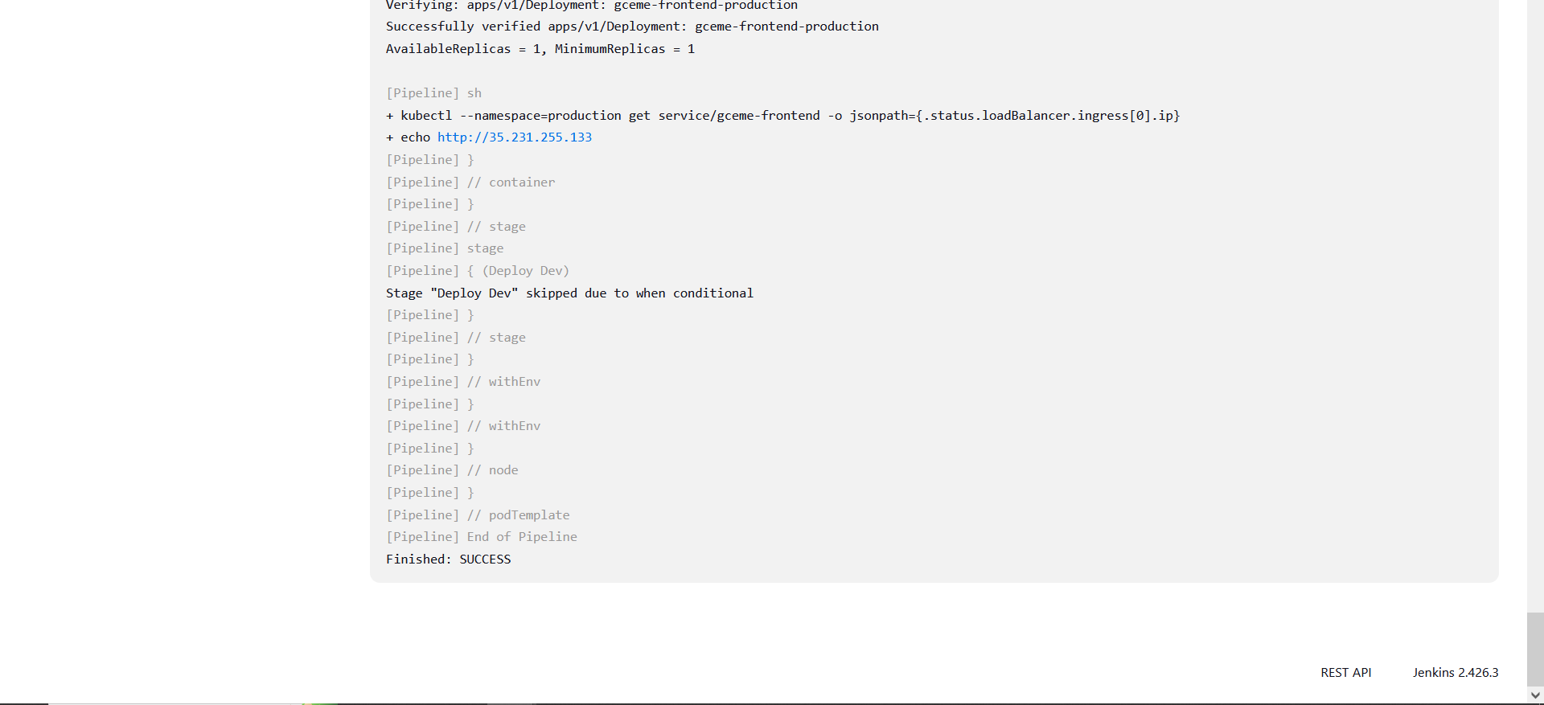

## Deploying a development branch



