The dataset should be changed to the given below proofs:

**DataSet Screenshots :**

Data Set of 3473 rows and 12 columns

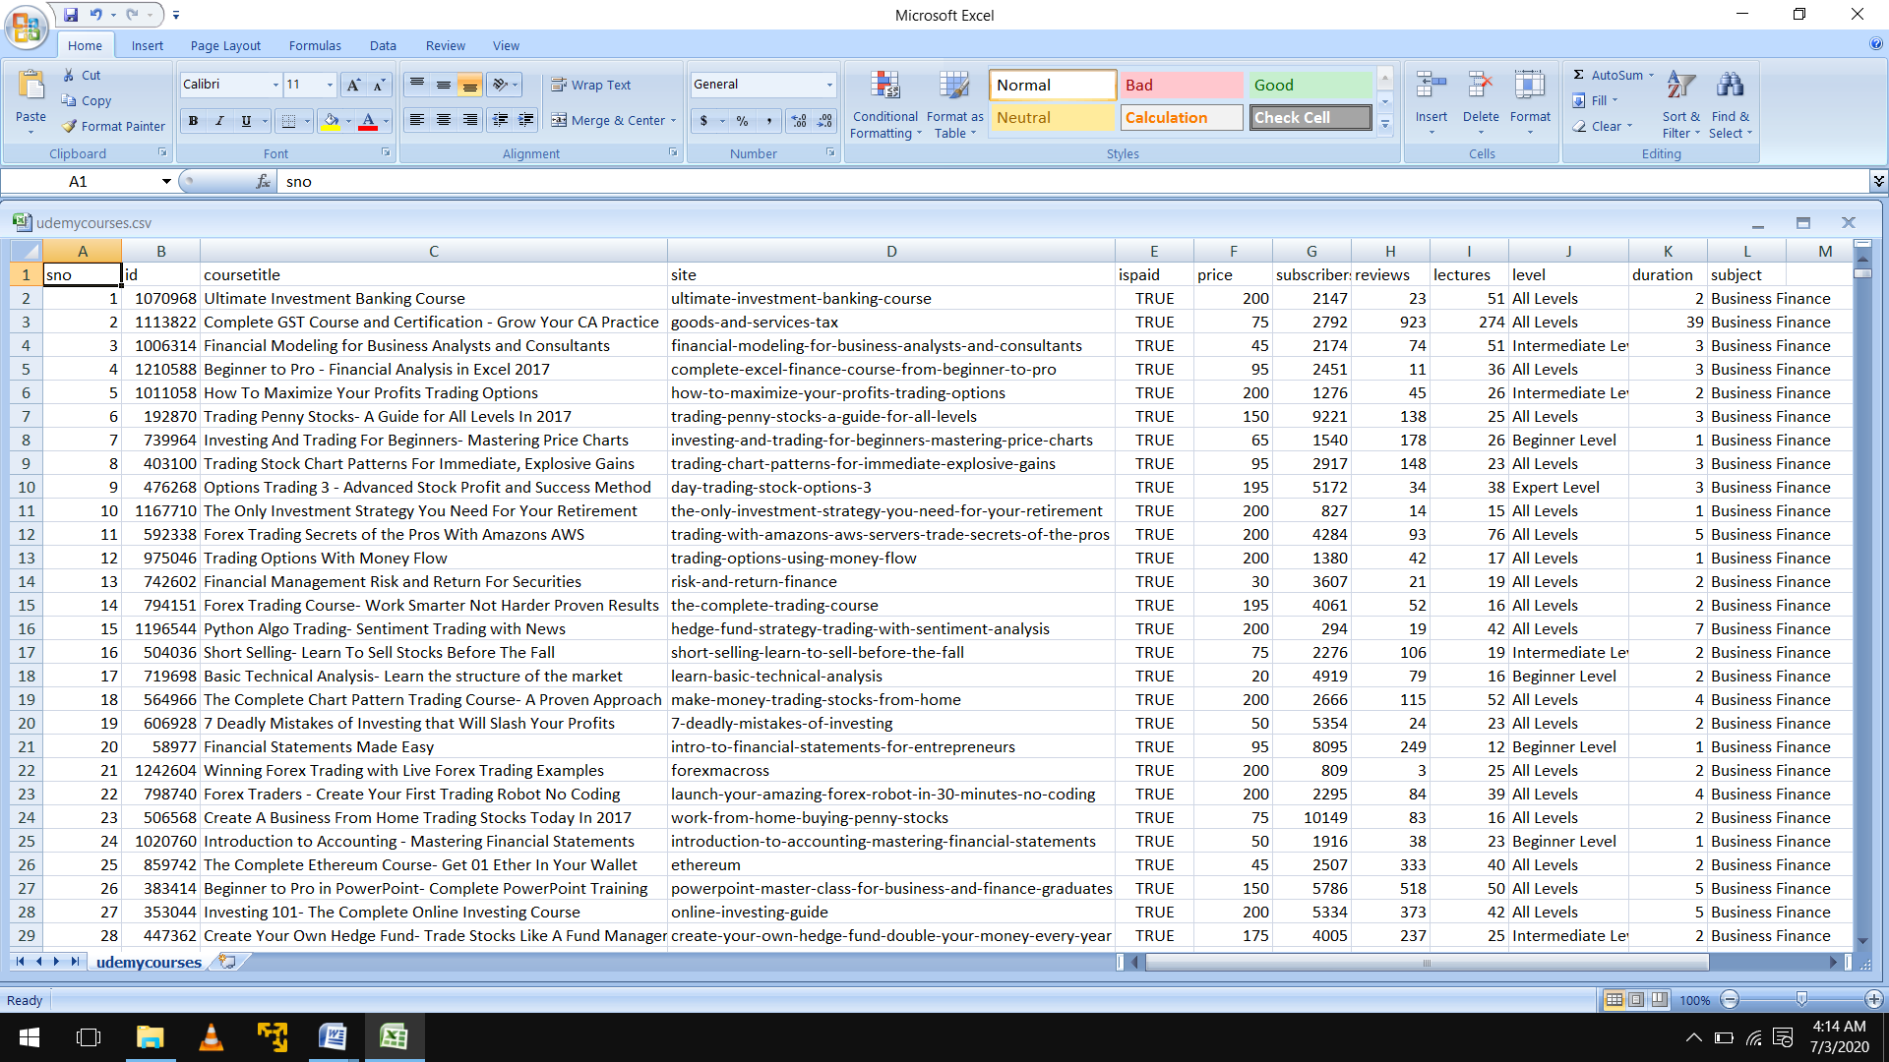

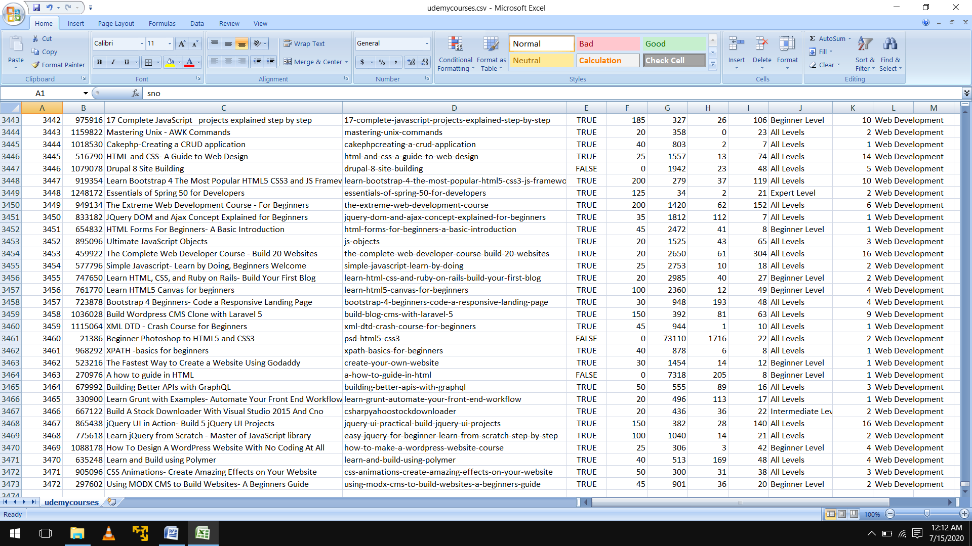

In Comma Separated View stored in Notepad file.

