**GIT Branching**

Name – Aniket Narale

Section – A

Objective: Commit HTML, CSS & JavaScript assignments into GIT.

**21. First take a backup of your assignments & projects. This is required because due to incorrect GIT operation you may lose your files**

**22. Create an empty directory ‘Assignments’ & cd to ‘Assignments’.**

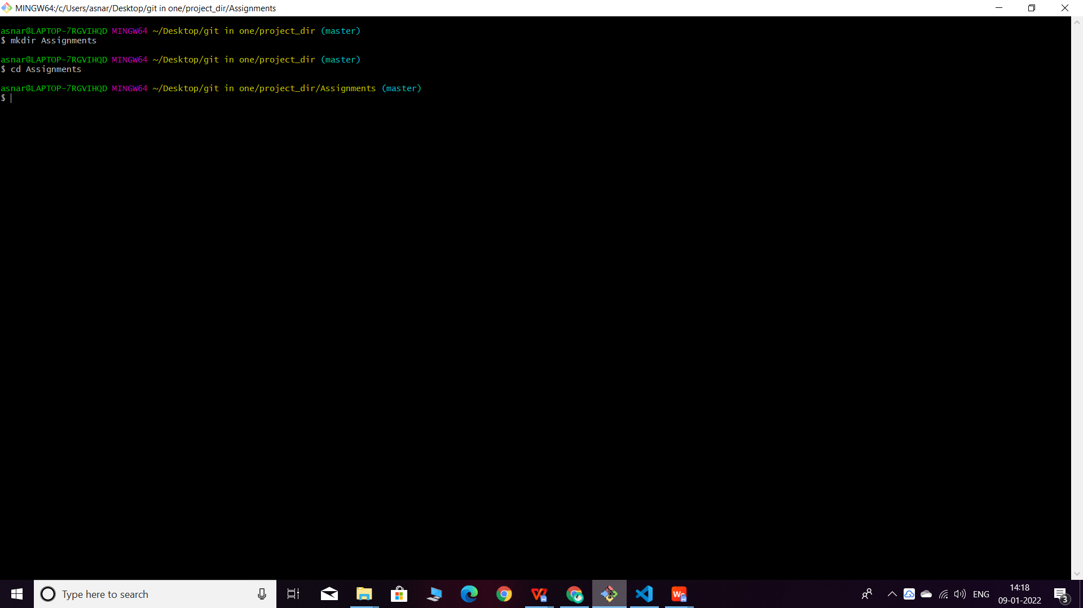

**23. Create a file README.txt inside ‘Assignments’ & write few lines about the contents of ‘Assignments’ folder.**

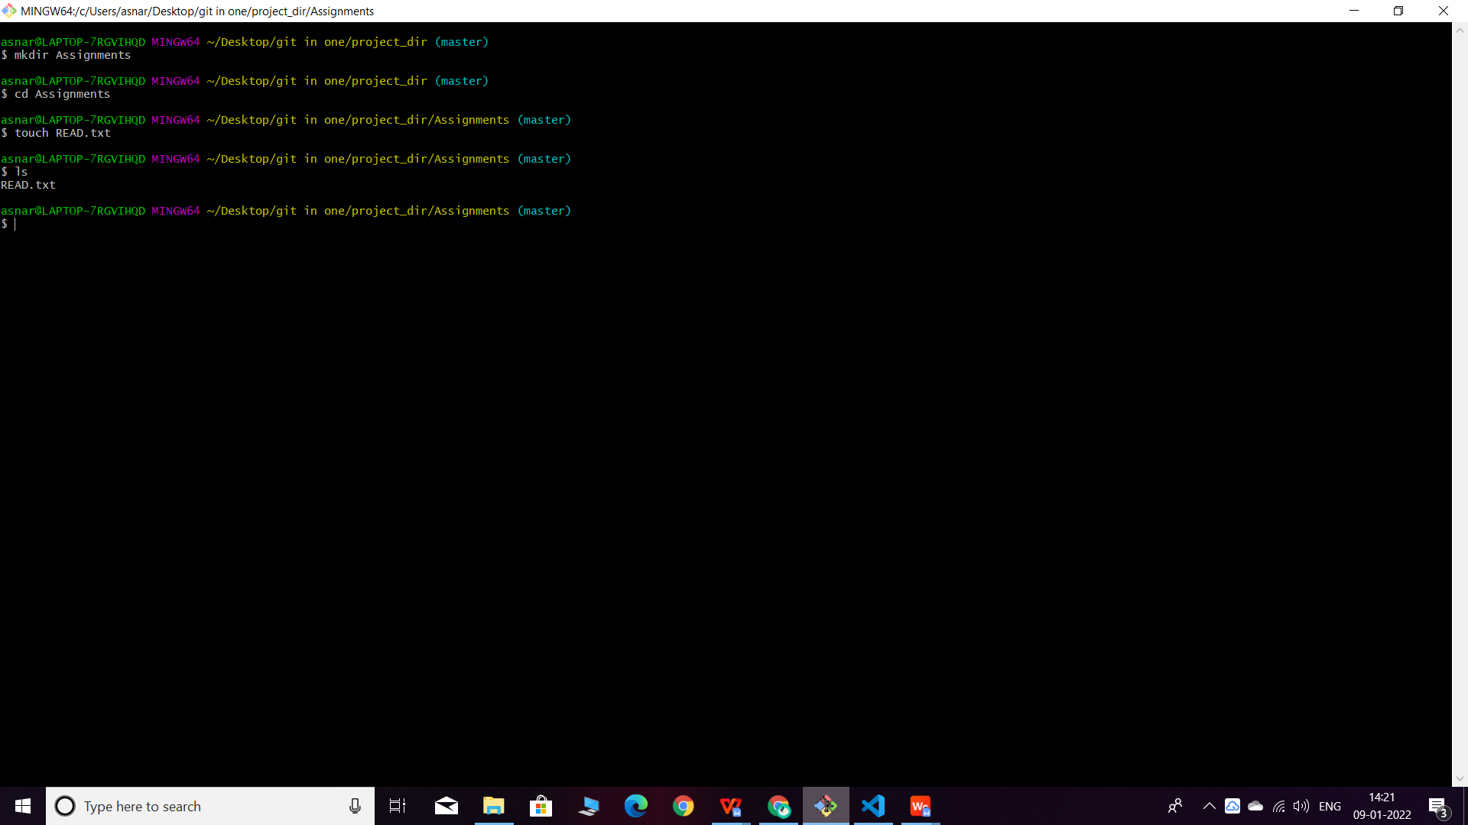**README.txt**

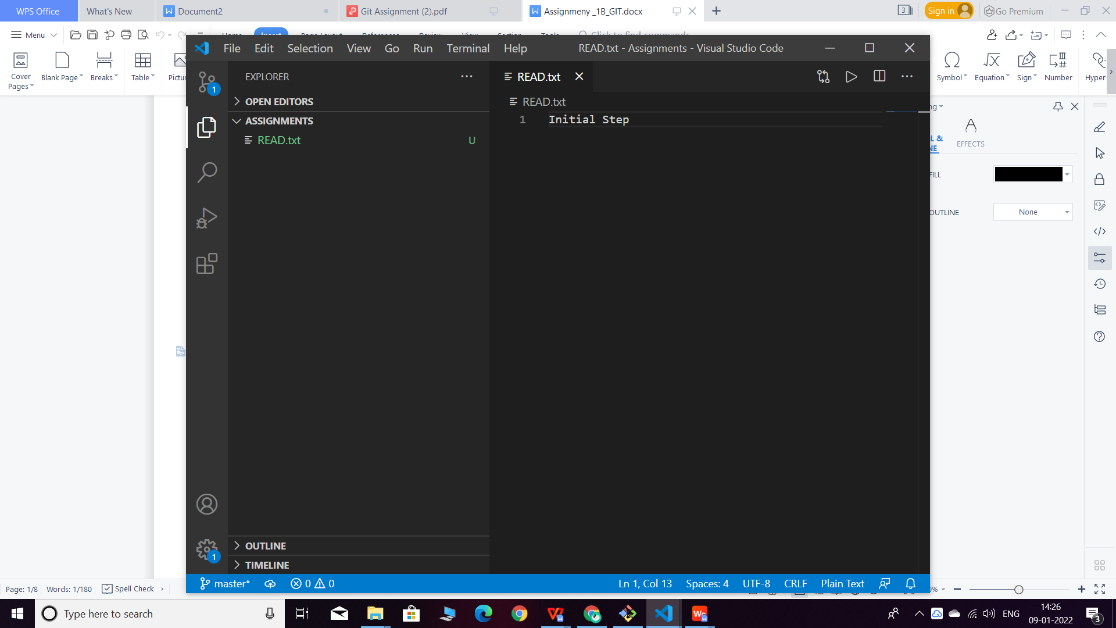**24. Commit README.txt file**

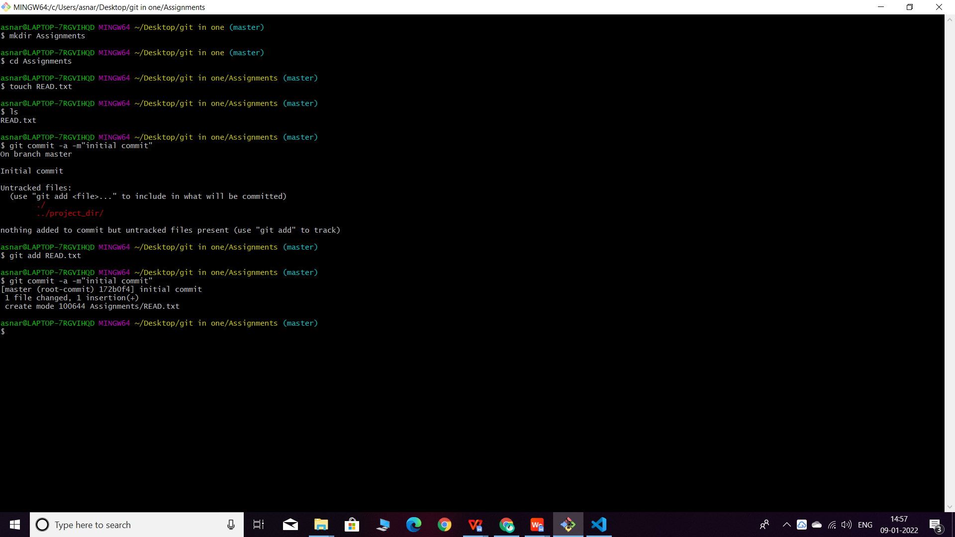**25. Now create a new branch ‘html-assignments’**

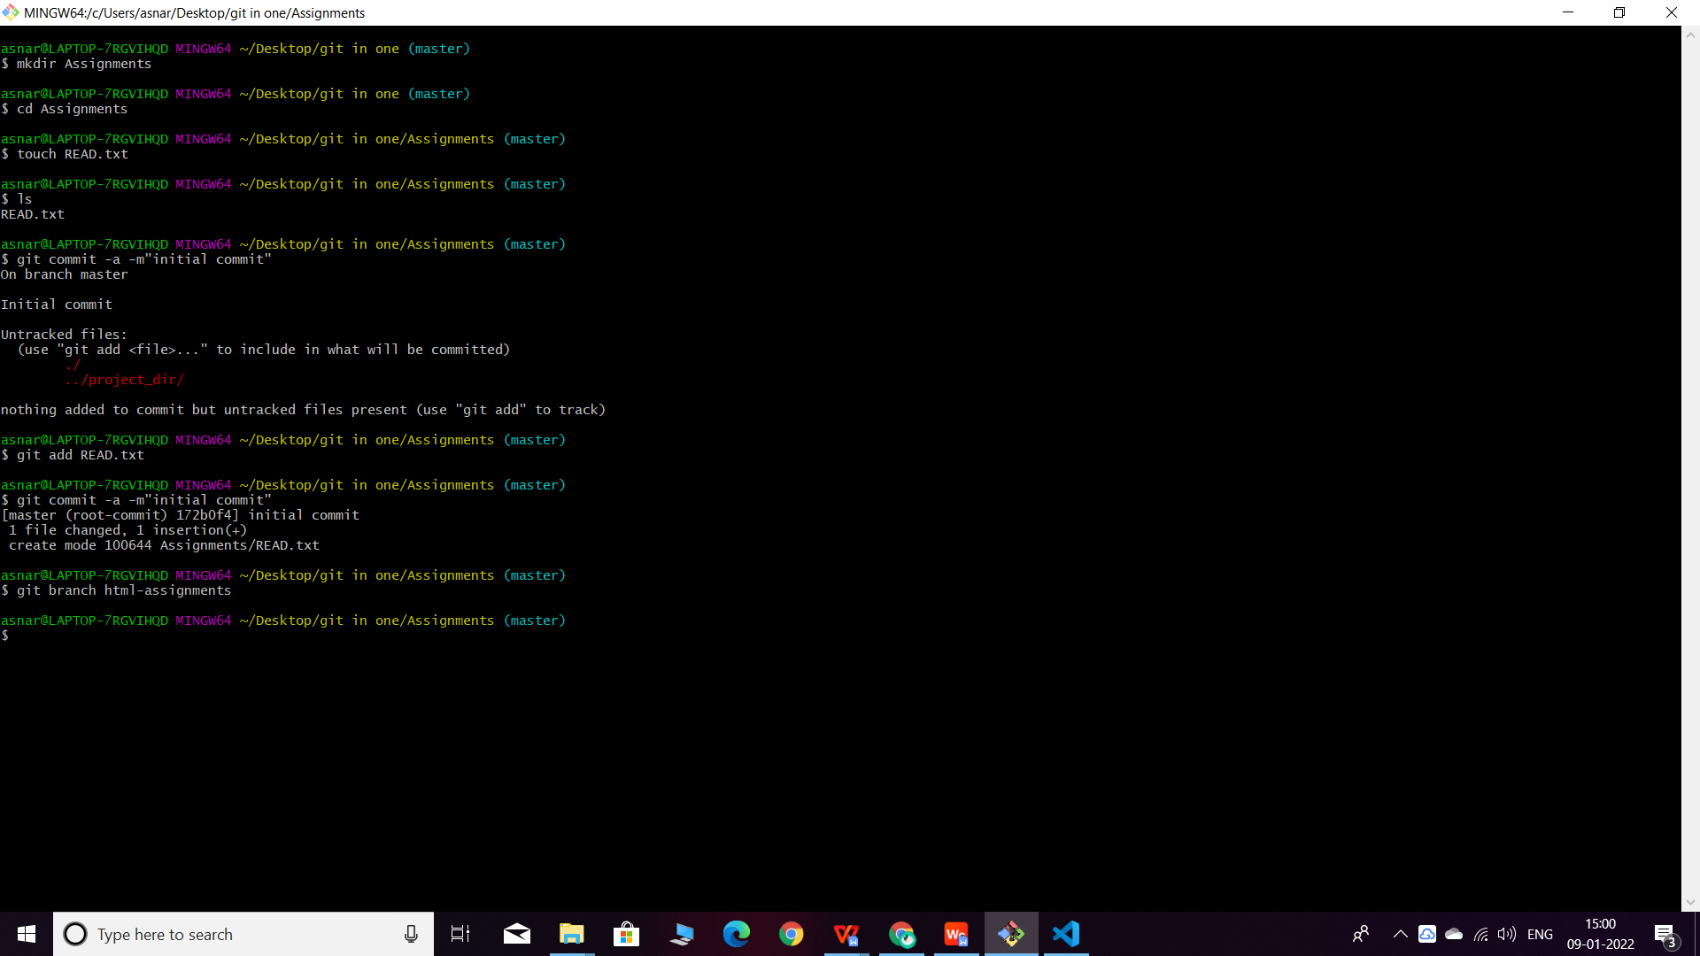

**26. Switch to ‘html-assignments’ branch.**

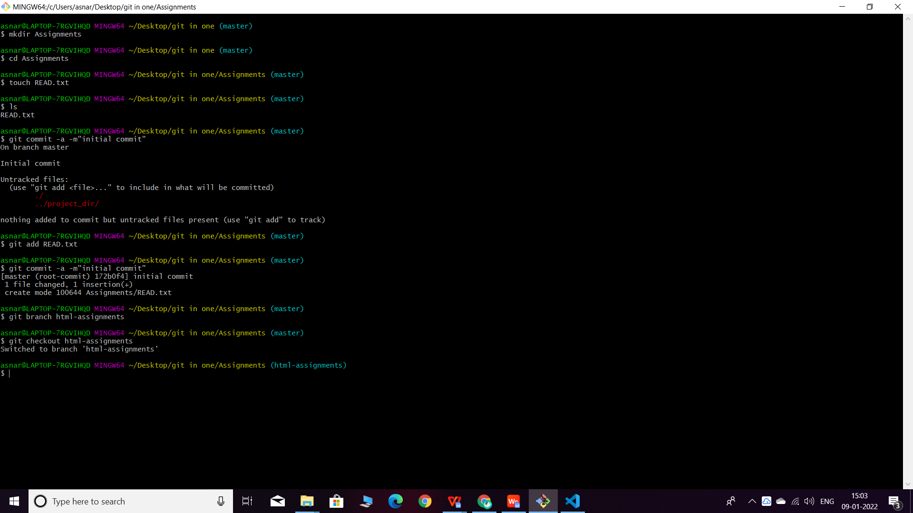

1. **Copy all HTML assignments inside ‘Assignments’ folder.**

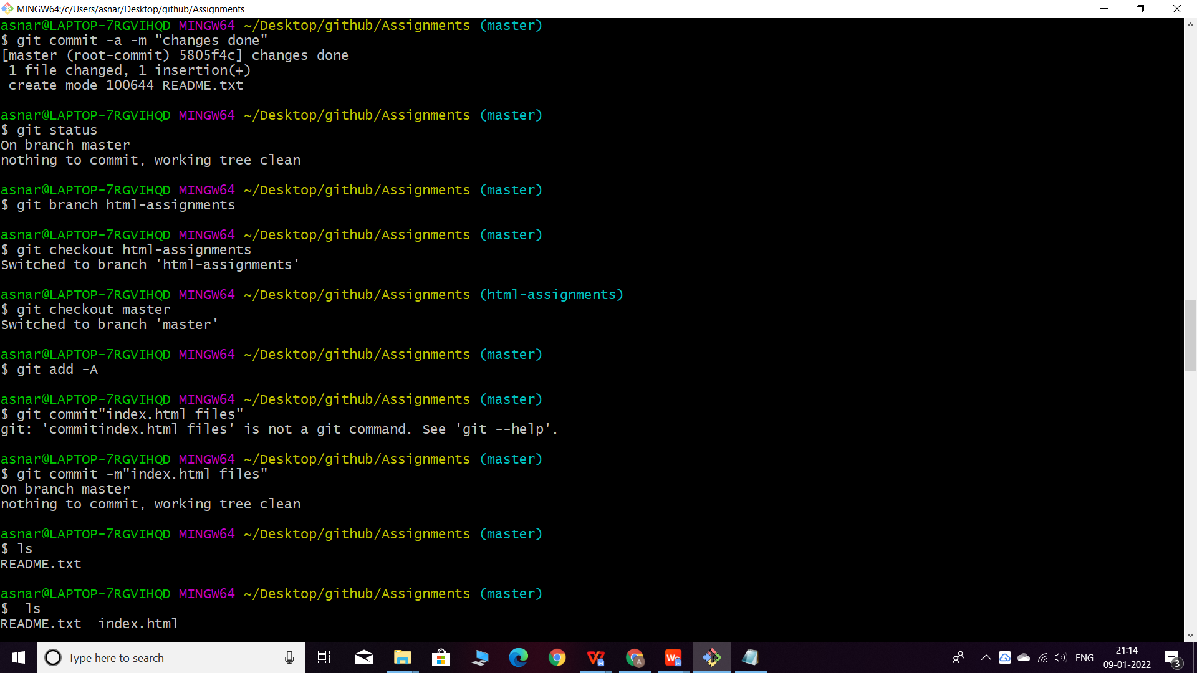

1. Commit HTML assignments into ‘html-assignments’ branch.

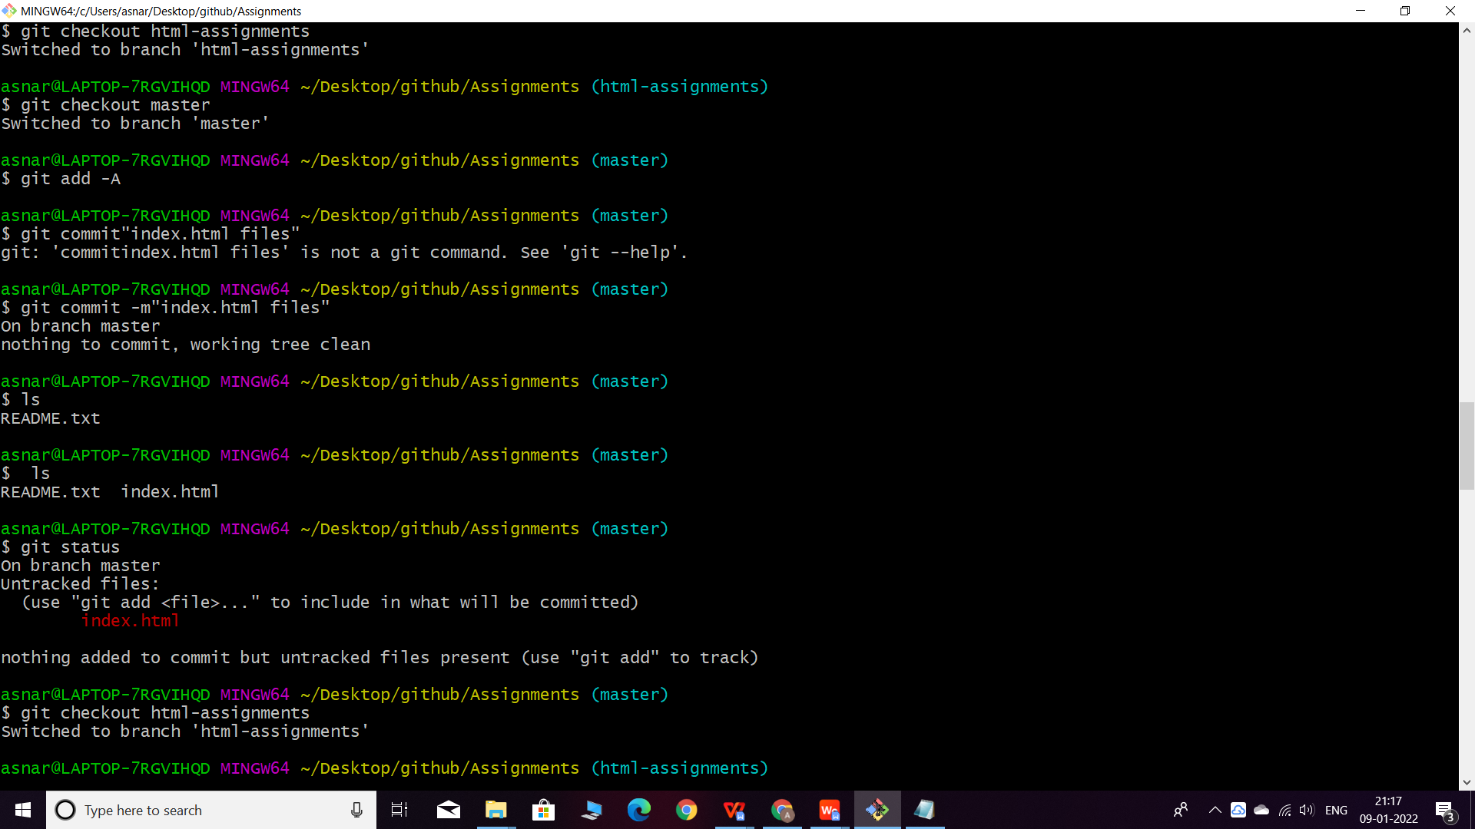

1. Make minor changes into few files belonging to ‘html-assignments’ branch.

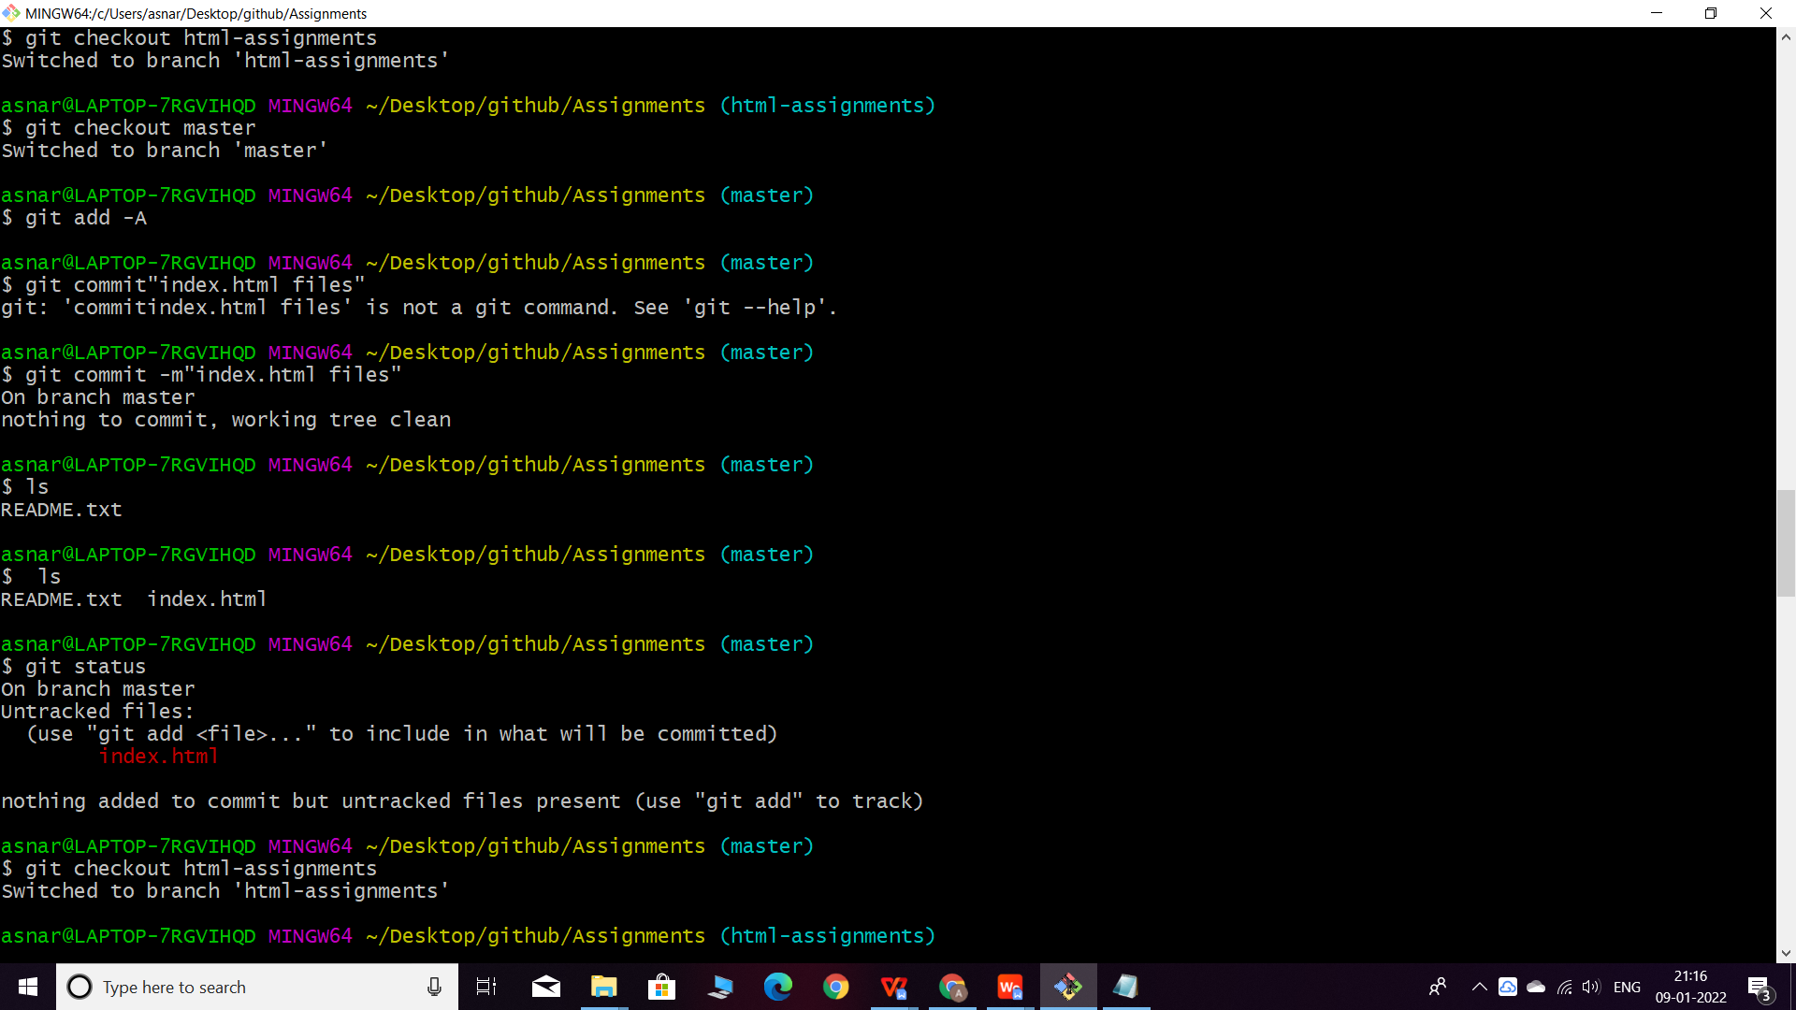

1. Commit those changed files.

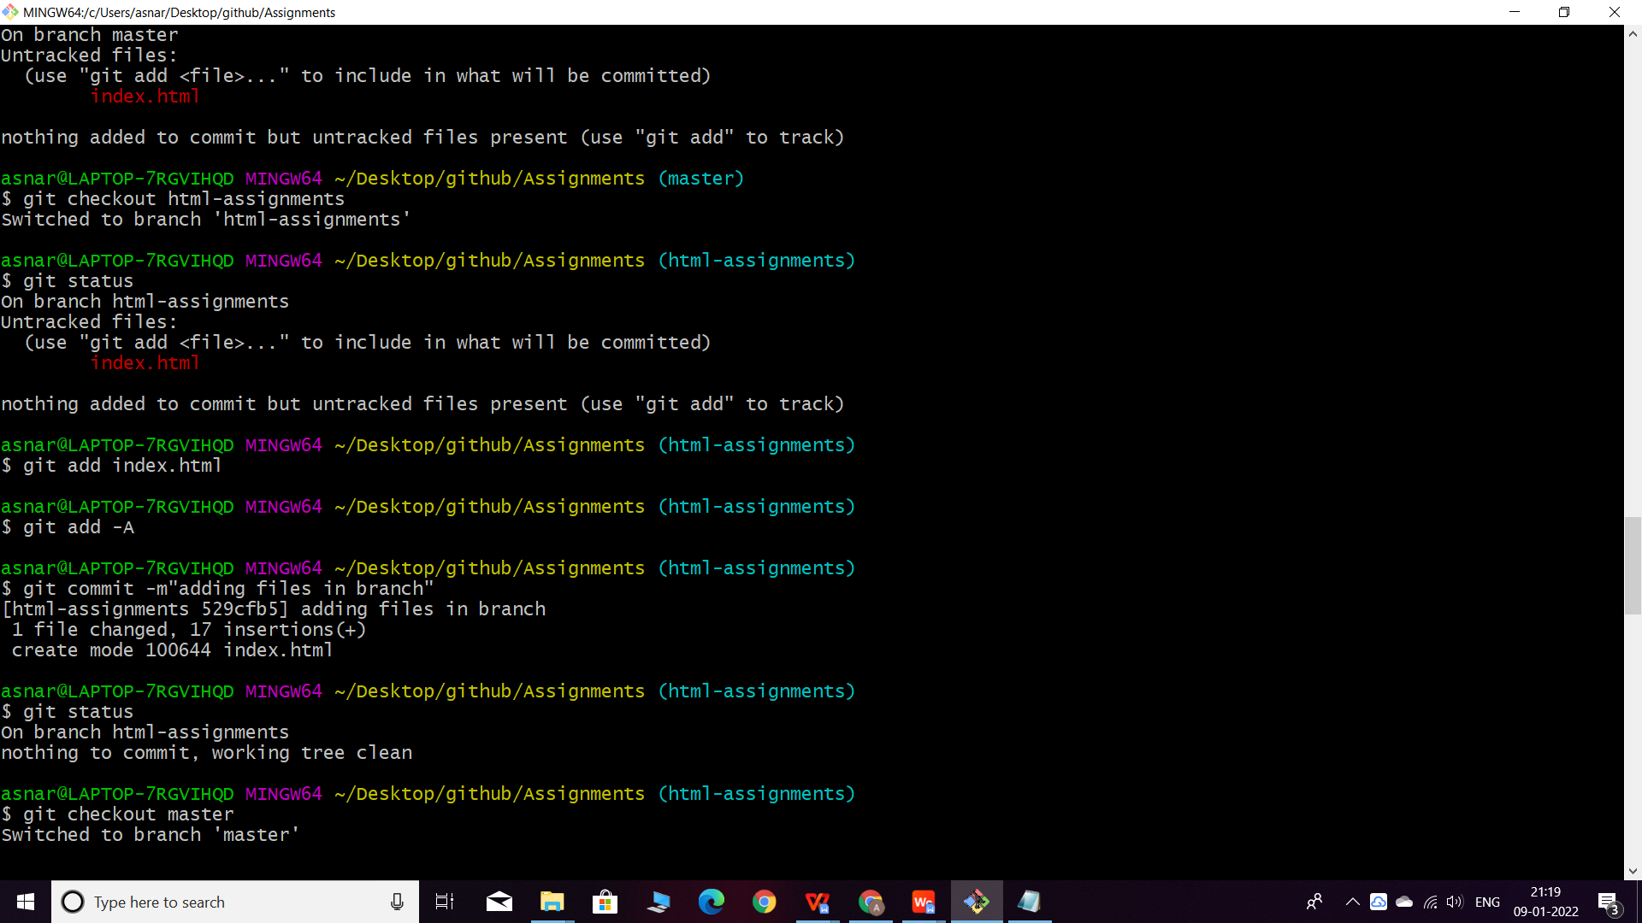

1. Switch to master branch.

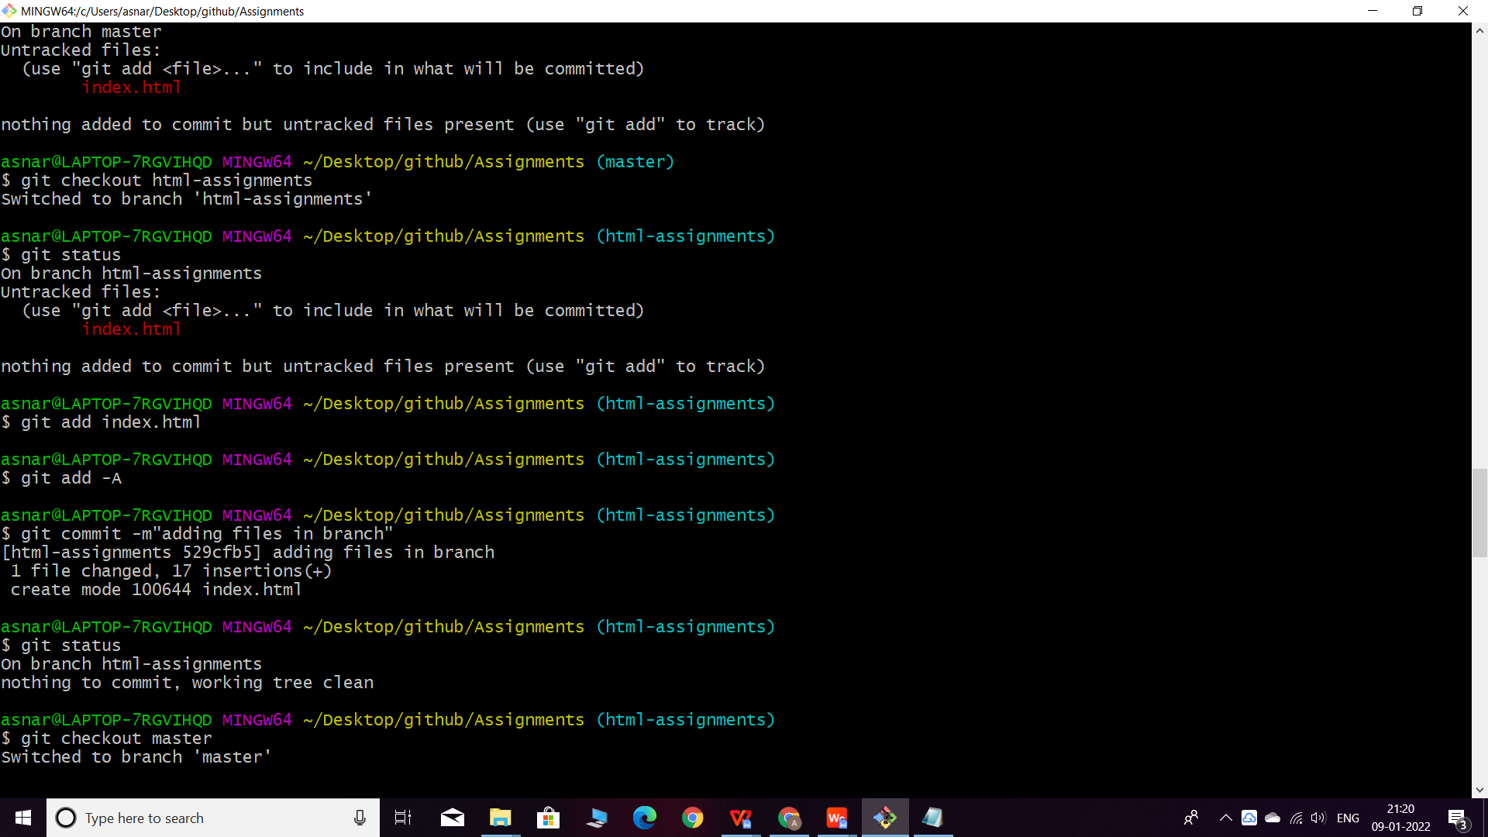

1. Make minor changes into README.txt file & commit those changes into master.

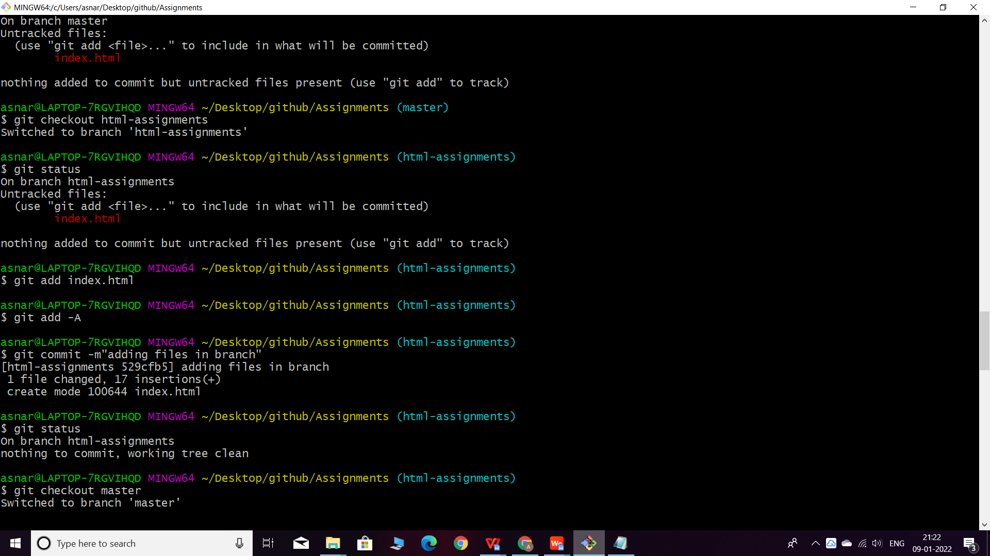

1. Again switch to ‘html-assignments’ branch.

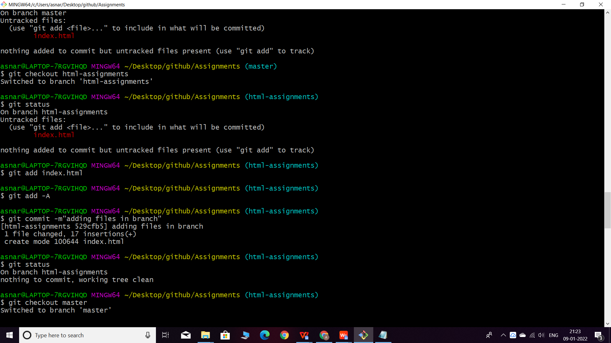

1. Make minor changes into few files belonging to ‘html-assignments’ branch.

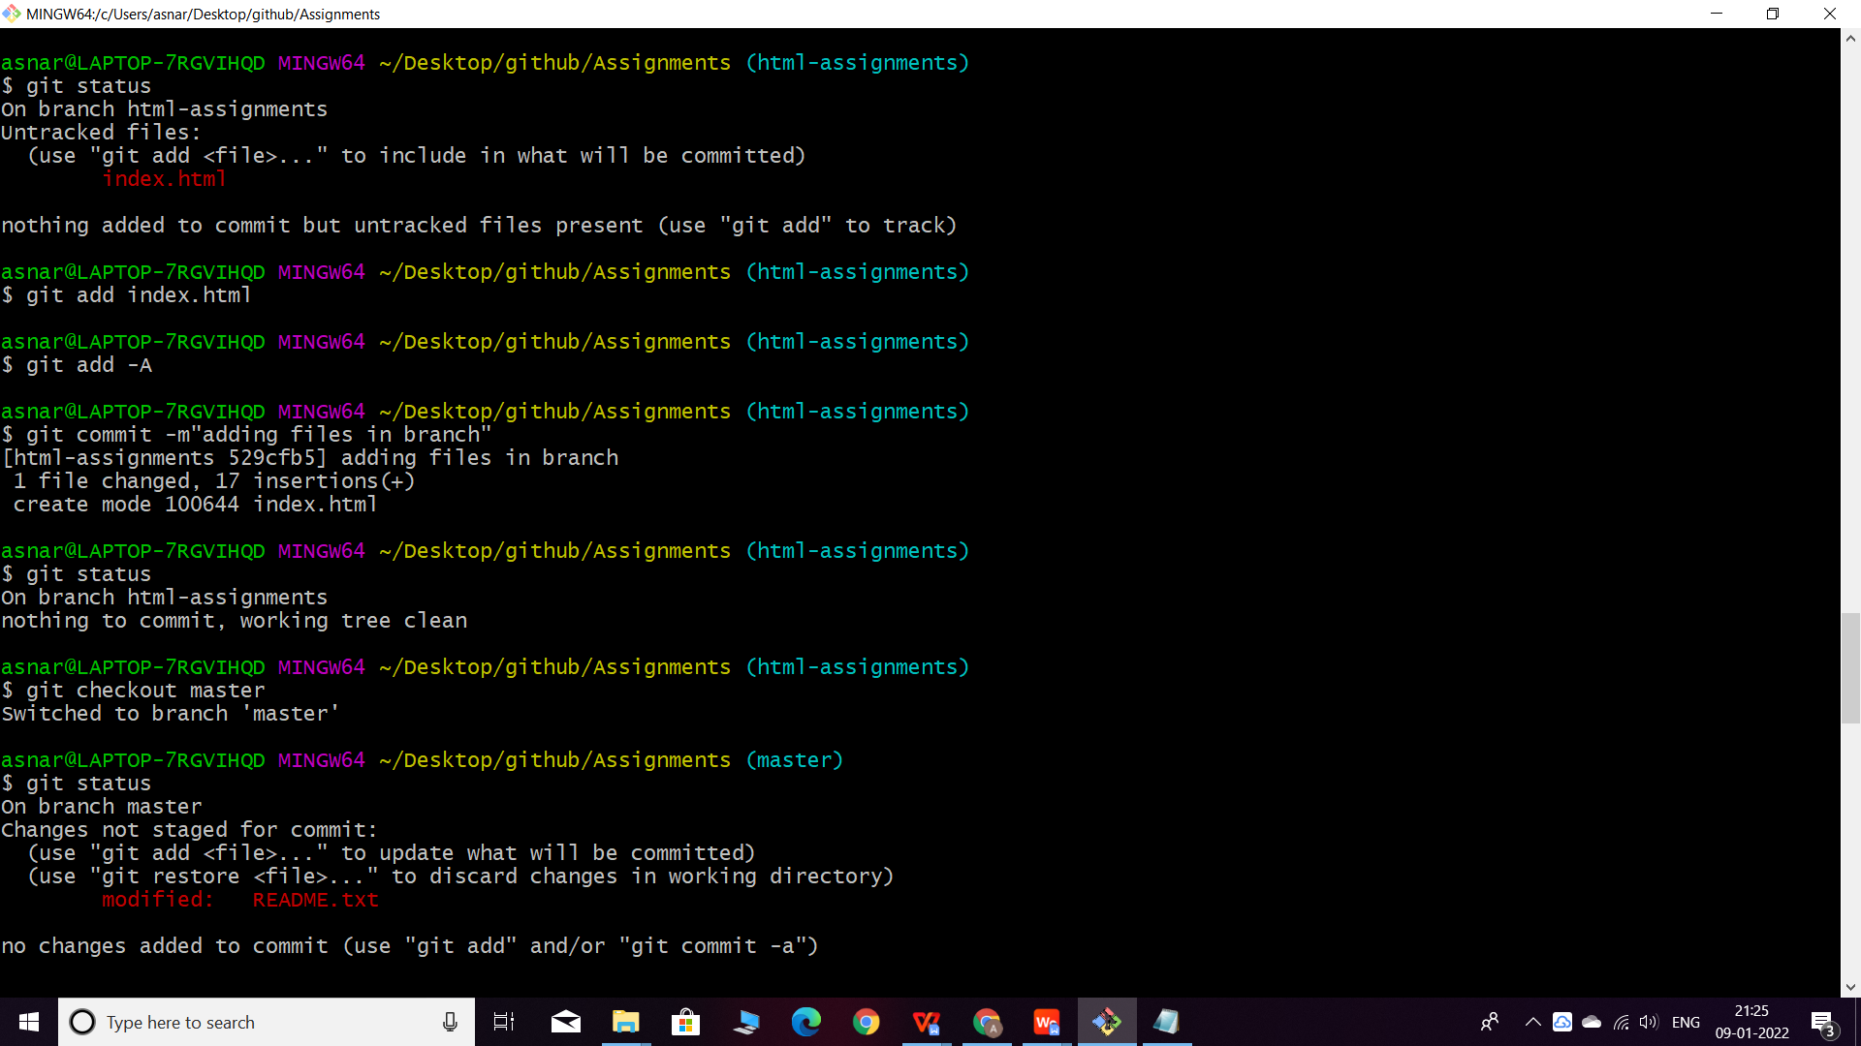

1. Commit those changes.

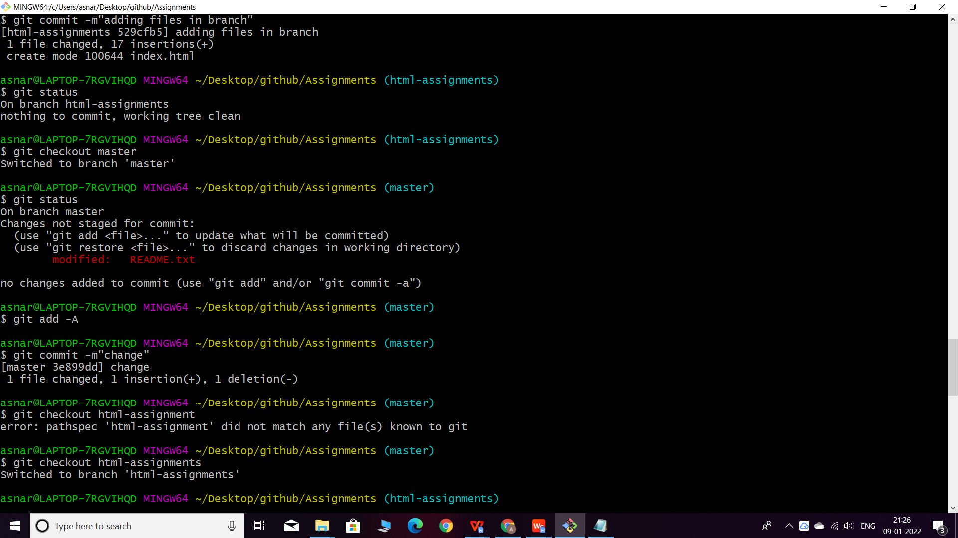

1. Switch to master.

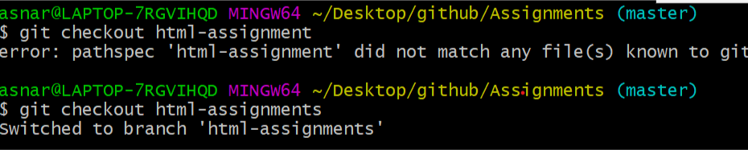

37. Merge ‘html-assignments’ branch into master. Confirm all html assignments are shown

in master.

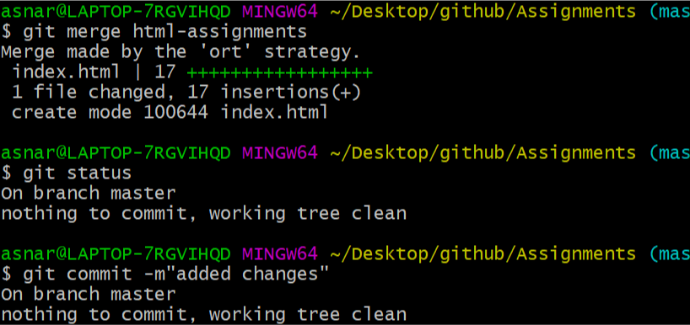

38.fiinally delete the ‘html-assignments’ branch.

