**GIT Branching**

Name – Aniket Narale

Section – B

Objective: Commit HTML, CSS & JavaScript assignments into GIT.

1. Create a new branch ‘css-assignments’.



1. Switch to ‘css-assignments’ branch.

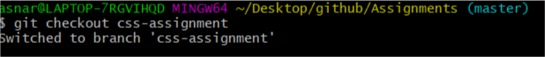

1. Copy all CSS assignments inside ‘Assignments’ folder.

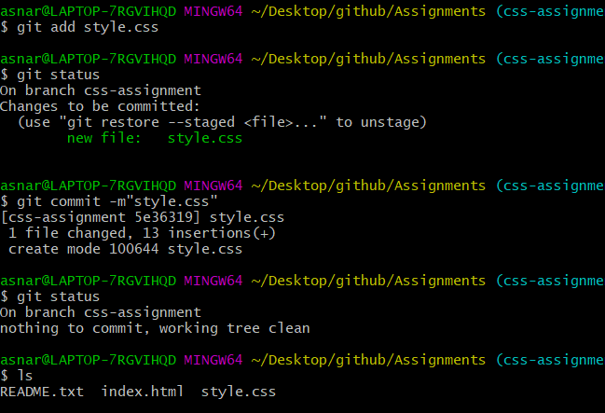

1. Commit CSS assignments into ‘css-assignments’ branch.

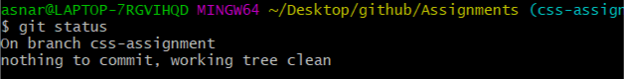

5. Make minor changes into README.txt file on line 1 belonging to ‘css-assignments’

branch.

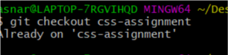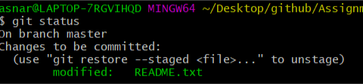

6.Commit those changed files.

1. 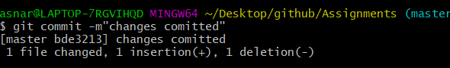
2. Switch to master branch.

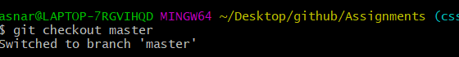

8. Make minor changes into README.txt file on line 3 & commit those changes into

master.

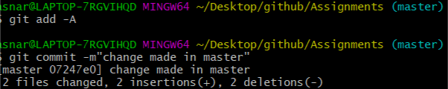

9.Again switch to ‘css-assignments’ branch.

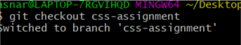

1. Make minor changes into few files belonging to ‘css-assignments’ branch.

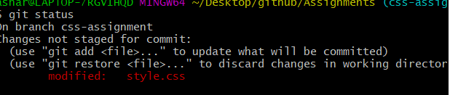

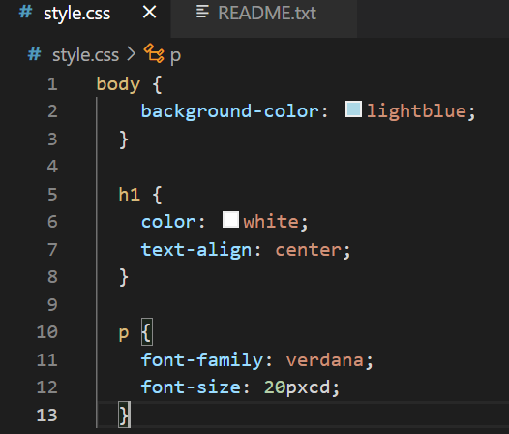

1. Commit those changes.

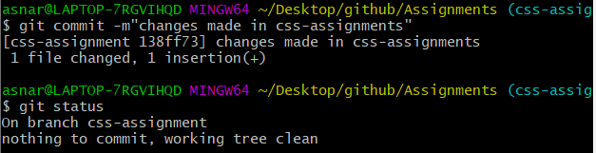

1. Switch to master.



13. Merge ‘css-assignments’ branch into master. Confirm all css assignments are shown in

master.

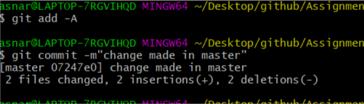

1. Finally delete the ‘css-assignments’ branch.

