# Chapter 2: Analysis

# 2.1 Introduction to analysis

It is defined as the systematic and the evaluation of the data or information by breaking down it into different parts. It is the phase of the software development life cycle. Analysis is used in the software development technique. It gathers the requirements of the client and solves it. It is done through SRS (Software Requirement Specification) document where consists of all the product requirements to design and development during the project life cycle.

The advantages of the Analysis are:

* Analysis helps to determine the quality of code.
* It gathers all the information and analyzes it.
* It allows for the qualitative and quantitative operation.
* It helps to evaluate alternatives and prioritize the requirements.

# 2.2 Analysis methodology

Analysis can be defined as how the job is done. It helps to identify the problem to solve it. It evaluates the data using analytical and logical to examine each components of the data. Data are reviewed, gather and analyzed from the various resources.

There is much information gathering method some of them are as follows:

* SWOT Analysis (strengths, weaknesses, opportunities and threats analysis)
* PEST Analysis (Political, Economic, Social and Technological)
* Interviews
* Questionnaires
* Brainstorming
* Observation
* Focus Group

Among these Analysis method I have choose following technique which may suit for my project and takes the less time and gain information’s.

1. Observation method

The observation is the method of researching effect of risk factor treatments. I have chosen the observation technique for my project because I can gather information by observing the people form natural environment. Observing the people and project helps to identify the requirement changes.

a) I can get the knowledge form the user.

b) I can make the changes according to the observation.

2. PEST Analysis

The pest analysis helps to take the better business decision and improve

efficiency by analyzing the various factors which might impact the project. I have chosen pest analysis for my project because it helps to manage the project efficiently.

1. To know the various factors that influences the project political,

economic, social and technology.

1. It helps to manage the project.

3. Focus group

It is the information gathering methods where a group of people are kept and gather the information related to the project. For example: Group of 20 people and ask them what they like and dislike about the project. The reason why I choose this for my project is to know actual result of the project and know what the problem in the project is.

1. It consumes less time, cost and effort.
2. We can know the pros and corn of the project.
3. We can get the real requirements for the user than what we actually like.

4. Brainstorming

It is group creating techniques which efforts are made to find the problem list them as priority and solve them. I have chosen this for my project because it helps to gather many ideas.

1. It helps to solve problem quick.
2. It helps to create many techniques.

In the following process I have select soft system methodology for my project because it can be used for the general solving and in management of change. It helps to solve the problem by its situation. It helps to structure complex problems and to develop desirable and feasible changes within a differentiated group of people.

These are the step while applying soft system methodology.

1. First is appreciate the problem situation
2. Write the problem situation and rich picture.
3. Formulate root definition
4. Building conceptual models of project.
5. Compare it with real world.

1. Rich picture

It can be defined as the drawing of the situation that illustrates the main elements and the relationship that need to be considered trying to intervene in order to create some improvement. It helps project to illustrate the richness and complexity of the situation.

The main advantages of the rich picture it is never wrong.

This is the rich picture of my project:

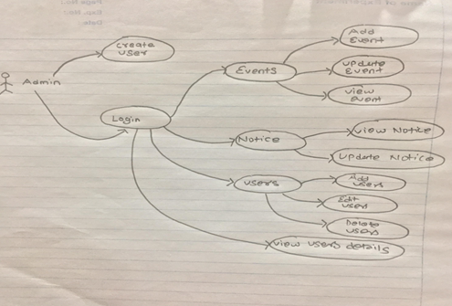

Screenshot1: Rich picture of Admin

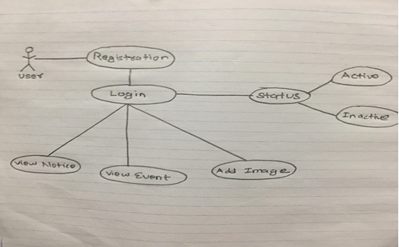

Screenshot2: Rich picture of users

2. Root definition:

Root definition is a description of the entire system. IT helps in project to describe its aims and functions of the system. It clarifies the day to day system process and the problem that held during the project.

CATWOE: It helps in proper formulation of the root definition. CATWOE analysis is as follows:

1. Customers: Customers are victims of the outputs for the business system. What problem? Who is on the receiving end? Reactions? Win /loss?
2. Actors: It carries out the task and activities within the transformation. It carries out your solution? What is the impact on them? What is the reaction?
3. Transformation process: It is the activity that delivers the service to the customer. What are the input/output of the transformation in the system?
4. World View: It looks in what are the possible activities exits. What is the impact of the solution? What is the real problem working on it.
5. Owner: Owner is who control the entire system. Owner of the project can make changes in the system and helps user.
6. Environmental Constraints: It is constraints imposed within the environment surrounding the business activity. Make the friendly environment for the user and easier to use.

Reason for choosing soft system methodology:

1. It helps to express the problem situation.
2. It compares the model with real world situation.
3. It is a flexible approach.
4. It takes action to improve problem situation.
5. It provides the overview of system.

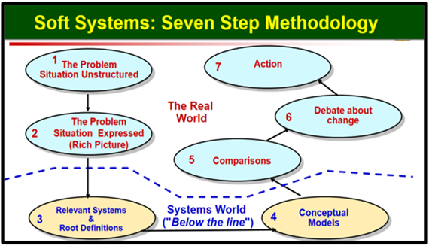

Screenshot3: Soft system methodology

3. Conceptual model: It is the representation of the system that uses concepts and ideas. It is constructing with the help of rich picture and root definition. It helps people [know](https://en.wikipedia.org/wiki/Knowledge), [understand](https://en.wikipedia.org/wiki/Understanding), or [simulate](https://en.wikipedia.org/wiki/Simulation) a subject the model represents.

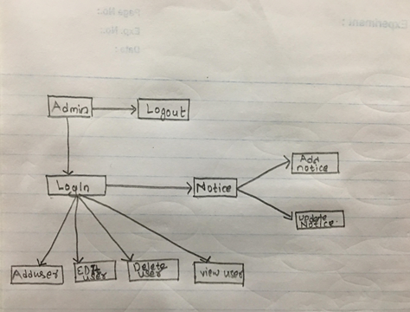

Screenshot4: Conceptual model of Admin

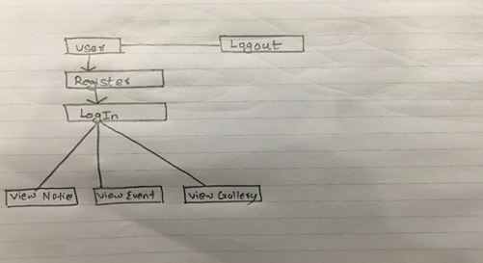

Screenshot5: Conceptual model of Admin

# 2.3 Feasibility study

Feasibility study analyzes all the relevant factors of a project to determine the probability and possibility to complete it successfully. It helps to evaluate the project potential for the success. Feasibility study helps to description of the product or service and the detail of the operation. Mainly it is used in precede technical development and project implementation. The main object of this feasibility study is for scalable, comfortable, compiles and accepts by the user.

The types of feasibility studies are:

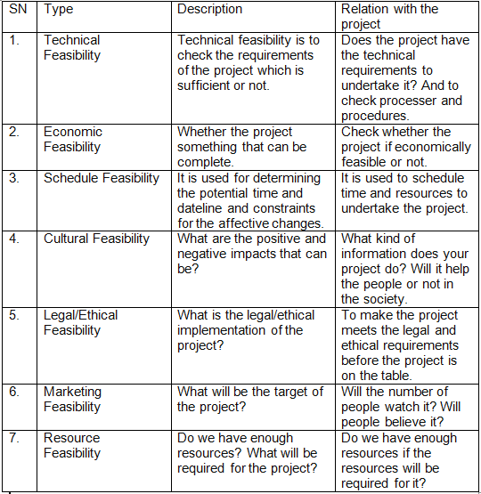 Screenshot6: Feasibility Study

# 2.4 Requirement Analysis

Requirements analysis is the process of defining the expectations of the users for an application that is to be built or modified. Therefore requirements analysis means to analyze, document, validate and manage software or system requirements

The advantages of the requirement analysis are:

1. It ensures that all stakeholders agree on what the system to be built project.

2. It helps to details all the requirements of the system, functional as well as non-functional.

# 2.4.1 Functional requirement

Functional requirement of the system can relate to software and hardware or both in terms. It can be document which explains the expected type of output when the device is placed in suitable environment. It also explains the interaction of the system like input and output. The functional requirement of my project is:

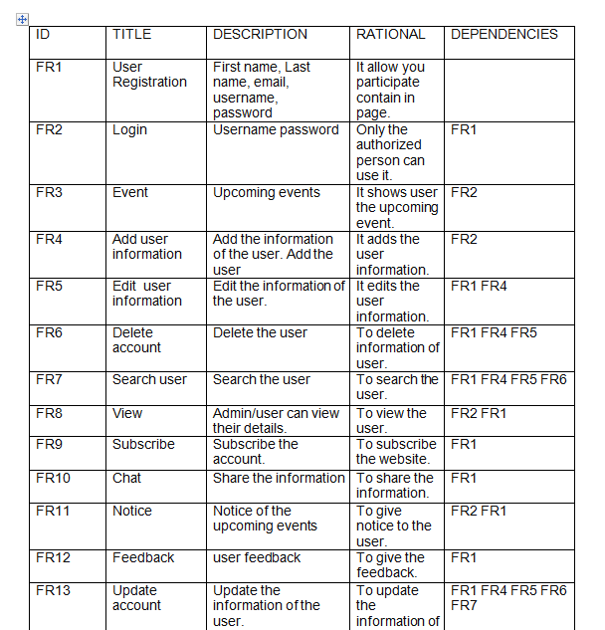

Screenshot7: Functional Requirement

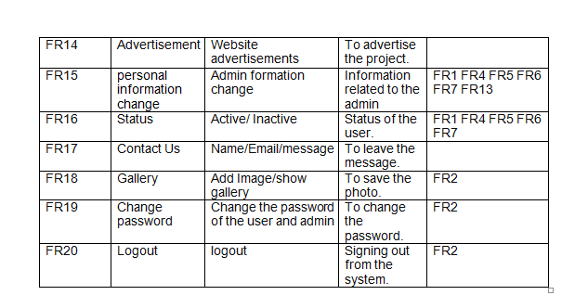

Screenshot8: Functional Requirement

# 2.4.2 Non-functional requirements

It covers the all the requirements which is not covered by the functional requirement. The plan for implementation of the non-functional requirement is detailed in system architecture. It is used to test the system.

The non-functional requirement for my project is:

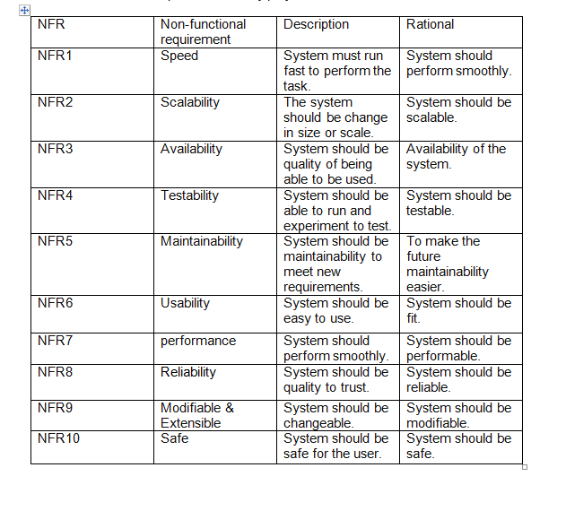

Screenshot9: Non-functional requirement

# 2.4.3 Moscow prioritization

MoSCow prioritization is defined as method or analysis and a popular prioritization technique for managing the requirements. It is commonly used to understand the significance of initiative in a specific release. There are 4 stage of the MoSCow prioritization they are:

1. Must Have: If the project won’t work without it or the system becomes useless without it, the initiative is likely called must-have.
2. Should Have: without the project may work but can be improved or left for future work.
3. Could have: It can be in the system either it can’t be in the system but without it project still works.
4. Won’t have: For the time it is not needed to system but it can be used in the future.

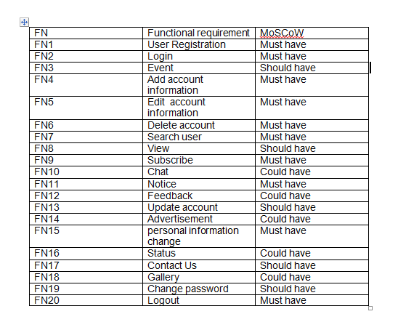

Screenshot10: Moscow prioritization functional requirement

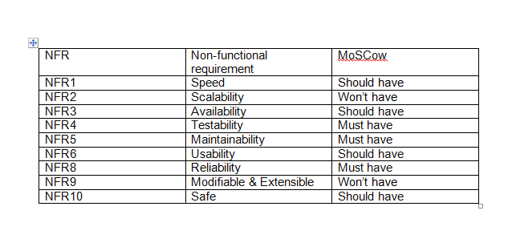

Screenshot11: Moscow prioritization non-functional requirement

# 2.4.5 SRS

Hardware Requirements Specification (SRS) provide the overview of the entire (SRS). It includes the reference scope overview and purpose. The best hardware requirements specification for my project is:

For Hardware

1. Ram: Minimum 2 GB
2. Processor (CPU): 2 gigahertz (GHz) frequency or above
3. Minimum 20 GB space

For Software

1. Windows 7, Windows 10 Linux
2. Database MySQL
3. Browsers: Mozilla Firefox, Safari, Internet Explorer, chrome

# 2.5 Use case diagram

Use case diagram is defined as a methodology used in system analysis to clarify, identify and organize system requirements.

The symbol used in use case diagram is:

1. The boundary defines the system.
2. Actors define their role.
3. Use cases which the specific roles are played by the actors around the system.
4. Relation between use cases and actor.

Use case diagram of the system/project are as follows:

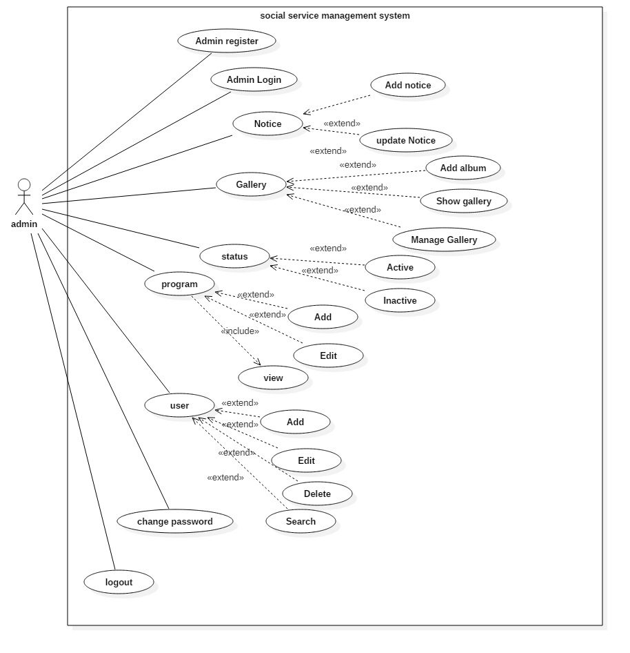

Screenshot12: Use case diagram of Admin

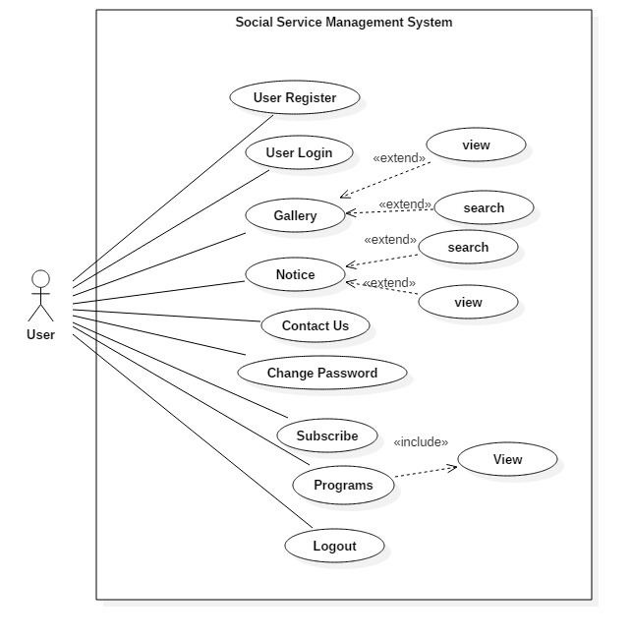

Screenshot13: Use case diagram of User

1. **Registration**

|  |  |
| --- | --- |
| Actor | Users, Admin |
| Flow of Event | * Users provide the personal information of them. * Users should enter unique username and password. * Then user’s registration is complete. |
| Alternative Flow | If username and password field is empty, error message is displaying to fill it properly. |
| Entry Condition | Username and password must be valid for entry. |
| Exit Condition | Successfully register message is display. |

1. **Login**

|  |  |
| --- | --- |
| Actor | Admin and users |
| Flow of Event | * Admin/user should provide correct username and password. * Username/password is check using username and password from database for authentication. * Then user/admin have right access to system. |
| Alternative Flow | Username/password is empty it display message to fill it properly. |
| Entry Condition | Username/password must be correct for authentication. |
| Exit Condition | Login successfully message is displayed. |

1. **Notice (Add, Update)**

|  |  |
| --- | --- |
| Actor | Admin |
| Flow of Event | * Admin can add delete notice. * Users can view the notice. |
| Alternative Flow | Empty file shows the error message. |
| Entry Condition | Added notice must need to be correct. |
| Exit Condition | Task is done message is displayed. |

1. **Actor**

|  |  |
| --- | --- |
| Actor | Users |
| Flow of Event | * Actor searches the user with its name. * System checks whether the name is the data is correct or not. * Actor gets the view of the user. |
| Alternative Flow | .If the username is not match no result is view. |
| Entry Condition | Inserted username must be correct to get searched. |
| Exit Condition | The username is view by the Actor. |

1. **Change Password**

|  |  |
| --- | --- |
| Actor | User/ Admin |
| Flow of Event | * Admin/user can change their password with the help of previous. * Admin/users are given new password. * If previous password matched with the data then system given new password. |
| Alternative Flow | If the previous password don’t match it show error message. |
| Entry Condition | Current password must match. |
| Exit Condition | Password is change message will display. |

1. **Change Profile and admin can manage users**

|  |  |
| --- | --- |
| Actor | Admin and user |
| Flow of Event | * Admin can change the profile. * Admin can view/edit/delete thee users’ profile |
| Alternative Flow | Empty filed will send error message. |
| Entry Condition | Data inserted must be valid. |
| Exit Condition | Task related to it is done message is displayed. |

1. **Program**

|  |  |
| --- | --- |
| Actor | User/Admin |
| Flow of Event | * Admin can add, edit and view the program (event). * Users can view the upcoming programs. |
| Alternative Flow | Empty field shows error message. |
| Entry Condition | Inserted data must be correct. |
| Exit Condition | Respective task have been done message is displayed. |

# 2.6 NLA and initial class diagram

Natural Language Analysis (NLA) is the component of artificial intelligence (AI)

It makes computer program understand human language as it is spoken. It used to analysis and to identify class.

Social service management system is located in the putalisadak which have been helping people doing events. So the owner wants to make website better.

User can register to be the member of social service. If they want to know about it further they can contact us. Admin can add, delete, edit and view the user details. Users/Admin can set their owned unique password and username. Admin can search the use by their name. User can online chat with the member and discuss about upcoming events. Admin can check the status whether the user/member are active or not. Admin can add, Update view the upcoming program (events). User can view the upcoming events and can participate in the event. User can change status by Active or Inactive. Admin can add edit delete the photo of the events. Admin can make the album where we can add the image related to the particular event. Users can view the gallery and see the past events. Admin can organize the program by setting the events and groping them for helps like awareness program, blood donation, cleaning programs etc. use can have the group discussion from chat. User can advertise the social work that they have done lately in the website. Users can motivate people through the advertisement of it.

From this application, for those people who are interested in social work they can participate here. People can register their name to become the member. So the main objective of this project is to motivate people for social work and add as many members for social work and keep them update for upcoming events.

|  |  |  |
| --- | --- | --- |
| **Nouns** | **Adjectives** | **Verbs** |
| user program booking  admin | Name username password surname | add edit delete update |

Class diagram

Class diagram is a diagram and part of unified modeling language (UML)

Which provides the overview and structure of a system in term of class attributes and method? It shows relationship between different classes. It describes the attributes and operation of a class. It is widely used in the modeling of object-oriented system.

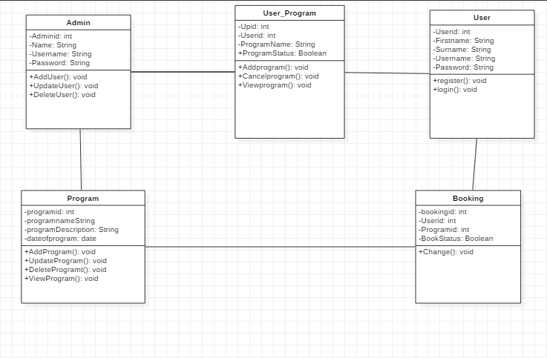  
 Screenshot14: Class Diagram