Introduction

My project is about social service management system. My project is web based application and it is about the social work which held in our society like cleaning program, awareness program and donation program.

Background of the project

You can be the member of any social work like Red Cross, Scout and donation. This project is for anyone who what to join in social work and know about the program which is going to be held.

Problem statements

The problem can be something that is hampering or disturbing the economic, social, psychological, and environmental.

Description of the project

The social work profession promotes social change, problem-solving in human relationship and the empowerment and liberation of people to enhance their independence and happiness.

Features of the project

The main feature of the project is you can me the member of the social service. You can participate in many social work. Upcoming programs are given. You can donate anything that can be helpful to the homeless people.

Overview of the project

The main concept of this project is to help many people. Join the new members for the volunteer work in society. Awareness program in the society.

Scope

Basically the scope of this website is it provide the information of social work and helps people who want to join it. It organize the program where people can help them. It provides the awareness program. It creates the more member and helps to build up the website.

Limitation

There might not be sufficient member to volunteer. Someone might get absent due to their personal issue. Managing the program can be difficult. Some people might find difficult to use website.

Aims

* The aim of this project is to join many members for the social work.
* Share the information related to the social work.
* Make people participate in the social work.
* Make website easier to use and understand to people.

Objective

The objective of this project is to:

* Define the project
* Setup project tasks
* Prepare the information architecture
* Figure the time and cost
* Obtain the terms
* Get started on your project

Overview of the scope

This website is about the social service this website is about helping other people through the social work. It schedule the program and provide the information of the social work. It helps to find or encourage the people about the social work. It also provide the awareness program by the help of the social service member. You can be the member of the social work.

Chapter 3: Development method

Description of the method

For this project I have use the waterfall model it is a project management methodology which is step by step design process. Waterfall model is simple and easy to use. Waterfall model is earliest SDLC approach that was used for software development.

I have choose waterfall model because it is easy to use and understand for everyone. It follow the step by step process. Waterfall model have the six phases they are:

* Analysis
* Design
* Code
* Test
* Display
* Maintain

Limitations of Waterfall Model is:

* It can be difficult to estimate the time and cost for each step.
* One project is tested it is difficult to go back and change something.

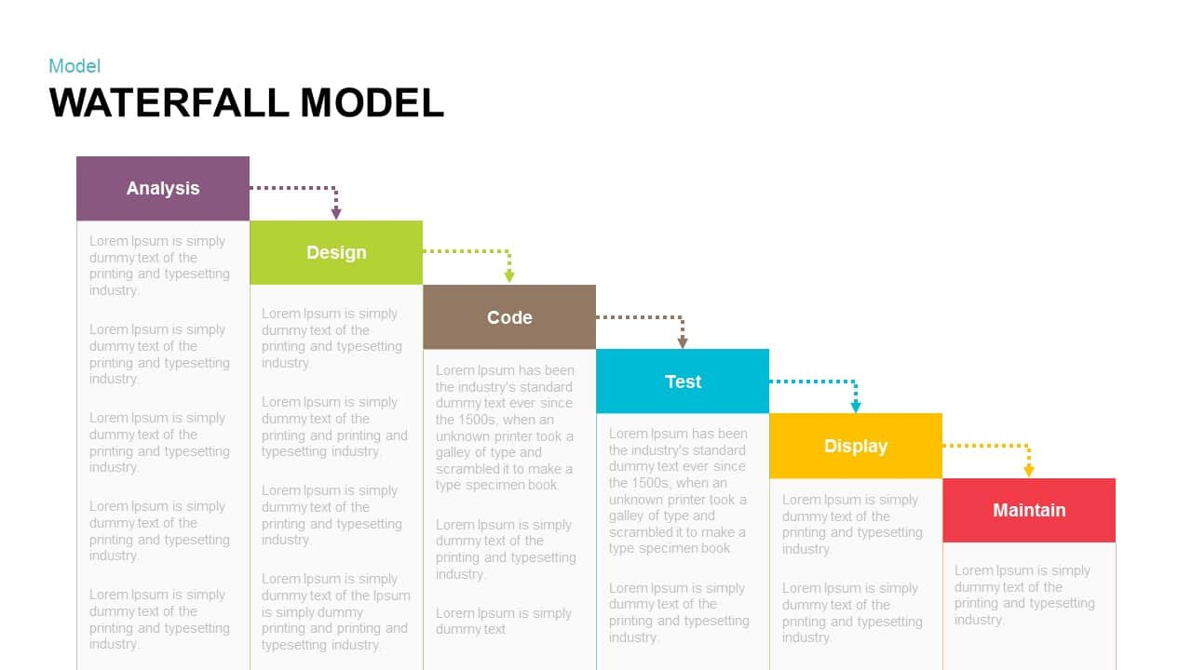

Figure: Waterfall Model

Design pattern

Design pattern is used to solve the common problem which occur during the development. I have select the MVP (Model view controller) for my project. The reason why I chose MVP it is faster development process. And using the MVP can be three time faster than other pattern. The components of the MVP is model, view and controller. The advantage of the MPV is:

1. It is faster developments process.
2. It provide multi views.
3. Friendly development platform.

Disadvantage of the MVP is:

1. It increased complexity.
2. Difficult to use modern user interface.
3. It needs multiple programmers.

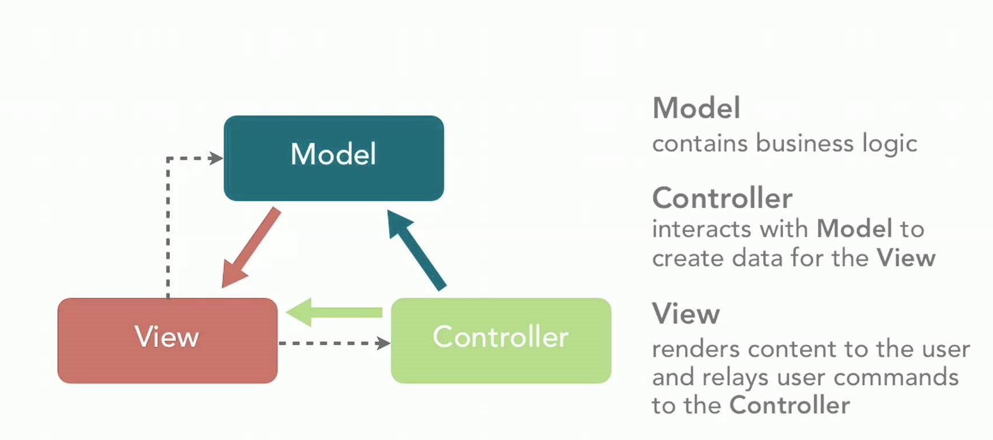

Figure: Model view controller

Architecture

Chapter4: Project planning

Work Breakdown Structure (WBS)

It is a key project deliverable that helps to organize the team’s work into manageable section. This is the work breakdown structure of the social service:

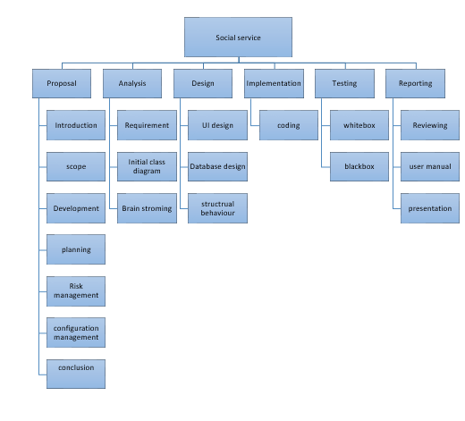

Figure: Work Breakdown structure

|  |  |  |  |  |
| --- | --- | --- | --- | --- |
|  |  |  |  |  |
|  |  |  |  |  |
|  |  |  |  |  |
|  |  |  |  |  |
|  |  |  |  |  |
|  |  |  |  |  |
|  |  |  |  |  |
|  |  |  |  |  |
|  |  |  |  |  |
|  |  |  |  |  |
|  |  |  |  |  |
|  |  |  |  |  |
|  |  |  |  |  |
|  |  |  |  |  |

Gantt chart 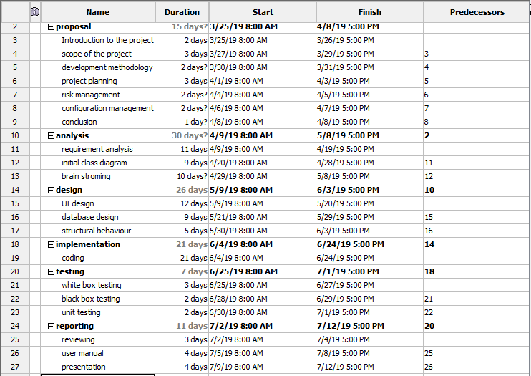

Figure: Separating time for each task

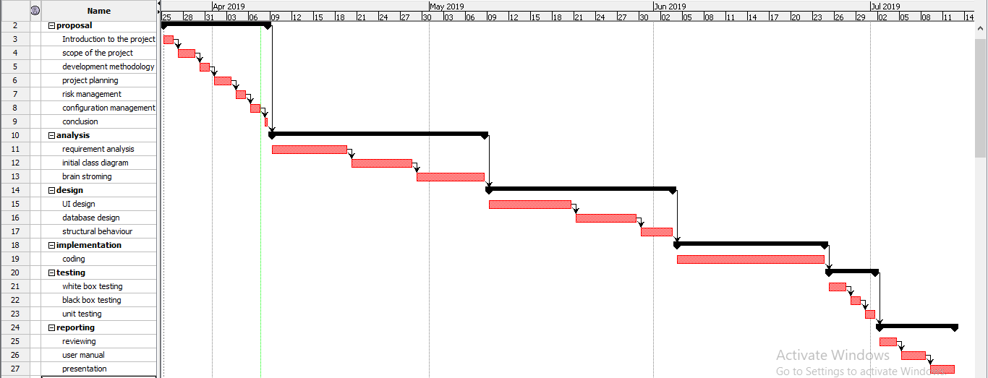

Figure: Gantt chart

Risk management

Risk management is the process of identifying and controlling the threats. Risk can be come from the various source at the phases like analysis design, code, test, display and maintain. Risk management is necessary because it protects from different kind of threat and save our assets. So in-order to minimize it we do risk management. Risk management also helps to create the safe environment while development phases. The five step of risk managements are:

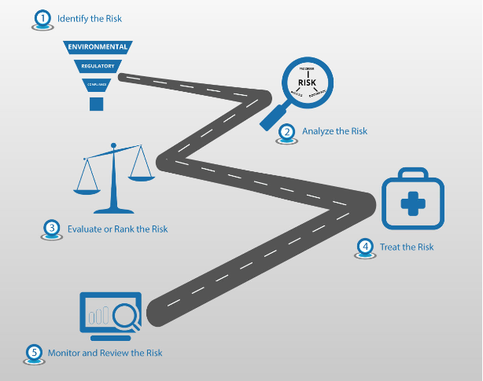

Figure: Risk management

1. Identify Risk
2. Analyze the risk
3. Evaluate the risk
4. Treat the risk
5. Monitor and review the risk
6. Identify the risk

It is the first step the risk that control the threats in its operating environments. It helps to identify as many risk factor that are possible.

1. Analyze the risk

After the risk is identify the scope of the risk should be determined. To analyze the risk we should understand the link between the risk and different factor in organization.

1. Evaluation of risk

Risk need to be grade and prioritized according to its threat. Some risk have high number of threats. Some have less amount of risk it needed to be ranked.

1. Treat the risk

After grading the risk it need to be eliminated as much as possible. Some risk might not need to solve but higher number of risk which affects the working environment need to solve soon.

1. Monitor and review the risk

Some of the risk remains in the system but market risks and environment risks need to be monitor always. So the risk should be monitor time to time to stop from threats and risks.

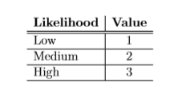

Table: Risk likelihood value

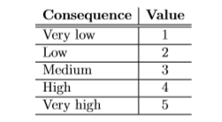

Table: Risk consequence value