Design

It is an activity specification or construction or the result of plan in the form of finished product, prototype or process. After requirement gathering and analysis it is done. Design helps in specifying hardware and system requirements and also helps defining it all. It is created to outline technical requirement such as architecture data sources hardware and service. We have many tool and techniques for design. It describes the overall mechanism of the system. The main aim of design is for usability, customer experiences, customer need, performance, accessibility and all the requirements of customer.

It helps in further performance of the project, for this project I have use different structural, behavioral and Database modeling.

Design helps for further implementation of project, so I will be illustrating Structural, Behavioral and Database Modeling. It will include prototyping, class diagram, and activity diagram etc.

Flowchart:

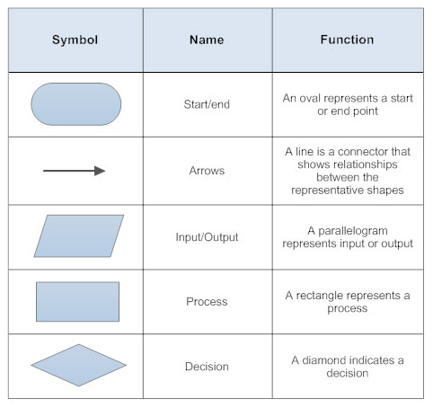

## 3.2) Behavior Modeling

### 3.2.1) Activity Diagram

An Activity Diagram is a behavioral diagram in UML diagram that presents flow of control or actions in a system. It is used to model the flow from one activity to other.

The reasons behind using Activity diagram are:

1. Illustrate the flow of activity of a system,
2. It is easy to understand and helps while coding,
3. It shows business logic in a simple format which helps in communication,
4. They are user-friendly so people with no programming knowledge can also understand it.

**Notations Used**

|  |  |  |
| --- | --- | --- |
| Symbol | Name | Use |
| Start | Start/ Initial Node | Used to represent the starting point or the initial state of an activity |
| Activity | Activity / Action State | Used to represent the activities of the process |
| Control flow | Control Flow / Edge | Used to represent the flow of control from one action to the other |
| Activity final node | Activity Final Node | Used to mark the end of all control flows within the activity |
| Decision node | Decision Node | Used to represent a conditional branch point with one input and multiple outputs |
| Fork | Fork | Used to represent a flow that may branch into two or more parallel flows |
| Note or comment | Note/ Comment | Used to add relevant comments to elements |

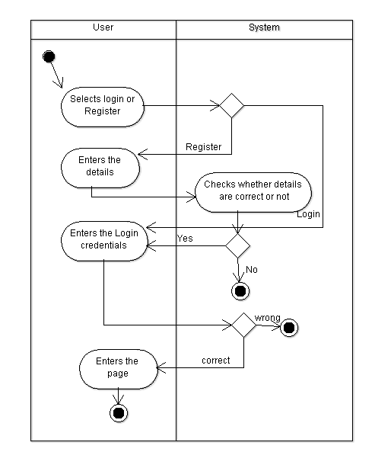

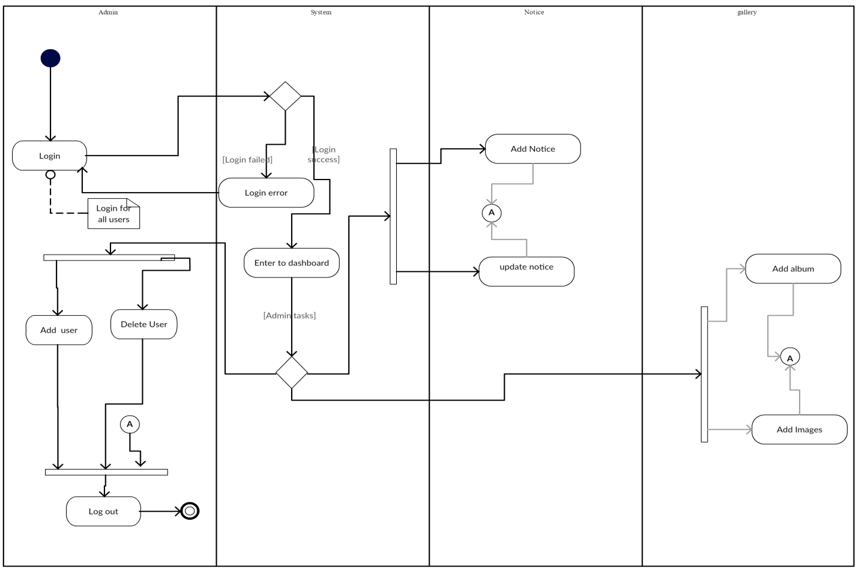

Sequence diagram:

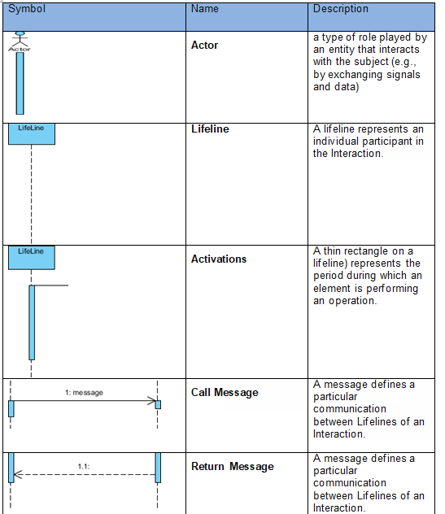

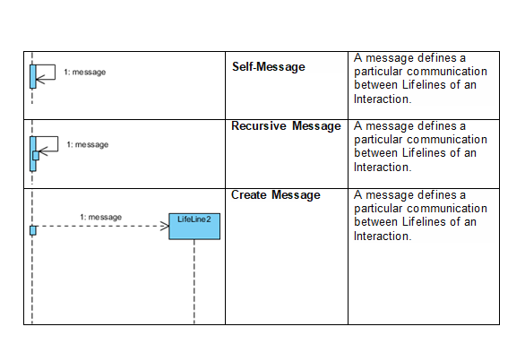

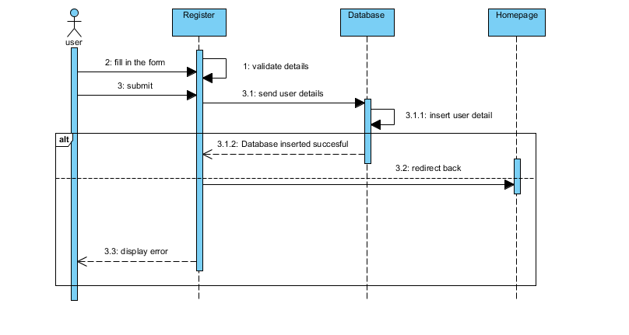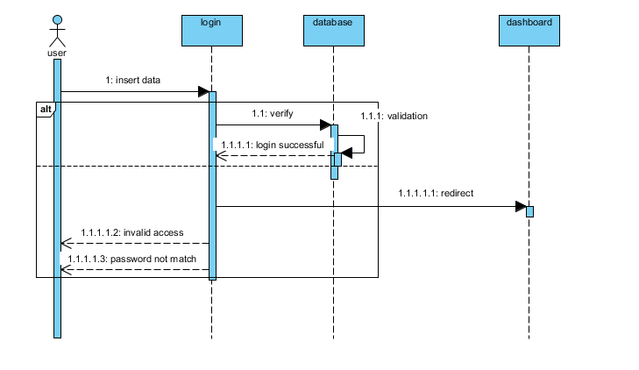

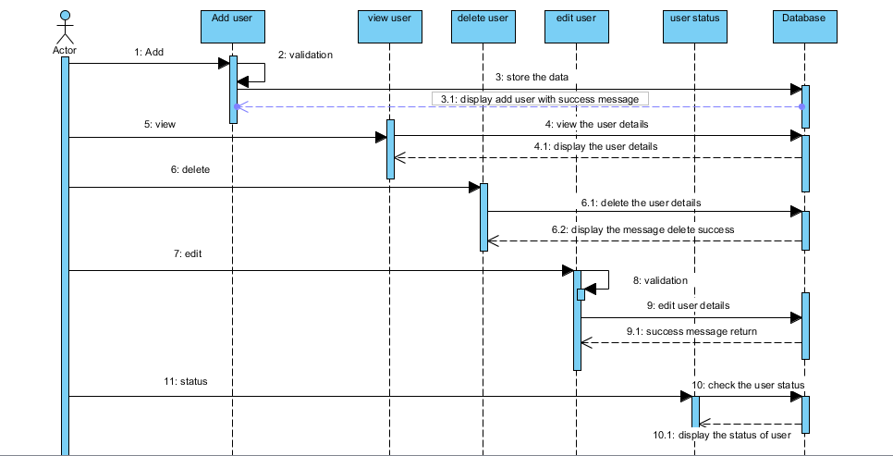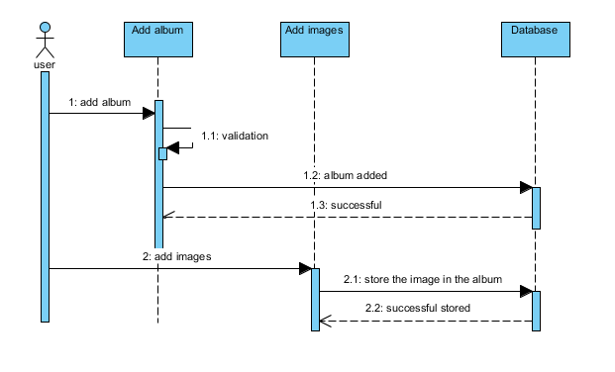3.3) Database Modeling

### 3.3.1) Data Dictionary

