Computer Graphics - Assignment 1

# Aniket Agarwal

# (17317437)

Exercise 1: Make the fragment shader use the colour specified in the vertex buffer object and the resulting triangle should be multi-coloured.

To do this I created an array containing the respective colours for each vertex which is bound to a buffer object. This is then passed into the vertex shader to be displayed by the fragment shader. Inside the fragment shader, each of the colours are assigned to their respective shader and the rest of triangle is coloured by interpolation. The result is show below:

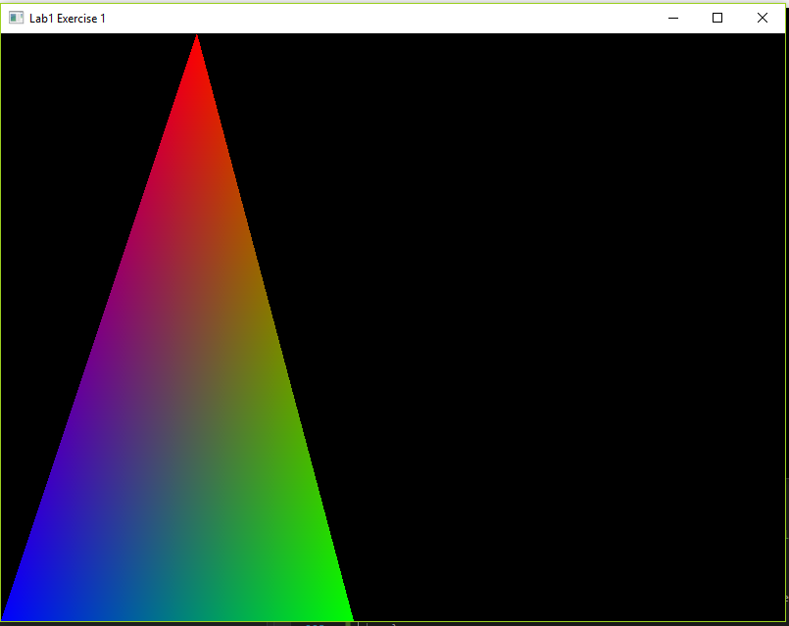

Exercise 2: Draw 2 triangles next to each other using “glDrawArrays” by adding more vertices to your data.

To do this I simply added more values in the vertices array and changed the glDrawArrays is parameters from 3 to 6 as there were more vertices this time. I also made some other small changes in the program as I demonstrated during the evaluation. The result is shown below:

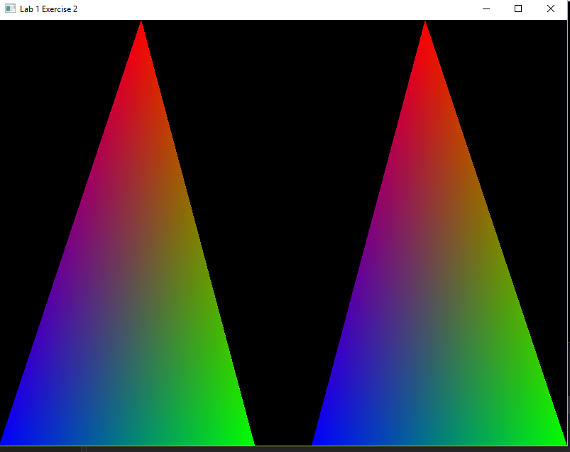

Exercise 3: Draw 2 triangles next to each other using different VAOs and VBOs

To do this I created two different arrays containing the respective colours for each vertex bound to a buffer object. A separate VAO is then created for each buffer object and then passed into the vertex shader by the fragment shader. The result is shown below:

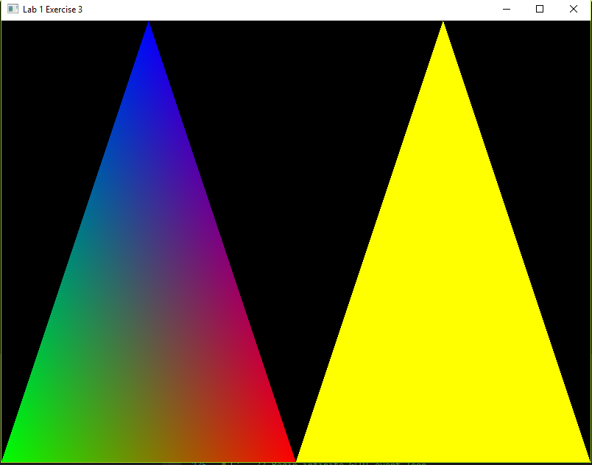

Exercise 4: Create two shader programs where the second program uses a different fragment shader that outputs the colour yellow; draw both triangles again where one outputs the colour yellow.

This exercise was just an extension of the exercise 3 and to implement this I created an array of shaderprogramIDs which took the information of each VAO separately and then gave the desired output. The result is shown below:

