**CS4052: Computer Graphics-LAB 2**

Aniket Agarwal (17317437)

For the following lab we have five tasks. In each task we had to apply various different transformations to the triangle when the key is pressed. For completing the first three tasks I modified the vertex shader to include 3 mat4 uniforms representing translations, scale and the rotation transformation to be applied. The output of the vertex shader is then set to the product of scale, rotation and translation and a vec4 containing the vertex position.

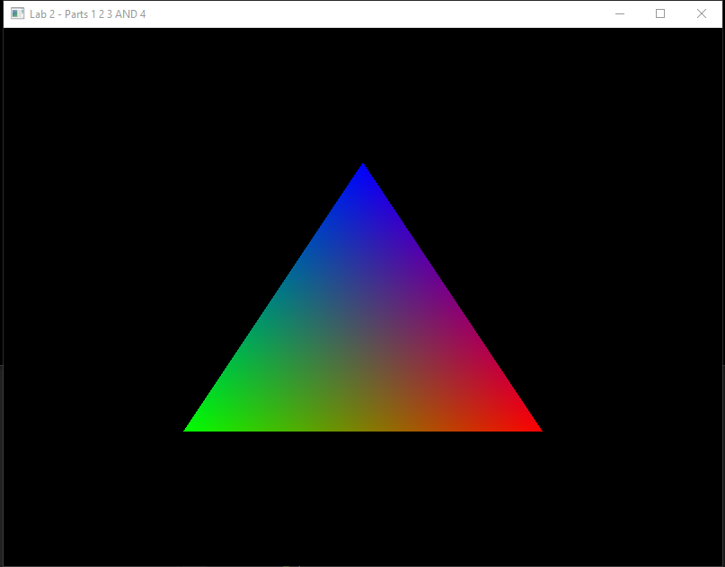

(Original image)

The first task as to rotate the triangle along x, y and z axis with the second task to translate along x, y and z axis which can be seen in the following screenshots. To apply rotation transformation on a figure depends on which axis you are rotating around, but whichever axis you rotate all the transformations are done by setting 4 different values in the transformation matrix to values in terms of cos and sine of the angle of rotation. Whereas the application of a translation is done by adjusting the right most column of the matrix which is in the row-major format. (Screenshots in the order in which the tasks were assigned)

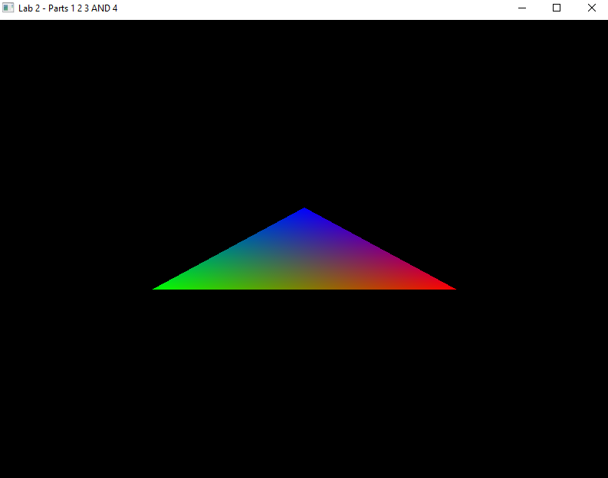 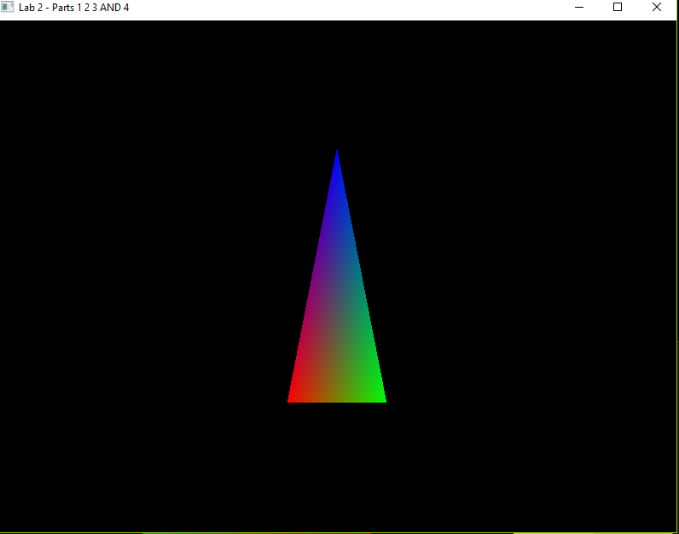 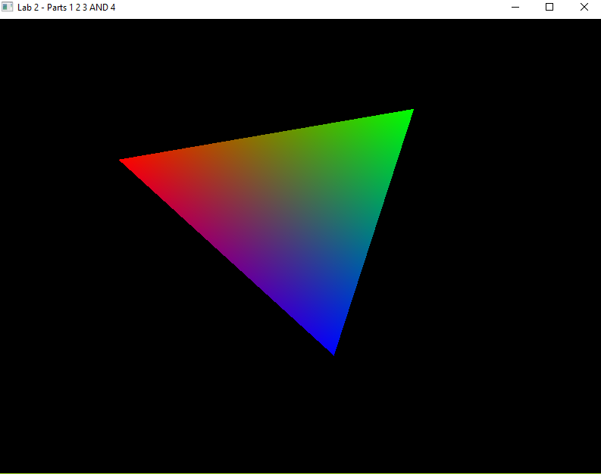

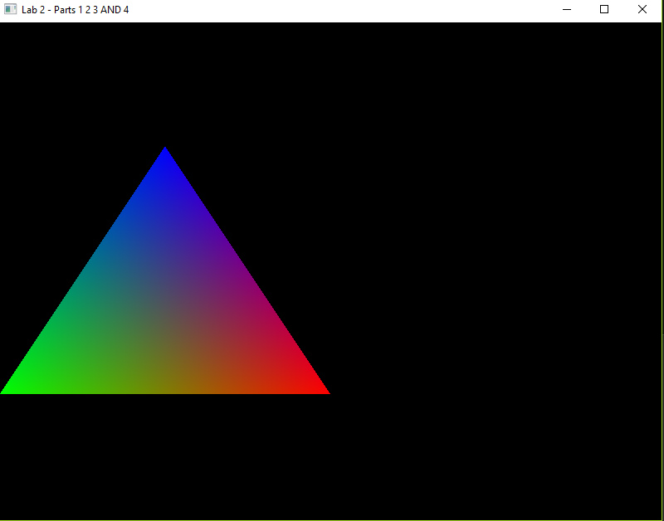 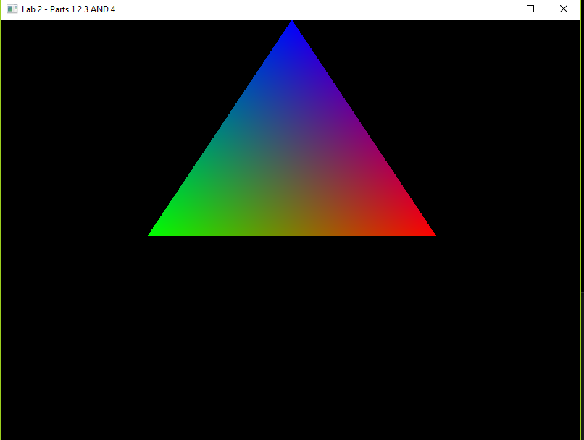 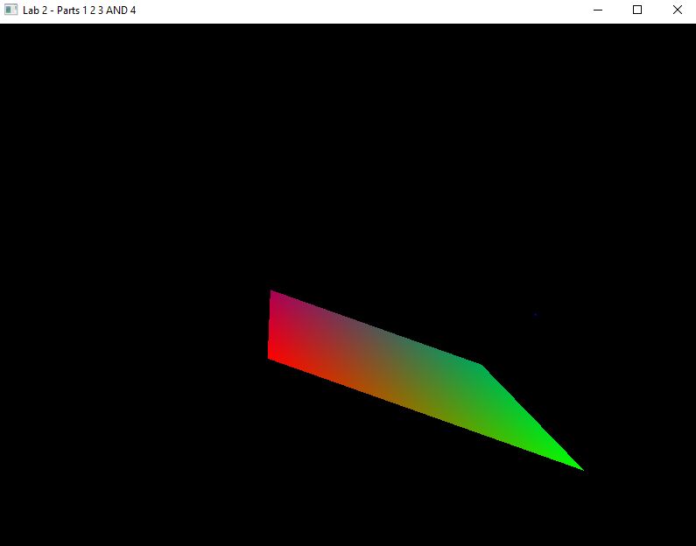

The third task was to perform two types of scale transformations, uniform and non-uniform which is done by adjusting the values along the main diagonal in the identity matrix. The results can be seen below:

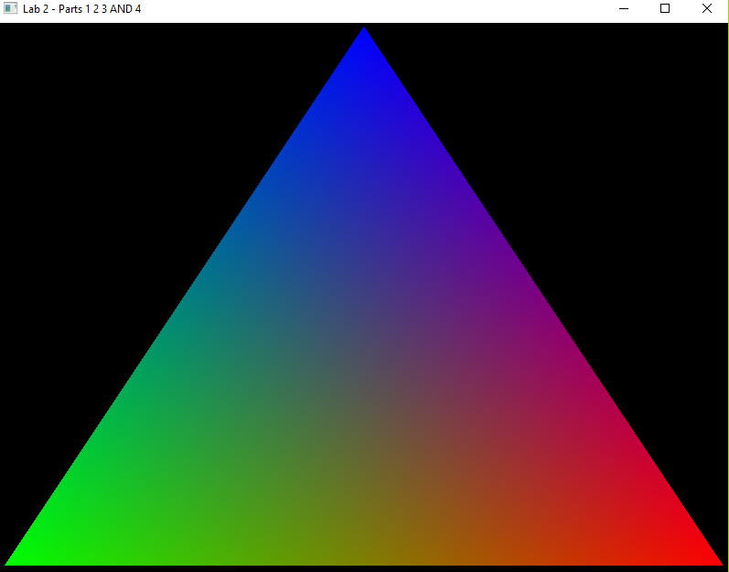 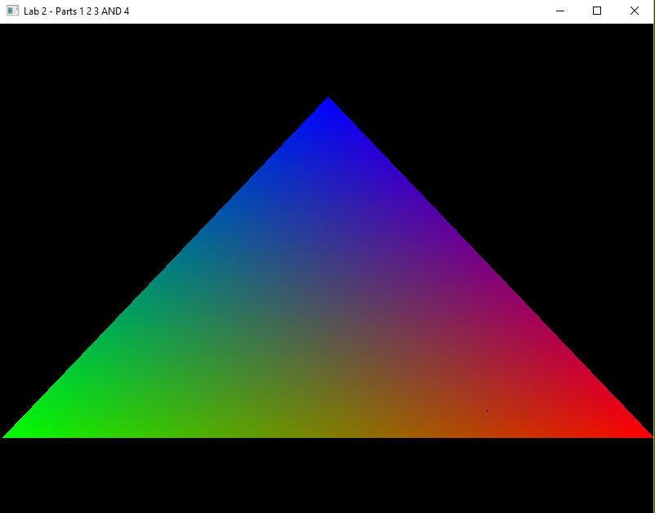

The fourth task was to do a combined transformation that is the rotation, translation and scaling at the same time to the triangle. The results can be seen below:

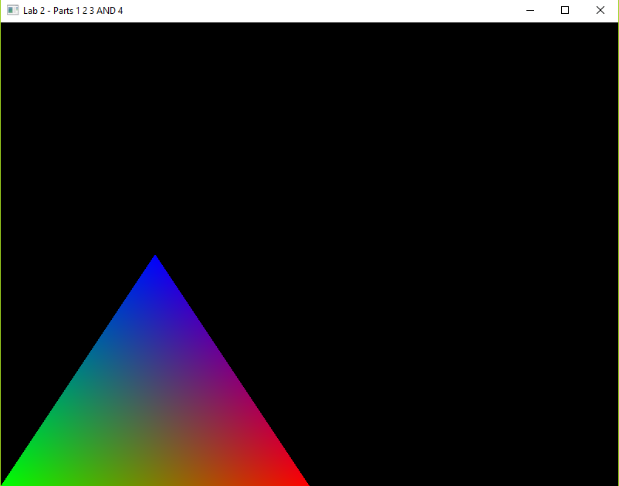 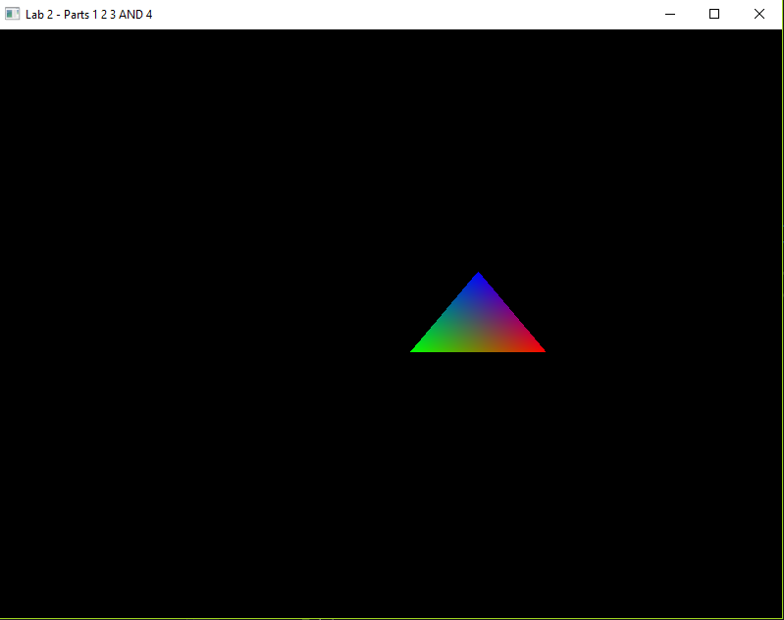 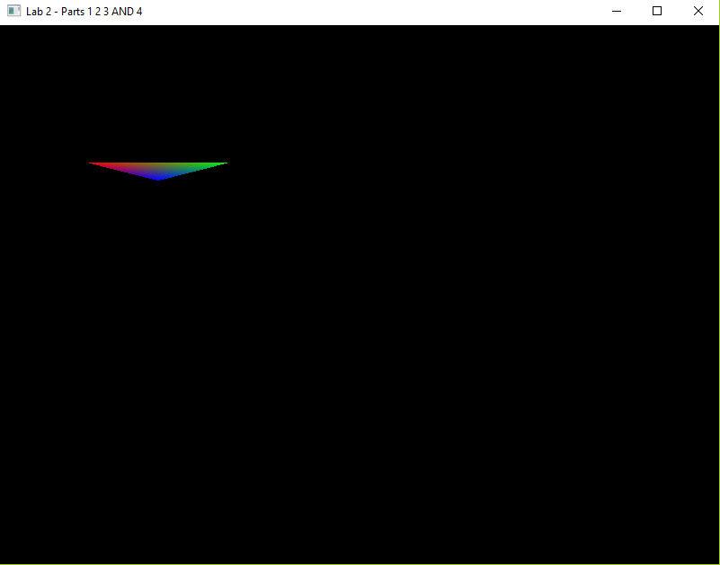

The fifth task was to have multiple triangles in the scene and using the same buffer but creating a new transformation matrix for each one.

