**NAME :- ANIKET BEDI**

**LINUX BASICS ASSIGNMENT**

A1. 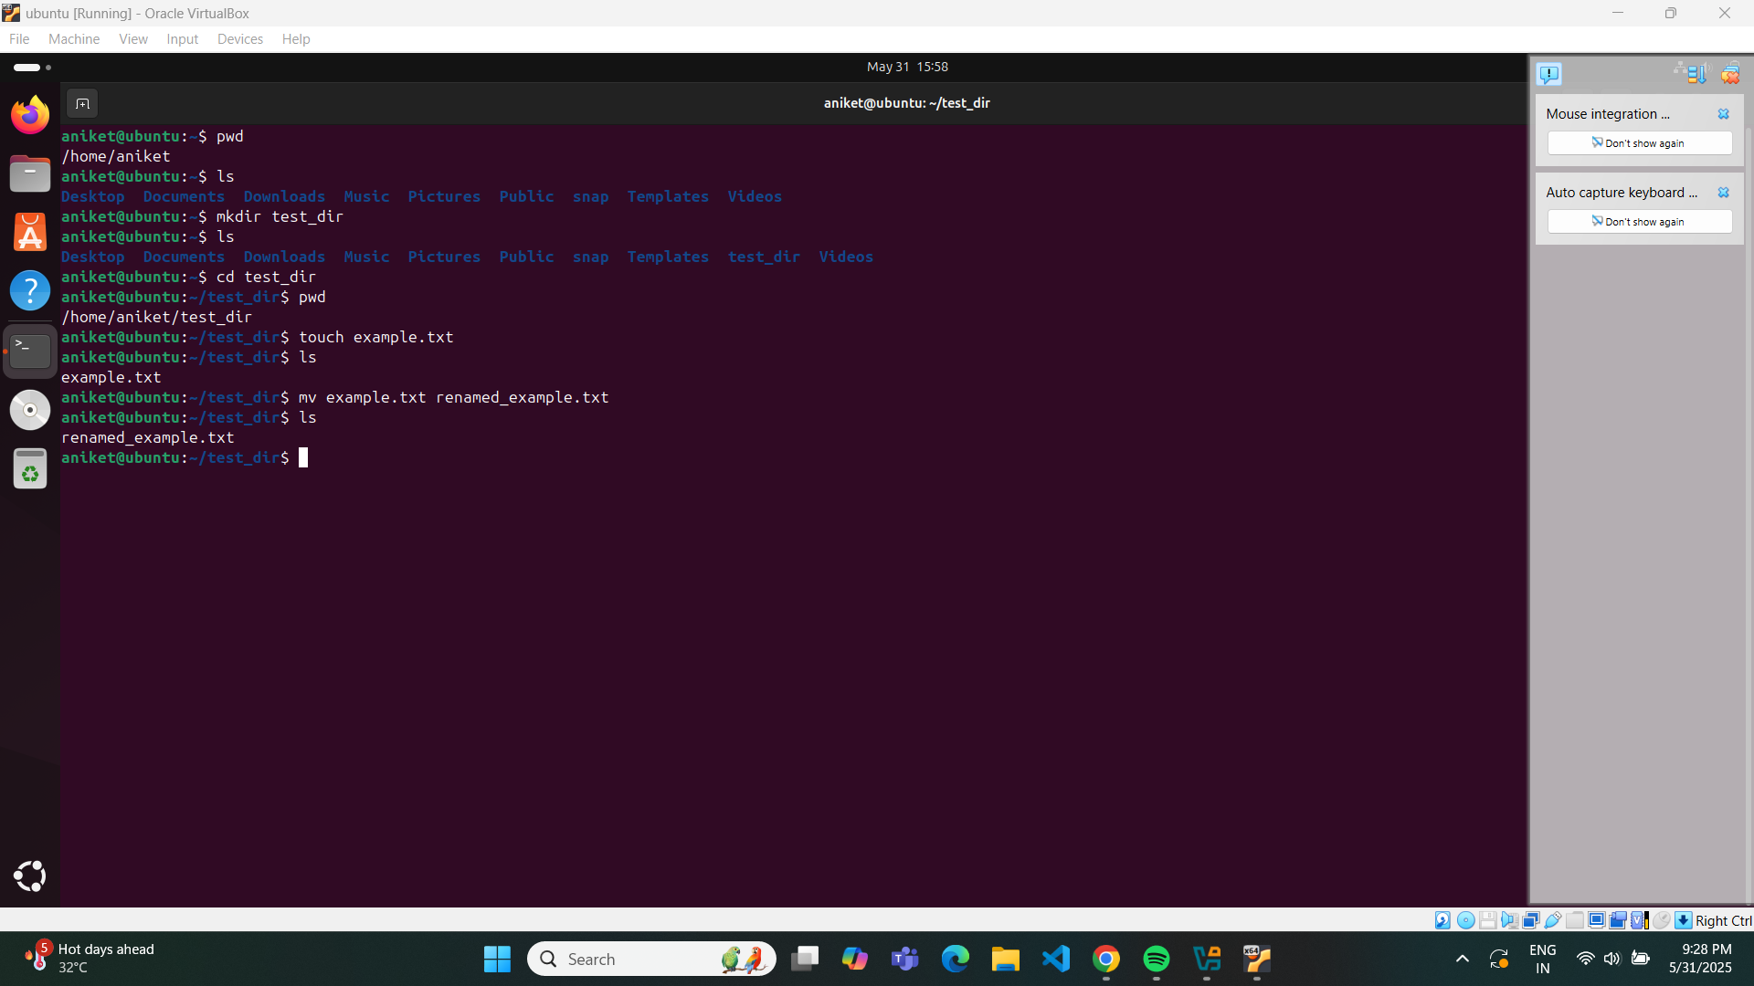

A2. 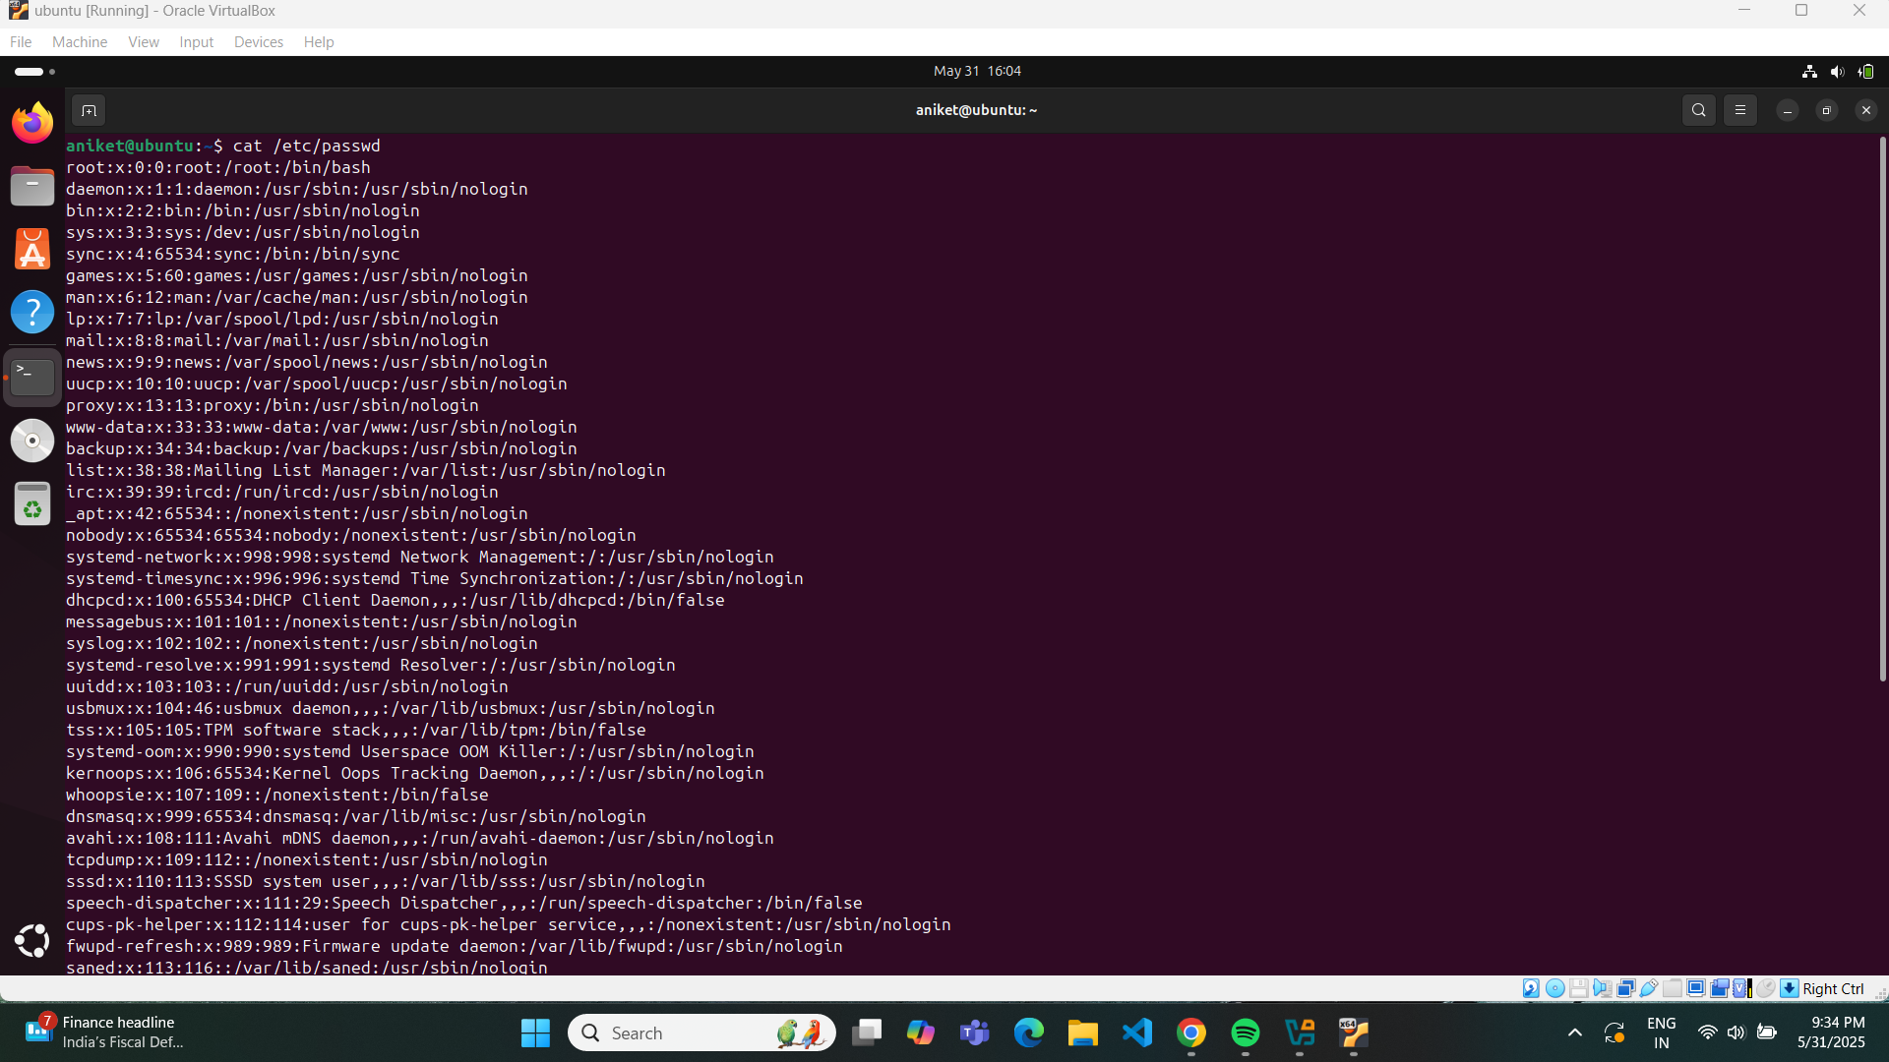

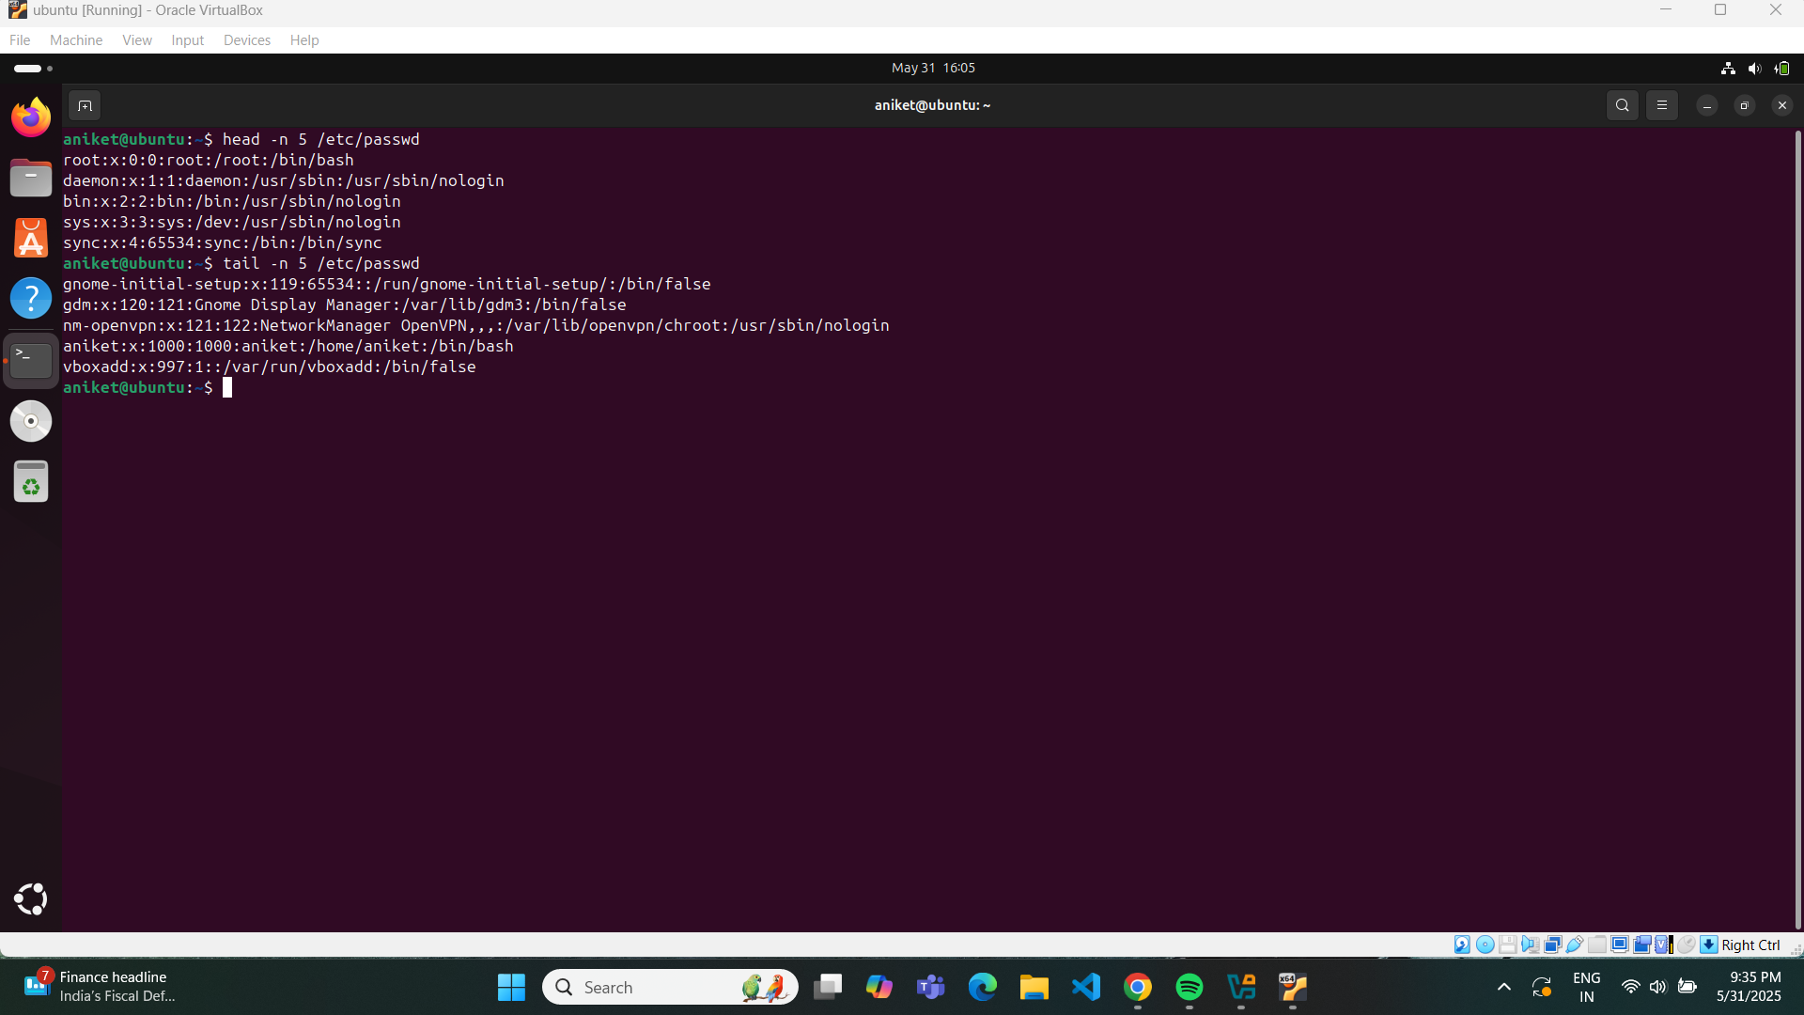

A3. 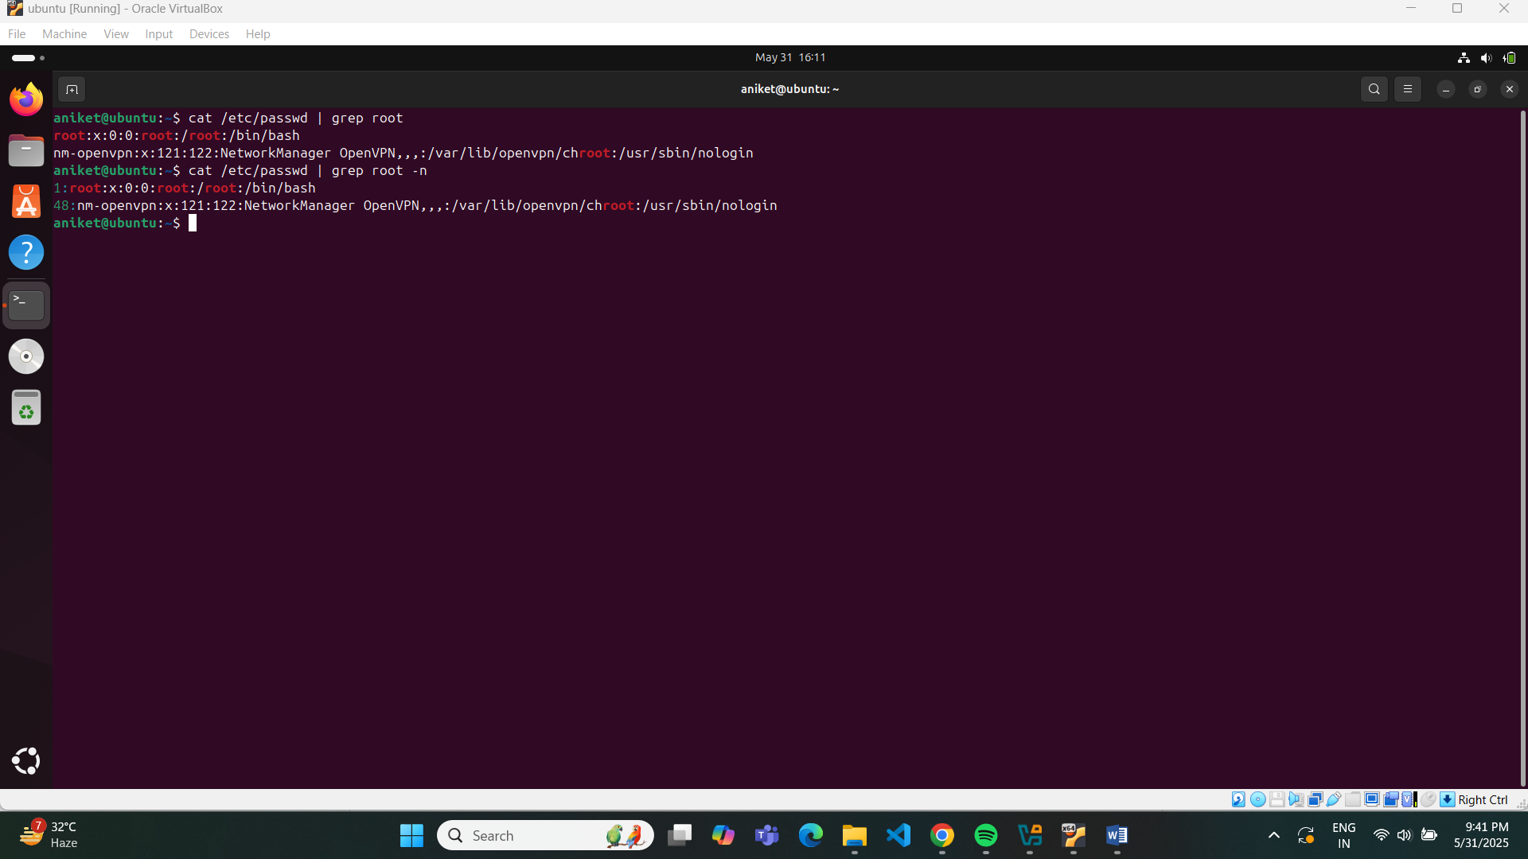

A4. 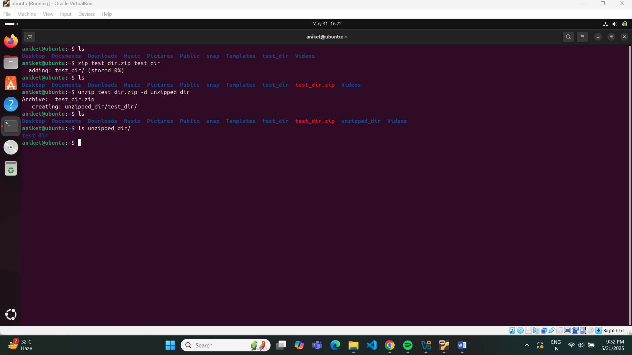

A5. 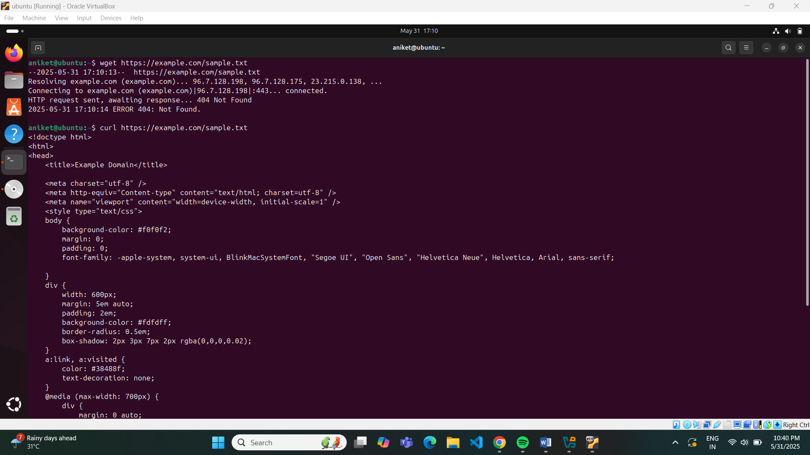

In this question it was told to use the link given in assignment to download a file using wget but in here it shows error as u can see from the above screenshot. I used curl to print the output and it worked but not the wget.

A6. 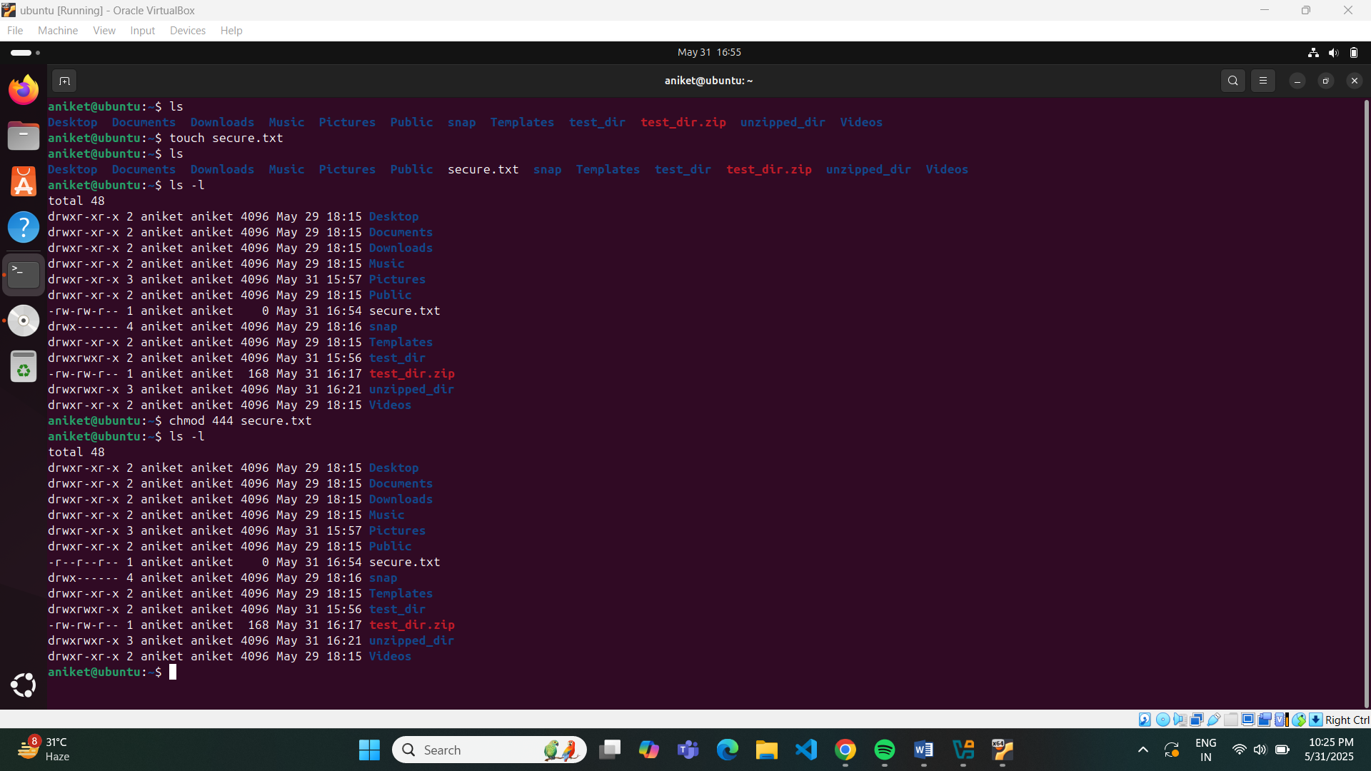

A7. 