LAB 3 — PERFORMANCE ANALYSIS
Execution Time, Memory Usage, and Complexity Comparison of Greedy Algorithms
Student Name | Aniket Chauhan
Roll No. | 2401201032
Course / Semester | BCA / 5th
Subject | Design and Analysis of Algorithms

1. Objective
To measure execution time and Python-tracked peak memory for the implemented Fractional Knapsack, Activity Selection, and Huffman Compression algorithms, and to compare their theoretical time and auxiliary-space complexities.

2. Methodology
The notebook uses time.perf_counter() to measure elapsed runtime and tracemalloc to estimate peak memory allocated by Python during each function call. The measurements shown here are transcribed from the supplied notebook screenshot and represent one run on small predefined test inputs. They can vary across machines and repeated runs.
def measure_performance(function, *args):
tracemalloc.start()
start_time = time.perf_counter()
result = function(*args)
end_time = time.perf_counter()
current_memory, peak_memory = tracemalloc.get_traced_memory()
tracemalloc.stop()
execution_time = end_time - start_time
peak_memory_kb = peak_memory / 1024
return result, execution_time, peak_memory_kb

Explanation of the measurement code
- tracemalloc.start() begins tracing Python memory allocations.
- time.perf_counter() provides a high-resolution clock suitable for elapsed-time measurement.
- The algorithm is executed between the start and end timestamps.
- get_traced_memory() returns current and peak traced memory; peak_memory / 1024 converts bytes to KB.
- The function returns the algorithm result, elapsed time, and peak traced memory.

3. Experimental Results
The table below reproduces the values visible in the supplied performance screenshot. The Fractional Knapsack and Huffman results use the larger test data defined in the performance cell.
Algorithm | Output | Execution time (seconds) | Peak memory (KB)
Fractional Knapsack | 250.0 | 0.000118 | 0.234375
Activity Selection | [(1, 2), (3, 4), (5, 7), (8, 9)] | 0.000329 | 0.226562
Huffman Compression | 107 | 0.000816 | 9.697266
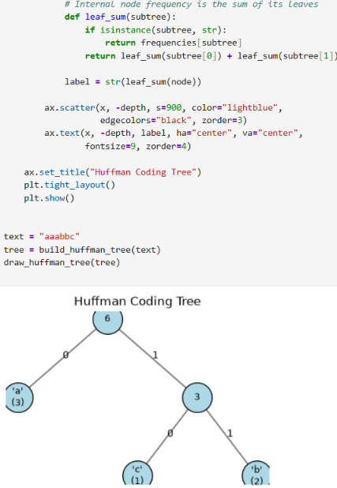
Figure 1. Actual notebook performance results.

4. Code explanation and interpretation

Fractional Knapsack
Items are sorted by value-to-weight ratio. The algorithm takes items in descending ratio order until the capacity is filled. The observed output 250.0 corresponds to the five-item test dataset shown in the performance cell, not the smaller sample that produces 240.0.

Activity Selection
Activities are sorted by finishing time. An activity is accepted when its start time is greater than or equal to the finish time of the last accepted activity. The measured output lists four non-overlapping activities.

Huffman Compression
The text is counted by character, then a min-heap repeatedly combines the two least frequent nodes. The total of merged frequencies is the encoded size. The performance cell uses a longer text than the simple 'aaabbc' demonstration, so its observed size is 107 bits.

5. Theoretical Complexity Comparison
Algorithm | Best time | Average time | Worst time | Auxiliary space
Fractional Knapsack | O(n log n) | O(n log n) | O(n log n) | O(n)
Activity Selection | O(n log n) | O(n log n) | O(n log n) | O(n)
Huffman Compression | O(n + k log k) | O(n + k log k) | O(n + k log k) | O(k)
Here n denotes the number of items or activities, or the text length for Huffman coding; k denotes the number of distinct characters. Sorting dominates the first two algorithms. Huffman frequency counting costs O(n), followed by O(k log k) heap merging.
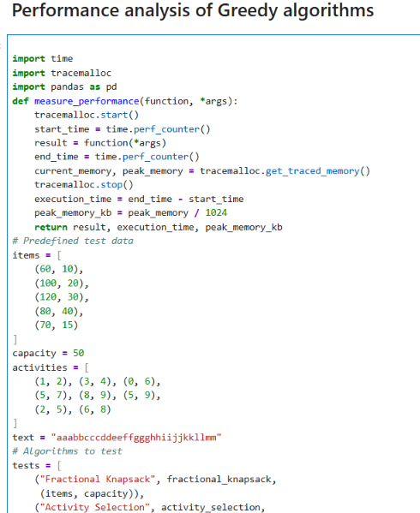
Figure 2. Complexity comparison table from the notebook.
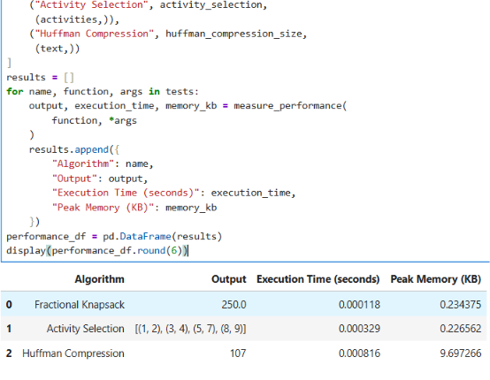
Figure 3. Saving the results tables as CSV files.

6. Conclusion
The performance measurements provide a practical snapshot, while asymptotic complexity explains how the algorithms scale as input grows. For this particular run, Fractional Knapsack had the smallest measured runtime and Huffman Compression had the highest measured peak traced memory. Because the test inputs are small, these observations should not be treated as universal rankings. For a stronger benchmark, repeat each test several times and use larger datasets.
https://github.com/AniketChauhan10

