Project Execution Instructions (GR 19):
- The code can be run online via Google Colab or offline by installing Anaconda (Jupyter Notebook). It is saved in the .ipynb format.

- The desired model is saved in the .h5 format and embedded into the flaskapp.py file. Flask is a framework or an API of python for building Web Applications.

- The following packages are required to be installed if running the module via an offline machine:
- numpy
- json
- os
- math
- librosa
- sklearn
- tensorflow

- Also, the required dataset and metadata must be stored in the local machine or drive depending upon offline or online execution respectively. The corresponding location must be updated in the program code as well as shown:

If the dataset is kept in the google drive, it needs to be mounted in order to fetch the dataset as shown below.

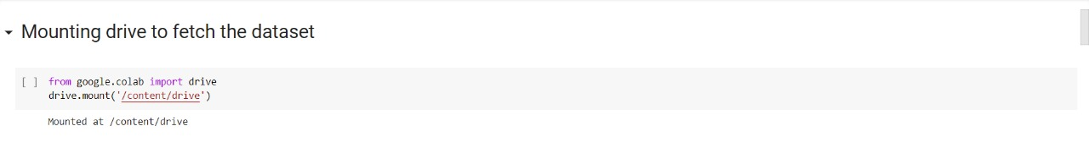

This is the required dataset path.
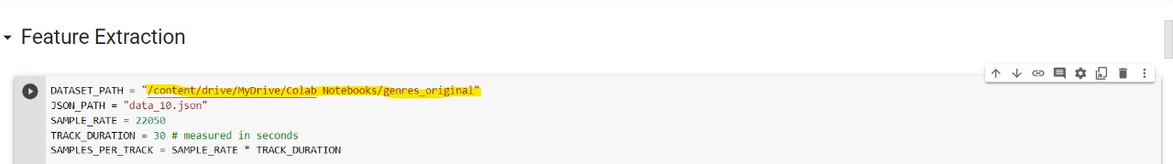

- For execution of the code each individual cell must be run in a Top-Down manner using the run button or pressing Ctrl+Enter.

