**Terraform Training Tasks**

**Terraform cloud.**

**1.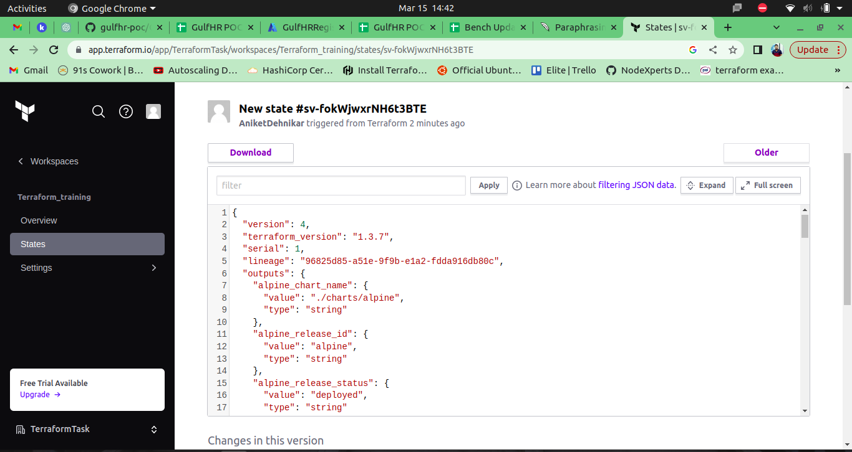State file**

**2. Terraform init**

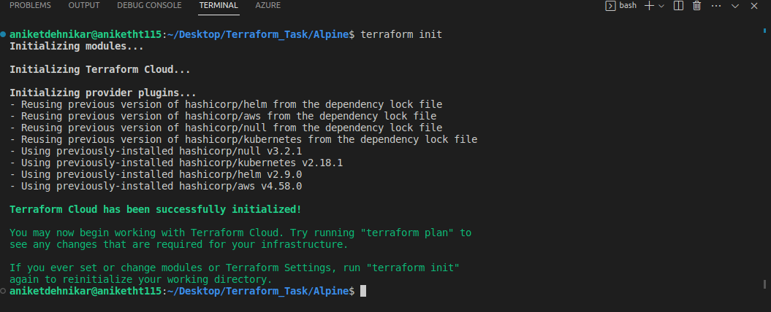

**3. terraform plan**

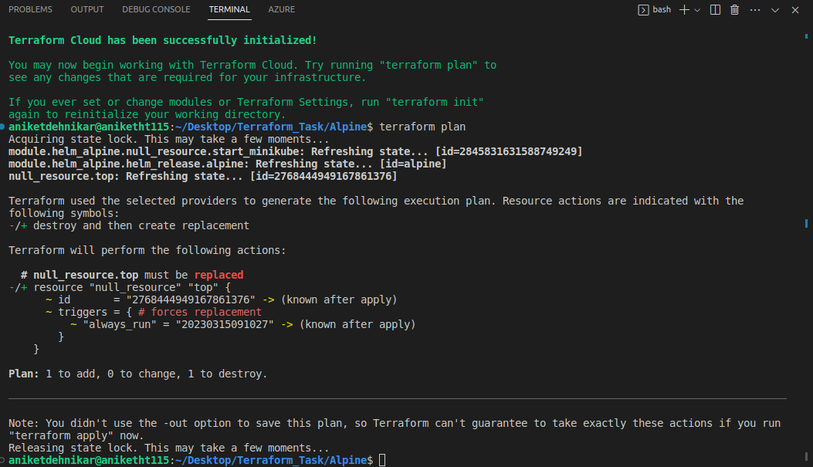

**4.terraform apply**

