**Project Report: Research & Development Website**

Designed and Developed By – Aniket Dey and Santanu Raj

Contact - meaniketdey@gmail.com / 9679812051

Student ids – NIT/2023/1946 and NIT/2023/1947

**1. Introduction**

The Research & Development (R&D) Website for JIS Group has been developed to streamline the research grant application and project management process. The platform serves as a centralized system where faculty members can apply for research grants, monitor their progress, and communicate with the Research Facilitation & Monitoring Office (RFMO). The primary goal is to facilitate a seamless research management experience by providing a digital interface that minimizes paperwork and optimizes workflow efficiency. By leveraging this system, the institution aims to encourage faculty members to engage in innovative research projects that contribute to academic and scientific advancements. The website functions as a bridge between researchers and the administrative bodies, ensuring transparency and accountability at each stage of the research lifecycle.

**2. Objectives**

The primary objectives of the R&D website are:

* To provide a user-friendly interface for faculty members to register, apply for grants, and track project progress. The ease of access is crucial to ensuring that all faculty members, regardless of their technical proficiency, can navigate the platform effortlessly.
* To enable the RFMO to manage research grants, sanction projects, and evaluate their progress efficiently. This involves a structured workflow that includes application submission, initial screening, review processes, project approvals, funding allocation, and periodic assessments.
* To establish a transparent and organized system for research project lifecycle management. The platform ensures that all project activities are recorded and accessible, thereby fostering a culture of openness and accountability among researchers and administrators.

**3. System Overview**

**3.1 User Roles and Access Levels**

The platform accommodates the following user roles:

* **Faculty Members**: Faculty members can register and create an account, apply for research projects, submit required documents, and track their applications. They also have the capability to submit periodic progress reports and update project statuses.
* **Principal Investigators (PIs)**: PIs have similar access as faculty members but with additional functionalities that allow them to manage their research teams, assign roles, and track the contributions of team members. PIs are also responsible for ensuring that projects meet their deadlines and requirements.
* **RFMO Administrators**: RFMO administrators oversee all submitted applications and grant approvals. They evaluate faculty applications based on institutional guidelines, allocate resources, and monitor the overall progress of sanctioned projects. They also generate reports for senior management regarding the status of research projects.

**4. Functional Modules**

**4.1 User Authentication & Registration**

The website features a secure login and registration system that ensures only authorized personnel can access the platform. Faculty members can register using their institutional credentials, which are verified through an email authentication process. The platform also includes a password recovery mechanism that utilizes a secure OTP-based authentication process.

**4.2 Home Page**

The home page serves as an introductory section that provides an overview of JIS R&D initiatives. It highlights recent research achievements, upcoming funding opportunities, and key announcements. A well-structured navigation menu allows users to easily explore various sections of the website, ensuring an intuitive user experience.

**4.3 Research Grant Projects**

The research grant projects module provides a comprehensive list of active, upcoming, and past research grants. Faculty members can filter grants based on funding availability, deadlines, and eligibility criteria. The module includes an "Express Interest" functionality that allows researchers to indicate their willingness to apply for specific grants and receive personalized updates.

**4.4 Project Management**

This module is designed to streamline the entire project application and management process. Faculty members can submit project proposals, including detailed research plans, budgets, and expected outcomes. Once a project is approved, faculty members can submit monthly or quarterly progress reports, upload research data, and maintain detailed records of their work. The RFMO administrators can access these reports, provide feedback, and evaluate the project's adherence to objectives.

**4.5 Admin Dashboard**

The admin dashboard provides comprehensive management tools for RFMO administrators. It allows them to review research applications, track funding disbursements, approve or reject grant requests, and monitor the overall progress of research initiatives. The dashboard includes real-time statistics, visual analytics, and reports that offer insights into institutional research trends and funding utilization.

**4.6 Faculty Dashboard**

The faculty dashboard is a personalized interface where faculty members can manage their research activities. It includes sections for applying for research grants, viewing allocated projects, submitting progress reports, and tracking project milestones. The dashboard provides an organized view of all ongoing and completed projects, allowing faculty members to maintain a structured research workflow.

**4.7 Contact & Support**

To ensure smooth communication, the website includes a dedicated contact and support section. Faculty members can reach out to the RFMO for queries, technical support, and administrative assistance. The module also includes a frequently asked questions (FAQs) section and chatbot integration for instant responses. Users can also submit feedback and issue reports, ensuring that the platform remains responsive to their needs. In the feedback form we have intergraded google sheets. The response will directly shown to the google sheet ( <https://docs.google.com/spreadsheets/d/1HuurZ1gavmBzW_Med-j1lnbN1TcyhVsKFDXHqwDTGIU/edit?usp=sharing> ) .

**5. Technology Stack**

The website is built using modern web development technologies that ensure high performance, security, and scalability. The frontend is developed using HTML, CSS, and JavaScript to provide a responsive and user-friendly interface. The backend is powered by PHP and MySQL, ensuring a robust database system that efficiently handles user data, project applications, and funding details.

**6. Data Flow Representation**

Based on the provided data flow diagram, users begin their journey from the **Home Page**, where they can log in or register. Upon successful login, users are redirected to their respective dashboards, such as **Faculty Dashboard, Principal Dashboard, or Admin Dashboard**. Faculty members can **apply for research grants, view project allocations, submit progress reports, and track ongoing projects**. RFMO administrators can **manage project applications, monitor active projects, evaluate submitted reports, and allocate funding accordingly**. The system also allows for the tracking and archival of completed projects, ensuring a structured and well-documented research repository.

**7. Conclusion**

The R&D website provides a structured and efficient approach for faculty members to engage in research activities. By digitizing the research application and management processes, the platform ensures seamless communication between researchers and the RFMO, making the research grant process more transparent and manageable. The platform also enables institutional leaders to monitor research progress, allocate resources effectively, and enhance the overall quality of research output.

**8. Future Enhancements**

Moving forward, several enhancements can be implemented to further improve the functionality and usability of the website. These include integrating AI-based recommendation systems that suggest relevant grants based on research interests, automated reminders for report submissions and deadlines,. Additionally, expanding the platform to include research collaboration tools, digital libraries, and conference management features can further strengthen its impact on the research community. In these 14 days we have worked on major functionalities but there are multiple minor feather are left behind the the principal side is not fully functional yet.

**9. Use case diagram**

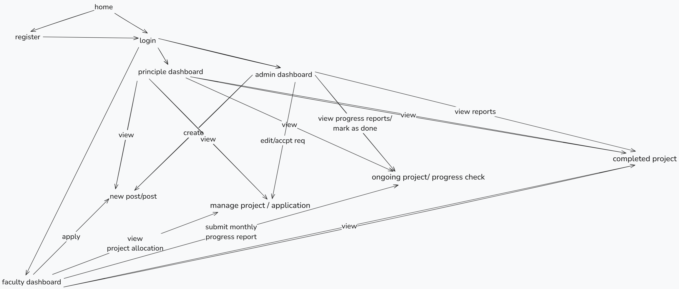

We have cover 3 kinds of users here-

**9.1. User Authentication & Navigation**

* The system starts at the **home page**, from where users can either navigate to the **register** page (for new users) or proceed directly to **login**.
* After successful login, users are redirected to different dashboards based on their roles:
  + **Admin Dashboard**
  + **Principal Dashboard**
  + **Faculty Dashboard**

**9.2. Principal Dashboard**

* The principal can:
  + **View existing posts** related to project applications.
  + **Create new posts** to invite applications from faculty.
  + **View and manage project applications** submitted by faculty.

**9.3. Admin Dashboard**

* The admin has the authority to:
  + **View and manage applications** submitted by faculty members.
  + **Edit or accept project requests** as per institutional guidelines.
  + **Monitor progress reports** of ongoing projects.
  + **Mark projects as completed** once the necessary conditions are met.
  + **View reports** of completed projects for record-keeping.

**9.4. Faculty Dashboard**

* The faculty members can:
  + **Apply for projects** by submitting applications in response to principal posts.
  + **View project allocations** assigned to them.
  + **Manage ongoing projects**, including documentation and updates.
  + **Submit monthly progress reports** for ongoing projects.
  + **View their own submitted reports** to track progress.

**9.5. Ongoing & Completed Projects**

* The admin and principal can monitor the **progress of ongoing projects**.
* The admin has the authority to review progress reports and **mark projects as completed**.
* Once a project is marked complete, it moves to the **completed project** section, where the data remains accessible for future reference.

**9.6. Data Flow Summary**

* **Authentication:** Users must register and log in to access their respective dashboards.
* **Project Management:** Faculty apply for projects, which are reviewed and assigned by the principal and admin.
* **Monitoring & Evaluation:** Ongoing projects require monthly progress reports, which are reviewed before final completion.
* **Completion & Record Keeping:** Completed projects are stored for future reference and institutional documentation.

**10.Basic Demo –**

Home Page-

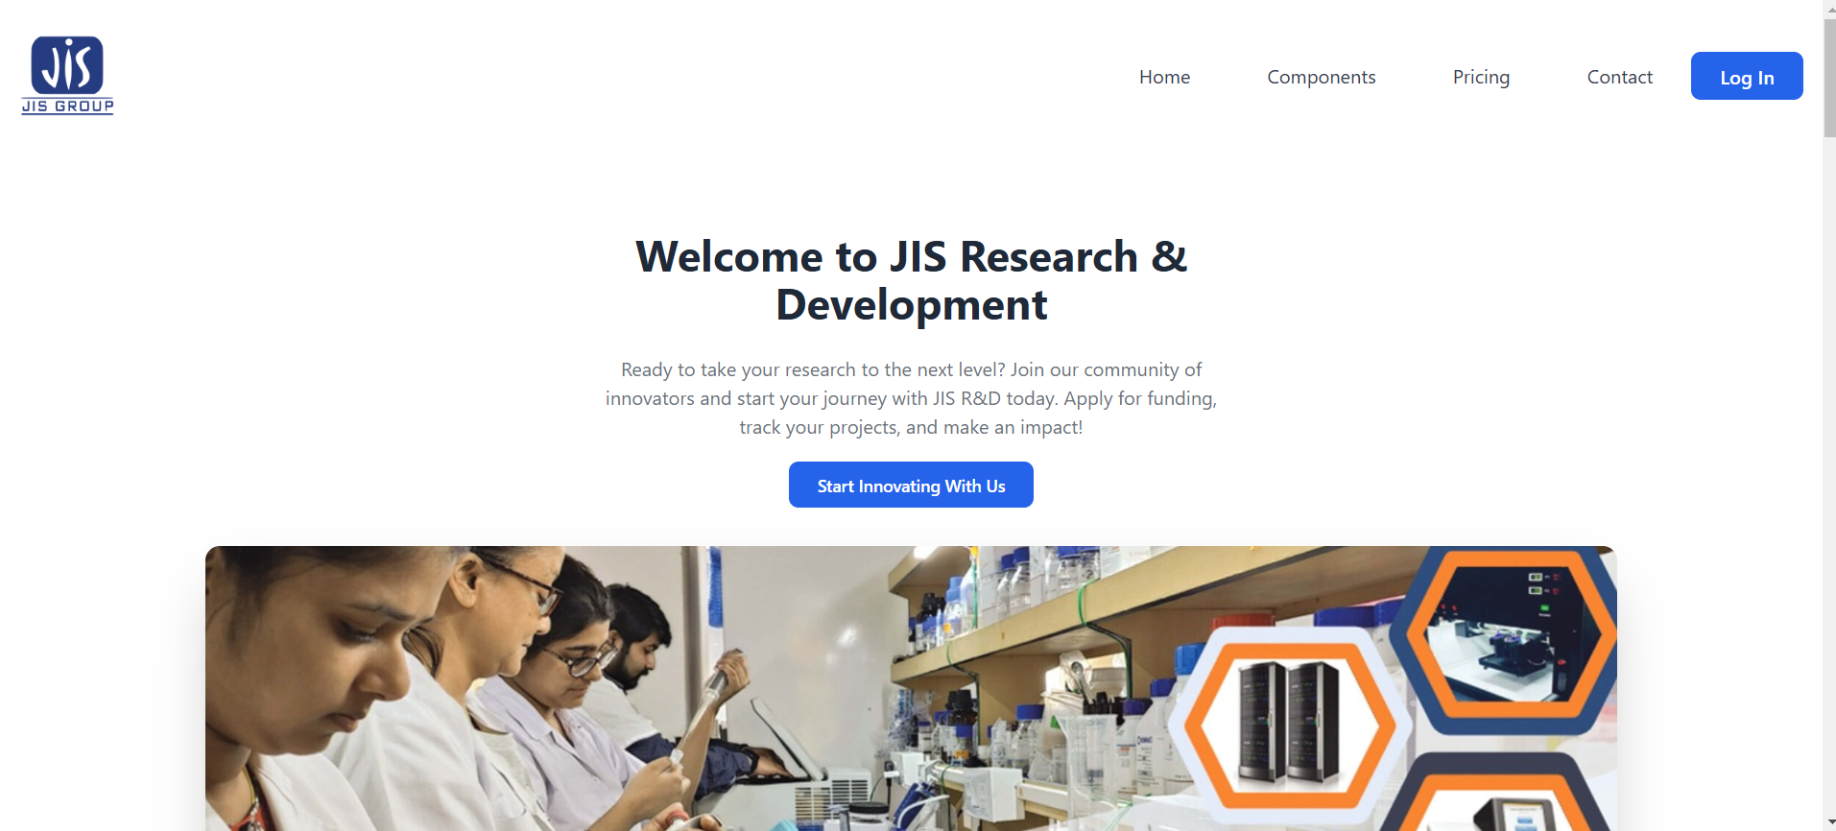

Registretion Page-

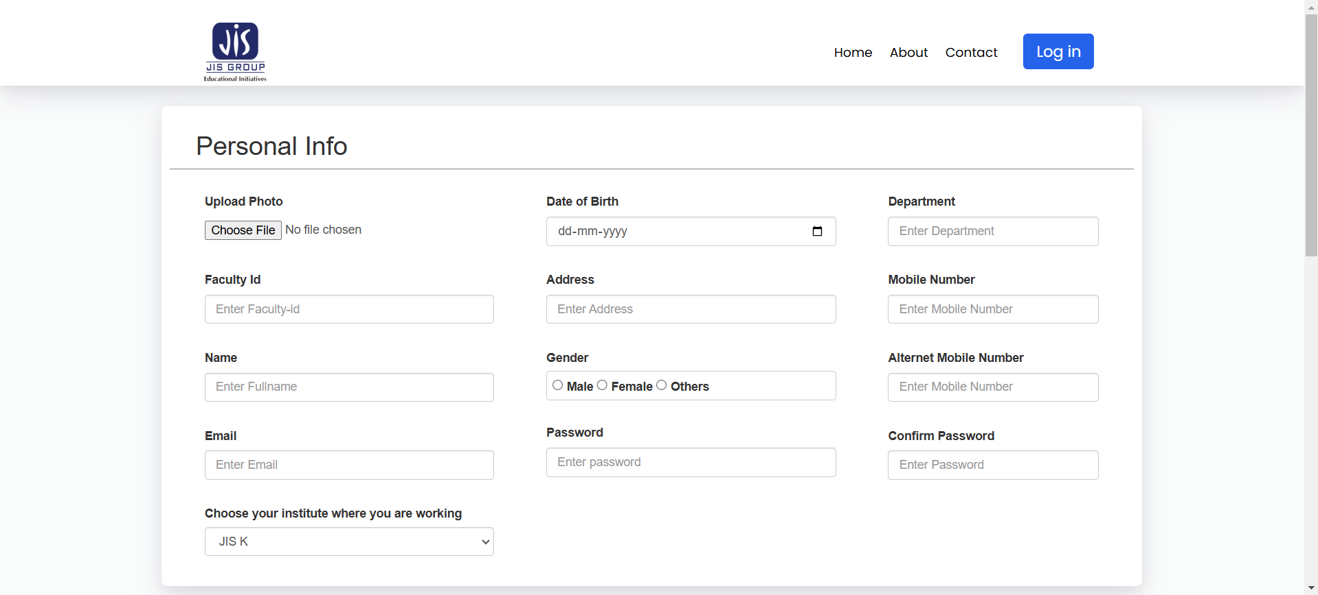

Login Page-

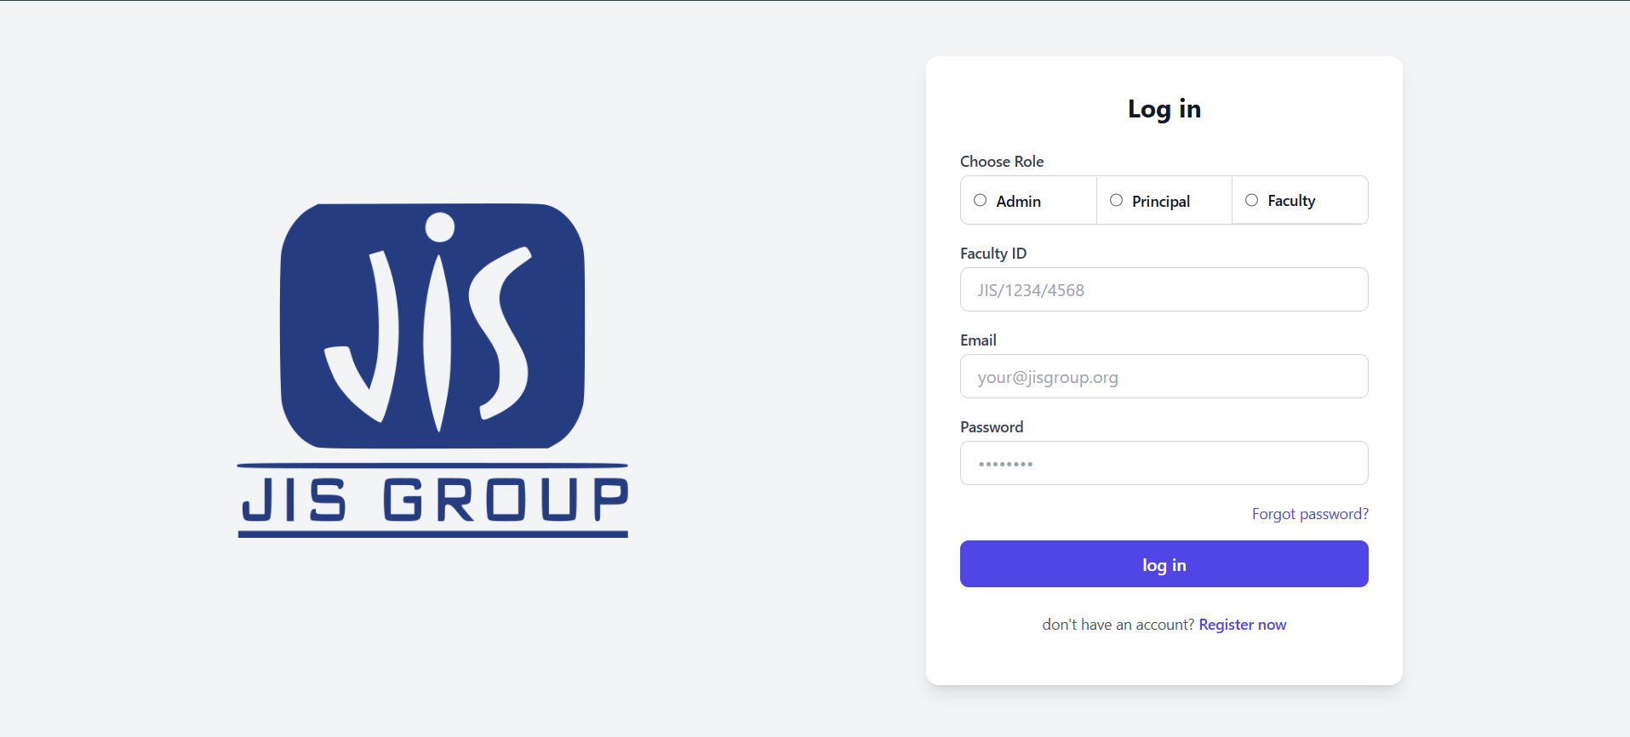

Forget Password-

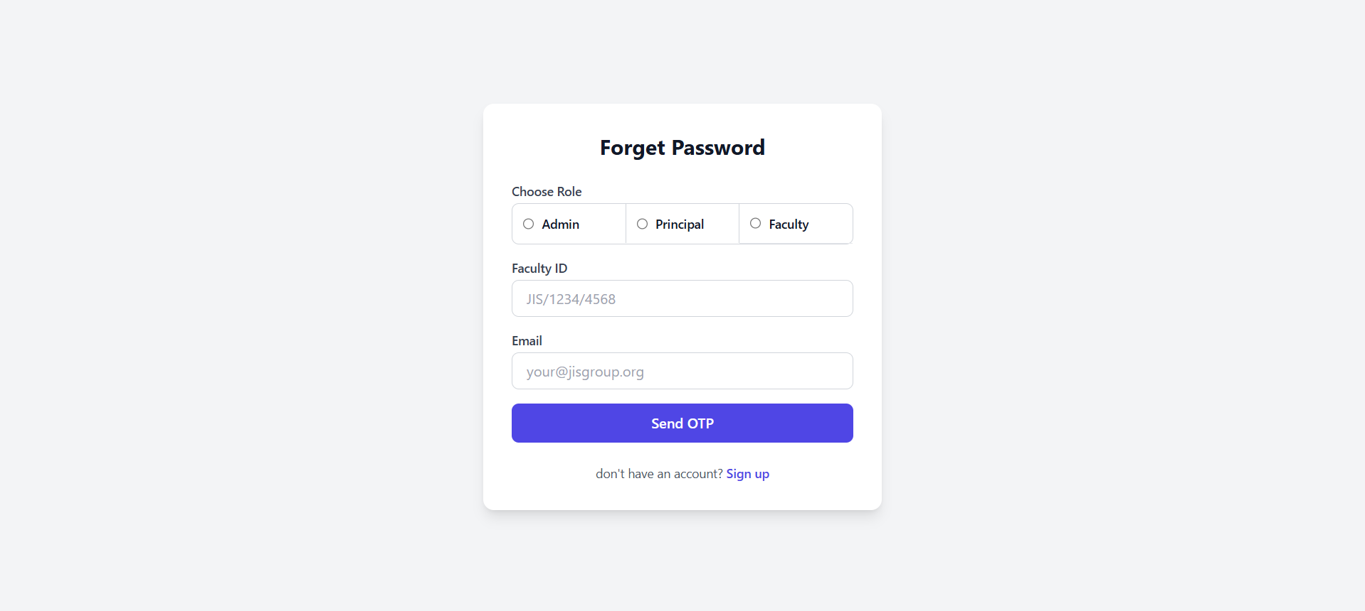

OTP-

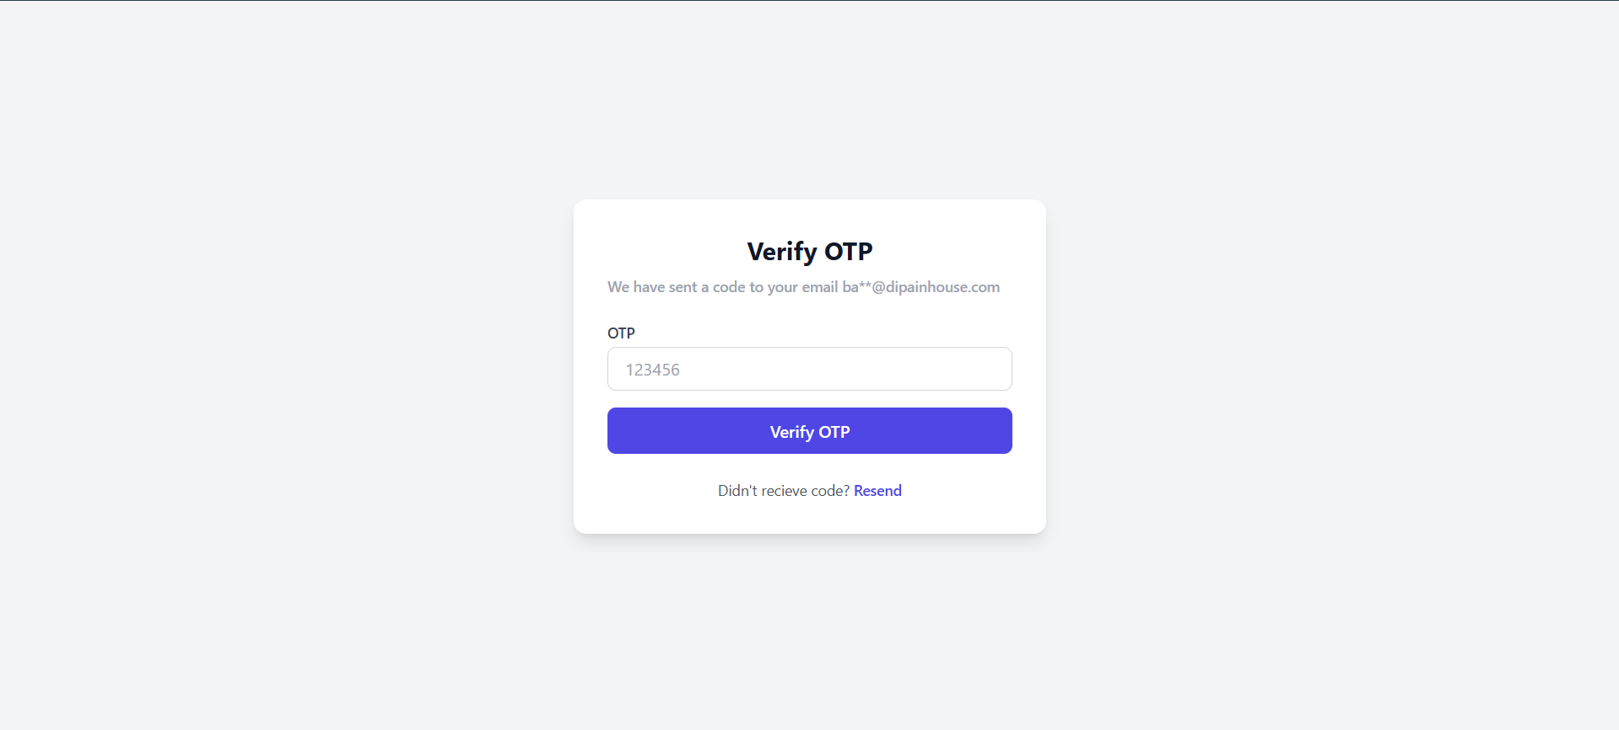

Set New password –

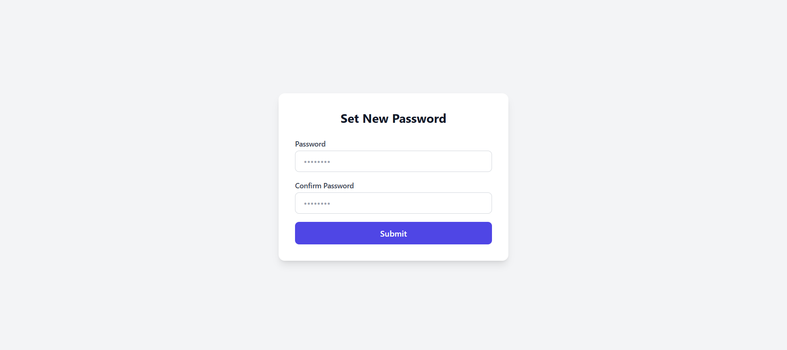

Admin Dashboard- For testing admin login details are

Admin id - ADM-00001

Email - [admin@example.com](mailto:admin@example.com)

Password - 123

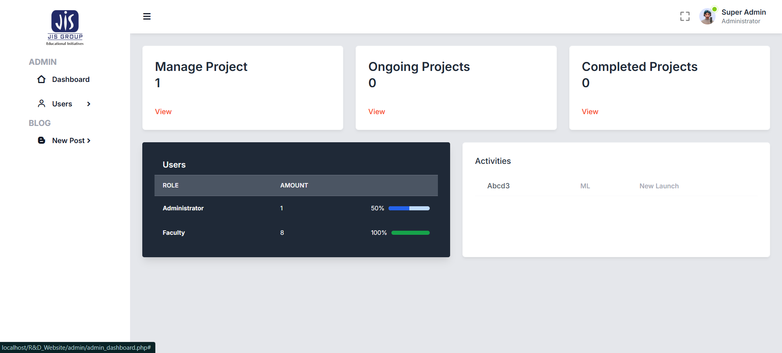

List of projects- These projects are newly listed

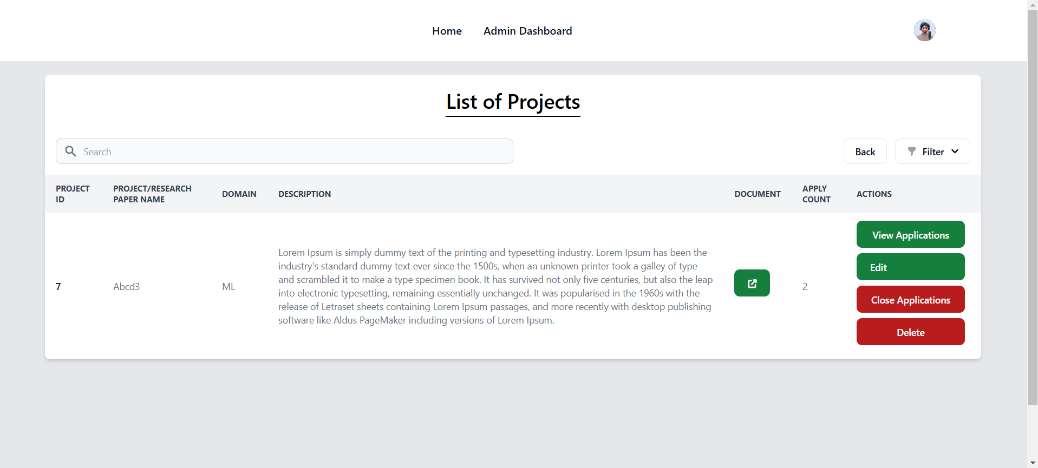

View Application – Who have applied for the project

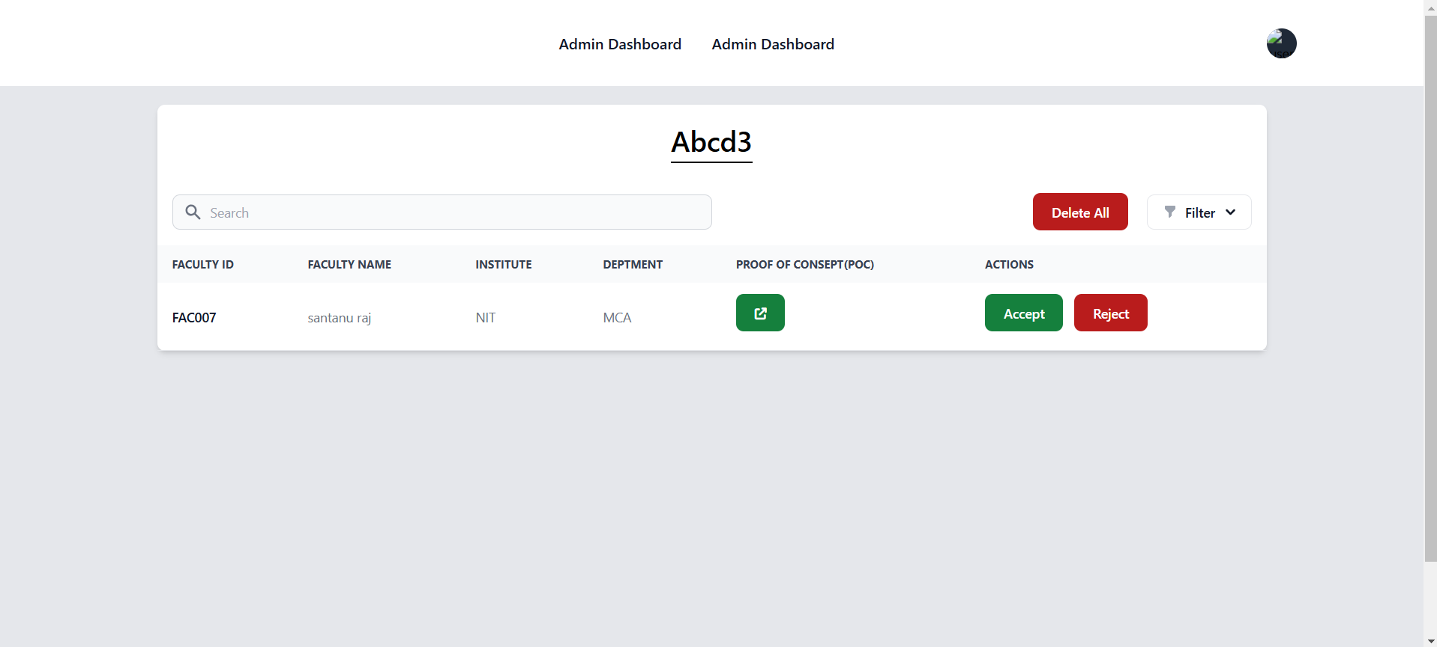

After Hitting the accept button the application has been approved by admin -

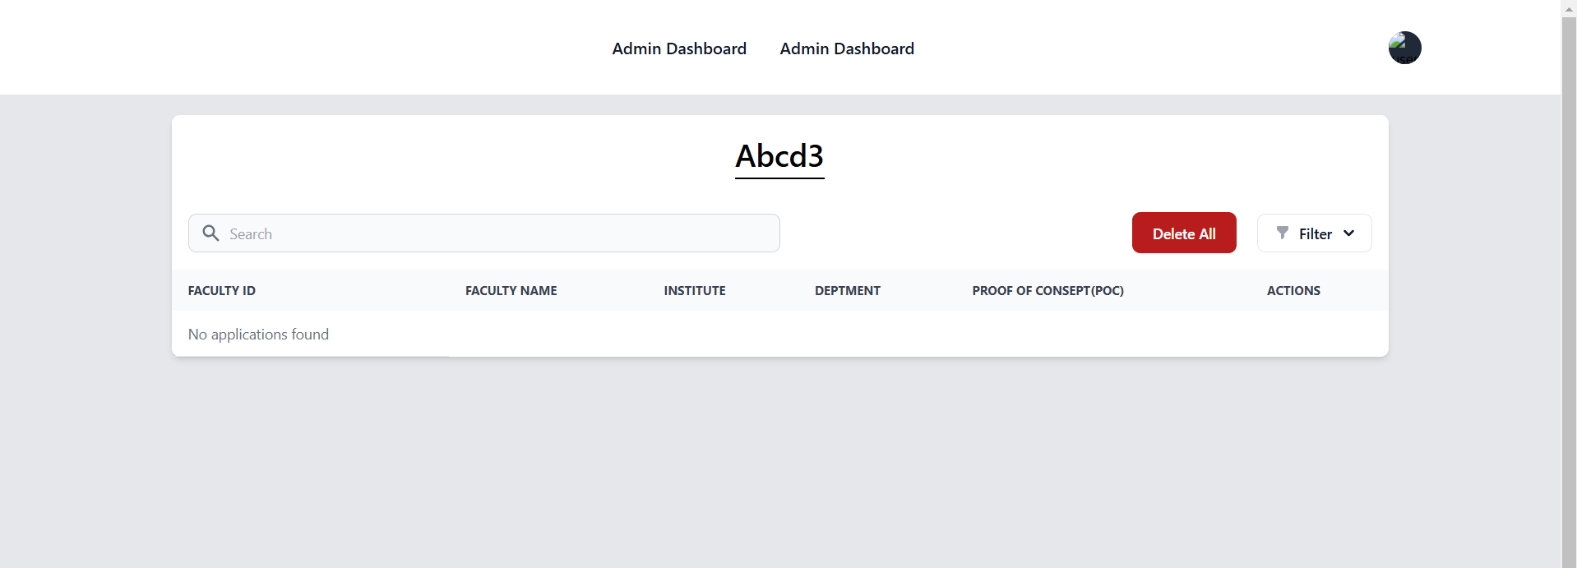

Under Ongoing Projects, he / she can the three allocated projects-

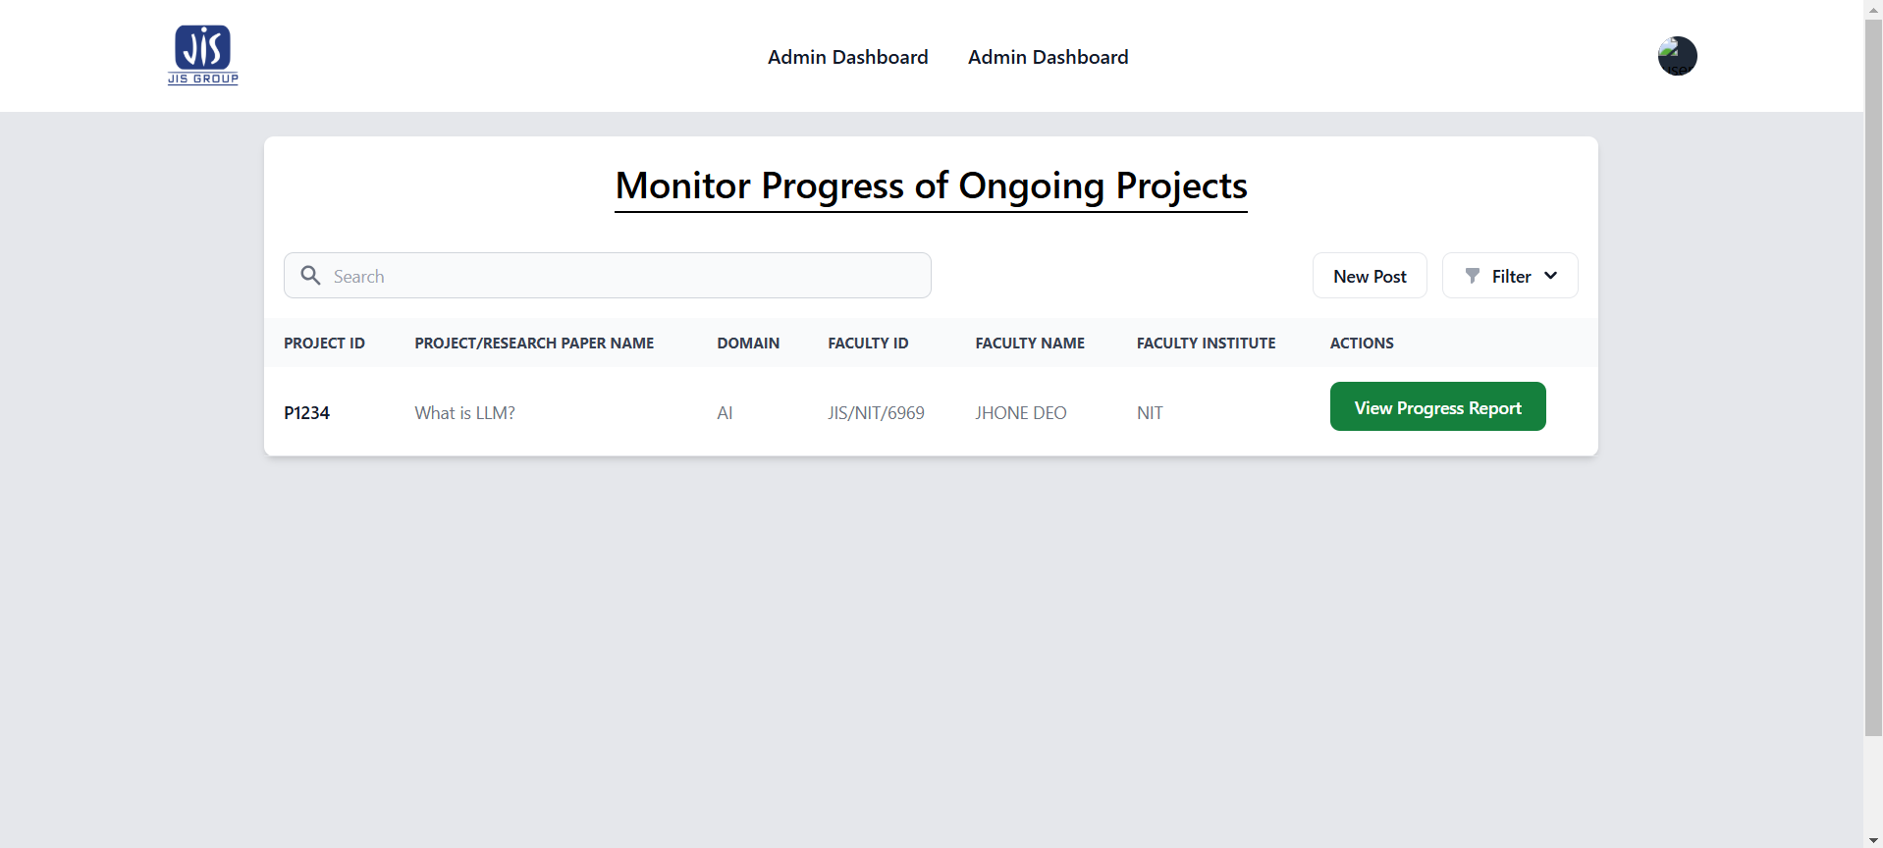

View Progress Reports-

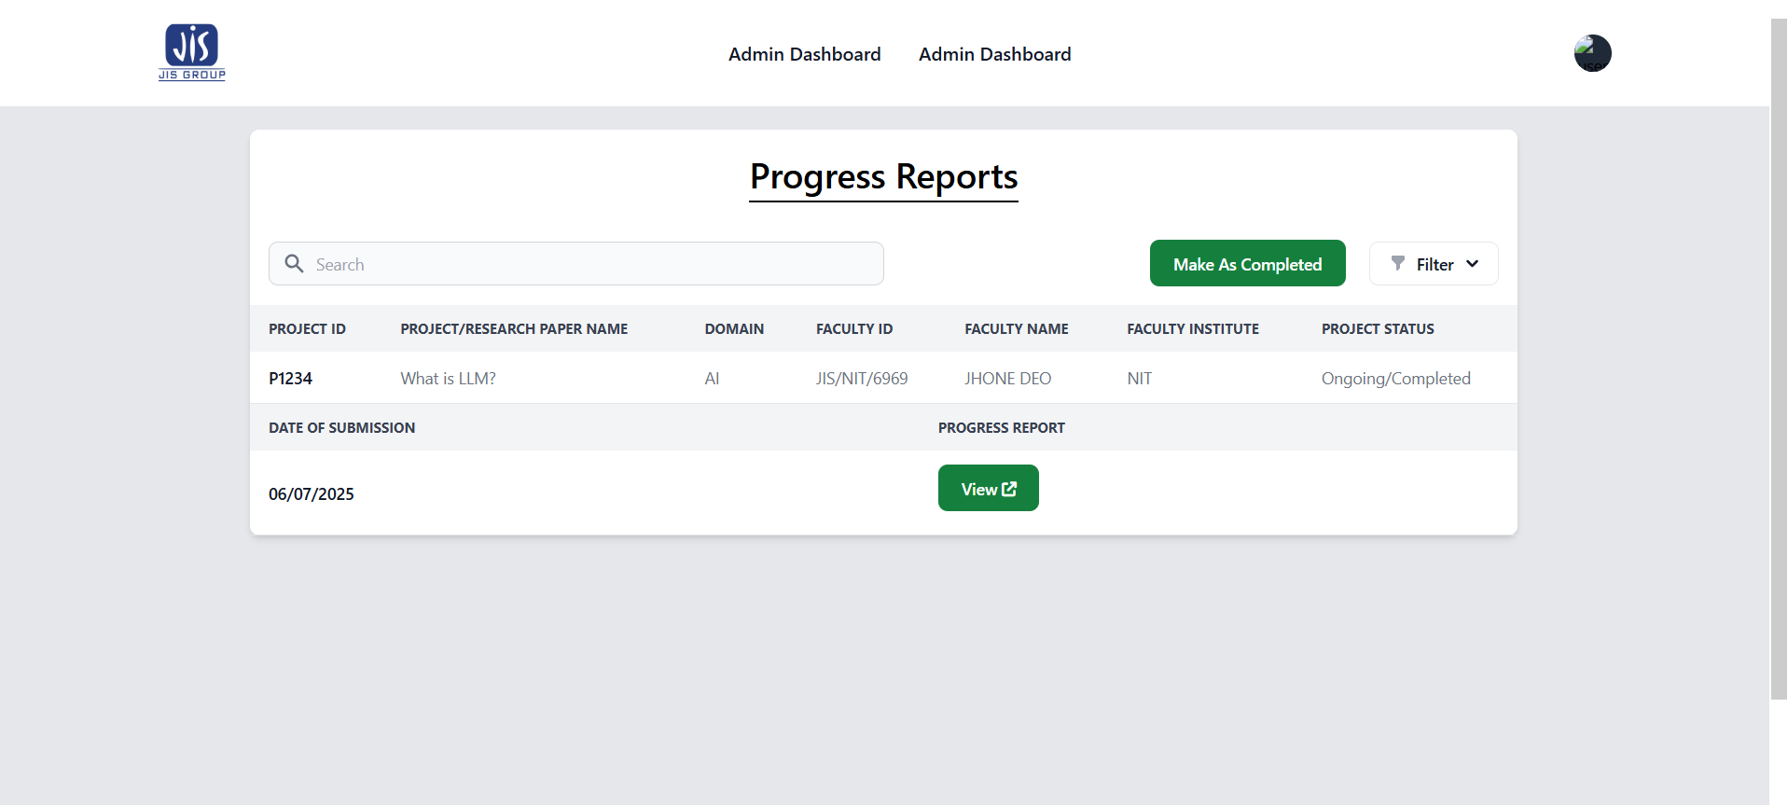

After hitting mark as Done the reports show on compled projects section-

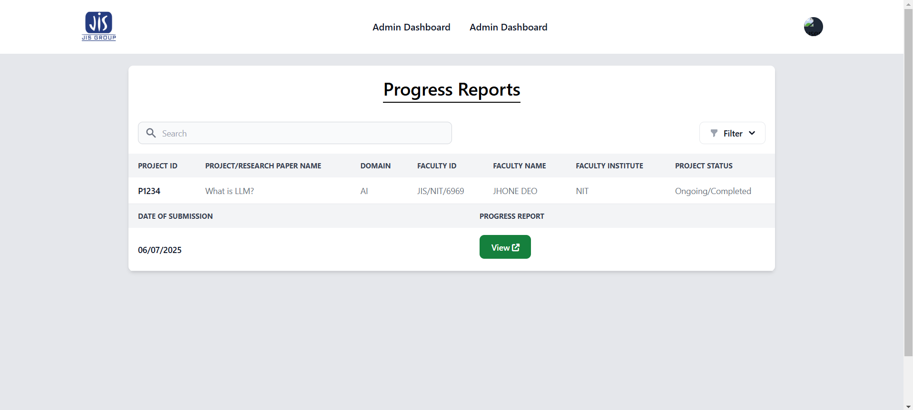

Faculty dashboard- For testing Facuty login details are

Admin id - FAC007

Email - admin@util.com

Password – 1234 or 123

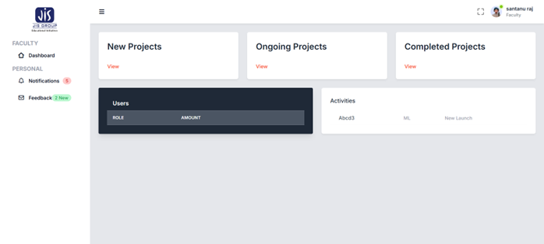

New project section-

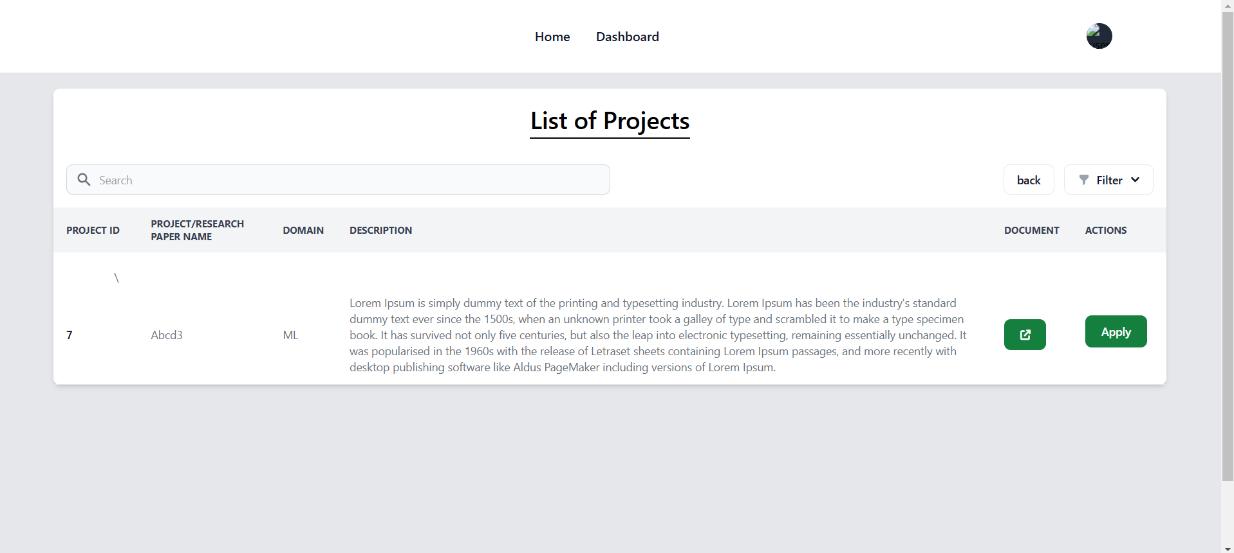

Apply section-

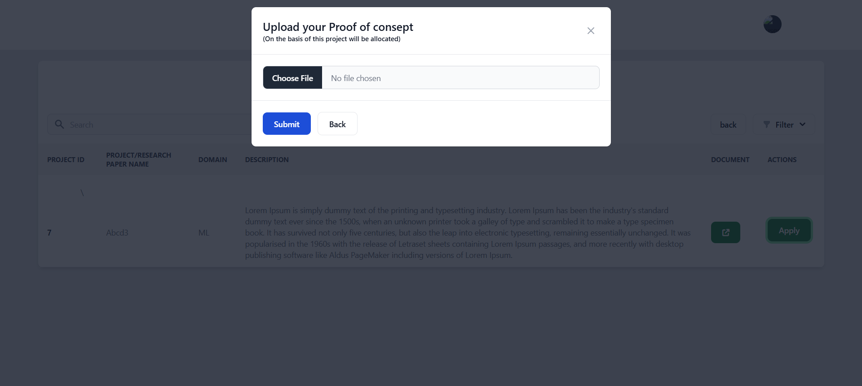

Ongoing section of faculty-

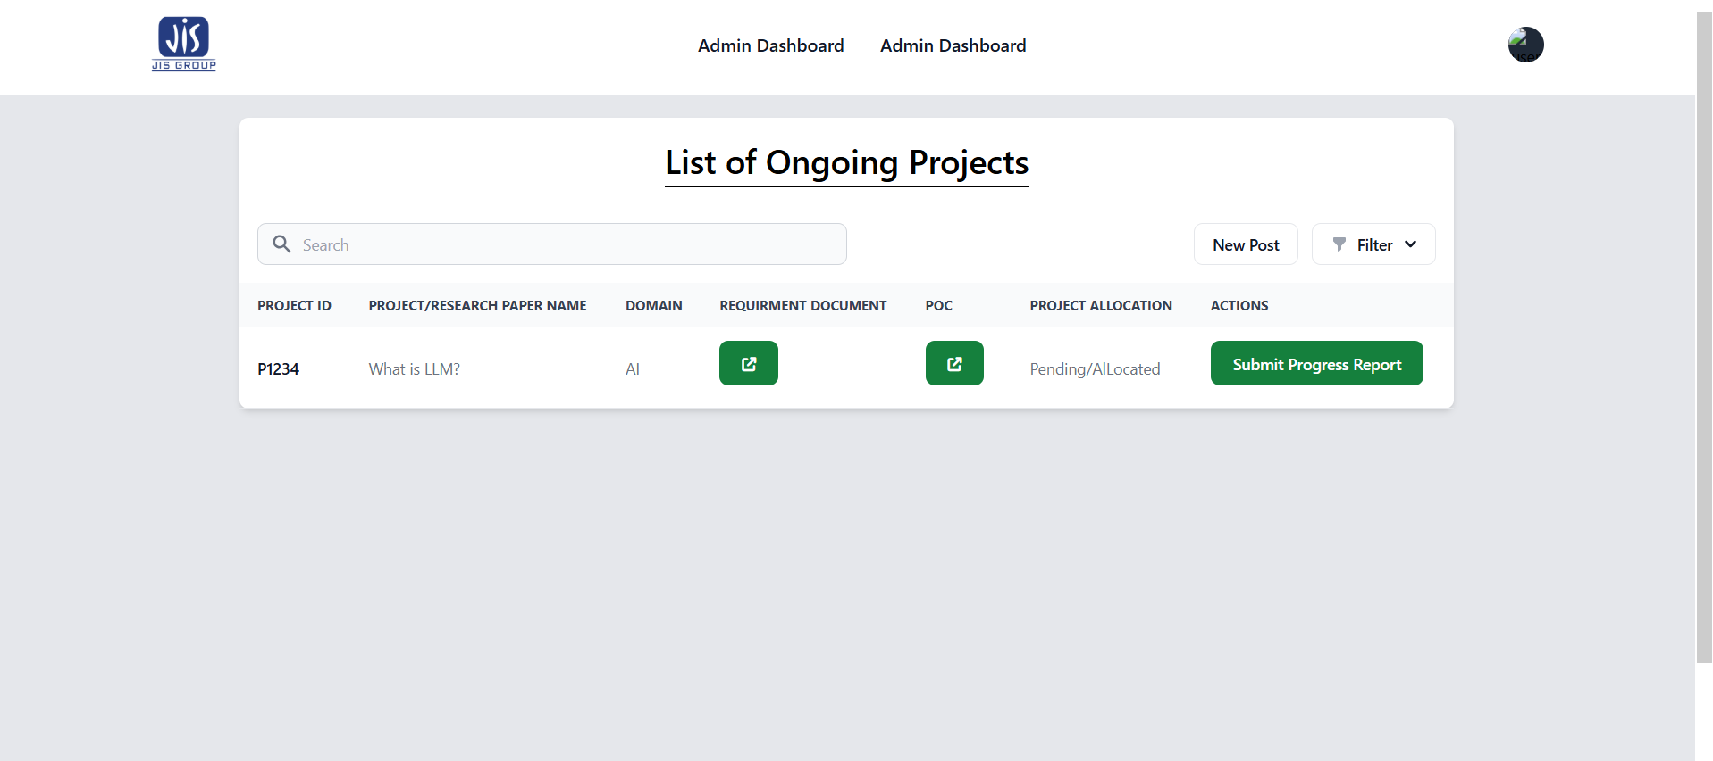

Submit progress report-

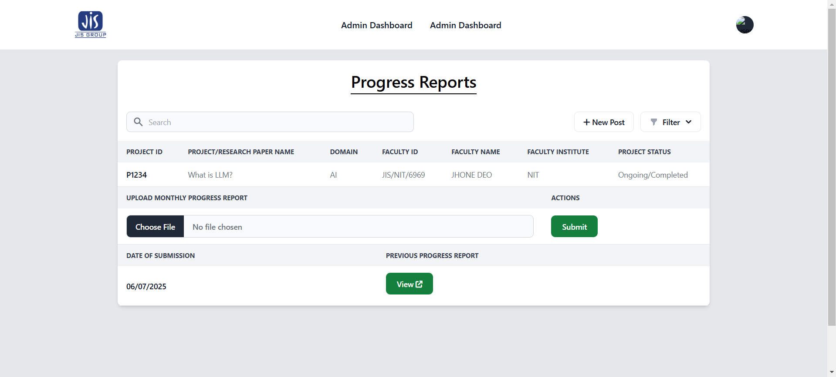

Complete section-

