//Binary Search Tree
#include <stdio.h>
#include <stdlib.h>
struct node
{
int key;
struct node *left, *right;
};
struct node *newNode(int item)
{
struct node *temp = (struct node *)malloc(sizeof(struct node));
temp->key = item;
temp->left = temp->right = NULL;
return temp;
}
void inorder(struct node *root)
{
if (root != NULL) {
inorder(root->left);
printf("%d -> ", root->key);
inorder(root->right);
}
}
struct node *insert(struct node *node, int key) {
if (node == NULL) return newNode(key);
if (key < node->key)
node->left = insert(node->left, key);
else
node->right = insert(node->right, key);
return node;
}

struct node *minValueNode(struct node *node) {
struct node *current = node;

// Find the leftmost leaf
while (current && current->left != NULL)
current = current->left;

return current;
}

// Deleting a node
struct node *deleteNode(struct node *root, int key)
{
// Return if the tree is empty
struct node *temp;
if (root == NULL) return root;

// Find the node to be deleted
if (key < root->key)
root->left = deleteNode(root->left, key);
else if (key > root->key)
root->right = deleteNode(root->right, key);
else
{
// If the node is with only one child or no child
if (root->left == NULL)
{
struct node *temp = root->right;
free(root);
return temp;
}
else if (root->right == NULL)
{
struct node *temp = root->left;
free(root);
return temp;
}

temp = minValueNode(root->right);
root->key = temp->key;
root->right = deleteNode(root->right, temp->key);
}
return root;
}

void main()
{
struct node *root = NULL;
root = insert(root, 8);
root = insert(root, 3);
root = insert(root, 1);
root = insert(root, 6);
root = insert(root, 7);
root = insert(root, 10);
root = insert(root, 14);
root = insert(root, 4);

printf("\tInorder traversal: ");
inorder(root);
printf("\n\tAfter deleting 10\n");
root = deleteNode(root, 10);
printf("\tInorder traversal: ");
inorder(root);
}

OUTPUT
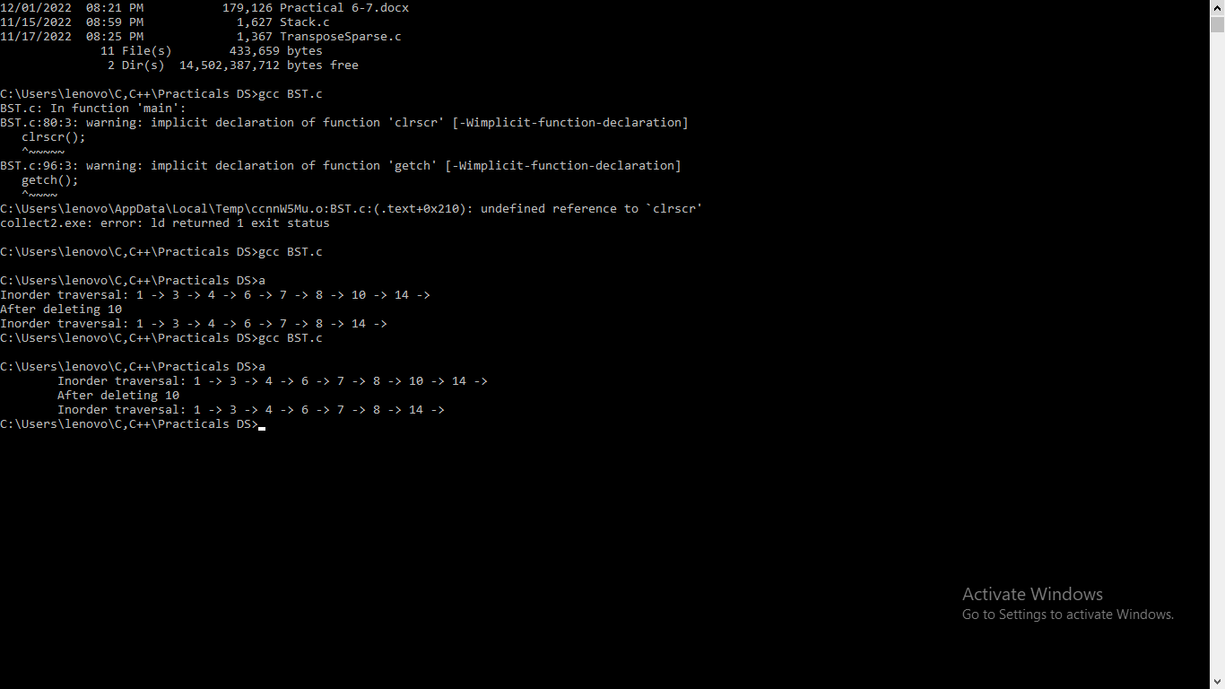

// Linear Search
#include <stdio.h>
void main()
{
int array[100], search, c, n;
int count=0;
printf("Enter number of elements in array\n");
scanf("%d", &n);
printf("Enter %d integer(s)\n", n);

for (c = 0; c < n; c++)
scanf("%d", &array[c]);

printf("Enter a number to search\n");
scanf("%d", &search);

for (c = 0; c < n; c++)
{
if (array[c] == search) /* If required element is found */
{
printf("%d is present at location %d.\n", search, c+1);
count++;
}
}
if (count == 0)
printf("%d isn't present in the array.\n", search);
}
OUTPUT
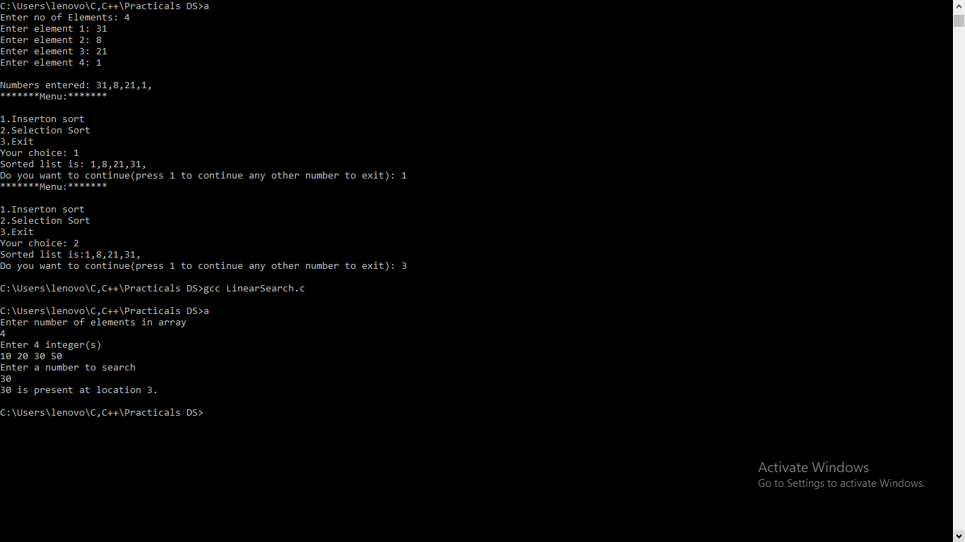

// Binary Search
#include <stdio.h>
int binarySearch(int arr[], int l, int r, int x, int i)
{
while (l <= r)
{
int m = l + (r - l) / 2;
i++;
if (arr[m] == x)
{
printf("\nTotal iterations: %d\n",i);
return m;
}
if (arr[m] < x)
l = m + 1;
else
r = m - 1;
}
return -1;
}
void main()
{
int arr[100],n,c;
int it=0;
int num, result;
printf("Enter number of elements in array\n");
scanf("%d", &n);
printf("Enter %d integer(s)\n", n);
for (c = 0; c < n; c++)
scanf("%d", &arr[c]);
printf("Enter a number to search\n");
scanf("%d", &num);
result = binarySearch(arr, 0, n - 1, num, it);
(result == -1) ?printf("Element is not present"
" in array")
: printf("Element is present at "
"index %d",result);
}
OUTPUT
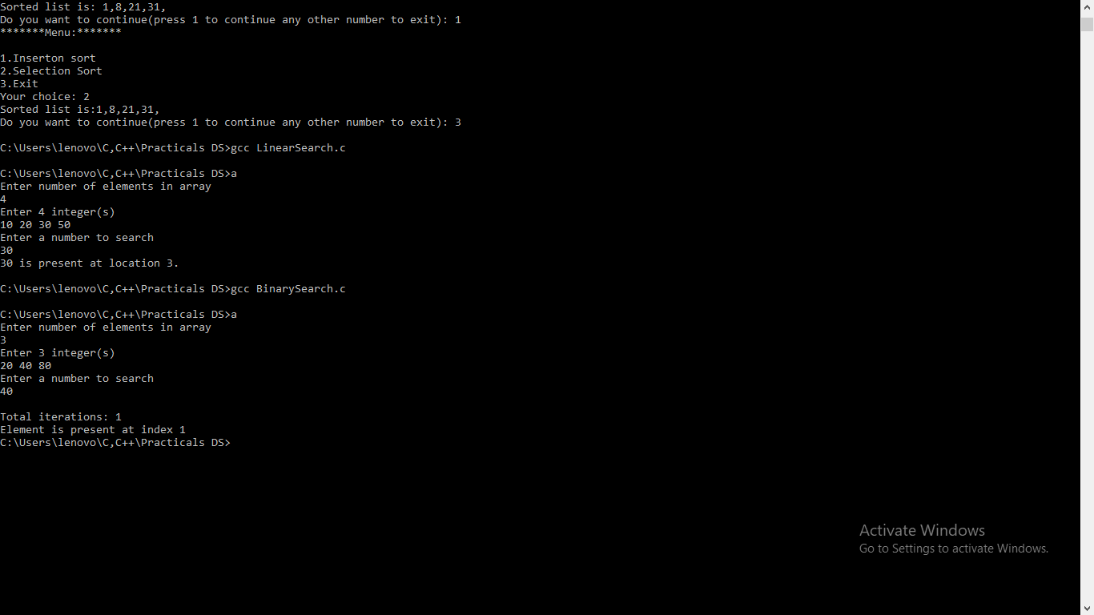

//Insertion and Selection sort
#include<stdio.h>
#include<stdlib.h>
void selection(int *,int);
void insertion(int *,int);
int main()
{
int count=0; //size of array
int choice=0,ch=0; //variables used to store user choice
int i=0; //loop variable
int list[100];
printf("Enter no of Elements: ");
scanf("%d",&count);
//filling in the array
for(i=0;i<count;i++)
{
printf("Enter element %d: ",i+1);
scanf("%d",&list[i]);
}
printf("\nNumbers entered: ");
for(i=0;i<count;i++)
printf("%d,",list[i]);
printf("\n");
do
{
printf("*******Menu:*******\n\n");
printf("1.Inserton sort\n2.Selection Sort\n3.Exit\nYour choice: ");
scanf("%d",&choice);
switch(choice)
{
case 1: //performs insertion sort
insertion(list,count);
break;
case 2: //performs selection sort
selection(list,count);
break;
case 3: return 0;
default: printf("Invalid option\nRetry: ");
break;
}
printf("Do you want to continue(press 1 to continue any other number to exit): ");
scanf("%d",&ch);
}
while(ch==1);
return 0;
}
void insertion(int *list,int n)
{
int temp;
int i=0,j=0;

for(i=1;i<n;i++)
{
temp=list[i];
j=i-1;
while((j>=0)&&(list[j]>temp))
{
list[j+1]=list[j];
j--;
}
list[j+1]=temp;
}

printf("Sorted list is: ");
for(i=0;i<n;i++)
{
printf("%d,",list[i]);
}
printf("\n");
}
void selection(int *list,int n)
{
int i;
int j,min;
int k;
for(j=0;j<n-1;j++)
{
min=list[j];
k=j;
for(i=j+1;i<n;i++)
{

if(list[i]<min)
{
min=list[i];
k=i;
}
}

list[k]=list[j];
list[j]=min;
}
printf("Sorted list is:");
for(i=0;i<n;i++)
{
printf("%d,",list[i]);
}
printf("\n");
}
OUTPUT
