

Redhat
Mr. Aniket A. Firke

Description
Note taking is an essential learning skill for college students to implement during and outside of class time. The notes recorded during a class lecture should be compiled of the important facts or ideas presented by the professor. Implementing a system of note taking is important for several reasons. First, the faculty member may be presenting supplemental material not found in your text book but critical for you to learn in order to make a connection to prior knowledge or introduce new material within your textbook. Secondly, the information presented within a lecture may be used for future assessments (quizzes, exams, reflection papers). Finally, a system of good note taking is an important study strategy. Actively listening and taking notes during class increases the retention of the material. Reviewing the notes immediately after class to add additional points or to generate questions for clarification creates opportunity for additional retention and understanding. Effective note taking skills will assist in preparing for exams and future knowledge base of material.

Introduction

Red Hat is a leading global provider of open-source software solutions, primarily known for its enterprise-level Linux operating system, Red Hat Enterprise Linux (RHEL). The company was founded in 1993 by Bob Young and Marc Ewing, and it has played a significant role in the open-source community.
- Linux Distribution: Red Hat Enterprise Linux (RHEL) is one of the most popular and widely used Linux distributions in the corporate world. RHEL is known for its stability, security features, and support for mission-critical workloads.
- Open-Source Advocacy: Red Hat is a strong advocate for the open-source software model. The company actively contributes to various open-source projects and communities, and it has a history of promoting open standards and collaboration.
- Enterprise Solutions: In addition to the Linux operating system, Red Hat provides a wide range of enterprise solutions, including middleware, cloud computing technologies, virtualization, and storage. Red Hat's solutions are designed to address the needs of businesses and organizations, offering robust and scalable platforms.
- Red Hat Enterprise Linux (RHEL): RHEL is the flagship product of Red Hat and is widely used in data centers and server environments. It provides a stable and secure platform for running applications, and it is backed by Red Hat's support and services.

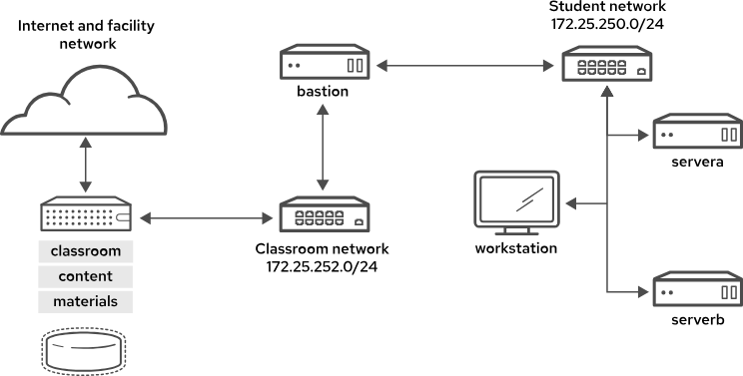
Classroom environment

Table of Content
Sr. No | Content | Page No
 | Description
 | Introduction
 | Get Started with Red Hat Enterprise Linux
 | 1.1 Linux
 | Access the Command Line
 | 2.1 Command Line with the Desktop
 | 2.2 Execute Commands with the Bash Shell
 | Manage Files from the Command Line
 | 3.1 Describe Linux File System Hierarchy Concepts
 | 3.2 Specify Files by Name
 | 3.3 Manage Files with Command-line Tools
 | 3.4 Make Links Between Files
 | 3.5 Match File Names with Shell Expansions
 | Get Help in Red Hat Enterprise Linux
 | 4.1 Read Manual Pages
 | Create, View, and Edit Text Files
 | 5.1 Redirect Output to a File or Program
 | 5.2 Edit Text Files from the Shell Prompt
 | 5.3 Change the Shell Environment
 | Manage Local Users and Groups
 | 6.1 Describe User and Group Concepts
 | 6.2 Gain Superuser Access
 | 6.3 Manage Local User Accounts
 | 6.4 Manage Local Group Accounts
 | 6.5 Manage User Passwords

- Get Started with Red Hat Enterprise Linux
Linux is a powerful and flexible family of operating systems that are free to use and share. It was created by a person named Linus Torvalds in 1991. What’s cool is that anyone can see how the system works because its source code is open for everyone to explore and modify. This openness encourages people from all over the world to work together and make Linux better and better. Since its beginning, Linux has grown into a stable and safe system used in many different things, like computers, smartphones, and big supercomputers.
Why Should You Learn about Linux?
Linux is in widespread use, worldwide. Internet users interact with Linux applications and web server systems daily, by browsing the World Wide Web and using e-commerce sites to buy and sell products.
- A Windows user needs to interoperate with Linux systems and applications.
- In application development, Linux commonly hosts the application and its runtime.
- In cloud computing, both private and public cloud instances use Linux as the operating system.
- Mobile applications and Internet of Things (IoT) devices commonly run on Linux.
- When looking for new IT career opportunities, Linux skills are in high demand.

What Makes Linux Great?
- Linux is open-source software.
Being open-source means that you can see all of how a program or system works. You can also experiment with changes and share them freely for others to use.

- Linux provides a command-line interface (CLI) for easy access and powerful scripting.
Linux is built around a basic design philosophy that users can perform all administration tasks from the CLI. It enables easier automation, deployment, and provisioning, and simplifies both local and remote system administration .

- Linux is a modular operating system that is designed to easily replace or remove components.
System components can be upgraded and updated when needed. A Linux system can be a general-purpose development workstation or a purposefully minimized software appliance.

What Is Open-Source Software?
Open-source software is software with source code that anyone can use, study, modify, and share.
Source code is the set of human-readable instructions that are used to make a program. Code might be in interpretive form, such as a script, or compiled into a binary executable that the computer runs directly. Source code becomes copyrighted when created, and the copyright holder controls the terms under which the software can be copied, adapted, and distributed. Users can use the software according to its software license.
Some software uses "proprietary" or "closed source" source code that only the originating person, team, or organization can see, or change, or distribute. Proprietary licenses typically restrict the user to running the program, and provide limited or no access to the source.
Open-source software is different. When a copyright holder provides software under an open-source license, they grant the user the right to run the program and to view, modify, compile, and redistribute the source to others, royalty-free.
Anyone can sell open-source code, but open-source licensing generally allows the customer to redistribute the source code.
Open source has many benefits for the user:
- Control: See what the code does and improve it.
- Training: Learn from real-world code and develop more applications that are useful.
- Security: Inspect sensitive code, and fix it even without the original developers' help.
- Stability: Rely on code that can survive the loss of the original developer.

Types of Open-Source Licenses
The developers of open-source software can license their software in different ways. The software license terms control how the source can be combined with other code or reused. To be open source, licenses must allow users to freely use, view, change, compile, and distribute the code.
Two general classes of open-source license are particularly important:
- Copyleft licenses are designed to encourage keeping the code open source.
- Permissive licenses are designed to maximize code reusability.
Copyleft, or "share-alike" licenses, require that anyone who distributes the source code, with or without changes, must pass along the freedom for others to also copy, change, and distribute the code. The advantage of copyleft licenses is that they help to keep existing code, and improvements to that code, open and increase the amount of available open-source code. Common copyleft licenses include the GNU General Public License (GPL) and the Lesser GNU Public License (LGPL).
Permissive licenses maximize the reusability of source code. You can use the source for any purpose if the copyright and license statements are preserved, including reusing code under more restrictive or proprietary licenses. Examples of permissive licenses include the MIT/X11 license, the Simplified BSD license, and the Apache Software License 2.0.
Who Develops Open-Source Software?

Open-source development today is overwhelmingly professional. Open source is no longer solely developed by a body of volunteers. Today, most open-source developers work for organizations that pay them to participate with open-source projects to construct and contribute the enhancements that the organization and their customers need.
What is a Linux Distribution?
A Linux distribution is an installable operating system that is constructed from a Linux kernel and that supports user programs and libraries. A complete Linux system is developed by multiple independent development communities that work cooperatively on individual components. A distribution provides an easy method to install and manage a working Linux system.
In 1991, graduate student Linus Torvalds developed a UNIX-like kernel that he named Linux, and licensed it as open-source software under the GPL. The kernel is the core of the operating system and manages hardware, memory, and the scheduling of running programs. The Linux kernel also includes other open-source components, such as the Send mail server and the Apache HTTP web server, to become a complete open-source UNIX-like operating system.
A major challenge for Linux users is to assemble all these software pieces from many sources. Early Linux developers provided a distribution of prebuilt and tested tools that users could download and install to quickly implement Linux systems.
Many Linux distributions exist, each with differing goals and support criteria. Generally, distributions have some common characteristics:
- Distributions consist of a Linux kernel and support user-space programs.
- Distributions can be small and single-purpose, or can include thousands of open-source programs.
- Distributions provide a means to install and update the software and its components.
- The distribution provider supports the software, and ideally, participates in the development community.

Who Is Red Hat?

Red Hat is the world's leading provider of open-source software solutions, by using a community-powered approach to reliable and high-performance cloud, Linux, middleware, storage, and virtualization technologies. The mission of Red Hat is to be the catalyst in communities of customers, contributors, and partners to create better technology the open-source way.
The role of Red Hat is to help customers to connect with the open-source community and their partners to effectively use open-source software solutions. Red Hat actively participates in and supports the open-source community. Many years of experience have convinced the company of the importance of open source to the future of the IT industry.
Red Hat is best known for its participation in the Linux community and the Red Hat Enterprise Linux distribution. Red Hat is also active in other open-source communities, including middleware projects that are cantered on the JBoss developer community. Red Hat also provides virtualization solutions, cloud technologies such as OpenStack and OpenShift, and the Ceph and Gluster software-based storage projects, plus others.

Red Hat Enterprise Linux Ecosystem
Red Hat Enterprise Linux (RHEL) is Red Hat's commercial production-grade Linux distribution. Red Hat develops and integrates open-source software into RHEL through a multistage process.
- Red Hat participates in supporting individual open-source projects. It contributes code, developer time, resources, and support, and often collaborates with developers from other Linux distributions, to improve the general quality of software for everyone.
- Red Hat sponsors and integrates open-source projects into the community-driven Fedora distribution. Fedora provides a free working environment to serve as a development lab and proving ground for features to be incorporated into CentOS Stream and RHEL products.
- Red Hat stabilizes the CentOS Stream software to be ready for long-term support and standardization, and integrates it into RHEL, the production-ready distribution.

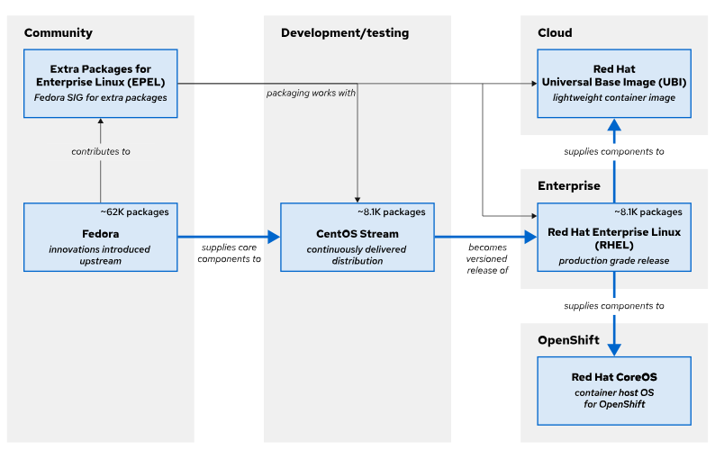
Fig1.1: The Red Hat Enterprise Linux ecosystem
Fedora
Fedora is a community project that produces and releases a free, comprehensive Linux-based operating system. Red Hat sponsors and works with the Fedora community to integrate the latest upstream software into a fast-moving, secure distribution. The Fedora project contributes back to the open-source world, and anyone can participate.
Fedora prioritizes innovation and excellence above long-term stability. Major updates occur every six months, and bring significant changes. Fedora supports releases for about a year, which means the latest two updates, making it less suited for supportable production use. Fedora remains the source of innovation for the entire Enterprise Linux ecosystem. In general, packages start out in Fedora and are included into CentOS Stream only when they are considered mature in stability, security, performance, and customer demand.

Extra Packages for Enterprise Linux
A Fedora project Special Interest Group (SIG) builds and maintains a community-supported package repository called Extra Packages for Enterprise Linux (EPEL). EPEL versions align with major RHEL releases, and enable RHEL customers to run workloads with software dependencies that are not supported in RHEL. EPEL packages are not included in Red Hat support, but are equivalent to Fedora's level of quality.
Typically, EPEL packages are built against RHEL releases. EPEL Next is an additional repository for package maintainers to build against CentOS Stream. This repository is useful when CentOS Stream contains an upcoming RHEL library rebase, or if an EPEL package has a minimum version build requirement that is already in CentOS Stream but not yet in RHEL.
CentOS Stream
CentOS Stream is the upstream project for RHEL. Development of the next RHEL version is transparent and open for community contributions that can directly influence the next release. Patches that are submitted to CentOS Stream are integrated faster to RHEL, to allow significant changes during the current RHEL version lifecycle. CentOS Stream is a continuous integration and delivery distribution, with tested and stable nightly builds.
The CentOS project welcomes contributors worldwide, to give RHEL derivatives the opportunity to contribute to CentOS Stream for their own benefit. The CentOS project also aims to promote sustainable open source software that responds faster to security exploits, emerging technologies, and changing customer requirements.
Many innovative technology organizations have proven that CentOS Stream is a viable replacement for the original downstream CentOS Linux. CentOS Stream can be freely downloaded and installed for many use cases, including development and light production. For community users with use cases that are not suitable for a continuously delivered distribution with asynchronous patch releases, Red Hat provides free individual RHEL developer subscriptions for small-scale use, such as demos, prototyping, quality assurance, and limited production.
Red Hat Enterprise Linux
Red Hat Enterprise Linux (RHEL) is Red Hat's production-ready, commercially supported Linux distribution. In the computing industry, RHEL is acknowledged as the leading platform for open-source computing. RHEL is extensively tested and has a worldwide ecosystem of support partners for hardware and software certifications, consulting services, training, and multi-year support and maintenance guarantees.
Red Hat builds RHEL major releases directly from the CentOS Stream continuous development project, which is sourced from Fedora. In contrast to the previous RHEL development model, the releases were constructed internally with less transparency, and the source was provided only for building as CentOS Linux after the RHEL release. Now the new CentOS Stream development model is open and available to all, for feedback and contribution, and the code is prepared to be the next major RHEL release.
RHEL uses a subscription-based support model, and does not charge license fees for open-source software. Red Hat support subscriptions provide product support, maintenance, updates, security patches, and access to the Customer Portal Knowledgebase, utilities, and downloadable releases of Red Hat products.
RHEL for Edge
RHEL for Edge is an image-based variant of RHEL, with a different deployment mechanism. RHEL provides the ability to create purpose-built operating system images through a tool called Image Builder. With this mechanism, IT teams can build, deploy, and maintain these RHEL images in less time over the life of the system. Image-based deployments are optimized for various edge architectures, but are customizable for specific edge deployments.
The Edge features in RHEL include secure management and scaling capabilities, including zero-touch provisioning, system health visibility, and quick security remediations from within a single interface.
Red Hat CoreOS
RHEL CoreOS (RHCOS) is not a stand-alone operating system, but it is built from RHEL components, and is then released, upgraded, and managed as part of the Red Hat OpenShift Container Platform (RHOCP) for cloud-native applications. RHCOS is fundamentally an image-based RHEL container host, which uses the Container Runtime Interface (CRI-O)-compliant container engine that is integrated in RHOCP. To learn more about Red Hat CoreOS, begin by becoming familiar with OpenShift and containers.
Red Hat Universal Base Image
A Red Hat Universal Base Image (UBI) is essentially a freely redistributable derivative of RHEL. UBI is designed to be a foundation for cloud-native and web application use cases that are developed in containers. All UBI content is a subset of RHEL, with packages sourced from secure RHEL channels, and UBI is supported similar to RHEL when run on a Red Hat supported platforms such as OpenShift and RHEL hosts.
With UBI, developers can focus their efforts on their application in the container image. UBI is a set of base images, and a set of application images (such as python, ruby, node.js, httpd, or nginx). UBI also consists of a set of RPM repositories, from which you can update any UBI base image to include the package dependencies that your application requires.
Red Hat Enterprise Linux Continuous Development
In the Fedora upstream community, Fedora Rawhide is the continuous development environment for a regular cadence of public Fedora releases. The community tests and prepares new Linux kernel versions, device drivers, utilities, and applications for the next Fedora distribution. Major RHEL release development begins with selection of the latest Fedora release as the base for the current CentOS Stream continuous development distribution.
Before a package is formally introduced to CentOS Stream, it undergoes rigorous testing to meet the standards for packages to be included in RHEL. Updates that are posted to CentOS Stream are the same as to those updates that are posted to the unreleased minor version of RHEL in development.
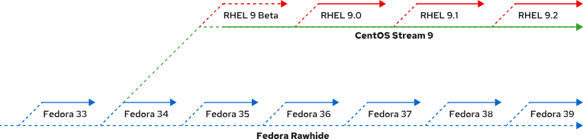
Fig 1.2: Red Hat Enterprise Linux continuous development

Conclusion
- Open-source software has source code that anyone can freely use, study, modify, and share.
- A Linux distribution is an installable operating system that is constructed from a Linux kernel and that supports user programs and libraries.
- Red Hat participates in supporting and contributing code to open-source projects; sponsors and integrates project software into community-driven distributions; and stabilizes the software to offer it as supported enterprise-ready products.
- Red Hat Enterprise Linux is the open source, enterprise-ready, commercially supported Linux distribution that Red Hat provides.
- A free Red Hat Developer Subscription is a useful method for obtaining learning resources and information, including developer subscriptions to Red Hat Enterprise Linux and other Red Hat products.

- Access the Command Line
Introduction to the Bash Shell
A command line is a text-based interface that is used to input instructions to a computer system. The Linux command line is provided by a program called the shell. Many shell program variants have been developed over the years. Every user can use a different shell, but the Red Hat recommends using the default shell for system administration.
The default user shell in (RHEL) is the GNU Bourne-Again Shell (bash). The bash shell is an improved version of the original Bourne Shell (sh) on UNIX systems.
The shell displays a string when it is waiting for user input, called the shell prompt. When a regular user starts a shell, the prompt includes an ending dollar ($) character:
[user@host ~]$
A hash (#) character replaces the dollar ($) character when the shell is running as the superuser, root. This character indicates that it is a superuser shell, which helps to avoid mistakes that can affect the whole system.
[root@host ~]#
Using bash to execute commands can be powerful. The bash shell provides a scripting language that can support task automation. The shell has capabilities that can enable or simplify operations that are hard to accomplish at scale with graphical tools.
Shell Basics
Commands that are entered at the shell prompt have three basic parts:
- Command to run.
- Options to adjust the behavior of the command.
- Arguments, which are typically targets of the command.
The command is the name of the program to run. It might be followed by one or more options, options normally start with one or two dashes (-a or --all, for example) to distinguish them from arguments. Commands might also be followed by one or more arguments.
For example, in the usermod -L user01 string, usermod is the command, -L is the option, and user01 is the argument. This command locks the password of the user01 user account.
Log in to a Local System
A terminal is a text-based interface to enter commands into and print output from a computer system. To run the shell, you must log in to the computer on a terminal.
This is the physical console from the Linux machine. The physical console supports multiple virtual consoles, which can run on separate terminals. You can switch between the virtual consoles by pressing Ctrl+Alt and a function key (F1 through F6) at the same time. Most of these virtual consoles run a terminal that provides a text login prompt. If you enter your username and password correctly, then you log in and get a shell prompt.
Log in to a Remote System
Linux users and administrators often need to get shell access to a remote system by connecting to it over the network. In a modern computing environment, many headless servers are virtual machines or are running as public or private cloud instances. These systems are not physical and do not have real hardware consoles. They might not even provide access to their (simulated) physical console or serial console.
In Linux, the most common way to get a shell prompt on a remote system is to use Secure Shell (SSH). Most Linux systems and macOS provide the OpenSSH command-line program ssh for this purpose.
In this example, a user with a shell prompt on the host machine uses ssh to log in to the remote Linux system remotehost as the user remoteuser:
[user@host ~]$ ssh remoteuser@remotehost
remoteuser@remotehost's password: password
[remoteuser@remotehost ~]$
In the next example, a user with a shell prompt on the host machine logs in to remotehost as remoteuser with ssh, by using the public key authentication method. The ssh command -i option is used to specify the user's private key file, which is mylab.pem. The matching public key is already set up as an authorized key in the remoteuser account.
[user@host ~]$ ssh -i mylab.pem remoteuser@remotehost
[remoteuser@remotehost ~]$
For the connection to work, only the user who owns the file can have access to read the private key file. In the preceding example, where the private key is in the mylab.pem file, you can use the chmod 600 mylab.pem command to ensure that only the owner can read the file. How to set file permissions is discussed in more detail in a later chapter.
Users might also have configured private keys that are tried automatically, but that discussion is beyond the scope of this section. The References at the end of this section contain links to more information about this topic.
ssIf the local machine does have a saved host key and it does not match the one that the remote host sent, then the connection is closed automatically with a warning.
Log Out from a Remote System
When you are finished with the shell and want to quit, you can choose one of several ways to end the session. You can enter the exit command to terminate the current shell session. Alternatively, finish a session by pressing Ctrl+D.
The following example shows a user who logs out of an SSH session:
[remoteuser@remotehost ~]$ exit
logout
Connection to remotehost closed.
[user@host ~]$

