**Drowsiness Detection System Report**

**Submitted to:** L&T EduTech  
**Submitted by:** Aniket Jha  
**Roll Number:** 22BEC0523  
**Date:** 07/07/25

**Table of Contents**

|  |  |
| --- | --- |
| **S.No** | **Section Title** |
| 1 | Problem Statement |
| 2 | Scope of the Solution |
| 3 | Required Components |
| 4 | Simulated Circuit |
| 5 | Video of the Demo |
| 6 | Gerber File |

# Problem Statement

Driver drowsiness is a critical safety concern that contributes significantly to **road accidents**, particularly during nighttime driving. Fatigue and drowsiness are among the **leading causes of major accidents on highways**, posing serious threats to driver safety and public welfare. The lack of real-time monitoring systems to detect and alert drowsy drivers necessitates the development of an effective drowsiness detection and alerting system.

# Scope of the Solution

This project aims to develop a **microcontroller-based drowsiness detection system** that provides comprehensive driver monitoring capabilities. The system offers:

## Real-time Eye Monitoring

Continuously tracks driver's eye blink patterns using **infrared sensor technology**. The eye blink sensor uses infrared LED technology with transmitter and receiver components to detect eye movements.

## Drowsiness Detection Algorithm

Analyzes eye closure duration to identify drowsiness episodes. The system uses a **millis() function** to measure the duration of eye blink and triggers alerts when closure exceeds **1000 milliseconds**.

## Immediate Alert System

Provides instant **audio alerts using a buzzer** to wake up drowsy drivers. The buzzer remains active for 2 seconds when drowsiness is detected.

## Wireless Communication

Enables remote monitoring through **433 MHz RF transmission**. The system uses RF transceiver modules with Amplitude Shift Keying (ASK) for wireless data transmission.

## Portable Design

Compact and wearable solution utilizing sunglasses-mounted sensors for practical implementation.

# Required Components to Develop Solutions

## Hardware Components

The system requires specific electronic components for optimal functionality:

|  |  |  |
| --- | --- | --- |
| **Component** | **Specification** | **Function** |
| **Arduino Nano** | 5V DC operating voltage | Main microcontroller for data processing |
| **Eye Blink Sensor** | 5V DC, TTL output, infrared technology | Detects eye movements and blink patterns |
| **433 MHz RF Transceiver** | ASK modulation, 5V operation | Wireless data transmission |
| **HD12E & HD12D IC** | Encoder/Decoder pair | RF signal processing |
| **Buzzer** | 5V compatible | Audio alert generation |
| **7805 Voltage Regulator** | 9V to 5V conversion | Power supply regulation |
| **9V Battery** | Portable power source | Transmitter power supply |
| **12V DC Supply** | External power adapter | Receiver circuit power |

## Components Not Used in Simulation but Relevant for Real-World Deployment:

In the final simulation on Tinkercad, some components were omitted due to platform limitations or simplification. However, these components play a crucial role in real hardware implementation and are explained below.

|  |  |  |
| --- | --- | --- |
| **Component** | **Specification** | **Explanation** |
| **HD12E & HD12D IC** | Encoder (HT12E) & Decoder (HT12D), 18-pin DIP | These ICs are typically used with RF modules to encode and decode serial data before transmission and after reception. In your simulation, this encoder-decoder pair was not implemented, likely due to Tinkercad limitations or simplification of the wireless system. |
| **433 MHz RF Transceiver** | ASK modulation, 5V operation | This module is used for wireless communication between the transmitter (blink sensor) and the receiver (Arduino). In the simulation, a direct connection or mock signal was likely used instead of actual RF communication, either due to hardware constraints or the focus being on sensor-to-alert functionality. |
| **Arduino Nano** | 5V operating voltage, compact size | Although the Nano was listed, the actual simulation uses an **Arduino Uno**. Functionally similar, the Nano is preferred in compact real-world hardware setups but may be substituted in simulation environments for simplicity. |
| **7805 Voltage Regulator** | Converts 9V–12V DC to 5V | This regulator ensures a steady 5V supply for 5V devices when using higher voltage sources like a 9V battery or 12V adapter. In your simulation, USB power likely provides a direct 5V supply, making the regulator unnecessary. |
| **9V Battery** | Portable power supply | Intended for powering the transmitter unit (e.g., blink sensor + RF module) in a standalone hardware build. In Tinkercad, a stable USB or simulated 5V source is used instead, so the 9V battery isn’t modeled. |
| **12V DC Adapter** | Wall-powered 12V supply | This would typically power the receiver circuit when deployed physically. In the simulation, it's replaced by USB or built-in Tinkercad power rails for convenience. |

## Software and IDE Requirements

**Arduino IDE 2.3.6**: The primary development environment offers comprehensive programming capabilities:

• **Free and** open-source programming environment with community support

• **Cross-platform compatibility** supporting Windows, macOS, and Linux

• **Built-in code** editor with syntax highlighting and auto-completion features

• **Integrated compiler** and uploader for seamless development workflow

• **Serial monitor** and plotter for debugging and data visualization

## Circuit Design and Simulation Tools

**TinkerCAD**: Web-based circuit simulation platform providing accessible design capabilities:

• **Free online** circuit design with drag-and-drop component library

• **Real-time circuit** simulation with Arduino code execution support

• **Virtual instruments** including oscilloscope and multimeter functionality

• **Educational focus** making it ideal for learning and prototyping

**Fritzing**: Electronic design automation software for comprehensive circuit development:

• **Breadboard view** for physical prototyping visualization

• **Schematic diagram** creation with standard circuit symbols

• **PCB layout** design capability for professional manufacturing

• **Extensive component** library organized in categories

• **Export options** for manufacturing and documentation

# Simulated Circuit (TinkerCAD/Fritzing)

## Circuit Architecture

The drowsiness detection system implements a **dual-section design** with transmitter and receiver components:

### Transmitter Section

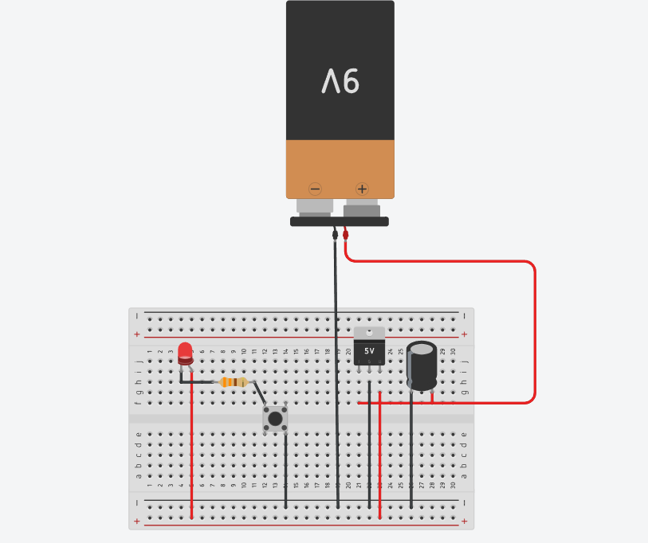

## The transmitter section in the simulation focuses on basic sensor input and signal transmission logic, with some components not implemented due to simulator limitations:

## Eye blink sensor is directly interfaced with the Arduino using digital input.

## Power is supplied via the Arduino’s USB 5V source; the 9V battery and 7805 regulator are not used in simulation but are required in a real-world build for portable power regulation.

## The RF transmitter and antenna are not simulated; instead, the sensor logic is tested using wired connections or mock inputs.

### Receiver Section

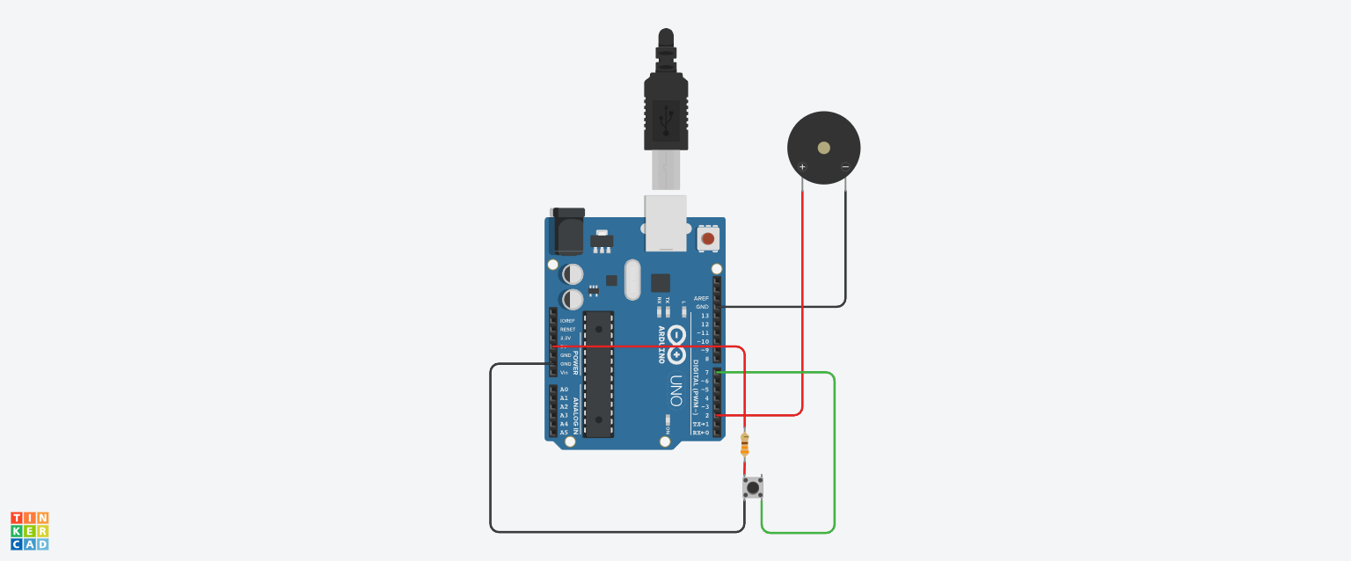

**The receiver section handles the response mechanism based on sensor input:**

## An Arduino Uno is used in the simulation instead of the Nano for simplicity.

## The RF receiver module and decoder IC (HD12D) are not included in the simulation; input is assumed to come directly from the sensor or a pushbutton.

## A buzzer is connected to digital pin 2 and used to generate alerts when the signal is detected.

## Serial communication can be used for debugging via the USB connection.

## Working Principle

## the Driver Drowsiness Detection and Alert System works by using an Eye Blink Sensor to continuously monitor the driver's eye movement. The sensor detects whether the eyes are closed or blinking abnormally (indicating drowsiness) and sends a digital signal to the microcontroller. This signal is then wirelessly transmitted through a 433 MHz RF transmitter module, which uses an HT12E encoder to convert the sensor output into a serial data stream. On the receiving end, an RF receiver module captures the signal and decodes it using an HT12D decoder, which then passes it to an Arduino Nano. The Arduino processes this data and, if drowsiness is detected, triggers a buzzer alarm connected to its digital output pin to alert the driver. The system also includes voltage regulation using a 7805 regulator to ensure stable 5V operation from a 9V battery for the transmitter, and a 12V adapter powers the receiver circuit. This setup ensures continuous monitoring and timely alerts, promoting road safety.

# Video of the Demo

A comprehensive demonstration should showcase the complete system functionality:

Transmitter:



Receiver:



# Gerber File

# This project was developed and simulated using Tinkercad, an online platform designed primarily for breadboard-based circuit prototyping and educational simulations. Tinkercad does not support PCB layout design or Gerber file export functionalities. As a result, the project was not implemented on a custom printed circuit board (PCB), and therefore, Gerber files are not applicable for this stage of development. In a real-world deployment scenario, the circuit can be recreated using PCB design software such as EasyEDA or KiCad to generate the necessary Gerber files for fabrication.

# Code for the Solution

## const int buzzerPin = 2;

## const int switchPin = 7;

## void setup() {

## pinMode(buzzerPin, OUTPUT);

## pinMode(switchPin, INPUT_PULLUP);

## }

## void loop() {

## int switchState = digitalRead(switchPin);

## if (switchState == LOW) {

## digitalWrite(buzzerPin, HIGH); // Switch closed (pressed)

## } else {

## digitalWrite(buzzerPin, LOW); // Switch open

## }

## }

# Conclusion

The drowsiness detection system represents a **comprehensive solution for enhancing road safety** through intelligent driver monitoring technology. By combining **reliable hardware components with sophisticated software algorithms**, the system provides an effective early warning mechanism for drowsy drivers.