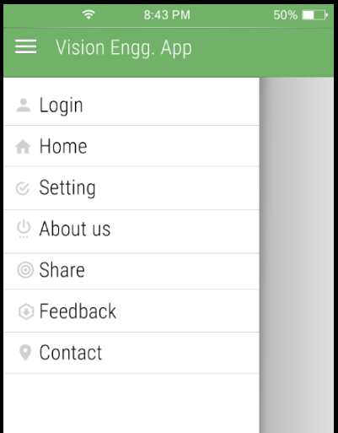

3

2

1

1. Title bar app name is “Vision Engineering Academy”.
2. Make title bar text size and font as Gmail app.
3. Make logos for login, Home, Setting, About us, Share, Feedback and Contact as per Gmail app.
4. Make sequence of all these menu items as Login, Home, Share, About us, Contact, Setting, Feedback, Logout.
5. Add one more menu item in side menu is Logout.

Please remove pen and that logo which is you used, I will provide the same.