IoT-Smart Doorbell

1. Vijay Gaikwad,1 b) Aastha Jain,1 c) Jannu,1 d) Aniket Kalbhor,1 e) Sujit Kanawade,1 f) Karan Harshey

1*Vishwakarma Institute of Technology, Pune – 411037, India Author Emails*

*a)* [*vijay.gaikwad@vit.edu*](mailto:vijay.gaikwad@vit.edu)

*Corresponding authors: b)* aastha.jain22@vit.edu

*c)* undefined.jannu22@vit.edu

*d)* aniket.kalbhor22@vit.edu

*e)* sujit.kanawade221@vit.edu

*f)* karan.harshey22@vit.edu

**Abstract.** The concept of a contactless doorbell emerged during the COVID-19 pandemic, a time when prioritizing social distancing was crucial. Even though those times may have passed, this innovative idea remains highly relevant in today's world, where security and convenience are paramount. The proposed system incorporates several key components: a PIR sensor to detect motion in front of the door, an integrated camera that activates upon motion detection to capture footage, and a mobile app for instant user notification. Through the app, users can seamlessly view the captured footage and are presented with two options: to grant access by remotely unlocking the door or to dismiss the alert if necessary. This thoughtful integration of technology not only enhances the safety of households but also ensures a secure and convenient way to interact with visitors, all while maintaining vigilant surveillance of the area outside the door. This endeavor represents a significant advancement in the realm of smart home security, offering a sophisticated solution for safer and more controlled access.

**Keywords-** IoT, Firebase, ESP32 CAM, Solenoid Door Lock, Android Studio, PIR

# INTRODUCTION

Traditional locks can lead to forgetfulness or uncertainty about whether the door is locked, potentially compromising the residence's safety [1]. Security issues can arise from traditional locks since they are vulnerable to key loss or unauthorized key copying. Additionally, they lack the smart locks' convenient remote access and individualized access rights, which restricts control and monitoring options. Several nations are embracing advanced smart home security control systems. Nowadays, a majority of the appliances found in homes and offices make use of microprocessors. While these appliances come with a user interface, many individuals encounter frustration when attempting to navigate the intricate functionalities of their devices. Additionally, these smart home systems can be quite expensive and not affordable in the long run.

Our concept intends to deliver an effective and affordable system that aims to revolutionize the traditional doorbell in an era distinguished by technological innovation and the growing desire for seamless security solutions. This not only makes it easier to access the door lock remotely, but it also fixes problems with existing doorbell systems. Our technology streamlines the procedure by sending the user a real-time notification, in contrast to the conventional method, which requires them to physically attend the door when it rings. With the help of this notice, the user can conveniently unlock the door from a distance.

The most important part of any home security system is accurately detecting visitors who enter and leave through the door [1]. Our project facilitates the use of PIR sensor for the same which efficiently detects the presence of a person standing near the door.

# RELATED WORK

Sukeshini Tabhane et al. introduced a Door Security System, incorporating an ESP32 and Internet of Things (IoT) technology, designed for monitoring door status, door management, and enhancing home security. They utilize the Blynk communication protocol to establish a connection between a smartphone and the door lock system, contributing to heightened home security. [2]. Shaik Anwar et al. proposed a system that uses a controller interface system with Raspberry Pi which is low-cost and consumes a smaller amount of power. When visitor motion is detected at the Door, a Camera module interfaced with Raspberry Pi captures images, saves them on the system, and sends them as an Email alert via TCP/IP. [2] Trinanjana Bagchi et al. talked about their project, which focuses on creating a robust door lock system using facial recognition technology. They have developed a security system based on Face-ID, utilizing the ESP32-CAM platform. This system can promptly and accurately detect and recognize faces in real-time when they appear in front of a camera. [3]

Bradley Quadros et al. developed Dashbell, a system that empowers homeowners to view images of visitors, enabling remote identification. Additionally, it offers the capability for homeowners to grant or deny access requests from anywhere with an internet connection. The Dashbell system, depicted in Figure 1, comprises components such as a dash button (serving as the doorbell), a WiFi router, a computing device (e.g., a Raspberry Pi), a webcam, a buzzer, cloud computing services (e.g., Amazon Web Service), a smartphone, and internet connectivity. [4] . Dr.B. Mouli Chandra et al. proposed a system that implemented Arduino based touchless doorbell using ultrasonic sensor to detect a person or object by the distance. [5] . Shefali Raina et al. wrote about using Arduino board along with Ultra Sonic Sensor HC-SR04 to make the doorbell smart where Ultra Sonic Sensor can sense the presence of a person and send the signal to the Arduino Board, and then Arduino Board reserves the signal and sends it to the Servo motor where Servo motor can rotate 90 degrees to press the switch of the traditional doorbell. [6]. V Valarmathi et al. proposes a system that acknowledges an individual person standing at a set distance of 1m-2m before of the camera at that time an Arduino signal is initiated which in turn initiates to ring the autonomous door bell and also it initiates the Node MCU Camera module to take the snap of the face and sends the captured image to the M-application and stored in the firebase. [7]. Gimhan Rodrigo et al. expressed their views on the contactless doorbell that was created with the help of a Raspberry Pi and a modified ResNet-50 model using ArcFace loss as the feature extractor to efficiently extract visible features from a masked face and support very accurate recognition. [8] Dilip Prathapagiri et al. introduced a Door Security System application that employs Wi-Fi Door Lock technology with ESP32 CAM and Internet of Things (IoT) technology. This system is designed to oversee door status, facilitate door management, and enhance home security. Utilizing the Blynk communication protocol, it establishes a connection between a smartphone and the door lock system, contributing to heightened home security. [9]. Namrata Singhet al. talks about ESP32-CAM Faces Recognition Door Lock System is combined with an FTDI board, Relay Module, and Solenoid Lock. [10]

Toubid Ahmed et al. proposed a system which uses ESP32 CAM and Node MCU along with Firebase Database. Camera captures the intruder and sends the photo to the android application along with an alarm and GSM module messaging. [11]. Sourabh et al. proposed a system which alerts the user using PIR and Flame sensor which update their data in Real Time at Firebase. Node MCU is used and an Android app is developed [12]. Uma Pujari et al. proposed a system which monitors home appliances with ESP32 and PIR, MQ6 and DHT22 sensors. These sensors update their values in Real time at Firebase which are later fetched by Android app at user side. [13]. Nuba Shittain Mitu et al. discussed an IoT and cloud-based real-time environmental monitoring system, highlighting the development of an Android App for data access. The system employs sensors and microcontrollers, such as the ESP8266 and DHT11, for temperature and humidity data collection. Firebase, a NoSQL database, is used for cloud data storage and real-time monitoring. The Android App, created with MIT App Inventor, allows users to access and monitor the live sensor data seamlessly. The system offers a flexible and cost-effective solution for real-time environmental data collection and monitoring. [14]. Anderies et al. proposed a system which uses ESP8266 along with TTGO Camera, Solenoid Lock and PIR which update the data in Real time to Firebase. The user can control the door lock and see the photo using the android app. [15]. M S Z M Zabidi et al. introduces an enhanced RFID security system integrated with IoT technology. The system uses a Wi-Fi capable microcontroller (ESP-8266/ESP-12E) along with an RFID module (MCRF522). It identifies RFID card UIDs and activates a relay if the card is authorized, sending the information to Firebase. Users can access and configure the system through a dedicated app, offering greater control and monitoring capabilities. [16]. Sanjib Kumar Dhara et al. proposed a system with an ESP-8266/ESP-12E microcontroller to control a 12V solenoid lock through a relay mechanism. It includes security features like knock pattern recognition and remote control via a mobile app. Sensors like LEDs and a piezo element are integrated for functionality. The system ensures secure and convenient door locking and unlocking using Firebase and MIT APP INVENTOR.[17]. CH. M. Shruthi et al. suggested an Android application that utilizes IoT technology to enhance locker security. It employs an ESP32 microcontroller, PIR sensor for motion detection, and magnetic switches to monitor the locker's status. If an intrusion is detected, the system uploads data to Firebase, sends alert notifications via Twilio, and activates a mobile app buzzer. Future enhancements may include equipping the locker with a camera to capture intruder images and inform the police. [18].

# METHODOLOGY

# System Architecture

Figure 1 provides us a block diagram about the working of the proposed system. It is classified in 5th level of IoT. The system is initiated by the sensor nodes- Passive Infrared (PIR) sensor, and sensors- OV2640 camera module and Manual switch, and actuated by- Solenoid door lock. PIR sensor node is used for motion detection which triggers image capture by OV2640 module. Solenoid door lock is used for locking and unlocking the door, switch is used as manual trigger for image capture.

START

PIR Sensor

DOORBELL BUTTON



If visitor detected

If visitor not detected

Send Image and Alert notification to user

Send Image and Alert notification to user

User decides to let visitor in

User grant Permission from remote device

Permission not Granted

DOOR OPENS

Figure 1: Block Diagram

Firebase Storage, Real-time Database (RTDB) rules are updated to allow ESP32 CAM and Android App to communicate to Firebase.

The data collected by sensors and sensor nodes is provided to the central node (ESP32 CAM). The status of PIR sensor, switch and door lock is stored in variables in ESP32 CAM and then it is uploaded on NoSQL based Firebase Real-Time Database via HTTP protocol and REST API. Android App fetches those variables and uses conditioning to display current status in the activity and alerting via notification.

Conditional statements are used by ESP32 which then captures a live image when triggered in “jpg” format. Captured image is uploaded to Firebase Storage and is fetched by Android App using in URL format. Picasso image loader library converts URL to “jpg” format in application layer for displaying image in the activity. App can also request live image which will by captured. Multiple users can install and use this app simultaneously in real time.

# RESULTS AND IMPLEMENTATION

# Information Model

Figure 2 represents the information flow of variables and data from sensors to ESP32 CAM to Android App, vice versa via Firebase.

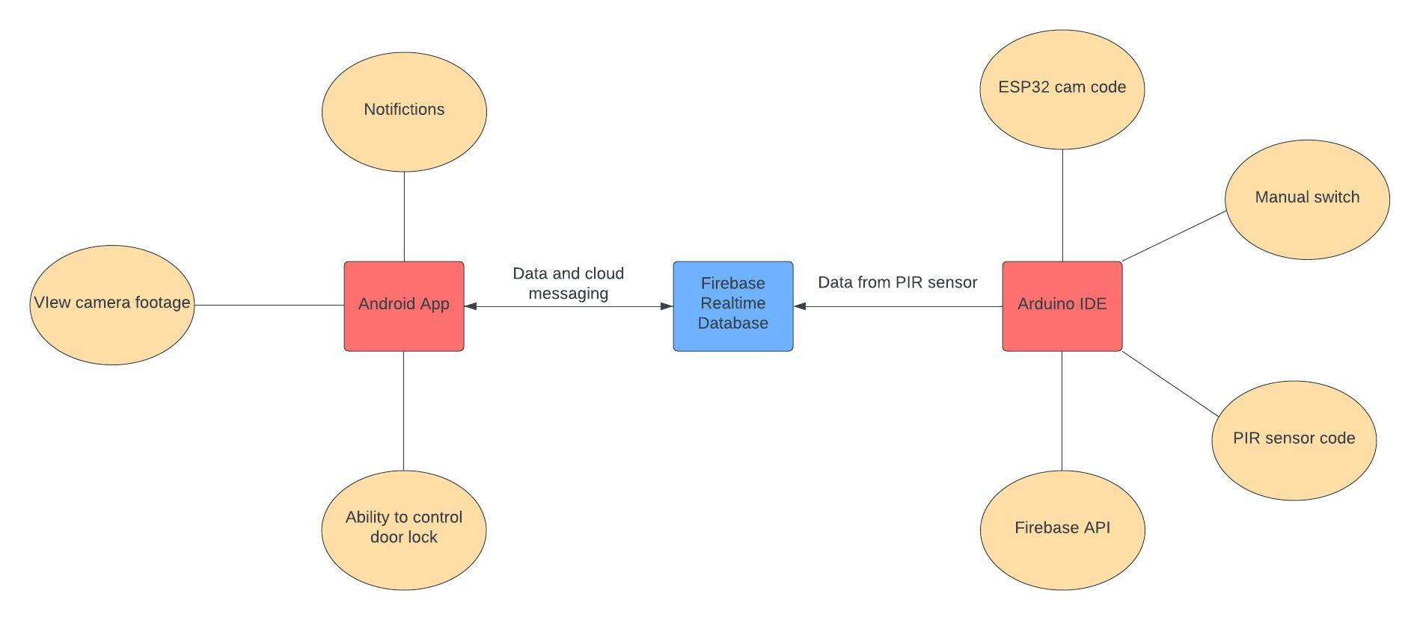

Figure 2: Information Flow

# Design of System

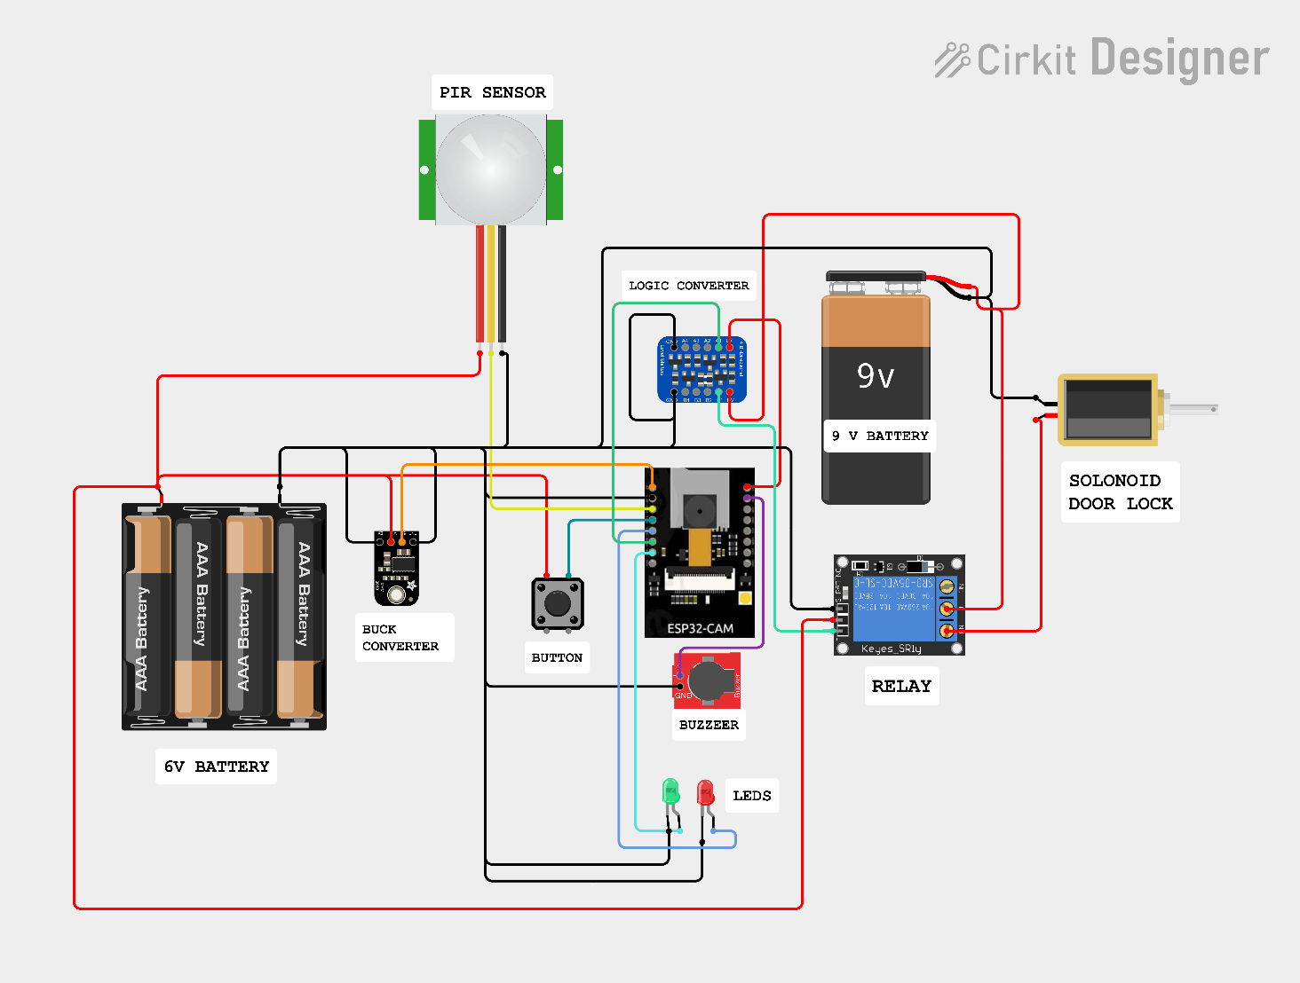

Figure 3: Circuit Design

Figure 3 Gives the circuit diagram for the system depicting all the connections required for implementing the proposed Smart doorbell System.

|  |  |
| --- | --- |
| **PIN** | **CONNECTION** |
| 3.3V | Battery |
| GPIO 16 | Buzzer |
| 5V | Buck Convertor |
| GND | Ground Pins of all devices |
| GPIO 12 | PIR |
| GPIO 13 | Button |
| GPIO 15 | Red LED |
| GPIO 14 | Logic Convertor |
| GPIO 2 | Green LED |

Table : Pin connection for ESP32 CAM

Here we have used two separate power supply one for actuating solenoid and other one for everything else that is because solenoid draws lot of current when actuated which can fluctuations in supply causing mal functioning of another component. Further to keep 5v power supply constant and reliable for ESP 32 cam we have used buck converter as is it very sensitive to power supply. For actuating the relay, we cannot use the GPIO pin from ESP 32 because it works on 3.3V logic but relay works on 5v logic that’s why a logic converter is used here which converts 3.3v signal from esp board and forwards it to relay and relay further control actuation of solenoid door lock. PIR sensor used to detect motion/presence of human in case of sensor failure we have a button which can manually trigger the action corresponding to PIR sensor.

Table 2 shows how the Buzzer and LED act as status indicators when following conditions occur.

|  |  |  |  |
| --- | --- | --- | --- |
| **BUZZER** | **GREEN** | **RED** | **CONDITION** |
| - | - | Blink with 200ms delay | On startup and connecting network |
| - | Blink for 1s | - | System ready to start |
| 2s | - | Blink for 2s | PIR sensor detects movement |
| - | Blink with 200ms delay | - | Uploading photo to Firebase |
| - | Glows | - | Door lock is open |

Table : LED and Buzzer status indicator

# Actual Prototype

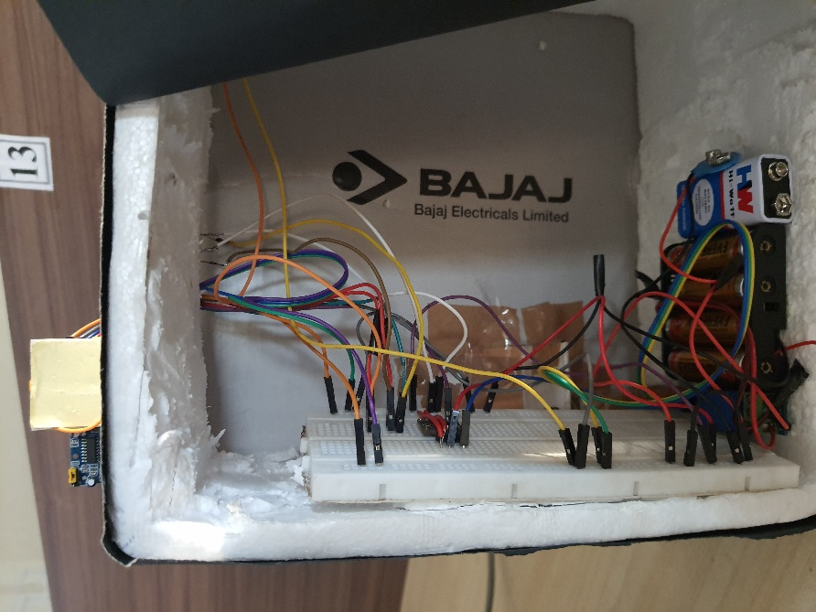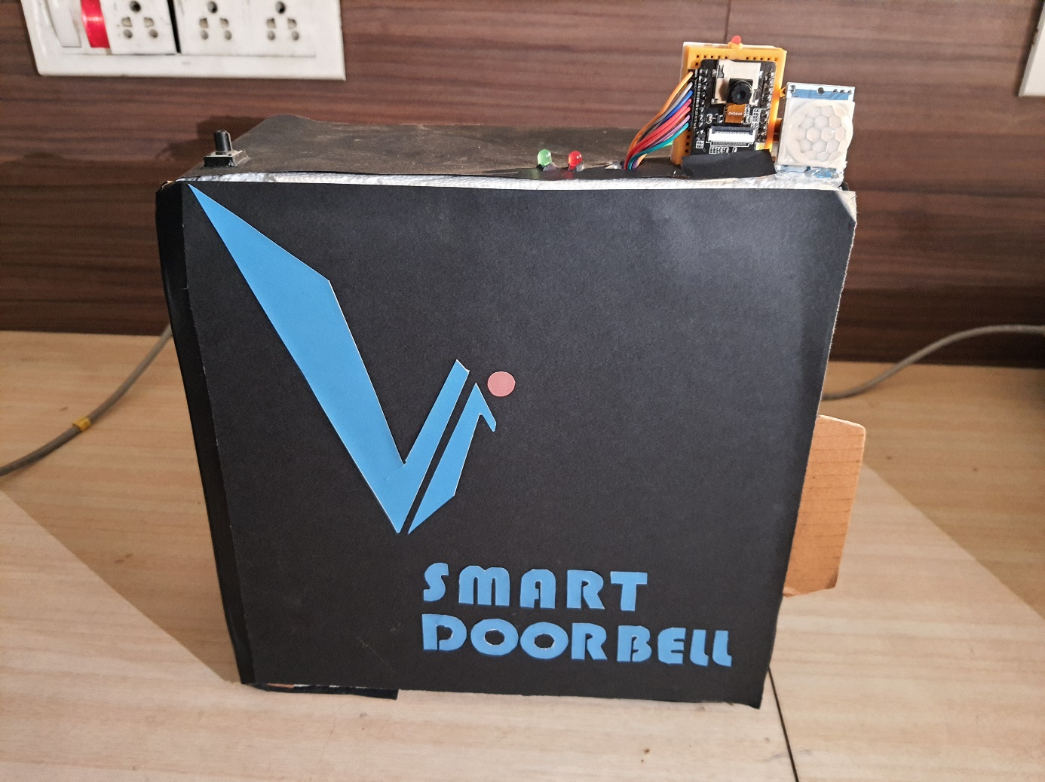

Figure 4: Final prototype representation

# Cloud Backend

Figure 5 represents the captured image stored in Firebase Storage. It is accessed by the Android app via URL and loaded in the activity. It gets overwritten when a new image is captured.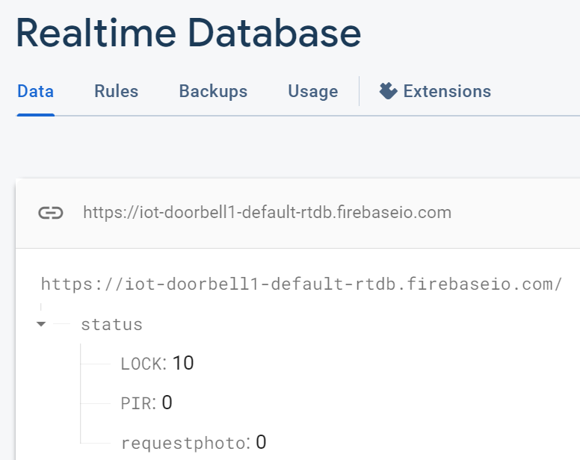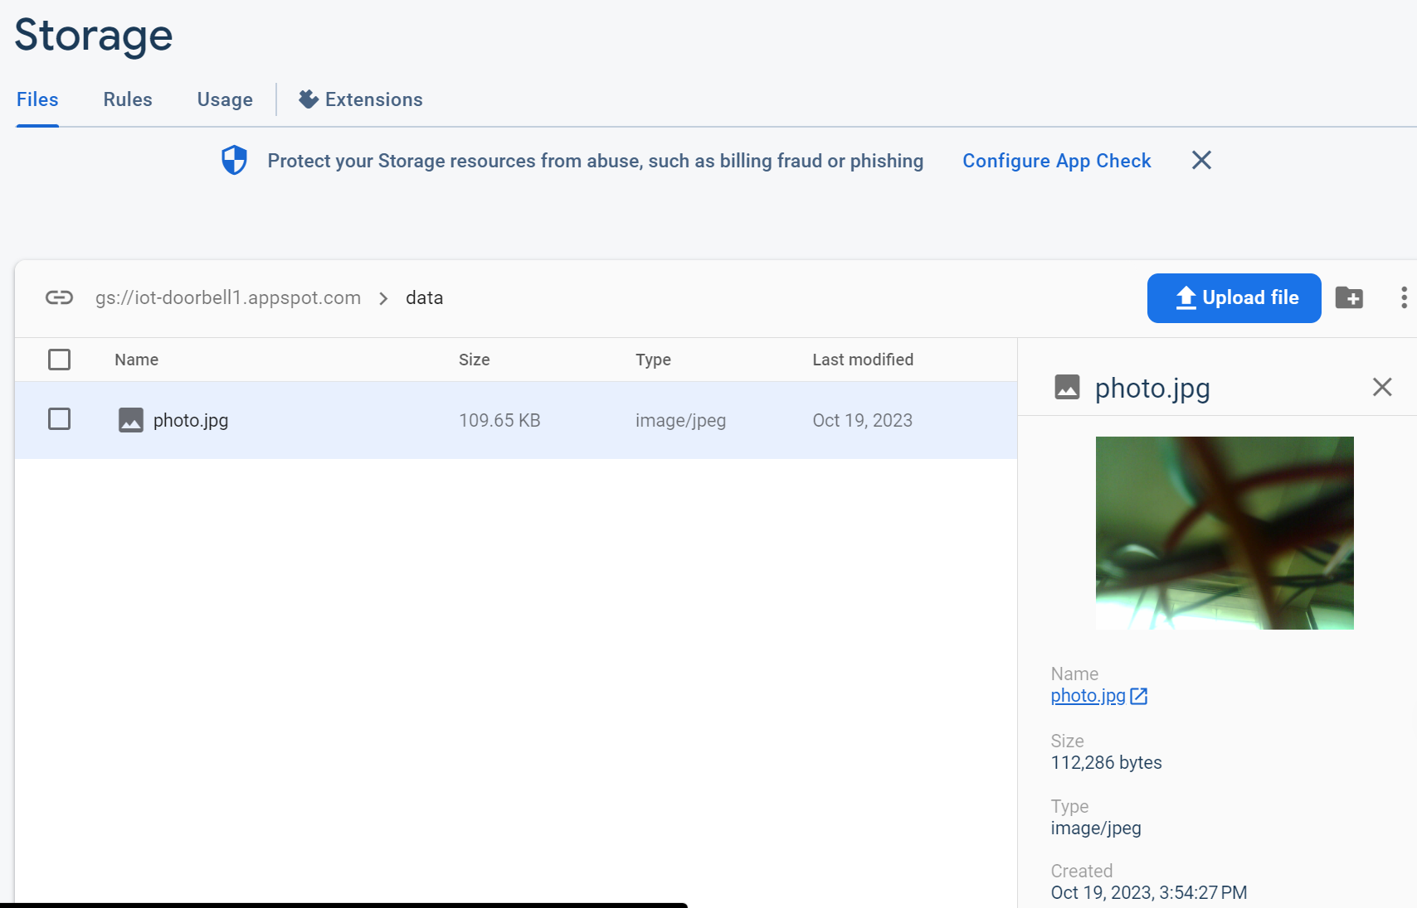

Figure 5a: Sensors and Actuator Variables Figure 5b: Image storage bucket

Table 3 represents the status variables of the proposed system.

|  |  |
| --- | --- |
| **VARIABLE** | **IMPLEMENTATION** |
| LOCK | 11- Locked (Turns on Solenoid Door Lock)  10- Unlocked (Turns off Solenoid Door Lock) |
| PIR | 1- Motion Detected (PIR sensor gets activated)  0- No Motion Detected (PIR doesn’t get activated) |
| requestphoto | 1- Manual trigger initiated from App for image capture  0- Nothing is triggered |

Table : Variables in Firebase RTDB

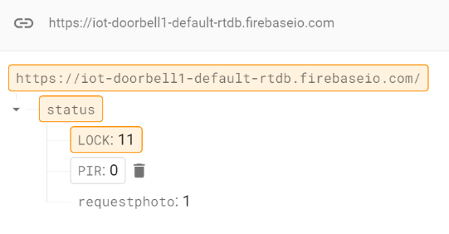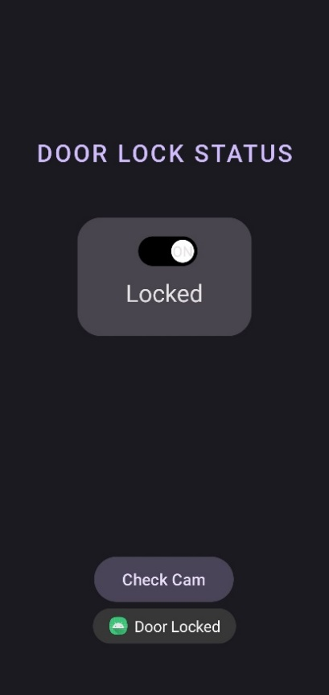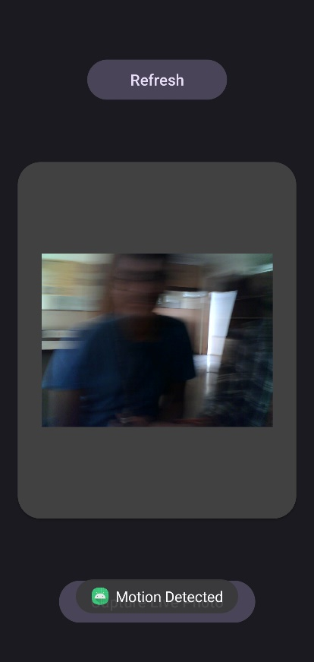

Figure 6: Implementation of App

In Figure 6, when door lock switch is pressed it changes the “LOCK” variable to “11” which turns on the Solenoid door lock actuator. The “Check Cam” button opens the second image activity, which loads the latest image on creation. “Refresh button” reads the latest image from the Storage, and “Capture Live Photo” sets “requestphoto” variable to “1”, which activates the OV2640 camera module of ESP32 CAM to capture a live image.

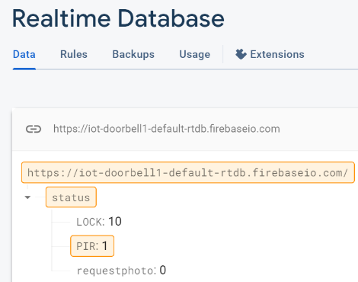

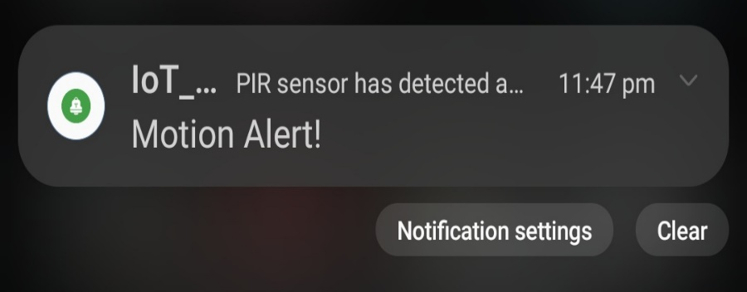

Figure 7: When Motion is Detected by PIR

In Figure 7, The App notifies the user when a motion is detected, and the user can click on it to redirect it to the first activity.

# CONCLUSION

In conclusion, the concept of a contactless doorbell, conceived in response to the imperative need for social distancing during the COVID-19 pandemic, continues to hold significant relevance in today's world. Beyond its initial inspiration, this system addresses paramount concerns of security and convenience. Through the integration of a PIR sensor for motion detection and an activated camera for seamless footage capture, users are promptly notified via a dedicated mobile application. This app further empowers users with the ability to view the captured footage and make informed decisions. The presented options of either granting access or dismissing the alert through the app exemplify a streamlined and secure interaction process. By incorporating a solenoid lock for immediate access, this system enhances both safety and convenience. This initiative stands as a commendable endeavor in the domain of smart household and security solutions, offering a sophisticated and effective means to manage visitor interactions while maintaining vigilant surveillance outside the door.

# REFERENCES

|  |  |
| --- | --- |
| [1] | D. K. Shaik Anwar, "IOT based Smart Home Security System with," *International Journal of Engineering Research & Technology (IJERT),* vol. Vol. 5 , no. Issue 12, 2016. |
| [2] | P. K. M. G. H. C. U. K. Sukeshini Tabhane, "Smart Door Lock System Using ESP32," *International Journal of Advanced Research in Science, Communication and Technology (IJARSCT),* pp. Volume 2, Issue 7, May 2022. |
| [3] | A. M. D. Y. D. M. A. P. P. C. A. K. Trinanjana Bagchi, "Intelligent security system based on face recognition and IoT," *ScienceDirect,* vol. 64, 2022. |
| [4] | R. K. S. W. S. ,. K. Bradley Quadros, "Dashbell: A Low-cost Smart Doorbell System for," *ArXiv,* 2017. |
| [5] | .. M. ,. S. S. K. Dr.B. Mouli Chandra. Sravanib, "TOUCHLESS DOOR BELL FOR POST-COVID," *South Asian Journal of Engineering and Technology ,* 2022. |
| [6] | V. P. S. S. A. S. R. R. A. S. Shefali Raina, "CONTACTLESS IOT DOORBELL," *Journal of Emerging Technologies and Innovative Research (JETIR),* vol. 9, no. 4, 2022. |
| [7] | T. S. J. N. S. S. R. M. P. S. V valarmathi, "Design and implementation ofsecured contactless doorbell using IOT," *International Conference on Computer, Power and Communications (ICCPC), IEEE,* 2022. |
| [8] | D. D. S. Gimhan Rodrigo, "IoT-enabled Contactless Doorbell with Facial Recognition," *IEEE,* 2023. |
| [9] | K. E. Dilip Prathapagiri, "Wi – Fi Door Lock System Using ESP32 CAM Based," *The International journal of analytical and experimental modal analysis,* vol. 8, 2021. |
| [10] | D. R. S. R. K. S. P. S. S. Namrata Singh, "ESP32 CAM Face Detection Door Lock," *International Research Journal of Engineering and Technology,* vol. 9, no. 2, 2022. |
| [11] | A. T. B. N. S. S. A. Touhid Ahmed Asif Bin Latif, "Real-Time Controlled Closed Loop IoT Based Home Surveillance System for Android using Firebase", *2020 6th International Conference on Control, Automation and Robotics (IEEE).* |
| [12] | S. S. S. G. Saurabh Bilgaiyan, “Android based Home Securtiy Systems using Internet of Things(IoT) and Firebase“, *International Conference on Inventive Research in Computing Applications (IEEE), 2018* |
| [13] | U. P P. P. N. B. Manvita Asnodkar, “Internet of Things based Integrated Smart Home Automation System”, *International Conference on Communication and Information Processing*  *(ICCIP-2020), Research Gate* |
| [14] | N. S. M. V. T. V. Myasar Tabany, “Low Cost, Easy-to-Use, IoT and Cloud-Based Real-Time Environment Monitoring System Using ESP8266 Microcontroller”, *International Journal of Internet of Things and Web Services,* vol. 6, 2021 |
| [15] | A. B. A. J. R. Y. Alexander Agung Santoso Gunawan,“ The Development Of A Smart Door Decision System, Based On Pir Sensor, Embedded Face Recognition And Server Request Using Ttgo Esp 32”, *ICIC International,* vol.12, no.10 2021 |
| [16] | M S Z M Zabidi, “IoT RFID Lock Door Security System”, *Journal of Physics: Conference Series*, 2022 |
| [17] | S. K. D. N. B. T. V. V. Supriyo De, “IOT Based Digital Door Lock”, *International Research Journal of Engineering and Technology (IRJET)*, vol. 8, issue. 10, 2021 |
| [18] | CH. M. S. S. K. B. C. K. R. A. Muralidhar Reddy, “Locker Security System using Internet of Things”, *E3S Web of Conferences 391,* 2023 |
|  |  |
|  |  |