NAME- Aniket Kalbhor

PRN- 12210601

ROLL- CSB-48

CODE- **1.A. Write a program to implement Stack using linked list**

#include <stdio.h>

#include <stdlib.h>

struct node{

int data;

struct node *next;

};

struct node *top = 0;

void push(int x){

struct node *t;

t = (struct node*)malloc(sizeof(struct node));

t->data = x;

t->next = top;

top = t;

}

void pop(){

if (top == NULL)

printf("\n underflow");

else

{

struct node *t;

t = top;

int pop = t->data;

printf("\n %d",pop);

top = top->next;

free(t);

}

}

void peek(){

if (top == NULL)

printf("underflow");

else

printf("\n %d",top->data);

}

void display(){

if (top == NULL)

printf("underflow");

else

{

struct node *t;

t = top;

while (t!=NULL)

{

printf("\n %d",t->data);

t=t->next;

}

}

}

void sortStack() {

if (top == NULL || top->next == NULL) {

printf("Stack is empty or has one element only");

}

struct node *current, *nextNode;

int temp;

current = top;

while (current != NULL) {

nextNode = current->next;

while (nextNode != NULL) {

if (current->data > nextNode->data) {

temp = current->data;

current->data = nextNode->data;

nextNode->data = temp;

}

nextNode = nextNode->next;

}

current = current->next;

}

}

int main(){

push(2);

push(3);

push(1);

peek();

display();

sortStack();

display();

pop();

peek();

pop();

pop();

peek();

}

OUTPUT-

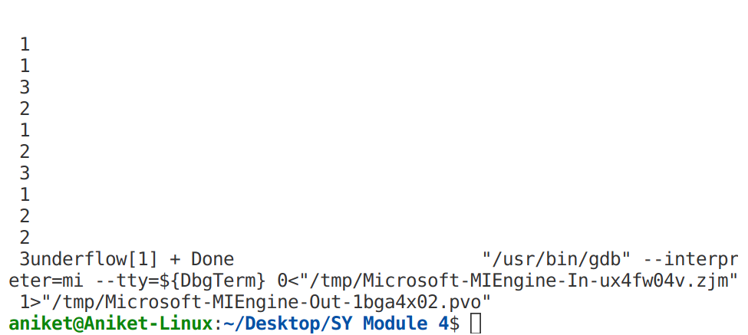

CODE- **1.B. Write a program to implement Queue using linked list**

**#include <stdio.h>**

#include <stdlib.h>

struct node

{

int data;

struct node * next;

};

struct node *front, *rear;

int isEmpty()

{

if(front == NULL && rear == NULL){

printf("\nEmpty\n");

return 1;

}

else

return 0;

}

void enqueue(int data)

{

struct node *temp;

temp = (struct node*)malloc(sizeof(struct node));

temp->data = data;

if(isEmpty())

{

front = temp;

rear = temp;

}

else

{

rear->next = temp;

rear=temp;

}

}

void dequeue()

{

if(isEmpty());

else if (rear == front)

{

struct node *temp;

temp = (struct node*)malloc(sizeof(struct node));

temp = front;

free(temp);

rear == NULL;

front == NULL;

}

else

{

struct node *temp;

temp = (struct node*)malloc(sizeof(struct node));

temp = front;

front = front->next;

free(temp);

}

}

void display()

{

if (isEmpty());

else

{

struct node *temp;

temp = (struct node*)malloc(sizeof(struct node));

temp = front;

while (temp!=NULL)

{

printf("%d->",temp->data);

temp=temp->next;

}

printf("\n");

}

}

void peek()

{

if(isEmpty());

else

printf("\nPeek=%d\n",front->data);

}

int main()

{

display();

enqueue(2);

enqueue(6);

enqueue(1);

enqueue(5);

display();

peek();

dequeue();

dequeue();

dequeue();

dequeue();

dequeue();

dequeue();

}

OUTPUT-

