|  |  |  |  |  |
| --- | --- | --- | --- | --- |
|  | **Title:** **Project Registration & Progress Review** | | **FF No. 180** |  |
|  | | | | | |
|  | | | | | |
| **Department:** Computer Enginnering | | **Academic Year:** 2023-24 | | | |
| **Semester:** IV | | **Group No. :** 24 | | | |
| **Project Title:** Emergency Vehicle Detection system | | | | | |
| **Project Area:** Smart City | | | | | |
| |  |  |  |  |  |  |  | | --- | --- | --- | --- | --- | --- | --- | | Sr. No. | Class & Div. | Roll No. | PRN No. | Name of Student | Contact No. | Email ID | | 1 | SY  CS -B | 41 | 12210209 | Jannu | 9419466245 | undefined.jannu22@vit.edu | | 2 | SY  CS - B | 48 | 12210601 | Aniket Kalbhor | 9028404360 | aniket.kalbhor22@vit.edu | | 3 | SY  CS-B | 52 | 12210612 | Karan Harshey | 9975398741 | karan.harshey22@vit.edu | | 4 | SY CS-B | 89 | 12320120 | Prutha Sanjay Pawade | 7745069117 | prutha.pawade23@vit.edu |   **Group Members Details:** | | | | | |
|  | | | | | |
| **Name of Internal Guide:** Dr. M.L Dhore  **Contact No:** 9421052850  **Email Id:** manikrao.dhore@vit.edu | | | | | |
| Project approved / Not approved  **Guide Project Coordinator Head of Department** | | | | | |

T

**FF No** **180**

**Project Synopsis**

**Introduction**

This project aims to enhance traffic flow and efficiency at intersections by employing image processing for real-time analysis of traffic conditions. In India, traffic is primarily managed by traffic signals and police presence. However, the reliance on policemen can lead to delays in responding to traffic situations. Leveraging smart technologies, this project proposes an Automatic Light Controlling System to minimize waiting times on empty roads and prioritize routes for emergency vehicles. The approach involves the use of a microcontroller to capture video footage from each lane, calculate vehicle count, detect emergency vehicles, and assess traffic density through appropriate functions. The timing for green lights is dynamically adjusted based on the traffic density, giving priority to roads with higher vehicle volume and freeing lanes with emergency vehicles.

**Review of Literature**

• Smart Control of Traffic Light System using Image Processing: This paper suggests a traffic control system using MATLAB code for image processing, adjusting signal timings based on traffic density and count.

• Density-Based Traffic Control System Using Image Processing: This paper proposes a system that calculates vehicle count using image processing tools in Matlab, allocating different timings based on the count and providing a green signal accordingly.

• Smart Traffic Light Switching and Traffic Density Calculation using Video Processing: This paper discusses live video feed usage for traffic count calculation and presents an algorithm for adaptive traffic light switching based on road vehicle density.

• IoT-based Smart Traffic Density Control using Image Processing: This paper involves capturing and storing images on a server, comparing them with real-time images via a camera, identifying density, and providing a software application for manual adjustment of traffic signal timings.

• Emergency Vehicle Detection: This paper focuses on detecting emergency vehicles through image processing algorithms from live camera feeds. If a vehicle remains idle for a fixed interval, nearby policemen are alerted via a mobile application

**Problem Statement**

Current traffic management lacks real-time adaptability, resulting in inefficiencies and congestion for both regular and emergency vehicles. Traditional traffic controllers rely on pre-defined timings, leading to suboptimal outcomes. This project addresses these issues by proposing a real-time traffic control system using image processing. The system utilizes webcams at traffic light stages to capture footage from each lane, enabling dynamic adjustments in signal timings based on real-time traffic conditions.

**Objective**

**Traffic Flow Monitoring:** To Analyze real-time traffic images to understand the flow of vehicles on roads, identify areas of congestion, and suggest alternative routes.

**Emergency Vehicle Detection:** Rerouting the traffic and informing nearby policeman.

**Vehicle Counting and Classification:** To Analyze and Count the number of vehicles passing through a specific area and classify them based on type (e.g., cars, trucks, bicycles).

**Improved Safety:** To Analyze Properly timed traffic lights can reduce the likelihood of accidents at intersections.

**Flowchart**

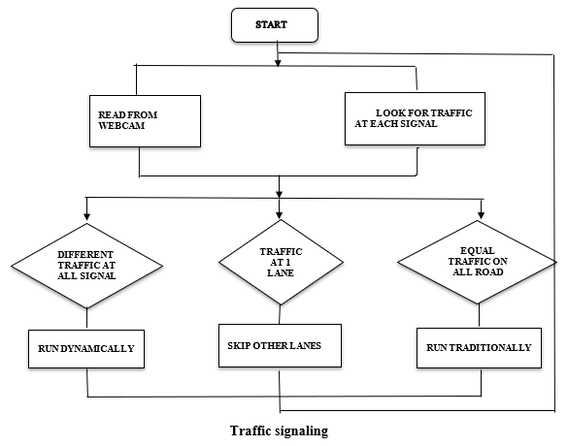

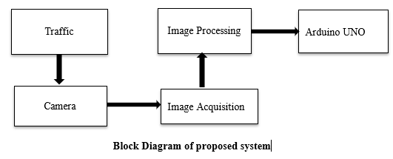

**Hardware Requirement**

* Camera Module
* Servo Motor
* Microcontroller

**Software Requirement**

* Yolo Algorithm
* Python
* C++
* Arduino IDE

**FF No** **180**

|  |  |  |  |
| --- | --- | --- | --- |
| **Group No.** | **24** | | |
| **Activity** | **Review Schedule** | **Progress Review Report submitted** | **Signature of Guide** |
| Review 1 | Mid Sem. Semester | Yes / No |  |
| Review 2 | End of Semester | Yes / No |  |

|  |
| --- |
| **Review No.: 1 Group No.: 24 Date:** |
| **Progress Review Report** |
| **Signature of Guide:** |

|  |
| --- |
| **Review No.: 2 Group No.: 24 Date:** |
| **Progress Review Report** |
| **Signature of Guide:** |