Submission of Final Report of IAC Data Set In Word Format

Submitted by :- Aniket Katiyar

Linkedin:- www.linkedin.com/in/aniket-katiyar-85540b257

1.What is the average CGPA of the students ?

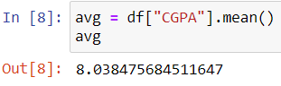

2. What is the distribution of student across different graudation years ?

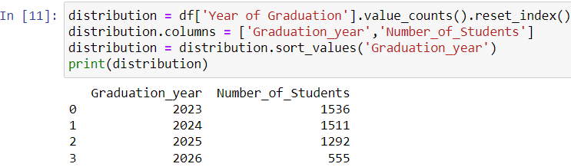

3. What is the distribution of student’s experience in python programming ?

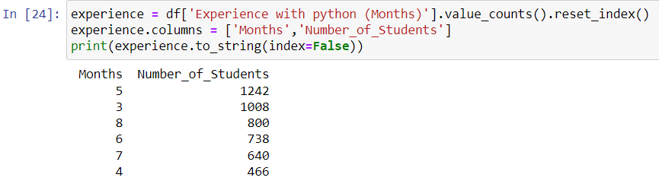

4. What is the average family income of student ?

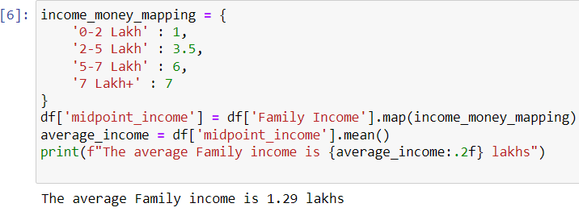

5. How does the GPA vary among different collages ? (Show Top 5 result only

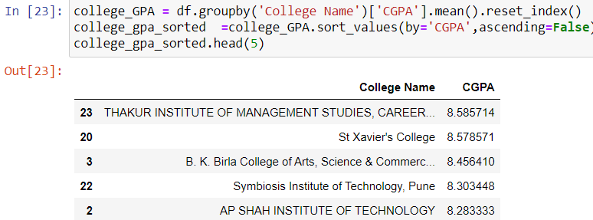

6. Are there any outliers in the quantity (number of courses completed) attribute

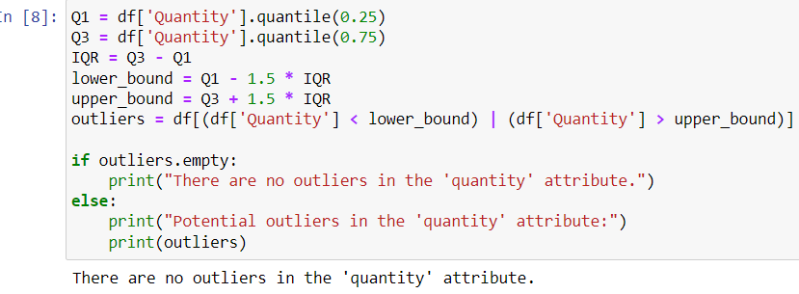

7. What is the average CGPA for student from each city ?

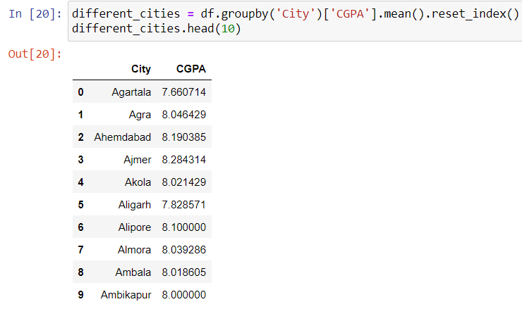

8. Can we identify any relationship between family income and GPA ?

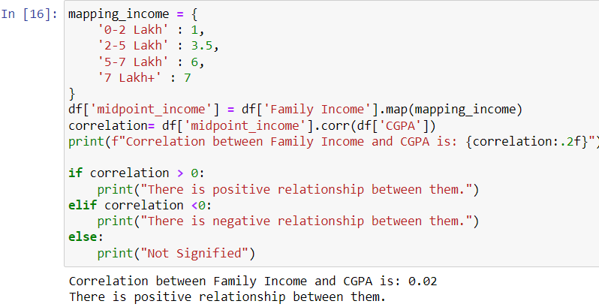

9. How many students from various cities ?

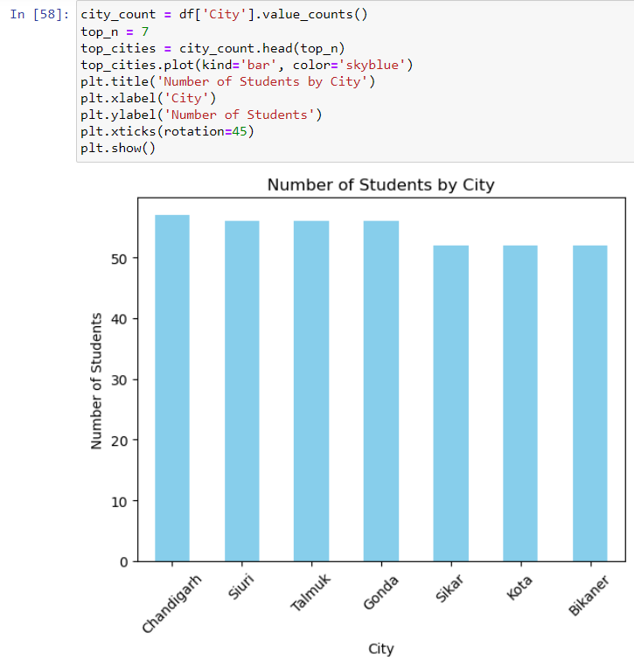

10. Which event tend to attract more student from specific field of study ?

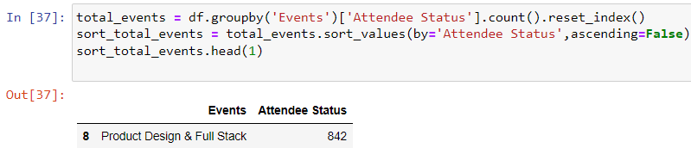

11. Do students in leadership position during their collage years tend to have higher GPAs or better Expected Salary ?

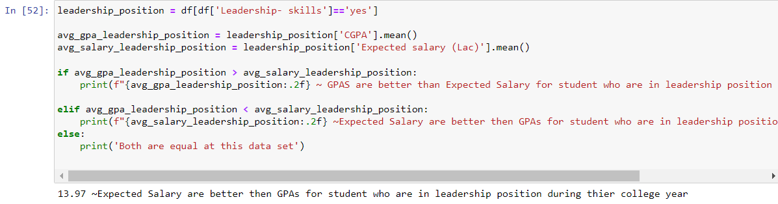

12. How many student are graduating by the end of 2024 year ?

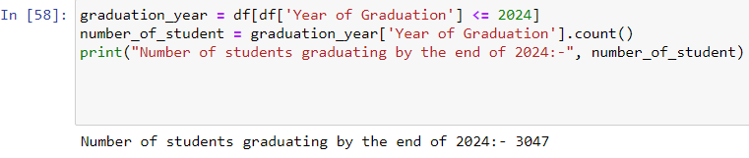

13. Which promotion channel brings in more student participation for the event ?

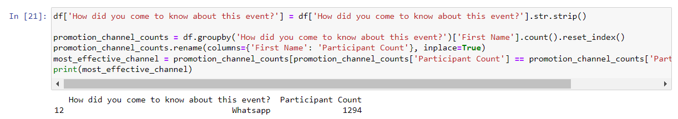

14. Find the total number of student who attended the event related to data science (from all data science related course).

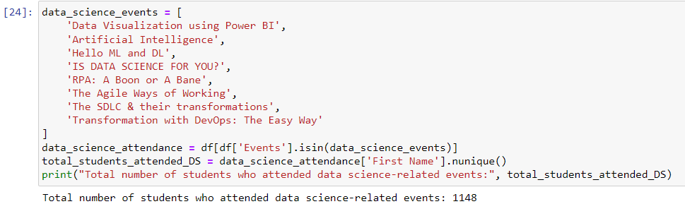

1. How does the expected salary vary based on factor like ‘CGPA’, ‘Family Income’, ‘Experience with python(Months)’?

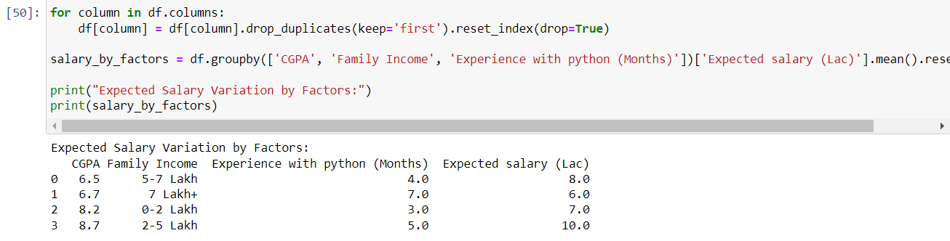

1. How many students know about the event from their college? which of these top 5 collages?

