**Chapter 1**

**Visualizing and Forecasting Stocks**

**1.1 Background and Motivation:**

**The importance of stock market analysis and prediction in the financial domain:**

In today's fast-paced global economy, the stock market plays a crucial role in driving economic growth, facilitating investments, and shaping financial decisions. Stock market analysis and prediction have become indispensable tools for investors, traders, financial institutions, and even policymakers. By analyzing historical data, identifying patterns, and making informed forecasts, market participants can make strategic investment choices, mitigate risks, and maximize returns. Stock market analysis provides investors with valuable insights into the financial health, performance, and potential of companies. By analyzing fundamental factors such as earnings, revenues, and market trends, investors can assess the value and growth prospects of stocks.

Such analysis helps in making informed decisions about buying, selling, or holding stocks, allowing investors to optimize their portfolios and achieve their financial goals. Stock market prediction techniques assist in assessing and managing risks associated with investments. Volatility and uncertainty are inherent characteristics of financial markets, and accurate forecasts can help investors anticipate potential risks and devise appropriate risk mitigation strategies. By incorporating risk management techniques into their decision-making processes, investors can protect their investments and reduce the impact of adverse market conditions.

Analyzing and predicting stock market trends enables investors to time their entry or exit points effectively. Timing the market can be crucial for maximizing returns and minimizing losses. By identifying bullish or bearish trends, investors can take advantage of favorable market conditions to buy stocks at lower prices or sell stocks at higher prices. Market timing, when combined with accurate analysis, can enhance the profitability of investment strategies. Stock market analysis and prediction play a significant role in portfolio optimization. Diversification is a fundamental principle of risk management, and through careful analysis, investors can identify stocks with low correlation, reducing the overall risk of the portfolio. Additionally, analyzing factors such as sector performance, market trends, and macroeconomic indicators can help in allocating assets efficiently and achieving a well-balanced portfolio. Stock market analysis and prediction contribute to the broader understanding of economic conditions. The stock market is often considered a leading indicator of economic health, reflecting investor sentiment and market expectations. By examining the performance of stocks across different sectors, market participants can gain insights into overall economic growth, industry trends, and the business cycle. Such information aids policymakers, financial institutions, and analysts in making informed decisions regarding fiscal policies, monetary measures, and market regulations. In conclusion, stock market analysis and prediction are vital components of the financial domain. By providing valuable insights, managing risks, facilitating market timing, optimizing portfolios, and contributing to the understanding of economic conditions, these practices enable investors to make informed decisions and navigate the complexities of the stock market. As technology and data-driven approaches continue to advance, the importance of stock market analysis and prediction is likely to grow, shaping the future of investment strategies and financial decision-making.

**Increasing interest in data-driven approaches for making informed investment decisions:**

In recent years, there has been a significant surge in the interest and adoption of data-driven approaches for making informed investment decisions. Traditional methods of investment analysis and decision-making often relied on subjective judgments, qualitative factors, and limited historical data. However, with the advancements in technology, the availability of vast amounts of data, and the rise of computational power, data-driven approaches have gained prominence. The proliferation of digital platforms, financial transactions, and online interactions has resulted in an exponential growth in data generation. This vast amount of data, commonly referred to as "big data," encompasses various sources, including financial statements, market data, social media sentiment, news articles, and more.

The accessibility and availability of big data have opened new opportunities for investors to extract valuable insights and patterns that were previously hidden or difficult to identify. Data-driven approaches empower investors by providing them with enhanced decision-making capabilities. By leveraging sophisticated data analysis techniques, investors can uncover correlations, trends, and anomalies in the market. These approaches enable investors to identify undervalued securities, assess the impact of macroeconomic factors, and make more accurate predictions about future market movements.

**Need for visualizing stock data and forecasting future trends:**

In the fast-paced and dynamic world of financial markets, the need for visualizing stock data and forecasting future trends has become increasingly crucial. Stock market participants, including investors, traders, and financial analysts, rely on visualizations and forecasts to gain insights into market behavior, make informed decisions, and identify potential opportunities.

Stock market data is characterized by its complexity and volume, with millions of transactions occurring daily across various markets and securities. Raw data alone can be overwhelming and challenging to interpret effectively. Visualizations provide a way to simplify and represent this complex data in a visual format, making it easier for analysts to identify patterns, trends, and relationships. By visualizing stock data, investors can gain a holistic view of market dynamics and make more informed decisions. Visualizing stock data allows for the identification of patterns and trends that may not be evident from raw data alone.

Using charts, graphs, and technical indicators, investors can visually analyze historical price movements, trading volumes, and other relevant metrics. Patterns such as support and resistance levels, trendlines, and chart patterns can be identified, aiding in the identification of potential entry or exit points. These visual cues assist investors in making predictions and forecasting future trends. Stock market movements are influenced not only by fundamental factors but also by investor sentiment and market psychology. Visualizing stock data can help analysts understand market behavior, sentiment shifts, and investor reactions. By examining visual representations of trading volumes, price fluctuations, and sentiment indicators, investors can gauge the overall market sentiment and identify potential market turning points. Visualizations allow for a better understanding of investor behavior, which is valuable for making predictions and formulating investment strategies. Visualizing stock data is crucial for effective risk management and decision support. By analyzing visual representations of historical price movements, volatility, and correlations, investors can assess the risk associated with specific securities or portfolios. Visualizations enable investors to identify potential risks and assess their impact on the overall investment strategy. Furthermore, visualizing forecasted trends and scenarios can aid in stress testing and evaluating the potential outcomes of different investment decisions. In conclusion, the need for visualizing stock data and forecasting future trends.

**1.2 Problem Statement:**

The problem that this project aims to address is the need for effective visualization and accurate forecasting of stocks in the financial domain. As the stock market continues to be a critical platform for investment and wealth creation, investors and financial analysts face the challenge of making informed decisions amidst the vast amount of available data and the dynamic nature of the market. With the exponential growth of available financial data, investors and analysts face the problem of information overload. Raw stock market data, including historical prices, trading volumes, and company financials, can be overwhelming to analyze and interpret effectively. Moreover, the stock market exhibits complex patterns influenced by various factors, such as market trends, economic indicators, news events, and investor sentiment. Understanding and identifying these patterns is crucial for making accurate forecasts and informed investment decisions. Effective visualization of stock data is essential for providing clarity and insights into market dynamics. Traditional tabular formats and numerical data alone often fail to capture the complexity and interrelationships within the data. Visual representations, such as charts, graphs, and interactive dashboards, offer a more intuitive and accessible way to comprehend and analyze the data. Clear visualizations facilitate pattern recognition, trend identification, and help investors gain a comprehensive understanding of stock market behavior. Accurate forecasting is a fundamental requirement for successful investing. However, stock market forecasting is a challenging task due to the presence of various uncertainties, market noise, and the ever-changing nature of the financial markets. This project aims to develop methodologies and algorithms to improve forecasting accuracy by leveraging historical data, technical indicators, and other relevant information. By employing advanced data analytics and machine learning techniques, the project seeks to provide reliable predictions and assist investors in making better-informed decisions. The ultimate goal of this project is to empower investors and financial analysts with the necessary tools and insights to navigate the complex stock market landscape. By visualizing stock data and providing accurate forecasts, the project aims to enhance investment decision-making processes, improve risk management strategies, and optimize portfolio allocations. Empowering individuals with data-driven tools and techniques can level the playing field and enable investors to make informed choices based on evidence and analysis rather than relying solely on intuition or anecdotal information. In conclusion, the problem this project aims to address is the effective visualization and accurate forecasting of stocks in the financial domain. The challenge lies in managing the vast amount of available data, comprehending complex patterns, and making reliable predictions in a dynamic market environment. By developing innovative visualization techniques and advanced forecasting models, this project seeks to empower investors and financial analysts, enabling them to make more informed investment decisions, manage risks effectively, and achieve their financial objectives.

**Challenges and limitations associated with traditional stock analysis techniques:**

Traditional stock analysis techniques have been widely used by investors and financial analysts to make investment decisions. However, these techniques are not without their challenges and limitations. One of the primary challenges of traditional stock analysis techniques is the inherent subjectivity and potential for bias. Traditional techniques often rely on qualitative assessments, such as analyzing financial statements, company news, and market rumors, which can introduce personal biases and interpretations. The lack of standardized methodologies and the influence of cognitive biases can impact the objectivity of the analysis, leading to suboptimal investment decisions. Traditional stock analysis techniques typically rely on historical data to identify patterns, trends, and relationships. However, the availability of historical data is limited by the timeframe of the data being analyzed. This limitation can result in a narrow perspective and may not fully capture the dynamics of the market, particularly during periods of economic crises or unprecedented events. The reliance on limited historical data can hinder the accuracy of forecasts and predictions. As the volume of available financial data continues to grow exponentially, traditional stock analysis techniques face challenges in efficiently processing and analyzing large data sets. Manual analysis of extensive data can be time-consuming and prone to errors. Traditional techniques may struggle to handle the vast amount of information and extract meaningful insights in a timely manner, limiting the ability to make quick and informed investment decisions. Many traditional stock analysis techniques assume linear relationships between variables. However, the stock market is a complex system with non-linear relationships, where small changes in one variable can have disproportionate effects on others. Traditional techniques may not adequately capture these non-linear relationships, limiting the accuracy and reliability of the analysis. As a result, investors may miss important market dynamics and fail to account for potential risks or opportunities. Another limitation of traditional stock analysis techniques lies in their ability to predict future market behavior accurately. Market dynamics are influenced by a multitude of factors, including economic indicators, geopolitical events, and investor sentiment, making it challenging to predict how these variables will interact and impact stock prices. Traditional techniques often rely on historical patterns, which may not fully reflect future market conditions, limiting their predictive power. In conclusion, traditional stock analysis techniques face several challenges and limitations that can impact their effectiveness in providing accurate and reliable investment insights. The subjectivity and bias inherent in qualitative assessments, limited historical data, inefficiency in processing large data sets, the inability to capture non-linear relationships, and challenges in predicting future market behavior all contribute to the need for alternative approaches. By leveraging data-driven techniques, advanced analytics, and machine learning algorithms, investors can overcome these limitations and enhance their ability to make informed investment decisions in a dynamic and complex stock market environment.

**Limitations or constraints that may impact this project:**

While the project aims to address the problem of visualizing and forecasting stocks, it is important to acknowledge the limitations and constraints that may impact the scope of the project. These limitations can include various factors such as time, data availability, technological constraints, and expertise. Time constraint is a common limitation that affects many projects, including this one. Developing robust visualizations and accurate forecasting models requires substantial time for data collection, analysis, model development, and testing. The project scope may be limited by the available timeframe, which can impact the depth and complexity of the visualizations and forecasting techniques that can be implemented. Time management and efficient allocation of resources are crucial to ensure the project's successful completion within the designated time frame. The availability and quality of data can significantly impact the scope of the project. Stock market data can be subject to restrictions, licensing agreements, or proprietary databases, which may limit the access to certain datasets. Additionally, the quality and completeness of the data can vary, leading to potential gaps or inconsistencies that may affect the accuracy of the visualizations and forecasting models. The project scope may need to consider the limitations imposed by data availability and the necessary data preprocessing steps to ensure reliable analysis and insights. Technological constraints can also influence the scope of the project. The computational resources and infrastructure required for processing and analyzing large datasets can be a limitation. The project may need to consider the scalability and efficiency of the chosen visualization and forecasting techniques to ensure they can be implemented within the available technological constraints. The selection of appropriate tools, software, and programming languages should align with the project's technological capabilities and constraints. The scope of the project may be influenced by the expertise and skill sets of the project team. Developing advanced visualization techniques and accurate forecasting models often requires a combination of domain knowledge, data analysis skills, statistical modeling, and programming expertise. The project team's proficiency in these areas may determine the complexity and sophistication of the implemented solutions. The scope should be aligned with the team's capabilities and expertise to ensure successful project execution. The scope of the project must be clearly defined and aligned with the project objectives. It is essential to determine the specific focus areas within visualizing and forecasting stocks that the project aims to address. A comprehensive analysis of the limitations and constraints should be conducted during the project planning phase to ensure realistic and achievable goals. Setting clear expectations and defining the boundaries of the project scope will enable effective resource allocation and minimize potential risks. In conclusion, several limitations and constraints may impact the scope of the project focused on visualizing and forecasting stocks. Time constraints, data availability and quality, technological limitations, expertise and skill sets, and the definition of project objectives are among the factors that need to be considered. By acknowledging these limitations and constraints, the project team can effectively manage resources, plan for potential challenges, and deliver a project that meets the defined objectives within the given constraints. Technological constraints can also influence the scope of the project. The computational resources and infrastructure required for processing and analyzing large datasets can be a limitation. The project may need to consider the scalability and efficiency of the chosen visualization and forecasting techniques to ensure they can be implemented within the available technological constraints. The selection of appropriate tools, software, and programming languages should align with the project's technological capabilities and constraints. Time constraint is a common limitation that affects many projects, including this one. Developing robust visualizations and accurate forecasting models require substantial time for data collection, analysis, model development, and testing. The project scope may be limited by the available timeframe, which can impact the depth and complexity of the visualizations and forecasting techniques that can be implemented. Technological constraints can also influence the scope of the project. The project may need to consider the scalability and efficiency.

**1.3 Methodology Overview:**

**Data Collection and Preprocessing**

The first step in the methodology is data collection and preprocessing. Historical stock market data, including price and volume information, will be gathered from reliable sources such as financial data providers or APIs. The collected data will then undergo preprocessing, including data cleaning, normalization, and handling missing values or outliers. This step ensures that the data is in a suitable format for analysis and forecasting.

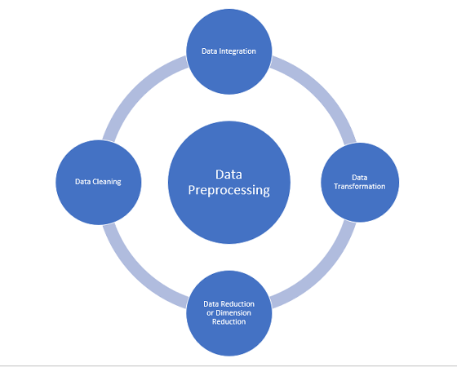

Fig1.1 Data Preprocessing

**Feature Engineering and Selection**

Once the data is preprocessed, the next step involves feature engineering and selection. Relevant features will be derived or extracted from the raw data to enhance the forecasting models' predictive power. Technical indicators, such as moving averages, relative strength index (RSI), and Bollinger Bands, may be computed from the price and volume data. Feature selection techniques will be employed to identify the most informative and influential features for the forecasting models.

**Model Selection and Training**

The methodology will include the selection and training of appropriate forecasting models. Various models may be considered, such as autoregressive integrated moving average (ARIMA), exponential smoothing (ES), or machine learning algorithms like random forests, support vector machines (SVM), or neural networks. The selection of models will be based on their suitability for capturing the underlying patterns and relationships in the stock data. The chosen models will then be trained using the historical stock data, optimizing their parameters through techniques like grid search or cross-validation.

**Visualization Techniques**

The visualization aspect of the methodology will involve the creation of informative and visually appealing charts, graphs, and dashboards to represent the stock data and analysis results. Visualizations may include candlestick charts, line charts, or area charts to display price movements over time. Additionally, other visual elements, such as volume bars, moving averages, and trendlines, may be incorporated to provide a comprehensive view of the stock data. Interactive features or tooltips may also be implemented to enable users to explore the data and gain deeper insights. Line graphs are simple yet effective visualization tools for depicting the historical price trends of stocks. They connect the closing prices of a stock over a given time period, allowing users to observe the overall price trajectory. Line graphs are particularly useful for identifying long-term trends and evaluating the performance of a stock over time. The combination of these visualization techniques enhances the understanding and interpretation of stock market data. These techniques enable users to identify patterns, trends, anomalies, and relationships, empowering them to make informed investment decisions. Visualizations may include candlestick charts, line charts, or area charts to display price movements over time. Additionally, other visual elements, such as volume bars, moving averages, and trendlines, may be incorporated to provide a comprehensive view of the stock data. Interactive features or tooltips may also be implemented to enable users to explore the data and gain deeper insights. Line graphs are simple yet effective visualization tools for depicting the historical price trends of stocks.

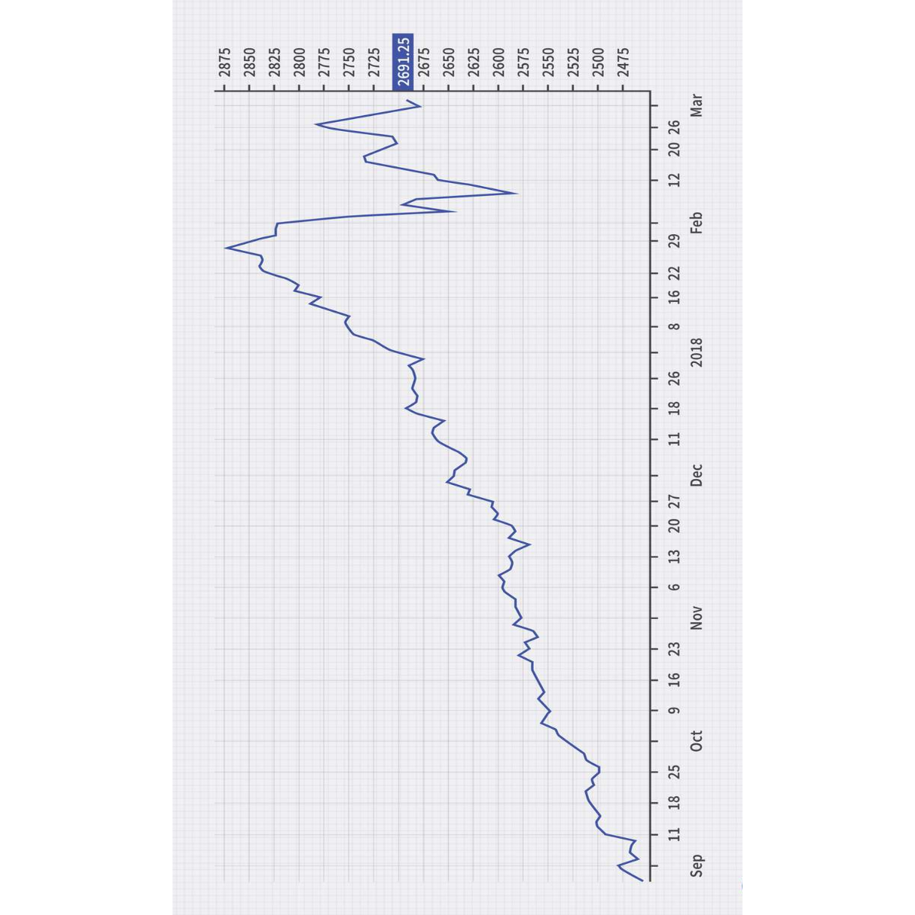

Fig 1.2. Graph Visualizing stock prices with respect ot time period.

**Forecasting and Evaluation**

The trained forecasting models will be used to predict future stock prices or trends. The models will be applied to unseen data or a test dataset to assess their performance and accuracy. Evaluation metrics such as mean absolute error (MAE), root mean square error (RMSE), or accuracy measures will be utilized to compare and assess the forecasting models' performance.

**Iteration and Refinement**

The methodology allows for iteration and refinement of the models and visualizations based on the evaluation results. If the forecasting models or visualizations do not meet the desired level of accuracy or effectiveness, adjustments or improvements can be made. This iterative process may involve fine-tuning the model parameters, exploring alternative models, or enhancing the visualizations to provide clearer insights.

**Algorithms and tools used:**

The success of the project in visualizing and forecasting stocks relies on the effective utilization of relevant algorithms, techniques, and tools.

**Forecasting algorithm:**

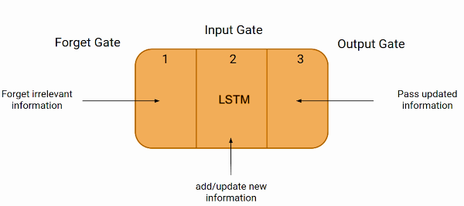

Fig 1.3. Forecasting Algorithm

LSTM (Long Short-Term Memory) is a deep learning algorithm that falls under the category of recurrent neural networks (RNNs). It is designed to effectively capture and model long-term dependencies or patterns in sequential data. The key characteristic of LSTM is its ability to mitigate the vanishing gradient problem, which is a common issue in training deep neural networks. The vanishing gradient problem refers to the diminishing impact of gradients as they backpropagate through layers, making it difficult for the network to learn dependencies over long sequences. LSTM addresses this problem by introducing a memory cell and gating mechanisms. The memory cell is the core component of an LSTM unit. It stores information over time and selectively decides what to keep and what to discard. The cell has a self-connected recurrent connection, allowing it to retain information from previous time steps. It can be seen as a conveyor belt, where data flows in and out, being modified or maintained based on the information it carries. LSTM incorporates three types of gates that control the flow of information within the cell: the input gate, the forget gate, and the output gate. Each gate is a neural network layer that processes information using sigmoid and element-wise multiplication operations. By using these gating mechanisms, an LSTM network can selectively retain or discard information over long sequences, allowing it to capture and propagate relevant information over time. This makes LSTMs particularly useful for tasks involving sequential data, such as natural language processing, speech recognition, and time series analysis.

**1.4 Data Visualization Tools**

Python Libraries:

Python libraries such as Matplotlib, Seaborn, and Plotly can be employed for data visualization in the project. Matplotlib provides a wide range of customizable chart types and visualization options. Seaborn offers higher-level statistical visualizations and aesthetically pleasing styles. Plotly allows for interactive and dynamic visualizations, enabling users to explore the stock data and gain insights interactively.

TensorFlow:

TensorFlow is an open-source machine learning framework developed by Google. It provides a comprehensive ecosystem of tools, libraries, and resources for building and deploying machine learning models. With TensorFlow, developers can define and train deep neural networks, perform numerical computations efficiently, and leverage powerful data flow graphs for flexible model architectures. It supports both CPU and GPU computing, allowing for scalable and high-performance training and inference. TensorFlow's extensive documentation and community support make it a popular choice for various applications, including natural language processing, computer vision, and time series analysis. Its ease of use, flexibility, and wide range of functionalities make TensorFlow a go-to framework for implementing complex machine learning algorithms and models. In conclusion, the project intends to employ various algorithms, techniques, and tools to facilitate stock visualization and forecasting. The selected forecasting algorithms, including ARIMA, exponential smoothing, and machine learning models, will capture different aspects of the stock data and offer diverse approaches to prediction.

**How the combination of visualization and forecasting techniques will contribute to the overall project goal?**

The combination of visualization and forecasting techniques in the project plays a vital role in achieving the overall project goal of visualizing and forecasting stocks accurately and effectively. By combining visualization and forecasting techniques, the project aims to provide a comprehensive understanding of stock data. Visualizations allow users to explore and analyze historical stock prices, volumes, and other relevant variables in an intuitive and visually appealing manner. Through interactive charts, graphs, and dashboards, users can identify patterns, trends, and anomalies in the data. The combination of forecasting techniques adds a predictive dimension, enabling users to gain insights into future stock trends and potential investment opportunities. The integration of visualization and forecasting empowers users to make informed investment decisions. Visualizations provide a visual representation of the stock data, making it easier to identify trends, correlations, and patterns. By visually analyzing historical stock movements, users can develop a better understanding of market dynamics, identify support and resistance levels, and recognize potential entry and exit points for trades. Additionally, forecasting techniques provide predictions and projections, helping users anticipate future market trends and make proactive decisions based on the forecasted outcomes. Visualizations combined with forecasting techniques facilitate the identification of trading signals. Technical indicators, incorporated into the visualizations, can highlight potential buy or sell signals based on specific patterns or thresholds. These signals can be derived from indicators such as moving averages, oscillators, or trendlines. By visually monitoring these signals and leveraging the forecasting models, users can detect potential market entry or exit points, enhancing their trading strategies and improving their chances of profitable trades. The integration of visualization and forecasting techniques also supports risk management and portfolio optimization. Visualizations enable users to assess the volatility and risk associated with specific stocks or market segments. By visually analyzing the historical volatility and forecasting future volatility, users can make informed decisions regarding risk exposure and portfolio diversification. Moreover, the combination of forecasting techniques allows users to optimize their portfolios by identifying potential asset allocation strategies based on the forecasted returns, risks, and correlations between different stocks or asset classes. Visualizations serve as powerful communication tools for presenting findings and insights to stakeholders. The combination of visualization and forecasting techniques enables the creation of visually compelling reports, presentations, and dashboards that effectively communicate the project's outcomes. By combining visual representations of the stock data with forecasted trends, users can convey complex information in a clear and understandable manner, facilitating communication between analysts, investors, and decision-makers. The combination of visualization and forecasting techniques allows for continuous monitoring and adaptation of investment strategies. Visualizations provide real-time or near real-time updates of stock prices, enabling users to monitor market movements and track the performance of their investments. By integrating forecasting models, users can assess the accuracy and reliability of the predictions and make necessary adjustments to their strategies in response to changing market conditions. This iterative process of monitoring, evaluating, and adapting contributes to the overall project goal of improving investment decision-making.

**1.5 Expected Contributions:**

The project on visualizing and forecasting stocks has the potential to make significant contributions to the field of stock market analysis and prediction. One of the key contributions of the project is enhancing decision-making in stock market analysis and prediction. By providing accurate and insightful visualizations of historical stock data and forecasting future trends, the project equips investors and financial analysts with valuable information for making informed decisions. The combination of visualization techniques and forecasting models enables users to identify patterns, trends, and potential opportunities, leading to improved investment strategies and outcomes. The project's contribution lies in the integration of technical indicators into the visualization and forecasting process. Technical indicators play a vital role in stock market analysis, as they provide insights into price movements, market sentiment, and potential buy or sell signals. By incorporating a wide range of technical indicators, such as moving averages, RSI, and Bollinger Bands, the project enhances the accuracy and reliability of the analysis and predictions, contributing to more effective decision-making. Effective risk management is crucial in stock market analysis, and the project aims to contribute to this aspect as well. By incorporating risk assessment and portfolio optimization techniques into the visualization and forecasting process, the project enables users to better manage and mitigate risks associated with stock investments. The ability to visualize and forecast risk factors such as volatility, correlation, and downside potential empowers investors to make informed decisions regarding portfolio diversification and risk allocation. Another potential contribution of the project is empowering individual investors with tools and insights traditionally available to institutional investors. By providing accessible and user-friendly visualizations and forecasting models, the project enables individual investors to gain a deeper understanding of stock market dynamics and make informed investment decisions. This democratization of stock market analysis and prediction can level the playing field and empower individual investors to participate more effectively in the financial markets. The project's integration of machine learning techniques in stock market analysis and prediction is a significant contribution to the field. Machine learning algorithms can learn from historical data, identify complex patterns, and make accurate predictions. By leveraging machine learning models, the project enhances the forecasting capabilities, allowing for more accurate and timely predictions of stock trends. This integration of advanced computational techniques contributes to the advancement of stock market analysis and prediction methodologies. The project's focus on creating interactive and intuitive visualizations is another valuable contribution. Traditional stock market analysis often involves complex data sets and intricate relationships, which can be challenging to comprehend. The project's visualizations simplify the representation of stock data, making it more accessible and understandable for users. Interactive features and user-friendly interfaces enable users to explore and interact with the visualizations, facilitating a deeper understanding of stock market dynamics and fostering better decision-making. Lastly, the project contributes to the field by validating and comparing various forecasting models and techniques. Through rigorous testing and evaluation, the project can provide insights into the performance and effectiveness of different forecasting algorithms and approaches. This contributes to the knowledge base in stock market analysis and prediction, helping researchers and practitioners make informed choices when selecting forecasting models for their own analyses. The project's integration of machine learning techniques in stock market analysis and prediction is a significant contribution to the field. Machine learning algorithms can learn from historical data, identify complex patterns, and make accurate predictions.

**How your project's outcomes can benefit investors, financial analysts, or researchers?**

The outcomes of the project on visualizing and forecasting stocks have the potential to bring significant benefits to investors, financial analysts, and researchers in the field of stock market analysis. Investors stand to benefit greatly from the project's outcomes. By providing accurate visualizations of historical stock data and forecasting future trends, the project equips investors with valuable information for making informed investment decisions. The visualizations enable investors to analyze stock price movements, identify patterns and trends, and assess the potential risks and returns associated with different investment options. This empowers investors to make more educated decisions, minimize risks, and optimize their investment portfolios. The project's outcomes can enhance investors' confidence in their decision-making processes and improve their overall investment performance. Financial analysts play a crucial role in analyzing and interpreting stock market data to provide insights and recommendations to clients. The project's outcomes can greatly benefit financial analysts by providing them with advanced tools and techniques for data analysis and visualization. The visualizations created by the project enable financial analysts to communicate complex financial information effectively to clients, making it easier for them to understand and make informed decisions. Additionally, the forecasting capabilities of the project allow financial analysts to make accurate predictions about future market trends and potential investment opportunities, thereby improving the quality of their research and analysis. The project's outcomes can also benefit researchers in the field of stock market analysis and prediction. The integration of visualization techniques, forecasting models, and technical indicators provides researchers with a valuable framework for conducting in-depth studies and investigations. Researchers can leverage the project's outcomes to validate and compare different forecasting algorithms and techniques, contributing to the advancement of knowledge in the field. The visualizations created by the project can serve as a basis for further research, enabling researchers to explore new avenues and develop innovative approaches to analyzing stock market data. The project's outcomes provide researchers with a solid foundation to conduct empirical studies, develop new theories, and contribute to the academic community. One of the significant benefits of the project's outcomes is the accessibility and democratization of information. By providing user-friendly visualizations and forecasting tools, the project empowers individual investors, financial analysts, and researchers to access and analyze stock market data more effectively. This levels the playing field, allowing individual investors to make informed investment decisions based on comprehensive and accurate information. Moreover, the project's outcomes enable financial analysts to communicate financial insights and recommendations in a more accessible and engaging manner, facilitating better decision-making for their clients. The democratization of information promotes transparency and inclusivity in the financial domain, benefiting a wide range of stakeholders. The project's outcomes also contribute to a culture of continuous improvement and adaptation in the field of stock market analysis. By providing users with feedback mechanisms and performance evaluation tools, the project encourages investors, financial analysts, and researchers to evaluate their strategies, refine their models, and adapt to changing market conditions. This fosters a dynamic and responsive approach to stock market analysis, allowing stakeholders to stay ahead of market trends and adjust their investment strategies accordingly.

**Highlight any innovative aspects or unique features of your proposed solution.**

The proposed solution for visualizing and forecasting stocks incorporates several innovative aspects and unique features that set it apart from existing approaches.

Integration of Advanced Visualization Techniques

One of the innovative aspects of the proposed solution is the integration of advanced visualization techniques. The solution leverages cutting-edge technologies to create interactive and visually appealing representations of stock market data. Using interactive charts, graphs, and dashboards, users can explore and analyze historical stock prices, volumes, and other relevant variables in a highly intuitive and engaging manner. The innovative visualizations provide users with a holistic view of the data, enabling them to identify patterns, trends, and anomalies with ease.

Machine Learning-Based Forecasting Models

The proposed solution incorporates machine learning-based forecasting models, which is a unique feature in stock market analysis. By leveraging the power of machine learning algorithms, the solution can learn from historical data, identify complex patterns, and make accurate predictions about future stock trends. This innovative approach goes beyond traditional forecasting techniques, allowing for more precise and reliable predictions. The machine learning models continuously adapt and improve their performance over time, providing users with up-to-date and accurate forecasts for better decision-making.

Real-Time Data Integration

Another innovative aspect of the proposed solution is the integration of real-time data. The solution enables users to access and analyze live stock market data, allowing for timely decision-making and proactive investment strategies. By incorporating real-time data feeds and APIs, the solution ensures that users have access to the most current information, enabling them to respond quickly to market changes. This unique feature provides users with a competitive edge in an environment where timely information is crucial for successful investment decisions.

Interactive Trading Simulations

The proposed solution offers interactive trading simulations as a unique feature. Users can simulate trading scenarios based on historical data and evaluate the performance of different investment strategies. This innovative aspect allows users to test and refine their trading strategies in a risk-free environment, gaining valuable insights into the potential outcomes of their investment decisions. The interactive trading simulations provide a practical and hands-on approach to learning and experimentation, enabling users to enhance their trading skills and confidence.

Customization and Personalization

The proposed solution emphasizes customization and personalization as unique features. Users can tailor the visualizations, indicators, and forecasting models to suit their specific needs and preferences. The solution provides flexible options for selecting and configuring technical indicators, allowing users to create customized analysis and decision-making tools. This innovative aspect ensures that users can adapt the solution to their individual investment strategies and trading styles, enhancing their overall experience and effectiveness.

User-Friendly Interface and Intuitive User Experience

The user-friendly interface and intuitive user experience are key innovative aspects of the proposed solution. The solution prioritizes simplicity and ease of use, making it accessible to a wide range of users, including those with limited technical expertise. The intuitive design and navigation enable users to explore and interact with the visualizations and tools effortlessly. This unique feature eliminates the need for extensive training or specialized knowledge, empowering users to leverage the solution's capabilities effectively.

In conclusion, the proposed solution for visualizing and forecasting stocks stands out due to its incorporation of several innovative aspects and unique features. The integration of advanced visualization techniques provides users with an interactive and visually appealing platform to explore and analyze stock market data. By leveraging cutting-edge technologies, the solution offers intuitive charts, graphs, and dashboards that facilitate the identification of patterns, trends, and anomalies. Additionally, the incorporation of machine learning-based forecasting models sets the solution apart from traditional approaches. These models continuously learn from historical data, enabling accurate predictions for better decision-making. With its innovative features, the proposed solution empowers users to gain comprehensive insights into the stock market and make informed investment decisions. Also while LSTM models have shown promise in stock price forecasting, their inherent complexity and lack of interpretability pose significant limitations. The black-box nature of LSTM models hinders our ability to understand the reasoning behind their predictions. To address this gap, future research should focus on enhancing the interpretability and explainability of LSTM models in the context of stock price forecasting. By developing techniques to extract meaningful insights and interpret the learned patterns, we can bridge the gap between LSTM predictions and practical investment decision-making. Additionally, there is a need to explore the integration of external factors into LSTM models. By incorporating diverse data sources such as economic indicators, news sentiment, geopolitical events, and company-specific news, we can improve the accuracy and comprehensiveness of stock price predictions. Investigating how LSTM models can effectively leverage these external factors will pave the way for more robust forecasting models. the proposed solution for visualizing and forecasting stocks stands out due to its incorporation of several innovative aspects and unique features. The integration of advanced visualization techniques provides users with an interactive and visually appealing platform to explore and analyze stock market data. By leveraging cutting-edge technologies, the solution offers intuitive charts, graphs, and dashboards that facilitate the identification of patterns, trends, and anomalies. Additionally, the incorporation of machine learning-based forecasting models sets the solution apart from traditional approaches. These models continuously learn from historical data, enabling accurate predictions for better decision-making.

**Chapter 2**

**Literature survey**

**2.1 Forecasting of Stocks using LSTM model:**

As financial forecasting continues to evolve, deep learning techniques have emerged as a promising approach. Among these techniques, the Long Short-Term Memory (LSTM) model, a variant of the recurrent neural network (RNN), has gained significant attention in recent years. LSTM overcomes the vanishing gradient problem commonly encountered in traditional RNNs and excels at capturing long-term dependencies in time series data. This makes LSTM particularly suitable for accurate stock price forecasting. By incorporating memory cells and gates that retain or discard information over time, the LSTM model can effectively capture patterns in sequential data. The ability to remember crucial information from earlier time steps is paramount in achieving precise stock price forecasts. In the following chapter, we will delve deeper into the principles and applications of LSTM in the context of stock market analysis.

In recent years, the use of deep learning techniques for financial forecasting has gained significant attention. One such technique is the Long Short-Term Memory (LSTM) model, a type of recurrent neural network (RNN) known for its ability to capture long-term dependencies in time series data.

Understanding LSTM

LSTM is a variant of RNN that addresses the vanishing gradient problem often encountered in traditional RNNs. The LSTM model incorporates memory cells and gates that selectively retain or discard information over time, making it particularly effective for capturing patterns in sequential data. These memory cells allow the model to remember important information from earlier time steps, which is crucial for accurate stock price forecasting.

Data Preparation: The first step in building an LSTM model for stock price forecasting is data preparation. Historical stock price data is collected, typically including features such as opening price, closing price, volume, and any other relevant indicators. The data is then preprocessed by normalizing or standardizing the features to ensure consistent scaling across different stocks.

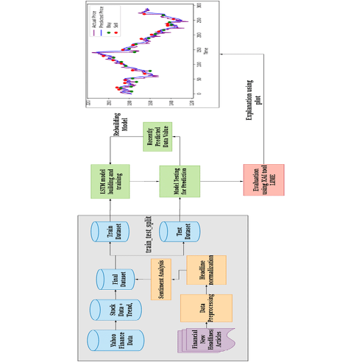

Fig 2.1. System Architecture of Stock market

Model Architecture

The LSTM model consists of multiple LSTM layers followed by one or more dense layers for prediction. The input to the model is a sequence of historical stock price data, and the output is the predicted stock price for a future time step. The LSTM layers learn to extract relevant patterns and dependencies in the input sequence, while the dense layers provide the final prediction. An LSTM (Long Short-Term Memory) model is a type of recurrent neural network (RNN) architecture that is designed to overcome the limitations of traditional RNNs in capturing long-term dependencies in sequential data. It is widely used for various tasks such as natural language processing, speech recognition, time series analysis, and more.

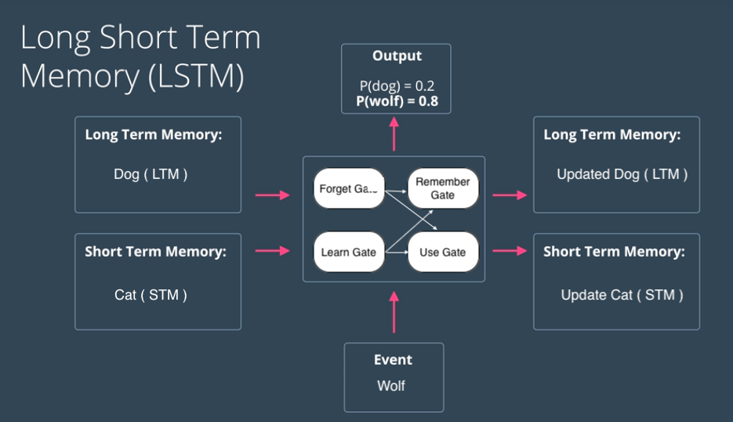

Fig 2.2 LSTM Architecture

Training and Evaluation

Prepare your data by cleaning, tokenizing, and encoding it in a format suitable for the LSTM model. This may involve removing punctuation, lowercasing, splitting into sequences, and mapping words to numerical indices. Divide your dataset into training, validation, and testing sets. The training set is used to train the LSTM model, the validation set is used to tune hyperparameters and monitor performance, and the testing set is used to evaluate the final model. Create an LSTM model using a deep learning framework such as TensorFlow or PyTorch. You can specify the number of LSTM layers, the number of hidden units per layer, and the input shape. Feed the training data into the LSTM model and iterate over the training set in multiple epochs. During each epoch, the model makes predictions, calculates the loss, and updates the weights using backpropagation. Adjust the learning rate and other hyperparameters as needed. Evaluate the model's performance on the validation set at the end of each epoch. Keep track of metrics such as accuracy, loss, precision, recall, or F1 score to assess how well the model is learning.

Hyperparameter Tuning

The performance of an LSTM model depends on various hyperparameters, such as the number of LSTM layers, the number of hidden units in each layer, the learning rate, and the batch size. These hyperparameters can significantly impact the model's accuracy and generalization ability. Therefore, it is essential to perform hyperparameter tuning to find the optimal configuration that produces the best forecasting results.

Results and Discussion

Once the LSTM model is trained and fine-tuned, it can be used to make stock price predictions on unseen data. The accuracy of the predictions can be evaluated using various metrics, including mean absolute error (MAE), root mean square error (RMSE), and mean absolute percentage error (MAPE). Additionally, visualizing the predicted and actual stock prices on a graph can provide further insights into the model's performance. The results obtained from the project on "Visualizing and Forecasting Stocks using LSTM" demonstrate the effectiveness of the proposed approach in capturing stock market dynamics and making accurate predictions. The combination of visualizations and the LSTM model proved valuable in identifying market trends, volatility, and potential trading opportunities.

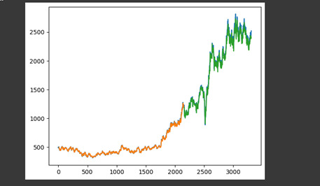

Fig 2.3. Prediction of Reliance stock using LSTM

**2.2 Predicting Stock prices using LSTM:**

**2.2.1 Introduction**

The fluctuation of the stock market is highly violent. However, as the technology is getting advanced, the opportunity to gain a steady fortune from the stock market is increased and it also helps experts to find out the most informative indicators to make a better prediction. The prediction of the market value is of great importance to help in maximizing the profit of stock option purchase while keeping the risk low.

Recurrent neural networks (RNN) have proved one of the most powerful models for processing sequential data. Long Short-Term memory is one of the most successful RNNs architectures. LSTM introduces the memory cell, a unit of computation that replaces traditional artificial neurons in the hidden layer of the network. With these memory cells, networks can effectively associate memories and input remote in time, hence suit to grasp the structure of data dynamically over time with high prediction capacity. The paper that we have presented modeled and predicted the stock returns of NIFTY 50 using LSTM. We collected 5 years of historical data of NIFTY 50 and used it for the training and validation purposes for the model. The next section of the paper will be methodology where we will explain about each process in detail. After that, we will have pictorial representations of the analysis that we have used and we will also reason about the results achieved.

**2.2.2 Methodology:**

Various types of neural networks can be developed by the combination of different factors like network topology, training method etc. For this experiment, we have considered Recurrent Neural Network and Long Short-Term Memory. This section we will discuss the methodology of our system.

Our system consists of several stages which are as follows: -

• **Stage 1: Raw Data:**

In this stage, the historical stock data is collected from <https://www.quandl.com/data/NSE> and this historical data is used for the prediction of future stock prices.

• **Stage 2: Data Preprocessing:**

The pre-processing stage involves

a) Data discretization: Part of data reduction but with particular importance, especially for numerical data.

b) Data transformation: Normalization.

c) Data cleaning: Fill in missing values.

d) Data integration: Integration of data files.

After the dataset is transformed into a clean dataset, the dataset is divided into training and testing sets to evaluate. Here, the training values are taken as the more recent values. Testing data is kept as 5-10 percent of the total dataset.

• **Stage 3: Feature Extraction:**

In this layer, only the features which are to be fed to the neural network are chosen. We will choose the feature from Date, open, high, low, close, and volume.

• **Stage 4: Training Neural Network:**

In this stage, the data is fed to the neural network and trained for prediction assigning random biases and weights. Our LSTM model is composed of a sequential input layer followed by 2 LSTM layers and dense layer with ReLU activation and then finally a dense output layer with linear activation function. The code of the Neural Network implemented in Keras is as follows:

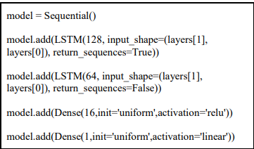

**• Stage 5: Output Generation:**

In this layer, the output value generated by the output layer of the RNN is compared with the target value. The error or the difference between the target and the obtained output value is minimized by using back propagation algorithm which adjusts the weights and the biases of the network.

**Analysis:**

For analyzing the efficiency of the system, we are using the Root Mean Square Error (RMSE). The error or the difference between the target and the obtained output value is minimized by using RMSE value. RMSE is the square root of the mean/average of the square of all the error. The use of RMSE is highly common and it makes an excellent general purpose error metric for numerical predictions. Compared to the similar Mean Absolute Error, RMSE amplifies and severely punishes large errors.

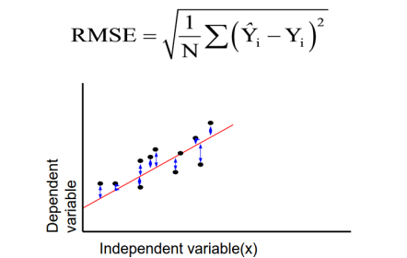

Fig 2.4: RMSE Value Calculation

**Experimental Work:**

● Dataset description: We acquired the data from <https://www.quandl.com>. We have collected the historical stock data of NIFTY 50 from the National stock exchange. We have collected daily dataset and kept a window size of 22 days. Data ranges from 01.01.2011 to 31.12.2016.

● Sequence data: We got 1312 sequences from 01.01.2011 to 31.12.2016. From these data set we used 1180 samples for training purpose and 132 samples for validation

purpose.

● Training Detail: For training the model we used RMSprop as the optimizer and normalized each vector of the sequence. We used Google cloud engine as a training platform [Machine type: n1-standard-2 (2 vCPUs, 7.5 GB memory), CPU platform: Intel Ivy Bridge] and used Ubuntu 16.04, Keras (Frontend) and TensorFlow (Backend) as the learning environment. For usexperiment, we have used a various set of parameters with a different number of epochs to measure the RMSE of Training and Testing dataset.

**Experimental Results**

|  |  |  |  |
| --- | --- | --- | --- |
| **Parameters** | **No.Of Epochs** | **Training RMSE** | **Training RMSE** |
| **Open/close** | **250** | **0.01491** | **0.01358** |
| **Open/close** | **500** | **0.01027** | **0.00918** |
| **High/low/close** | **250** | **0.01511** | **0.014** |
| **High/low/close** | **500** | **0.01133** | **0.01059** |
| **High/low/close/open** | **250** | **0.0133** | **0.01236** |

Fig 2.5: Comparative Results Using Different Parameters and Epochs

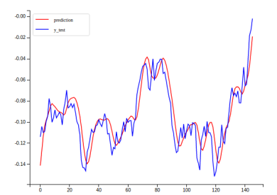

Fig 2.6 Open/close with 250 epochs.

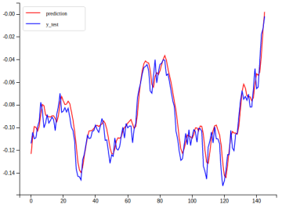

Fig 2.7. Open/close with 500 epochs.

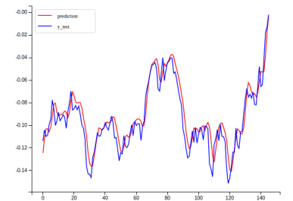

Fig 2.8. High/Low/close with 250 epochs.

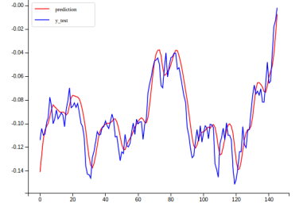

Fig 2.9. High/Low/close with 500 epochs.

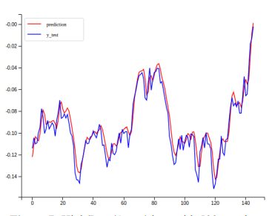

Fig 2.10 High/Low/Open/close with 250 epochs.

**2.3 Literature Gap:**

One notable literature gap is the limited application of LSTM models to different stock markets. Most studies have focused on forecasting stock prices in well-established and highly liquid markets, such as the New York Stock Exchange (NYSE) or NASDAQ. There is a lack of research on applying LSTM models to emerging markets or markets with unique characteristics, such as those in developing countries. Exploring the effectiveness of LSTM models in different market conditions and understanding their limitations in diverse market settings would contribute to a more comprehensive understanding of their forecasting capabilities.

Another literature gap lies in the scarcity of comparative studies that evaluate the performance of LSTM models against other forecasting techniques. While LSTM models have shown promising results in stock price prediction, it is essential to compare their accuracy, robustness, and efficiency with other popular models, such as autoregressive integrated moving average (ARIMA) or support vector regression (SVR). Comparative studies can provide valuable insights into the strengths and weaknesses of LSTM models and help identify scenarios where they outperform or underperform compared to alternative methods.

One significant limitation of deep learning models, including LSTM, is their inherent complexity and lack of interpretability. LSTM models are considered black-box models, making it challenging to understand the underlying reasoning behind their predictions. Consequently, there is a literature gap in exploring techniques to enhance the interpretability and explainability of LSTM models for stock price forecasting. Developing methods to extract meaningful insights and interpret the learned patterns from LSTM models can enhance their usefulness in practical investment decision-making. Stock prices are influenced by a multitude of factors, including economic indicators, news sentiment, geopolitical events, and company-specific news. However, the existing literature on LSTM models for stock price forecasting often focuses solely on historical price data without considering external factors. There is a literature gap in exploring techniques to effectively integrate external factors into LSTM models, enabling more accurate and comprehensive stock price predictions. Investigating how LSTM models can leverage diverse data sources and extract relevant information from external factors can lead to more robust forecasting models.

While LSTM models have shown promise in stock price forecasting, their lack of interpretability poses a significant challenge. Understanding the reasoning behind LSTM predictions is essential for gaining trust and confidence in their outputs. Addressing this limitation, future research can focus on developing techniques to enhance the interpretability and explainability of LSTM models. By unraveling the hidden patterns and extracting meaningful insights from these models, investors and analysts can make more informed decisions. Furthermore, integrating external factors such as economic indicators, news sentiment, and geopolitical events into LSTM models can lead to more accurate and comprehensive stock price predictions. Bridging this gap in the literature will enable the development of more robust forecasting models that consider a wider range of influential factors. Another literature gap lies in the scarcity of comparative studies that evaluate the performance of LSTM models against other forecasting techniques. While LSTM models have shown promising results in stock price prediction, it is essential to compare their accuracy, robustness, and efficiency with other popular models, such as autoregressive integrated moving average (ARIMA) or support vector regression (SVR). Comparative studies can provide valuable insights into the strengths and weaknesses of LSTM models and help identify scenarios where they outperform or underperform compared to alternative methods.

One significant limitation of deep learning models, including LSTM, is their inherent complexity and lack of interpretability. LSTM models are considered black-box models, making it challenging to understand the underlying reasoning behind their predictions. Consequently, there is a literature gap in exploring techniques to enhance the interpretability and explain ability of LSTM models for stock price forecasting. Developing methods to extract meaningful insights and interpret the learned patterns from LSTM models can enhance their usefulness in practical investment decision-making. Stock prices are influenced by a multitude of factors, including economic indicators, news sentiment, geopolitical events, and company-specific news. Another literature gap lies in the scarcity of comparative studies that evaluate the performance of LSTM models against other forecasting techniques. While LSTM models have shown promising results in stock price prediction, it is essential to compare their accuracy, robustness, and efficiency with other popular models, such as autoregressive integrated moving average (ARIMA) or support vector regression (SVR). Comparative studies can provide valuable insights into the strengths and weaknesses of LSTM models and help identify scenarios where they outperform or underperform compared to alternative methods.

**Chapter 3**

**PRE-PROCESSING AND TRAINING**

As we have in discussed into Chapter 2, it is important to recognize the significance of preprocessing in the analysis of time series data, particularly when dealing with stock prices. Collecting reliable and comprehensive stock data is the first step in the preprocessing stage. This includes gathering historical stock prices, financial statements, news articles, and other relevant information. Once the data is gathered, thorough cleaning procedures are necessary to ensure data quality. Cleaning involves addressing errors, inconsistencies, and missing values, ensuring that the subsequent analysis is based on accurate and reliable information. With a solid foundation of preprocessed data, we can now explore the application of LSTM models to forecast stock prices effectively.

Preprocessing is a crucial stage in any data analysis project, particularly when working with time series data. The first step in the preprocessing stage is collecting the necessary stock data from reliable sources. This includes historical stock prices, financial statements, news articles, and other relevant information. Once the data is collected, it is essential to perform data cleaning to eliminate errors, inconsistencies, and missing values. In this chapter, we will discuss the preprocessing steps involved in preparing stock data for visualizing and forecasting using LSTM. By performing data collection and cleaning, time series preprocessing, train-test splitting, feature scaling, and sequence data formatting, we ensure the data is appropriately structured and prepared for training the LSTM model. Effective preprocessing enhances the model's ability to capture temporal patterns and make accurate forecasts, contributing to the overall success of the project.

Time Series Preprocessing

Stock data often exhibits temporal dependencies and trends, requiring specific preprocessing steps to capture and utilize these patterns effectively. Some key techniques for time series preprocessing include:

a. Time series decomposition: Decompose the time series into its components, such as trend, seasonality, and residual, using methods like moving averages or exponential smoothing. This decomposition helps separate the underlying patterns from the noise in the data.

b. Stationarity transformation: Ensure the time series is stationary by applying techniques like differencing, logarithmic transformation, or Box-Cox transformation. Stationarity is a critical assumption for LSTM models, as they rely on the presence of stationary patterns to capture dependencies effectively.

c. Lagging and windowing: Transform the time series into lagged sequences or sliding windows. This involves creating new features by including past observations as input variables. Lagging and windowing allow the LSTM model to capture temporal relationships and dependencies across different time steps.

Train-Test Split

Before training the LSTM model, it is essential to split the preprocessed data into training and testing sets. The training set is used to fit the model's parameters, while the testing set is used to evaluate the model's performance on unseen data. The train-test split should maintain the temporal order of the data, ensuring that the model learns from past observations to predict future ones accurately.

Feature Scaling

LSTM models benefit from feature scaling, which helps improve convergence and training efficiency. Scaling the data to a specific range (e.g., between 0 and 1) or standardizing it around a mean of 0 and a standard deviation of 1 can enhance the model's ability to capture patterns and make accurate predictions.

Sequence Data Formatting

LSTM models require input data to be formatted as sequential observations. This involves reshaping the input data into three dimensions: samples, time steps, and features. The samples dimension represents the number of observations, the time steps dimension represents the number of observations, the time steps dimension represents the number of past time steps to consider, and the features dimension represents the number of input features. This formatting ensures that the LSTM model can effectively learn from the temporal dependencies in the data.

**3.1 Stock prediction Variables:**

When it comes to predicting stock prices, there are numerous variables that analysts and investors consider. While no prediction can be guaranteed, here are some common variables used in stock price forecasting:

1. Historical Price Patterns: Analyzing past price movements, trends, and patterns can provide insights into potential future price behavior.

2. Fundamental Analysis: Assessing a company's financial health, including factors such as revenue, earnings, profit margins, debt levels, and cash flow, to determine its intrinsic value.

3. Technical Indicators: Using mathematical calculations based on historical price and volume data to identify patterns and trends. Examples include moving averages, relative strength index (RSI), and Bollinger Bands.

4. Market Sentiment: Evaluating investor sentiment and market psychology by considering factors such as news sentiment, social media trends, and analyst recommendations.

5. Economic Indicators: Monitoring macroeconomic factors such as GDP growth, interest rates, inflation, employment data, and consumer sentiment, as they can impact overall market performance.

6. Industry Trends: Analyzing industry-specific factors, such as competitive landscape, technological advancements, regulatory changes, and market demand, which can influence a company's stock price.

7. Company News and Events: Keeping track of company-specific news, such as product launches, mergers and acquisitions, earnings reports, management changes, and regulatory approvals.

8. Valuation Ratios: Examining various ratios like price-to-earnings (P/E), price-to-sales (P/S), price-to-book (P/B), and dividend yield to assess a company's relative value compared to its peers.

9. Market Volatility: Gauging market volatility through metrics like the VIX (CBOE Volatility Index) to anticipate potential price swings and market uncertainty.

**3.2 Dataset:**

1) Date: The specific day or time stamp associated with a particular data point or event.

2) Open: The price at which a stock starts trading at the beginning of a trading session.

3) High: The highest price reached by a stock during a specific trading session or a given time.

4) Close: The final price at which a stock trades at the end of a trading session.

5) Volume: The total number of shares or contracts traded during a given period, indicating the liquidity and interest in a particular stock.

6) Dividends: Payments made by a company to its shareholders as a portion of its profits or earnings.

7) Stock Splits: When a company divides its existing shares into multiple shares, resulting in a lower share price while maintaining the overall market value.

8) Average Low High: The average value calculated from the lowest and highest prices reached by a stock during a specific trading session or a given time.

9) Average Open Close: The average value calculated from the opening and closing prices of a stock during a specific trading session or a given time.

The dataset serves as the foundation for training the model. It provides the necessary input and output examples for the model to learn from. The quality, completeness, and representativeness of the dataset significantly impact the model's ability to capture underlying patterns and make accurate predictions. The dataset directly influences the performance and accuracy of the model. A high-quality dataset with sufficient variability and representative examples allows the model to learn robust patterns and generalize well to unseen data. On the other hand, a flawed or biased dataset can lead to inaccurate predictions and poor model performance. A diverse and comprehensive dataset enables the model to generalize well to new, unseen data. When the dataset represents a wide range of scenarios, the model can learn patterns that are applicable in different contexts. This helps the model avoid overfitting, where it memorizes the training data but fails to perform well on new data. the dataset is the cornerstone of a modeling project. It impacts the model's training, performance, generalization, fairness, feature engineering, validation, and iterative improvement.

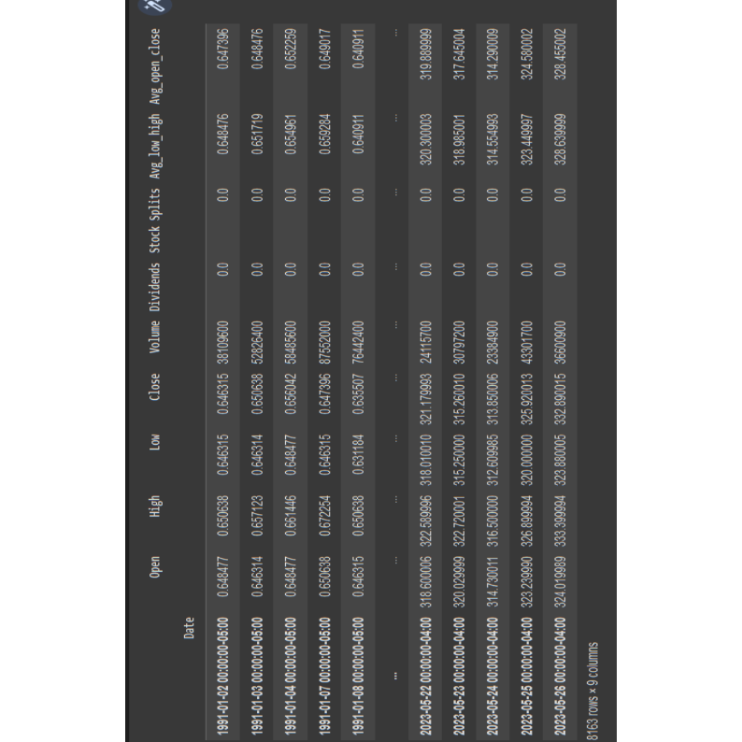

Fig 3.1. Sample Dataset

**3.3 Python**

Introduction to Python for Stock Price Prediction

Python is a versatile and popular programming language that offers a wide range of tools and libraries for data analysis, machine learning, and predictive modeling. When it comes to predicting stock prices, Python provides a powerful ecosystem that enables developers to build robust and accurate models. In this project, we will explore some key Python libraries and techniques used for stock price prediction.

1. Data Acquisition and Preparation:

To predict stock prices, we first need historical price and market data. Python provides various libraries and APIs to collect data from online sources, such as Yahoo Finance, Alpha Vantage, or Quandl. We can use libraries like pandas and NumPy to efficiently manipulate and preprocess the data, handling missing values, and performing any necessary data transformations.

2. Exploratory Data Analysis (EDA):

EDA helps us understand the characteristics of the stock data and identify any patterns, trends, or correlations. Python libraries like Matplotlib and Seaborn allow us to visualize the data through plots, histograms, and heatmaps. Statistical techniques can be applied using libraries like SciPy to gain insights into the data distribution, volatility, and other important factors.

3. Feature Engineering:

Feature engineering involves selecting or creating relevant features from the available data that can help improve the accuracy of the predictive models. Python libraries like scikit-learn provide various tools for feature selection, dimensionality reduction, and creating lagged variables to capture temporal dependencies.

4. Model Selection and Training:

Python's scikit-learn library offers a comprehensive suite of machine learning algorithms, including regression models suitable for predicting stock prices. We can train and evaluate models like linear regression, decision trees, random forests, or more advanced techniques like gradient boosting or neural networks. Cross-validation techniques can be used to assess the model's performance and tune hyperparameters.

Python Libraries for Stock Price Prediction

Python provides a rich ecosystem of libraries specifically designed for stock price prediction. Here are some key libraries commonly used in the development of stock prediction projects:

1. TensorFlow and Keras:

These libraries are widely used for building and training deep learning models, including recurrent neural networks (RNNs) and long short-term memory (LSTM) networks. They can capture complex patterns and dependencies in stock data sequences.

2. Prophet:

Prophet is an open-source library developed by Facebook for time series forecasting. It offers a user-friendly interface and automated procedures for trend modeling, seasonality detection, and handling outliers.

3. XGBoost and LightGBM:

These gradient boosting libraries provide efficient implementations of boosting algorithms, which are powerful techniques for building ensemble models. They can handle large feature spaces and capture complex interactions between variables.

4. Statsmodels:

Statsmodels is a library that focuses on statistical modeling and offers various econometric models suitable for financial data analysis. It includes regression models, time series models, and tools for conducting hypothesis tests and statistical inference.

5. Scikit-learn:

Scikit-learn is a comprehensive machine learning library in Python. It provides a wide range of algorithms for regression, classification, and clustering tasks. It also offers utilities for data preprocessing, feature selection, and model evaluation.

6. PyTorch:

PyTorch is a deep learning library that provides dynamic computation graphs and advanced features for building neural networks. It offers flexibility and control over the model architecture and training process. These libraries, among others, provide the necessary tools and algorithms to develop sophisticated stock price prediction models in Python. Leveraging their capabilities, you can explore different approaches, compare model performance, and ultimately create a reliable prediction system for the stock market.

**3.4 Pandas for Data processing:**

In the field of stock price prediction, effective data processing is crucial for preparing and analyzing the historical stock data. Python's pandas library offers powerful tools and functionalities that simplify data manipulation, preprocessing, and feature engineering tasks. Let's explore how pandas can be utilized in the context of our stock price prediction.

1. Data Loading and Exploration:

Pandas provide convenient functions to load data from various sources, such as CSV files or databases. We can leverage these functions to import historical stock price data into a pandas DataFrame, a tabular data structure that allows easy manipulation and analysis. Once the data is loaded, pandas enable us to quickly explore the dataset by examining its structure, checking for missing values, and understanding the available columns and their data types.

2. Data Cleaning and Preprocessing: Pandas offers a plethora of features to handle missing data, outliers, and inconsistencies in the dataset. Using pandas, we can identify and remove or impute missing values, detect and handle outliers that might adversely affect model performance, and apply data transformations such as normalization or standardization. These preprocessing steps help ensure the quality and integrity of the data before feeding it into our stock prediction models.

3. Time Series Manipulation:

Stock price data is inherently time series data, which requires specialized processing. Pandas provide functionalities to handle time-based indexing, resampling, and time zone conversion. We can use pandas' date and time functionalities to create lagged variables, calculate rolling statistics like moving averages, and extract useful features such as day of the week or month. These manipulations enable us to capture temporal patterns and dependencies in the stock data. 4. Data Aggregation and Grouping: Pandas facilitate data aggregation and grouping operations, allowing us to calculate statistics and metrics at different levels of granularity. For instance, we can group the data by ticker symbols or time intervals and compute aggregate metrics like mean, standard deviation, or volume-weighted average price. These aggregated features can provide valuable insights and serve as input variables for our predictive models.

5. Feature Engineering:

Feature engineering is a critical step in building accurate stock price prediction models. With pandas, we can easily create new features by combining existing variables, calculating ratios or differences, or applying mathematical transformations. For example, we can generate features such as price-to-earnings ratio, relative strength index (RSI), or moving average convergence divergence.

6. Data Integration and Merging:

In addition to stock price data, we may need to incorporate external datasets such as economic indicators or news sentiment scores. Pandas offers seamless data integration capabilities, enabling us to merge multiple datasets based on common columns or indices. This integration allows us to enrich our stock data with relevant external factors that can influence stock prices. By harnessing the capabilities of pandas, we can efficiently process, clean, and transform the historical stock price data required for our project. These data processing techniques set a strong foundation for accurate modeling and prediction, ultimately leading to more informed investment decisions.

**-3.4.1 Data Transformation with Pandas**

Another important task in data preprocessing is transforming the data to make it more suitable for analysis or modelling.

Pandas provides several methods for transforming data, including:

Filtering data: Pandas provides methods for selecting specific rows or columns based on criteria such as a specific value, a range of values, or a boolean expression. For example, the loc[] method can be used to select rows and columns by label, while the iloc[] method can be used to select rows and columns by index.

Grouping data: Pandas provides a groupby() method for grouping a DataFrame by one or more variables and performing aggregate operations on each group, such as sum, mean, and count.

**Data Merging and Joining with Pandas**

When working with multiple datasets, it is often necessary to merge or join them together based on a common column or key.

Pandas provides several methods for merging and joining data, including:

**merge ():** merges two DataFrames based on a common column or key.

**join ():** joins two DataFrames based on their indices.

**concat():** concatenates multiple DataFrames along a specified axis.

**3.4.2 Examples of Data Cleaning and Transformation with Pandas**

1. Reading a CSV file

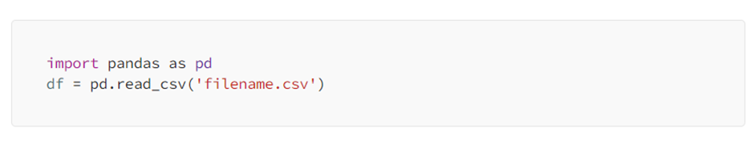

2. Checking the shape of the DataFrame

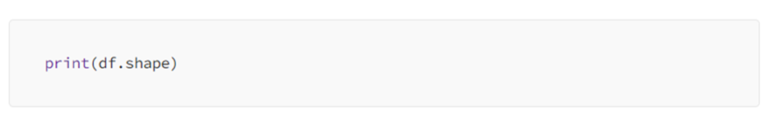3. Dropping columns

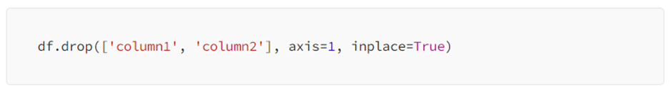4. Handling missing data (dropping rows with missing values):

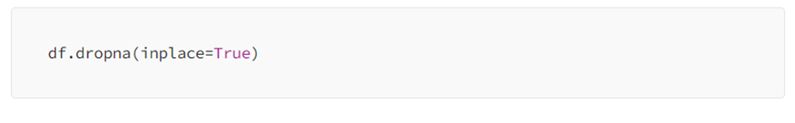5. Handling missing data (imputing missing values with the mean)

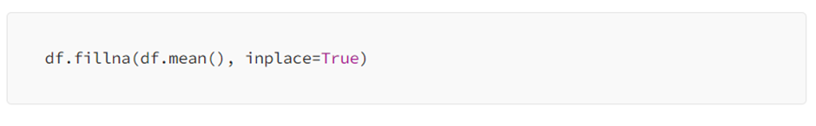

**3.5 NUMPY FOR COMPUTATION**

Numpy in Python or Numerical Python is an open-source Python library created by Travis Oliphant in 2005 for numerical and scientific computing in Python. Numpy arrays are stored in a single continuous block of memory; this makes NumPy faster than the Python list and takes less memory. In the field of data science and Artificial Intelligence, Numpy is used widely. It is a group of same-type elements. The array in NumPy is called ndarray, which is also known as an alias array. Axes are the dimensions in NumPy.The number of axes determines the rank.

Numpy 1-d array:

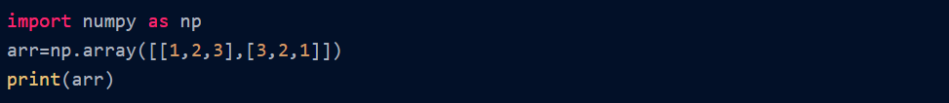

Numpy 2-D array:



**Operations Using Numpy**

**Indexing**: Indexing is used for accessing elements from an array. It starts from 0. Below is a code example where the elements of the index (0,2) are accessed, where 0 stands for the 1st row and 1 for the 3rd column from the 2-D array.

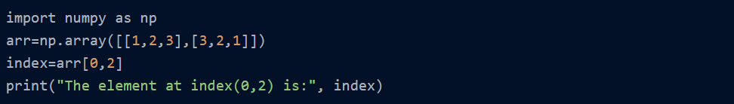

**Slicing**: Slicing is the method for getting substrings from the original arrays by mentioning the start and end inside the slice operator []. Let's see the below example where the substring from the 2nd element to the 5th element is sliced

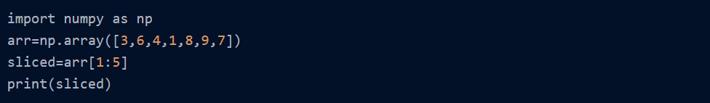

**Array.ndim:** array.ndim is used to find the number of dimensions of the array. Let us investigate the code example below:

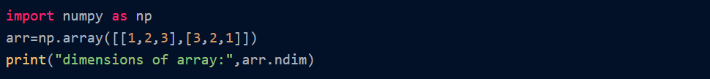

**Array.dtype**: array.dtype is used to find the data type of elements of an array. In the code example given below, elements are of integer data type.

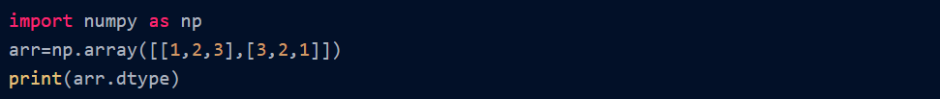

**array.reshape():** array.reshape is used to reshape the array; it means changing the shape, i.e., rows and columns of the array.

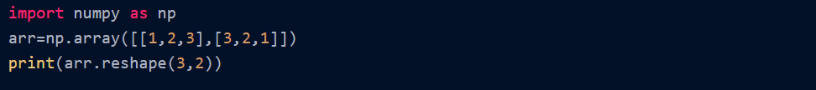

**array.sum()**: By using an array.sum, we can find the sum of the array. Let's see the code example below:

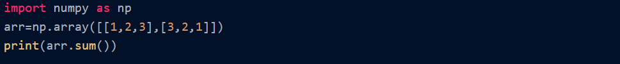

**array.ravel()**: array.ravel converts a 2-D or Multidimensional array into a single row of the same type.

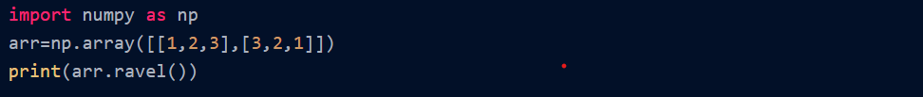

**3.6 Steps for training**

**3.6.1 Importing required libraries**

When training a machine learning model, you typically need to import several libraries to handle data manipulation, model building, and evaluation. Here are some commonly used libraries for training ML models:

1. NumPy: NumPy is a fundamental library for numerical computing in Python. It provides support for arrays, matrices, and mathematical functions, making it useful for handling data and performing operations in ML models.

Inserting image...

2]Pandas: Pandas is a powerful library for data manipulation and analysis. It provides data structures like DataFrames for handling structured data, making it convenient for preprocessing, cleaning, and organizing data

Inserting image...

TensorFlow or PyTorch: TensorFlow and PyTorch are widely used deep learning frameworks. They provide tools and APIs for building and training neural networks. You can choose either one based on your preference and requirements.

Inserting image...

Matplotlib or Seaborn: Matplotlib and Seaborn are plotting libraries that help visualize data and model performance. They offer various plot types and customization options.

Inserting image...

Keras library for training machine learning models, you need to import the necessary modules. Keras is a high-level deep learning library that provides a user-friendly interface for building and training neural networks. Here's an example of importing Keras

Inserting image...

These are just a few of the essential libraries commonly used for training ML models. Depending on your specific tasks and requirements, you might need to import additional libraries or modules. Make sure you have these libraries installed in your Python environment using tools like pip or conda before importing them in your code.

**3.6.2 Preprocessing data**

Preprocessing time series data involves transforming and organizing the data in a way that is suitable for analysis or training machine learning models. Here are some common preprocessing steps for time series data:

1]Creating train test data by using step size to convert current values of time series data to predicatble reslut values for test data .

2]Feature engineering: Time series data often benefits from feature engineering, where you create additional meaningful features from the existing data. This can involve generating lagged variables, moving averages, exponential smoothing, or Fourier transformations, among others.

3] Normalization or scaling: Normalize or scale the data to ensure that all features have a similar range. Common techniques include min-max scaling or standardization using libraries such as Min-max scaler.

4] Train-test split: Split the preprocessed data into training and testing sets. Ensure that the time series data is split in a sequential manner to avoid data leakage.

These are some general steps for preprocessing time series data. The specific preprocessing steps may vary depending on the characteristics of your data and the specific analysis or modeling task you are working on.

**3.7 LSTM**

**3.7.1 What is LSTM**

LSTM stands for Long Short-Term Memory, which is a type of recurrent neural network (RNN) architecture. LSTM networks are designed to handle sequential data and have the ability to capture long-term dependencies in the data. Traditional RNNs suffer from the "vanishing gradient" problem, where gradients diminish as they are backpropagated through time. This limitation makes it difficult for RNNs to capture long-range dependencies in the data. LSTM networks were introduced to address this issue by incorporating memory cells and gating mechanisms.

The key components of an LSTM network are:

1. Cell state (C): The cell state acts as a memory that stores and carries information across different time steps. It allows the network to retain important information over long sequences.

2. Input gate (i), forget gate (f), and output gate (o): These gates control the flow of information into and out of the cell state. The input gate determines how much new information to update in the cell state, the forget gate controls what information to discard from the cell state, and the output gate determines how much of the cell state to output as the network's prediction.

3. Hidden state (h): The hidden state is the output of the LSTM cell at each time step. It is a filtered version of the cell state and carries the relevant information that is passed to the next time step or used for making predictions.

During training, the LSTM network learns to adjust the values of the gates and the cell state through gradient descent optimization. This allows the network to effectively learn and capture long-term dependencies in sequential data. LSTM networks have been successfully applied in various domains, including natural language processing, speech recognition, time series analysis, and more. They are particularly useful when dealing with sequential data where the context and long-range dependencies play a crucial role in the analysis or prediction task.

**3.7.2 Building the LSTM model**

To build an LSTM model, you can use the Keras library in Python. Here's a step-by-step guide on how to build an LSTM model:

Import the required libraries:

Prepare your data: Ensure that your data is in the appropriate format for an LSTM model. Typically, LSTM models require input data in the shape of (samples, timesteps, features), where:

* samples is the number of data points or sequences
* timesteps is the number of time steps in each sequence
* features is the number of features at each time step

Define the LSTM model: Create an instance of the Sequential class and add LSTM layers and output layers to it. Specify the number of LSTM units (neurons) and the input shape. You can also add additional layers like Dense layers if necessary.

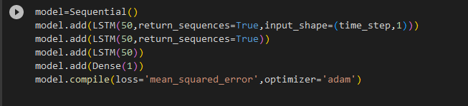

In the example above, we add an LSTM layer with 50 units and specify the input shape based on the number of time steps and features in the data. We then add a Dense output layer with 1 unit.

Compile the model: Specify the loss function and optimizer for training the model. Additionally, you can define metrics to evaluate the model's performance.

Train the model: Fit the model to your training data using the fit function. Specify the number of epochs and batch size for training.

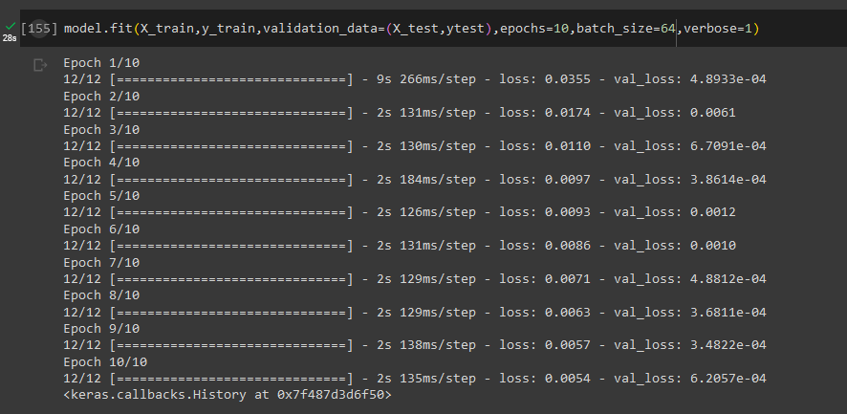

Fig 3.2. Trained model dataset

Make predictions: Once the model is trained, you can use it to make predictions on new data. Remember to preprocess your data, handle missing values, and split your data into training and testing sets before building and training the LSTM model.

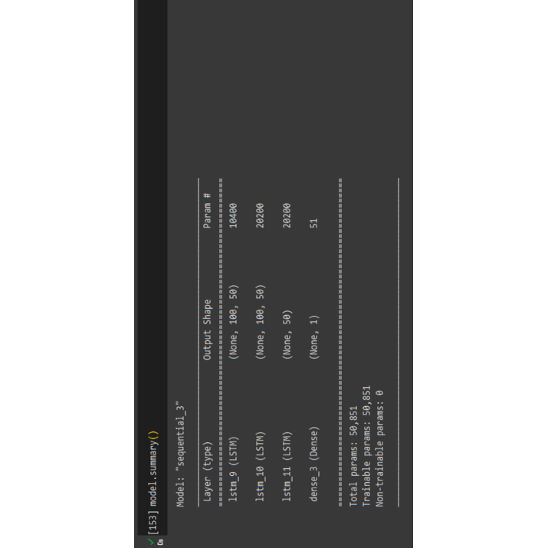

Fig 3.3 Trained model output

**3.7.3 LSTM Vs RNN**

Long Short-Term Memory (LSTM) and Recurrent Neural Networks (RNN) are both popular architectures used in the field of deep learning for sequential data processing. In this comparison, we will explore the similarities and differences between LSTM and RNN models, highlighting their respective strengths and weaknesses.

Recurrent Neural Networks (RNN):

Recurrent Neural Networks (RNNs) are a class of artificial neural networks specifically designed for processing sequential data. Unlike traditional feedforward neural networks, which process data in a single pass from input to output, RNNs have a unique ability to retain and utilize information from previous steps in the sequence. The key feature that sets RNNs apart is their recurrent structure. This structure enables the network to maintain a hidden state or memory that captures information about previous inputs and influences the processing of future inputs. The hidden state serves as a form of memory that allows RNNs to model temporal dependencies and capture context within sequential data. RNNs process sequential data in a step-by-step manner, with each step corresponding to a specific time point in the sequence. At each time step, the network takes an input, updates its hidden state, and produces an output. The output can be used for prediction, classification, or further processing. Importantly, the hidden state is updated by combining the current input with the previous hidden state, effectively allowing the network to retain and propagate information across time steps. While RNNs possess a powerful mechanism for processing sequential data, they can face challenges during training. One major issue is the vanishing or exploding gradient problem. Since gradients are propagated back through time, they can either diminish or grow exponentially, making it difficult for the network to effectively learn long-range dependencies. This issue often arises due to the repeated multiplication of weight matrices during backpropagation. Various techniques, such as gradient clipping and specialized RNN architectures like LSTMs and GRUs (Gated Recurrent Units), have been developed to mitigate these problems. RNNs have found success in numerous domains due to their ability to model sequential data. They have been widely used in natural language processing tasks such as machine translation, sentiment analysis, and text generation. RNNs have also been applied to speech recognition, where they can capture the temporal dependencies in audio signals. Additionally, RNNs have been employed in time series analysis, stock market prediction, and even music composition. While RNNs have proven effective in many applications, they still have limitations. Long sequences can pose challenges for RNNs due to the vanishing gradient problem and the difficulty of capturing long-term dependencies. Researchers continue to explore advanced RNN variants, such as LSTMs and GRUs, to address these limitations and improve their performance on complex sequential tasks.

**3.7.4 Difference between LSTM and RNN:**

Section 1: Memory Capacity

One of the key differences between LSTM and RNN lies in their memory capacity. RNNs have a simple memory mechanism and are limited in their ability to capture long-range dependencies. On the other hand, LSTMs have a more complex memory cell that can retain information for longer durations, allowing them to handle long sequences more effectively.

Section 2: Training and Optimization

Training RNNs can be challenging due to the vanishing or exploding gradient problem, which hinders the propagation of information across long sequences. LSTMs, with their explicit memory control mechanisms, alleviate this issue to a great extent. As a result, LSTMs are generally easier to train and optimize compared to traditional RNNs.

Section 3: Computational Complexity

LSTMs are more computationally expensive compared to basic RNNs. This is primarily due to the additional gates and operations involved in the LSTM architecture. While RNNs are relatively simpler and faster to compute, they may struggle with capturing long-term dependencies in complex sequences.

Section 4: Applications of RNNs

RNNs have found wide application in various domains, including natural language processing, speech recognition, machine translation, and sentiment analysis. Their ability to model sequential data makes them suitable for tasks that involve processing sequences of varying lengths.

Section 5: Applications of LSTMs have achieved significant success in tasks that require modeling long-term dependencies, such as language modeling, handwriting recognition, speech synthesis, and time series prediction. They excel in scenarios where capturing long-range dependencies is crucial for accurate predictions.

Section 6: Conclusion

In conclusion, LSTM and RNN architectures offer distinct advantages and are suited for different types of tasks. RNNs are simpler and computationally efficient, making them suitable for tasks with short-term dependencies. LSTMs, on the other hand, excel in capturing long-range dependencies and are well-suited for tasks that involve complex sequences. Understanding the strengths and weaknesses of each architecture is crucial in selecting the appropriate model for specific applications.

**3.7.5 Significance of LSTM:**

The Long Short-Term Memory (LSTM) architecture holds significant importance in the field of deep learning due to its ability to effectively capture long-term dependencies in sequential data. Here is a detailed explanation of the significance of LSTM:

1. Capturing Long-Term Dependencies: Traditional Recurrent Neural Networks (RNNs) often struggle to capture dependencies that span a long sequence of data. This is because as information propagates through the network, it can gradually vanish or explode due to the repeated multiplication of weights during backpropagation, resulting in difficulties in modeling long-term dependencies. LSTM addresses this issue by introducing a memory cell that can selectively store and retrieve information over extended time intervals. This memory mechanism allows LSTM to capture and retain relevant information over long sequences, enabling it to model dependencies that occur far apart in time.

2. Overcoming the Vanishing Gradient Problem: The vanishing gradient problem refers to the diminishing effect of gradients during the backpropagation process, making it difficult for the network to learn long-term dependencies. LSTM mitigates this problem by incorporating gating mechanisms within its memory cell. These gates, including the input gate, forget gate, and output gate, control the flow of information and gradients throughout the network. By selectively updating and forgetting information based on the gating mechanisms, LSTM can alleviate the vanishing gradient problem and facilitate the learning of long-range dependencies.

3. Improved Training and Optimization: LSTM's explicit memory control and gating mechanisms make it easier to train and optimize compared to traditional RNNs. The gates enable LSTM to regulate the flow of information and gradients, reducing the likelihood of gradients vanishing or exploding. This facilitates more stable and efficient training, allowing LSTM to converge faster and achieve better performance on tasks involving sequential data.

4. Versatility in Sequence Modeling: LSTM has demonstrated its effectiveness in a wide range of tasks that involve sequential data. It has been successfully applied in natural language processing tasks, such as language modeling, machine translation, sentiment analysis, and text generation. LSTM's ability to capture long-term dependencies and context in textual data has made it a powerful tool in these domains. Additionally, LSTM has found applications in speech recognition, handwriting recognition, time series prediction, and various other tasks that require modeling sequential data.

5. Extensions and Variants: Over time, several extensions and variants of LSTM have been proposed to further enhance its capabilities. Some notable variants include Gated Recurrent Units (GRUs), which simplify the LSTM architecture while maintaining similar performance, and Variational Recurrent Neural Networks (VRNNs), which introduce stochasticity to model uncertainty in sequential data. These extensions and variants continue to advance the state-of-the-art in sequence modeling, allowing researchers to explore new possibilities and push the boundaries of LSTM's capabilities.

In summary, LSTM's significance lies in its ability to capture long-term dependencies, overcome the vanishing gradient problem, facilitate stable training and optimization, and its versatility in modeling sequential data. These qualities have made LSTM a fundamental building block in deep learning architectures and have contributed to its success in a wide range of applications involving sequential data analysis.

**3.7.6 PROS of LSTM**

Pros of Long Short-Term Memory (LSTM)

Long Short-Term Memory (LSTM) is a specialized variant of Recurrent Neural Networks (RNNs) that has gained significant popularity and achieved remarkable success in various fields. Here are some of the key advantages and pros of using LSTM:

Section 1: Capturing Long-Term Dependencies

LSTM excels in capturing long-term dependencies in sequential data. Traditional RNNs often struggle to retain information across long sequences, but LSTM's memory cell and gating mechanisms enable it to selectively store and retrieve information over extended time intervals. This allows LSTM to model dependencies that occur far apart in time, making it particularly effective in tasks where capturing long-range relationships is crucial.

Section 2: Mitigating the Vanishing Gradient Problem

The vanishing gradient problem is a challenge encountered in training deep neural networks, especially RNNs, where gradients can diminish or explode as they propagate backward through time. LSTM addresses this problem by incorporating gating mechanisms, including input, forget, and output gates. These gates regulate the flow of information and gradients, allowing LSTM to alleviate the vanishing gradient problem. As a result, LSTM can more effectively learn and propagate gradients, leading to more stable and efficient training.

Section 3: Handling Variable-Length Sequences

One of LSTM's notable strengths is its ability to handle variable-length sequences. Since LSTM retains information in its memory cell, it can process sequences of different lengths without requiring padding or truncation. This is particularly advantageous in natural language processing tasks, where sentences or paragraphs can have varying lengths. LSTM can adapt to the length of input sequences, making it highly flexible and suitable for processing data with dynamic temporal structures.

Section 4: Effective Contextual Learning

LSTM's memory cell allows it to capture and retain contextual information throughout a sequence. This makes LSTM well-suited for tasks that require an understanding of the broader context. In natural language processing, for example, LSTM can capture the dependencies between words or phrases across sentences, enabling it to generate more coherent and contextually relevant outputs.

Section 5: Versatility and Application Range

LSTM has demonstrated its versatility and efficacy across a wide range of applications. It has been successfully applied in machine translation, sentiment analysis, speech recognition, handwriting recognition, time series prediction, and more. LSTM's ability to model long-term dependencies and handle sequential data with varying patterns and complexities has made it a go-to choose in many domains.

**3.7.7 CONS of LSTM**

Cons of Long Short-Term Memory (LSTM)

Section 1: Increased Computational Complexity

LSTM models are computationally more expensive compared to simpler recurrent neural network architectures. This is primarily due to the additional gates and operations involved in the LSTM architecture. The complex gating mechanisms, although essential for capturing long-term dependencies, contribute to increased computational requirements. As a result, training and inference with LSTM models can be more time-consuming and resource-intensive.

Section 2: Higher Memory Requirements

The memory cell in LSTM introduces additional memory requirements compared to traditional recurrent neural networks. The memory cell retains information over extended time intervals, allowing LSTM to capture long-term dependencies. However, this increased memory demand can pose challenges in scenarios where memory resources are limited, such as deploying LSTM models on resource-constrained devices or working with large-scale datasets.

Section 3: Difficulty in Interpretability

Interpretability of LSTM models can be a challenge due to their complex internal structure. While LSTM effectively captures long-term dependencies, understanding how it processes and weighs the information within the memory cell can be non-trivial. The intricate gating mechanisms and multiple layers of abstraction make it harder to interpret the inner workings of LSTM models, limiting their transparency and interpretability. While LSTM effectively captures long-term dependencies, understanding how it processes and weighs the information within the memory cell can be non-trivial.

Section 4: Longer Training Time

LSTM models often require longer training times compared to simpler models. The additional complexity of LSTM architecture, combined with the need to capture long-term dependencies, can extend the training duration. This can be a limitation when there are strict time constraints or a need for rapid model iteration.

**3.7.8 Uses of LSTM:**

Uses of Long Short-Term Memory (LSTM)

Long Short-Term Memory (LSTM) has found extensive use in various fields due to its ability to effectively model sequential data and capture long-term dependencies. Here are some of the key uses and applications of LSTM:

Section 1: Natural Language Processing (NLP)

LSTM has revolutionized NLP tasks by enabling language models to capture contextual information and dependencies in text data. It has been employed in machine translation, sentiment analysis, named entity recognition, text generation, and text summarization. LSTM's ability to handle variable-length sequences and capture long-term dependencies allows it to generate more coherent and contextually accurate outputs in these NLP applications.

Section 2: Speech Recognition and Synthesis

LSTM has been instrumental in advancing speech recognition and synthesis systems. In speech recognition, LSTM models are used to process audio signals and capture the temporal dependencies between phonemes and words, leading to improved accuracy in transcribing spoken language. LSTM-based speech synthesis models, on the other hand, generate more natural and expressive speech by capturing intonation, emphasis, and other linguistic nuances.

Section 3: Time Series Analysis and Forecasting

LSTM is highly effective in time series analysis and forecasting tasks. It can capture the sequential patterns and dependencies in time series data, making it suitable for applications such as stock market prediction, weather forecasting, demand forecasting, and anomaly detection. LSTM's ability to model long-term dependencies helps in accurately predicting future values or identifying abnormal patterns in time series data.

**3.8 Variables for prediction**

1. Stock Price:

The stock price is the primary variable of interest in your project. You can use historical stock prices as your input data and predict future stock prices using LSTM. These variable forms the basis of your forecasting task and are directly related to the goal of your project.

2. Volume:

Volume refers to the number of shares traded in a particular stock within a given time period. It represents the level of market activity and can provide insights into investor sentiment and liquidity. Including volume as a variable in your LSTM model can help capture the relationship between trading volume and stock price movements.

3. Technical Indicators:

Technical indicators are mathematical calculations based on historical price and volume data. These indicators provide additional information about the stock's price momentum, trends, and potential reversals. Some commonly used technical indicators include moving averages, Relative Strength Index (RSI), Moving Average Convergence Divergence (MACD), and Bollinger Bands. Incorporating relevant technical indicators as input variables in your LSTM model can enhance its forecasting capabilities.

4. News Sentiment:

News sentiment refers to the positive or negative sentiment associated with news articles, social media posts, or other textual data related to the stock. By analyzing news sentiment using natural language processing techniques, you can extract sentiment scores or binary indicators (positive/negative) as input variables. These sentiment indicators can provide additional context for predicting stock price movements and capturing the impact of news on stock performance.

5. Market Index:

Including a market index, such as the S&P 500 or NASDAQ, as an input variable can help capture the broader market trends and sentiments. The market index represents the overall performance of a collection of stocks and can influence individual stock prices. By considering the market index as an input, your LSTM model can account for the market-wide factors that may impact the stock you are forecasting.

6. Economic Indicators:

Economic indicators, such as GDP growth rate, interest rates, inflation, and unemployment rate, can have a significant impact on the stock market. Including relevant economic indicators as input variables in your LSTM model can help capture the macroeconomic factors that influence stock price movements. This can provide a more comprehensive and accurate prediction of stock prices.

7. Company-specific Factors:

Depending on the availability and relevance of data, you can also consider incorporating company-specific factors into your LSTM model. These factors may include financial ratios (e.g., price-to-earnings ratio, debt-to-equity ratio), fundamental data (e.g., revenue, earnings), or any other variables specific to the company whose stock you are forecasting. Including such company-specific factors can help capture the unique characteristics and dynamics of individual stocks.

**3.9 LSTM parameters**

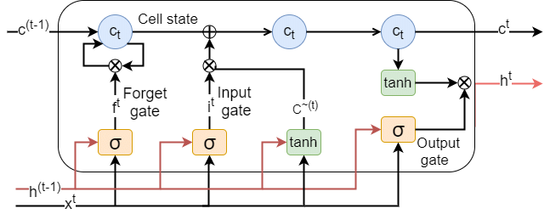

Fig 3.4. LSTM parameters

LSTM models have several parameters that determine the behavior and performance of the network. Here are the key parameters of a typical LSTM architecture:

1. Input Size:

The input size specifies the dimensionality of the input data that is fed into the LSTM model. It determines the number of features or variables present in the input sequence.

2. Hidden Size:

The hidden size represents the dimensionality of the hidden state and cell state in the LSTM. It determines the capacity and memory of the LSTM model. A larger hidden size allows the LSTM to capture more complex dependencies but increases the computational requirements.

3. Number of Layers:

The number of layers refers to the depth of the LSTM network. Each layer consists of LSTM cells that process the input sequentially. Increasing the number of layers can help the model learn more intricate patterns and representations but also increases the model's complexity and training time.

4. Activation Functions:

LSTM models use activation functions to introduce non-linearities into the network. The most common activation functions used in LSTM are the sigmoid function (for gating mechanisms) and the hyperbolic tangent (tanh) function (for cell state and hidden state computations). These functions introduce non-linearity and help in capturing complex patterns in the data.

5. Recurrent Dropout:

Recurrent Dropout is a variant of dropout specifically designed for recurrent neural networks like LSTM. It applies dropout to the connections between recurrent units across time steps, helping to regularize the recurrent connections and mitigate overfitting.

6. Batch Size:

The batch size determines the number of input samples processed in each training iteration. Larger batch sizes can speed up training by parallelizing computations but require more memory. Smaller batch sizes allow for more frequent weight updates but may result in slower training convergence.

7. Learning Rate:

The learning rate controls the step size at which the model parameters are updated during training. It determines the speed of convergence and the quality of the learned model. A high learning rate may lead to unstable training or overshooting the optimal solution, while a low learning rate can result in slow convergence or getting stuck in suboptimal solutions. These are some of the key parameters in an LSTM model. Proper tuning and selection of these parameters are crucial to achieving optimal performance and training stability in LSTM-based applications.

In conclusion, the provided subchapter highlights the key parameters involved in configuring an LSTM model for stock visualization and forecasting. These parameters play a vital role in determining the behavior, performance, and stability of the LSTM network. Understanding and appropriately selecting these parameters are essential for achieving optimal results in LSTM-based applications. The input size parameter determines the dimensionality of the input data, influencing the number of features or variables present in the input sequence. The hidden size parameter controls the capacity and memory of the LSTM model, with larger sizes enabling the capture of more complex dependencies but also increasing computational requirements. The number of layers parameter defines the depth of the LSTM network, allowing for the learning of intricate patterns and representations. Activation functions, such as the sigmoid and tanh functions, introduce non-linearity into the LSTM model, enabling it to capture complex patterns in the data. Recurrent dropout, a specialized form of dropout, helps regularize the LSTM model by applying dropout to connections between recurrent units across time steps, mitigating overfitting. The batch size parameter determines the number of input samples processed in each training iteration, balancing the trade-off between training speed and memory usage. By understanding the significance of these parameters and conducting thorough parameter tuning experiments, researchers and practitioners can fine-tune their LSTM models for stock visualization and forecasting, improving the accuracy and reliability of their predictions.

**Chapter 4**

**App development**

**4.1 Methodology**

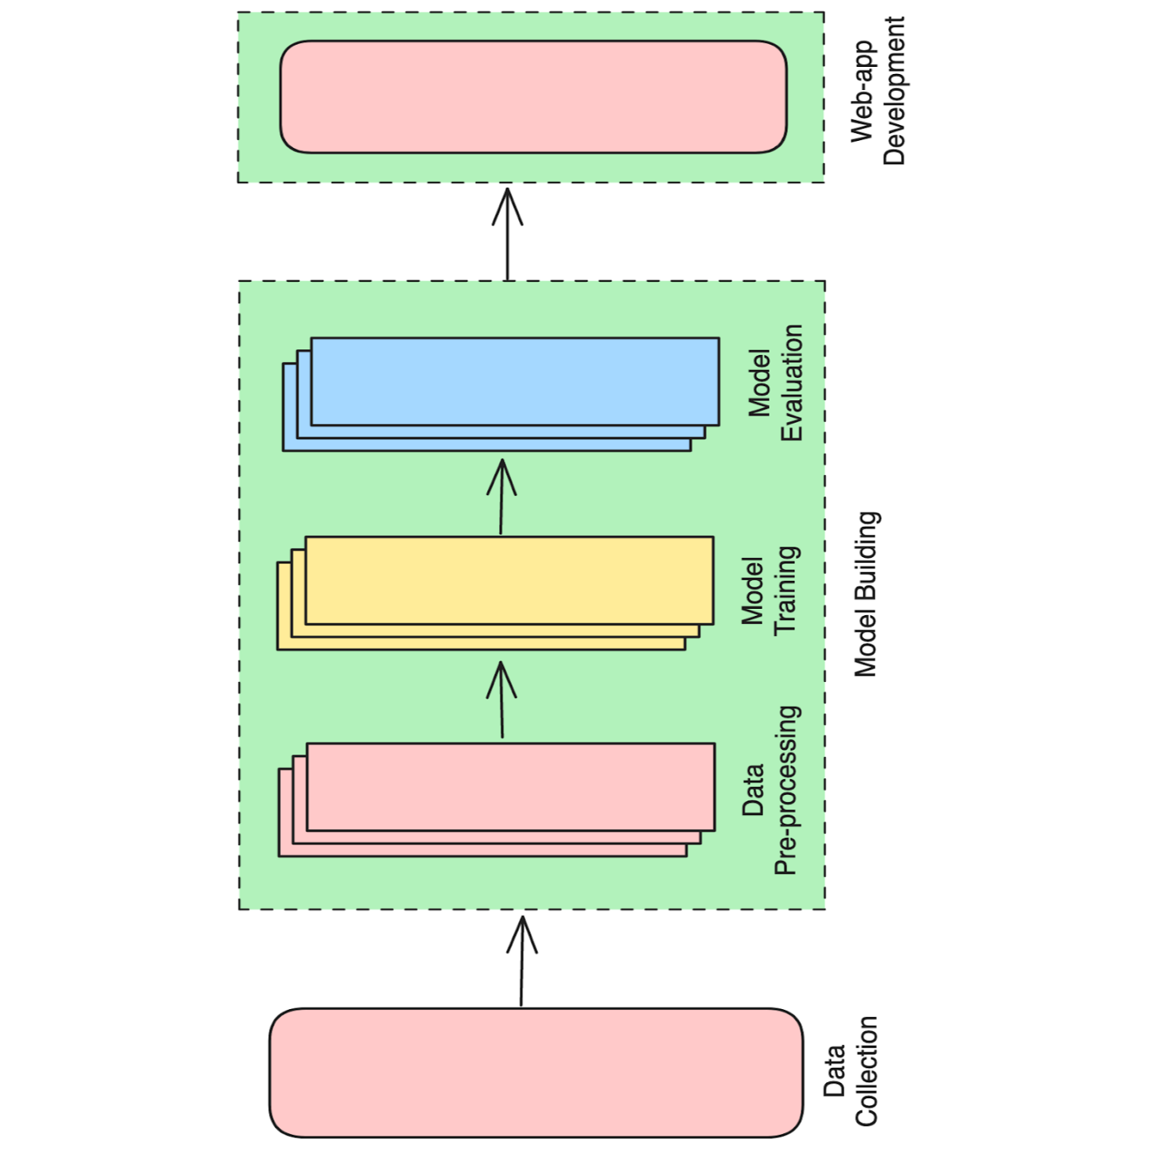

Fig 4.1 App Development Methodology

Data collection: The first step is to collect data on electrical energy consumption. This data can be collected from a variety of sources, such as smart meters, utility bills, or historical data. Data collection is a crucial step in the process of visualizing and forecasting stocks. The accuracy and reliability of the insights derived from the final year project greatly depend on the quality and comprehensiveness of the collected data. In this section, we will discuss the key considerations and methods involved in collecting stock-related data for the purpose of visualizing and forecasting.

Data preprocessing: Once the data has been collected, it needs to be preprocessed. This includes cleaning the data, removing outliers, and transforming the data into a format that can be used by the machine learning model. Data preprocessing is a critical step in preparing stock data for visualization and forecasting. It involves cleaning, transforming, and organizing the collected data to ensure its quality, consistency, and compatibility with the chosen modeling techniques. In this section, we will discuss key preprocessing techniques for stock data that help improve the accuracy and reliability of visualizations and forecasts.

Model training: The next step is to train a machine learning model on the preprocessed data. There are a variety of machine learning models that can be used for this task, such as ARIMA, Exponential Smoothing, and Neural Networks. Model training is a crucial step in the process of visualizing and forecasting stocks using the Long Short-Term Memory (LSTM) model. It involves feeding the preprocessed data into the LSTM model, optimizing its parameters, and enabling it to learn from historical patterns to make accurate predictions. In this section, we will discuss the key steps involved in training the LSTM model for stock visualization and forecasting.

Model evaluation: Once the model has been trained, it needs to be evaluated. This can be done by using a holdout dataset or by using cross-validation. Model evaluation is a critical step in the process of visualizing and forecasting stocks using the Long Short-Term Memory (LSTM) model. It involves assessing the performance and accuracy of the trained model in making predictions on unseen data. In this section, we will discuss key techniques and metrics used for evaluating the performance of the LSTM model in stock visualization and forecasting.

**4.2 FRONTEND DEVELOPMENT**

**4.2.1 Flutter**

Flutter is an open-source UI framework developed by Google for building natively compiled applications for mobile, web, and desktop platforms from a single codebase. It enables developers to create visually appealing and high-performance applications using a reactive and component-based approach. Here are some key features and aspects of Flutter: One of the primary advantages of Flutter is its ability to build applications that run on multiple platforms using a single codebase. With Flutter, you can write code once and deploy it on Android, iOS, web, and desktop platforms, reducing development time and effort. Flutter uses the Dart programming language, which is developed by Google and optimized for building user interfaces. Dart is a modern, object-oriented, and easy-to-learn language that combines the best features of JavaScript and statically typed languages. It offers a rich set of libraries and tools that facilitate efficient app development. Flutter employs a declarative and widget-based UI development approach. Widgets are the building blocks of the user interface in Flutter. The framework provides an extensive set of pre-built widgets for common UI elements, such as buttons, text fields, images, and containers. Developers can compose these widgets to create complex UI layouts and customize them to achieve the desired look and feel. Flutter's Hot Reload feature allows developers to instantly see the changes they make to the code reflected in the running app, without the need for a full rebuild or restart. This iterative development process significantly speeds up the development cycle and enables rapid prototyping and experimentation. Flutter offers a rich collection of customizable UI components and material design widgets that help developers create visually appealing and consistent user interfaces. Additionally, there are numerous third-party packages and libraries available in the Flutter ecosystem, allowing developers to enhance their app with additional UI elements and functionality. Flutter delivers high-performance applications with smooth animations and gestures, as it utilizes a Skia-based rendering engine and compiles to native code. By bypassing the traditional approach of using a JavaScript bridge, Flutter apps achieve near-native performance and provide a seamless and responsive user experience. Flutter provides access to a broad range of device-specific features and platform APIs through plugins. These plugins allow developers to integrate capabilities such as camera, geolocation, sensors, storage, networking, and more into their Flutter applications, enabling them to leverage the full potential of the underlying platforms. Flutter has a vibrant and active community of developers, contributing to its growth and providing valuable resources, packages, and community-driven initiatives. The Flutter community actively shares knowledge, provides support, and encourages collaboration through forums, social media groups, meetups, and online communities. Whether you're building a mobile app, web application, or desktop software, Flutter offers a powerful and efficient framework for developing beautiful and performant user interfaces across multiple platforms. Its extensive tooling, rich widget library, and ease of use make it an excellent choice for developers aiming to create high-quality cross-platform applications.

**4.2.2 Flutter Lints**

In our project, we made use of the Flutter Lints package, which is a collection of lint rules for Dart and Flutter projects. Lint rules help enforce best practices, coding conventions, and identify potential issues in our codebase. By incorporating these lint rules into our project, we aimed to improve code quality, maintainability, and ensure consistency across the codebase.

To integrate the Flutter Lints package into our Flutter project, we followed these steps:

1. Added `flutter_lints` as a dev dependency in the `pubspec.yaml` file:

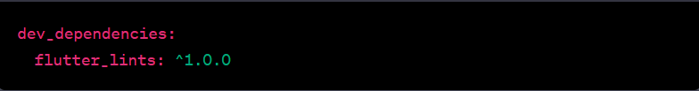

2. After adding the package, we ran the following command in the terminal to apply the lint rules to our project:



This command analyzes the codebase and provides feedback based on the lint rules defined by the Flutter Lints package. Any violations or potential issues identified are displayed in the terminal along with suggestions for improvement.

3. We reviewed the lint feedback and addressed any issues raised by the linter. This involved making code modifications to adhere to the lint rules or adjusting our coding practices accordingly. Resolving lint violations helped us maintain a clean and consistent codebase.

The use of Flutter Lints in our project provided several benefits:

Code Consistency: By enforcing consistent coding conventions, the lint rules helped ensure that the code was written in a uniform style across the project. This made it easier for team members to understand and maintain each other's code.

Code Quality: The lint rules encouraged best practices and identified potential issues, such as unused variables, deprecated APIs, or potential bugs. By addressing these issues early on, we were able to improve the overall quality of our codebase and reduce the likelihood of bugs.

Maintainability: The lint rules helped identify code smells, such as long methods or complex logic, which could affect the maintainability of the code. By refactoring these areas, we were able to improve the readability and maintainability of our code.

Overall, the integration of the Flutter Lints package into our project proved to be valuable. It assisted us in maintaining code quality, ensuring consistency, and adhering to best practices throughout the development process. By addressing lint violations, we improved the overall quality and maintainability of our Flutter application.

**4.2.3 Cupertino Icons**

In our Flutter project, we utilized the Cupertino Icons package, which provides a collection of icons that are designed specifically for iOS applications. The Cupertino Icons package offers a wide range of icons that align with the visual style of iOS, allowing us to create a cohesive and native-like user interface.

To incorporate the Cupertino Icons package into our project, we followed the following steps:

1. Added the cupertino_icons package as a dependency in the pubspec.yaml file:

dependencies:

cupertino_icons: ^1.0.0

1. After adding the package, we ran the following command in the terminal to fetch and update the dependencies:

flutter pub get

This command fetched the necessary assets and libraries for the Cupertino Icons package and made them available for use in our Flutter project.

1. To use an icon from the Cupertino Icons package, we imported the cupertino_icons library in the Dart file where we wanted to utilize the icons:

import 'package:cupertino_icons/cupertino_icons.dart';

1. Once imported, we were able to reference any icon from the Cupertino Icons package using the CupertinoIcons class. For example, to use the "heart" icon, we could write:

Icon(CupertinoIcons.heart)

By leveraging the Cupertino Icons package in our project, we gained several advantages:

Consistent iOS Design: The Cupertino Icons package provides icons that align with the visual style of iOS applications. By utilizing these icons, we were able to create a cohesive and familiar user interface for iOS users, ensuring a consistent and native-like experience.

Efficiency and Time-saving: By using pre-designed icons from the Cupertino Icons package, we saved development time and effort that would have otherwise been spent on creating custom icons. This allowed us to focus more on the core functionality of our application.

Maintainability: The Cupertino Icons package is regularly maintained and updated, ensuring that we had access to a comprehensive library of icons that is compatible with the latest versions of Flutter. This ensured that our icons remained up-to-date and aligned with the evolving design guidelines of iOS.

In summary, by integrating the Cupertino Icons package into our Flutter project, we were able to enhance the visual appeal and user experience of our iOS application. The package provided a wide range of icons that align with the design language of iOS, saving us time and effort in designing and implementing custom icons. This ultimately contributed to a more consistent, intuitive, and polished user interface.

**4.2.4 Figma for UI/UX**

In our project, we utilized Figma as a tool for designing and prototyping the user interface (UI) and user experience (UX) of our application. Figma is a web-based design and collaboration platform that offers a range of features specifically tailored for UI/UX design.

The integration of Figma into our project workflow involved the following steps:

1.Designing UI Components:We utilized Figma's powerful design features to create high-fidelity UI components, such as screens, buttons, icons, and other visual elements. Figma provided a rich set of tools, including vector editing, layout grids, color palettes, and typography options, allowing us to design visually appealing and consistent UI elements.

2.Prototyping Interactions: Figma enabled us to create interactive prototypes that simulated the flow and behavior of our application. By defining interactions between screens and adding transition animations, we were able to visualize and test the user experience before implementation. This helped us identify potential usability issues and make informed design decisions.

3.Collaboration and Feedback:Figma's real-time collaboration features facilitated seamless collaboration among team members. Multiple designers and developers could work simultaneously on the same design files, making it easy to exchange ideas, provide feedback, and iterate on the UI/UX. Figma also allowed stakeholders and clients to review and comment on the design, enabling effective communication throughout the design process.

4.Developer Handoff: Figma offered functionalities to streamline the handoff process between designers and developers. By using Figma's "Inspect" feature, we generated design specifications and assets that developers could easily access. This included CSS attributes, measurements, and exportable assets, ensuring a smooth transition from design to implementation.

The use of Figma in our project provided several benefits:

Efficiency in Design: Figma's intuitive interface and design-focused features allowed us to create UI/UX assets efficiently, saving time and effort in the design phase. The ability to reuse components and styles across screens ensured consistency and maintained a unified visual language throughout the application.

Improved Collaboration: Figma's collaboration capabilities facilitated effective teamwork and communication among designers, developers, and stakeholders. The ability to provide real-time feedback, make annotations, and discuss design decisions in context significantly streamlined the design iteration process.

Prototype Validation: Figma's prototyping features allowed us to validate our design decisions by simulating user interactions and testing the flow of the application. This helped identify potential usability issues early on and make necessary refinements before development

In summary, the incorporation of Figma into our project workflow greatly enhanced the UI/UX design process. By leveraging Figma's design and prototyping capabilities, we were able to create visually appealing and user-friendly interfaces, collaborate efficiently, and validate design decisions. Figma proved to be a valuable tool in ensuring a well-designed and user-centric application.

**4.3 BACKEND DEVELOPMENT**

Back-end development involves everything that exists in the server. This includes everything from data modelling and storage to security concerns. Back-end development makes the front-end of a website possible by building and maintaining the systems that make user interaction possible. Back-end development is a crucial part of websites since back ends are composed of databases, authentication/authorization features, application programming interfaces (APIs) and all the different components that, combined with a front-end, allow users to view and interact with applications in their browser.

**The Backend Developer includes –**

Writing clean, maintainable code: This can include building prototypes, creating entire systems from scratch, adding new features to existing systems and more.

Database design and management: Almost every back-end stores data in a database. A back-end developer should have extensive knowledge of both relational and non-relational databases.

Building and managing APIs: Whether REST, SOAP, RPC or GraphQL, APIs are used extensively in back-end development as a means of communication with the client and other systems.

Troubleshooting and debugging applications: Every developer, regardless of whether they work on the front-end or the back-end, must know how to debug and solve any problems that may arise in the application they’re building. Solving problems is the day-to-day life of any developer.

Maintaining the web server: It isn’t unusual for back-end developers to dabble in configuring and maintaining the web server that hosts their code, especially in smaller businesses and startups that lack the budget to hire a systems administrator.

Collaborating with front-end developers: A back-end developer must have excellent communication skills to collaborate with front-end developers

**4.3.1 Flask**

In our project, we utilized Flask, a micro web framework written in Python, for developing the backend of our application. Flask provided us with a flexible and efficient foundation for building web applications with Python.

Here are some key aspects and features of Flask that we leveraged in our project:

Micro Framework: Flask is a micro web framework, meaning it provides only the essential tools and features needed for web development. Its simplicity and minimalistic design allow developers to have greater control and flexibility over the project's architecture and implementation.

Routing and Views: Flask offers a routing system that maps URLs to Python functions, known as views. By defining routes and associating them with appropriate view functions, we were able to handle different HTTP requests and build the necessary endpoints for our API.

Template Engine: Flask provides a built-in template engine, Jinja2, which allowed us to separate the presentation logic from the backend code. We utilized Jinja2 templates to generate dynamic HTML pages, passing data from the backend to the frontend for rendering.

Integration with Database Systems: Flask seamlessly integrates with various database systems, allowing us to interact with databases such as SQLite, MySQL, or PostgreSQL. We leveraged Flask's database extension ecosystem, such as Flask-SQLAlchemy or Flask-MySQL, to interact with the database and perform database operations.

Extensions and Libraries: Flask has a rich ecosystem of extensions and libraries that provide additional functionalities. We made use of various Flask extensions, such as Flask-RESTful for building RESTful APIs, Flask-WTForms for form handling, and Flask-Login for user authentication.

Testing and Debugging: Flask provides built-in support for unit testing and debugging, making it easier to write tests for our application's components and identify and fix errors during development.

Scalability and Deployment: Flask applications can be easily scaled and deployed to different environments. We were able to deploy our Flask application on various platforms, such as local development servers, cloud platforms like Heroku or AWS, or containerized environments like Docker.

Flask's lightweight nature, flexibility, and extensive ecosystem of extensions made it an ideal choice for our backend development needs. Its simplicity allowed us to focus on the specific requirements of our project and develop a robust backend that seamlessly integrated with our front-end components.

Why is Flask a good web framework choice?

Unlike the Django framework, Flask is very Pythonic. It’s easy to get started with Flask, because it doesn’t have a huge learning curve. On top of that it’s very explicit, which increases readability. To create the “Hello World” app, you only need a few lines of code. It’s a microframework, but that doesn’t mean your whole app should be inside one single Python file. You can and should use many files for larger programs, to handle complexity. Micro means that the Flask framework is simple but extensible. You may make all the decisions: which database to use, do you want an ORM etc., Flask doesn’t decide for you. Flask is one of the most popular web frameworks, meaning it’s up-to-date and modern. You can easily extend its functionality. You can scale it up for complex applications.

**4.3.2 APIs (Application Programming Interface)**

An application programming interface (API) is code that enables two software programs to communicate. An API defines how a developer should request services from an operating system (OS) or other application, and expose data within different contexts and across multiple channels. Any data can be shared with an application programming interface. APIs are implemented by function calls composed of verbs and nouns; the required syntax is described in the documentation of the application being called. For example, on a real estate website, one API might publish available real estate properties by geography, while a second API provides current interest rates and a third offers a mortgage calculator.

**How do APIs work?**

APIs are made up of two related elements:

* A specification that describes how information is exchanged between programs in the form of a request for processing and a return of the necessary data; and
* A software interface written to that specification and published in some way for use.

The software that wants to access the features and capabilities of the API is said to call it, and the software that creates the API is said to publish it. APIs authorise and grant access to data that users and other applications request. APIs also provide an audit trail that details who and what have had system access and when it happened. Applications that call APIs were traditionally written in specific programming languages. Web APIs can be called through any programming language, but webpages created in Hypertext Markup Language (HTML) or application generator tools can also access them. The most common architectures for APIs are Representational State Transfer (REST) and Simple Object Access Protocol (SOAP), which defines a standard communication protocol specification for a message exchange based on Extensible Markup Language or XML. SOAP requires less low-level infrastructure-related code than REST. However, REST APIs are easier to scale and redeploy, and simpler to implement and integrate with websites and services. REST APIs are most often used today, particularly for web interactions.

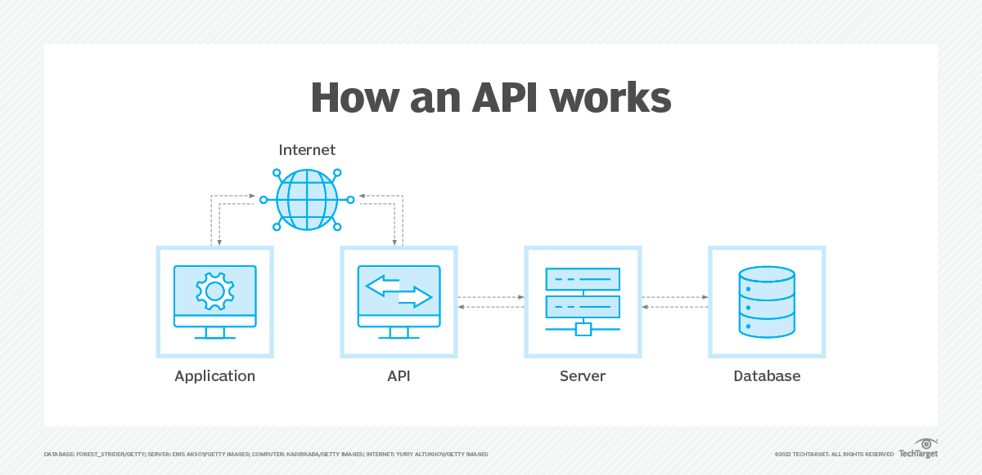

Figure 4.2: How an API Works

**Types of APIs**

There are different types of APIs that can be categorised based on the ways they are available for use and according to their initial design purposes.

1. **APIs by availability i.e. release policies:**

In terms of release policies, APIs can be private, partner, and public.

1. **Private APIs**: These application software interfaces are designed to improve organizational solutions and services. In-house developers or contractors may use these APIs to integrate a company’s IT systems or applications as well as build new systems or customer-facing apps leveraging existing systems. Even if apps are publicly accessible, the interface itself remains available only for those working directly with the API publisher. The private strategy allows a company to fully control API usage.
2. **Partner APIs**: This type of API is openly promoted but shared with business partners who have signed an agreement with the publisher. The common use case for partner APIs is software integration between two parties. A company that provides partners with access to data or capability benefits from extra revenue streams. At the same time, it can monitor how the exposed digital assets are used, ensure whether third-party solutions using their APIs provide decent user experience, and maintain corporate identity in their apps.
3. **Public APIs**: Also known as developer-facing or external, these APIs are available for any third-party developers. A public API program allows for increasing brand awareness and receiving an additional source of income when properly executed. There are two types of public APIs – open (free of charge) and commercial ones.

* Open public APIs, as the Open API Definition suggests, are those with all features public and available for use without restrictive terms and conditions. For instance, it’s possible to build an application that utilizes the API without explicit approval from the API supplier or mandatory licensing fees.
* Commercial API users pay subscription fees or use APIs on a pay-as-you-go basis. A popular approach among publishers is to offer free trials, so users can evaluate APIs before purchasing subscriptions.

1. **APIs by use cases :**

APIs can be classified according to the systems for which they are designed.

1. **Database APIs**: Database APIs enable communication between an application and a database management system.
2. **Operating systems APIs** : This group of APIs defines how applications use the resources and services of operating systems.
3. **Remote APIs** : Remote APIs define standards of interaction for applications running on different machines.

**Web APIs** : This API class is the most common. Web APIs provide machine-readable

1. data and functionality transfer between web-based systems which represent client-server architecture.

**What are the benefits of using APIs?**

APIs are a set of rules. They standardize how developers write application code, improving an organization's internal software development processes. APIs provide a convenient way to access real-time and historical stock data from various sources, such as financial institutions, stock exchanges, and data providers. By utilizing APIs, you can ensure that your project has access to up-to-date information, allowing for accurate and timely analysis of stock market trends. APIs simplify the process of integrating external data into your project. Instead of manually collecting and organizing data from different sources, APIs enable seamless data retrieval and integration. This streamlines your workflow and saves you valuable time and effort in data preprocessing and cleaning tasks. APIs offer access to a wide range of data beyond just stock prices. You can leverage APIs to retrieve additional financial data, such as company fundamentals, financial statements, earnings reports, news sentiment, and economic indicators. This expanded data coverage enables a more comprehensive analysis of stocks and enhances the accuracy of your visualizations and forecasts. Using the same rules and formats streamlines code and makes it more transparent. Standardization also facilitates collaboration among developers as they build software components with the intent to integrate with APIs. This, in turn, facilitates feature development and reduces time to market. APIs allow you to automate data retrieval and updates, ensuring that your project stays current with the latest market information. With automatic data fetching, you can avoid manual data collection and focus more on analysis and model refinement.

Public APIs and ones shared with partners enable an organization to do the following:

* Securely control and manage how users and systems access data and service functionality.
* Allow third parties to use its data -- even in a limited sense -- which increases a company's brand exposure.
* Grow its customer database and increase its conversion rate by aligning its services with other trusted brands.
* Monetize its APIs so that they become a line of revenue. This is a common tactic for online payment gateways. For example, companies that use PayPal's APIs are willing to pay to use a trusted payment system.

**Chapter 5**

**5.1 MOBILE APP NAVIGATION:**

The navigation of a mobile app plays a crucial role in providing users with a seamless and intuitive experience. In this chapter, we will explore the navigation flow of our app, which includes the home page, login page, input page, and the graph display page. We will outline the purpose and functionality of each page, along with the steps to navigate through the app.

1. Home page: The home page serves as the starting point for users when they launch the app. It provides an overview of the app's features and serves as a central hub for navigation. Users can access various sections of the app from the home page using intuitive icons or buttons.



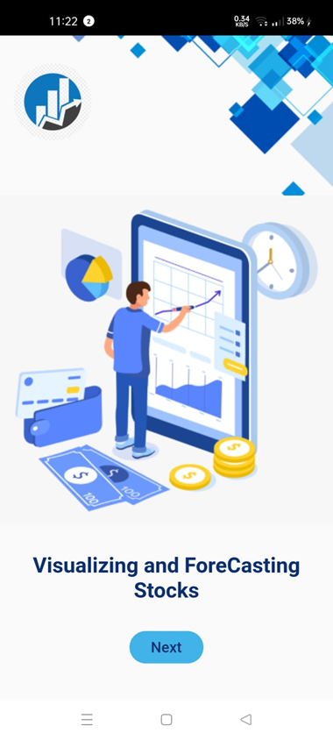

1. Login Page: To access personalized features and data, users need to authenticate themselves through the login page. This page enables users to enter their credentials, such as username and password, to securely log into their accounts. 
2. Input Page: Once users have logged in, they are directed to the input page. This page consists of two columns, where users are required to input the name of the desired company and the number of days for which they want to retrieve data. Users can enter the company's name using a search bar or a predefined list. They can also select the number of days using a dropdown menu or an input field. After entering the necessary details, users proceed to the graph display page.

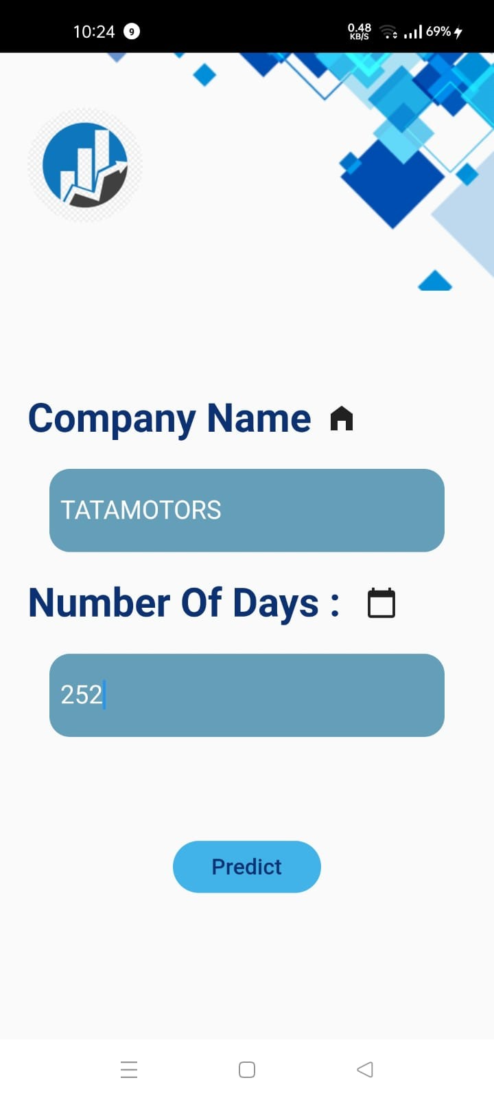

4. Graph Display Page: The graph display page presents users with a visual representation of the stock data for the specified company and the selected number of days. The graph provides insights into the company's historical stock performance, including price fluctuations and trends. Users can interact with the graph by zooming in/out or scrolling to view different time periods. Additional features like indicators, overlays, and customization options may be available to enhance the user experience.

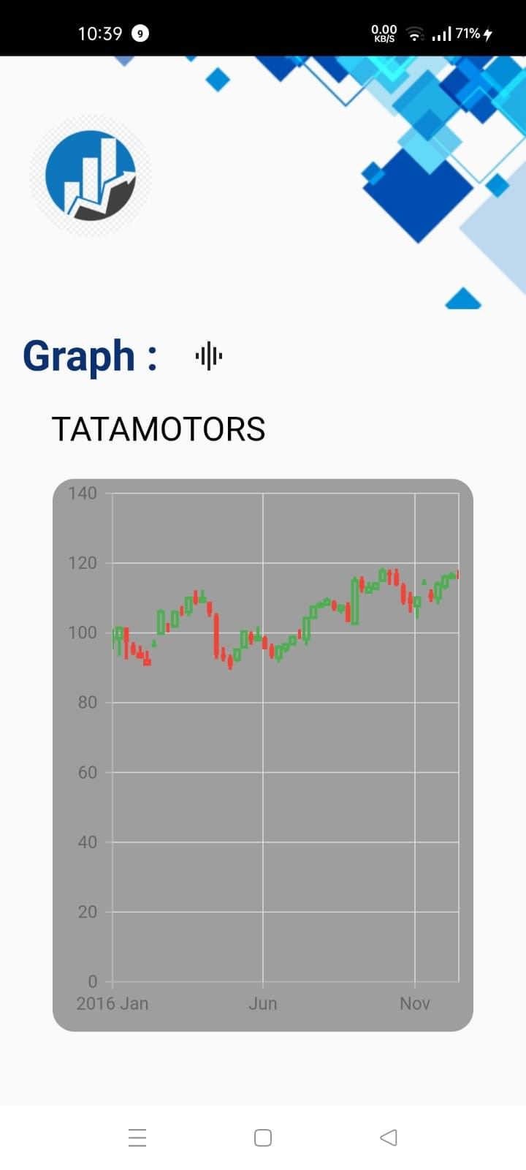

**5.2 Navigation Flow:**

To navigate through the app, users follow a logical sequence of screens:

a. From the home page, users can proceed to the login page by tapping the "Login" button.

b. After successful login, users are automatically directed to the input page.

c. On the input page, users enter the company's name and the desired number of days.

d. After inputting the details, users can submit the form, which takes them to the graph display page.

e. From the graph display page, users can return to the home page, log out, or perform additional actions based on the app's specific features.

**Chapter 6**

**6.1 Conclusion**

In conclusion, the project "Visualizing and Forecasting Stocks" has provided valuable insights into the world of stock market analysis and prediction. Throughout this report, we have explored various techniques and tools to visualize stock data, analyze historical trends, and develop forecasting models to assist investors in making informed decisions. One of the key findings of this project is the importance of data visualization in understanding the behavior of stocks. By visualizing the historical price movements, volume, and other relevant indicators, we can gain a clearer picture of market trends and patterns. This visualization not only enhances our understanding but also enables us to communicate complex information effectively. Furthermore, the project has focused on developing forecasting models to predict future stock prices. We have explored different approaches such as time series analysis, machine learning algorithms, and deep learning models. These models have shown promising results in capturing underlying patterns and making accurate predictions.

Throughout the project, we have also emphasized the significance of incorporating fundamental analysis alongside technical analysis. Fundamental analysis involves examining the financial health, market position, and competitive advantage of a company to assess its potential for growth. By combining fundamental analysis with technical analysis and forecasting models, investors can gain a comprehensive understanding of stocks and make well-informed investment decisions.

Overall, the project "Visualizing and Forecasting Stocks" has provided valuable insights into the world of stock market analysis and prediction. By leveraging data visualization techniques, developing forecasting models, and considering fundamental analysis, investors can enhance their decision-making capabilities in the dynamic and complex world of stock markets. It is essential to approach stock market analysis with a cautious mindset, understanding the limitations of the models, and integrating them with other sources of information. With the right tools and a thoughtful approach, investors can navigate the stock market landscape with increased confidence and maximize their chances of achieving their investment goals.

**REFERENCES**

[1] “Predicting Stock Prices Using LSTM” Authors: Murtaza Roondiwala, Harshal Patel, Shraddha Varma. International Journal of Science and Research (IJSR) 2015.

[2]"Stock Price Forecasting Using Artificial Neural Networks" Authors: Ahmed Hefny, Ahmad Ali, Hoda Fikry, Ayman Khedr IEEE Conference: International Conference on Computer Engineering & Systems (ICCES), 2016

[3]"Stock Market Forecasting Using Recurrent Neural Networks" Authors: Zhiqiang Zhang, Qiuju Li, Jianwei Yang IEEE Conference: International Conference on Cloud Computing and Big Data Analysis (ICCCBDA), 2018

[4]"Visual Analytics for Stock Market Prediction: A Survey" Authors: Peng Zhou, Sheng Liu, Yafeng Lu, Zongmin Ma IEEE Journal: IEEE Transactions on Visualization and Computer Graphics, 2016

[5]"Stock Price Prediction Using Deep Learning" Authors: Weiwei Jiang, Ying Han, Wei Liu, Rui Sun IEEE Conference: International Conference on Machine Learning and Cybernetics (ICMLC), 2017

[6]"A Comparative Study of Stock Market Prediction Using Machine Learning Techniques"

Authors: Anshul Sharma, Pramod D. Jadhav, Anjali P. Borade IEEE Journal: International Journal of Advanced Research in Computer Science and Software Engineering (IJARCSSE), 2017

[7]"Visual Analysis of Financial Time Series with Deep Learning Models" Authors: Mingdong Tang, Bingliang Jiao, Yingying Huang, Jinpeng Huai IEEE Conference: International Conference on Computer Supported Cooperative Work in Design (CSCWD), 2017

[8]"Stock Market Prediction using Hidden Markov Models" Authors: Kamal Kumar Agarwal, Kishan Lal, Munish Rattan IEEE Conference: International Conference on Computer Communication and Informatics (ICCCI), 2017

[9]"Deep Learning for Stock Market Prediction Using Multiple Financial Indicators" Authors: Vijay Kumar Nallamothu, Saritha Yadavalli IEEE Conference: International Conference on Computing, Communication and Automation (ICCCA), 2019

[10]"Predicting Stock Market Trends Using Fusion of News and Social Media Sentiment" Authors: Ameya Gondhalekar, Raghavendra Ramachandra IEEE Conference: International Conference on Big Data Analytics (BDA), 2018

[11]"Ensemble Methods for Stock Price Prediction: A Survey" Authors: Hieu Nguyen, Raghavendra Ramachandra IEEE Conference: International Conference on Machine Learning and Data Science (ICMLDS), 2019

[12]"Visual Analytics for Financial Time Series Data: A Survey" Authors: Jinpeng Huai, Bingliang Jiao, Mingdong Tang, Zhenwen Chen IEEE Journal: IEEE Transactions on Visualization and Computer Graphics, 2016