**Airbnb Salse Report**

This report is to analyze Airbnb listing data to identify trends, pricing strategies, and optimal locations for new listings. This report provides insights into pricing patterns, occupancy rates, and customer preferences to assist in data-driven decision-making.

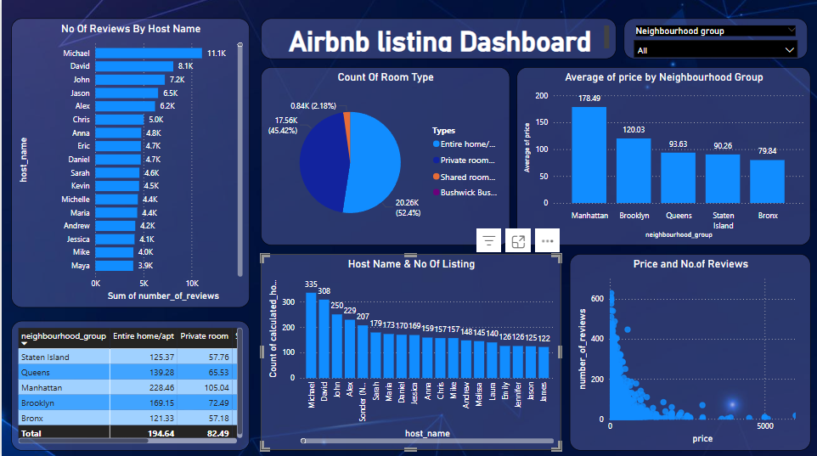

**1.Key Findings**

**Price Analysis:**

- Overall average price per night is 140$.

- The Highest average price per night is in Manhattan with 178$ & lowest is Bronx with 79$.

- Room type as ‘Entire home/apt’ in Manhattan is Highest average 228$ per Night.

- There are 7-8% overpriced listings.

**Availability & Demand:**

* Manhattan & Brooklyn has highest no of listings more than 16000+ listings.
* Bronx & Staten island has lowest listing count less than 1000.
* There are listings that are always available are 3% and never booked 33% listing.

**Host & Property Insights:**

* Sonder (NYC), Blueground, kara, Kazuya, Jeremy & Laura these are the top hosts
* Entire Home property type dominates the market.
* There are some fake repetitive listings like Sonder (NYC), Kazuya, John These are host names.

**Review & Rating Analysis:**

* Low price listing has more reviews than high price listings.
* Brooklyn has highest no of reviews and Manhattan has second highest no of reviews.