1. Design and draw UML class diagram to represent an airline reservation system. The system enables the customer to search for airline flight on a specified date and choose a flight based on some details like availability. The customer can reserve a flight or cancel his reservation. The system displays all the flight details such as flight number, name, price and duration of journey.

Answer:

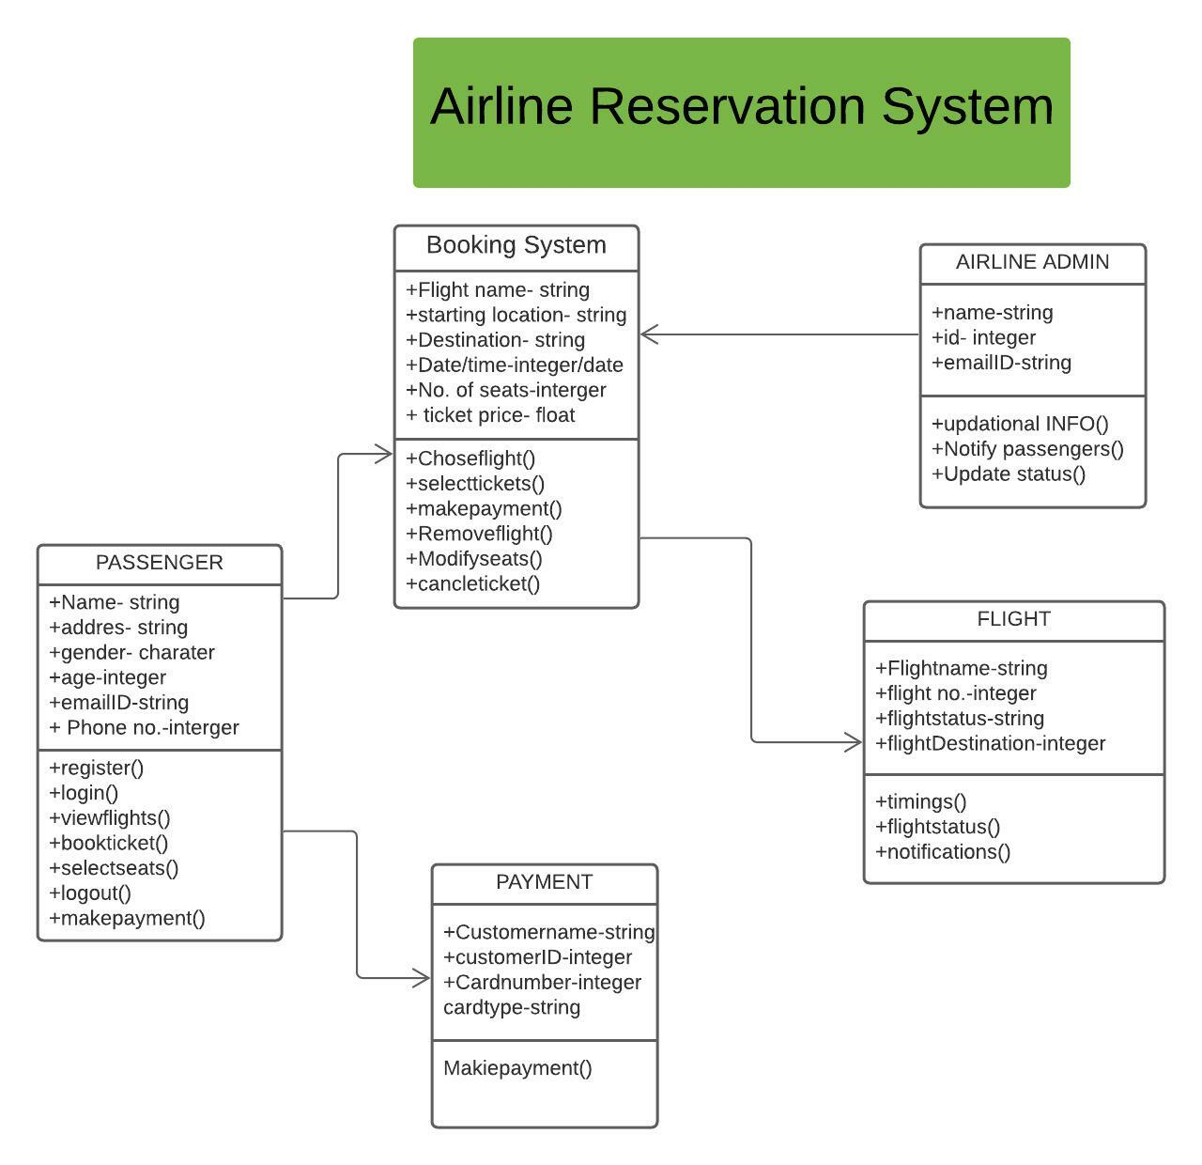

2. Design and draw UML class diagram with attributes, behaviour, and class relationships for the following scenario. In a university there are various departments. A department has a name and is associated to classrooms and offices. An employee working at the university has a unique Id and can be a professor or an instructor. A professor can be a full professor or associate professor, or assistant professor and he/she belongs to a department in the university. Offices and classrooms also have unique IDs and classrooms have fixed number of seats. Also, every employee is assigned an office.

Answer:

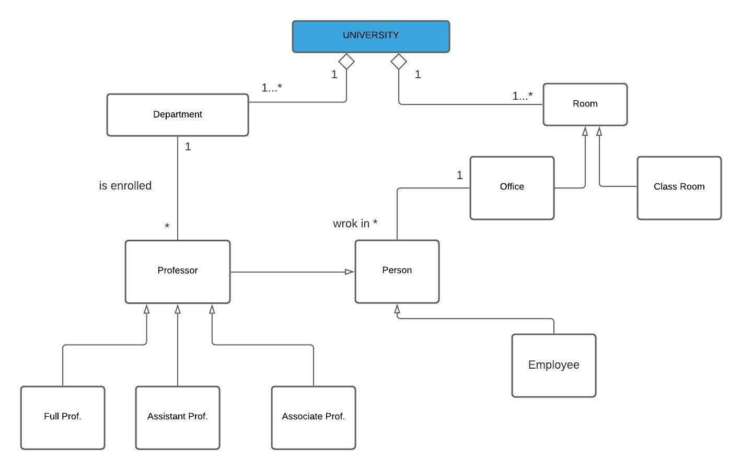

3. Draw an activity diagram for the given scenario where a student needs to enroll with the university for the given course. Process for student enrolment in the university is as follows:

• An applicant wants to enrol in the university.

• The applicant hands a filled-out copy of Enrolment Form.

• The registrar inspects the forms.

• The registrar determines that the forms have been filled out properly.

• The registrar informs student to attend in university overview presentation.

• The registrar helps the student to enrol in seminars

• The registrar asks the student to pay for the initial tuition

Answer:

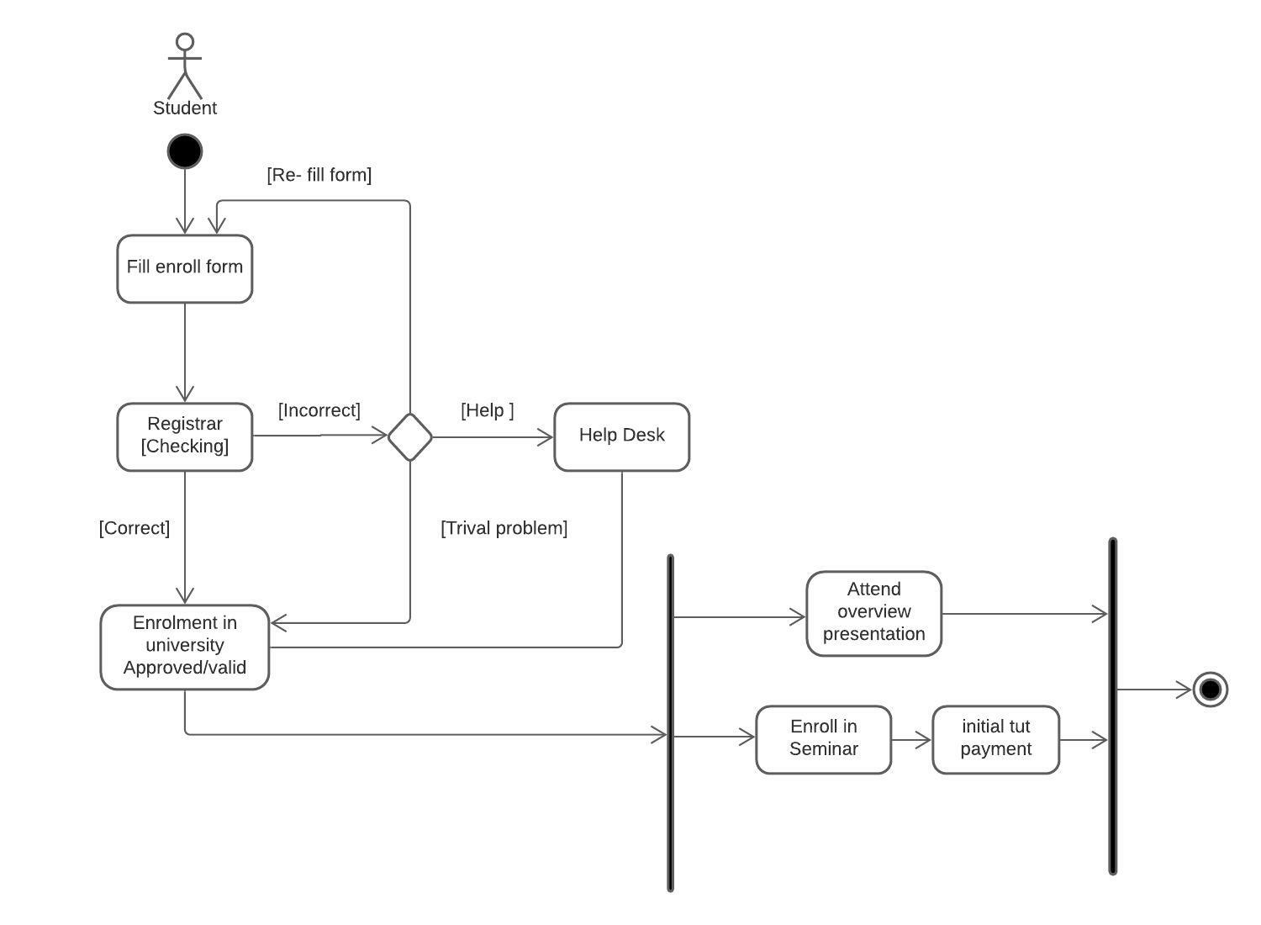

4. A scenario of Online Library Management System is given below. You need to refer the use case diagram and moving further need to create a sequence diagram for the same. Here are the steps that occur in the given use case named ‘Create New Library User Account’.

• The librarian requests the system to create a new online library account

• The librarian then selects the library user account type

• The librarian enters the user’s details

• The user’s details are checked using the user Credentials Database

• The new library user account is created

• A summary of the new account’s details is then emailed

Answer:

