**GIT Branching**

**Objective: Commit HTML, CSS & JavaScript assignments into GIT.**

**SECTION-1 (HTML assignments)**

**Answer:21 to 23**

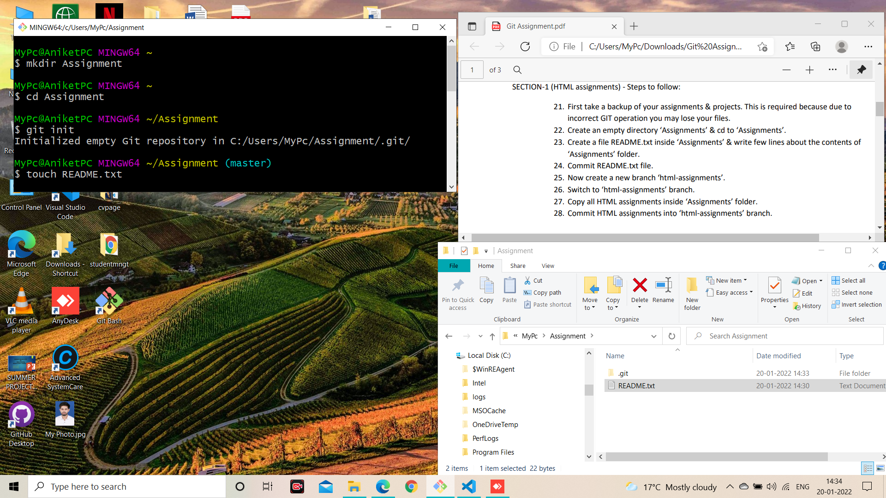

**Answer: 24 to 28**

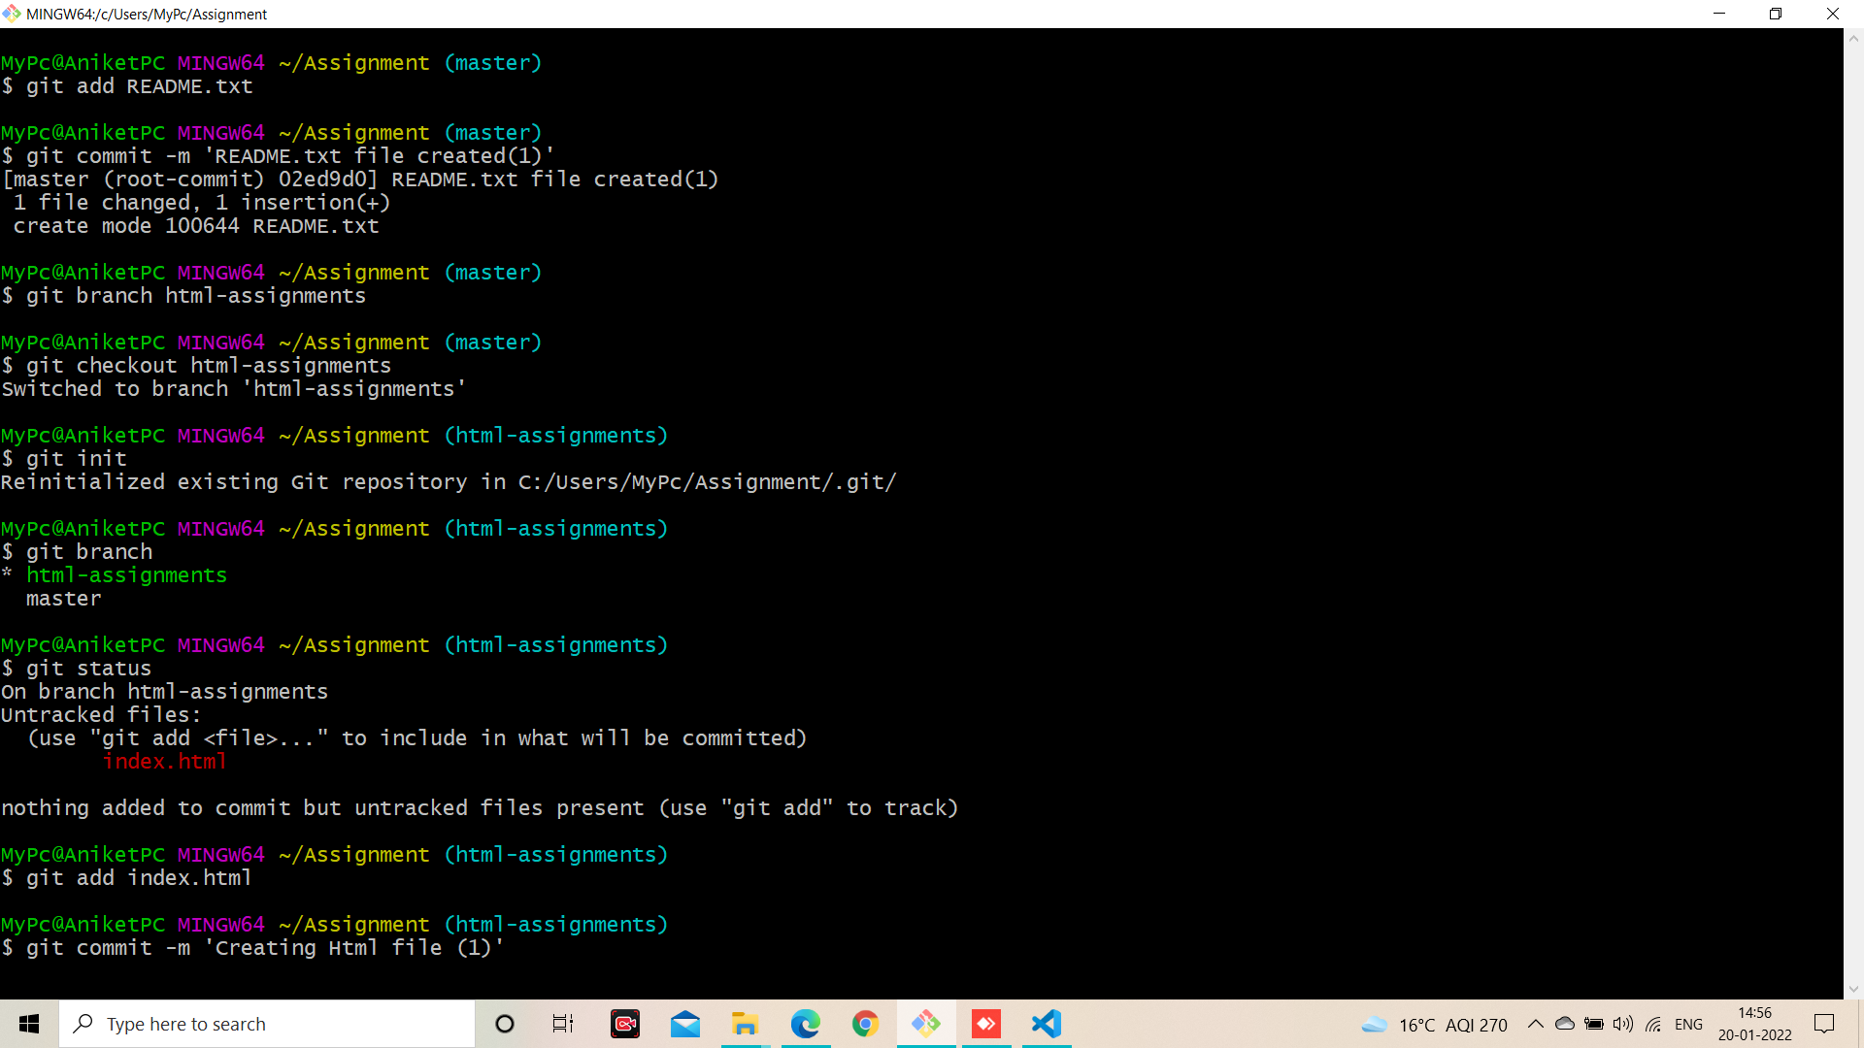

**Answer: 29 to 31**

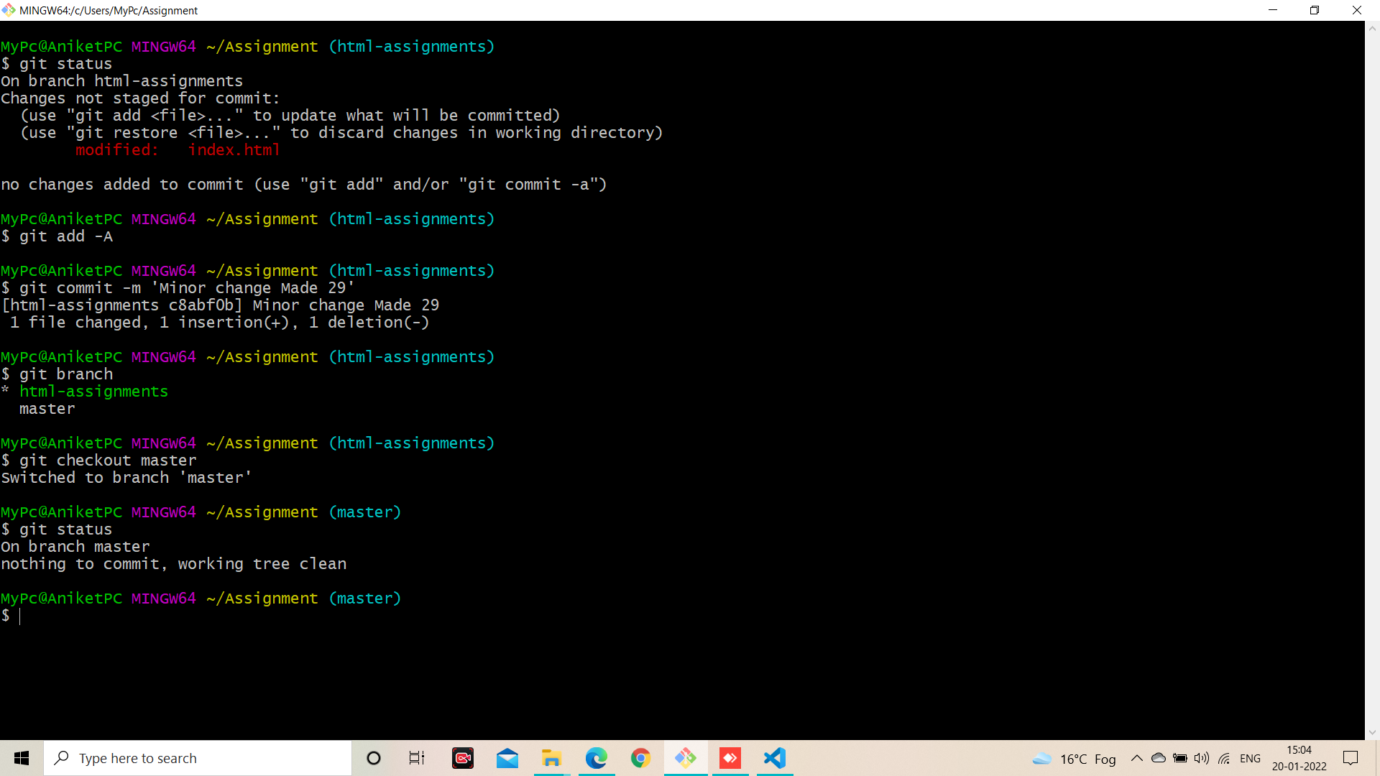

**Answer: 32 to 35**

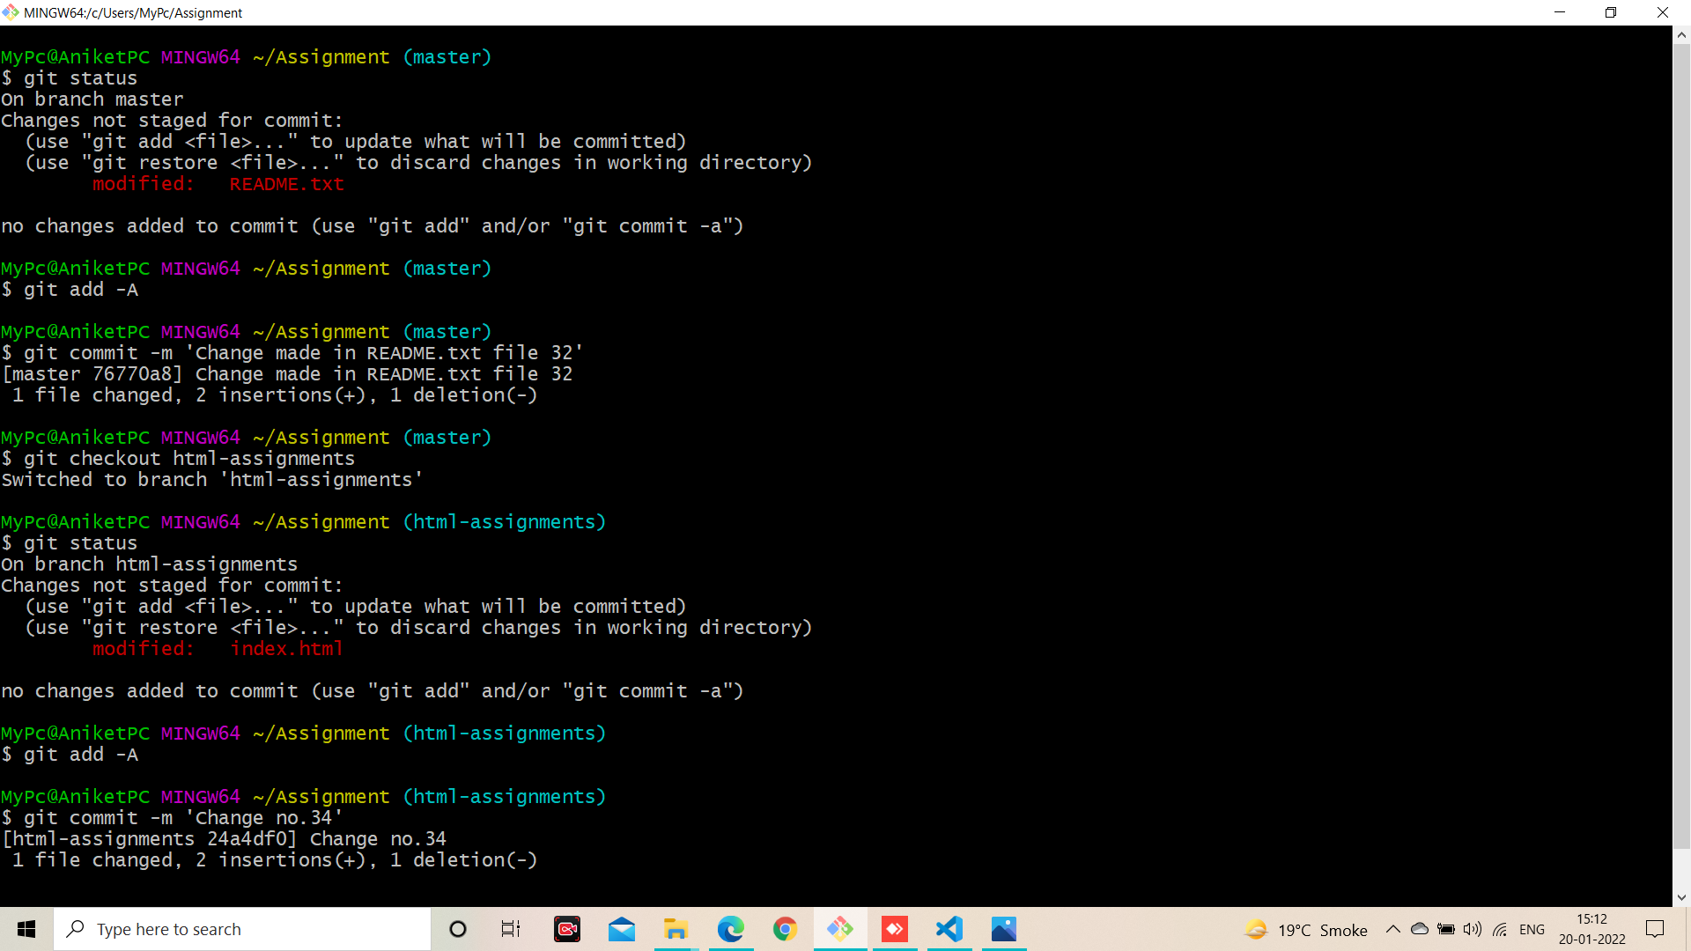

**Answer: 35 to 38**

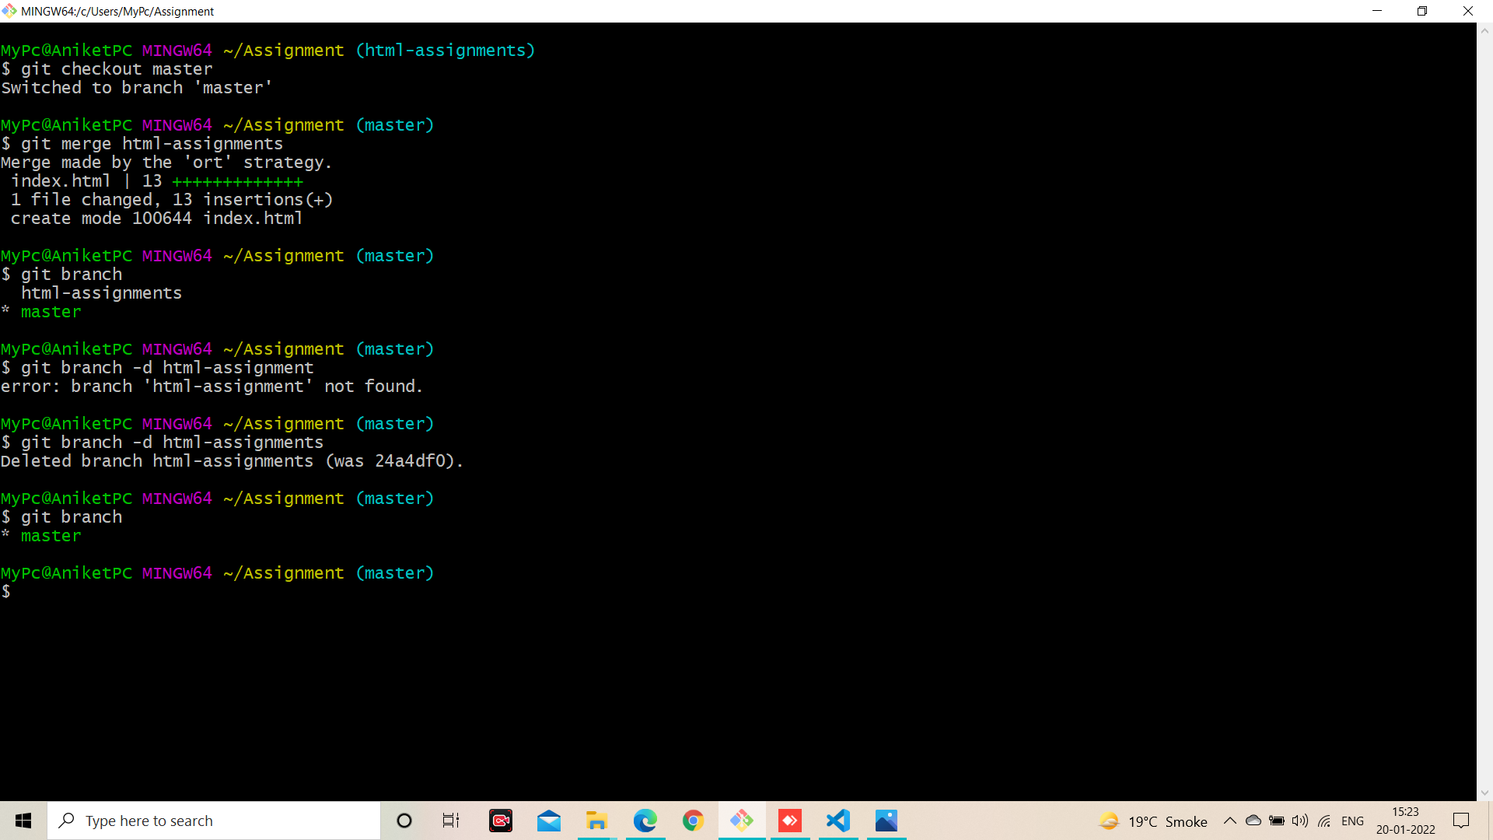

**SECTION-2 - (CSS assignments)**

**Answer: 1 to 5**

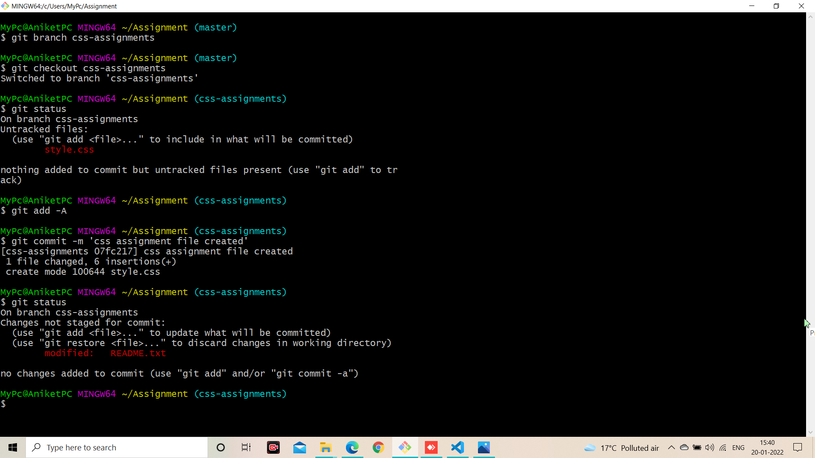

**Answer: 6 to 9**

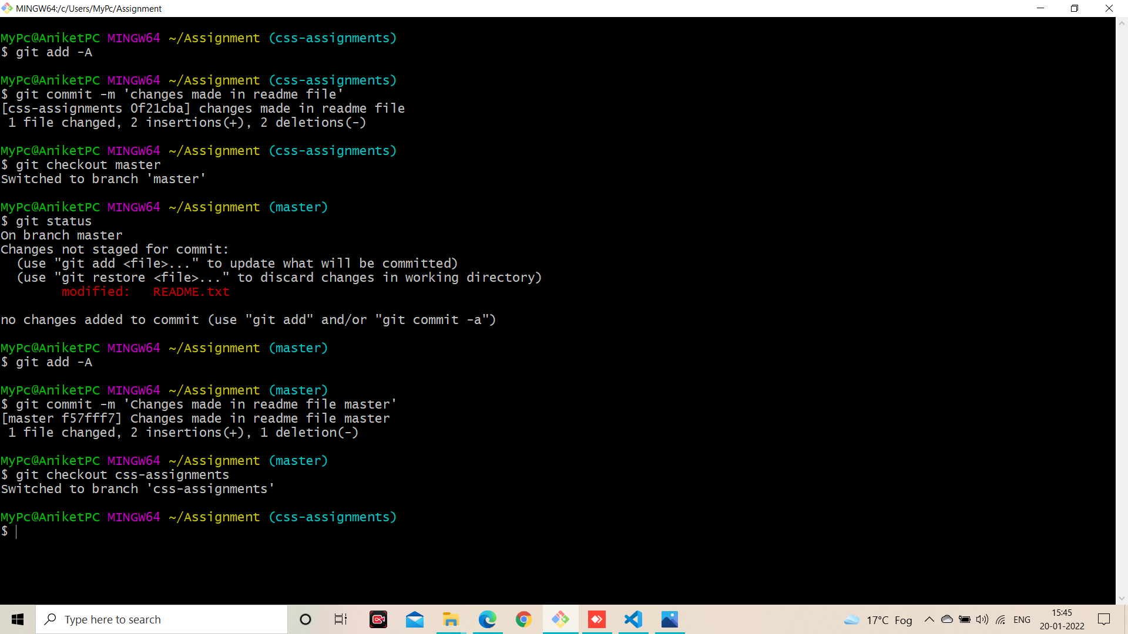

**Answer: 10 to 12**

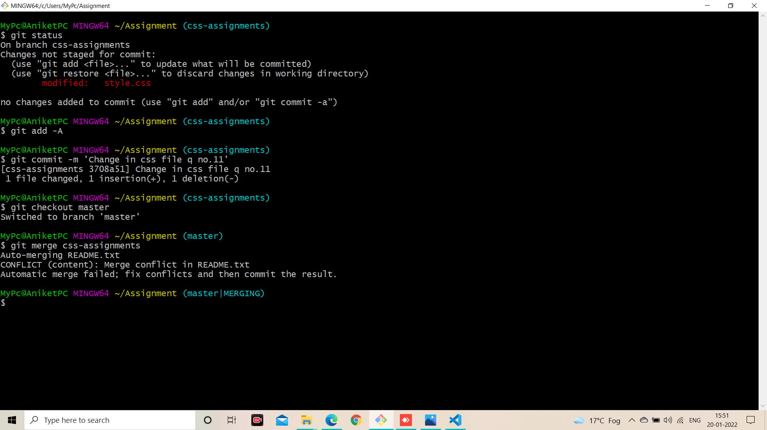

**Answer: 13 to 14**

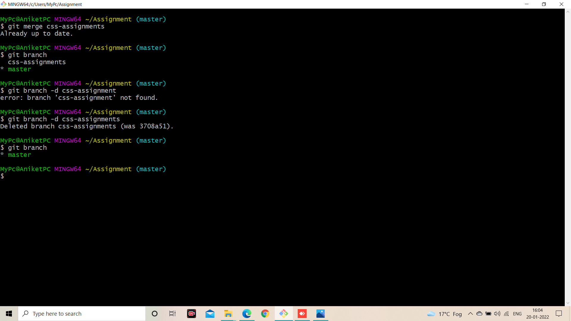

**SECTION-3 - (JavaScript assignments)**

**Answer: 1 to 7**

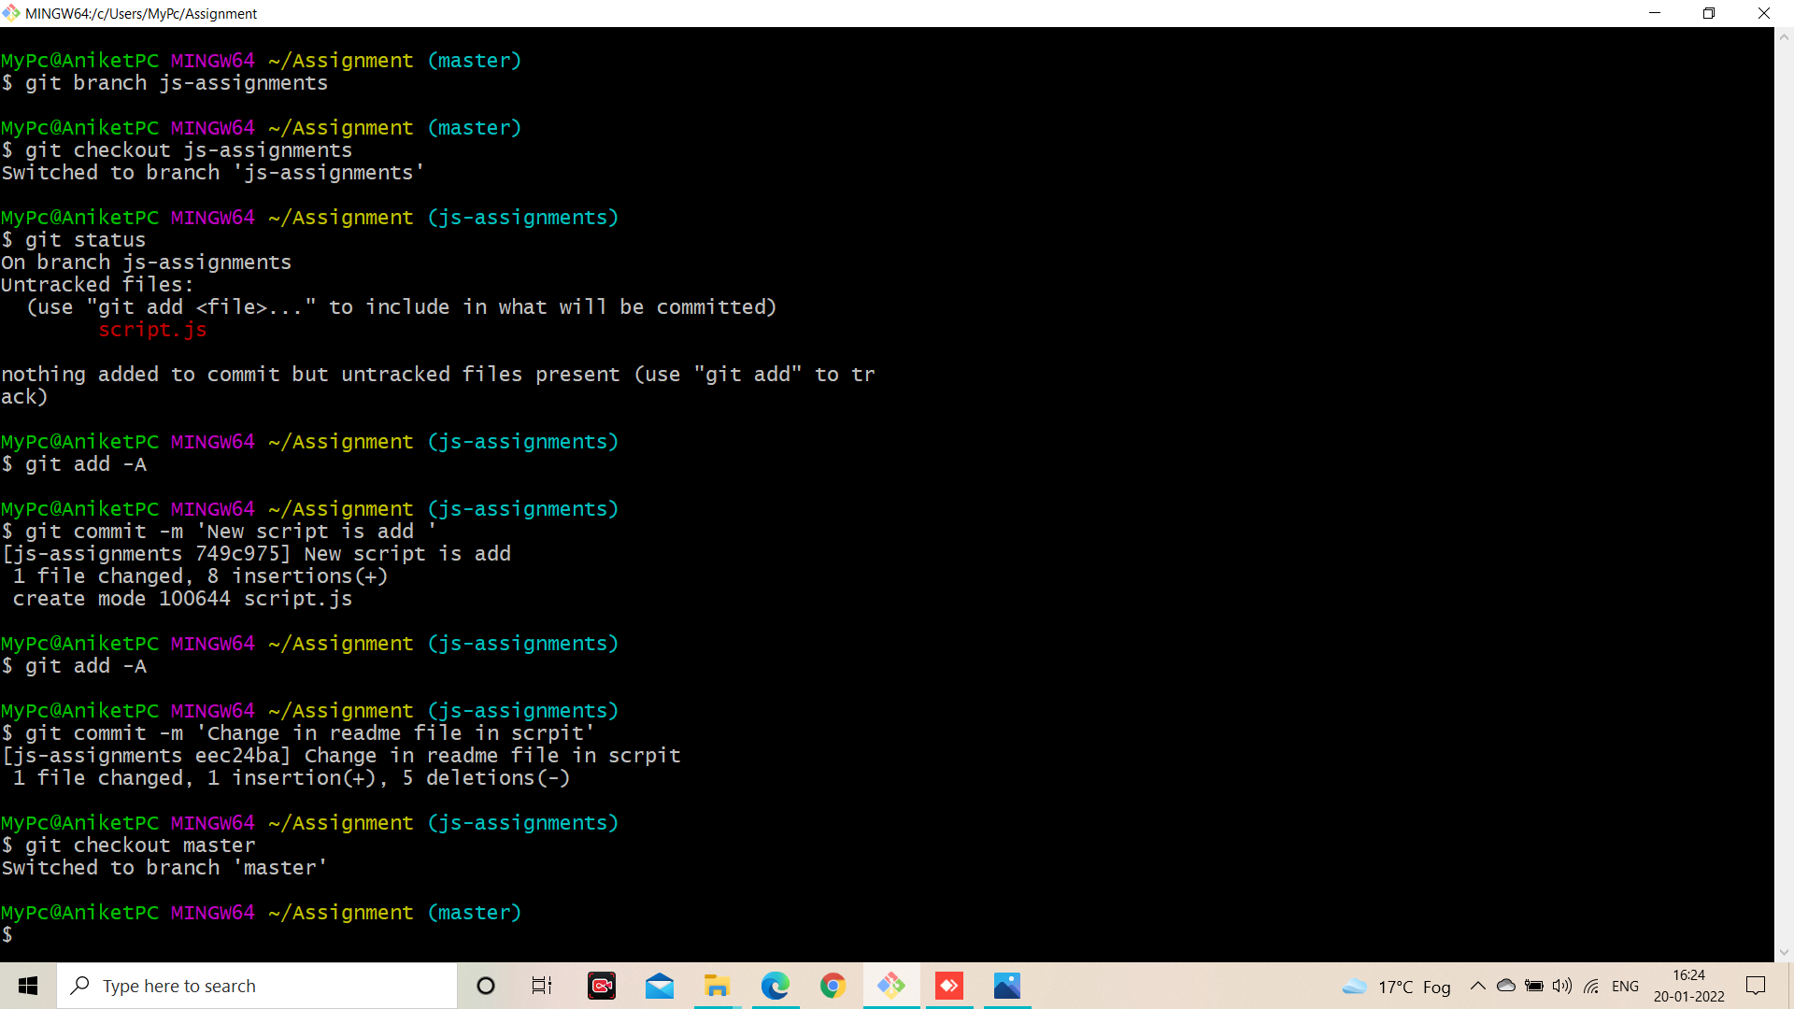

**Answer: 8 to 11**

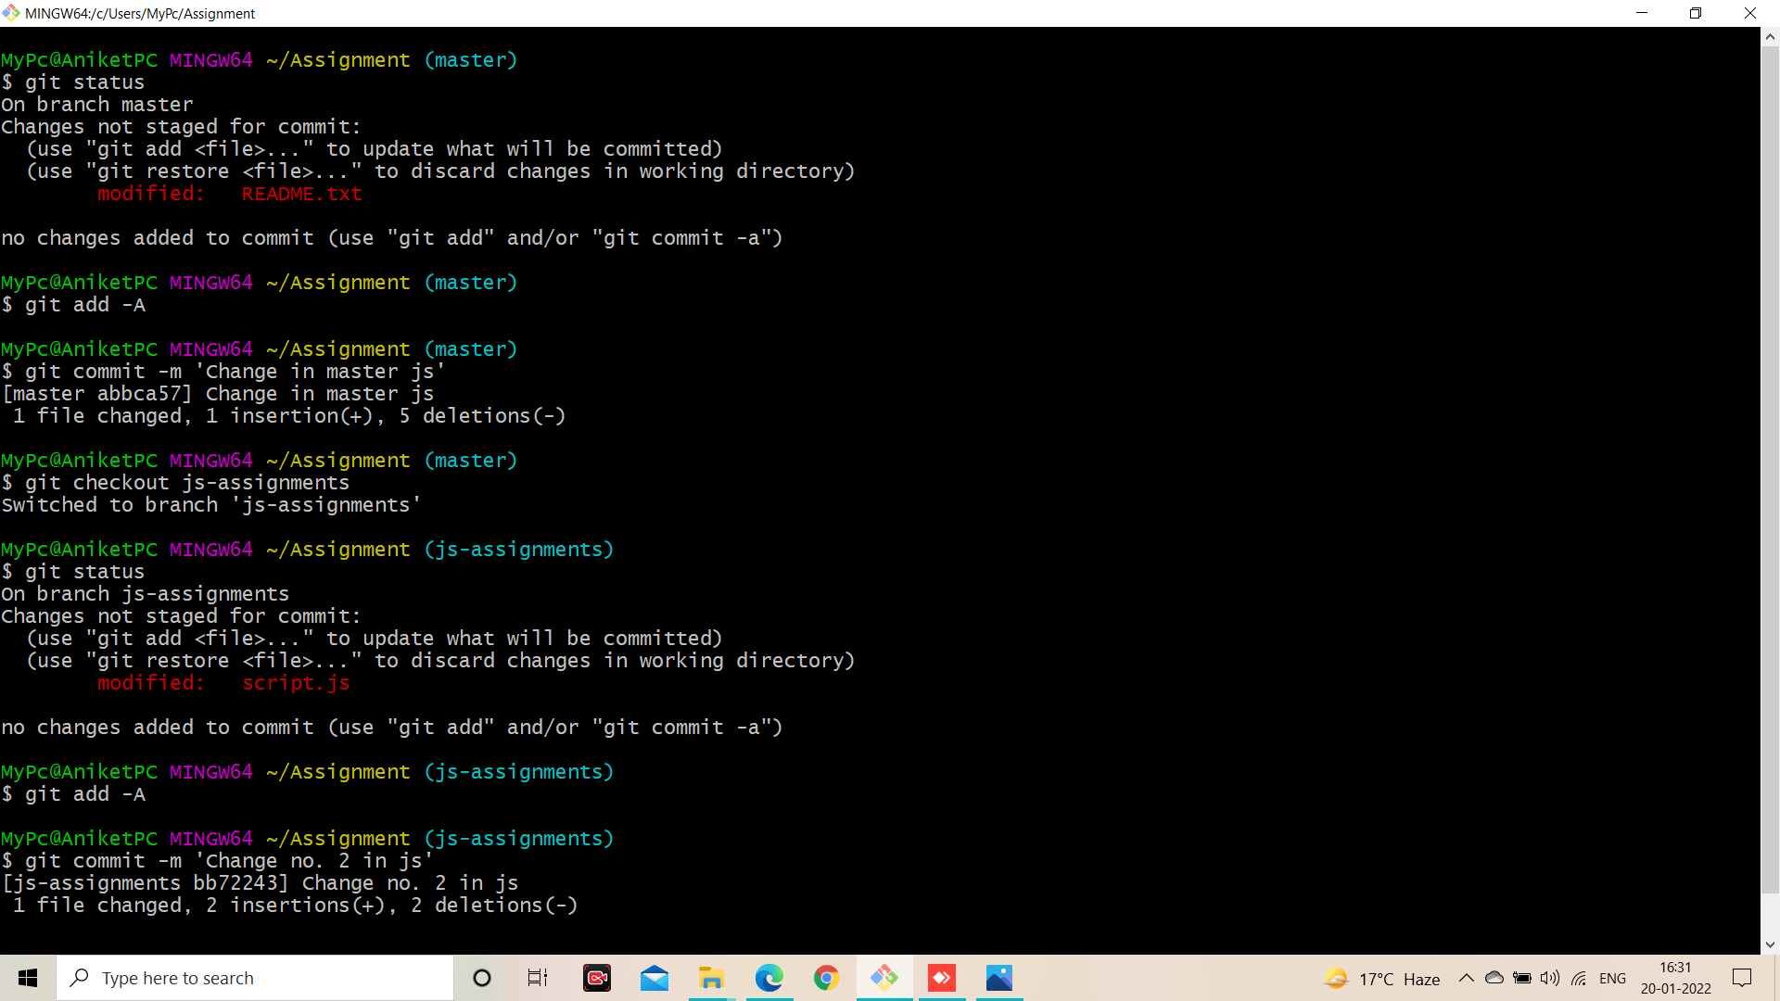

**Answer: 12 to 14**



