1)

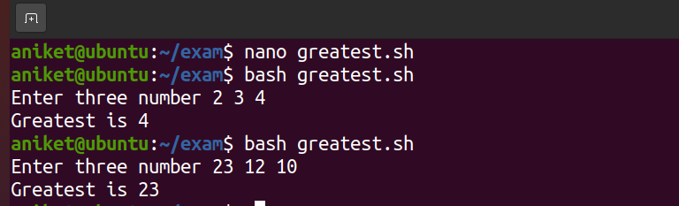

Script

#!/bin/bash

read -p “Enter 3 number “ num1 num2 num3

if [ $num1 -gt $num2 ] && [$num1 -gt $num3 ]

then

echo “Greater is $num1’

fi

if [ $num2 -gt $num1 ] && [$num2 -gt $num3 ]

then

echo “Greater is $num2’

fi

if [ $num3 -gt $num1 ] && [$num3 -gt $num2 ]

then

echo “Greater is $num2’

fi

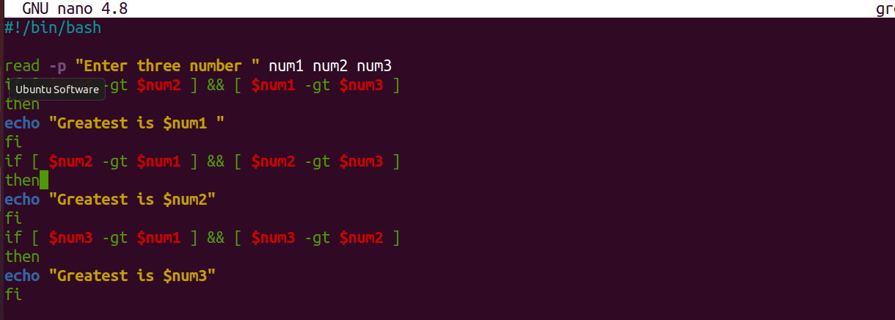

3)

i) 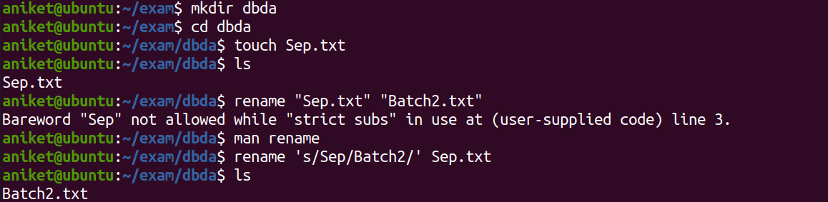

mkdir dbda

cd dbda

touch Sep.txt

rename ‘s/Sep/Batch2/’ Sep.txt

ii)

mkdir dbda_B2

mv Batch2.txt dbda_B2

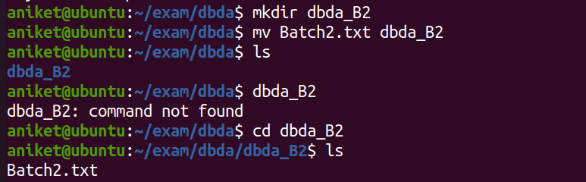

4)

Step 1) login to your aws account

Step 2) In EC2 machine go to instance and create new instances

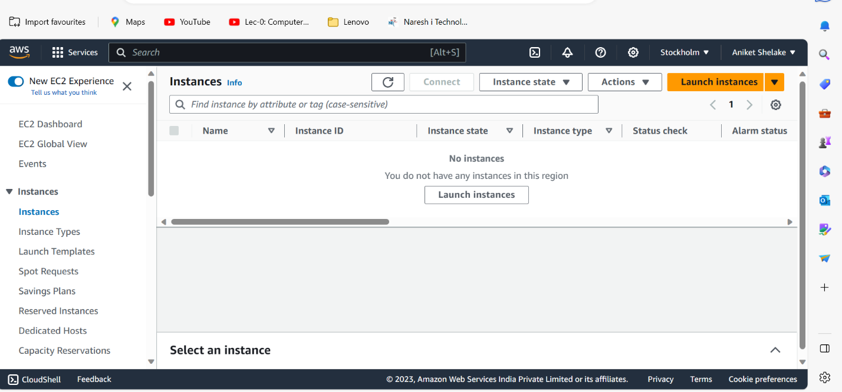

Step 3) add name and tags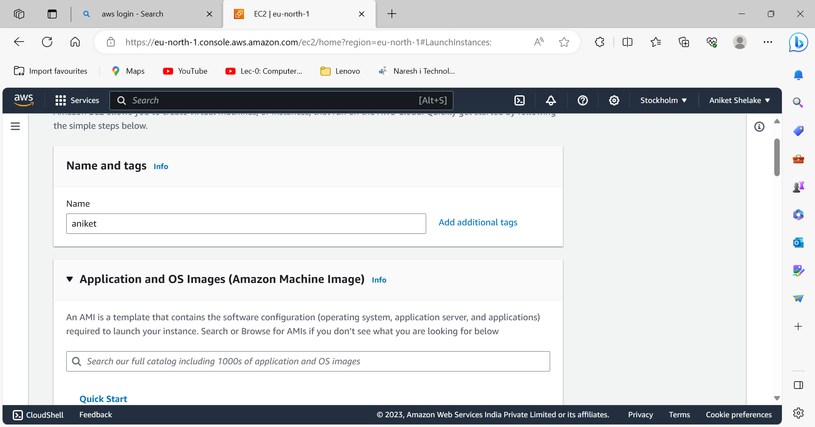

Step 4)

Select os which you want

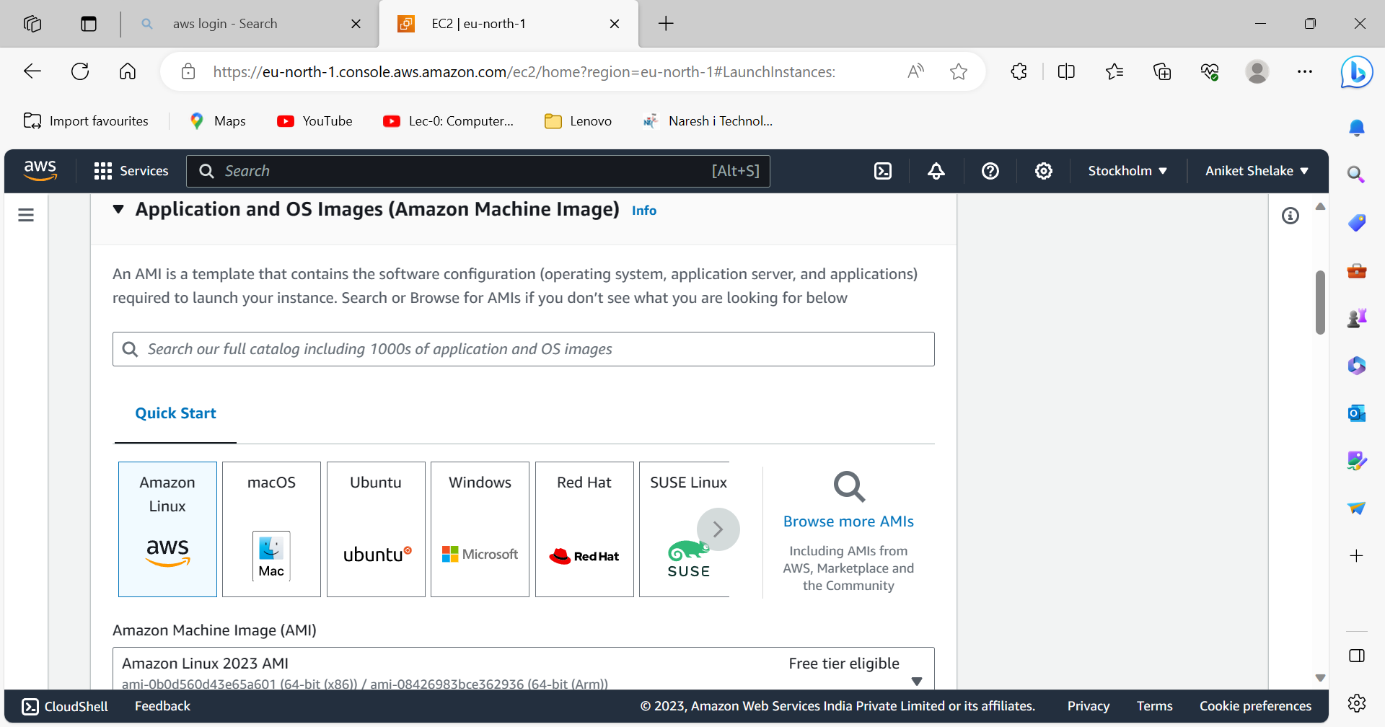

Step 5) Select instance type

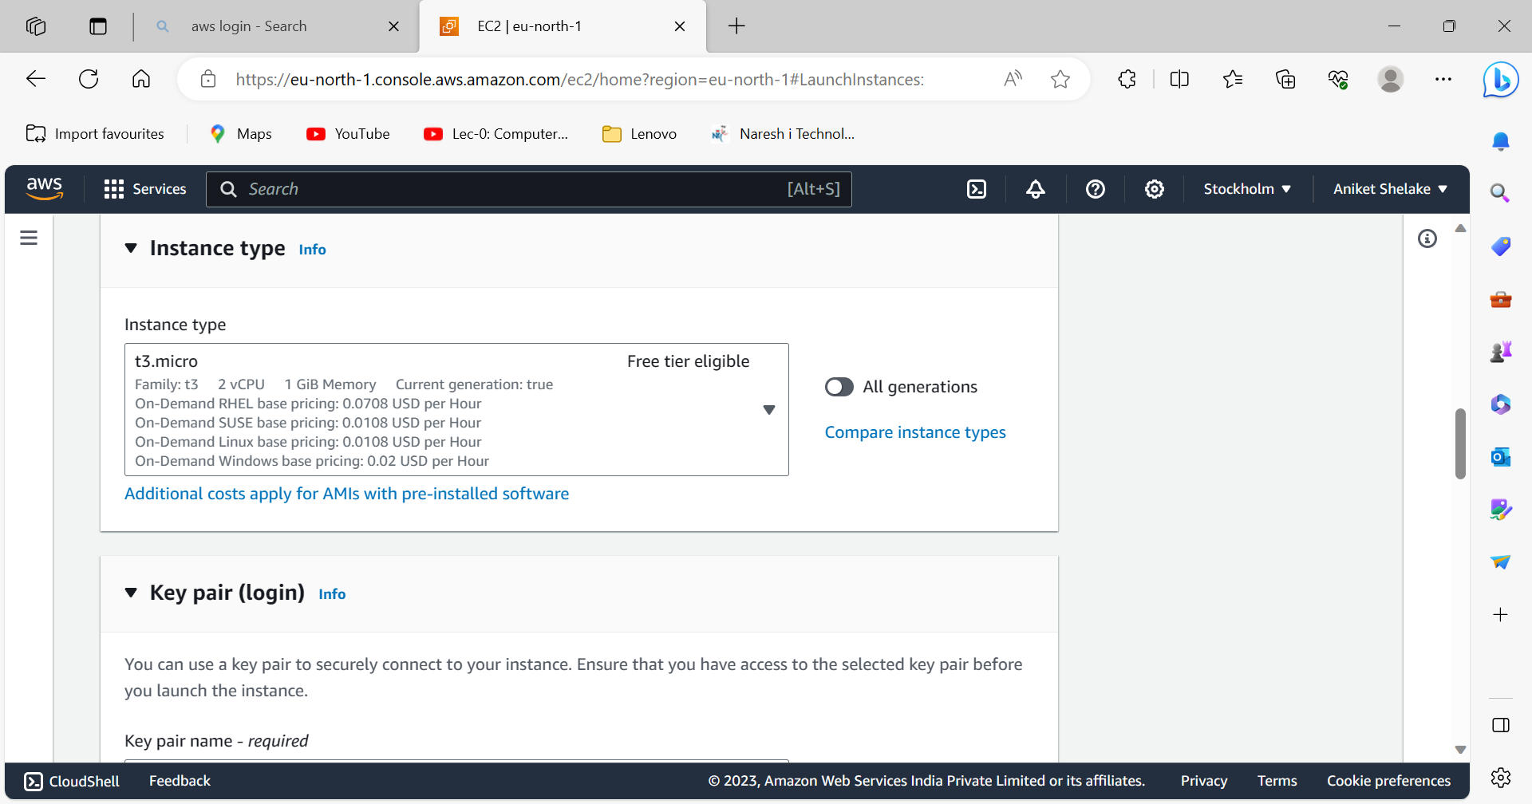

Step 6) Select key pair login which you created using putty

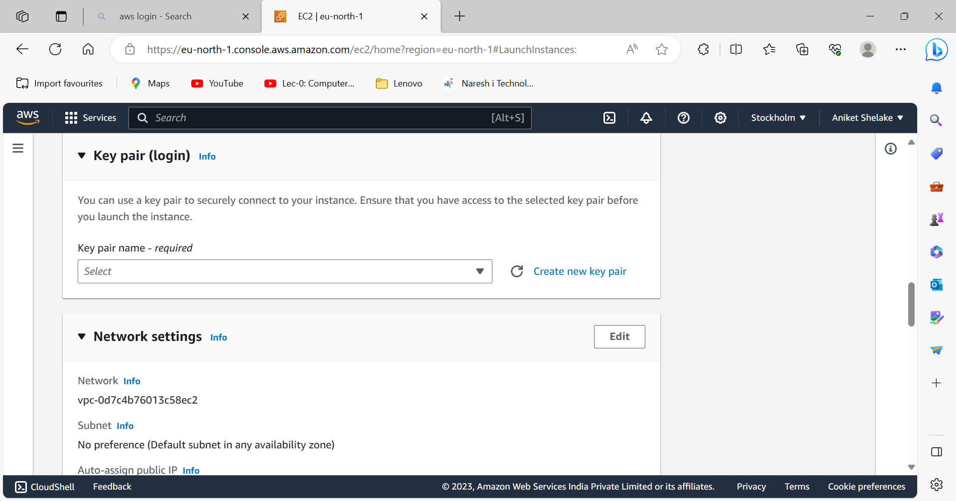

Step 7) select all check boxes

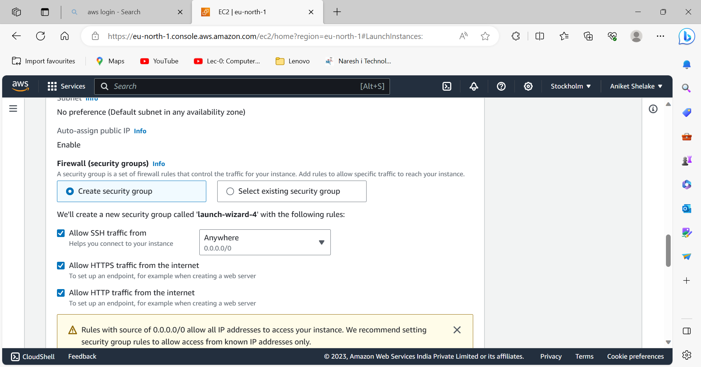

Step8)Go through your summary and launch instance

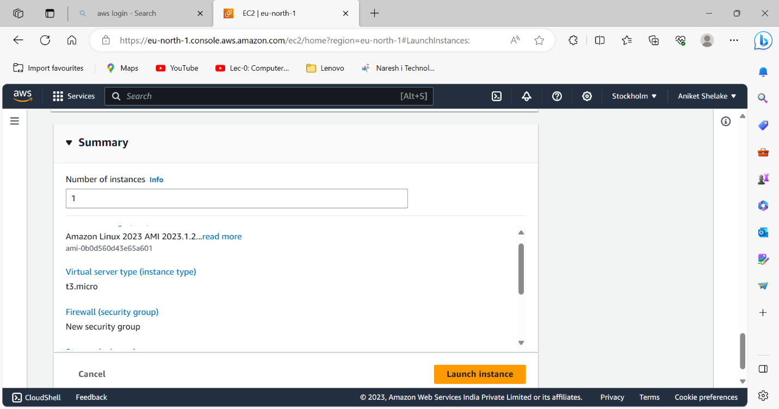

Step 9) Instance is successfully launch

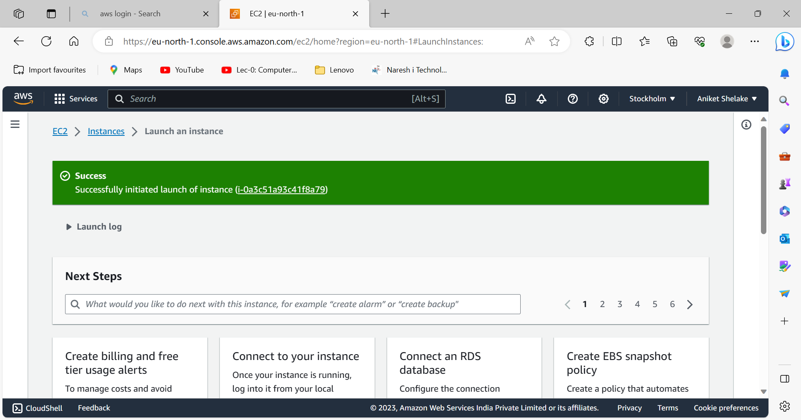

Step 10)Go to instance and copy Public IPV4 address

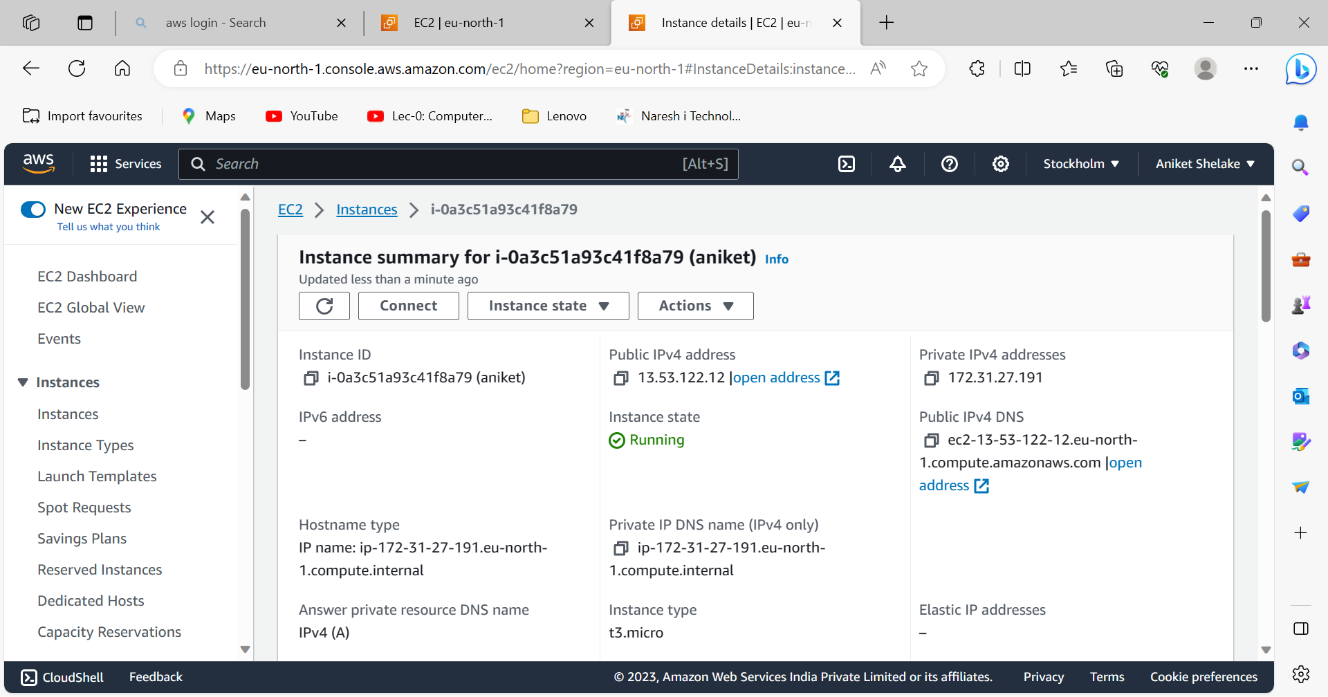

Step 11) copied Public ip paste at Host name as ec2-user@{public-ip}

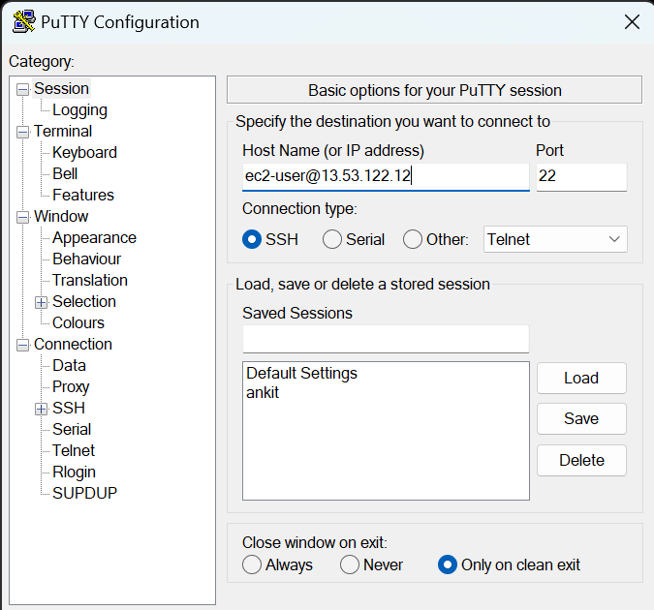

Step 12)select SSH ->Auth ->Credential and browse appropriate private key which you give while creating instances

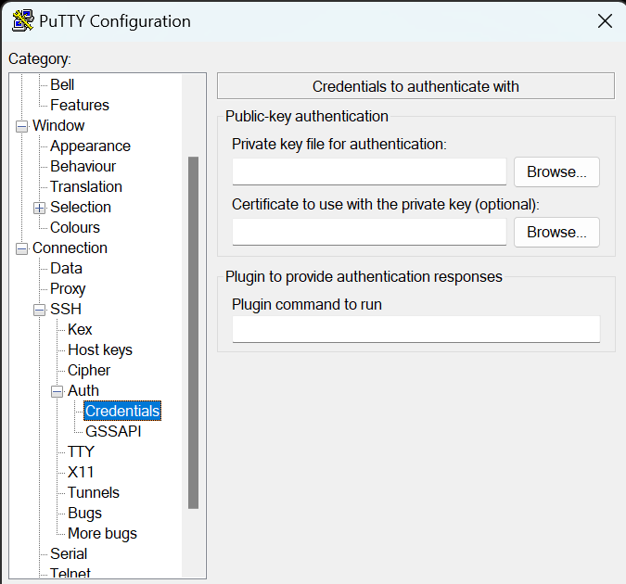

Step13) sudo -i // to enter in root user

Yum update -y // to update

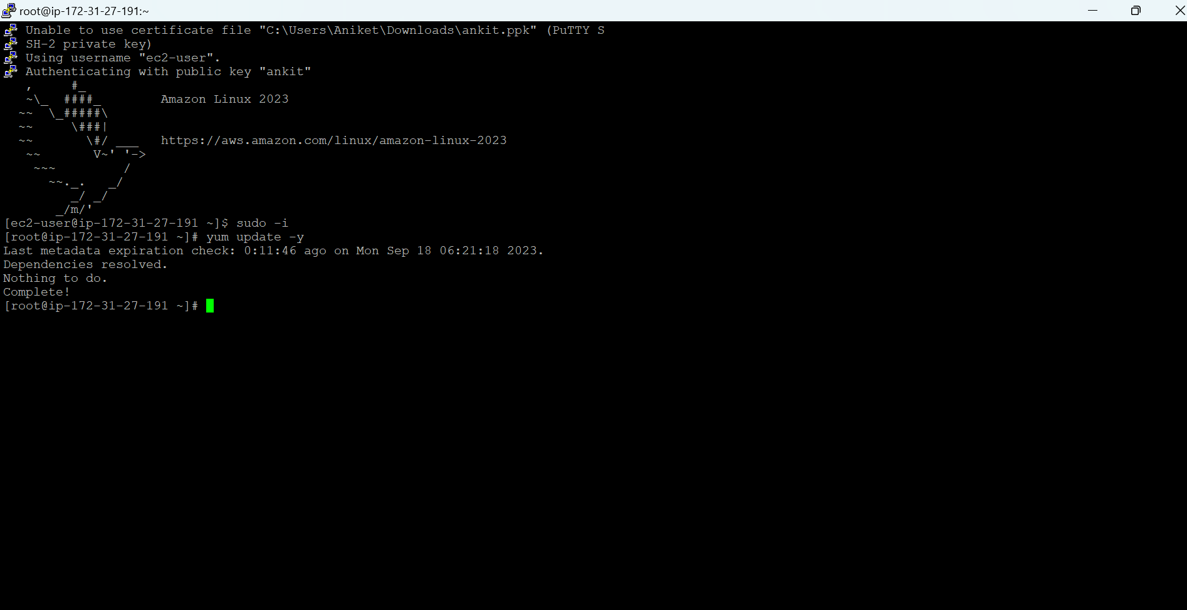

Step 14) yum install httpd -y // to install httpd package

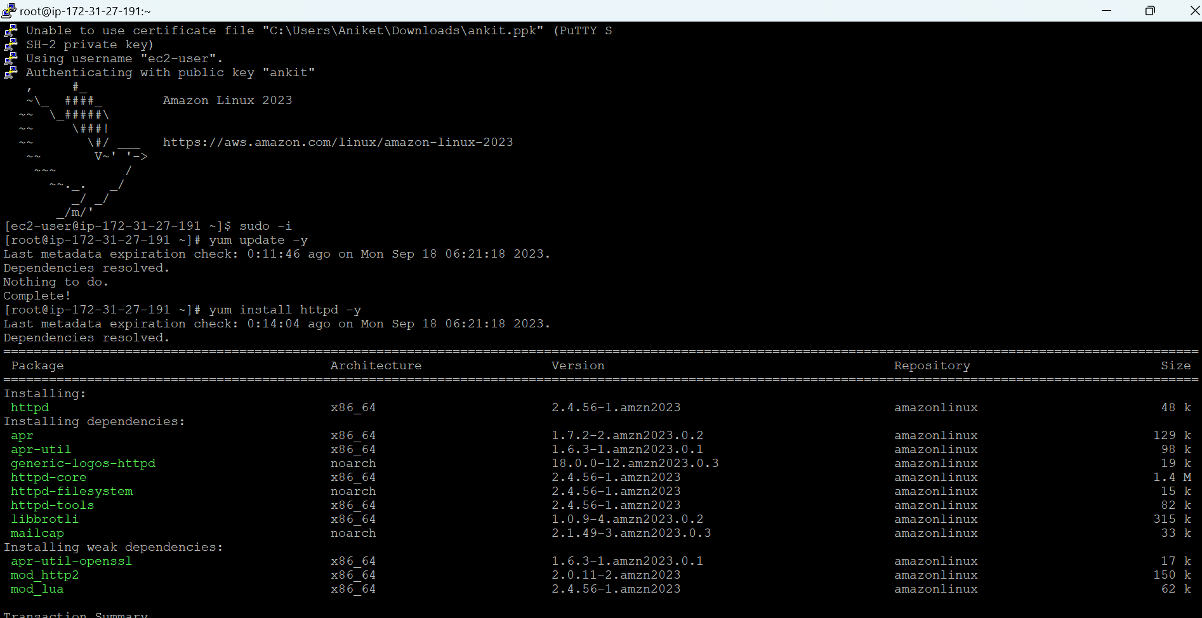

Step 14) systemctl start httpd// to start

Systemctl status httpd // to check status

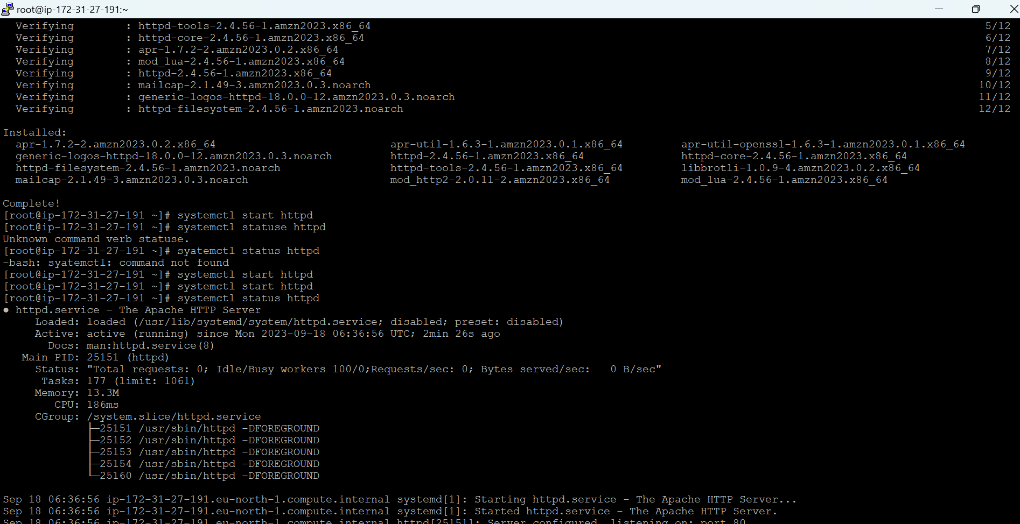

Step 15)

systemctl enable httpd

cd /var/www/html

nano index.html // to create html file

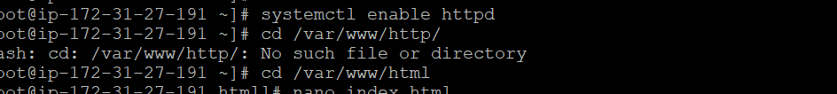

Step 16) hello in index.html file

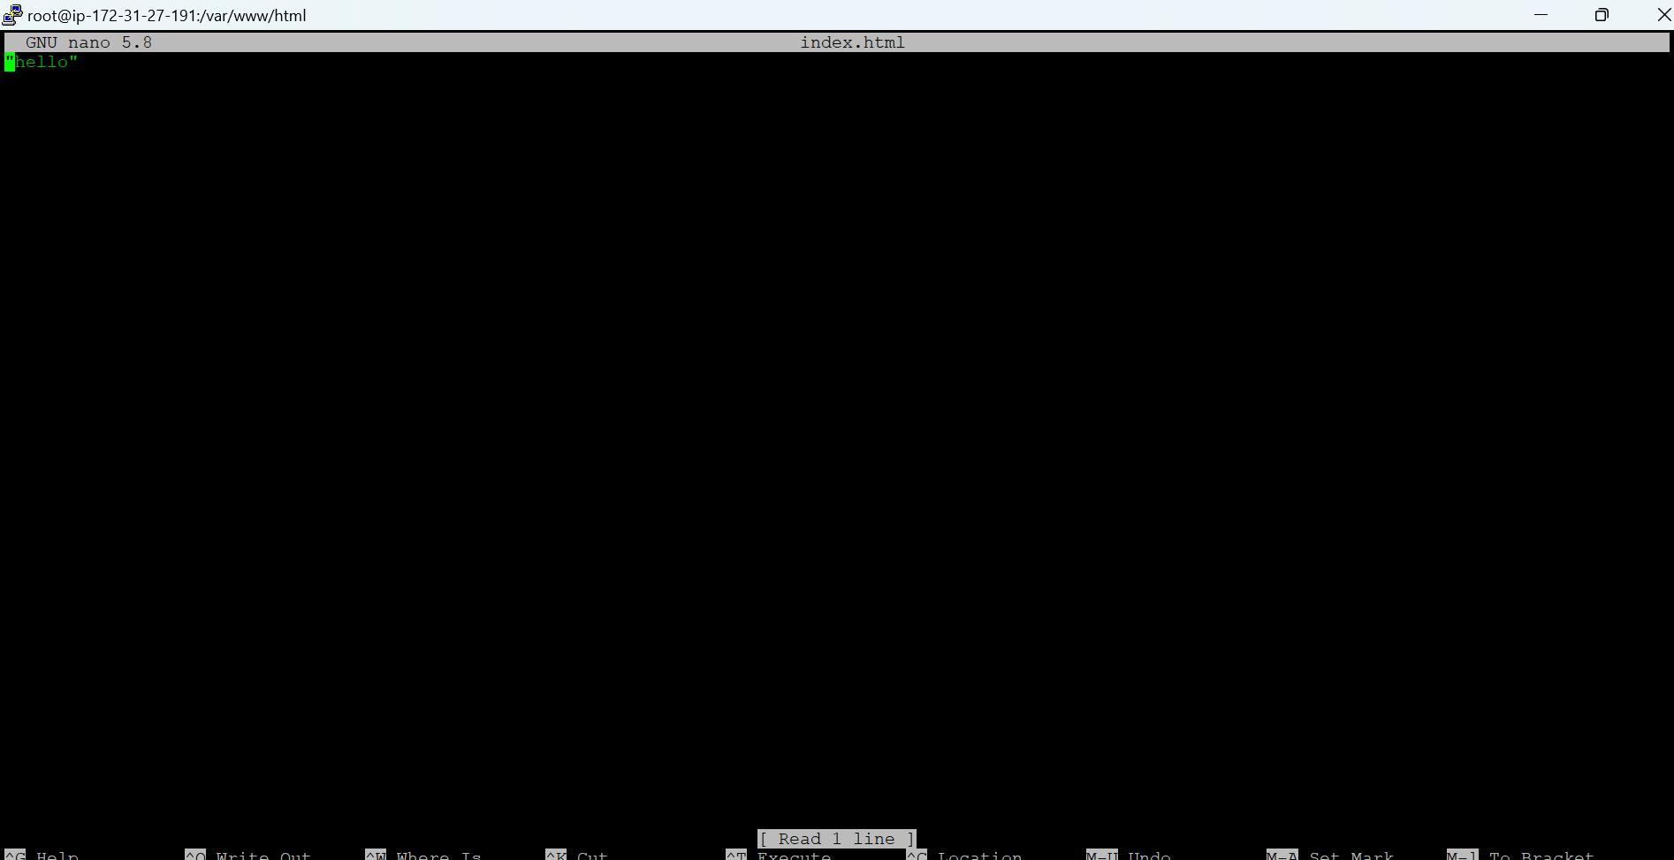

Step 17) copy public ip and paste it on browser you get , here I save hello in index file so out put get

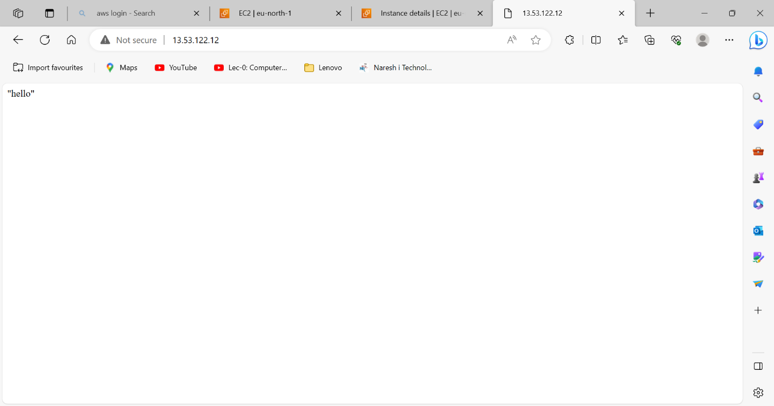

5)