CUSTOMER ENGAGEMENT &
PRODUCT UTILIZATION ANALYTICS
FOR RETENTION STRATEGY
Research Paper and Technical Project Report

Data Analytics | Customer Retention | Streamlit | Machine Learning

Prepared by
Aniket Chakraborty
2026

Abstract
This project examines customer retention through the joint lens of engagement, product utilization and financial relationship depth. Using 10,000 European bank customer records, the work validates the dataset, constructs interpretable engagement segments and retention KPIs, compares churn across geography, activity, product count, age and balance, and develops a fairness-aware random-forest decision-support model. The observed churn rate is 20.37%. Active customers retain at 85.73%, while inactive high-balance customers churn at 30.47%. Germany, one-product relationships and customer inactivity emerge as major priorities. A Streamlit application operationalizes the analysis with dynamic filters, premium-risk queues, downloadable results and a customer risk simulator. The project recommends targeted engagement recovery, responsible cross-sell toward appropriate two-product relationships and controlled intervention pilots.

1. Background and Context
Customer retention in banking depends on more than demographic characteristics or financial capacity. A customer can maintain a high balance or salary while showing weak engagement, limited product adoption and low relationship depth. Such customers may look valuable on a static financial report but remain vulnerable to churn. Understanding how customers use banking products and services enables more precise cross-sell, loyalty and engagement-driven retention strategies.
This project evaluates historical churn as a behavioral and relationship-strength problem. It emphasizes actionable segments rather than a single opaque prediction score.

2. Problem Statement
The bank has customer engagement, balance, credit and product-usage data but lacks a consolidated analytical view showing which behaviors drive retention, whether product depth supports loyalty and which high-value relationships are quietly disengaging. Generic retention campaigns can therefore be misaligned with actual customer behavior.
- Quantify the relationship between activity, product utilization and churn.
- Identify high-balance customers whose inactivity signals relationship risk.
- Measure whether credit-card ownership creates meaningful retention stickiness.
- Build understandable relationship-strength and engagement profiles.
- Deliver a live dashboard and a governed churn-risk decision-support model.

3. Project Objectives
- Evaluate the relationship between customer engagement and historical churn.
- Measure retention impact across product count and product-mix indicators.
- Identify disengaged yet financially valuable customers.
- Create practical KPIs and customer profiles for retention strategy.
- Develop a Streamlit dashboard with filters, live analytics and downloads.
- Train and evaluate an interpretable, fairness-aware churn risk model.

4. Dataset Description and Validation
The supplied dataset contains 10,000 customer records and 14 variables. Validation found 0 missing values, 0 duplicate rows and 0 duplicate customer identifiers.
Column | Description
Year | Observation year
CustomerId | Unique customer identifier
Surname | Customer surname
CreditScore | Creditworthiness score
Geography | France, Spain or Germany
Gender | Descriptive fairness-monitoring field
Age | Customer age
Tenure | Years with the bank
Balance | Account balance
NumOfProducts | Number of banking products
HasCrCard | Credit-card indicator
IsActiveMember | Customer activity indicator
EstimatedSalary | Estimated salary
Exited | Historical churn target

5. Analytical Methodology

Data ingestion and validation
Load the CSV, validate required columns, check missing values, duplicates, ranges and target consistency.

Engagement classification
Create Active Engaged, Active Low-Product, Inactive High-Balance and Inactive Disengaged profiles.

Product-utilization analysis
Compare customer volume, churn, retention and activity across product counts and credit-card ownership.

Financial commitment analysis
Use balance quartiles to identify premium customers and quantify inactivity and churn inside the group.

Relationship-strength assessment
Create a transparent 0-100 index combining activity, product configuration, tenure, card ownership and balance rank.

Predictive decision support
Train a class-balanced random forest, evaluate on a stratified holdout, then refit for customer risk ranking.

Dashboard delivery
Expose all major metrics through dynamic filters, interactive charts, searchable records and CSV downloads.

6. Key Performance Indicators
KPI | Result | Definition
Overall churn rate | 20.37% | Exited / all customers
Overall retention rate | 79.63% | Retained / all customers
Active member rate | 51.51% | Active / all customers
Engagement retention ratio | 85.73% | Retention among active customers
Average products | 1.53 | Mean products per customer
Product depth index | 38.26% | Mean product count / observed maximum
High-balance threshold | €127,644 | 75th balance percentile
High-balance disengagement | 49.88% | Inactive share in top balance quartile
Inactive premium churn | 30.47% | Churn among inactive top-quartile customers
Credit-card stickiness | 79.82% | Retention among cardholders
Relationship strength | 57.5/100 | Average composite score

7. Exploratory Analysis and Findings

7.1 Geography
Germany records the highest churn rate at 32.44%, compared with 16.67% in Spain and 16.15% in France. Germany should be the first market for a localized diagnostic and retention pilot.
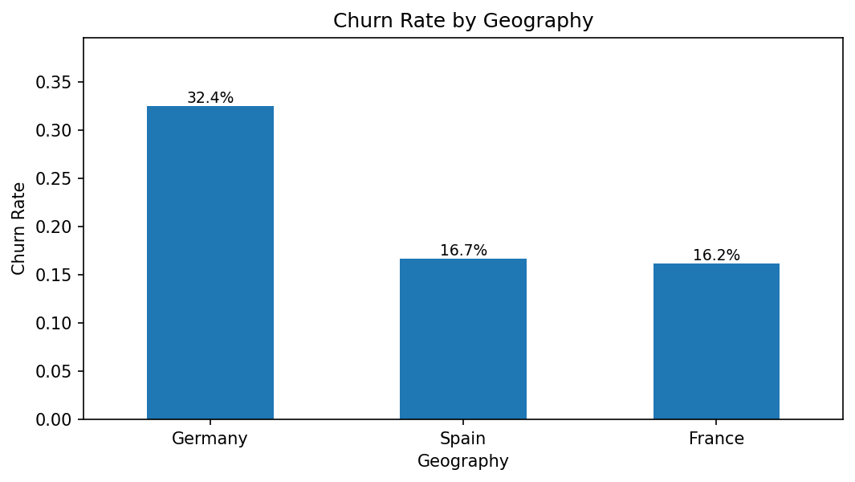

7.2 Engagement and Activity
Inactive customers churn at 26.85%, nearly twice the 14.27% observed among active customers. This establishes activity as one of the strongest actionable retention indicators.
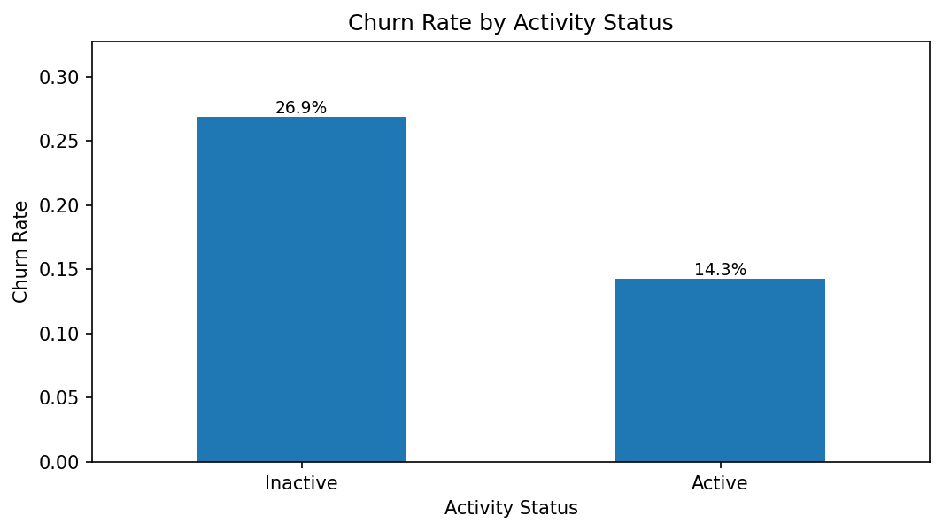

7.3 Product Utilization
One-product customers constitute 5,084 records and churn at 27.71%. Two-product customers churn at only 7.58%, the strongest observed retention outcome. Three-product and four-product customers churn at 82.71% and 100.00%, respectively, but these groups contain only 266 and 60 customers. The extreme rates require investigation rather than automatic interpretation as causation.
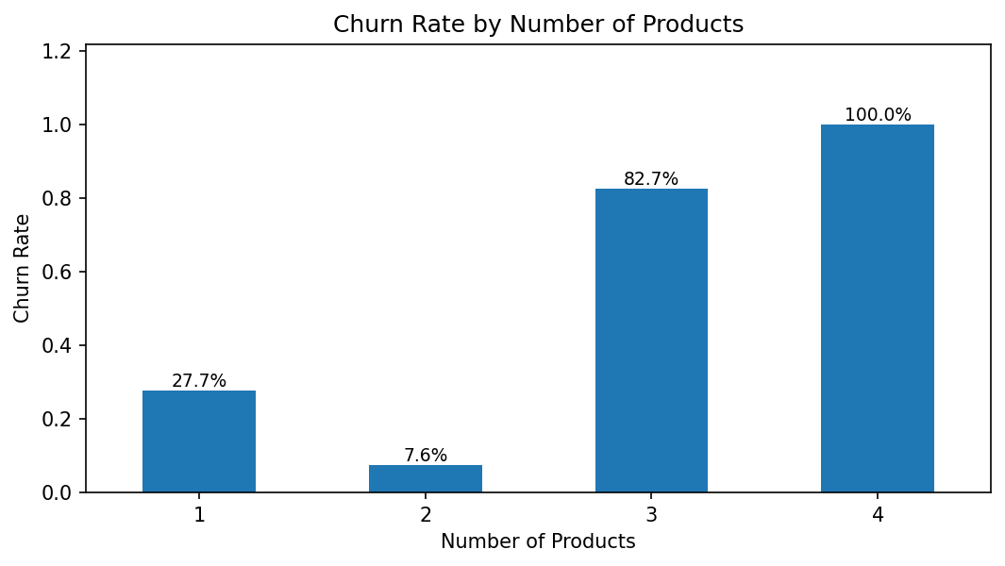

7.4 Age and Customer Life Stage
Churn increases materially through middle-age and older groups in this dataset. Age is useful for descriptive service-design analysis, but interventions should be based on customer needs and behavior rather than age alone.
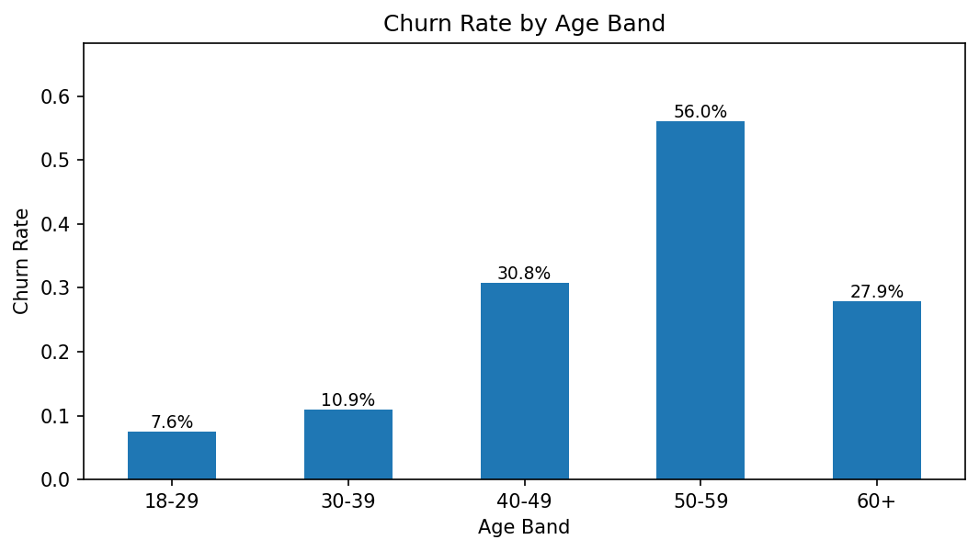

7.5 Credit Card Stickiness
Credit-card holders churn at 20.18%, while customers without a card churn at 20.81%. The gap is small, so card ownership alone should not be treated as a strong retention mechanism. Card usage quality, transaction activity and benefits would be more informative if available.

7.6 Premium Customer Risk
The top balance quartile begins at €127,644 and contains 2,500 customers. 49.88% are inactive. Within the inactive premium group, historical churn reaches 30.47%. This group combines financial value with behavioral disengagement and should be the highest-priority outreach queue.

8. Relationship Strength and Engagement Profiles
The Relationship Strength Index is a transparent, descriptive score rather than a causal model. It allocates 35 points to active membership, up to 30 points to product configuration, 15 points to tenure, 5 points to credit-card ownership and 15 points to balance rank. A two-product relationship receives the strongest product component because it shows the best historical retention in this dataset.
Segment | Customers | Churn | Avg Balance | Products | Strength
Inactive High-Balance | 1,247 | 30.47% | €148,858 | 1.38 | 42.6
Inactive Disengaged | 3,602 | 25.60% | €52,304 | 1.57 | 38.3
Active Low-Product | 2,563 | 18.92% | €98,902 | 1.00 | 68.2
Active Engaged | 2,588 | 9.66% | €53,071 | 2.07 | 80.9

9. Churn Risk Model
A class-balanced random forest was selected because it captures non-linear behavior such as the unusual product-count effect while remaining explainable through feature importance. The dataset was split using a stratified 80/20 holdout with random state 42. Gender was excluded from operational prediction and retained only for descriptive fairness monitoring.
Metric | Result | Meaning
ROC AUC | 0.855 | Ranking ability across thresholds
Accuracy | 84.35% | Overall correct classifications
Precision | 60.83% | Share of predicted churners who churned
Recall | 64.86% | Share of churners identified
F1 Score | 0.628 | Precision-recall balance

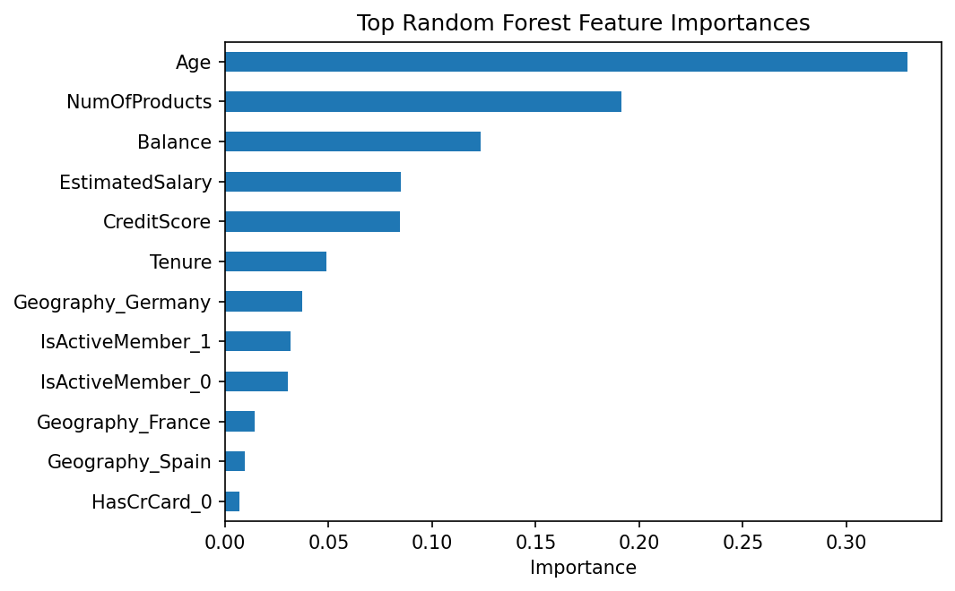
The model should rank customers for human review and controlled outreach. It should not be used to deny service, alter pricing automatically or make decisions based on protected characteristics.

10. Streamlit Web Application
- Dynamic filters for geography, gender, age, tenure, product count and balance.
- Executive KPIs for churn, retention, engagement, product depth and relationship strength.
- Engagement segment analysis and activity-product heatmaps.
- Product-utilization and credit-card stickiness comparisons.
- Premium-customer risk map and downloadable retention priority queue.
- Model evaluation, feature importance and single-customer risk simulator.
- Searchable customer explorer with filtered CSV download.

11. Strategic Recommendations

Recover inactive premium relationships
Prioritize inactive top-quartile balance customers for personalized service calls, digital reactivation and relationship-manager review.

Improve one-product relationship depth
Offer a needs-based second product where suitable. Avoid indiscriminate cross-selling and measure incremental retention.

Investigate three- and four-product churn
Review fees, product overlap, service complexity, complaints and onboarding journeys. The small segment sizes require qualitative validation.

Localize the Germany retention plan
Examine product, channel and service differences in Germany and test a market-specific intervention.

Treat cards as a supporting signal
Credit-card ownership alone shows weak stickiness. Add transaction frequency, spend and benefit-use data before designing card-led retention.

Implement next-best-action pilots
Use predicted risk, engagement segment and customer value to prioritize human-reviewed outreach. Compare results through controlled experiments.

Monitor fairness and drift
Track outcome quality by gender and age bands, verify that interventions do not create unequal harm and retrain only after data-quality review.

12. Limitations
- The dataset is cross-sectional and does not contain transaction timelines, campaign exposure, complaints or channel activity.
- Historical associations do not prove that a variable causes churn.
- The three- and four-product segments are small and produce unstable extreme rates.
- Estimated salary and static activity indicators may not represent current customer circumstances.
- Model performance must be revalidated on future and market-specific data before production use.

13. Conclusion
The analysis reframes retention from a demographic or balance-only problem into a behavioral relationship problem. Customer activity, appropriate product depth and premium-customer engagement provide clearer strategic direction than isolated demographic or card indicators. The completed dashboard converts these findings into an operational workflow: diagnose segments, identify premium risk, rank customers for review, export priority queues and measure intervention outcomes. The strongest immediate actions are to reactivate inactive high-balance customers, strengthen suitable one-product relationships and investigate product complexity among the small three- and four-product groups.

References
1. European Bank customer dataset supplied for this project (10,000 records, 2025 observation field).
2. Neslin, S. A., Gupta, S., Kamakura, W., Lu, J., & Mason, C. H. (2006). Defection Detection: Measuring and Understanding the Predictive Accuracy of Customer Churn Models. Journal of Marketing Research, 43(2), 204-211.
3. Verbeke, W., Martens, D., Mues, C., & Baesens, B. (2012). New Insights into Churn Prediction in the Telecommunication Sector: A Profit Driven Data Mining Approach. European Journal of Operational Research, 218(1), 211-229.
4. Scikit-learn User Guide: model selection, preprocessing, ensemble methods and classification metrics.
5. Streamlit Documentation: application architecture, caching, interactive widgets and deployment.

