Cars Launch Event

Problem Statement:

The landing page for the Cars Launch Event exhibits several strengths in design, content, and functionality, including a modern design theme, engaging content, and a compelling call-to-action.

Objective:

To enhance the effectiveness of the landing page for the Cars Launch Event by addressing key areas of improvement, including responsiveness, accessibility, SEO optimization, and multimedia enhancement.

Technology Used: HTML, CSS

Source Code:

Index.html:

<!DOCTYPE html>

<html lang="en">

<head>

    <meta charset="UTF-8">

    <meta http-equiv="X-UA-Compatible" content="IE=edge">

    <meta name="viewport" content="width=device-width, initial-scale=1.0">

    <title>Cars</title>

    <link rel="stylesheet" href="https://cdnjs.cloudflare.com/ajax/libs/font-awesome/6.4.0/css/all.min.css">

    <link rel="stylesheet" href="style.css">

</head>

<body>

    <header>

        <nav>

            <img src="img/car-logo.png" class="logo" alt="">

            <div class="menu">

                <a href="#">Home</a>

                <a href="#">About</a>

                <a href="#">Features</a>

                <a href="#">Variations</a>

                <a href="#">Specials</a>

                <a href="#">Contact</a>

            </div>

            <div class="social">

                <a href="#"><i class="fa-brands fa-facebook-f"></i></a>

                <a href="#"><i class="fa-brands fa-twitter"></i></a>

                <a href="#"><i class="fa-brands fa-instagram"></i></a>

            </div>

        </nav>

    </header>

    <div class="hero">

        <div class="text">

            <h4>Powerful, Fun and</h4>

            <h1>Fierce to <br> <span>Drive</span></h1>

            <p>Real Poise, Real Power, Real Perfomance.</p>

            <a href="#" class="btn">book a test ride</a>

        </div>

    </div>

    <script>

        let heroBg = document.querySelector('.hero');

        setInterval(() => {

            heroBg.style.backgroundImage = "url(img/bg-light.jpg)"

            setTimeout(() => {

                heroBg.style.backgroundImage = "url(img/bg.jpg)"

            }, 1000);

        }, 2200);

    </script>

</body>

</html>

Style.css:

@import url('https://fonts.googleapis.com/css2?family=Poppins:wght@300;400;500;600;700;800;900&display=swap');

\*{

    padding: 0;

    margin: 0;

    box-sizing: border-box;

    text-decoration: none;

    font-family: 'Poppins', sans-serif;

}

header{

    position: fixed;

    top: 0;

    left: 0;

    right: 0;

}

header nav{

    width: 90%;

    margin: auto;

    display: flex;

    justify-content: space-between;

    align-items: center;

    height: 80px;

}

header nav .logo{

    width: 150px;

}

header nav .menu{

    display: flex;

    align-items: center;

}

nav .menu a{

    color: #fff;

    margin-left: 30px;

    position: relative;

}

nav .menu a::after{

    content: '';

    position: absolute;

    bottom: -5px;

    left: 0;

    width: 0%;

    height: 2px;

    background-color: #dd0707;

    transition: 0.4s;

}

nav .menu a:hover::after{

    width: 100%;

}

nav .social a i{

    color: #fff;

    font-size: 22px;

    margin-left: 10px;

    transition: 0.3s;

}

nav .social a i:hover{

    transform: scale(1.3);

    color: #dd0707;

}

.hero{

    width: 100%;

    height: 100vh;

    background: url(img/bg.jpg);

    background-position: center;

    background-size: cover;

    display: flex;

    justify-content: center;

    align-items: center;

}

.hero .text{

    width: 90%;

    margin: auto;

}

.hero .text h4{

    font-size: 40px;

    color: #fff;

    font-weight: 500;

    margin-bottom: 10px;

}

.hero .text h1{

    color: #fff;

    font-size: 65px;

    text-transform: uppercase;

    line-height: 1;

    margin-bottom: 30px;

}

.hero .text h1 span{

    color: #dd0707;

    font-size: 80px;

    font-weight: bold;

}

.hero .text p{

    color: #fff;

    margin-bottom: 30px;

}

.hero .text .btn{

    padding: 10px 30px;

    background-color: #dd0707;

    text-transform: uppercase;

    color: #fff;

    font-weight: bold;

    border-radius: 30px;

    border: 2px solid #dd0707;

    transition: 0.3s;

}

.hero .text .btn:hover{

    background-color: transparent;

}

Actual Output:

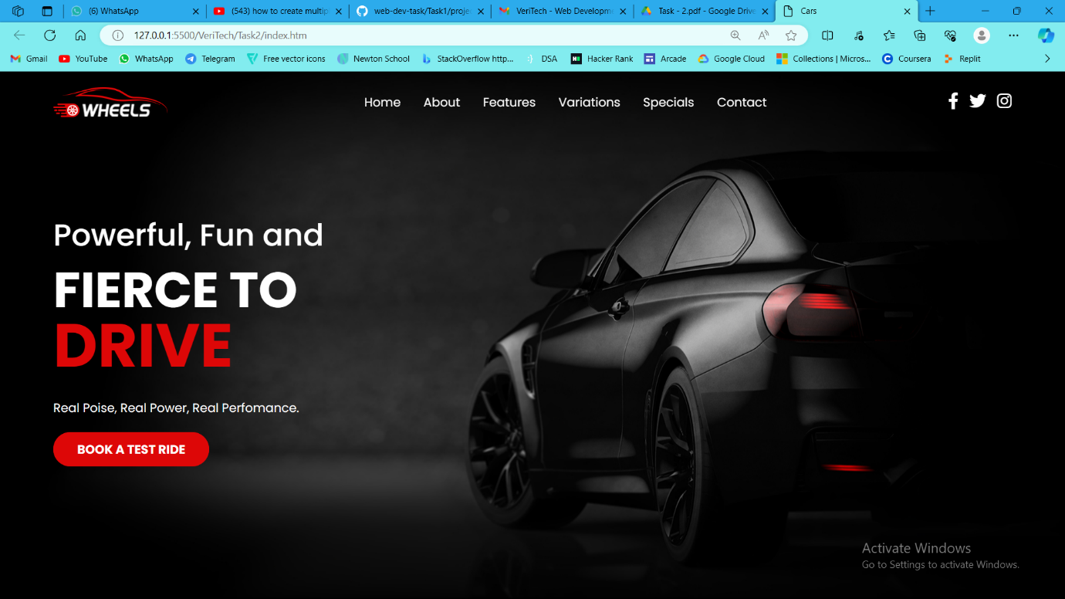Conclusion:

The landing page for the Cars Launch Event demonstrates effective use of design elements, engaging content, and a compelling call-to-action. By implementing responsive design principles and optimizing for accessibility and SEO, the page can further enhance its effectiveness in attracting and engaging users.