**TO RECOGNIZE THE FACIAL EMOTION OF CUSTOMERS FOR FOOD COURT**

###### Project submitted to

***Shri Ramdeobaba College of Engineering & Management, Nagpur in partial fulfillment of requirement for the award of***

###### degree of

**Bachelor of Engineering**

In

**Computer Science and Engineering**

*By*

**Pravesh Dholwani(108)**

**Atharva Pandhare(100)**

**Rishabh Mittal(101)**

**Aniket Tawani(17)**

*Guide*

**Prof. Abhijeet Raipurkar**



**Computer Science and Engineering**

**Shri Ramdeobaba College of Engineering & Management, Nagpur 440 013**

(An Autonomous Institute affiliated to Rashtrasant Tukdoji Maharaj Nagpur University Nagpur)

## May 2022

**TO RECOGNIZE THE FACIAL EMOTION OF CUSTOMERS FOR FOOD COURT**

###### Project submitted to

***Shri Ramdeobaba College of Engineering & Management, Nagpur in partial fulfillment of requirement for the award of***

###### degree of

**Bachelor of Engineering**

In

**Computer Science and Engineering**

*By*

**Pravesh Dholwani(108)**

**Atharva Pandhare(100)**

**Rishabh Mittal(101)**

**Aniket Tawani(17)**

*Guide*

**Prof. Abhijeet Raipurkar**



**Computer Science and Engineering**

**Shri Ramdeobaba College of Engineering & Management, Nagpur 440 013**

(An Autonomous Institute affiliated to Rashtrasant Tukdoji Maharaj Nagpur University Nagpur)

## May 2022

**SHRI RAMDEOBABA COLLEGE OF ENGINEERING & MANAGEMENT, NAGPUR**

(An Autonomous Institute Affiliated to Rashtrasant Tukdoji Maharaj Nagpur University Nagpur)

Department of Computer Science and Engineering

## CERTIFICATE

This is to certify that the thesis on “To recognize the facial emotion of customers for food court” is a bonafide work of Pravesh Dholwani, Atharva Pandhare ,Rishabh Mittal, Aniket Tawani submitted Rashtrasant Tukadoji Maharaj Nagpur University, Nagpur in partial fulfillment of the award of a Bachelor of Engineering in Computer Science and Engineering has been carried out at the Department of Computer Science and Engineering ,Shri Ramdeobaba College of Engineering and Management,Nagpur during the academic year 2021-2022

Date: 9th May

Place: Nagpur

Prof. Abhijeet Raipurkar Dr. Avinash J. Agrawal

Project Guide H.O.D.

Department of Computer Department of Computer

Science and Engineering Science and Engineering

Dr.R. S. Pande

Principal

**DECLARATION**

I, hereby declare that the thesis titled “To recognize facial emotion of customers for food court” submitted herein, has been carried out in the Department of Computer Science and Engineering of Shri Ramdeobaba College of Engineering & Management, Nagpur. The work is original and has not been submitted earlier as a whole or part for the award of any degree / diploma at this or any other institution / University

Date: 9th May 2022

Place: Nagpur

Pravesh Dholwani Atharva Pandhare

(108) (100)

Rishabh Mittal Aniket Tawani

(101) (17)

**Approval Sheet**

#### This report entitled “To recognize facial emotion for customers for food court” by Pravesh Dholwani, Atharva Pandhare , Rishabh Mittal, Aniket Tawani is approved for the degree of Bachelor of Engineering.

Supervisor External Examination

Prof. Abhijeet Raipurkar

HOD

Dr. Avinash Agrawal

Date: 9th May 2022

Place: Nagpur

**Acknowledgment**

We would like to express our heartfelt appreciation to **Prof. Abhijeet Raipurkar**, Asst. Professor, Dept. of Computer Science and Engineering, for her gracious advice, assistance, helpful suggestions, ongoing support, and supervision during the duration of our effort. We are grateful to **Dr. Avinash J. Agrawal**, Head of Department, Computer Science and Engineering, for his inspiring leadership. The success of any job is dependent on the efforts of many people.

Our gratitude and appreciation also extend to our colleagues in the development of this project, as well as to all those who have generously assisted us with their skills.

We would want to use this time to convey our heartfelt appreciation to everyone who helped us achieve this project.

We are grateful to **Dr. R. S. Pande, Principal**, for providing us with working facilities, without which this study would not have been feasible.

**Abstract**

Automatic emotion recognition based on facial expression is an intriguing field that has been presented and implemented in a variety of fields including safety, health, and human-machine interfaces. Deep learning is currently widely used in a variety of fields, including computer vision. Indeed, a convolutional neural networks (CNN) model may be learned to assess images and recognize facial expressions. Every year, six out of ten restaurants close, with only 40% surviving for a long time. Many of them believed that the main reason for the restaurant's closure was its location, but the truth is that 50% of restaurants closed due to a lack of technology. For restaurant operators, the most crucial thing is to analyze their services and food. However, many of them overlook this characteristic. In this project, we developed a Web Application for the food stalls/ food court to fetch data i.e., detecting faces from the installed cameras at their place and detect customer satisfaction via their facial expressions. Our system consists of two phases: face detection using cvlib in Python and emotion recognition using CNN on FER 2013 database with five types of expressions. Results obtained would ultimately help these restaurant owners to improve their services.

**Keywords:** FER2013, cvlib, emotion, face detection, restaurants, technology, cnn, computer vision, facial expressions, deep learning, human computer interaction

**Table of Contents**

**CHAPTER 1** 1

**INTRODUCTION** 1

**1.1.INTRODUCTION** 1

**1.2. MOTIVATION** 2

**1.3.OBJECTIVE** 2

**1.4.BRIEF DESCRIPTION** 2

**1.4.1.THE MOBILENET MODEL** 2

**1.4.2.CHANGES PROPOSED IN ORIGINAL MOBILENET** 3

**CHAPTER 2** 4

**LITERATURE SURVEY** 4

**CHAPTER 3** 7

**TEHNOLOGY & METHODOLOGY** 7

**3.1. TECHNOLOGY** 7

**3.1.1. PYTHON** 7

**3.1.2. TENSOR FLOW** 7

**3.1.3. OPENCV** 8

**3.1.4. SCIKITLEARN** 8

**3.1.5. NUMPY** 8

**3.1.6. MATPLOTLIB** 9

**3.1.7. KERAS** 9

**3.1.8. CVLIB** 9

**3.1.9. FACE RECOGNITION** 10

**3.1.10. MONGODB** 10

**3.1.11. NVIDIA DGX SERVER** 11

**3.2 DATA GATHERING AND PREPROCESSING** 11

**3.3 METHDOLOGY** 12

**3.4 DATABASES** 13

**CHAPTER 4** 15

**RESULT** 15

**CHAPTER 5** 21

**CONCLUSION** 21

**CHAPTER 5** 22

**FUTURE SCOPE & APPLICATIONS** 22

**4.1 FUTURE SCOPE** 22

**4.2 OTHER APPLICATIONS** 22

**REFERENCES** 24

**List of figures**

|  |  |  |
| --- | --- | --- |
| **Figure No.** | **Name** | **Page No.** |
| 1 | Emotion Recognition Overview | 2 |
| 2 | MobileNet Model Architecture | 3 |
| 3 | Recognition Process | 5 |
| 4 | Process Methodoly | 6 |
| 5 | Structure of Train Labels | 12 |
| 6 | Depthwise Convolution | 13 |
| 7 | Point Convolution | 14 |
| 8 | Loss And accuracy | 17 |
| 9 | Output1 Login/Signup Page | 18 |
| 10 | Output 2 Analytics Page | 18 |
| 11 | Output 3 History Page | 19 |
| 12 | Output 4 Recent Customers page | 19 |
| 13 | Output 5 Actual Emotion Visualization | 20 |

**List of tables**

|  |  |  |
| --- | --- | --- |
| **Table No.** | **Name** | **Page No.** |
| 1 | Loss, Accuracy | 16 |

# **CHAPTER 1**

# **INTRODUCTION**

# **INTRODUCTION**

Facial Emotion Recognition (FER) is the technology that analyses facial expressions from both static images and videos in order to reveal information on one’s emotional state. The complexity of facial expressions, the potential use of the technology in any context, and the involvement of new technologies such as artificial intelligence raise significant privacy risks.

Facial Emotion Recognition is a technology used for analysing sentiments by different sources, such as pictures and videos. It belongs to the family of technologies often referred to as ‘affective computing’, a multidisciplinary field of research on computer’s capabilities to recognise and interpret human emotions and affective states and it often builds on Artificial Intelligence technologies. Facial expressions are forms of non-verbal communication, providing hints for human emotions. For decades, decoding such emotion expressions has been a research interest in the field of psychology[6] but also to the Human Computer Interaction field. Recently, the high diffusion of cameras and the technological advances in biometrics analysis, machine learning and pattern recognition have played a prominent role in the development of the FER technology.

FER analysis comprises three steps: a) face detection, b) facial expression detection, c) expression classification to an emotional state (Figure 1). Emotion detection is based on the analysis of facial landmark positions (e.g. end of nose, eyebrows). Furthermore, in videos, changes in those positions are also analysed, in order to identify contractions in a group of facial muscles (Ko 2018). Depending on the algorithm, facial expressions can be classified to basic emotions (e.g. anger, disgust, fear, joy, sadness, and surprise) or compound emotions (e.g. happily sad, happily surprised, happily disgusted, sadly fearful, sadly angry, sadly surprised) (Du et al. 2014). In other cases, facial expressions could be linked to physiological or mental state of mind (e.g. tiredness or boredom).

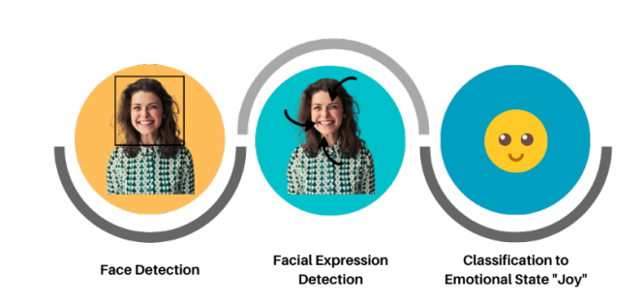

**Figure 1:Emotion Recognition Overview**

# **1.2. MOTIVATION**

Every year, six out of ten restaurants close, with only 40% surviving for a long time. For restaurant owners, the most important thing is to analyse their services and food. However, many of them overlook this feature.

Our motivation was to learn about deep learning and apply what we learned to assist restaurant and café owners in receiving customer feedback in the form of facial expressions and maximising their services.

# **OBJECTIVE**

* To create a system with the help of facial emotion detection of the costumers so that restaurants and café owner can improve their services.
* Detecting facial expressions and check whether the customer is happy or not with the food.

# **BRIEF DESCRIPTION**

# **1.4.1.THE MOBILENET MODEL**

MobileNet is a convolutional neural network designed for mobile and embedded vision. They are based on a streamlined architecture that builds lightweight deep neural networks with low latency for mobile and embedded devices using depthwise separable convolutions.

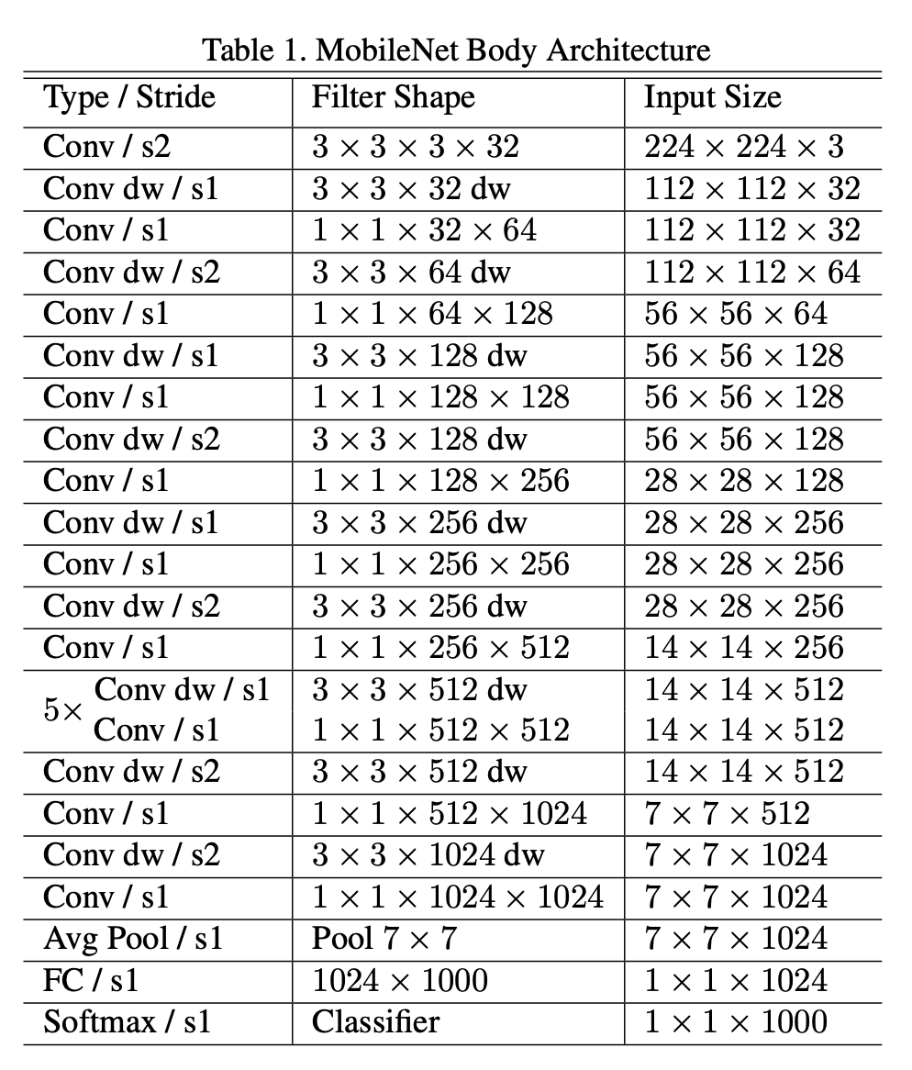

**Figure 2: MobileNet Model Architecture**

# **CHANGES PROPOSED IN ORIGINAL MOBILENET**

The MobileNet Model is customized according to our number of classes of emotions so we have added 4 layers on top of the model i.e 4 dense layers with 3 activation of RELU and 1 activation of SOFTMAX

# **CHAPTER 2**

# **LITERATURE SURVEY**

We studied multiple research papers to understand what is a neural network, how they work, and how to detect facial emotion using a neural network from an image. Some of the papers are mentioned below with brief descriptions of their studies.

**In PAPER** [1] ,Humans have always had an easy time detecting emotions through facial expression, but achieving the same feat with a computer algorithm is quite difficult. It is now possible to detect emotions from images thanks to recent advances in computer vision and machine learning. We propose a novel facial emotion recognition technique based on convolutional neural networks in this paper (FERC). The FERC is based on a two-part convolutional neural network (CNN): the first part removes the background from the image, while the second part focuses on the extraction of facial feature vectors.

The expressional vector (EV) is used in the FERC model to identify the five different types of regular facial expressions. The stored database of 10,000 images provided supervisory data (154 persons). Using an EV of length 24 values, it was possible to correctly highlight the emotion with 96 percent accuracy. The two-level CNN operates in series, with the final perceptron layer adjusting the weights and exponent values with each iteration. With single-level CNN, FERC differs from commonly used strategies, improving accuracy. Furthermore, prior to the generation of EV, a novel background removal procedure is used to avoid dealing with multiple issues that may arise (for example distance from the camera). The extended Cohn–Kanade expression, Caltech faces, CMU, and NIST datasets were used to test FERC with over 750K images. We expect the FERC emotion detection to be useful in a variety of applications, including student predictive learning, lie detectors, and so on.

**In PAPER** [2] ,This paper provides an overview of the current stages, techniques, and datasets for Facial Emotion Recognition (FER). For decades, FER has been recognised, and it is an important topic in the fields of computer vision and machine learning. Automatic FER can be used in a variety of applications, including healthcare, education, criminal investigation, and Human Robot Interface (HRI). The goal of this paper is to understand the fundamental principles of FER and to compare current research. Nowadays, facial emotion recognition is an important issue in many applications. The study of facial emotion recognition has grown in popularity in recent years. The goal of facial emotion recognition is to use specific facial images to help identify the state of human emotion (e.g., neutral, happy, sad, surprise, fear, anger, disgust, contempt). The goal of facial emotion recognition is to recognise facial emotion states accurately and automatically. As a result, determining the similarity of the same emotion state between different people can be difficult because they may express the same emotion state in different ways. For instance, the expression may change depending on the individual's mood, skin colour, age, and surroundings. As shown in Figure 1, FER is divided into three major stages: Face detection, feature extraction, and emotion classification are the three steps. An image of a face is detected at the first stage, which is a preprocessing stage, and facial components of the face are detected from the region. Eyes, brows, nose, and mouth are examples of facial components. The second stage involves extracting informative features from various parts of the face. A classifier must be trained before being used to generate labels for the Emotions using the training data in the final stage.

**In PAPER [3]** Facial expression recognition is a subset of facial recognition that is gaining in importance as the demand for it grows. Though there are methods for identifying expressions using machine learning and Artificial Intelligence techniques, this work attempts to recognise expressions and classify them using deep learning and image classification methods. In this paper, various datasets are investigated and explored for training expression recognition models. With the Kaggle (Facial Expression Recognition Challenge) and Karolinska Directed Emotional Faces datasets, Inception Net is used for expression recognition. The final accuracy of this Inception Net v3 Model expression recognition model is 35%.

Facial Recognition is a branch of computer science that deals with methods and techniques for detecting emotions in facial expressions. Emotion recognition has become easier thanks to various technological advancements in the fields of Machine Learning and Artificial Intelligence. A Need for automatic emotion recognition from facial expression increases tremendously. Research work in this area mainly concentrates on identifying human emotions from videos or from acoustic information. Most of the research work recognizes and matches faces but they have not used convolutional neural networks to infuse emotions from images.

Emotion Recognition is the study of identifying emotions, as well as the techniques and methods used to do so. Emotions can be detected through facial expressions, speech signals, and other indicators. To infer emotions, massive methods such as machine learning, neural networks, artificial intelligence, and emotional intelligence have been adapted. Emotion Recognition is gaining traction in research, which is essential for solving many problems. The primary requirement of Emotion Recognition from Facial Expressions is a difficult task in emotional Intelligence systems that use images as input.

**In PAPER [4]** Facial emotion recognition (FER) is important for human-computer interaction in areas like clinical practice and behavioral description. Due to the variability of human faces and differences in photos such as varied facial poses and illumination, accurate and robust FER by computer models remains a challenge.

Deep learning models, particularly Convolutional Neural Networks (CNNs), have showed tremendous promise among all FER techniques because to their powerful automatic feature extraction and computational efficiency. On the FER2013 dataset, we reach the maximum single network classification accuracy in this paper. We use the VGGNet architecture, fine-tune its hyperparameters, and try out several optimization techniques. Without using any additional training data, our model achieves state-of-the-art single-network accuracy of 73.28 percent on FER2013.

Various ways have been offered to boost performance even more. To eliminate gradient dispersion difficulties and speed up training, the Sigmoid activation function has been replaced by Rectified Linear Unit (ReLU) activation. To down sample the inputs and aid in generalisation, various pooling approaches such as average pooling and max pooling are used. To avoid overfitting, dropout, regularisation, and data augmentation are used. Batch normalisation was created to keep gradients from vanishing and exploding.

# **CHAPTER 3**

# **TEHNOLOGY & METHODOLOGY**

# **3.1. TECHNOLOGY**

# **3.1.1. PYTHON**



The entire project was executed using python. The project was executed on JupiterNotebook on the DGX Server and on Google Colab as well. As it was a Deep learning project various python libraries were used such as TensorFlow, ScikitLearn, Matplotlib, OpenCV, Rasterio, GDAL, Keras, etc.

# **3.1.2. TENSOR FLOW**



TensorFlow is a Python library that was created an released by Google for mathematical computation. It has a comprehensive, flexible ecosystem of tools, libraries, and community resources that lets researchers push the state-of-the-art in ML and developers easily build and deploy ML-powered applications.

# **3.1.3. OPENCV**



OpenCV is an open-source python library that is used in computer vision, machine learning, and image processing. It is used for processing images and videos to identify objects, faces, human handwriting, and much more.

# **3.1.4. SCIKITLEARN**



It is a python library that can be freely used and provides features such as classification, regression, and clustering algorithms. It was designed so that it can interoperate with NumPy and SciPy Python libraries.

# **3.1.5. NUMPY**



NumPy stands for Numerical Python and is an open-source Python library that is used to work with linear algebra, Fourier transformation, and matrices. It makes the work of manipulating images much easier as images are represented as matrices of a number representing pixels.

# **3.1.6. MATPLOTLIB**



It is a python library that is used for visualization. It helps in creating static, animated, and interactive visualization in python. It is used for plotting accuracy and training of model against error rate, training, and testing accuracy, etc. in machine learning.

# **3.1.7. KERAS**



It is a powerful free open-source python library for developing and evaluating deep learning models. It wraps the efficient numerical computation libraries Theano and Tensorflow and allows us to create and train neural network models with a shortcode.

# **3.1.8. CVLIB**

**cvlib** is a simple, high level, easy to use, open source Computer Vision library for Python.It was developed with a focus on enabling easy and fast experimentation. Being able to go from an idea to prototype with least amount of delay is key to doing good research.Guiding principles of cvlib are heavily inspired from [Keras](https://keras.io/) (deep learning library).

* simplicity
* user friendliness
* modularity and
* extensibility

# **3.1.9. FACE RECOGNITION**

Recognize and manipulate faces from Python or from the command line with the world’s simplest face recognition library.

Built using dlib’s state-of-the-art face recognition built with deep learning. The model has an accuracy of 99.38% on the Labeled Faces in the Wild benchmark.

This also provides a simple face_recognition command line tool that lets you do face recognition on a folder of images from the command line!

# **3.1.10. MONGODB**



MongoDB is an open-source document-oriented database that is designed to store a large scale of data and also allows you to work with that data very efficiently. It is categorized under the NoSQL (Not only SQL) database because the storage and retrieval of data in the MongoDB are not in the form of tables.

The MongoDB database is developed and managed by MongoDB.Inc under SSPL(Server Side Public License) and initially released in February 2009. It also provides official driver support for all the popular languages like C, C++, C#, and .Net, Go, Java, Node.js, Perl, PHP, Python, Motor, Ruby, Scala, Swift, Mongoid. So, that you can create an application using any of these languages. Nowadays there are so many companies that used MongoDB like Facebook, Nokia, eBay, Adobe, Google, etc. to store their large amount of data.

# **3.1.11. NVIDIA DGX SERVER**



The DGX-A100 server has 4 60GB GPU for deep learning and neural network model. It consisted of 512 GB of RAM (DDR4) and 8TB of storage. We have used the DGX server for the training purpose of our model.

# **3.2 DATA GATHERING AND PREPROCESSING**

The dataset of facial emotion recognition is available on Kaggle.com and named as **FER 2013**.

The data consists of 48x48 pixel grayscale images of faces. The faces have been automatically registered so that the face is more or less centred and occupies about the same amount of space in each image.

The task is to categorize each face based on the emotion shown in the facial expression into one of seven categories (0=Angry, 1=Disgust, 2=Fear, 3=Happy, 4=Sad, 5=Surprise, 6=Neutral). The training set consists of 28,709 examples and the public test set consists of 3,589 examples.

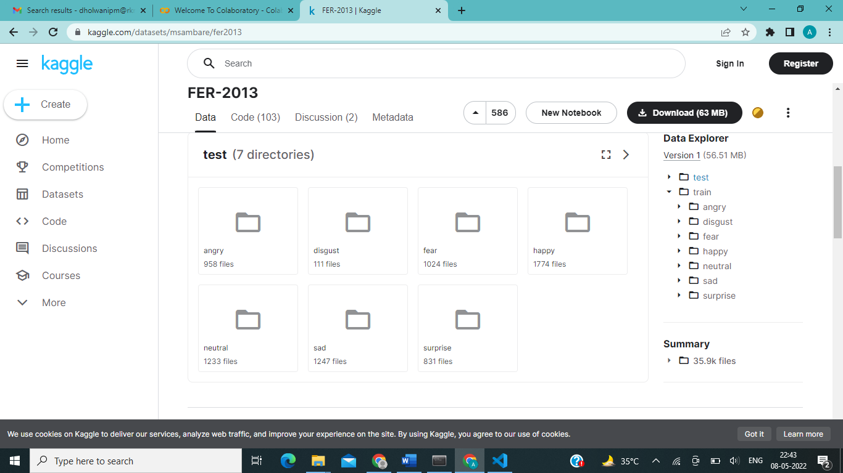

**Figure 3: Structure of train labels**

# **3.3 METHDOLOGY**

The **MobileNet model** is designed to be used in mobile applications, and it is TensorFlow’s first mobile computer vision model.

MobileNet uses **depthwise separable** **convolutions.**It significantly **reduces the number of parameters** when compared to the network with regular convolutions with the same depth in the nets. This results in lightweight deep neural networks. MobileNet is a class of CNN that was open-sourced by Google, and therefore, this gives us an excellent starting point for training our classifiers that are insanely small and insanely fast.

**Depthwise convolution** is the **channel-wise DK×DK spatial convolution**. Suppose in the figure above, and we have five channels; then, we will have 5 DK×DK spatial convolutions.

**Pointwise convolution** is the **1×1 convolution** to change the dimension.

**Depthwise convolution.**

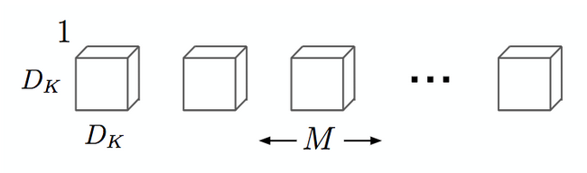

**Figure 4:Depthwise Convolution**

It is a map of a single convolution on each input channel separately. Therefore its number of output channels is the same as the number of the input channels. Its computational cost is

**Df² * M * Dk²**.

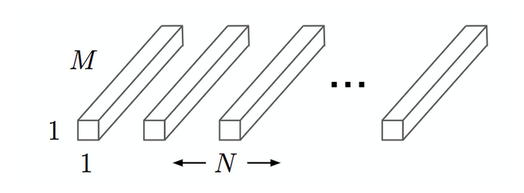

**Figure 5: Pointwise Convolution**

Convolution with a kernel size of 1x1 that simply combines the features created by the depthwise convolution. Its computational cost is **M * N * Df²**.

# **3.4 DATABASES**

In this system, we have used MongoDB as data storing service. We have created a few collections in our database and they are as follows

**Cameras**

* + objectid
  + address
  + name

**customer_feeds**

* + objectid
  + customer_name
  + date
  + feed

**customer**

* + id
  + customer_name
  + cutomer_email

**history**

* + object_id
  + cam_address
  + feedback from
  + to

**records**

* + time
  + cam_address
  + emotion

**settings**

* + camera_name
  + camera_address
  + is_started

**users**

* + id
  + name
  + email
  + password

# **CHAPTER 4**

# **RESULT**

We have trained our model through transfer learning approach.

The dataset consist of around 28000 images for training of 7 classes of emotions and around 7000 images for testing.

So we have calculated our loss and accuracy of the model. All the metrics are shown below

**Table**

**Table 1 Output data**

|  |  |  |
| --- | --- | --- |
|  | **Loss** | **Accuracy** |
| **Training** | 0.650 | 0.77 |
| **Validation** | 0.965 | 0.68 |

The graph of the above statistics is as follows:

**Graph of loss in training and validation data:**

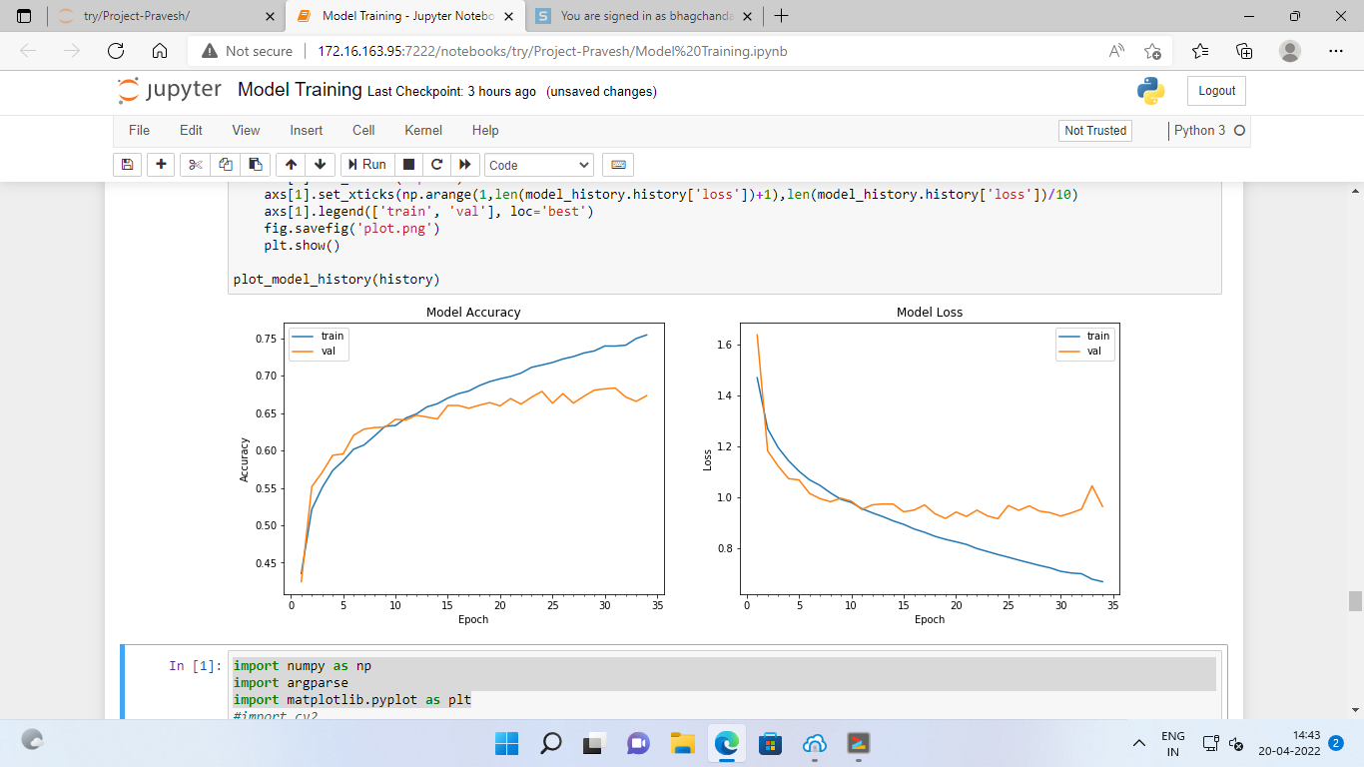

**Figure 6.a: Loss**

**Graph of accuracy in training and validation data:**



**Figure 6.b: Accuracy**

**Output:**

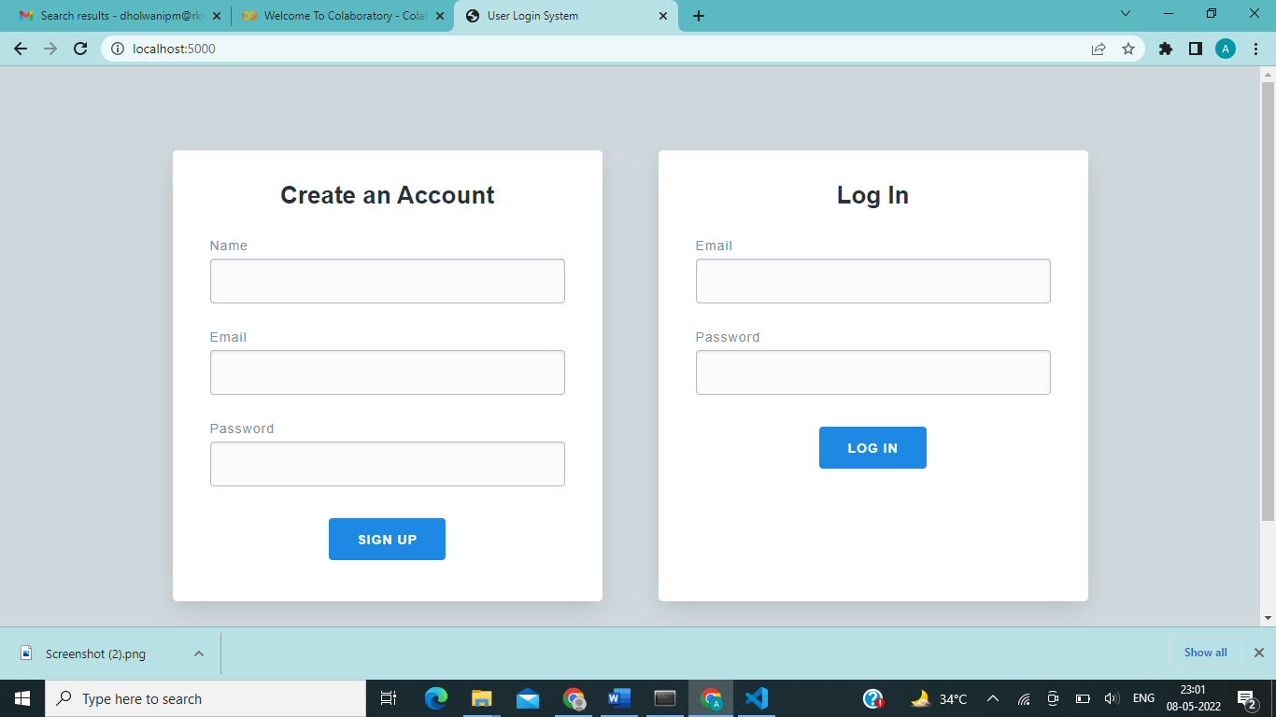

**Figure 7 Output 1:Login/SignUp Page**

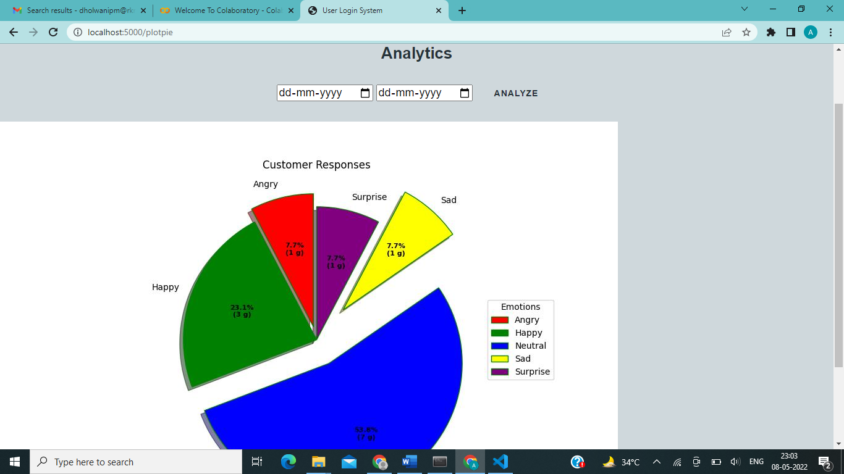

**Figure 8 Output 2 Analytics Page**

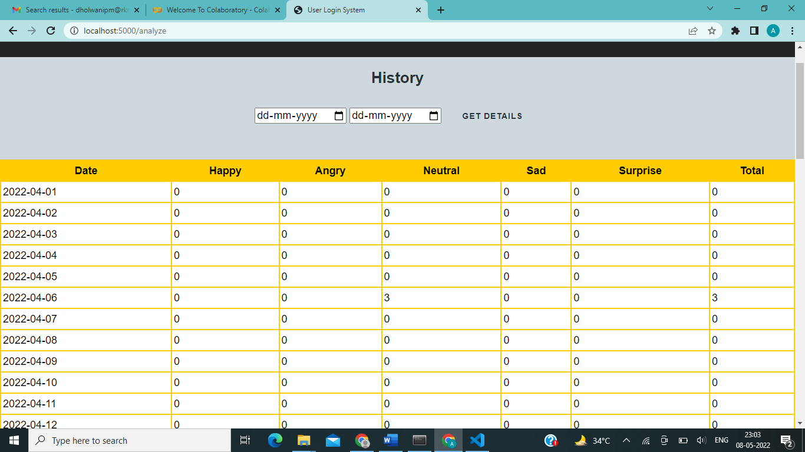

**Figure 9 Output 3 Datewise History**

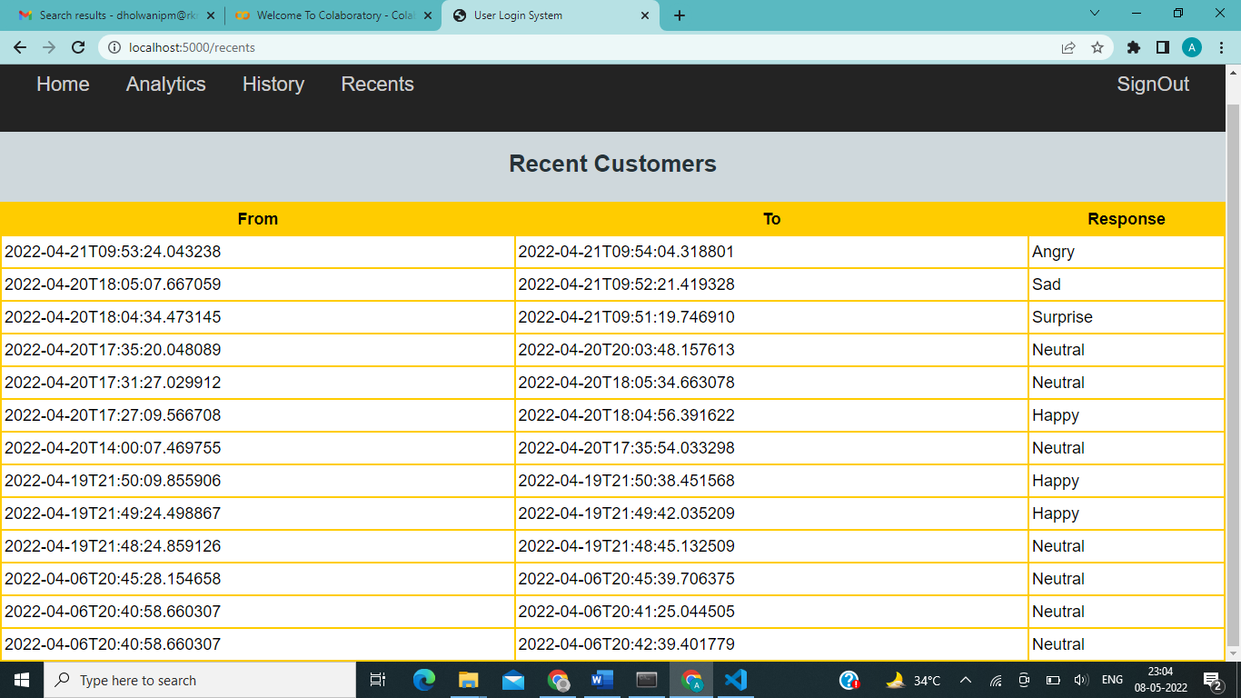

**Figure 10 Output 4 Recent customers Page**

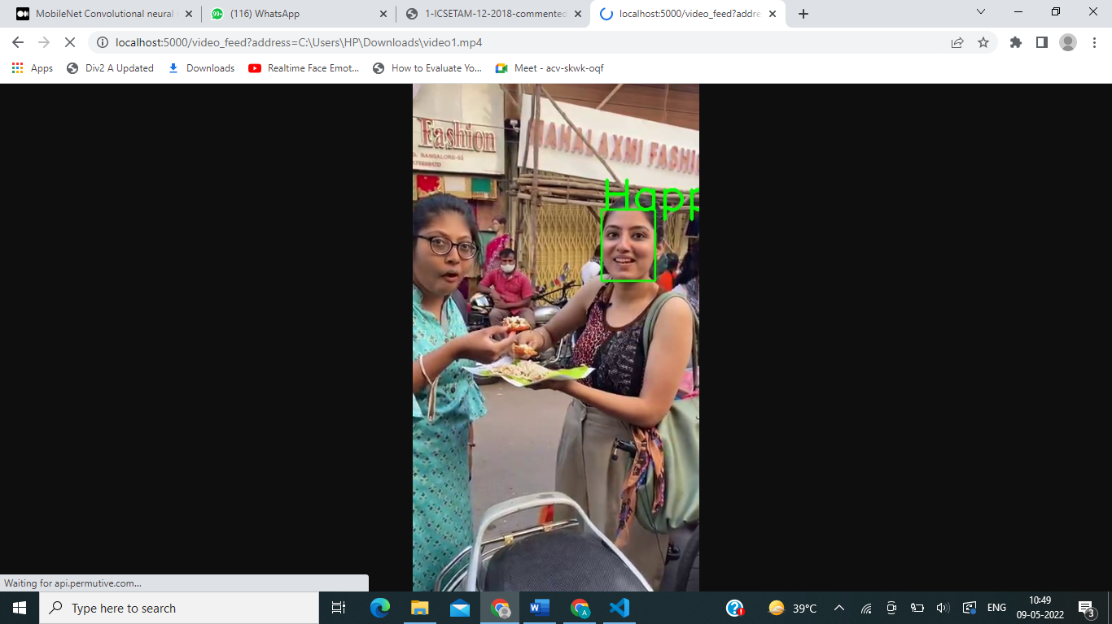

**Figure 11 Output 5: Actual Emotion Visualization**

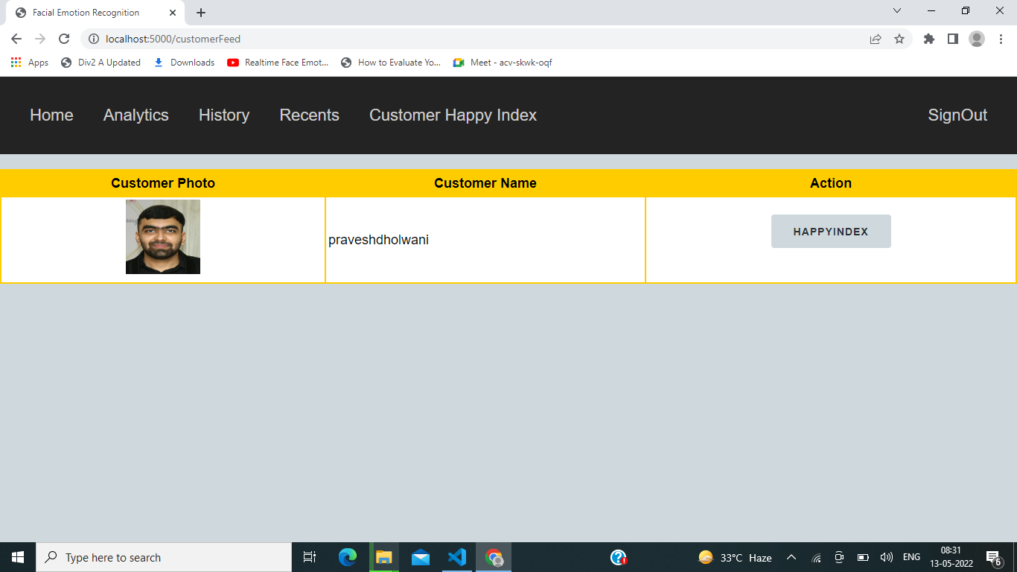

**Figure 12:Output 6:List of Customers**

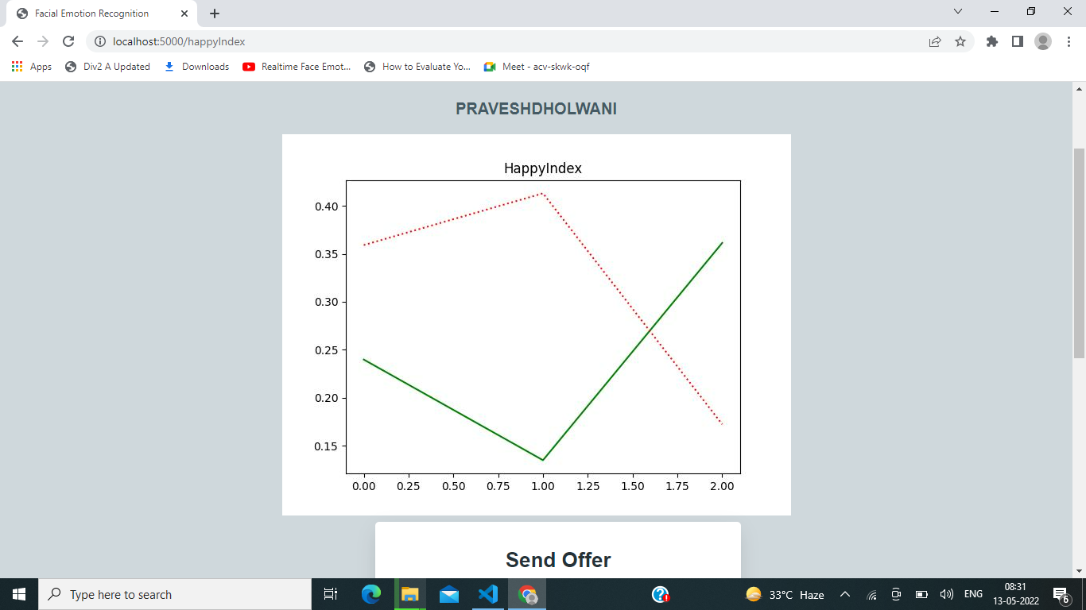

**Figure 13 :Output 7:Happy Index**



**Figure 14 :Output 8:Send Offer to unhappy Customers**

# **CHAPTER 5**

# **CONCLUSION**

Facial expression recognition or computer-based facial expression recognition system is important because of its ability to mimic human coding skills. Facial expressions and other gestures convey nonverbal communication cues that play an important role in interpersonal relations.

Emotion expression is important in communication improving the quality of interaction between human. The study of facial emotion recognition may contribute a better feedback to the society and also interaction between Human Robot Interface (HRI) in a near future. The emotion detection mostly involves with the geometric part of the face (eg; eyes, eyebrow, and mouth). The review takes consideration of experiment which been conducted in a controlled environment, real-time, and wild images. The main issues are highlighting the accuracy of the techniques chosen in their research. The face detection and emotion recognition are very challenging problems. They require a heavy effort for enhancing the performance measure of face detection and emotion recognition. This area of emotion recognition is gaining attention owing to its applications in various domains such as gaming, software engineering, and education.

# **CHAPTER 6**

# **FUTURE SCOPE & APPLICATIONS**

# **6.1 FUTURE SCOPE**

* Analysis from dish specific emotions.
* Analyzing multiple table through a single camera.
* Emotion recognition of side faces.

# **6.2 OTHER APPLICATIONS**

* **MARKET RESEARCH**

Companies have traditionally done market research by conducting surveys to find out about what consumers want and need. This method however, assumes that the preferences stated are correct and reflect future actions. But this is not always the case. Another popular approach in [market research](https://sightcorp.com/market-research/) is to employ behavioral methods where user’s reactions are observed, while interacting with a brand or a product. Although effective, such techniques can quickly become very labor-intensive as the sample size increases. In such circumstances, facial expression recognition technology can save the day by allowing companies to conduct market research and measure moment-by-moment facial expressions of EMOTIONS automatically, making it easy to aggregate the results.

* **VIDEO GAME TESTING**

Facial expression recognition can also be used in the video game testing phase. In this phase, usually a focus group of users is asked to play a game for a given amount of time and their behaviour and emotions are monitored. By using facial expression recognition, game developers can gain insights, information and draw conclusions about the emotions experienced during game play and incorporate that feedback in the making of the final product.

* **Facial Emotion Detection in Interviews**

Can measure candidate's facial expressions to capture their moods and further assess their personality traits. Recently, Unilever is already starting to incorporate this technology into their recruitment process. With this technology, a recruiter will be able to know the overall confidence level of an candidate and make a decision about whether or not this candidate will be able to perform well at a client-facing job. Similarly, it will be possible to find whether the candidate is honestly replying to all the questions by measuring the change in emotions during his responses.

# **REFERENCES**

|  |  |
| --- | --- |
| [1] | Mehendale, N. Facial emotion recognition using convolutional neural networks (FERC). SN Appl. Sci. 2, 446 (2020). |
| [2] | Russell JA (1994) Is there universal recognition of emotion from facial expression? A review of the cross-cultural studies. Psychol Bull 115(1):102 |
| [3] | Bartlett M, Littlewort G, Vural E, Lee K, Cetin M, Ercil A, Movellan J (2008) Data mining spontaneous facial behavior with automatic expression coding. In: Esposito A, Bourbakis NG, Avouris N, Hatzilygeroudis I (eds) Verbal and nonverbal features of human–human and human–machine interaction. Springer, Berlin, pp 1–20. |
| [4] | Gizatdinova Y, Surakka V (2007) Automatic detection of facial landmarks from AU-coded expressive facial images. In: 14th International conference on image analysis and processing (ICIAP). IEEE, pp 419–424 |
| [5] | Liu Y, Li Y, Ma X, Song R (2017) Facial expression recognition with fusion features extracted from salient facial areas. Sensors 17(4):712. |
| [6] | Ekman R (1997) What the face reveals: basic and applied studies of spontaneous expression using the facial action coding system (FACS). Oxford University Press, New York |
| [7] | S. H. Wang, P. Phillips, Z. C. Dong, and Y. D. Zhang, “Intelligent facial emotion recognition based on stationary wavelet entropy and Jaya algorithm,” Neurocomputing, vol. 272, pp. 668–676, 2018. |
| [8] | N. Irtija, M. Sami, and A. R. Ahad, “Fatigue Detection Using Facial Landmarks,” pp. 1–6, 2018 |
| [9] | Ekman, P. (2013). Emotion in the Human Face. USA: Malor Books |
|  |  |