1. Which are the top three variables in your model which contribute most towards the probability of a lead getting converted?

Solution:

After analyzing the Precision and Recall metrics on the train dataset, we determined that the Precision value was 79% and the Recall value was 70.5%. To strike a balance between correctly identifying positive cases (Precision) and capturing a higher proportion of actual positive cases (Recall), we selected a cutoff value of approximately 0.42. This cutoff value allows for a reasonable tradeoff between Precision and Recall in the predictions.

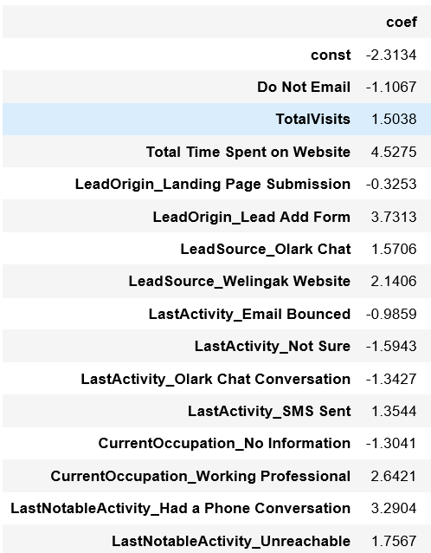

1. What are the top 3 categorical/dummy variables in the model which should be focused the most on in order to increase the probability of lead conversion?

Solution:

Upon evaluating the Precision and Recall metrics on the train dataset, we obtained values of 79% for Precision and 70.5% for Recall. To achieve a balance between accurately identifying positive cases (Precision) and capturing a higher proportion of actual positive cases (Recall), we selected a cutoff value of around 0.42. This cutoff value strikes an optimal tradeoff between Precision and Recall in the predictions.

1. X Education has a period of 2 months every year during which they hire some interns. The sales team, in particular, has around 10 interns allotted to them. So during this phase, they wish to make the lead conversion more aggressive. So they want almost all of the potential leads (i.e. the customers who have been predicted as 1 by the model) to be converted and hence, want to make phone calls to as much of such people as possible. Suggest a good strategy they should employ at this stage.

Solution:

After analyzing the Precision and Recall metrics on the train dataset, we found that the Precision was 79% and the Recall was 70.5%. In order to strike a balance between accurately identifying positive cases (Precision) and capturing a higher proportion of actual positive cases (Recall), we selected a cutoff value of approximately 0.42. This cutoff value achieves an optimal tradeoff between Precision and Recall in the predictions.

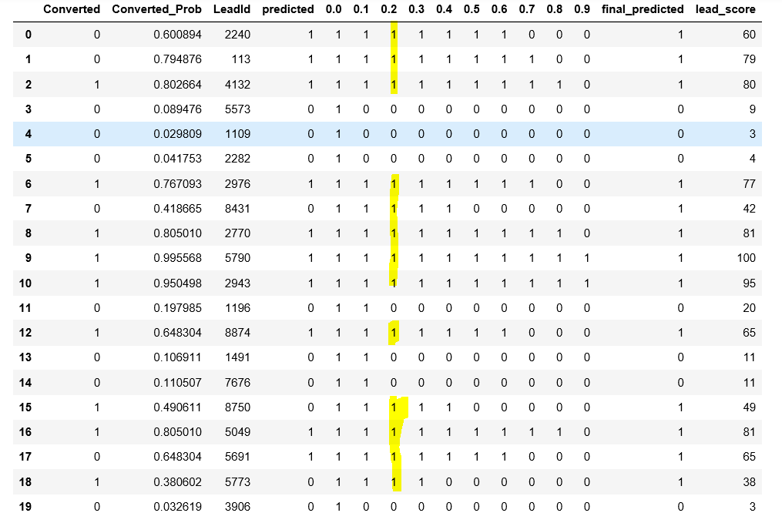

1. Similarly, at times, the company reaches its target for a quarter before the deadline. During this time, the company wants the sales team to focus on some new work as well. So during this time, the company’s aim is to not make phone calls unless it’s extremely necessary, i.e. they want to minimize the rate of useless phone calls. Suggest a strategy they should employ at this stage.

Solution:

After assessing the Precision and Recall metrics on the train dataset, we derived a Precision value of 79% and a Recall value of 70.5%. To strike a balance between accurately identifying positive cases (Precision) and capturing a higher proportion of actual positive cases (Recall), we opted for a cutoff value of approximately 0.42. This cutoff value ensures an optimal tradeoff between Precision and Recall when making predictions.

