NIYRO
PROJECT SUBMISSION DOCUMENT

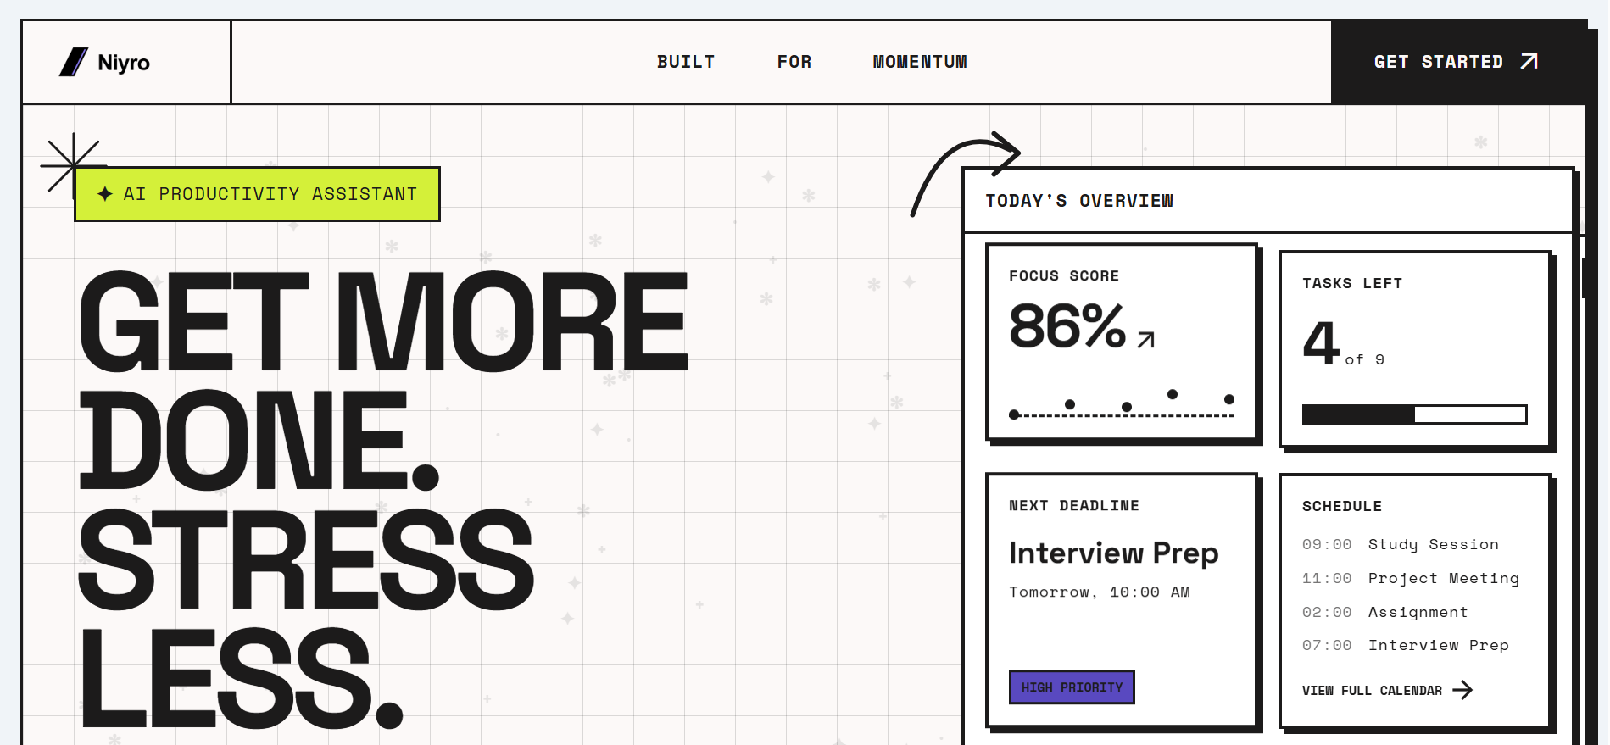

IMPORTANT LINKS & PLATFORM

• Project Link (Live): https://niyro-e3ddb.web.app
• GitHub Link: https://github.com/Aniketdhar810/Niyro
• Presentation Link: ____

• Platform: Web Application (Responsive Desktop & Mobile)

PROBLEM IT SOLVES

In today's fast-paced digital work environment, professionals are overwhelmed by context switching and scattered communication. Tasks, deadlines, and critical updates are fragmented across emails, chat applications, and manual to-do lists.

This leads to missed deadlines, increased burnout, and a lack of deep, uninterrupted focus. Niyro solves this by being a centralized intelligence layer that automatically prioritizes what matters and actively blocks out distractions so you can execute without burning out.

CHALLENGES FACED

1. Unifying Asynchronous Data Streams: Handling incoming webhooks from Telegram, Slack, and Gmail simultaneously required building a robust, idempotent ingestion pipeline so tasks wouldn't be duplicated or lost.

2. Deterministic LLM Output: Relying on Gemini 3.5 to process natural language into actionable calendar commands meant we had to heavily engineer our prompts and use LangChain-style function calling to ensure it didn't hallucinate dates or times.

3. High-Performance RAG: Keeping the vector search fast using Vertex AI and Firestore meant we had to structure our database carefully, ensuring that the AI only retrieved contextually relevant tasks for the specific user requesting them.

4. Implementing Neo-Brutalism: Moving away from standard component libraries to build a purely custom, high-contrast, brutalist interface using Tailwind CSS took significant design effort to ensure it remained accessible and readable.

SOLUTION OVERVIEW

Niyro is an AI-powered, context-aware productivity assistant designed to unify task management. By automatically ingesting tasks from multiple communication channels, Niyro acts as a centralized intelligence layer.

It uses advanced AI models to assess deadline risks, prioritize daily workloads, and provide a conversational interface for users to query their schedules. Furthermore, Niyro actively combats burnout through a dedicated, customizable Focus Mode that encourages deep work.

KEY FEATURES

• Multi-Channel Task Ingestion: Automatically aggregates tasks and deadlines via webhooks from Gmail, Telegram, and Slack.
• Conversational AI Assistant: A context-aware chat interface utilizing Retrieval-Augmented Generation (RAG) over their personal task data.
• Predictive Risk Engine: Continuously analyzes pending tasks and deadlines, flagging items below critical thresholds.
• Automated Daily Briefings: Synthesizes the day's priorities into a concise summary delivered via Telegram.
• Customizable Focus Mode: A dedicated environment with visual countdown timers designed to block out distractions.
• Autonomous Actions: Capability to enforce deep work by intelligently managing calendars (e.g., auto-declining meetings).

TECHNOLOGIES USED

• Frontend: React, TypeScript, Vite, Tailwind CSS, Framer Motion
• Backend: Node.js, Express.js
• Architecture: Serverless API architecture with webhook integration for external platforms.

GOOGLE TECHNOLOGIES UTILIZED

• Google Gemini API: Powers the core conversational intelligence, reasoning, and automated task summarization.
• Google Vertex AI: Provides high-quality text embeddings to power the vector search and RAG architecture.
• Google Cloud Run: Serverless compute platform used to host and scale the Express backend securely.
• Firebase Suite (Auth, Firestore, Hosting): Handles secure user onboarding, scalable NoSQL data storage, and frontend hosting.
• Google Workspace APIs: Integrates directly with Gmail and Google Calendar.
• Google Cloud Scheduler: Triggers the backend cron routes reliably for the Automated Daily Briefings.

