**SRI KRISHNA INSTITUTIONS**

**SRI KRISHNA COLLEGE OF ENGINEERING AND TECHNOLOGY**

**CREDIT CARD MANAGEMENT SYSTEM**

**TEAM**

**GREY MATTER**

**MEMBERS**

**NAVEEN R**

**16EUCS101**

**SANKARA NARAYANAN M**

**16EUIT132**

**PRABHU SARATHY G**

**16EUCS118**

**INDEX PAGE NUM**

* About us 3
* Contact us 3
* Abstract 4
* Objective 4
* Existing System 4
* Proposed System 5
* Specifications 5
* Budget 5
* HDD 6
* Sample Screenshots 10
* LDD 12
* Control Flow Diagram 15
* Pseudo code 17
* Algorithm 18
* Flow Chart 20
* Code 21
* Quality Assurance-Test Cases 31
* Output Screens 34
* Complexity Number of Lines 36
* Conclusion 37
* Future Enhancements 37
* References 37

**ABOUT US:**

We the team grey matter, believe in team work and coordination. We are ought to fulfill the client’s need and develop the best product, satisfying all their needs. We are three young, powerful, smart working and perseverant engineers who are here to produce high tech products for the people in various sectors.

Grey matter means the part of the brain that is used for creative thinking and logical reasoning. Our team has an energetic Software Developer, tough Tester and mind-blowing Business analyst.We have completed our Bachelor of Engineering from Sri Krishna college of Engineering and Technology, Coimbatore.

We have undergone special training in the respective fields and have collaborated to form a startup company.We thank our teachers and mentors for giving us the knowledge and ardous training to excel in this field of Engineering.

**CONTACT US:**

You are free to contact us as we are available all time for useful talks

Naveen R (Software Developer) : 9566435047

Sankara Narayanan M (Software Tester): 9543332249

Prabhu Sarathy G (Business Analyst): 8675960856

**ABSTRACT:**

The main idea of this project is to provide a central management for credit cards. The system is designed in such a way that it holds the account details of all the customers who have an account in the bank. Their account details are used to retrieve the credit card usage and the bill amount for the month. The project is divided into four main modules. The persons are issued a credit based on their credit score. The credit cards with various cash limits are issued to different account holders on basis of their repaying capacity, such that it doesn’t affect the bank in future. The entire data of the customers are stored in this system. This system reduces the difficulties involved in credit card management and ease up the process of getting a credit card.

**OBJECTIVE:**

The main objective of this system is to reduce the complications involved in getting a credit card. The credit cards are given to a set of people and if they are not clear about their repaying capacity, the bank would end up losing their funds. The way of distributing the credit cards to the customers should be precise that they would repay the due amount regularly. The module helps in enhancing the present system with its new technological elements and providing the best management system for credit cards.

**EXISTING SYSTEM:**

The current system used for credit card management is not centralized. The system provides credit cards to the users based on their cibil scores. The cibil score is calculated based on their loan history, default cheques and bank transaction history. The people who are having a higher cibil score are benefitted. If a person who is in need of a credit card aren’t benefitted by this method. Even if the salary of the person is high , he’s not given a credit cards, due to the loan history. That is an issue with the current credit card system. Inorder to be beneficial to all, a new method for filtering the credit card customers has to be found, without affecting the bank funds. The customers who need a credit card, with a good repaying capacity should be filtered from the account holders. The banks need such an optimal system to get more customers.

**PROPOSED SYSTEM:**

The new system has a credit score based evaluation. The credit score is a value which is calculated from the customer’s CIBIL score, salary and job type. The type of the job plays a vital role here. The government employees are much preferred as they have a regular salary. They are given priority here compared to the private. The startup organisations are also considered based on their future project details to check their repaying capacity. The system collects the precise billing info of a credit card user and intimates the due date to pay back the bills. If its beyond the due date, then the calculated interest percentage is added to the bill amount.

**SPECIFICATIONS:**

The following modules are present in the project.

1.Account details

2.Eligibility criteria

3. Card holder

4.Customer support

**BUDGET:**

The budget of this product is calculated from the modules developed, development process, implementation process and marketing. The overall cost of the module is given from the project value(PV).The PV is 2.5 lakhs as proposed by the client. The work completed for the development phase is 80%.The amount spent for the project till date is 1.5 lakh. Hence the Earned Value EV of the project is 1Lakh INR.

**HDD:**

This document contains the high level design of the project that has to be executed in order to complete the course Programming Fundamentals.

The project is a Credit Card Management System.

**1.Business Requirements**

Following are the business requirements for this project,

|  |  |  |
| --- | --- | --- |
| **SI.NO** | **REQUIREMENTS** | **STATUS** |
|  |  |  |
| 1 | Account details | To be |
|  |  | implemented |
| 2 | Eligibility for credit card | To be |
|  |  | implemented |
| 3 | Card holders | To be |
|  |  | implemented |
| 4 | Customer support | To be |
|  |  | implemented |

**2.LIST OF FILES TO BE INCLUDED**

1.model.c - This is source code file which contains all the files required to handle for the functions of input and output.

2.customer_database.csv - This is a database of all the customers in the client bank.

3.export_eligibility.csv - This will export the database of the customers who are eligible to have the credit card

4.process.h- This is c file which is to use to process the customer_database.csv into the export_eligibility.csv which is to get included in the model.c.

5.cibil.c-This will give the CIBIL score of all the database.

6.existing.h-This will have the entire set of data on all the existing customers.

**3.ACCOUNT DETAILS**

This module will clearly tell about the account details of all

the customers(Account holders) of this bank which includes credit

card and non credit card holders. This file is stored in

customer_database.csv. This is required to cross check who else

have the eligibility to have a credit card.

**4.ELIGIBILITY FOR CREDIT CARD**

This module will take input from customer_database.csv file and process something with the simple program and out it to the export_eligibility.csv. Here the mentioned simple program will find Eligible person by some constrains. Here the process is to process the cibil value into the salary and some customer details which returns the customers who are eligible for the credit card and export it into the export_eligibility.csv. And here the auto generated message will be sent to all those eligible customers.

**5.CARD HOLDERS**

In this module we have two sections one is New Customers and other is Existing customers.

**In new customers,**

Here the interested people from the selected group will approach the bank for their credit card. Here they will be again

cross checked with the details and they should be within the three schemes,

First Scheme - Silver Card

Second Scheme - Gold Car

Third card-Platinum Card

They will be given with unique id.

**In the existing customers,**

Here the existing customers will be able to see their bill amount,their valuable details,so and so.

**6.CUSTOMER SUPPORT**

Here all the helps for the customer will be done, like loss of card and block of cards,issues with cards,and many other transactions issues will be made easy here.

**SAMPLE SCREENSHOTS:**

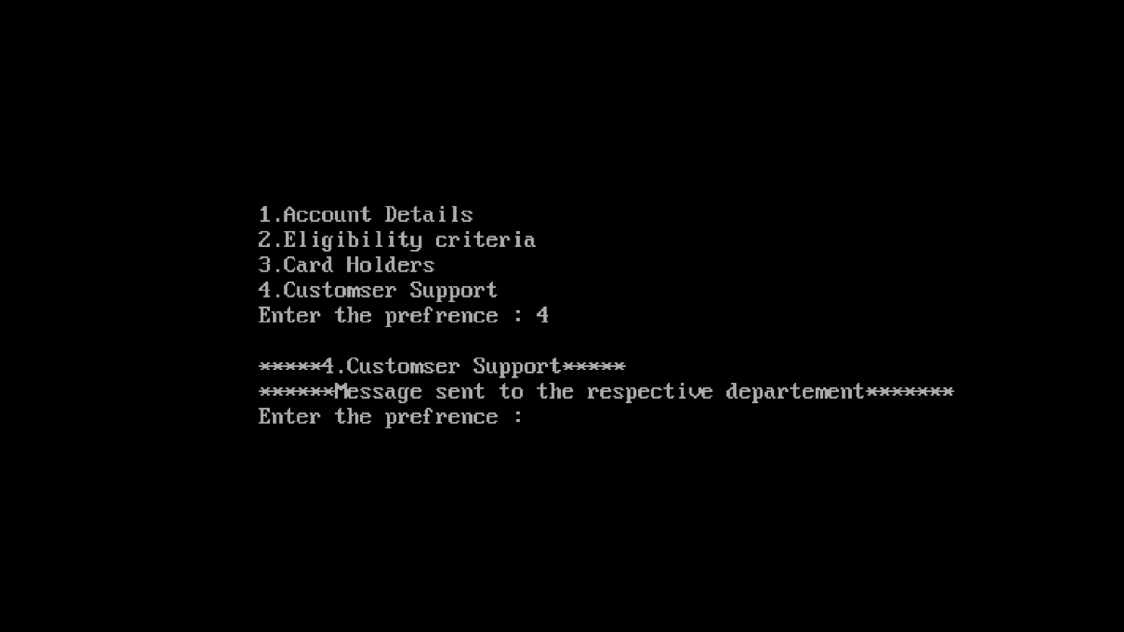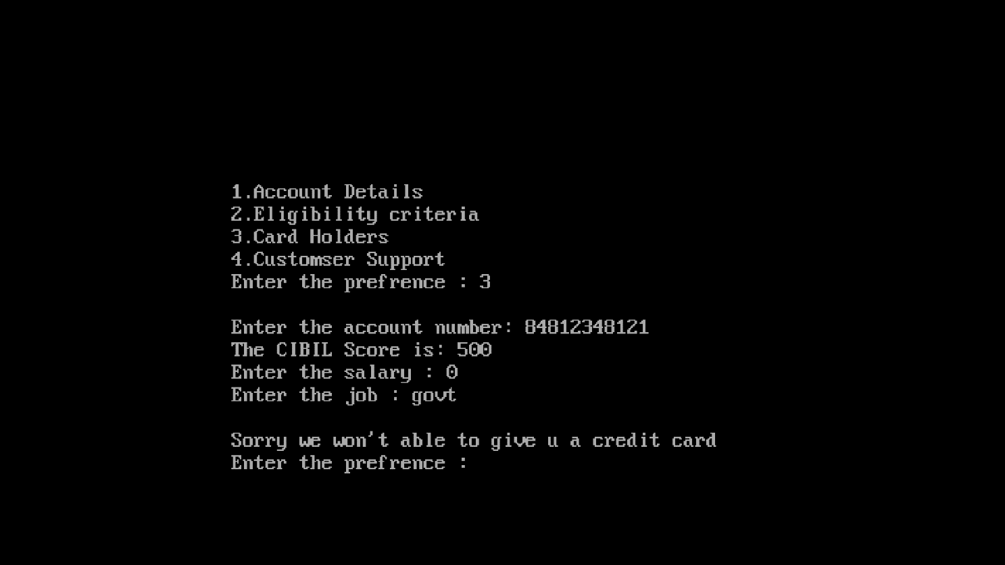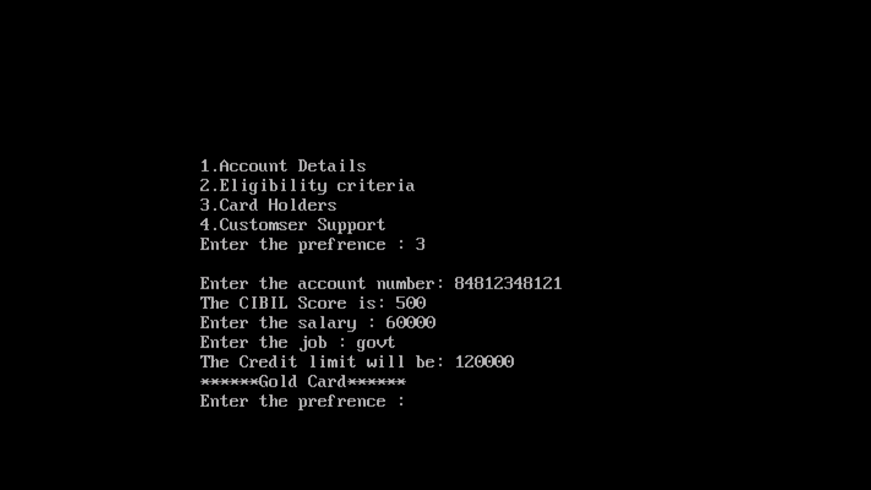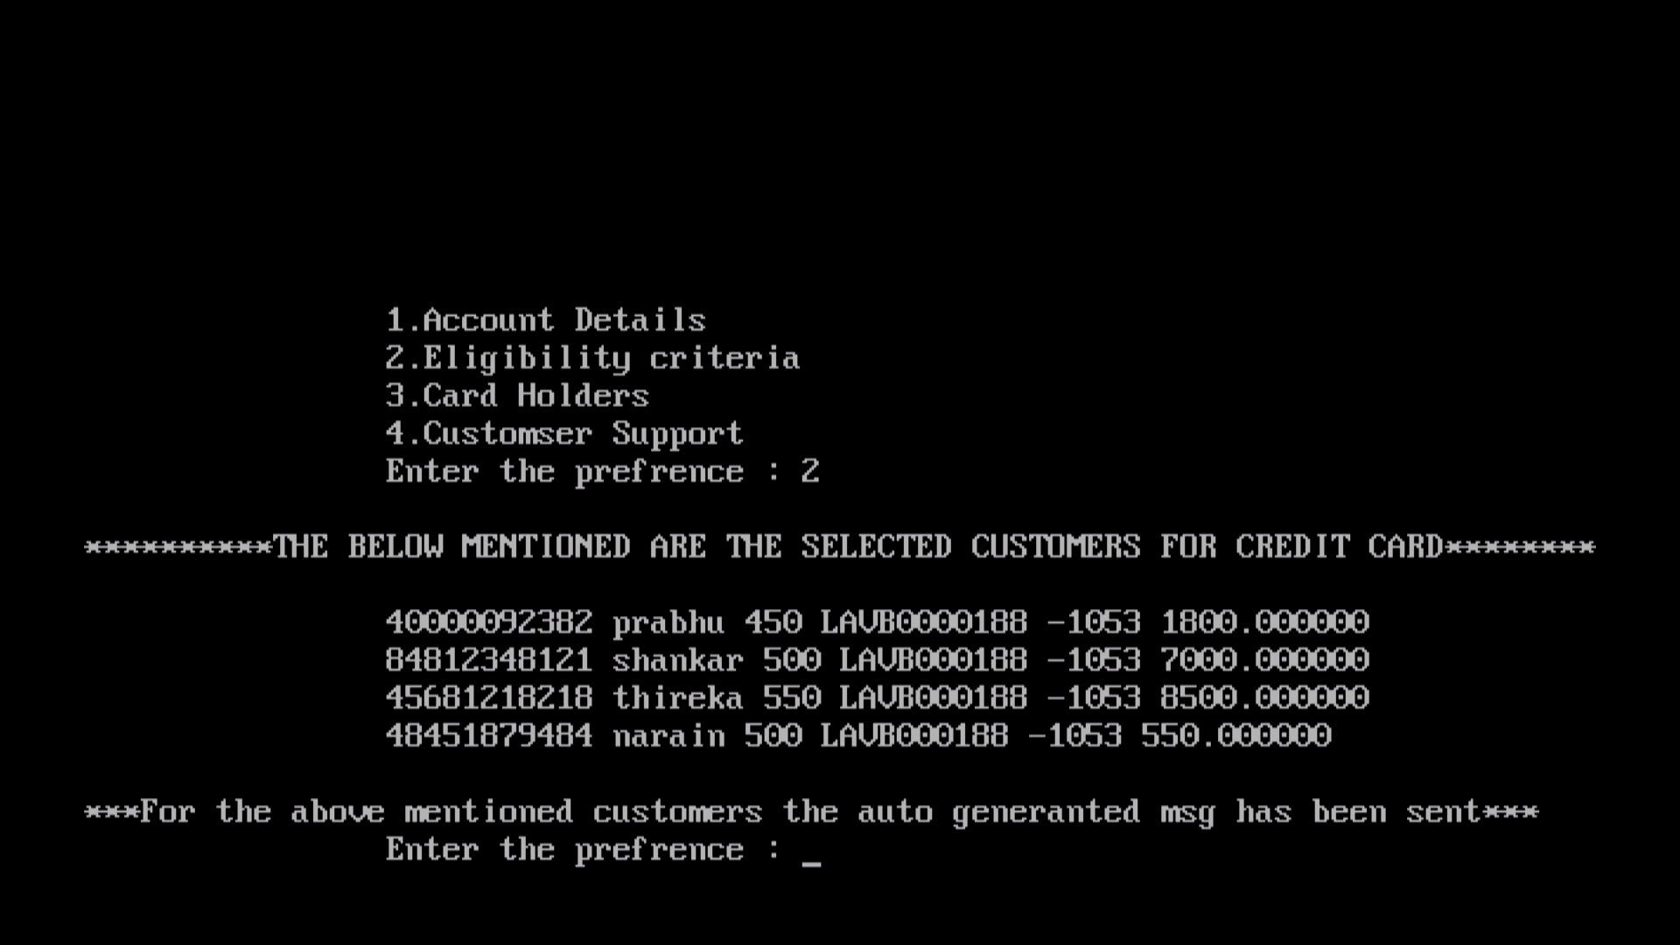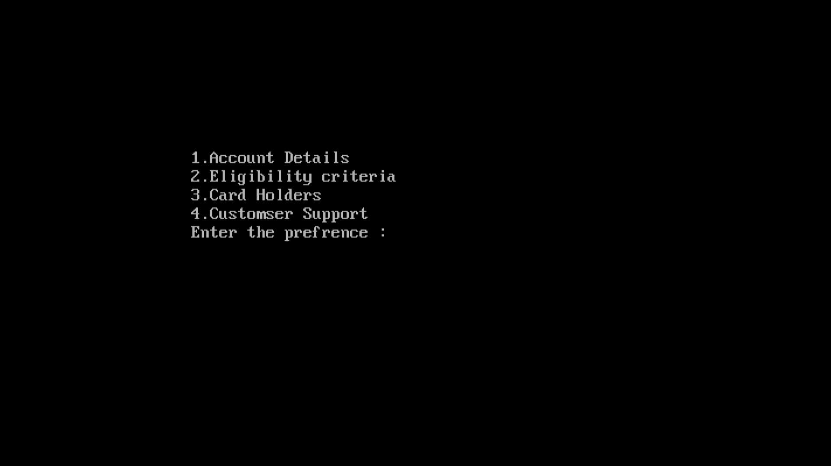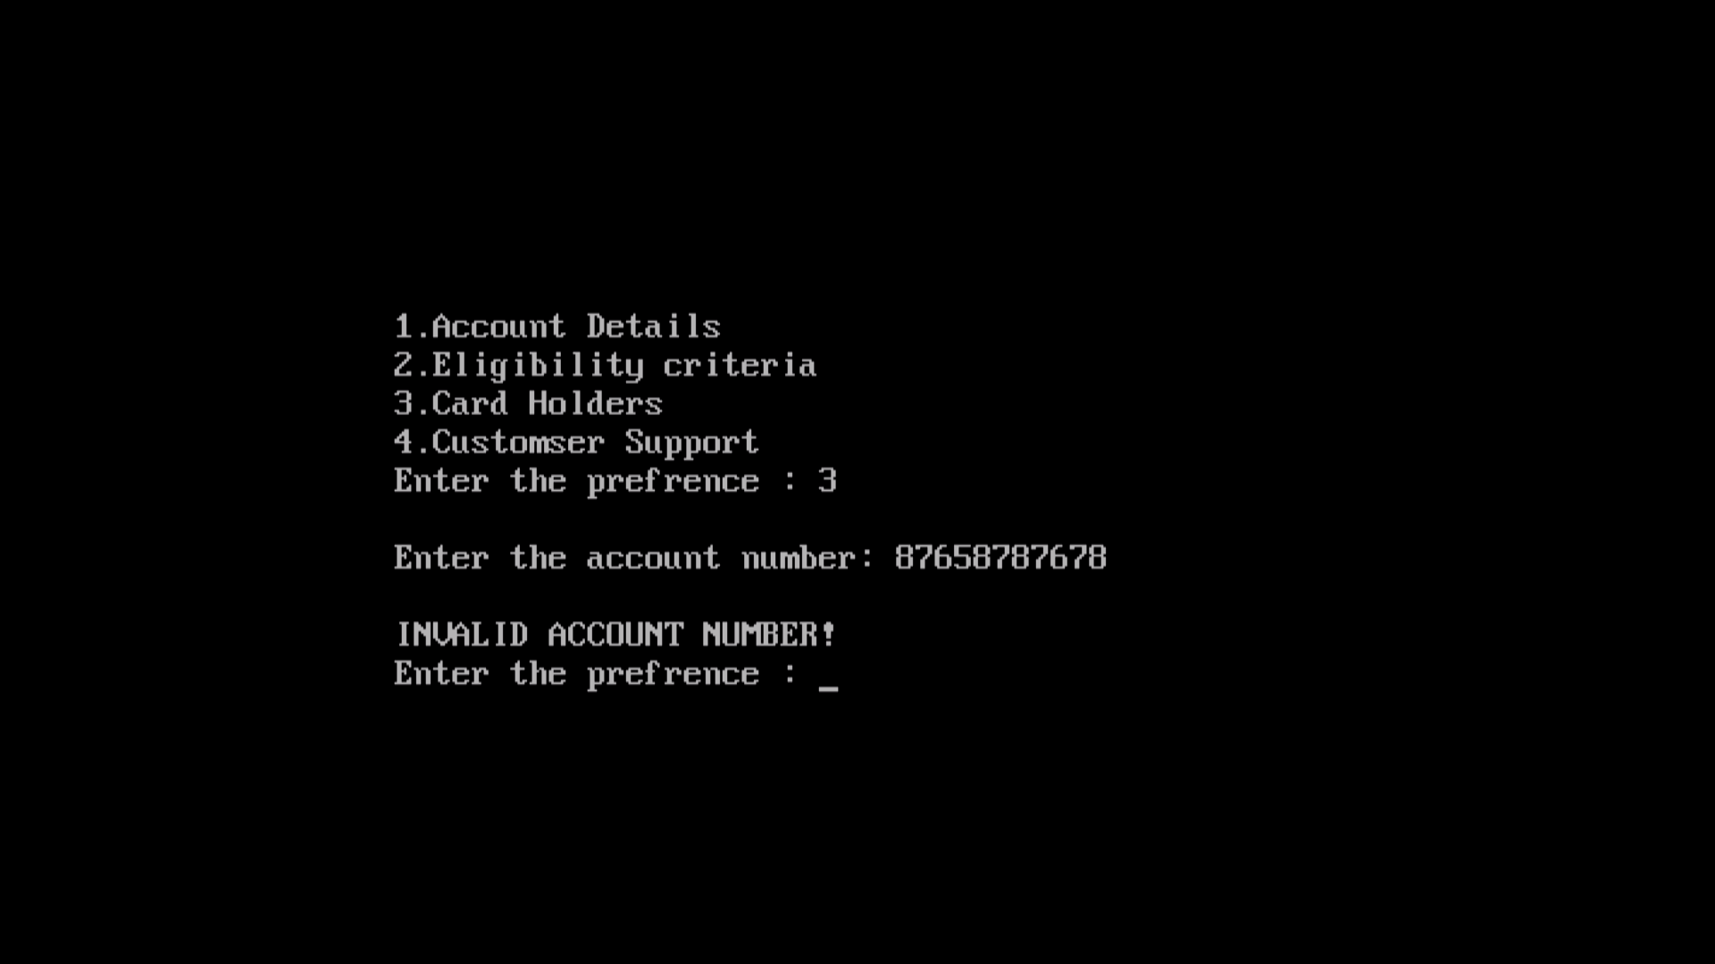

**LOW LEVEL DESIGN:**

This document contains the low-level design of the credit card management system. The sub levels of the modules are explained here. The following are the modules present in the HLD of the credit card management system.

1.ACCOUNT DETAILS

2.ELIGIBILITY FOR CREDIT CARD

3.CARD HOLDERS DATA

4.CUSTOMER SUPPORT

These are the modules present in the system and they have certain sub modules and attributes. They are included in the document. The files are stored in .c and .h format and are used in the source code.

**1.ACCOUNT DETAILS:**

The account details module contains the details of the people who have an account in the bank. The details include **account number, name, available balance, address, contact number, transactions history, age of the person, CIBIL score of the person.**

Once we enter the account number, these data of any person having an account in the bank can be obtained. The account number is the key value here. If there is no such account number in the database, its entitled as invalid number. The data is secured such that only the management authorities are permitted to access the system. The data are stored in a separate file and is imported to the source file.

**2.ELIGIBILITY CRITERIA:**

This is an important segment in the program, where the bank database is filtered out to pick the people who are eligible to get a credit card. The eligibility criteria is given by calculating each individual’s CIBIL score and income per annum.

**CIBIL SCORE:**

CIBIL score is used to determine whether the person has the potential to repay the debts and has a good economy. Credit Information Bureau (India) Limited, commonly known as CIBIL, is India’s first Credit Information Company or Credit Bureau. It maintains records of all credit-related activity of individuals and companies including loans and credit cards. The records are submitted to CIBIL by registered member banks and other financial institutions on a periodic (usually monthly) basis. Based on this data, CIBIL issues a Credit Information Report or CIR (commonly referred to as a credit report) and a credit score. The loan history of the person is also considered here. A good score has the range >500. That indicates the person has cleared the previous loans and has a good transaction history.

The people with a positive credit score are eligible to have a credit card. The range of the credit score is given as input. The filtered data of the account details are obtained here. An invitation for credit card is sent to those people from the management. The interested people could reply and are eligible to have a credit card.

**3.CARD HOLDERS DATA:**

The users of the credit card are the card holders. The module provides all those credit card usages and the card usage history. It is subdivided into two modules namely,

**-NEW USER**

**-EXISTING USER**

**NEW USER:**

The users who are new to the world of credit card are given cards based on their income per annum and loan history. The cards have the limits of 50,000 2,00,000 and 3,00,000 INR. The cards are classified into Gold, Diamond and Platinum, based on the monetary value. The card with highest monetary value is given for premium customers. They have a time limit of 40 days from the day of card usage at the interest rate of 1%. The amount is interest free, if it’s paid before the due date. For the other cards, the due date varies at the same interest rate. The customers are penalized with an amount once they have crossed their due date and transaction limit. The users can enjoy credit card access upto the transactional limit. They’ll be given a unique card number with expiry date. The users can add amount to their credit cards.

**EXISTING USER’S DATA:**

For the existing user’s data, the balance amount to be used can be known by their account number. They can add money to their credit card. The bills of the users are maintained here. If any user has penalty, the interest amount is added to the principle amount on day to day basis. They are penalized in that manner and the card will be blocked if their usage goes beyond the bounds.

**4**.**CUSTOMER SUPPORT**:

If the customer has encountered any problem such as loss of credit card, theft of card, change of card location and international usage, they can file a complaint. Those complaints are present in this module. Based on the complaints received, the necessary initiatives will be taken. If the complaint is about loss of credit card, the card of the individual is stopped and a new card is generated. The access bounds can be changed from local usage to international usage. It can be made by the credit score of the individual.

**CONTROL FLOW DIAGRAM:**

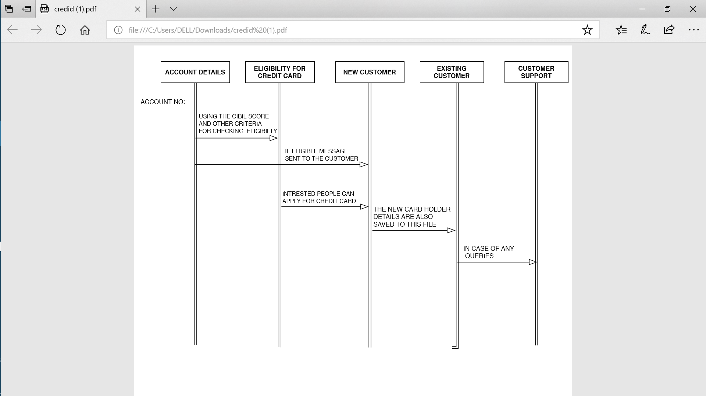

**PSEUDO CODE:**

35-P.1 - ACCOUNT DETAILS

BEGIN

IMPORT customer_database.csv

READ customer_database.csv

DECLARE pin,qpin,Customer_data

IF pin equals qpin:

Print Customer_data

ELSE

Print “INVALID PIN!!”

END_IF

END

35-P.2- ELIGIBILITY CRITERIA

BEGIN

IMPORT customer_database.csv

IF cb_score > 400 and card_in equals “no” THEN

Call message(cb_score,card_in)

END_IF

END

35.P-3- CARD HOLDERS

35.P.3.1 NEW USER

BEGIN

IMPORT interest.csv

INPUT salary,job

Salary<-salary/100

P<-cb_score+salary

IF job equals govt THEN

P<-P+100

ELSE

P<-p+50

END_IF

Score=P*100

IF score between 50000 and 100000 THEN

Card=silver

ELSE IF score between 100000 and 200000 THEN

Card=gold

ELSE IF score >200000

Card = platinum

Cust=1

ELSE cust=0

END_IF

PRINT u_id

END

1. P.3.2 EXISTING USER

` BEGIN

IMPORT credit_cust.csv

INPUT p_id u_id

IF p_id equals u_id THEN

PRINT bills

END_IF

END

35.P.4- CUSTOMER SUPPORT

BEGIN

INPUT cpr,cde

PRINT cde

END

**ALGORITHM:**

1. A.1 - Account details

1.Import file customer_database.csv into the program

2.The user should enter the pin to get the account details.

3.When the pin is correct user details will be displayed on the screen.

4.When the pin is incorrect it will through an exception as “Enter the correct pin”.

1. A.2 - Eligibility Criteria

1.Import the CIBIL score and credit card details from the customer_database.csv

2.Filter the person who have the CIBIL score >400 and doesn’t have the credit card.

3.Sends message to those filtered customers.

4.Export it to the export_eligibility.csv

1. A.3 - Card Holders
2. A.3.1 - New Customers

1.Import the file intrest.csv

2.Get the salary of the person and job type.

3.Divide the salary of the person by 100.

4.Add the above value to the CIBIL score of the person.

5.When the job type is government add 100 to above value and store it to the points.

6.When the job types is private add 50 to above value and store it to the points.

7.Multiply the points by 100 to get the consolidated credit card value.

8.When the value is between 50,000 - 1,00,000 Silver card is issued to them.

9.When the value is between 1,00,000 - 2,00,00 Gold

Card is issued to them.

10.When the value is greater than 2,00,000 Platinum card is issued to them and valued as premium customers.

1. Unique id is generated.

35.A.3.2- Existing Customers

1.Import creditcust.csv

2.Get the unique id of the customer

3.Print the bill amount.

35.A.4- Customer Support

1.Enter the customer’s query in the console.

2. The required action will be provided for the query.

**FLOW CHART:**

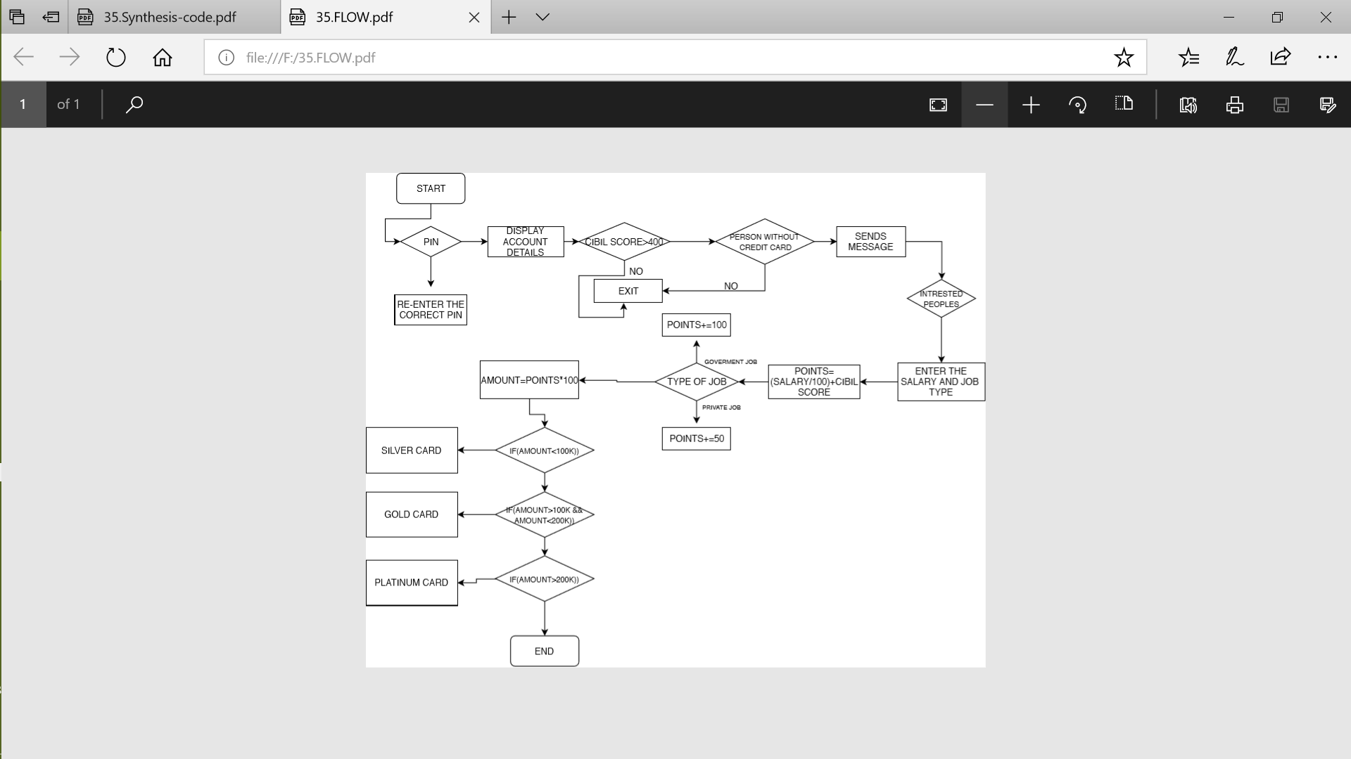

**CODE:**

#include<stdio.h>

main()

{

FILE *ptr; //this is file pointer to access the below used files

char arr[100]; //this array is to store the complaints

int n; //this will take the prefrence

pin=12345; //the default password

int x; //this will take the password input

int a;

printf("\n\n\n\n\n\n\n");

printf("\n\t\t1.Account Details");

printf("\n\t\t2.Eligibility criteria");

printf("\n\t\t3.Card Holders");

printf("\n\t\t4.Customser Support");

printf("\n\t\tEnter the prefrence : ");

scanf("%d",&n);

switch(n)

{

case 1:

{

int roll; //to store roll

int cibil; //to store CIBIL

int x; //to store password

char name[20];

printf("\n\t\t****1.Account Details****");

printf("\n\t\tEnter the pin : ");

scanf("%d",&x);

if(x==pin)

{

ptr=fopen("database.txt","r");

while(fscanf(ptr,"%d %s %d",&roll,name,&cibil)!=EOF) //scans the every roll,name of account holder and their respected cibil values from the databse

{

printf("%d %s %d",roll,name,cibil); //prints the same

}

}

else

{

} printf("\n\t\tOOPS Wrong pin!"); //if the pin fails

break;

}

case 2:

{

FILE *ptr;

struct emp{

char accno[15]; //to store the acc.no

char name[20]; //to store acc. holder's name

int cibil; //to store CIBIL

char ifsc[50]; //to store the ifsc

char type[20]; //to store the type of account

float bal; //to store the balance

char credicardstatus[5];

}e;

ptr=fopen("sample.txt","r");

if(ptr==NULL)

{

printf("Cannot open file");

}

else

{

printf("\n\n\n\n\n\n");

printf("**********THE BELOW MENTIONED ARE THE SELECTED CUSTOMERS FOR CREDIT CARD**********\n\n");

while(fscanf(ptr,"%s %s %d %s %s %f %s",e.accno,e.name,&e.cibil,e.ifsc,&e.type,&e.bal,e.credica rdstatus)!=EOF) //this will scan for the entire information

{

if(e.cibil>400&&!strcmp(e.credicardstatus,"no"))

//our criteria

{

printf("%s %s %d %s %d %f\n",e.accno,e.name,e.cibil,e.ifsc,e.type,e.bal);

}

}

}

fclose(ptr);

printf("\n**********For the above mentioned customers the auto generanted msg has

been sent***********");

break;

}

case 3:

{

FILE *ptr;

long int p;

score=0;

int flag=0;

struct emp{

char accno[15];

int cb_score;

//to store the points

//to store the credit limits

//to check wheather it is completed

long int salary;

char job[5];

}e,*q;

char account[15];

ptr=fopen("interest.txt","r");

if(ptr==NULL){

printf("Cannot open file");

}

printf("\n\t\tEnter the account number: ");

scanf("%s",account);

while(fscanf(ptr,"%s %d",e.accno,&e.cb_score)!=EOF) //here the scanf reads nly the accno and corresponding cibil score

{

if(strcmp(account,e.accno)==0)

{

printf("\n\t\tThe CIBIL Score is: %d",e.cb_score);

printf("\n\t\tEnter the salary : ");

scanf("%ld",&e.salary);

printf("\n\t\tEnter the job : ");

scanf("%s",e.job);

e.salary=e.salary/100; /

p=e.salary+e.cb_score;

if(strcmp(e.job,"govt")==0)

{

p+=100;

}

else

{

p+=50;

}

score=p*100;

printf("\n\t\tThe Credit limit will be: %ld",score);

flag=1;

break;

}

}

if(flag==0)

printf("\n\t\tINVALID ACCOUNT NUMBER!");

if(flag==1)

{

if(score>50000&&score<=100000)

printf("\n******Silver Card******");

else if(score>100000&&score<=200000)

printf("\n******Gold Card******");

else

printf("\n******Platinum Card******");

fclose(ptr);

break;

}

case 4:

{

printf("\n\t\t*****4.Customser Support*****");

printf("\n\t\tYour issues: ");

gets(arr);

printf("******Your issues are recorded and our team working on it and will update you soon*******");

break;

}

default:

{

printf("\nSorry You entered wrong input!") ;

}

}

}

**QUALITY ASSURANCE-TEST CASES:**

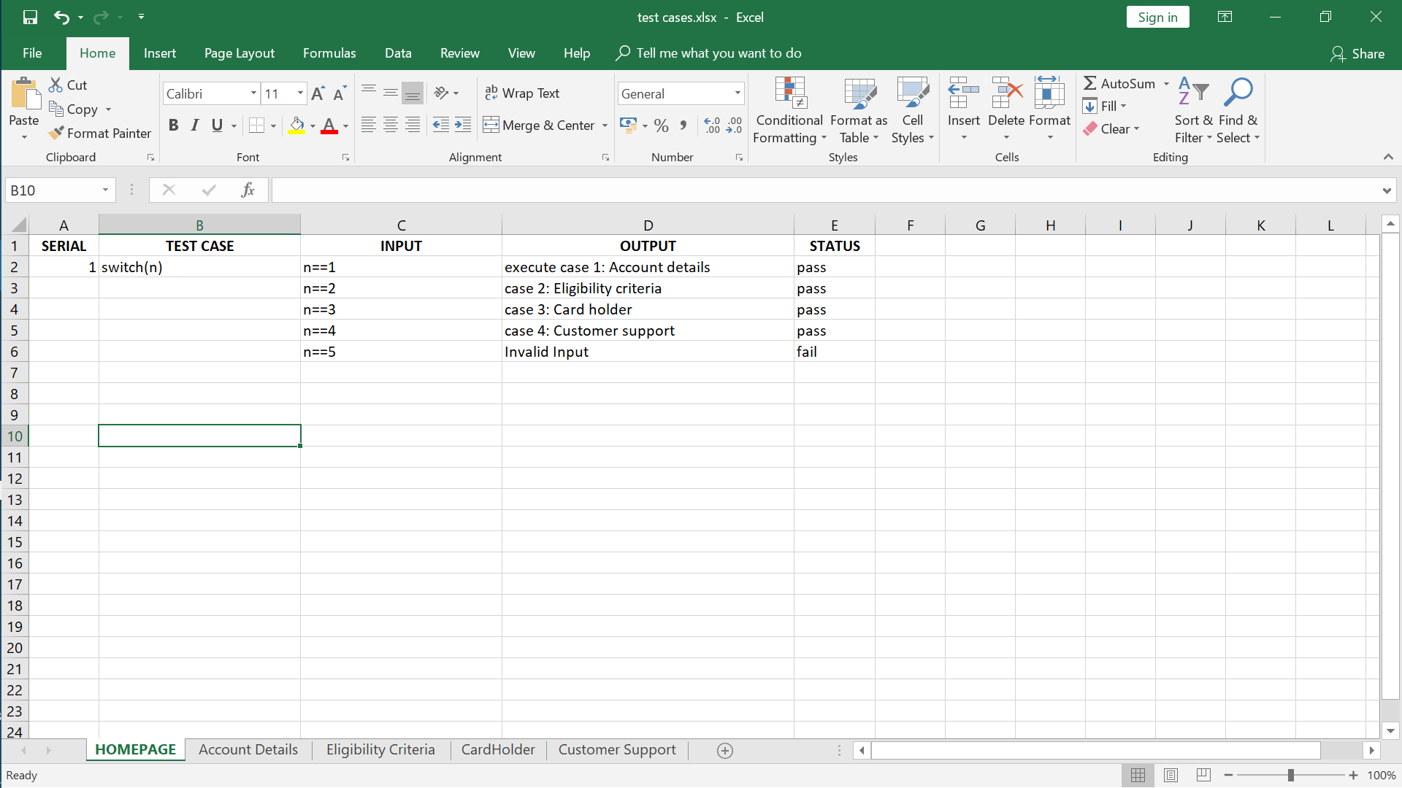

**HOME PAGE**

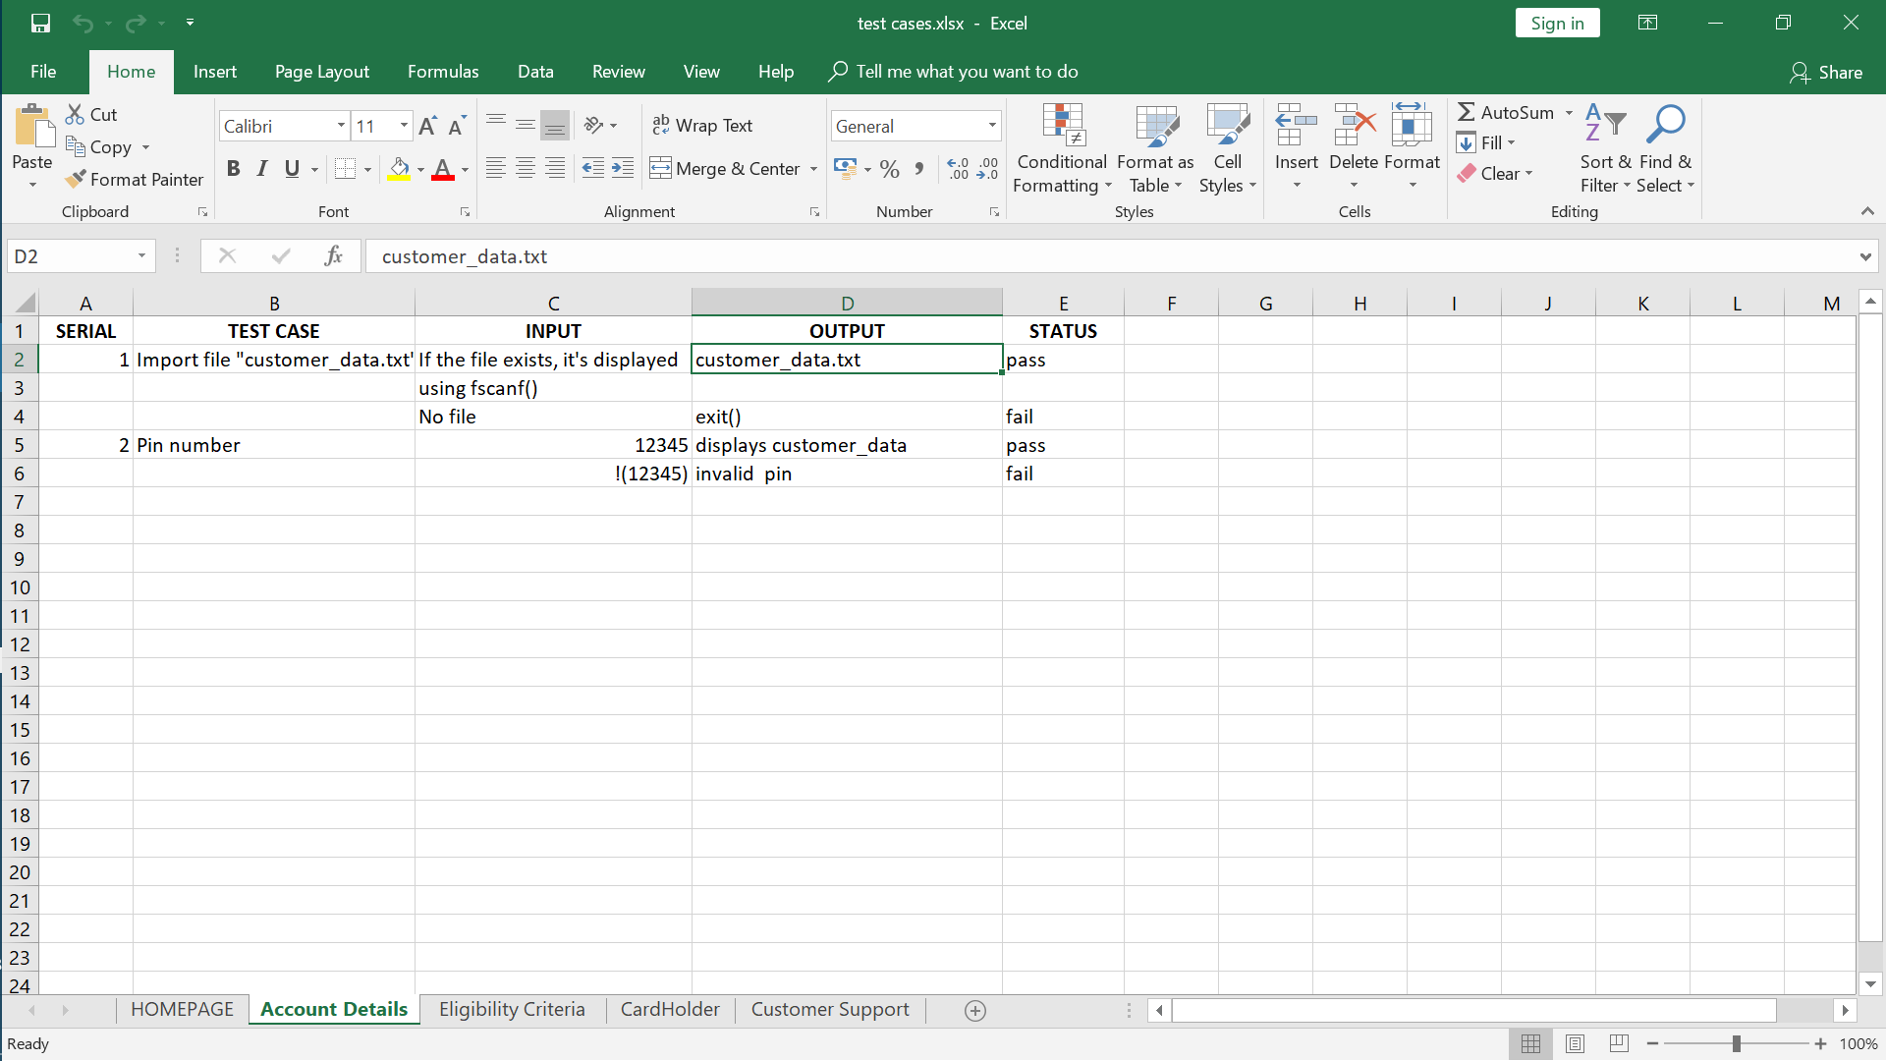

**ACCOUNT DETAILS**

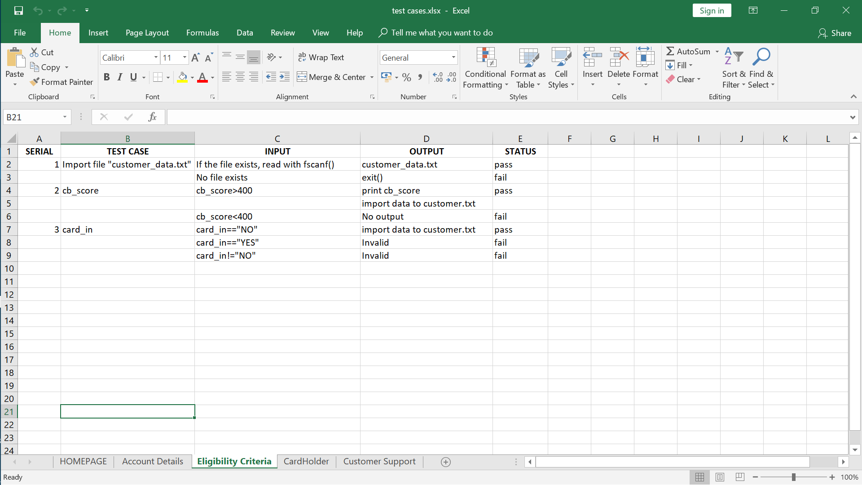

**ELIGIBILITY CRITERIA**

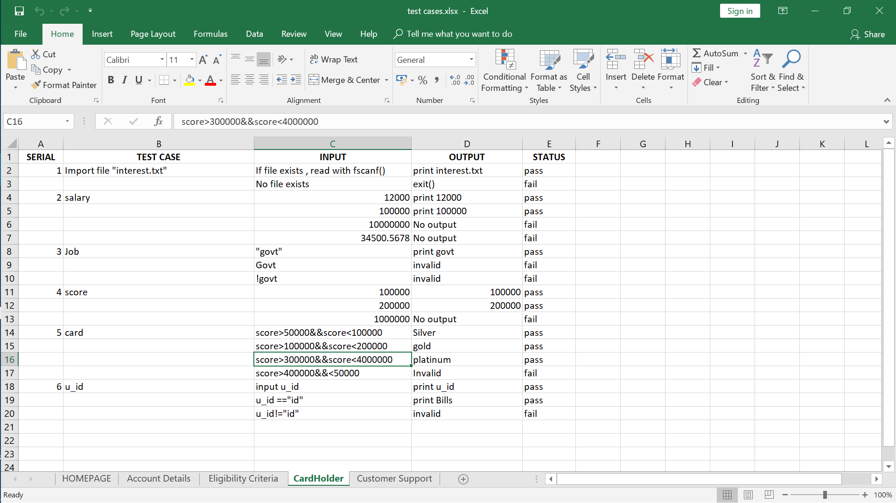

**CARD HOLDER**

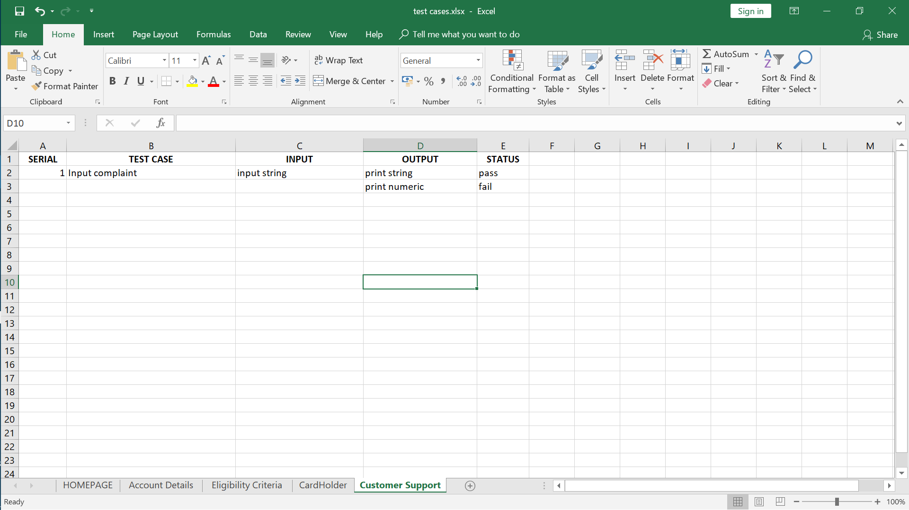

**CUSTOMER SUPPORT**

**OUTPUT SCREENS:**



**COMPLEXITY-NO OF LINES AND EXECUTION TIME**

Total number of lines of code: 169

Coding platform: Turbo C

**CONCLUSION:**

All the modules in the project have been described properly and the code segment executed properly without any bug issues. The credit card management system software has been tested with different set of inputs and the corresponding outputs have been generated successfully. The product had no issues while being executed.

The future implementations for this product will be carried out and will be released in the next fiscal year.

**FUTURE ENHANCEMENT:**

The future updates will be given for this product. The features for the card users will be improvised. The customer support module will be improvised further by adding theft protection subroutine. Some minor bug fixes will be made. The software will be made into a cloud network for ease of access.

The user interface will be improvised from character user interface to GUI. The model would be made interactive. Plans are made to write the program in python language.

**REFERENCES:**

<http://www.banksoft.com.tr/en/Content.aspx?UstIcerikID=0&ParentId=81&IcerikID=140>

<https://www.mymoneykarma.com/credit-score/cibil/cibil-score/cibil-score.html>

[*"How Credit Scores Work"*](http://money.howstuffworks.com/credit-score.htm)*.*

https://www.geeksforgeeks.org/structures-c/