Heart Disease Prediction Model Using ML

IBM SkillsBuild Data Analytics with AI Academic Internship Program
Author: Aniket Kumar
Conducted by BharatCares in association with AICTE

1. Introduction
Cardiovascular diseases are the leading cause of death globally. Early detection of heart disease can significantly improve the chances of survival and effective treatment. This project aims to build a predictive machine learning model capable of assessing the risk of heart disease based on various clinical parameters of a patient.

2. Dataset Description
The project utilizes the Cleveland database from the UCI Machine Learning Repository. The dataset contains 76 attributes, but this study focuses on the 14 most critical attributes, including the target variable which indicates the presence of heart disease.
- Key Features:
- Age: Age in years
- Sex: 1 = male; 0 = female
- Chest Pain Type (cp): 4 values indicating typical angina, atypical angina, non-anginal pain, or asymptomatic
- Resting Blood Pressure (trestbps): in mm Hg
- Serum Cholestoral (chol): in mg/dl
- Fasting Blood Sugar (fbs): > 120 mg/dl (1 = true; 0 = false)
- Resting Electrocardiographic Results (restecg): values 0, 1, 2
- Maximum Heart Rate Achieved (thalach)
- Exercise Induced Angina (exang): 1 = yes; 0 = no
- Oldpeak: ST depression induced by exercise relative to rest
- Slope: the slope of the peak exercise ST segment
- Number of Major Vessels (ca): 0-3 colored by flourosopy
- Thal: 3 = normal; 6 = fixed defect; 7 = reversable defect

3. Data Preprocessing
To ensure the model receives high-quality data, several preprocessing steps were implemented:
- Handling Outliers: Using the Interquartile Range (IQR) method, outliers in continuous variables like resting blood pressure, cholesterol, and maximum heart rate were capped.
- Transformations: A log1p transformation was applied to the "oldpeak" feature to reduce skewness.
- Scaling: The StandardScaler from scikit-learn was used to standardize features by removing the mean and scaling to unit variance.

4. Model Building & Evaluation
Several machine learning algorithms were trained and evaluated on the preprocessed data to find the most accurate predictor:
- Random Forest Classifier
- Logistic Regression
- Multi-Layer Perceptron (MLP) Neural Network
- Support Vector Classifier (SVC)
The models were evaluated using metrics such as Accuracy, Precision, Recall, F1-Score, and ROC-AUC. The dataset was split into 80% training data and 20% testing data, ensuring stratification to maintain the distribution of the target variable.

5. User Interface Application
An interactive web application was developed using Streamlit to allow users to input clinical parameters and receive real-time predictions. The interface displays the predictions from multiple models alongside their test accuracies and highlights the clinical features driving the prediction.
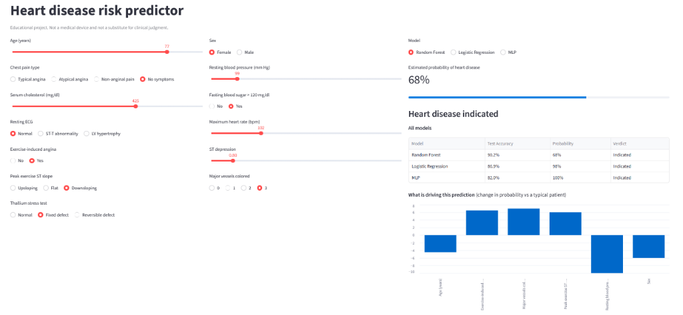
Figure 1: Streamlit User Interface for Heart Disease Prediction

6. Conclusion
The machine learning pipeline successfully processes clinical data and predicts the likelihood of heart disease with high accuracy. Based on the evaluation metrics, ensemble methods like Random Forest and linear models like Logistic Regression provided robust and reliable predictions, making them highly suitable for early diagnostic aids in healthcare.

